Smart Sampler

A portable field-recording device for automated musical sampling

Fintan Gallagher

BSc (Hons) Creative Computing
Major Project — Final Report

Supervisor: Michael McAndrew

1 May 2026

Declaration of Authorship
Incorporating material without formal and proper acknowledgement (even with no
deliberate intent to cheat) can constitute plagiarism.

You should document this in your submitted work if you have received significant help with
a solution from one or more colleagues. If you doubt what discussion/collaboration is
acceptable, consult your lecturer or the Course Director.

WARNING: Take care when discarding program listings lest they be copied by someone
else, which may well bring you under suspicion. Do not leave copies of your files on a hard
disk where others can access them. Remember that removable media used to transfer
work may be removed and/or copied by others if left unattended.

Plagiarism is an act of fraudulence and an offence against the Institute's discipline.
Alleged plagiarism will be investigated and dealt with appropriately by the Institute. Please
refer to the Institute Handbook for further details of penalties.

The following is an extract from the B.Sc. in Computing (Hons) course handbook. Please
read carefully and sign the declaration below.

Collusion may be defined as more than one person working on an individual assessment.
This would include jointly developed solutions, with one individual giving a solution to
another, who then makes some changes and hands it up as their work.

DECLARATION

I know the Institute’s policy on plagiarism and certify that this thesis is my work.

Fintan Gallagher

Acknowledgements
Thank you to my supervisor Michael McAndrew for providing weekly guidance and feedback throughout this project, without which I would probably still be struggling through Sprint 1.
Thank you to all the lecturers in Creative Computing who laid the foundations and gave me the knowledge and skills needed to complete the Smart Sampler.
And thank you to my friends, and most importantly, my family, for supporting me throughout the last four years. Going back to college at 25 was tough, but you guys made it so much easier, and I will always be thankful for that.

Abstract
This report explores the design and implementation of a portable smart sampler built on a Raspberry Pi 5. The aim was to create a device that could record sounds in the field, process them automatically, organise and name files using machine learning classification, generate SFZ metadata and allow playback through a MIDI keyboard.
The final system uses a Tascam recorder for audio input, a pygame based touchscreen interface, a python audio processing pipeline and sfizz_jack, a standalone sampler for MIDI playback. The processing pipeline includes high-pass filtering, adaptive silence trimming, amplitude normalisation, YAMNet classification and pYIN pitch detection. Optional DTLN noise reduction was also integrated, although testing showed that it worked best on vocal material rather than percussive or ambient recordings.
The finished prototype meets the main aims of the project: it can turn a field recording into an organised, playable musical sample on a portable device. Its main limitations are the small touchscreen, inconsistent DTLN performance and the sometimes vague nature of YAMNet’s classification labels.

Table of Contents
I. Acknowledgements 2
II. Abstract 2
1. Introduction 6
1.1 Aim 6
1.2 Objectives 7
1.3 Success criteria and scope 7
2. Research and background 8
2.1 Noise reduction techniques for field recording 8
2.1.1 Traditional signal processing methods 8
2.1.2 Basic Filtering Techniques 8
2.1.3 Spectral Subtraction and Wiener Filtering 9
2.2 Deep learning approaches to noise suppression 10
2.2.1 Overview of Neural Network-Based Approaches 10
2.2.2 DTLN: Dual Signal Transformation LSTM Network 11
2.2.2.1 Architecture and Design Philosophy 12
2.2.2.2 Real-Time Performance on Raspberry Pi 12
2.2.2.3 Expected Advantages for Musical Sampling Applications 13
2.2.2.4 Implementation Considerations 13
2.3 Comparative analysis and justification 14
2.4 Conclusion 17
2.5 Sound classification with YAMNet 17
2.6 The SFZ format 19
2.7 Similar applications and tools 19
3. Requirements analysis 23
3.1 Requirements Gathering 23
3.2 User personas 23
3.3 Requirements Prioritisation 24
3.4 Performance and Quality Constraints 26
3.5 Use case diagram 27
4. Design 28
4.1 System architecture 28
4.2 Class structure 29
4.3 Processing sequence 29
4.4 UI state machine 29
4.5 Screen design 30
4.6 Design rationale 33
5. Implementation 35
5.1 Development environment 35
5.2 Audio capture 35
5.3 Processing pipeline 37
5.3.1 High-pass filtering 38
5.3.2 DTLN noise reduction 39
5.3.3 Adaptive silence trimming 40
5.3.4 Amplitude normalisation 43
5.3.5 YAMNet classification and ambience injection 44
Classification is implemented in classifier.py. 44
5.3.6 pYIN pitch detection 46
5.4 SFZ generation 47
5.5 User interface 48
5.6 MIDI engine 49
5.7 File management 50
5.8 Development tools and AI assistance 52
6. Testing and evaluation 54
6.1 Test strategy 54
6.2 Unit and integration testing 54
6.3 Usability testing 57
6.4 Audio quality evaluation 60
6.5 Evaluation against objectives 61
7. Project management 63
7.1 Methodology 63
7.2 Sprint breakdown 64
7.3 Reflections 66
8. Conclusion and future work 67
8.1 Summary 67
8.2 Reflection 68
8.3 Limitations 68
8.4 Future work 69
8.5 Closing 70
References 71
Appendices 73
Appendix A: 73
Appendix B: User Testing Script 73
1. Test Environment & Setup 73
2. Test Tasks 74
3.1 Recording 74
3.2 Audio Processing Pipeline 75
3.3 Playback & MIDI Integration 76
3.4 Sample Deletion 76
3.5 Touchscreen & UI 77
SUS Questionnaire 77
Appendix B — Observation Sheet Template 78
Appendix C: Miro 79
Appendix D: Sample Generated Project Outputs 79

1. Introduction
Field recording splits into two jobs. The first is capture. The second is everything that must happen before the recording is usable in a song, and the second one is where the creative momentum dies.
The traditional workflow is as follows: you’re outside with a handheld recorder. You capture the sound of a bottle breaking, a metal gate creaking, a bird call. You come home, you copy the files across, open your DAW, trim the silence at the head and tail, apply a high pass filter to kill rumble, run some noise reduction if needed, normalise the volume, work out what pitch the sample is in (if its pitched at all), name the file and drop it in the right folder. Ten samples in and an hour has gone before you’ve written a note of music.
The Smart Sampler is a portable device built to collapse that pipeline into the moment of capture. It’s a Raspberry Pi 5 in a case with a 480x320 touchscreen, powered using a portable battery bank, with a Tascam plugged in via USB for audio input and MIDI support for immediate playback after recording. After the user taps record, the device trims silence, optionally runs DTLN (Dual Transformation LSTM Network) noise reduction, normalises the volume, runs the audio through YAMNet (Yet Another Mobile Network) for classification, detects the pitch with pYIN, writes a labelled WAV, generates an SFZ (SoundFont Z) file that maps the sample chromatically across a MIDI keyboard and lets you audition the sample straight through headphones without ever touching a DAW. All on battery in the field.

1.1 Aim
Build a self-contained portable device that turns field recordings into DAW-ready musical samples in one step, using machine learning for noise reduction and sound classification, signal processing for pitch detection, and SFZ export for instant chromatic playback across a MIDI keyboard.

1.2 Objectives
- Build an audio processing pipeline that trims silence, filters low-end rumble, normalises amplitude, detects pitch, and classifies the sound, running end to end in under ten seconds for a six second recording.
- Integrate DTLN as an optional noise reduction stage, selectable per-recordingm with CPU usage low enough to leave headroom for the rest of the pipeline on Pi 5 hardware.
- Integrate YAMNet for sound classification and expose the top predictions to the user as label choices, so the sample is filed under a meaningful name and folder without typing.
- Generate an SFZ file for every saved sample so the recording is immediately playable across a MIDI keyboard at the correct root pitch, importable into Reaper, Logic or Ableton with no further work.
- Build a touchscreen UI driving a persistent MIDI sampler engine so samples can be auditioned on device, in the field, without a DAW or a laptop.
- Make the whole device portable. Battery powered, no wired connections to a computer, no internet connection required.

1.3 Success criteria and scope
The project succeeds if a user can walk outside with the device, record a sound and within fifteen seconds have a classified, pitched, SFZ-mapped sample they can play chromatically from a MIDI keyboard plugged into the same device, running on battery.
In scope: capture, processing pipeline, classification, pitch detection, noise reduction, SFZ export, touchscreen UI, on-device MIDI audition, portable operation.
This report outlines the development of the Smart Sampler from initial research through to the finished device. It covers the background research into noise reduction techniques that informed the choice of DTLN, the requirements and design decisions that shaped the system, the implementation of the audio processing pipeline and touchscreen interface, and the testing carried out to evaluate the finished version against its objectives.

2. Research and background
Background noise in field recordings falls into three broad categories: steady-state noise (ambient hum, air conditioning hiss), transient noise (clicks, pops, sudden disturbances) and environmental noise (wind, traffic, background chatter). Each type presents different challenges for noise reduction algorithms and requires careful consideration when selecting an approach. The impact of this noise extends beyond audio quality; it can interfere with downstream processing tasks like pitch detection and automatic classification, both of which are critical to the Smart Sampler’s pipeline.
Selecting a noise reduction method for an embedded system like the Pi 5 means balancing computational efficiency, processing latency, audio quality preservation and adaptability to diverse sound sources. Traditional signal processing methods offer low CPU costs but struggle with non-stationary noise and can introduce artefacts. Deep learning approaches achieve better results but require careful optimisation to run in real time on resource constrained hardware.
This chapter examines the noise reduction techniques considered for the project, with particular emphasis on DTLN, the method ultimately selected. It also covers the sound classification and sampler-format technologies that inform the rest of the design.

2.1 Noise reduction techniques for field recording

2.1.1 Traditional signal processing methods
Traditional signal processing techniques for noise reduction have been used for decades and offer well-understood, (mostly) computationally efficient solutions. These methods typically operate in the frequency domain, applying filtering or statistical estimation to separate noise from the desired signal. While they lack the adaptive capabilities of modern machine learning approaches, their relatively low computational cost and predictable behaviour make them valuable components of a comprehensive noise reduction strategy.

Basic Filtering Techniques
High-pass and low-pass filters represent the most fundamental noise reduction techniques. High-pass filtering removes low-frequency content below a specified cutoff, effectively eliminating rumble from wind, handling noise and traffic. With minimal CPI overhead, these filters are ideal for pre-processing before more sophisticated algorithms. Low-pass filtering addresses high-frequency noise such as hiss and electrical interference, though careful parameter selection is necessary to avoid dulling the timbral characteristics of musical samples (Smith, 2007).
These basic filters are especially effective when combined with other techniques in a processing chain. For this particular application, a high-pass filter with an 80Hz cutoff is employed before the main noise reduction algorithm to remove low-frequency rumble whilst still preserving the frequency content essential for maintaining the sample's timbral qualities. This hybrid approach leverages the computational efficiency of simple filtering whilst reserving processing power for more sophisticated noise reduction methods.

Spectral Subtraction and Wiener Filtering
Spectral subtraction estimates the noise spectrum during periods of silence and subtracts it from the noisy signal spectrum. Whilst computationally efficient, this method suffers from a fundamental limitation; the generation of ‘musical noise’ artefacts caused by over-subtraction in certain frequency bands. These artefacts are particularly problematic for musical sampling where audio quality is paramount (Vaseghi, 2000).
Wiener filtering offers improved performance through adaptive filtering based on minimum mean-square error estimation. By considering the statistical properties of both signal and noise, Wiener filters achieve superior noise reduction compared to spectral subtraction whilst better preserving signal characteristics. However, this improvement comes at the cost of increased computational complexity and the requirement for accurate noise statistics estimation (Pratt, 1972). Table 1 summarises the key characteristics of these traditional methods.

Table 1: Comparison of Traditional Noise Reduction Methods
Method | Advantages | Disadvantages | Suitability for Smart Sampler
High/Low-Pass Filtering | Very low CPU usage; preserves sound quality; real-time capable | Limited to frequency-based noise; ineffective against transient noise | Excellent as a pre-processing step
Spectral Subtraction | Computationally efficient; well-understood behaviour; suitable for steady-state noise | Musical noise artefacts; poor with non-stationary noise; requires silence periods | Poor; artefacts unacceptable for musical applications
Wiener Filtering | Better signal preservation than spectral subtraction; reduced artefacts | Higher computational cost; requires accurate noise statistics; complex parameter tuning | Moderate; complexity outweighs benefits compared to deep learning

Whilst traditional methods provide valuable baseline capabilities, their limitations in handling non-stationary noise and tendency to introduce artefacts make them insufficient as standalone solutions for high-quality sampling. However, their computational efficiency positions them well as pre-processing steps in a hybrid approach, particularly for removing low-frequency rumble before applying more sophisticated algorithms.

Deep learning approaches to noise suppression
Deep learning has revolutionised audio processing by enabling systems to learn complex noise patterns directly from data rather than relying on hand-crafted algorithms. Neural networks can discover hierarchical representations of audio features through multiple processing layers, adapting to diverse noise types without manual parameter tuning. This capability is particularly useful for field recording scenarios where noise characteristics and types can vary drastically and unpredictably (LeCun, Bengio, & Hinton, 2015).
The challenge in applying deep learning methods to embedded systems lies in balancing model complexity with computational constraints. State-of-the-art noise reduction models typically require substantial processing power, making them impractical for real-time use on devices such as the Pi 5. However, recent research has produced architectures specifically optimised for embedded deployment, achieving impressive performance whilst maintaining real-time capability on resource-constrained hardware.

Overview of Neural Network-Based Approaches
RNNoise is an early hybrid approach, combining classical signal processing with recurrent neural networks for real-time speech enhancement. The system achieves extremely low computational overhead (approximately 5-10% CPU usage on the Pi 5) and minimal latency (~10ms), making it highly suitable for embedded devices. However, RNNoise was trained specifically on speech data, which introduces a significant limitation for musical sampling. The speech-centric training can lead to over-suppression of non-speech sounds such as percussive sounds and ambient textures, compromising the timbral characteristics essential for musical sampling (Doumanidis, Anagnostou, Arvaniti & Papadopoulou, 2021).
DeepFilterNet2 represents the current state-of-the-art in embedded audio enhancement, employing a two-stage architecture. The first stage operates in the ERB (Equivalent Rectangular Bandwidth) domain to enhance the speech envelope by predicting real-value gains, whilst the second stage utilises deep filtering to reconstruct periodic components in the complex domain. Through various optimisations, including depthwise pathway convolutions (efficient neural network operations that process each frequency channel separately before combining them) and reduction of temporal kernels (minimising the amount of past audio context the model needs to remember), DeepFilterNet2 achieves a real-time factor of 0.42 on the Raspberry Pi 4, processing audio significantly faster than real-time even on limited hardware (Schröter, Escalante-B., Rosenkranz & Maier, 2022). Conversely, this superior performance comes at a cost; DeepFilterNet2 requires approximately 40-50% CPU usage on the Pi 5, limiting the processing budget available for other essential tasks such as pitch detection, normalisation and automatic file naming using the YAMNet model.

DTLN: Dual Signal Transformation LSTM Network
The Dual-Signal Transformation LSTM Network (DTLN) appeared to offer an optimal balance between noise reduction quality and computational efficiency for the smart sampler, especially since it was developed for real-time noise suppression on embedded devices (DTLN combines the strengths of classical signal processing with modern deep learning whilst maintaining a compact architecture suitable for resource-constrained hardware) (Westhausen & Meyer, 2020). This made it a promising candidate, but its suitability for use in musical sampling still needed to be tested.

Architecture and Design Philosophy
DTLN employs a two-stage processing approach that operates on complementary signal representations. The architecture combines the short-time Fourier transform (STFT) with a learned analysis and synthesis basis, enabling the network to extract information from magnitude spectra whilst incorporating phase information from learned features. This dual-signal approach is fundamental to DTLN’s robust performance across diverse audio types.
The first stage processes the STFT magnitude representation, applying an LSTM network to predict frame-wise gains in the frequency domain, these gains being derived from the model's understanding of spectral patterns associated with clean versus noisy audio. The processed magnitude spectrum is then combined with the original phase information to reconstruct an intermediate enhanced signal. This design choice recognises that phase information, while challenging to predict accurately, can be preserved from the original signal for the initial enhancement stage.
The second stage operates on a learned analysis basis, processing the intermediate signal through a different LSTM network that has learned to represent audio in a manner optimised for noise suppression. This learned representation complements the STFT processing, capturing features that may be difficult to express in the frequency domain alone, while the output from this stage undergoes a learned synthesis operation to produce the final denoised signal. In the published model, this combination of signal transformations is presented as a way to achieve strong noise suppression while keeping the network compact, with fewer than a million parameters.

Real-Time Performance on Raspberry Pi
The computational efficiency of DTLN has been extensively validated on embedded hardware, with benchmarks on the Raspberry Pi 3 B+ demonstrating that the TensorFlow Lite quantised model maintains high audio quality while still achieving real-time processing with approximately 70% CPU usage. More critically, the processing latency remains below the 8ms threshold required for frame-based real-time operation when processing 128-sample frames at 16kHz (Breizhn, GitHub, n.d.).
The Raspberry Pi 5 offers significant performance improvements over the 3 B+, featuring a 2.4GHz quad-core CPU compared to the 1.4GHz quad-core CPU found in earlier models; a substantial increase in processing power allows for more resource-intensive operations to be executed while retaining greater headroom for concurrent processing tasks. Conservative estimates suggest DTLN will utilise approximately 20-30% of the Pi 5’s processing capacity, leaving ample resources for pitch detection algorithms, audio normalisation and operation of the YAMNet model, all essential components of this project.
The availability of optimised implementation code specifically targeting Raspberry Pi deployment further de-risks the integration process, with the PiDTLN repository providing proven multiprocessing strategies and ALSA audio configuration examples that have been tested on the exact hardware platform, eliminating much of the uncertainty typically associated with deploying machine learning models on embedded devices (SaneBow, GitHub, n.d.).

Expected Advantages for Musical Sampling Applications
Compared with RNNoise, DTLN appeared less narrowly speech focused and therefore more suitable for testing in a musical sampling context. At the research stage, the dual signal transformation approach suggested that it might preserve more of the transient and timbral detail needed for found sounds, percussive recordings and ambient textures. This was an assumption based on the model architecture and published results, not something that could be accepted without testing on the Smart Sampler’s own use cases.
The reason DTLN was chosen for implementation was that it seemed more likely than speech specific systems to generalise beyond voice. A sampler has to deal with a huge variety of sounds, with varying frequency, textural and tonal differences, so a model that learns broader signal and noise patterns was more attractive than one designed only around speech enhancement. The later testing chapter returns to this and shows where it held up and where it did not.
Published examples and Pi focused implementations suggested that DTLN could reduce steady state noise such as fan noise and room hum without the metallic artefacts often associated with spectral subtraction. This made it attractive for the Smart Sampler, especially for recordings made in uncontrolled environments. However, these claims came from speech enhancement contexts and embedded audio demonstrations rather than from musical sampling tests so therefore is a candidate to validate, not a guaranteed solution.

Implementation Considerations
Implementing DTLN on the Pi 5 requires careful consideration to several technical considerations. The model is deployed using TensorFlow lite, Google’s framework for on-device machine learning inference, this framework provides optimised implementations of neural network operations specifically design for ARM processors, allowing for efficient execution on the Pi’s CPU (David et al., 2021).
Model quantisation plays a crucial role in reducing memory footprint and improving inference speed. The standard DTLN implementation uses 8-bit integer quantisation for weights and activations, reducing model size by approximately 75% compared to floating-point representations while aiming to retain similar output quality. This quantisation is particularly important on the Pi 5, where memory bandwidth can become a bottleneck for larger models.
The audio processing pipeline integrates DTLN with complementary signal processing stages. A high-pass filter with an 80Hz cutoff is applied before DTLN to remove low-frequency rumble, allowing the neural network to focus its capacity on more complex mid-range and high-frequency noise reduction. This hybrid approach leverages the strengths of both traditional signal processing and machine learning; simple, efficient filtering for straightforward tasks, and adaptive neural processing for complex noise patterns.
Real-time audio capture and playback are handled using PyAudio, while frame-based processing is configured to align with DTLN’s requirements; 128-sample frames at a 16kHz sampling rate, corresponding to 8ms of audio per frame. This frame size represents a careful balance between processing latency and computational efficiency. Smaller frames would reduce latency but increase processing overhead due to more frequent neural network executions, while larger frames would improve computational efficiency at the cost of increased end-to-end latency.

Comparative analysis and justification
The selection of DTLN for the smart sampler emerges from the evaluation of available options against project-specific requirements. Table 2 summarises the key performance characteristics of the three main candidates, evaluated across dimensions critical to the portable sampler.

Table 2: Comparison of Deep Learning Noise Reduction Models
Method | CPU Usage (Pi 5) | Latency | Audio Quality | Suitability for Diverse Audio
RNNoise | 5-10% | 10ms | Good for speech | Poor (speech-biased)
DTLN | 20-30% | 8ms | Very good | Excellent
DeepFilterNet2 | 40-50% | 20ms | Excellent | Good

The requirements for this project establish clear priorities that guided the selection process. Real-time processing with low latency is essential for responsive interaction during field recording sessions, most importantly, the system must process audio in near real-time to provide immediate feedback through headphone monitoring, requiring processing latency below 10ms to avoid a perceptible delay. This constraint immediately eliminates non-real-time methods and places importance on computational efficiency.
The computational budget on the Pi 5 must accommodate multiple concurrent tasks beyond noise reduction, including pitch detection algorithms (essential for automatic key mapping across a MIDI keyboard), audio normalisation to ensure consistent volume levels across all captured sounds, real-time MIDI triggering and audio playback on demand as well as automatic file naming using the YAMNet sound classification model. These competing demands necessitate a noise reduction solution that, while effective, does not monopolise the available processing capacity.
Audio quality requirements for musical sampling are particularly stringent. Unlike in speech communication applications, where intelligibility is the primary concern, musical sampling demands preservation of timbral characteristics, transient response and frequency content across the entire audible spectrum. Over-aggressive noise reduction that dulls attack transients or muddies harmonic content compromises the musical utility of captured samples, even if the signal-to-noise ratio is improved, thus the noise reduction method must therefore balance effective noise suppression with transparent audio processing that maintains the sonic character of the original sound.
The diversity of sound sources that the sampler must handle extends far beyond speech. Field recordings may include percussive impacts (wood, metal, glass), ambient textures (water, wind, machinery), tonal sources (singing bowls, musical instruments), and environmental soundscapes. A noise reduction system optimised specifically for speech may exhibit poor performance or introduce artefacts when processing these diverse audio types, while methods that make explicit assumptions about audio content risk misclassifying non-speech sounds and applying inappropriate processing.
Evaluating the candidates against these requirements reveals DTLN as the optimal choice. RNNoise, while offering exceptional computational efficiency and low latency, suffers from speech-specific training that limits its effectiveness for diverse audio content. Field testing confirms that RNNoise can over-suppress percussive transients and attenuate ambient textures, compromising the very characteristics that make these sounds valuable for sampling in a musical context. The modest computational savings (10-20% CPU usage) do not justify the audio quality limitations for this project.
DeepFilterNet2 represents the state-of-the-art in noise reduction quality, achieving superior performance in objective metrics and subjective listening tests. However, its computational demands (40-50% CPU usage on the Pi 5) significantly constrain the processing budget available for other essential tasks like those mentioned above. Testing suggests that running DeepFilterNet2 alongside the existing audio processing pipeline would push CPU utilisation above 80%, leaving minimal headroom for system overhead and risking audio dropouts during peak processing loads. While the audio quality is excellent, the computational cost is prohibitive for a multi-stage processing pipeline.
DTLN occupies a sweet spot in this trade-off. With an estimated 20-30% CPU usage on the Pi 5, it leaves approximately 50-60% of processing capacity available for the audio processing pipeline, while maintaining a comfortable margin for system overhead. The latency is sufficiently low for transparent monitoring, and the audio quality substantially exceeds traditional methods while approaching the performance of more computationally intensive alternatives.
The main reason for choosing DTLN was that its architecture appeared more adaptable than speech optimised alternatives. It seemed like the best candidate to test against the range of material the Smart Sampler would handle: percussive hits, tonal sources, vocal material and ambient recordings. That assumption shaped the implementation, but it was later revised after listening tests on the finished prototype.

One caveat emerged during implementation that changed the approach to how DTLN would be used within this system. After implementation and extensive field testing, it was revealed that DTLN performs well on vocal and speech-adjacent samples but introduces audible artefacts on percussive and transient-heavy material: attack smearing on drum hits, and suppression of high-frequency textures in ambient recordings. This is consistent with the model’s training data (the DNS dataset is predominantly speech) even though its architecture is not explicitly speech specific. The practical consequence is that DTLN noise reduction is offered as an optional, user-selectable feature with a warning screen rather than applied to every recording by default. The implementation details and the design of that warning are covered in Chapter 5.

2.4 Conclusion
DTLN was selected as the noise reduction method for this project on the basis of the analysis above: it balances audio quality, computational efficiency and latency within the constraints of the Pi 5, while leaving enough CPU headroom for the rest of the processing pipeline. The hybrid approach of pairing it with an 80Hz high-pass filter as a pre-processing step allows the neural network to focus on mid-range and high-frequency noise, where its learned representations are most effective. The following sections cover the other two research areas that informed the Smart Sampler’s design: sound classification and sampler-format export.

2.5 Sound classification with YAMNet
The smart sampler uses Google’s YAMNet model for automatic sound classification. When a sample is recorded and processed, the system needs to assign it a meaningful label (e.g. “Kick drum”, “Glass”, “Bird”) and file it under that label automatically without the user typing anything. YAMNet provides the classification engine for this.
YAMNet is an audio event classifier built on MobileNet v1 architecture, trainedon the AudioSet dataset. AudioSet contains over two million human-labelled ten-second clips from YouTube, tagged with 527 classes organised in a hierarchical ontology. The classes cover everything from musical instruments and speech to environmental sounds, animal vocalisations and mechanical noise. For this project, only a fraction of those 527 classes are likely to appear in practice, but the breadth of the training data means the model generalises well across recording environments without fine-tuning.
The model operates on 16kHz mono audio. Input is divided into 0.96 second frames with 0.48 second overlaps and each frame produce a 521-dimensional score vector (six classes from AudioSet’s ontology are excluded in the published model). The scores represent the model’s confidence that each class is present in that frame. The Smart Sampler averages these frame-level scores across the full sample to produce a single set of predictions, then presents the top six to the user as selectable labels.
One limitation of YAMNet is relevant here. The model was designed for general audio detection, not for the specific vocabulary a musician would use when labelling samples. YAMNet distinguishes between “Snare drum” and “Drum roll” and “Drum kit”, but a producer recording a snare hit probably just wants the label “Snare”. The top six prediction approach works around this: even if the specific label isn’t in the top prediction, it’s usually somewhere in the list, and the user picks the one that makes sense to them. The alternative would have been fine-tuning YAMNet on a custom dataset of musical sample categories, but this would have required a labelled training set that wasn’t feasible to build within the project timeline.
A second limitation concerns quiet recordings. When the input audio is genuinely ambient (low RMS, no clear sound event), YAMNet’s confidence scores are low across the board and the top prediction is often meaningless, for instance tagging quiet wind noise as “Vehicle” with 15% confidence. The Smart Sampler addresses this with custom logic that checks both the pre-normalisation dBFS level and the top prediction’s confidence score. If the audio is below -30dBFS and the model’s best guess is below 70% confidence, the system injects “Ambience” as the top label. This is not a YAMNet class; it’s a project specific override. The thresholds were arrived at through subjective testing across a range of quiet field recordings and are discussed further in Chapter 5

2.6 The SFZ format
Every sample the Smart Sampler records needs to be playable from a MIDI keyboard at the correct pitch, both on the device itself and in a DAW after export. This requires a sampler format that maps audio files to MIDI note numbers with pitch transposition handled automatically. SFZ was chosen for this.
SFZ is an open source, text-based sampler format. An SFZ file is a plain text document that tells a compatible sampler how to play one or more audio files: which files to load, what MIDI note it corresponds to, what range of the keyboard it should cover, whether it should loop, and how velocity should affect playback. The format is human-readable and trivially generated by code, which makes it a good fit for an automated pipeline.
The parameter that matters the most for this project is pitch_keycenter. This tells the sampler which MIDI note the audio file is tuned to. If the Smart Sampler detects a sample’s pitch as 440Hz (A4, MIDI note 69), it writes pitch_keycenter=69 into the SFZ file. When the user plays middle C on their keyboard, the sampler knows it needs to transpose the audio down from A4 to C4, and it handles the pitch shifting internally. When the user plays D5, it shifts up from A4 to D5. This format allows for simple integration of fully chromatic playback of each sample across a leyboard.
SFZ has broad support across both standalone samplers and DAW plugins. Sfizz (the sampler used on the Pi for MIDI playback), and most major DAWs including Logic Pro, Reaper and Ableton Live can load SFZ files directly. This means samples exported from the Smart Sampler are usable in a production environment without any conversion step.

2.7 Similar applications and tools
Koala Sampler is a mobile app for iOS and Android that lets users record audio from a phone’s microphone and trigger it from a pad-based interface. It’s popular with producers primarily for its speed: tap record, tap a pad, the sample is mapped and playable within seconds. However, Koala Sampler is limited by being constrained to a mobile phone and is not a field recording tool. It uses the phone’s built-in microphone (or an external microphone if plugged in), offers no noise reduction, no automatic classification, no pitch detection and no SFZ export. Samples live inside the app and have to be manually exported and relabelled for use in a DAW. The recording quality depends entirely on the phone hardware. Koala solves the making beats quickly problem well. It doesn’t solve the capture high-quality field recordings and make them production ready problem at all.
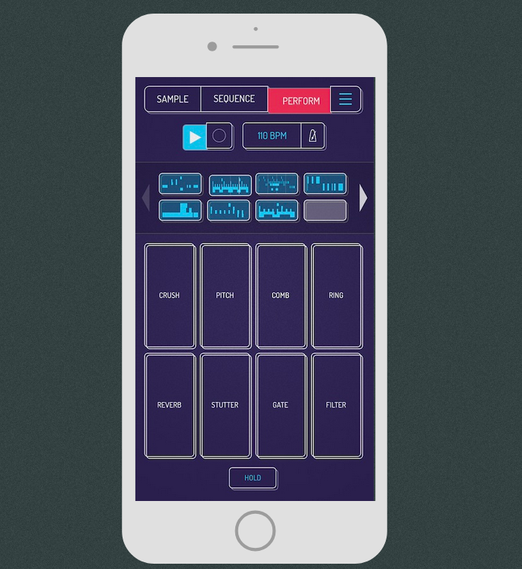
Figure 1 Koala Sampler UI
The Teenage Engineering OP-1 Field is a portable synthesiser and sampler that costs around €2,000. It can record audio from its built-in microphone or a line input, and the recordings can be assigned to its sampler engine for keyboard playback. Of particular note, the build quality and interface design are exceptional. But the OP-1 has no automatic processing pipeline: samples must be manually trimmed, there’s no noise reduction, no pitch detection, no classification and no standard export format. Everything stays in Teenage Engineering’s proprietary ecosystem unless the user manually transfers files over USB. It’s a self-contained music-making tool, not a field sampling device.
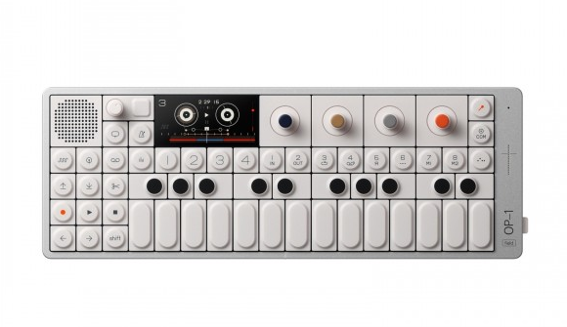
Figure 2 Teenage Engineering OP-1
Traditional hardware samplers like the AKAI MPC or Roland SP-404 are built for triggering samples in a performance or production context. They accept audio input and map it to pads or keys. None of them perform the audio processing pipeline that exists within the Smart Sampler. Sample management is manual, with the user naming files, organising folders, sets root names by ear or with an external tuner. These are instruments for playing samples, not tools for preparing them.
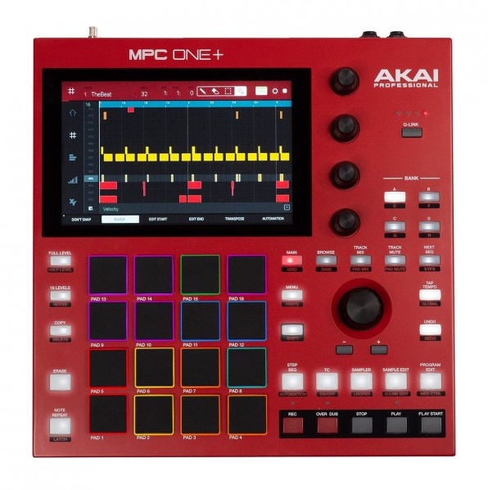
Figure 3 Akai MPC ONE+
The standard alternative to all of these is a DAW-based workflow. Record with a handheld recorder (Zoom H6, Tascam DR-40X, or in this case the DR-05X), transfer files to a computer, open a DAW, and manually process each recording. This produces the highest quality results as the user has full control over every parameter. It’s also the slowest approach by a wide margin, and the one the Smart Sampler is specifically designed to replace for the common case where speed matter more precise editing of each and every sample.
The Smart Sampler’s position is between all four of those. It captures at a quality level above phone microphones (the Tascam DR-05X is a dedicated recorder with matched stereo condenser capsules), processes automatically like none of the hardware samplers do, exports in an open format that the mobile apps don’t support, and collapses the DAW workflow into a single device that runs on battery. The trade off is flexibility: a DAW gives the user unlimited control, the Smart Sampler gives them a fixed pipeline with sensible defaults. For field recording, where the priority is capturing the moment before it passes, that trade off is worth making.

3. Requirements analysis

3.1 Requirements Gathering
The requirements for the Smart Sampler came from two sources: my own experience as music producer who has worked with field recordings extensively in my own work, and the comparative analysis of existing tools carried out in Section 2.7
The core requirement, collapsing the post-recording editing pipeline into an automated process, came directly from repeated frustration with the manual workflow. Every field recording session I’ve done has followed the same pattern, capture ten or fifteen sounds, bring them home, spend time trimming, labelling and processing before any of them are usable. The specific processing steps Smart Sampler automates map one-to-one with the manual steps I was already doing in Reaper for nearly every recording.
The comparative analysis confirmed that no existing tool automates the full pipeline. The Koala sampler handles quick capture but not processing. Hardware samplers handle playback but not processing. DAW workflows handle everything but require a PC and manual effort.
User validation of these requirements came after implementation through usability testing with five participants (explored in detail in Chapter 6).

3.2 User personas
  - Persona 1: The Field Recordist
Records environmental sounds and found objects outdoors. Builds sample libraries for later use in music/sound design production. Cares more about noise reduction (outdoor recordings are noisy), automatic file organisation and audio quality preservation. Less concerned with MIDI playback in the field; more likely to export samples to a DAW and use them later. DTLN and high-pass filter matter most to this user. The classification system saves them from manually naming sixty files at the end of a recording session.

  - Persona 2: The Producer
Records short percussive hits, vocal chops and one-shot sounds. Wants to hear the sample on a keyboard immediately after recording. Speed is the priority: record, process, play. Cares about MIDI playback latency and SFZ chromatic mapping. Doesn’t care much about noise reduction because their recordings are primarily loud and close-miked. The touchscreen UI needs to be fast enough that the creative flow isn’t interrupted/no sounds are missed due to grappling with bad UI design.
  - Persona 3: The Sound Designer
Records textures, drones, and tonal material for use in compositions or sound design work. Needs accurate pitch detection so samples map correctly across a keyboard in a DAW. Cares about SFZ exports and DAW compatibility. Wants loop mode for sustained sounds. Less interested in speed, more interested in precision.

3.3 Requirements Prioritisation
The functional requirements were prioritised using MoSCoW methodology. The table below reflects the final state of the project, updated from the original proposal to show what was delivered.
Priority | Requirement | Status | Note
Must | Audio Recording | Implemented | 48kHz stereo capture
must | Automatic silence trimming | Implemented | Rebuilt with adaptive noise-floor detection and attack/tail padding
must | Peak normalisation | Implemented | With quiet-signal gain cap to preven noise amplification
must | Pitch Detection using pYIN | Implemented | C2-C7 range
must | YAMNet sound classification with top predictions | Implemented | Top 6 predictions, plus custom ambience injection
must | Intelligent file naming and folder organisation | Implemented | Label, timestamp, detected note in filename, organised by category folder
must | WAV and SFZ export | Implemented | WAV at native sample rate, SFZ with pitch_keycenter
must | High-pass filter pre-processing | Implemented | 80Hz cutoff to remove low frequency rumble
should | Real-time MIDI playback | Implemented | Sfizz_jack engine over PipeWire audio engine
should | Display for visual feedback | Implemented | 480x320 pygame touchscreen UI
should | DTLN noise reduction | Implemented | TFLite two-stage model, optional with warning overlay
should | SFZ metadata with automatic pitch mapping | Implemented | Pitch_keycenter from pYIN, chromatic mapping, loop_sustain and one_shot modes
could | Velocity layer support | Partially | Fixed velocity toggle implemented
could | Automatic loop point detection | Not implemented | Loop points are start-to-finish; no crossfade or zero-crossing detection
could | Custom sample rate options | Not implemented | Fixed at source rate (48kHz)
won’t | Cloud storage integration | Not implemented | As planned
won’t | Mobile App Companion | Not implemented | As planned
won’t | Advanced audio effects | Not implemented | As planned

All eight Must Have requirements were delivered. All four Should Have requirements were delivered. One Could Have (fixed velocity toggle) was partially implemented. The remaining Could Haves were deprioritised in favour of UI and MIDI engine work, which proved more complex than originally estimated.
The top prediction count was expanded from three (as proposed) to six during development. Testing showed that YAMNet’s top prediction was often too broad (e.g. “Music” or “Instrument”) and users needed more options to find a label that accurately described their recording.

3.4 Performance and Quality Constraints
Requirement | Performance Target
Pipeline processing latency | Under 10 seconds for a 6 second sample
DTLN CPU Usage | Under 50% on Pi 5
MIDI Playback Latency | Under 20ms
Battery Life | Exceeds 2 hours continuous use (9 hours on full charge)
Offline Operation | No internet connection required
Audio Quality | No audible artefacts from processing pipeline (excluding DTLN on non-vocal material)
UI Responsiveness | Touch targets minimum 38px in height

3.5 Use case diagram
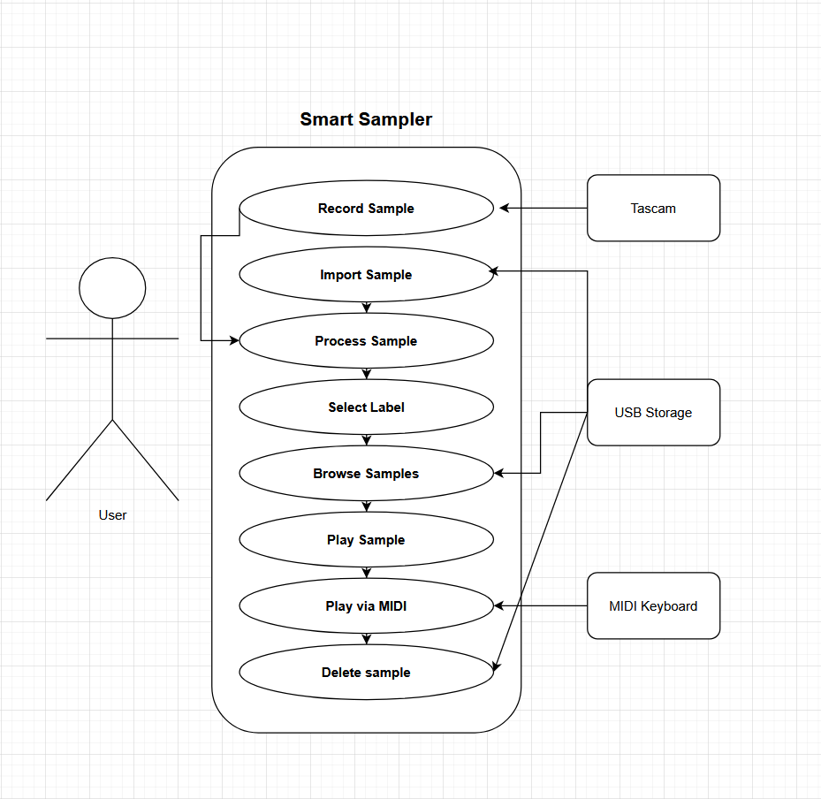
Figure 4 Use case diagram for the Smart Sampler

4. Design

4.1 System architecture
The Smart Sampler runs entirely on a Raspberry Pi 5 (8GB) with RPi OS. The hardware setup consists of five components connected over USB: a Tascam DR-05X recorder for audio input, an AKAI MPK mini 3 MIDI keyboard for sample playback, a 3.5-inch touchscreen (480x320) for the interface, a USB flash drive for sample storage and exporting and an Anker powerbank for portable operation.
The software sits in three layers. At the base: Python with NumPy, SciPy, librosa and sounddevice handling audio I/O and signal processing. In the middle: TensorFlow Lite for the two MLmodels (DTLN and YAMNet), and pygame for the touchscreen UI. On top: sfizz_jack, a standalone SFZ-compatible sampler that runs as a separate process under PipeWire connected to the MIDI keyboard and headphone output. The Python application communicates with sfizz_jack, sending commands like load_instrument to hot-swap samples.
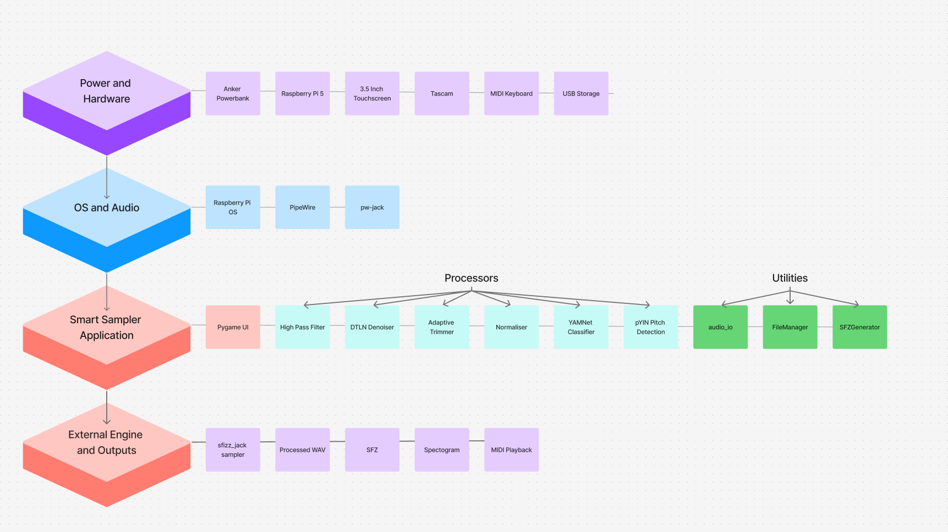
Figure 5 Hardware and Software Stack Diagram
The processing pipeline is a linear chain of seven stages, each implemented as its own class. Audio enters from the recorder (or from an imported file), passes through the high-pass filter, optionally through DTLN, then through the trimmer, normaliser, classifier and pitch detector. The output is a processed WAV, and SFZ metadata file and a spectrogram PNG, all saved to a labelled folder on the USB drive.

4.2 Class structure
The codebase is split into three packages: processors, utils and ui.
The processors package contains seven classes, each responsible for a single stage of the audio pipeline: AudioRecorder, HighPassFilter, DTLNDenoiser, AudioTrimmer, AudioNormaliser, PitchDetector and AudioClassifier. Every processor follows the same interface pattern: it takes a NumPy audio array and a sample rate, returns the processed array alongside a stats dictionary. The stats dict is a design choice that carries metadata like samples removed, gain applied, detected pitch and classification confidence through the pipeline without any processor needing to know what the others did.
The SmartSampler class in main.py orchestrates the processors. It owns one instance of each, calls them in sequence in its process() method, and collects the results into a single dictionary that the UI uses.
The utils package handles file I/O, folder structure and timestamped naming, SFZ generation and spectrogram rendering.

4.3 Processing sequence
The main user workflow runs as follows. The user taps Record on the home screen (or selects an imported file). The UI launches a recording worker in a background thread. When the user taps stop, the thread writes the WAV file and posts a custom pygame event back to the main loop. The main loop transitions to the Processing state and launches another background thread that calls SmartSampler.process(). This thread runs the full pipeline, saves the processed WAV, and posts EV_PROCESS_DONE. The UI transitions to Review, where the user sees a waveform and can tap “Label and Save”. The label screen shows six YAMNet predictions as tappable buttons. The user picks one and then a third background thread saves the files (clean WAV, raw WAV, SFZ, spectrogram) into a folder named after a chosen label, then transitions back to home.

4.4 UI state machine
The interface is a finite state machine with eight primary states: home, pre_record, recording, processing, review, label, browser and browser_files. Two overlay states (dtln_warning and confirm_delete) sit on top of the current screen and block input to everything beneath them until dismissed.
Transitions between states are triggered by two things: user actions (button taps) and background thread events (the custom pygame events described above).
The state machine went through one significant redesign during development. Early versions had a separate midi_play state that the user had to navigate to explicitly from the browser. In the final version, the MIDI engine starts automatically when the user enters the sample browser, and selecting a sample loads it into the engine immediately. This removed an entire state and two button taps from the workflow, which mattered on a small touchscreen where every unnecessary interaction is felt.

4.5 Screen design
All screens are rendered at 480x320 pixels, the native resolution of the touchscreen. Pygame runs in fullscreen mode on the Pi and in a windowed 480x320 frame on larger displays during development.
Due to the small size of the touchscreen, touch target sizing was a repeating constraint. On a 3.5-inch screen at 480x320, designing a UI that was relatively easy to use with the human finger was relatively difficult. Every tappable element has a height of at least 38px and most action buttons are 44-58 pixels tall.
Colour choice follows a simple rule: blue for primary buttons (Record, Process, Label and Save), red for destructive actions (Quit, Delete, Stop) and neutral gray for navigation (Back, Browse). The DTLN toggle sits on the home screen with a warning overlay that fires the first time a user enables it. The overlay explains that DTLN works best on vocal samples and includes a “don’t show this again” checkbox backed by a JSON preferences file.
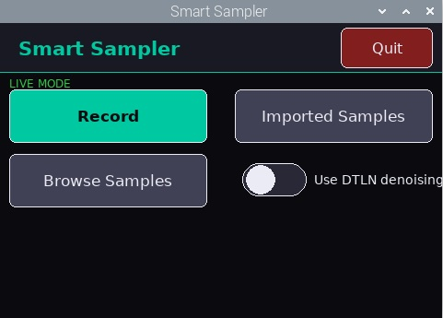
Figure 6 Smart Sampler UI: Home Screen
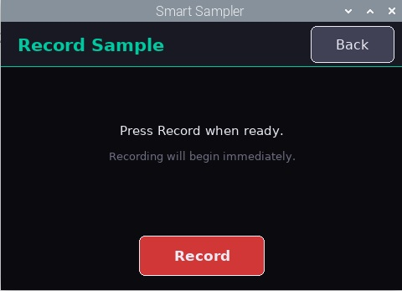
Figure 7 Smart Sampler UI: Recording Primed
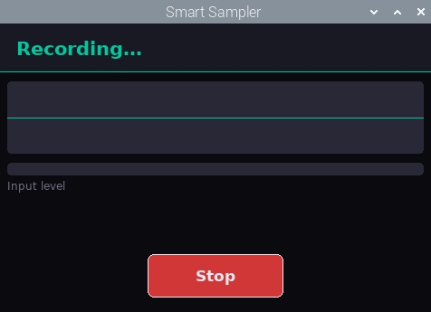
Figure 8 Smart Sampler UI: Recording in Progress
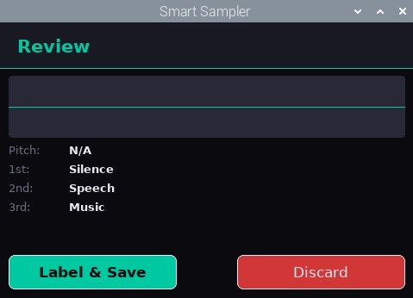
Figure 9 Smart Sampler UI: Recording Analysis
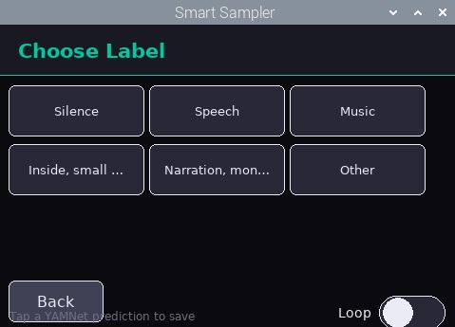
Figure 10 Smart Sampler UI: Classification Label Selection
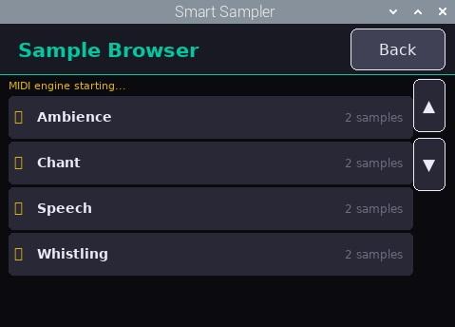
Figure 11 Smart Sampler UI: Sample Browser
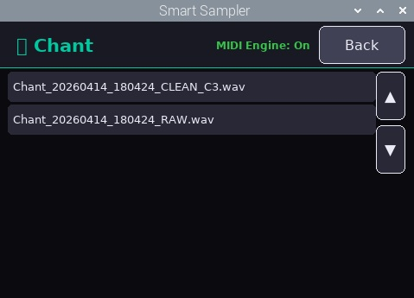
Figure 12 Smart Sampler UI: Sample List within Sample Folder
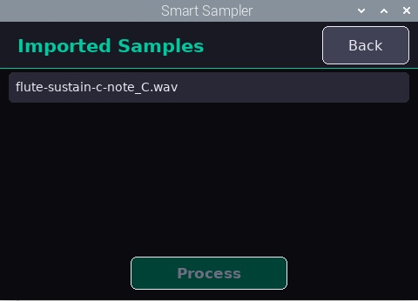
Figure 13 Smart Sampler UI: Imported Samples

4.6 Design rationale
Two decisions shaped the architecture in ways that differ from the original proposal.
SFZ-based transposition replaced in-pipeline pitch shifting. The proposal described a transposition stage that would shift every recorded sample to the nearest C note using librosa’s pitch_shift. However, after testing it was found that the pitch shifting introduced artefacts: smearing on percussive hits, warbling on sustained tones. It was also discovered that the SFZ format already solves this problem. By writing the detected pitch into pitch_keycenter, the sampler engine handles transposition at playback time using its own interpolation, which is what samplers are built to do. The audio file stays untouched resulting in higher output quality with the same end result.
Sfizz_jack replaced python-rtmidi. The proposal listed python-rtmidi as the MIDI integration method. That library handles MIDI message parsing, not audio playback, meaning it would have meant writing a custom sample playback engine from scratch. Instead, I decided to use sfizz_jack, a standalone SFZ compatible sampler. The design decision was to run it as a subprocess and control it through pipe commands rather than reimplementing sample playback in python. The trade off is a dependency on an external tool, but the alternative was weeks of work for a worse result.

5. Implementation

5.1 Development environment
Development took place almost entirely on the Pi 5, with Python as the primary language. The decision to develop entirely on the Pi was due to both convenience and compatibility issues between Windows and Linux. Performance on the Pi is tight enough that anything that works there will work most other places, but not the other way around (most laptops and PCs will have higher CPU headroom for example than the Pi). Building directly on the target hardware avoided the situation where something runs fine on PC and then fails when deployed on the Pi. Developing on the Pi also allowed me to monitor CPU usage as the project was developed, which was important due to the two neural networks (YAMNet and DTLN) which run locally and require significant CPU usage. This allowed me to avoid a situation where the processing pipeline runs fine on my PC but locks up when running on the less powerful Pi 5.
Audio testing was done using both recorded input from the Tascam and a sample library I built throughout development. The sample library contained a variety of cleanly recorded instrument, ambient, vocal and synthetic samples and was primarily used to test YAMNet’s capabilities as well as fine tuning the processing pipeline (the audio trimming processor in particular took significant fine tuning before it was consistent in its trimming).
GitHub was for version control, with regular commits being made as each sprint was completed (for the most part). Miro was used early on for research and sprint planning.

5.2 Audio capture
Audio capture is handled by the AudioRecorder class in recorder.py. The recorder attempts to locate the Tascam by scanning available input devices and matching the device name. If it fails to find it, the system falls back to the default input device rather than blocking execution.
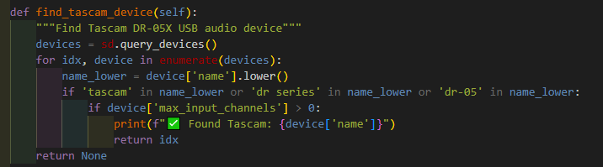
Figure 14 Tascam device detection, allowing the sampler to identify USB recorder
Recording itself is implemented using a callback-based stream. Incoming audio chunks are appended to a list and concatenated once recording stops.
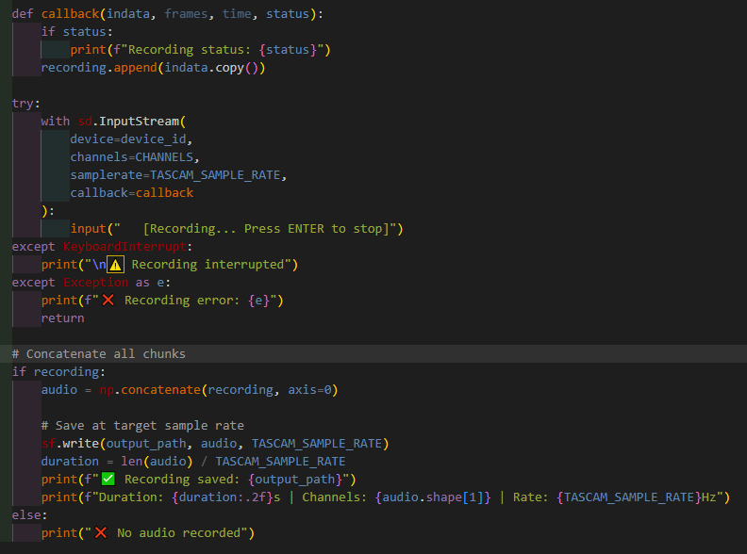
Figure 15 Callback based audio recording, where incoming audio chunks are concatenated
The system records at the devices native 48kHz rather than resampling immediately. A significant issue arose early in development around sample rate and channel handling. The initial implementation converted recordings immediately to 16kHz mono as several processing stages (primarily YAMNet, DTLN and pitch detection) required audio in this format. While this simplified integration, it degraded the final output. High-frequency detail was lost during resampling and stereo information was discarded entirely.
The current implementation separates analysis audio formats from output formats, with little to no noticeable change in processing time. Recordings are preserved in their original form wherever possible and only converted when required by a specific processor. This applies to both sample rate and channel configuration. The system now treats 16kHz mono audio as a temporary representation used for analysis, not as the final output format.

5.3 Processing pipeline
All processing is orchestrated through SmartSampler.process() in main.py
The pipeline applies each processing stage in sequence, passing the audio array through each component. Each stage returns both modified audio and a dictionary of statistics, primarily used for debugging.
As mentioned, a key change to this pipeline design was moving both sample rate conversions and mono conversions out of the recording stage and into individual processors. Individual processors create temporary representations when needed, but the final audio output remain at 48kHz stereo, keeping the final exported sample aligned with the original recording quality.
The processing order is linear and fixed:

- High-pass filtering
- Optional DTLN denoising
- Silence trimming
- Amplitude normalisation
- YAMNet classification
- Pitch detection

Classification is performed after the majority of the pipeline so that it has the cleanest audio possible to aid in its classification.
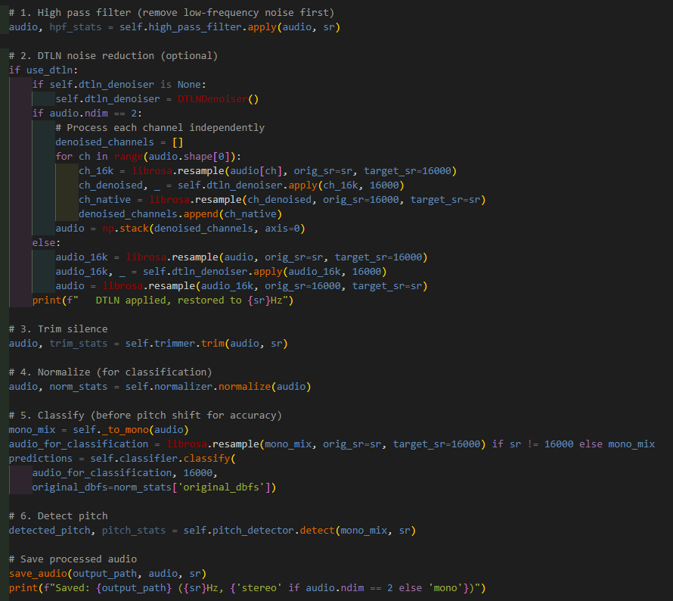
Figure 16 Main processing pipeline in main.py, showing temporary 16kHz mono audio for processors requiring it
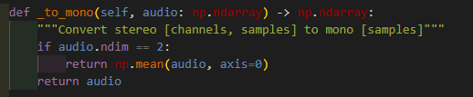
Figure 17 Temporary mono conversion for analysis stages

5.3.1 High-pass filtering
Low-frequency noise is removed in high_pass_filter.py.
The filter used is a Butterworth high-pass filter. A Butterworth filter is designed to have a smooth frequency response, meaning it does not introduce uneven amplification across frequencies, making it suitable for audio work where the goal is to remove unwanted frequencies without colouring the remaining sample (Podder et al., 2014).
The cutoff frequency defines the point below which frequencies are removed. In this case a cutoff of 80Hz is used. Frequencies below this point are reduced, while everything above this is largely preserved. This removes low frequency rumble from handling noise, room noise (air conditioning for example) and electrical interference without affecting most musical content.
Filtering is applied using scipy.signal.filtfilt(), which runs the filter forwards and backwards over the signal. A standard filter pass can introduce phase distortion, meaning different frequencies can be delayed by different amounts, shifting the timing of some features in the sample (this is particularly noticeable in samples featuring sharp transients, like a snare drum hit).
By applying a filter in both directions, filtfilt() cancels out this phase shift, resulting in what is known as zero-phrase filtering. The output signal is still filtered, but its timing remains aligned with the original audio.
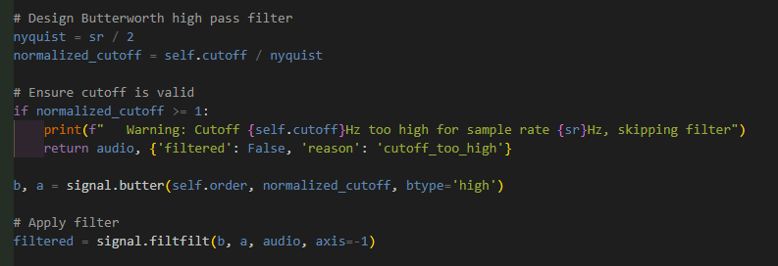
Figure 18 High-pass filter implementation

5.3.2 DTLN noise reduction
Machine learning based noise reduction is implemented in the DTLNDenoiser class in dtln_denoiser.py.
The integration of DTLN centres around the apply() method, which acts as the entry point for denoising, and process_chunk(), where the audio is processed in overlapping blocks. The block based approach follows the requirements of the pre-trained model and keeps memory usage low enough to run comfortably on the Pi 5.
As mentioned prior, a key change to the implementation of DTLN was how sample rate and stereo audio is handled. AS DTLN requires 16kHz mono audio, audio is resampled to 16kHz before being passed into the denoiser, then resampled back to 48kHz afterwards, allowing the model to be used without degrading the audio quality of the final, processed sample.
Stereo handling is achieved by running DTLN on each channel independently and then combining both channels before it is passed onto the trimming processor.
The model itself is loaded lazily using load_model(), which prevents the overhead of loading TensorFlow Lite unless the user has enabled DTLN. This reduces startup time and avoids unnecessary memory use when the feature is not needed.
In practice, as outlined in chapter 2, the model produced mixed results. It improved clarity on vocal based samples (talking, vocal runs, singing) but introduced artefacts or completely removed all audio on any recording not including the human voice, particularly ambient recordings. Instead of removing it, DTLN is implemented as an optional stage the user can choose to use from the UI, allowing the user to decide when DTLN should be used on a sample.
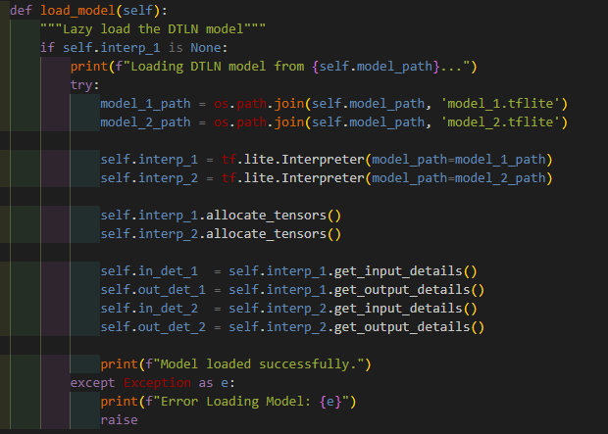
Figure 19 Lazy loading of the two DTLN models

5.3.3 Adaptive silence trimming
Silence trimming is implemented in trimmer.py.
The initial implementation relied on librosa.effect.trim, which reduced the trimming to a single function call. This method identified the loudest point of the signal and defined silence as anything more than a fixed number of decibels below the peak. With top_db set to 25, anything that fell below 25db of the maximum amplitude was trimmed.
In practice this method was unreliable due to it being anchored to the loudest point in the recording rather than the noise floor. For quieter recordings the peak level may only be slightly above the noise floor, meaning the trimmer would fail to detect any silence and return the full recording unchanged. At the other extreme, recordings with sharp transients and long decays (a cymbal crash for example) would produce the opposite problem; the transient sets a high peak level, and the 25db threshold cuts into the natural tail of the sound before it has fully decayed.
A second limitation of this approach is that the original implementation did not apply any padding, meaning that samples would frequently end quite abruptly which was particularly noticeable in percussive samples.
The revised implementation replaces this with an adaptive approach based on Root Mean Square energy. Instead of using the peak, the new trimmer estimates the noise floor of the recording by analysing the audio frame by frame:
- RMS is calculated for each frame of the incoming audio
- Values are converted to dB
- The 10th percentile of these values (the quietest 10%) is taken as the noise floor
This provides a stable estimation of the background noise level without being skewed by outliers. The trim threshold (still 25dB) is then defined relative to the noise floor rather than the peak level.
Audio frames above this threshold are identified and the first and last of these frames define the active region of the audio.
Padding is then applied to both ends of the audio:
- 30ms before the detected start
- 80ms after the detected end
This asymmetrical padding is due to the attack or beginning of a sound being more tolerant of a slightly early cur, while when the tail end or decay of a sound is cut too early it is much easier to notice. Allowing additional space at the end preserves natural decay and avoids any abrupt cutoffs.
If no frames exceed the threshold, which can happen with very quiet recordings, the original audio is returned unchanged.
This implementation is more complex than the original approach but results in significantly more consistent results across a variety of sound sources and types, but particularly in real-world samples where noise levels ad dynamics vary considerably.
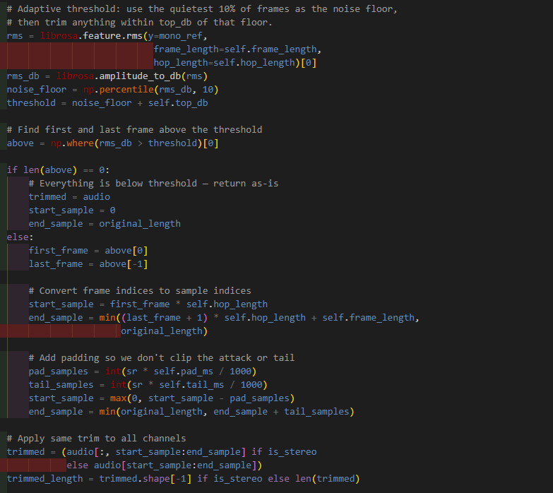
Figure 20 Adaptive trimming using frame based RMS energy, 10th percentile noise floor estimation and attack and decay padding

5.3.4 Amplitude normalisation
Normalisation is handled in normaliser.py.
The first version of the normaliser used basic peak normalisation. It measured the highest absolute sample value, divided the whole signal by that peak and scaled it to the target level. This worked for loud, clean recordings but it treated every recording the same. A quiet ambient recording and a close miked metal hit were both amplified to the same peak value.
This became a problem during testing. Quiet recordings were amplified too aggressively, distorting the audio and bringing up background noise along with the intended sound. The waveform appeared to be normalised, but the audio sounded worse.
The current implementation keeps peak normalisation but adds a gain limit based on the recordings RMS level. First, the processor measures the peak amplitude and the RMS energy of the signal. RMS gives a better sense of the overall level of the recording rather than the peak amplitude alone, as it measures average signal energy rather than one loud moment.
The RMS value is then converted to dBFS. If the recording is below -30 dBFS it is treated as quiet or ambient material. In that case the gain is capped at 6 dB. For louder recordings, the gain can rise as high as 20dB. The final gain is whichever is lower: the ideal gain needed to hit the target peak, or the maximum allowed gain for that type of signal.
This means the normaliser still raises usable recordings to a consistent level, but it avoids dragging quiet background noise into the foreground or distorting quiet audio. It also passes the original dBFS value forward in the stats dictionary, which is later used by the classifier’s ambience detection logic.
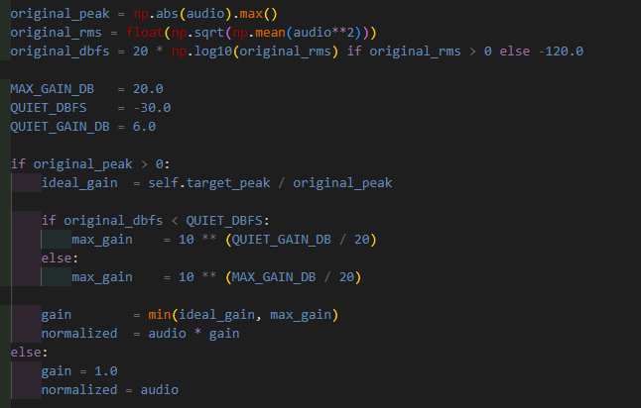
Figure 21 Adaptive normalisation with gain cap on quiet recordings

5.3.5 YAMNet classification and ambience injection

Classification is implemented in classifier.py.
The model operates on mono audio at 16kHz. To support this, the process function in main.py creates a temporary 16kHz mono mix using _to_mono(). If the current sample rate is not 16kHz, librosa.resample() converts this mono copy to the required sample rate.
YAMNet returns scores across multiple frames of audio, rather than one label for the whole file. The classifier averages these frame level scores using NumPy, then sorts the results from highest to lowest in confidence. The top six predictions are then returned to the UI. This was changed from the original top three results as YAMNet’s first prediction was often too broad (a flute sample for example would return “Woodwind” as the top result and “Flute” as the second). Giving the user six options made the labelling stage more reliable without requiring the user to type on the small 3.5 inch touchscreen.
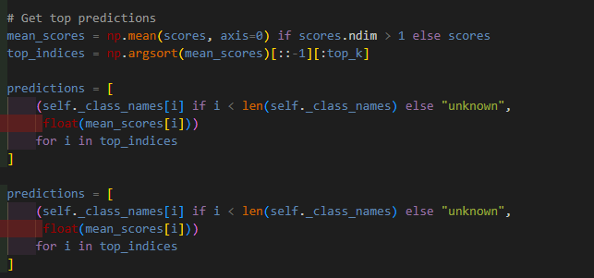
Figure 22 YAMNet prediction handling, with top six labels returned to user
A custom ambience override was also implemented. When given quiet ambient audio, such as birdsong in a park, YAMNet would repeatedly return low confidence results, most of which had little to do with what was actually recorded.
Due to this the classifier receives the pre-normalisation dBFS value from the normaliser, so it can judge whether the original audio was genuinely quiet. If the audio is below -30dBFS and YAMNet’s top confidence is below 0.7, the system inserts “Ambience” as the first label. This is not a YAMNet class, it is a project specific correction for quiet recordings.
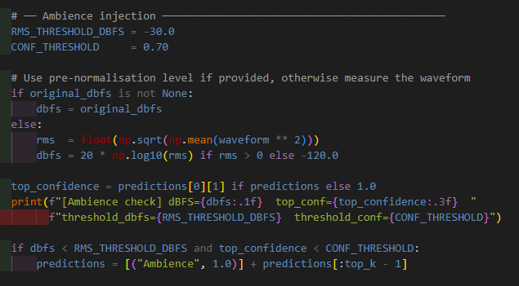
Figure 23 Ambience injection logic

5.3.6 pYIN pitch detection
Pitch detection is implemented in pitch_detector.py. The detector uses librosa.pyin(), a pitch tracking function from the Librosa audio analysis library. pYIN estimates the frequency of a sound over time, rather than returning one pitch value for the whole sample immediately. This works for the Smart Sampler because recordings can contain unstable attacks, background noise, or short sections where the pitch is unclear.
The detector is configured with a pitch range of C2 to C7, a range chosen as it covers the useful musical register for most samples without wasting time searching for extremely high or low pitches that are unlikely to be useful or playable on most keyboards. The range is defined in config.py and converted from note names to Hertz inside the pitch detector using librosa.note_to_hz().
Like classification pitch detection works on temporary mono audio rather than changing the final output.
The pYIN function returns three values: frame-level pitch estimates, voiced/unvoiced flags and voiced probabilities. The implementation only uses frames marked as voiced, unvoiced frames are ignored as they usually represent noise, silence or percussive material rather than audio containing a stable musical pitch. The final detected pitch is calculated using the median of voiced pitch values, avoiding the case where one unstable frame decides the sample’s root note.
If no voiced frames are found the detector returns None. This is important for percussive sounds, where forcing a pitch value would be misleading. The rest of the pipeline can then treat the sample as unpitched and fall back to a default MIDI note (C4) during SFZ generation.
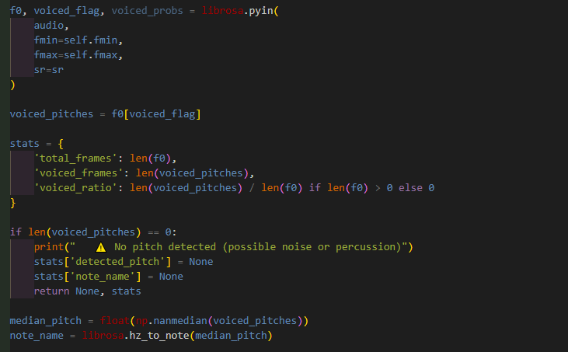
Figure 24 Pitch detection using pYIN

5.4 SFZ generation
SFZ generation is handled in sfz_generator.py. SFZ was used because it is a plain text sampler format, which meant the system cold generate it directly without needing a specialised export library. It was also chosen due to it being compatible with a large number of DAW’s and third part samplers, whether standalone or VST.
The most important value written into the SFZ file is pitch_keycenter. This tells the sampler which MIDI note represents the original pitch of the recording. If pYIN detects a pitch the SFZ generator converts to a MIDI note librosa.hz_to_midi(), whereas if no pitch is detected, the generator defaults to MIDI note 60, which is C4. This gives unpitched samples a predictable centre point rather than failing to export.
This replaced the original pitch transposition approach. The initial proposal described shifting each sample to the nearest C note using librosa.effects.pitch_shift() to alter the audio directly, but it is not used in the final pipeline as testing showed that direct pitch shifting introduced artefacts to the audio. SFZ mapping gave the same intended result without damaging the processed WAV file.

The generator also writes playback behaviour into the SFZ. If loop mode is enabled, it writes loop_mode=loop_sustain with loop_start=0 and loop_end value is based on the number of frames in the audio file using soundfile.info() which reads audio metadata without loading the full file into memory. If loop mode is disabled, the file is written as a one-shot sample instead.
Velocity behaviour is also handled here. With fixed velocity enabled, the SFZ uses amp_veltrack=0 so that MIDI velocity (how hard a key is pressed) does not affect playback volume. Without fixed velocity a velocity curve is written instead, giving the user a simple way to choose between consistent playback and more expressive keyboard control.
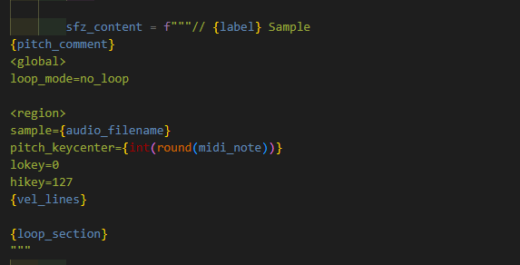
Figure 25 SFZ template definition

5.5 User interface
The user interface is built using pygame and organised around the SamplerApp class in app.py. Pygame was chosen because it gives direct control over drawing, input handling and screen size, which mattered on the small 480x320 touchscreen. A normal desktop GUI toolkit would have been heavier to run and less predictable on the Pi.
The interface works as a state machine, with the main states being home, pre_record, recording, processing, review, label, browser and browser_files. The current state decides which screen is drawn and which inputs are accepted.
Long running tasks are moved into background threads so the UI doesn’t freeze. For example _process_worker() in workers.py calls self.sampler.process() and stores the results. When processing finishes, it posts EV_PROCESS_DONE, a custom pygame event defined in events.py. HandlersMixin._handle_event() receives that event and moves the interface into the review state. This event based structure keeps the UI responsive while the Pi is processing audio.
Touchscreen layout was a recurring issue. The screen is only 480x320, so buttons had to be large enough to be hit with a finger. Shared values such as screen width, height, padding and colours are stored in theme.py, while reusable widgets such as Button, Toggle and WaveformWidget are defined in widgets.py, avoiding rewriting drawing and input logic for every screen.
The DTLN warning overlay and delete confirmation overlay are also handled inside the UI state logic. Both block input to the screen underneath until the user responds. As mentioned, this was needed as DTLN only works in specific circumstances and can degrade the quality of the processed audio, and deleting samples and folders needed a second confirmation to avoid accidental loss of a sample/samples.

5.6 MIDI engine
The MIDI playback system is implemented mainly through _midi_launch_worker() in workers.py. The system launches sfizz_jack as a subprocess rather than trying to implement sample playback directly in python (sfztools, 2024).
This was a major change from the proposal, the original plan mentioned python-rtmidi but that library only handles MIDI message parsing. It does not play audio, load samples, transpose them or manage voicing and velocity meaning it would have meant writing a sampler engine from scratch. Sfizz_jack already supports SFZ files, MIDI input, pitch transposition and playback so the final implementation uses it as a dedicated sampler process.
Implementing this was one of the most challenging pieces of the project, due to lack of documentation especially in regard to getting sfizz to run on the Pi. The Pi uses the PipeWire audio engine, while sfizz_jack expects a JACK compatible environment. The workaround for this was launching sfizz through pw-jack which provides JACK compatibility through PipeWire.
Before launching a new sampler instance, the code kills any existing sfizz_jack process and waits until it has fully exited, preventing two sampler engines fighting for the same audio or MIDI resources. The launch command is then built with pw-jack, the sfizz binary and optional SFZ path. If no SFZ is passed, the engine starts idle and can load an instrument later.
Hot swapping samples is handled by sending commands to sfizz after it has launched, meaning the user can browse saved samples and load a new SFZ without restarting the engine. The UI keeps track of whether the MIDI engine is loading, active or failed and displays the state in the sample browser screens.
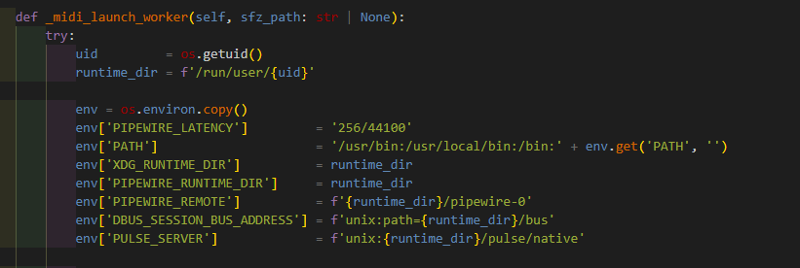
Figure 26 PipeWire and JACK environment configuration
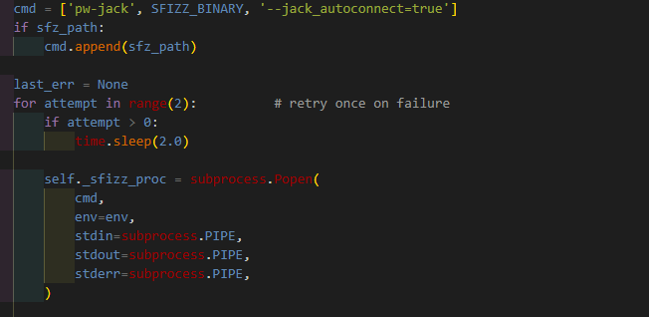
Figure 27 Launching sfizz_jack through pw-jack as a subprocess

5.7 File management
File management is handled in file_manager.py. This function is called from _save_worker() in workers.py after the user chooses a label provided by YAMNet.
The save process creates a folder based on the selected label, meaning that samples are stored by categories such as “Glass”, “Ambience”, “Snare Drum” etc. without the user needing to organise the files manually. Each saved file receives a timestamp, which prevents overwriting older samples in the same category and makes the recording easier to find later.
If a pitch was detected, the note name is included in the processed WAV filename using librosa.hz_to_note(), which converts the detected frequency into a readable musical note. If no pitch was detected, the filename uses UNPITCHED instead.
The save process stores several outputs together: the raw WAV, the processed WAV, a spectrogram image and the generated SFZ files. The raw WAV is copied while the processed file is moved into the labelled folder.
Storage paths are configured in config.py. The system checks whether the USB mounted path is available. If the USB drive is mounted, samples are written there, otherwise the system falls back to a local samples folder within the project. This gives the sampler a practical export workflow while still allowing testing without the USB stick attached.
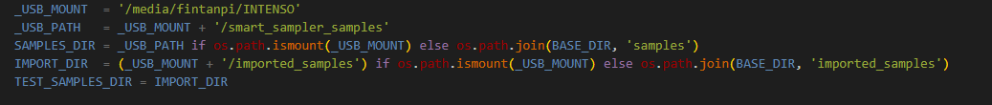
Figure 28 USB storage path detection in config.py
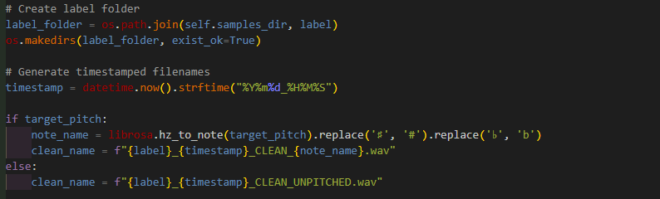
Figure 29 Automatic folder and filename generation using label, timestamp and detected pitch
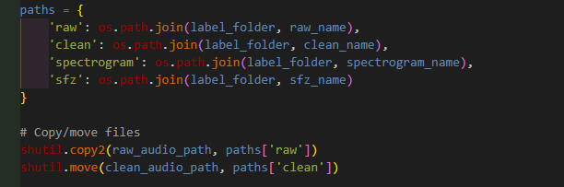
Figure 30 Final save operation copying raw WAV, moving processed WAV and generating spectrogram and SFZ outputs

5.8 Development tools and AI assistance
Development was managed through GitHub, with commits used to track major stages of the project and Miro was used during the early planning stage primarily for outlining each of the six sprints.
AI tools were used during development, primarily as a debugging and planning tool. The usual workflow was starting with documentation for the library or tool being used, attempt the implementation myself and then search Stack Overflow, relevant forums (such as the Raspberry Pi forum) or Reddit when errors appeared. If after this the error persisted, I would use AI to explain the error in as much detail as possible and suggest possible fixes.
This was most useful in areas where documentation was scarce, with the clearest example being sfizz_jack and PipeWire integration. Running sfizz as a standalone sampler inside a python controlled Raspberry Pi application was not a well-documented use case, and nearly all examples found assumed a more standard desktop JACK setup. AI helped identify why sfizz_jack refused to open and run, identified the issues around running sfizz_jack in a PipeWire environment and pointed me towards pw-jack.
AI was also used when integrating the DTLN model. While the model itself was researched before implementation, getting the TensorFlow Lite files loaded correctly, understanding the expected input format and working through block-based inference required a considerable amount of trial and error. AI helped explain TensorFlow Lite errors and suggested ways to structure the model loading and processing code.
A smaller role was using AI for commenting and print statements, being primarily used to help phrase comments more clearly and add temporary command line print statements while checking and debugging the processing pipeline.
AI was also used as a planning tool before writing more complex features, before making any larger changes such as refactoring the UI or processors, it was used to talk through possible code and workspace structures as to avoid refactoring code several times or in non-satisfactory ways. This did not remove the need to make decisions myself but helped expose multiple awkward design choices I had made earlier in the project.
AI output was not treated as correct by default and was most useful for detailed explanations of errors and for suggestions of alternative approaches to certain operations like best way to improve the behaviour of the trimmer as an example.

6. Testing and evaluation

6.1 Test strategy
Testing was split into automated tests and manual evaluation, with automated tests checking whether the main processing components behave correctly in isolation and whether the full pipeline produced valid output. Manual testing covered the parts that could not be judged properly unit and integration testing alone: UI usability, DAW imports, MIDI playback, battery use and subjective audio quality.
The test strategy covered six areas: unit tests, integration tests, performance benchmarks, user testing, DAW integration and listening tests. The automated test suite was written with pytest and used a mixture of synthetic signals (silence, sine waves, noise) and real audio such as kick drum, an ambient recording and harpsichord samples.

6.2 Unit and integration testing
The pytest suite covered the main processing files and end-to-end pipeline. Unit tests were written for filtering, trimming, normalisation, pitch detection, classification and SFZ generation. Integration tests then ran real audio through the entire processing pipeline to confirm that each stage worked together and produced a valid output WAV.
Table 3 Unit and Integration Tests
Test Area | Tests | Purpose
High-Pass Filter | 5 | Checks low frequency attenuation, high-frequency preservation and invalid cutoff handling
Trimmer | 7 | Checks silence removal, stats accuracy, stereo handling, and silence fallback
Normaliser | 6 | Checks peak target, gain limiting for quiet audio and dBFS reporting
Pitch detector | 5 | Checks 440Hz pitch detection, note naming, noise handling and silence behaviour
Classifier | 10 | Checks ambience injection, top-k behaviour, fixture classification and output format
SFZ generator | 10 | Checks pitch mapping, C4 fallback for non-voiced samples, loop mode, velocity behaviour and file writing
Pipeline | 9 | Checks full pipeline output, predictions, pitch handling and valid audio export

The tests reflect the main implementation risks. For example, the trimmer tests verify that silence is removed without breaking stereo input or returning an empty array for silent recordings. The normaliser tests check the adaptive gain cap added after early versions amplified quiet recordings too aggressively. The classifier tests use both mocked outputs and real YAMNet fixture tests, which allowed the ambience injection to be tested separately from the model itself.
The integration tests were more important than individual unit tests as most failures occurred between stages rather than inside a single processor. These tests confirmed that the system could load an audio file, process it, return predictions and pitch data, save a valid WAV and handle percussive or ambient material without crashing.
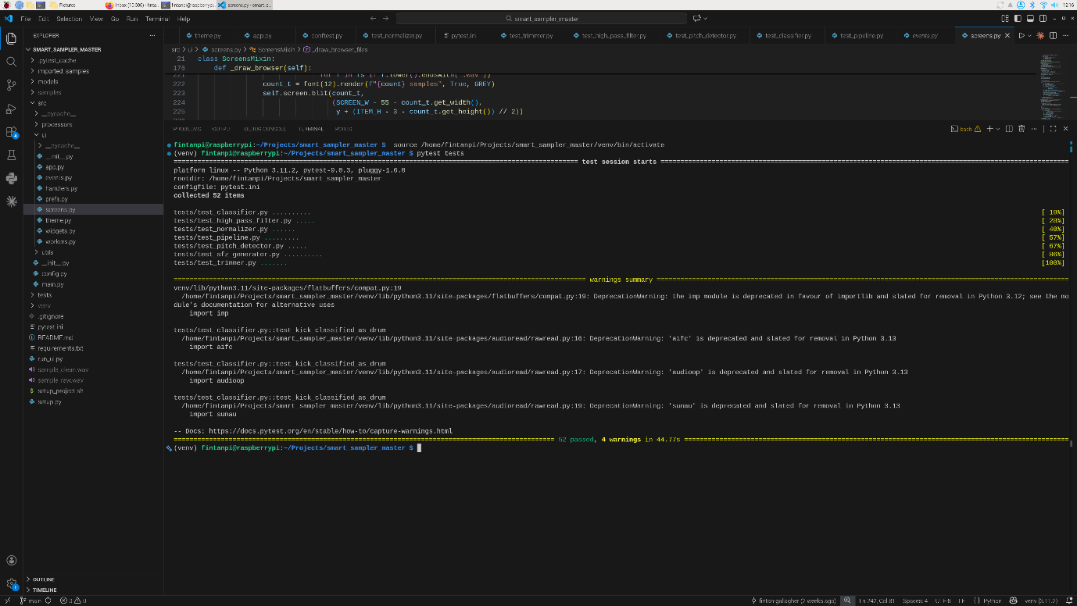
Figure 31 Pytest suite showing 52 tests passed covering the utils and processors folder
Test coverage was measured using pytest-cov on the processors and utils packages. All 52 tests passed. The processor package showed 58% total coverage, while the utility package showed 47% coverage.
These headline percentages need context. The core processors covered by automated tests achieved high coverage: high_pass_filter.py, normalizer.py, pitch_detector.py and trimmer.py all reached 100% coverage. Classifier.py reached 81% and sfz_generator.py reached 95%.
The lower overall percentages came from files that were either hardware dependent, manually tested or no longer used in the final pipeline. Recorder.py depends on Tascam input device and was tested on hardware rather than in pytest. Dtln_denoiser.py depends on TensorFlow Lite model files and was evaluated through subjective listening tests. Transposer.py remained in the codebase from the earlier pitch shifting approach but was not used in the final pipeline. In utils the lower coverage mostly came from file_manager.py and visualization.py, which were tested through the full application workflow rather than isolated unit tests.
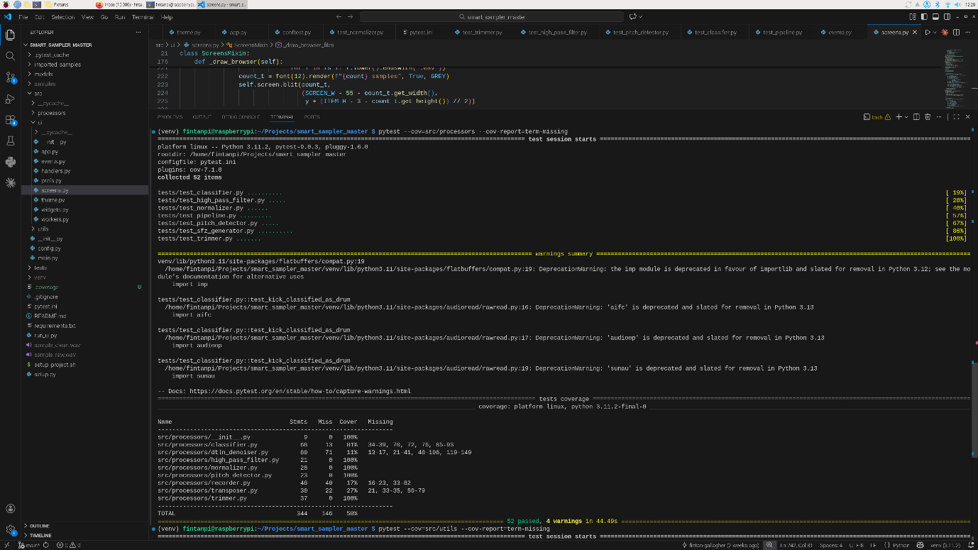
Figure 32 Processors package test coverage
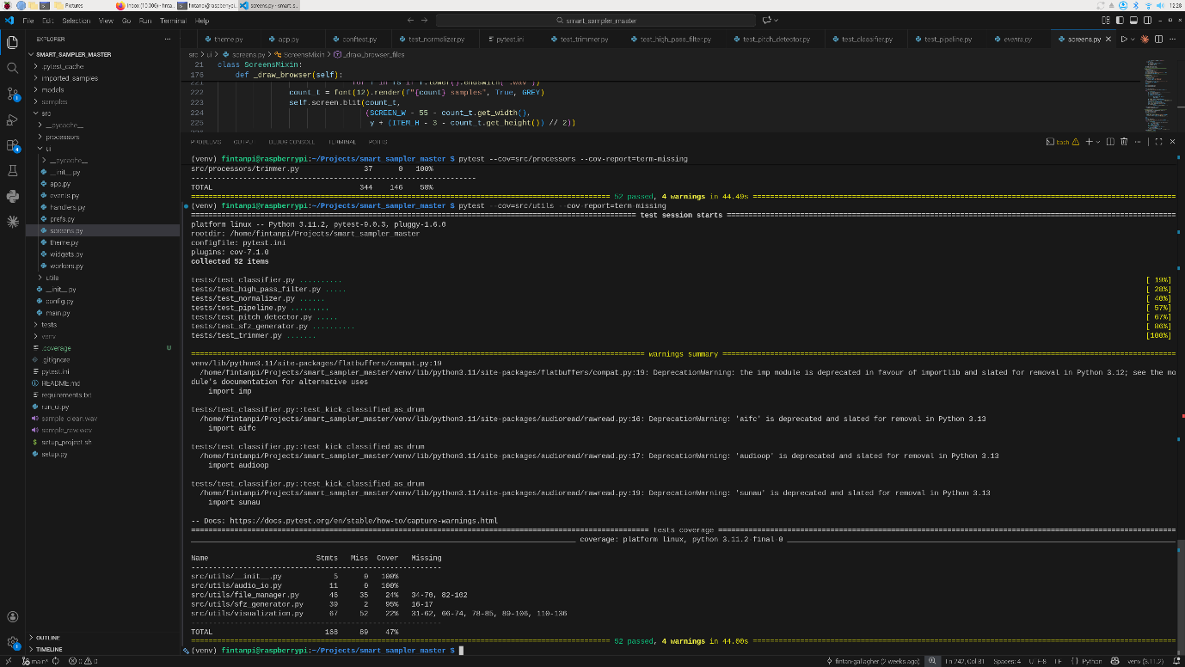
Figure 33 Utils package test coverage

6.3 Usability testing
Usability testing was carried out with five participants across different levels of musical and technical experience. The test plan asked participants to complete the main workflow on the physical device: record a sound, process it, choose a label, save the sample, browse saved samples, audition playback, use MIDI playback and delete files. The planned success criteria included task completion rate, error counts, time spent on each task, classification accuracy, pitch accuracy and any crashes were to be noted.
The sessions were designed to test the device rather than the user. Participants were encouraged to think aloud while using the sampler, and help was only given if they were fully blocked.
The first test, with a non-musician exposed two issues. The scroll buttons in the sample browser were too narrow, and the back and quit buttons were awkwardly positioned. More importantly, quiet recordings were being frequently misclassified by YAMNet, with silence or near silent recordings repeatedly being labelled as “Vehicle”. This led to two changes: the navigation buttons were resized and the ambience injection logic was added to the classifier.
The second test, with a musician experienced in sampling, exposed a different problem in the audio pipeline. A clapping sample was trimmed inconsistently; quieter claps were cut out while only the loudest clap remained, proving that the peak based trimming approach was not reliable for real recordings. The trimmer was then rebuilt around noise floor estimation, using the quietest 10 percent of frames to set an adaptive threshold. This user also brought up the idea of allowing the user to add simple effects during MIDI playback (reverb, chorus, delay) as well as implementing a simple MIDI sequencer. As these features would bring the Smart Sampler closer to being a standalone instrument rather than the sampler it was developed to be, I decided not to implement these.
The third and fourth tests mainly shaped the MIDI browser workflow. The earlier version required users to select a sample, launch the MIDI engine, play it, quit the engine and then relaunch it for another sample. The third tester pointed out that this made auditioning multiple samples unnecessarily slow. To remedy this, a separate MIDI section was introduced which launched the MIDI engine and allowed it to remain allowing the user to hot swap between multiple samples. However, the fourth tester made the point that this added unnecessary navigation on an already small and hard to use screen. As a result, the final version moved MIDI playback back into the sample browser while keeping the improved engine behaviour: the MIDI engine starts when the user enters Browse Samples, stays active and allows samples to be hot swapped until the user returns to the home screen.
The fourth test also exposed smaller interface and playback issues. The DTLN’s “do not show again” checkbox was too small, so the warning overlay was redesigned with better spacing and a larger checkbox. The velocity setting also caused confusion because low base velocity made quiet samples seem as if MIDI playback had failed. The SFZ velocity behaviour was adjusted so expressive playback remained possible, but the default response produced a more audible sound.
The final test was carried out with a participant experienced in music production and sampling. Most of the feedback at this stage was less about defects and more about future development. Some of the suggestions included developing a mobile companion app as a workaround for the small screen size, a visible timer during recording and using YAMNet frame level predictions to split longer recordings into multiple labelled samples. These were not implemented due to time, but they were noted as top priorities for future development.
Overall, the usability tests had a direct effect on improving the final prototype of the Smart Sampler. The main changes made after testing were:
Table 4 Test findings and subsequent changes
Finding | Change Made
Navigation buttons and scroll controls were too small | Buttons resized and repositioned
Quiet recordings were misclassified as unrelated sounds | Ambience injection added
Peak based trimming cut off useful quieter material | Adaptive noise floor trimming implemented
MIDI playback required too much launching and quitting | Persistent MIDI engine added to Sample Browser
DTLN warning checkbox was too small | Overlay spacing and checkbox size improved
Low velocity made playback seem broken | Base velocity behaviour adjusted
The most useful finding was that the system’s processing and technical pipeline worked better than its physical interaction design (partly constrained by the small touchscreen). Users could understand the purpose of the sampler, but the small touchscreen made mistakes easy. The final interface is usable, but the tests showed that the device could benefit from either a larger screen or a companion app for browsing, editing and recording samples.

6.4 Audio quality evaluation
Automated tests could confirm that the pipeline produced valid WAV files, but they could not confirm whether those files were musically useful. For that reason, a separate subjective audio quality evaluation was done using listening tests and spectrogram comparisons. The focus was on the DTLN denoising stage as this was the processor most likely to change the character of the processed sample.
The test compared recordings processed with DTLN disabled against the same recordings processed with DTLN enabled. Samples were grouped into three broad categories: percussive sounds, tonal sounds, and ambient recordings. Percussive tests included claps, taps, various drum kit hits and object impacts (ping pong ball hitting a paddle for example). Tonal tests included voice, humming and instruments. Ambient tests used quieter environmental recordings where background noise was part of the captured sound rather than a separate problem to be removed.
Each sample was judged on five points, whether noise was reduced, whether the attack and decay of a sound was preserved, whether the tone remained stable, were artefacts introduced and whether the output remained useful as a musical sample.
The clearest issue was with the percussive samples. DTLN often softened or smeared the attack of claps and drum hits, and in some cases quieter hits were supressed enough that they felt partially removed from the recording, with very little of the original characteristics of the original sound remaining. This made the samples less useful for musical triggering, where the attack is usually the part that gives a percussive sound its character.
Ambient recordings were a similar story. As ambient recordings are by their nature, recordings of background noise, DTLN would often remove details that were actually part of the texture of the ambient recording.
Tonal material produced better results. Vocal material in particular mostly benefitted from DTLN, especially where there was steady and consistent background noise (recordings of a conversation had during lunch in the canteen or singing in a room with loud air conditioning). In these cases, the model reduced some or most of the noise without damaging the focal point of the recording entirely. The results, while not perfect and some artefacts were present, was still usable and often favourable to the raw recording with discordant background noise remaining.
The outcome of this evaluation was a design change. DTLN was not removed as it was still useful on vocal material. Instead, DTLN was implemented as an optional part of the processing pipeline, with the user being warned of its shortcomings and having complete control over whether it would be applied to a sample. The UI includes a warning overlay explaining that denoising works best on vocal material and may affect the sound of a recording.

6.5 Evaluation against objectives
Testing showed that the core processing pipeline worked reliably. The automated tests confirmed that the individual processors handled expected inputs and edge cases, while the integration tests showed that the full pipeline could produce valid output audio with classification and pitch data.
The main weaknesses found throughout testing were primarily interaction issues. User testing in particular showed that the small touchscreen made navigation harder than expected, particularly in the sample browser and navigation buttons. Listening tests also showed that DTLN could not be used as a universal background removal tool and was best used optionally for specific use cases.
Several changes were made directly because of testing: ambience injection was added, the trimmer was rebuilt around noise floor estimation, navigation controls were resized, the MIDI engine was made persistent once the user was in the sample browser and DTLN was made optional with a warning overlay.
The final version therefore passed the main functional tests, but testing also exposed the limits of certain sections of the prototype. The main processing pipeline and MIDI playback are functional to a satisfying degree, but the touchscreen remains a compromise. It is usable but any future development would first be spent on remedying the physical interaction side of the Smart Sampler.

7. Project management

7.1 Methodology
The project followed an Agile development methodology with six sprints completed over 12 weeks. Sprint planning and progress tracking were done using Miro, with a board per sprint organised by To Do, In Progress and Done columns. Version control was handled using GitHub, with work committed to the main repository branch after local testing on the Pi 5.

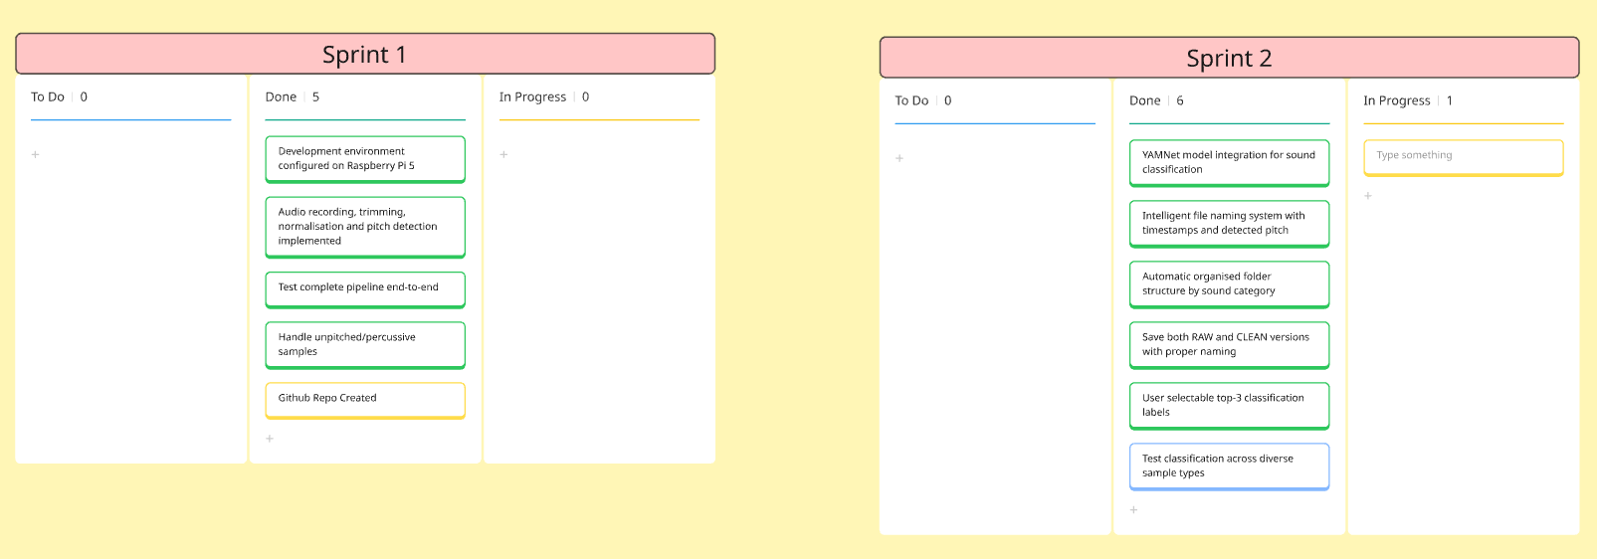
Figure 34 Sprint 1 and 2 featuring core processing pipeline, classification and file management
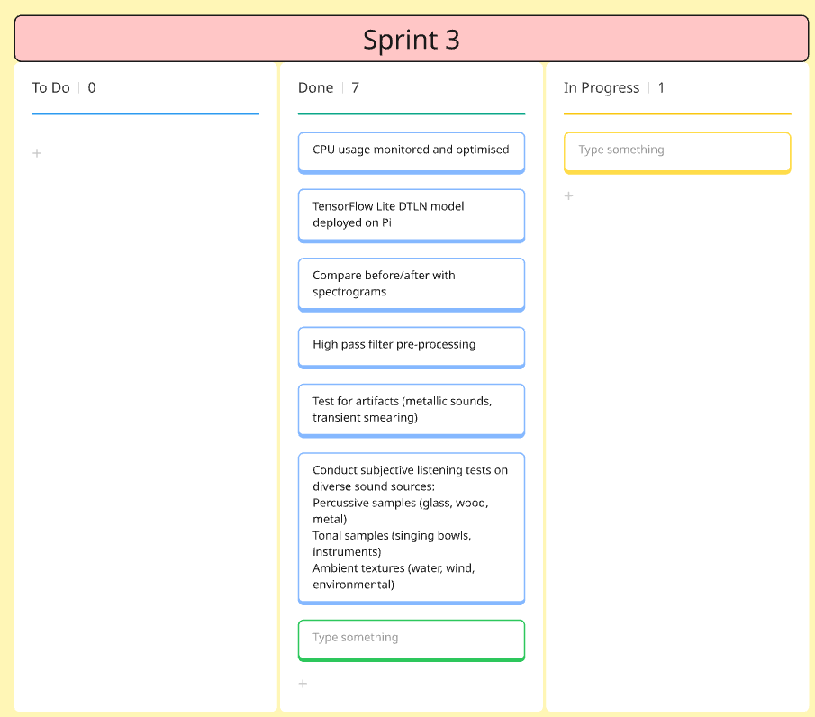
Figure 35 Sprint 3 which involved the implementation of DTLN
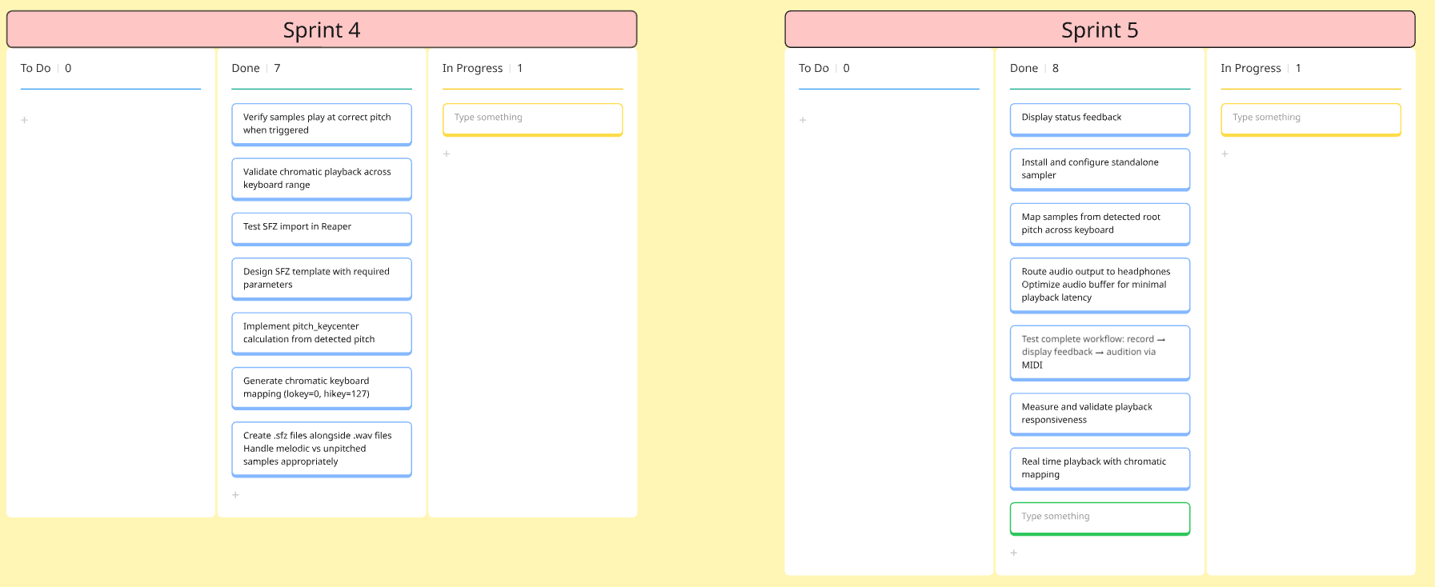
Figure 36 Sprint 4 and 5, featuring SFZ generation and MIDI playback
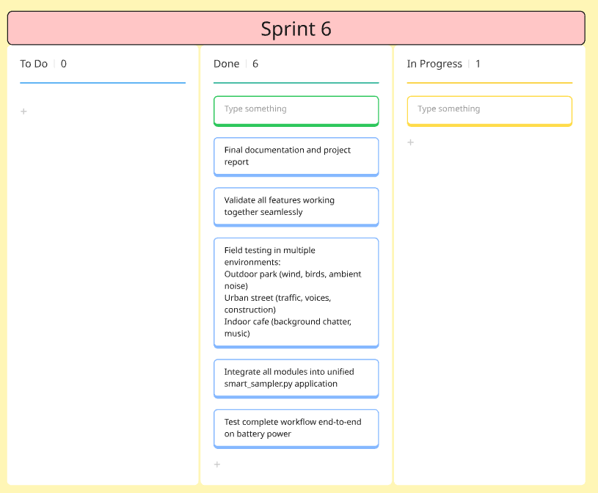
Figure 37 Sprint 6 which primarily involved testing and final documentation

7.2 Sprint breakdown
Sprint 1:
The development environment was configured on the Pi 5, the GitHub repository was created and the core audio processing pipeline was implemented: recording from the Tascam, silence trimming, peak normalisation and pitch detection using pYIN. By the end of this sprint a sample could be recorded, processed and saved from the command line.

Sprint 2:
YAMNet was integrated for sound classification and the file management system was built. Each sample recorded now had a timestamp, pitch detected and YAMNet’s top label prediction used for both the filename and folder name. YAMNet top 3 label choice was also implemented, with the user being given a choice between the top 3 classification predictions. Both raw and processed files were saved from this point forward.

Sprint 3:
Sprint 3 was the longest and most research intensive of the six sprints. The DTLN model was implemented on the Pi, the high-pass filter was added into the processing pipeline and CPU usage was monitored. Subjective listening tests were conducted across a variety of percussive, tonal and ambient samples. This was where it was discovered that DTLN introduced artefacts and significantly supressed any non-vocal samples, which drove the decision to make it optional with a warning overlay in the final UI.

Sprint 4:
This sprint focused on SFZ generation and, consequentially, DAW integration. The SFZ template was with pitch_keycenter calculated from the detected pitch, and output was tested by importing SFZ files and related samples into Reaper. Handling of unpitched samples (defaulting to MIDI note 60, otherwise known as middle C) was implemented during this sprint.

Sprint 5:
After obtaining the 3.5 inch touch screen, this was where the UI and MIDI playback engine were implemented. The original proposal suggested python_rtmidi would be used for on-device MIDI playback, but it was research during this sprint that revealed that it handles MIDI message parsing only, not sample playback. The pivot to sfizz_jack as a subprocess happened at this point.

Sprint 6:
This sprint covered testing and polishing. Five user tests were conducted, with small changes being made after each following user feedback (most of which related to issued with the UI on the small 3.5 inch touchscreen). The device was tested in three environments, a park, the canteen during lunchtime and the IADT car park, which validated battery powered operation after worries with the Pi 5’s power demands and the lack of available power banks that could deliver the required power. UI refinements were primarily around the resizing and placement of various UI elements (the back button in particular was hard to operate). The unit and integration tests were written during this sprint.

7.3 Reflections
The original sprint plan held up reasonably well but there were some points where diversions were made, particularly sprint 5. The proposal estimated MIDI integration would take about 2 weeks. In reality, implementing it fully took closer to three weeks. The pivot from python-rtmidi to sfizz_jack solved the sample playback problem but introduced an unexpected compatibility issue between sfizz_jack (a JACK audio client) and Pi 5’s PipeWire audio engine. Getting the two to communicate reliably took several days of investigation and research.

On top of that, the late decision to use a touchscreen for user interaction with the device added UI design and implementation that wasn’t planned. The original proposal called for a simple seven segment display rather than a UI touchscreen interface so the scope of the implementation of this was vastly underestimated.

If I were starting again, I’d split sprint 5 into at least two sprints: one for the UI framework and another for the MIDI engine. I’d also have budgeted time specifically for PipeWire integration research (which the issues of which were missed by me).

8. Conclusion and future work

8.1 Summary
The aim of this project was to build a portable Raspberry Pi based smart sampler that could capture field recordings and turn them into production ready musical samples without requiring a laptop or DAW. The final prototype meets that aim: a user can record a sound, process it on the Pi, choose from YAMNet labels, save the resulting audio in both processed and raw formats automatically named and organised, generate an SFZ file and play the sample back from a MIDI keyboard on the same device.
The project did not follow the initial proposal to the tee. Some of the most integral parts of the project cam from changes made during implementation rather than from the initial proposal. The original device was envisioned with a simple seven segment display and physical buttons, which was replaced by a touchscreen and meant having to implement a UI. The original idea of pitch shifting samples to the nearest C note was replaced by SFZ based pitch mapping, which preserved the original audio and let the sampler engine handle transposition. The original assumption that DTLN noise reduction would be applied universally also changed after listening tests showed that it damaged most non-vocal samples, and while it remained it was implemented as an optional step in the processing pipeline rather than being applied by default.
The core processing pipeline was completed: high-pass filtering, adaptive trimming, normalisation, classification and pitch detection all work together in the final build. The pipeline also preserves the source audio more carefully than earlier versions did. Instead of converting everything to 16kHz mono at the start, the final version only creates 16kHz or mono copies when a particular processor requires it, substantially improving the quality of processed audio.
The final system is strongest as a fast capture to sample tool. While not a replacement for a full DAW workflow (which is why a raw version of each sample is saved alongside the processed audio), its value is in removing the repetitive middle stage between field recording and musical creation.

8.2 Reflection
The most integral part of the project also led to the most frustration: building on the Raspberry Pi 5. The Pi made the project possible, but it also removed a lot of comfort during development (at least for a lifelong Windows user). Audio engines, USB devices, touchscreen compatibility, subprocesses and model loading all had to work together on a small machine with limited CPU power.
The first major lesson was that user interaction on a small touchscreen is harder than anticipated. A button that looks fine when developing it on a monitor can be irritating to use on a 3.5 inch screen. The sample browser, navigation buttons and MIDI workflow had to be reworked several times because the first few versions were functional but awkward to use.
The MIDI engine was the largest detour of the entire project. The proposal underestimated it badly. Python-rtmidi looked like the obvious choice at the planning stage, but it only handles MIDI message parsing, not playback. Moving to sfizz_jack solved the playback problem but introduced a new one: getting a JACK based sampler to behave inside the Pi’s PipeWire audio engine. That took far more time than anticipated and if I were starting again, I would have given myself much more time to implement this.
Other parts of the project went well. The processing pipeline ended up cleanly separated into processor classes, utility modules and UI workers. That structure made later changes such as adapting the trimmer, normaliser and ambience injection, easier. The decision to use SFZ was one of the better technical choices of the project as it removed unnecessary processing, improved output quality and made samples more compatible with other sampler and DAW software outside of the Smart Sampler.
If I were doing the project again, I would test with users earlier. The first user tests immediately exposed issues I had started to ignore purely due to my familiarity with the device.

8.3 Limitations
The main limitation of the final version is the interface. The 3.5 inch touchscreen works, but as mentioned is small enough that interacting with the UI can feel awkward. Several UI changes were made after user testing, but the screen size remains a physical constraint.
DTLN is another limitation, it is integrated and useful in certain cases but it cannot be treated as a universal improvement. On percussive material it can soften attacks and on ambient recordings it can remove textures that need to be preserved. This is why in the final version, DTLN is completely optional and left to the discretion of the end user.
YAMNet classification also has its limits. It was trained for general sound classification, not for the vocabulary of music producers. It returns accurate labels a majority of the time, but those labels are typically not what a producer would choose (YAMNet would choose the label “Snare Drum” instead of “Snare” as an example). Expanding the UI to display the top six predictions helped this issue, as well as the ambience injection but the system still relies on a model that was not designed for this particular use case.
The system also lacks sample editing. Loop points are basic, trimming is automatic and not always reliable and users can not fine tune any of the processors in the pipeline.
The hardware is portable, but very much still prototype like. The device runs on battery and does not require a laptop or internet connection but it still depends on several components: the Pi, touchscreen, Tascam, Midi keyboard, USB storage, power bank and external sound card. It works, but handheld use on the move can be awkward and would need polishing in future renditions of the Smart Sampler.

8.4 Future work
The most useful future improvement would be a companion mobile app, which was made clear during user testing, and was brought up by one testing participant. A phone screen would be better for browsing samples, editing names, managing folders and reviewing recordings. The Pi could remain as the capture and processing device, while the phone handles the UI.
The classification system could be improved by training or fine tuning a model around musical sample categories. Instead of returning generic labels, the system could use terms that musicians actually use: kick, snare, texture, drone, vocal chop etc. This would make file organisation more useful and reduce the need for user correction.
Another useful direction is frame-level classification for longer recordings. YAMNet already produces predictions over time, but the current implementation averages them into one label. Future versions could use those frame-level predictions to split long recordings into multiple labelled samples. For example, a recording that starts with birdsong and ends with traffic could export two separate files rather than one vaguely named file.
Looping could also be improved. The current SFZ generation supports loop and one-shot modes, but loop points are simple. Automatic zero-crossing detection, and crossfading would make sustained samples far more usable.
Effects and sequencing were also suggested during user testing. Reverb, delay chorus or a simple step sequencer would make the device more fun to use but would also shift it towards being a standalone instrument rather than the sampler it was intended to be.

8.5 Closing
The Smart Sampler works because it does one specific job: it shortens the distance between hearing a sound and using it in music.
It does not always make perfect samples, nor does it replace careful editing. But it does take the dull part of the process, trimming, naming, normalising, filtering and moves it into the moment of capture.
That was the point.

References
References
- Bengio, Y., Goodfellow, I., & Courville, A. (2017). Deep learning. MIT Press. https://www.deeplearningbook.org/

- Breizhn. (n.d.). DTLN: Tensorflow 2.x implementation of the DTLN real time speech denoising model. GitHub repository. https://github.com/breizhn/DTLN

- David, R., Duke, J., Jain, A., Reddi, V. J., Jeffries, N., Li, J., Kreeger, N., Nappier, I., Natraj, M., Regev, S., Rhodes, R., Wang, T., & Warden, P. (2021, March 13). TensorFlow Lite Micro: Embedded Machine Learning on TinyML Systems. ArXiv.org. https://doi.org/10.48550/arXiv.2010.08678

- Doumanidis, C. C., Anagnostou, C., Arvaniti, E.-S., & Papadopoulou, A. (2021). RNNoise-Ex: Hybrid speech enhancement system based on RNN and spectral features. arXiv preprint arXiv:2105.11813. https://arxiv.org/pdf/2105.11813

- LeCun, Y., Bengio, Y., & Hinton, G. (2015). Deep learning. Nature, 521(7553), 436–444. https://hal.science/hal-04206682/document

- Nogales, A., Caracuel-Cayuela, J., & García-Tejedor, Á. J. (2024). Analyzing the influence of diverse background noises on voice transmission: A deep learning approach to noise suppression. Applied Sciences, 14(2), 740. https://doi.org/10.3390/app14020740

- Podder, P., Mehedi Hasan, Md., Rafiqul Islam, Md., & Sayeed, M. (2014). Design and Implementation of Butterworth, Chebyshev-I and Elliptic Filter for Speech Signal Analysis. International Journal of Computer Applications, 98(7), 12–18. https://doi.org/10.5120/17195-7390

- Pratt, W. K. (1972). Generalized Wiener filtering computation techniques. IEEE Transactions on Computers, C-21(7), 636–641. https://web.archive.org/web/20170829180750id_/http://dfmf.uned.es/~daniel/www-imagen-dhp/biblio/wiener-filtering-general.pdf

- SaneBow. (n.d.). PiDTLN: Apply machine learning model DTLN for noise suppression and acoustic echo cancellation on Raspberry Pi. GitHub repository. https://github.com/SaneBow/PiDTLN

- Schröter, H., Escalante-B., A. N., Rosenkranz, T., & Maier, A. (2022). DeepFilterNet2: Towards real-time speech enhancement on embedded devices for full-band audio. arXiv preprint arXiv:2205.05474. https://arxiv.org/pdf/2205.05474

- sfztools. (2024, January 14). GitHub - sfztools/sfizz: SFZ parser and synth c++ library, providing a JACK standalone client. GitHub. https://github.com/sfztools/sfizz

- Smith, J. O. (2007). Introduction to digital filters: With audio applications. W3K Publishing. https://ccrma.stanford.edu/~jos/filters/

- Vaseghi, S. V. (2000). Spectral subtraction. In Advanced digital signal processing and noise reduction (2nd ed., pp. 353-378). John Wiley & Sons. http://wenzel.wanclik.free.fr/A/005/Advanced%20Digital%20Signal%20Processing%20and%20Noise%20Reduction%202nd%20Edition/Advanced%20Digital%20Signal%20Processing%20and%20Noise%20Reduction%202nd%20Edition.pdf#page=353

- Westhausen, N. L., & Meyer, B. T. (2020). Dual-signal transformation LSTM network for real-time noise suppression. In Proc. Interspeech 2020 (pp. 2477–2481). https://www.isca-archive.org/interspeech_2020/westhausen20_interspeech.pdf

Appendices

Appendix A:
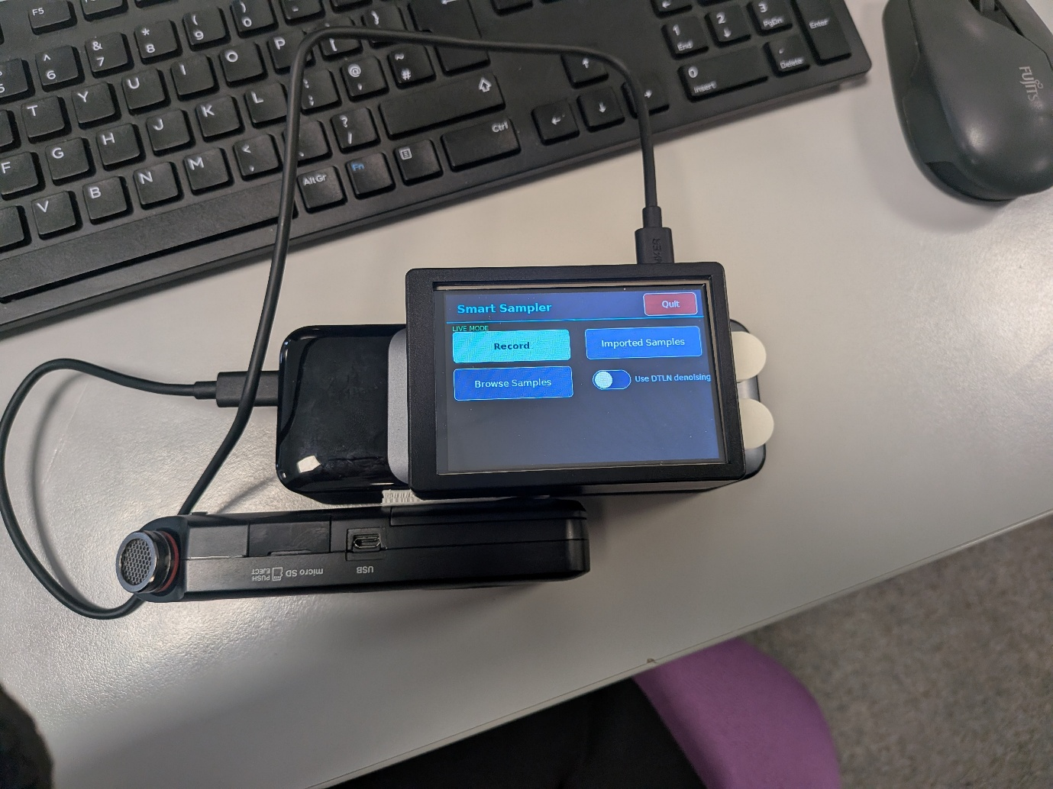
Figure 38 Finished prototype of the Smart Sampler, showing UI, Tascam for audio input and battery bank

Appendix B: User Testing Script
Portable Smart Sampler
User Testing Plan
Creative Computing Final Year Project

1. Test Environment & Setup
Component | Details
Device | Raspberry Pi 5 with 3.5” touchscreen
Audio Interface | Tascam USB interface (connected via USB)
MIDI Input | USB MIDI keyboard
Power | Anker 737 power bank
OS / UI | Raspberry Pi OS
Test Participants | Minimum 3 participants with varied technical backgrounds (1 audio-literate, 1 general tech user, 1 non-technical user)
Session Duration | ~45–60 minutes per participant
Facilitator Role | Observe without assisting unless participant is fully blocked. Note think-aloud comments.

2. Test Tasks

3.1 Recording
Task ID | Description & Steps | Expected Behaviour | Pass Criteria | Notes/Issues | P/F
REC-01 | Basic sample recording  - Navigate to the record screen via the touchscreen  - Press the record button  - Make a sound (e.g. tap the desk, speak a word)  - Press stop  - Check sample list to make sure new recording appears | Recording completes without error. Sample appears in the sample list. | Sample visible in list; playback audible with correct content.
REC-02 | Record multiple samples in sequence  - Record three distinct sounds one after another  - Verify each appears in the sample list | All three recordings saved separately with unique names. | Three distinct files present; no overwriting of previous samples.
REC-03 | Record silence / very quiet sound  - Start a recording with no sound source  - Stop after 3 seconds | Recording saves without crashing. File may be near-empty. | App does not crash; file is saved; pipeline handles gracefully.

3.2 Audio Processing Pipeline
Task ID | Description & Steps | Expected Behaviour | Pass Criteria | Notes/Issues | P/F
PIP-01 | Process recorded sample through full pipeline (DTLN enabled)  - Record a short sample of a voice (talking, singing, etc.)  - Enable DTLN noise reduction option  - Run pipeline | Sample is trimmed, normalised, high-pass filtered, noise reduced, pitch detected, and YAMNet-classified. Folder and file are named automatically. | Output file exists in correctly named folder; no pipeline errors shown.
PIP-02 | Process recorded sample (DTLN disabled)  - Record a short sample  - Disable DTLN option  - Run pipeline | Pipeline completes all steps except DTLN. Folder/file naming still generated. | Output file exists; processing time noticeably shorter than PIP-01.
PIP-03 | YAMNet classification accuracy check  - Record a recognisable sound (e.g. clap, whistle, voice)  - Run pipeline  - Check auto-generated folder/file name | Folder name reflects the correct or closest YAMNet sound category. | Category is plausible for the recorded sound. Log top-3 predictions.
PIP-04 | Pitch detection output  - Record a clear pitched tone (e.g. whistle, hum a note)  - Run pipeline  - Inspect filename with key detected | Detected pitch is noted in filename. MIDI root note reflects detected pitch. | SFZ root_key within +/- 2 semitones of actual played pitch.
PIP-05 | Process a pre-recorded sample (import path)  - Select the test sample list  - Choose a pre-existing .wav file  - Run pipeline | Pipeline processes test file identically to a freshly recorded sample. | Output file in named folder; SFZ generated; no errors.

3.3 Playback & MIDI Integration
Task ID | Description & Steps | Expected Behaviour | Pass Criteria | Notes/Issues | P/F
PLY-01 | Playback sample from sample list  - Record and process a sample  - Locate it in the sample list  - Tap the play button | Sample plays back through audio output at correct pitch and without distortion. | Audio is audible and matches the original recording.
PLY-02 | MIDI keyboard playback using auto-generated SFZ  - Process a pitched sample through the pipeline  - Connect MIDI keyboard  - Play keys across the keyboard range | SFZ data maps sample to MIDI notes correctly. Notes above/below root are pitch-shifted. | At least 3 octaves of playable range; root note sounds natural; no MIDI dropouts.
PLY-03 | Velocity sensitivity (MIDI playback)  - Play keys at low and high velocity (press keys softly and heavily) on MIDI keyboard | Volume responds to velocity if SFZ supports it. | Audible volume difference between soft and hard key presses.
PLY-04 | Velocity Toggle  - Toggle full velocity on and play sample on MIDI keyboard | Volume of each note remain consistent regardless of how hard key is pressed | Volume stays the same regardless of force of keyboard press

3.4 Sample Deletion
Task ID | Description & Steps | Expected Behaviour | Pass Criteria | Notes/Issues | P/F
DEL-01 | Delete a single sample  - Select a sample in the list  - Choose the delete option  - Confirm deletion | Sample is removed from the list and file is deleted from storage. | Sample no longer appears in list; file absent on filesystem check.
DEL-02 | Delete attempt cancelled  - Initiate deletion of a sample  - Choose to cancel rather than confirm | Sample is not deleted. No change to the list. | Sample remains in list after cancellation.

3.5 Touchscreen & UI
Task ID | Description & Steps | Expected Behaviour | Pass Criteria | Notes/Issues | P/F
UI-01 | Touchscreen navigation accuracy  - Tap each main navigation button  - Verify correct screen loads | Each tap registers correctly on the 3.5 inch display. | No missed taps at normal adult finger size across all UI elements.
UI-02 | Touch target size check  - Attempt to press all buttons and controls  - Note any that feel too small or too close together | All interactive elements are comfortably tappable. | No inadvertent mis-taps logged during the session.
UI-03 | Screen readability  - View sample list with 5+ samples loaded  - Check text clarity and truncation | Filenames and folder names are readable; long names truncate gracefully. | Participant can identify each sample without ambiguity.

SUS Questionnaire
Administer after each test session. Ask the participant to rate each statement from 1 (Strongly Disagree) to 5 (Strongly Agree).

# | Statement | Rating (1–5)
1 | I think that I would like to use this system frequently.
2 | I found the system unnecessarily complex.
3 | I thought the system was easy to use.
4 | I think that I would need the support of a technical person to be able to use this system.
5 | I found the various functions in this system were well integrated.
6 | I thought there was too much inconsistency in this system.
7 | I would imagine that most people would learn to use this system very quickly.
8 | I found the system very cumbersome to use.
9 | I felt very confident using the system.
10 | I needed to learn a lot of things before I could get going with this system.
 | SUS Score (calculated)

Appendix B — Observation Sheet Template
Task ID | Observed Behaviour / Verbatim Comment | Completed? (Y/N/H) | Severity (1–3)
REC-01
REC-02
REC-03
PIP-01
PIP-02
PIP-03
PIP-04
PIP-05
PLY-01
PLY-02
PLY-03
PLY-04
DEL-01
DEL-02
UI-01
UI-02
UI-03
H = completed with facilitator hint. Severity: 1 = cosmetic, 2 = significant friction, 3 = task-blocking.

Appendix C: Miro
https://miro.com/app/board/uXjVJ6PHQa8=/?share_link_id=53958821955

Appendix D: Sample Generated Project Outputs

D.1 Folder Structure
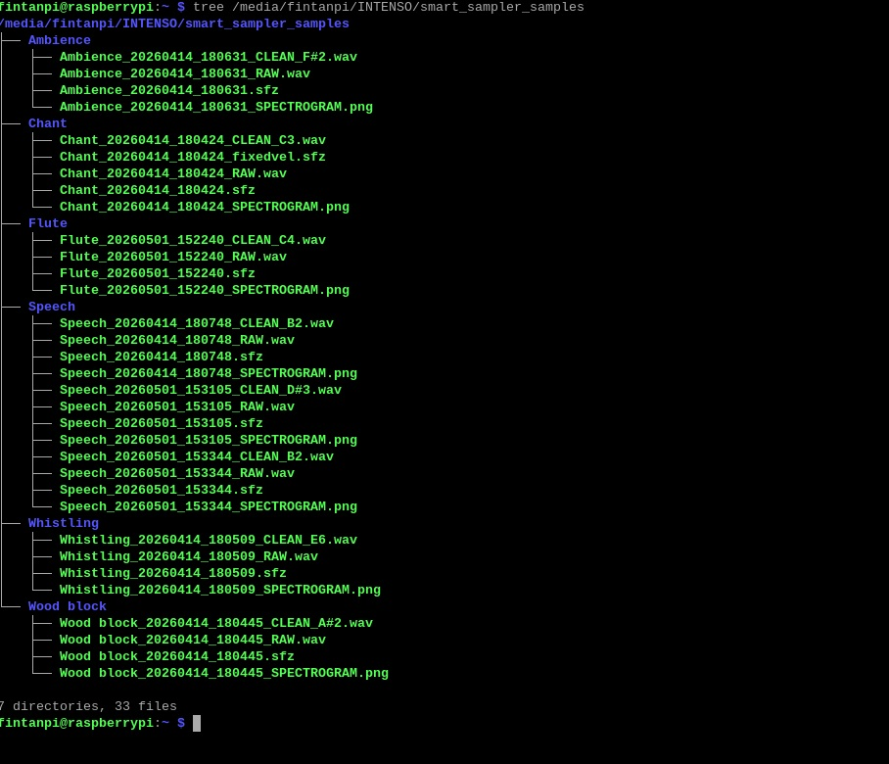
Figure 39 Automated Folder Structure Using YAMNet
This image shows the output folder generated after a sample is taken and a YAMNet classification is chosen by the user. The system saves the raw recording, processed WAV, SFZ metadata file and spectrogram image together under the selected label.

D.2 Filename Structure

Filename Part | Meaning
Flute | User selected YAMNet label
20260501_152240 | Timestamp of saved sample
RAW | Unprocessed original recording
CLEAN | Processed Recording
C4 | Detected pitch
.sfz | Sampler mapping file
If no pitch is detected, the processed WAV name uses unpitched instead of a note name

D.3 Example SFZ Output
// Flute Sample
// Detected Pitch: 124.91 Hz (B2)
<global>
loop_mode=no_loop
<region>
sample=Flute_20260501_152240_CLEAN_C4.wav
pitch_keycenter=47
lokey=0
hikey=127
lovel=0
hivel=127
amp_velcurve_1=0.25
// Loop settings — sustain loop while key is held
loop_mode=loop_sustain
loop_start=0
loop_end=192967

D.4 Example Spectrogram Analysis
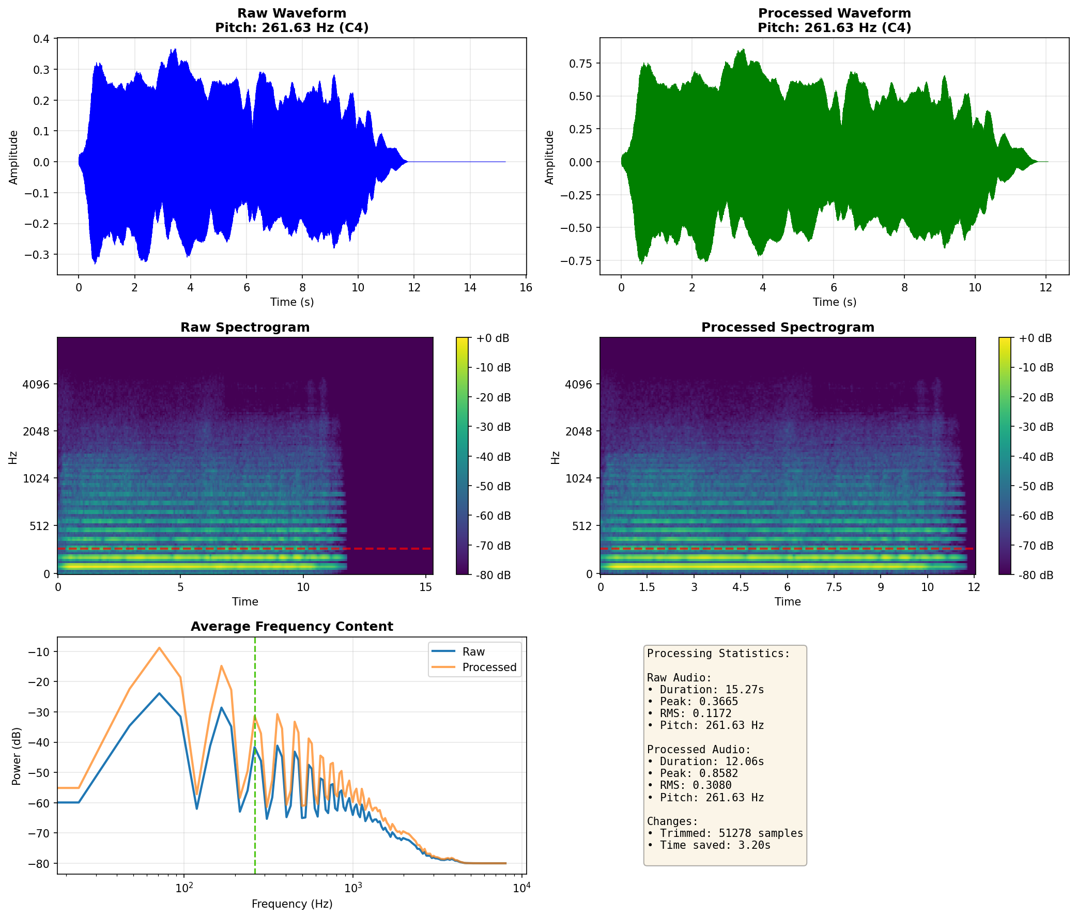
Figure 40 Example Spectrogram for processed flute sample

