
Academic Satisfaction After the Pandemic: A Mixed-Methods Study of Irish Third Level Students

Rebecca Clarke
N00226184

Research Supervisor: Emma Mathias

Dissertation submitted as a requirement for the degree of BSc (Hons) in Applied Psychology,
Dun Laoghaire Institute of Art, Design & Technology, 2026.

Declaration
☒ I, Rebecca Clarke, hereby declare that the work that I have submitted for/ contributed to
the assessment specified above is entirely my own work. Where I have drawn from the work
of others, including Generative AI systems, I have clearly indicated this within my submitted
work. I recognise that Generative AI creations, no matter how small, may not be permissible
within my submitted work and have checked this specific assessment brief for the admissible
use of such software. I have read and complied with the IADT Academic Integrity Policy for
this submission and recognise that breaches of this policy in my work may result in penalties,
up to and including disqualification from IADT.

☒ I, Rebecca Clarke, hereby declare that I recognise that IADT staff may provide feedback on
assessment via a range of methods, depending on the nature of
the assessment and the preference of the staff member. I recognise that any grades issued by a
lecturer are provisional but are not negotiable. Final grades will be issued following the
relevant exam board meeting and information on appeals procedures is available on the IADT
website. I agree to abide by the IADT Mutual Respect Policy in all of my communications
with and regarding all IADT staff members.

Word Count: 6150
Signature:

Acknowledgements
I would like to thank my brilliant supervisor Emma Mathias for guiding me through this journey from the very beginning, offering invaluable insight and guidance through a truly supporting manner. Through Emma Mathias’ guidance, I have discovered my true capabilities in research whilst equipping new skills which I can attribute solely to her.
I would also like to thank my friends and family for their endless support, standing by me as I have taken this new step in my academic journey whilst making it a truly enjoyable experience. They have provided encouragement and love throughout this journey, and I cannot express the gratitude I have for them.
I would like to thank the IADT staff for supporting me throughout this journey, offering guidance along the way whilst ensuring that I have all the tools needed at my disposal to carry out this major research project.
It is necessary to acknowledge the wonderful participants who have given data for this study; without you there would be no opportunity to discover valuable insights into the academic satisfaction of post-pandemic students and this major research project would have never happened.
Lastly, I would like to thank my pets Misty, Jet and Willow. You may not be fully aware of the support that you have offered throughout this process, but I will never forget it and will be offering many treats as gratitude.
Table of Contents
Declaration ii
Acknowledgements ii
Abstract 1
Introduction 2
1.1 Academic Satisfaction 2
1.2 Pre-Pandemic Academic Satisfaction in Higher Education 3
1.3 Disruption to Education During COVID-19 4
1.4 Post-Pandemic Academic Satisfaction in Higher Education 5
1.5 Current Study 6
Methodology 8
2.1 Research Design 8
2.2 Sample 8
2.3 Materials 8
2.4 Procedure 9
Analysis 9
2.5 Ethical Considerations 10
Results 11
3.1 Introduction 11
3.2 Quantitative Results 11
Reliability Analysis 11
Descriptive statistics 11
Assumption Testing 11
Independent Samples T-Test 12
3.3 Qualitative Results 13
Theme 1: Deterioration of Academic Quality 15
Subtheme 1: Reduced Academic Performance. 15
Subtheme 2: Unpreparedness for In-Person Learning. 16
Theme 2: Declining Academic Motivation 16
Subtheme 1: Academic Fatigue 16
Subtheme 2: Decreased goal Orientation and Focus 16
Theme 3: Institutional Resource and Support Limitations 16
Subtheme 1: Limited Mental Health Support 17
Subtheme 2: Restricted Access to Campus Facilities 17
Subtheme 3: Limited Academic Support 17
Theme 4: Social Disconnection 17
Subtheme 1: Loss of Academic Community 17
Subtheme 2: Peer Relationship Breakdown 18
Discussion 19
4.1 Overview 19
4.2 Quantitative Interpretative Analysis 19
4.3 Qualitative Interpretative Analysis 20
4.4 Strengths of the Current Study 20
4.5 Limitations of the Current Study 21
4.6 Theoretical and Practical Implications 22
Theoretical Implications 22
Practical Implications 22
4.7 Suggestions for Future Research 22
4.8 Conclusion 23
References 24
Appendices 28
Appendix A: Microsoft Survey 28
Appendix B: Information Sheet 29
Appendix C: Consent Form 33
Appendix D: Participant Anonymising Code and Questionnaire 34
Appendix E: Academic Satisfaction Scale 36
Appendix F: Confirmation of Consent and Debrief Form 37
Appendix G: Thematic Analysis Visual Framework 40
Appendix H: Ethical Approval 51
Appendix I: Ethical Approval Form 52

List of Tables and Figures

Tables
Table 1: Descriptive Statistics Comparing Academic Satisfaction 12
Table 2: Example of Identified Themes 13

Figures
Figure 1: Sample Boxplot of Total Academic Satisfaction Score by Academic Timing 12
Figure 2: Thematic Analysis Map of Perceived Educational Impacts 15

List of Abbreviations
Abbreviation | Definition
COVID-19 | Coronavirus-2019
SARS-CoV-2 | Severe acute respiratory syndrome coronavirus 2

Abstract
This mixed-methods study investigated the COVID-19 pandemic’s long-term educational potential impacts on third level students in Ireland. Quantitative data derived from online surveys utilising a validated Academic Satisfaction scale and further analysed, comparing academic satisfaction levels in third level students who studied in Ireland prior to the pandemic compared to those who studied after. Results found academic satisfaction scores to be significantly higher in pre-pandemic students, with a very large effect size, implying considerable long-term academic satisfaction disruption. Qualitative data was collected from Reddit data and analysed utilising thematic analysis, identifying four main themes: deterioration of academic engagement, declining academic motivation, institutional resource and support limitations, and social disconnection. These results support the student engagement theory (Astin, 1999), Tinto’s (2012) model of student integration, and expectancy-disconfirmation theory (Oliver, 1980), demonstrating that minimal support, engagement and socialisation leads to decreased academic satisfaction. The mixed-methods design allows triangulation, validating the interpretation of findings. However, limitations such as self-report measures and non-representative sampling may restrict generalisability and causal inference. Principally, findings indicate that the pandemic may be causation for continuous academic impacts on third level students in Ireland, highlighting the need for targeted social, academic and institutional support strategies.

Introduction
At the inauguration of this current decade, it was announced that a global health crisis was upon us. The Coronavirus rapidly spread worldwide with cases surging and the mortality rate rising, causing the World Health Organization (2020) to sanction a worldwide lockdown and deem the ordeal a global pandemic. Coronavirus-2019 (COVID-19) is a transmissible disease first documented in Wuhan, China during the December of 2019. The dispersion of such a virus is attributed to severe acute respiratory syndrome coronavirus 2, also referred to as SARS-CoV-2 (World Health Organization, 2020). The Taoiseach of Ireland, Leo Varadkar, announced the closure of all educational settings with the purpose of containing and limiting further sickness (Department of Education and Youth, 2020), thus integrating classes being held via technology which marked the initiation of online learning. On March 1st, 2021, Irish students were gradually permitted to attend in-person learning, with schools catering towards special educational needs, primary classes from junior infants up until second class, and secondary school Leaving Certificate classes commencing once again. The coalescing of all other students occurred by April 12th, 2021, with the promise of predicted grades compensating for Leaving Certificate exam results and classroom-based assessments for Junior Certificate results (Department of Education and Youth, 2021).
This paper aims to discern whether there is a statistically significant distinction in academic satisfaction between students who have experienced third level education in Ireland prior to the Coronavirus pandemic compared to students who have experienced third level education in Ireland after the Coronavirus pandemic, alongside an analysis of how students regard potential long-term impacts of Coronavirus-2019 on academic satisfaction.

1.1 Academic Satisfaction
Academic satisfaction is a multidimensional concept encompassing the evaluation of students in relation to academic experiences such as student belonging, academic resources, educational support, and the quality of teaching (Elliott & Shin, 2002). Regarding the Coronavirus-2019, such evaluations have been molded significantly by the transition to online education alongside learning models implemented through hybrid learning. As this study aims to investigate the long-term educational impacts of the pandemic, it is imperative to analyse the configuration of academic satisfaction in addition to student adaptation and engagement through the means of multiple reticular theoretical frameworks.

Theoretical Frameworks
The expectancy-disconfirmation theory (Oliver, 1980) elaborates that satisfaction is determined by an experience’s degree of deviation or alignment to previous expectations. In relation to education, students anticipate a certain level of support quality, social opportunities, and level of academic learning which in turn determines satisfaction dependent on met expectations (Brown & Mazzorol, 2009). In addition to this, Tinto’s (1993) model of student integration emphasises the importance of social integration and work engagement in relation to student satisfaction to allow for motivation and academic satisfaction. These theories coincide with the student engagement theory (Astin, 1999), which encompasses the ideologies of both by asserting that student learning quality and satisfaction derives from cognitive engagement influenced by teaching quality, motivation, and social opportunities.
Adjacent to these core theories, frameworks such as the digital divide framework and the education resilience theory prescribe further discernment of academic satisfaction, specifically in relation to the pandemic’s impact on satisfaction for students. The educational resilience theory depicts the adaptation of students to adversity, utilising resilience as a means of mediating educational outcomes, such as academic satisfaction and engagement, and disruption (Martin & Marsh, 2006). In accompaniment, the digital divide framework discusses how students’ academic experiences may be altered due to disparities in digital literacy, access to devices and internet connection (van Dijk, 2002). This framework claims that students without online resources show higher levels of dissatisfaction, disengagement, and resentment.
The knowledge of these frameworks can aid in the comprehension of the pandemic’s educational impact on academic satisfaction as they allow the visualisation of how reduced engagement, varying resilience levels, digital access and literacy discrepancies can all impact academic satisfaction due to the quantity of social integration, teaching quality and type, and support, potentially creating a misalignment of experience to previous expectations.

1.2 Pre-Pandemic Academic Satisfaction in Higher Education
With the purpose of discerning the long-term educational impact that the pandemic has had on third level students in Ireland, a comparison of pre-pandemic academic satisfaction must be drawn first. Preceding the COVID-19 pandemic, academic satisfaction was measured by student engagement, quality of academic facilities, teaching standard, campus experience, and academic support (Brown & Mazzorol, 2009).
The quality of teaching standards and feedback are habitually viewed as determinants of academic satisfaction. Preceding the pandemic, students gave high appraisal to faculty approachability, communication, and engaging learning of high quality (HEA, 2019). In relation to Irish academic satisfaction, Irish surveys reported that the standard of teaching was noted as the most highly rated factor of student contentment, having the most substantial influence on students’ academic satisfaction, emphasising responsiveness through communication, support and structured academic content all playing a role in this (HEA, 2019). This compliments the importance of workload balance as globally students appreciated assignments with manageable difficulty levels, favouring lecturers who allowed for ample time regarding the completion of projects (Thomas, 2012).
Along with this, pre-pandemic students valued the quality of their campus experience, including societies and technological facilities, aiming at harboring a sense of belonging among students (Tinto, 1993). Irish students reported in a national survey (HEA, 2019) that engagement related to campus facilities aided in self-development, improving their academic experience overall. Students also reported higher levels of academic satisfaction in relation to support facilities offered on campus. A paper by Danielsen, et al. (2011) aimed to configure the relationship between academic initiative and perceived support. Utilising surveys implementing the Likert scale (1932), the researchers gathered data from 3,125 Norwegian students relating to perceived teacher support, academic competence, academic satisfaction, and initiative. The data was analysed via structural equation modelling and a multi-mediator model testing between support, satisfaction, and initiative. The researchers found that support from faculty correlated strongly with academic initiative and satisfaction, demonstrating the worldwide correlation between support and academic satisfaction worldwide.
These pre-pandemic trends relating to academic satisfaction create a standard from which we can derive a comparison in relation to the global educational disruption of COVID-19. By emphasising areas such as support, campus interactions, workload equipoise and quality of educational teaching, comparisons can be drawn relating to areas of education that may have been more susceptible to the impact of online learning and those that had adapted.

1.3 Disruption to Education During COVID-19
The pandemic engendered worldwide disruption to education, creating sudden causation for online learning to ensue, changing the academic experience for countless students. Being unplanned in nature, online learning was aimed at rapidly maintaining fluidity in education. In a paper by Bond et al. (2021), a systematic mapping review of emergency remote learning in third level education was conducted to gain understanding of online curriculum and pre-existing research. A total of 282 English, German and Spanish empirical studies were analysed, finding that studies were cross-sectional and focused on student perception of rapid online learning, including satisfaction, which highlighted the divide between hypothetical pre-planned online education and the emergency remote learning that students were dealt. Furthermore, Quality and Qualifications Ireland (2022) implemented an evaluation how third level educational settings combatted the pandemic, finding successes in rapid conversion to online learning and maladaptation in terms of communication, technological inequality, and faculty adaption.
Throughout the pandemic, research has found trends in academic satisfaction, focusing on digital access and literacy, limited socialisation, and changes to curriculum. Aristovnik et al. (2020) conducted a global survey of 30,383 third-level students originating from 62 countries, aiming to investigate the impact of COVID-19 regarding substructures for online work, social life, and student satisfaction. Utilising ordinal logistic regression and qualitative analysis, the study found that students felt their online literacy to be inadequate whilst workloads increased, impeding their self-performance perception and negatively affecting academic satisfaction. In terms of a national context, Yang (2021) conducted a mixed-methods study, utilising surveys and open-ended texts responses from 132 Irish postgraduate business students aiming to understand their opinion of the shift to online learning. Quantitative data was analysed via descriptive statistics and qualitative analysed via thematic analysis, finding that in-person learning was favoured, altered workload impacted student satisfaction, engagement was lacking, and social interactions were limited due to screens and often Wi-Fi signal. This study compliments the topic of reduced interaction as it discusses the emphasis on communication, which was deemed a negative impact on academic satisfaction, similar to the study conducted by Bond et al. (2021) and Chambers (2024) which implements a mixed-methods study regarding higher level business students, comparing educational experiences pre-pandemic and during the pandemic and finding that lack of interaction and altered workloads within online learning led to a negative academic experience.
These studies are strengthened by their mixed-methods approach, allowing for richer data, alongside their vast quantities of participants ensuring disparities may be addressed. However, their use of convenience sampling and cross-sectional designs may discredit them due to more vocal students dominating data and causal claims limitations. Regardless, the evidence gathered from these studies illustrates the pandemic’s disruption to academic satisfaction in terms of diminished socialisation and communication, digital inequalities and workloads deviating from the standard, tying back to work of Brown and Mazzorol (2009). These negative impacts may identify causation for impacts to academic satisfaction on an extended scale of time, which this thesis will discuss in an Irish and global context.

1.4 Post-Pandemic Academic Satisfaction in Higher Education
The pandemic’s impact on education generated instantaneous impacts, nonetheless educational impacts are continuously unfolding. This chapter synthesises global and Irish research on post-pandemic academic satisfaction, perceptions and adaptation.
Comparative and empirical quantitative evidence points to the shift in academic satisfaction succeeding COVID-19. A study by Beltrán et al. (2023) utilised student satisfaction surveys focusing on 83,532 Spanish students over 12 terms. Employing quantile analysis, they found a decrease in academic satisfaction due to academic quality and online learning pre-pandemic and an increase post-pandemic due to in-person learning. National research has however lacked longitudinal data and implements cross-sectional designs focused on the pandemic interval, such as Mothersill et al. (2024) and Sheedy O’Sullivan et al. (2022), reporting adaption-related drops in self-reported academic satisfaction from 90.3% to 30.4% during the pandemic with no further results stated. Low et al. (2023) also focus on Irish educational experience during the pandemic, utilising surveys and questionnaires finding that medical students value in-person learning and 55.8% reported impacts to mental health, however research delved no further.
Qualitative research added rich data by identifying student perception of how academic satisfaction was impacted by the pandemic. Research by Peimani and Kamalipour (2021) explored Welsh students’ perceptions of online learning throughout the pandemic via online surveys, finding that 46.4% rated peer interactions poorly and preference for academic structure. However, this study is more descriptive than interpretive, blatantly highlighting the gap in research.
These peer-reviewed studies stipulate that the pandemic’s impact on academic satisfaction is ongoing due to teaching methods and student satisfaction. However, there is an apparent lack of Irish longitudinal quantitative and qualitative studies, an issue this study aims to address.

1.5 Current Study
Thematic synthesis has allowed for identification of research gaps, such as lack of comparative quantitative data and qualitative analysis, particularly in an Irish context. Integration of findings has produced three themes; academic experience, online adaptation, and social aspects, areas of which this study will integrate as to better understand impacts to academic satisfaction. Comprehensively, this interpretation of research gaps and critical synthesis allows clear causation for this study whilst creating a clear basis for the research design with the purpose of comprehending the pandemic’s long-term educational impact.
This study intends to determine whether there is a statistically significant distinction in academic satisfaction for third level students in Ireland based on their academic timing, indicating the pandemic’s disturbances to education and related adaptations. This hypothesis suffuses the mixed-methods design implemented, as a quantitative online survey analysed via a t-test allows for visualisation of statistical differences in academic satisfaction whilst a qualitative thematic analysis of preexisting information gathered through Reddit groups allows for nuanced data relating to student interpretation, answering the hypothesis whilst giving causation for it.

Methodology

2.1 Research Design
This study implemented a mixed-methods design, comprising of quantitative and qualitative approaches investigating the COVID-19 pandemic’s long-term educational impact on third level students in Ireland. A cross-sectional online survey was utilised to quantitatively compare academic satisfaction in third level students who studied prior to the pandemic compared to those who studied after, whilst Braun and Clarke’s (2006) qualitative thematic analysis of publicly accessible Reddit forum posts (Reddit, n.d.) provided exploration of perceived educational impacts caused by the pandemic in greater detail through recurring themes. Whilst the implemented survey may limit generalisability due to self-report measures and convenience sampling, the implemented mixed-methods approach allows for statistical comparison alongside a more in-depth investigation of the student experience whilst ensuring methodological coherence.

2.2 Sample
Participants for the online survey were individuals who have attended third level students in Ireland aged 18 and over. The inclusion criteria for the online survey called for participants to be currently attending, or graduated from, a third-level education institution in Ireland. Exclusion criteria were participants under the age of 18, individuals who have not attended third-level education in Ireland and failure of survey completion. Fifty Participants were categorised into two groups depending on their educational timing being before the pandemic or after, with 25 participants in each group. A convenience sampling method was utilised, with participants being recruited via online platforms, such as Instagram and LinkedIn. Participation was voluntary and no incentives were utilised.
Purposive sampling was utilised to gather publicly available data from the digital discussion forum Reddit (Reddit, n.d.), with data being gathered from Reddit communities discussing the long-term educational impacts of the pandemic in Ireland. Posts featuring general inquiries were omitted to avoid irrelevant data. Data collection concluded once data saturation occurred.

2.3 Materials
The materials utilised in this current study included an online invitation to participate in a Microsoft survey (Appendix A). This survey was comprised of an information sheet (Appendix B), a consent form (Appendix C), a participant anonymising code and demographic questionnaire collecting information on third level academic timing (Appendix D). This was followed by an Academic Satisfaction Scale (Huebner, 1991), a 7-item scale rated on a 5-point Likert scale (Likert, 1932) ranging from strongly disagree to strongly agree (Appendix E). This scale assessed student perception of academic experience, student satisfaction and educational content, with higher scores indicating greater academic satisfaction. This scale has demonstrated adequate reliability in previous research, allowing this study to adhere to methodological integrity standards with the use of Cronbach’s alpha. A confirmation of consent and debrief form was utilised upon survey completion (Appendix F).
Qualitative data was gathered from 6 publicly accessible subreddits (Reddit, n.d.) relating to the criteria of discussing the pandemic’s long-term impact on third-level education. Irrelevant posts including links to external sources and any potentially identifying information were excluded. These subreddits were chosen due to them receiving the highest engagement, allowing for potentially substantial insight for analysis. This data was transcribed to Microsoft Word 2024 for further analysis (Appendix G). Identifying information and usernames were excluded to ensure anonymity.

2.4 Procedure
Ethical approval was granted by the PEC and IADT before the commencement of this study (Appendix H). An online survey was then administered utilising Microsoft Forms with a pilot study of 5 participants being conducted first. Participants were provided with an information sheet depicting the purpose of this study, followed by an informed consent form. Participants made anonymising codes and completed a demographic questionnaire relating to their academic timing. Participants completed an Academic Satisfaction Scale (Huebner, 1991) which upon completion brought them to a confirmation of consent and debriefing form. This survey took approximately 5 minutes to complete, as indicated by the pilot study. The pilot study allowed for survey alterations such as larger font size and clear headings. Reddit posts from 6 subreddits meeting the inclusion criteria were then collected, paraphrased and transcribed into a Microsoft Word 2024 document for analysis. Once data was collected, a preliminary review was conducted so as to omit irrelevant posts. No Reddit login was used to ensure public availability and all data was anonymised prior to analysis.

Analysis
Quantitative survey data was analysed using IBM SPSS version 28 with an independent samples t-test being conducted to concur whether there was a significant difference in academic satisfaction for third level students who studied in Ireland before the pandemic compared to those who studied after. Data cleaning ensued addressing missing data, variable labelling and duplicates, and statistical significance was set at p < .05. Qualitative data was then analysed using thematic analysis following the six-phase framework outlined by Braun & Clarke (2006), resulting in familiarisation with the data allowing for initial coding and for potential themes to be colour-coded in a Word document. Theme development occurred, resulting in recognised patterns and subthemes, which upon further review and definition created solidified themes and alterations, allowing a final thematic map to be created for data visualisation. Themes were allowed to emerge naturally from the data due to an inductive approach being implemented. To ensure reliability of coded themes, an inter-rater agreement test was implemented with a critical friend technique (Noor & Shafee, 2021), the findings of which were thusly documented. Reflective journalling documented decisions throughout this process.

2.5 Ethical Considerations
An amber route ethics application (Appendix I) was submitted to the IADT Psychological Ethics Committee (PEC) due to direct contact with participants and the potentially upsetting topic of academic satisfaction. This ethics application was approved by the PEC (Appendix H). Ethical guidelines were adhered to in accordance with the British Psychological Society (BPS) for the Code of Human Research Ethics (2021) and Internet-Mediated Research (2021). For the survey component, participants provided informed consent prior to participation and were informed of their right to withdraw from the survey at any time in an information sheet provided. Participants were also issued with a debrief form upon survey completion. All data was stored securely in accordance with GDPR requirements. In correlation with anonymity and privacy BPS guidelines, all survey participants were issued anonymous codes and Reddit usernames, or other such identifiable information was omitted from qualitative data. Furthermore, no direct contact was made with Reddit users, and all qualitative data was publicly available and paraphrased to further ensure anonymity.

Results

3.1 Introduction
This chapter discusses both the quantitative and qualitative findings of this study, examining the long-term educational impacts of the COVID-19 pandemic on third-level students in Ireland. Quantitative data was procured via a cross-sectional online survey implementing an Academic Satisfaction scale (Huebner, 1991), employing a Likert scale design (Likert, 1932). An independent samples t-test alongside descriptive statistics were conducted to address research question 1 regarding whether there is a statistically significant difference in academic satisfaction for third-level students who studied prior to the pandemic compared to those who studied after.
Qualitative data was procured from Reddit discussion forums (Reddit, n.d.) in relation to publicly available statements regarding research question two of what exactly the potential long-term educational impacts of the pandemic are. Utilising the six-phase framework of thematic analysis (Braun & Clarke, 2006), these statements were analysed to identify the recurring themes of perceived impacts.

3.2 Quantitative Results

Reliability Analysis
A reliability analysis was conducted to examine the internal consistency of the Academic Satisfaction scale (Huebner, 1991). The analysis found there to be excellent internal reliability, with Cr items were utilised and combined to create a total academic satisfaction score for further analysis.

Descriptive statistics
Descriptive statistics were calculated to investigate academic satisfaction levels before and after the COVID-19 pandemic. Student academic satisfaction levels were found to be higher before the pandemic (M = 34.04, SD = 2.21) compared to after the pandemic (M = 22.24, SD = 6.45). This shows a notable decline in academic satisfaction in post-pandemic results.

Assumption Testing
Prior to conducting the independent samples t-test, the assumptions of homogeneity of variance and normality were assessed.
Homogeneity of variance was assessed utilising Levene’s test for equality of variances, indicating a significant result F(1, 48) = 41.13, p<.001. This indicates that the assumption of homogeneity of variance was violated, therefore the unequal variances estimate was used when interpreting the t-test results.

Independent Samples T-Test
An independent samples t-test was conducted to determine whether there was a significant difference in academic satisfaction scores between third level students based on their educational timing. The analysis revealed a statistically significant difference in academic satisfaction between the two groups, t(29.55) = 8 .65, p<.001. Students reported significantly higher academic satisfaction prior to the pandemic (M = 34.04, SD = 2.21) compared to after (M = 22.24, SD = 6.45). The mean difference between the groups was 11.80, with a 95% confidence interval ranging from 9.01 to 14.59. An analysis of effect size was conducted using Cohen’s d, indicating that the magnitude of difference between groups was very large, Cohen’s d = 2.45.

Table 1
Descriptive Statistics Comparing Academic Satisfaction Before and After the Pandemic
Group | N | Mean | SD
Before the pandemic | 25 | 34.04 | 2.21
After the pandemic | 25 | 22.24 | 6.45
Note. t(29.55) = 8.65, | Cohen’s d = 2.45 | P < .001
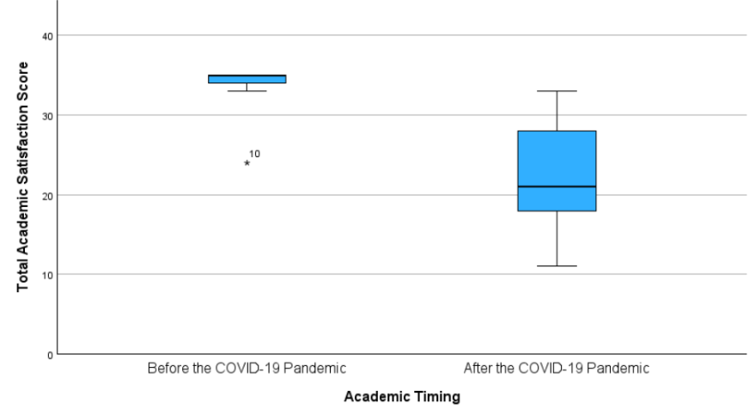
Note: this table demonstrates the differences in mean and standard deviation of the two groups
Figure 1
Simple Boxplot of Total Academic Satisfaction Score by Academic Timing

Note: this figure shows the total academic satisfaction scores of the two groups “Before the COVID-19 Pandemic” and “After the COVID-19 Pandemic” with a line demonstrating the median of each group’s results.

3.3 Qualitative Results
A thematic analysis was conducted regarding third-level students’ online comments of the perceived educational impacts of the COVID-19 pandemic in Ireland. This identified four main overarching themes from the data: deterioration of academic engagement, social disconnection, institutional resource and support limitations, and declining academic motivation as seen in table 2. The aforementioned themes and subthemes are displayed in Table 2 and Figure 2 below with Table 2 discussing codes that allowed for further theme definition, proceeded by a report of all findings.

Table 2
Example of Identified Themes
Theme | Definition | Codes
Deterioration of Academic Quality  Subthemes:  Reduced academic performance  Unpreparedness for in-person learning | A clear disparity in grades, knowledge of practical educational tools, and ability to function during in-person classes compared to pre-pandemic students. | Difficulty in learning modality transition, poor grades, lack knowledge of educational tools.
Declining Academic Motivation  Subthemes:  Academic fatigue, Decreased goal orientation and focus | A lack of motivation to participate and exceed in academic work due to the ability to focus and mental exhaustion. | Concentration difficulties, educational burnout.
Institutional Support and Resource Limitations  Subthemes:  Limited mental health support  Restricted access to campus facilities  Limited academic support | The lack of academic and emotional support for students whilst simultaneously diminishing recreational and educational facilities. | Difficulty accessing mental health support services, closure of student spaces, lack of guidance from faculty members.
Social Disconnection  Subthemes:  Loss of academic community  Peer relationship breakdown | Student decline in socialisation and class groupwork due to the lack of communal facilities and open discussions about mental health. | Lack of communication, minimal academic participation, limited interaction with peers, lack of peer support, reduced campus social life.

Note: this table demonstrates the identified themes, further definition of said themes and examples of codes used in the thematic analysis.

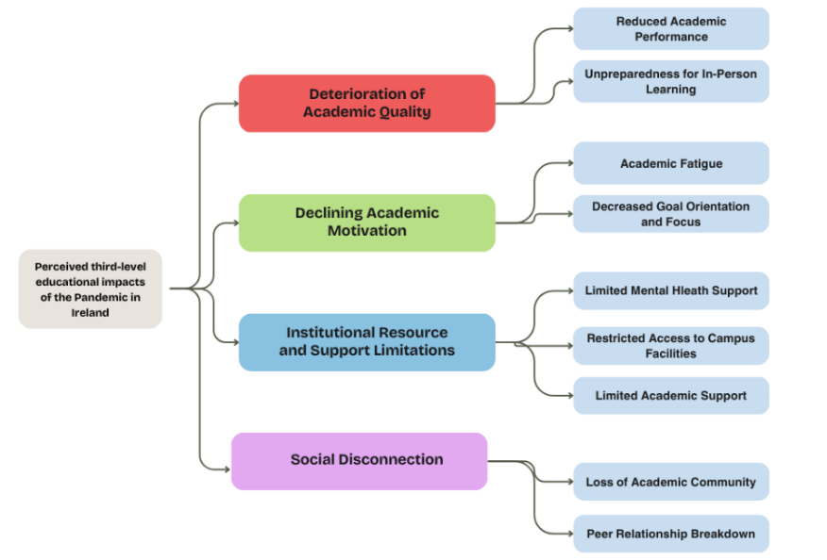
Figure 2
Thematic Analysis Map of Perceived Educational Impacts
Note: this figure illustrates the final thematic analysis map conducted during the qualitative results.

Theme 1: Deterioration of Academic Quality
Participants routinely described concerns regarding their perceived decline in the quality of academic work after the COVID-19 pandemic. This was commonly attributed to the disruption to education, the change of learning formats and reduced interactions of students and facilitators. The two subthemes identified in relation to this theme were reduced academic performance and unpreparedness for in-person learning due to these academically altering factors.

Subtheme 1: Reduced Academic Performance.
Multiple participants described experiencing declines in both their academic performance and in the performance of their peers following the adjustment from online learning back into in-person learning, most noticeably in their current work. Students reported difficulties in adapting to third level education considering their most impactful academic years were shaped by online learning. This can be seen in from participant 10, stating that “student preparation for higher ed and attitudes toward learning that were shaped by terrible remote HS aren’t behind us.”, and participant seven’s “Students that can't read and follow directions written in short declarative sentences”.

Subtheme 2: Unpreparedness for In-Person Learning.
Participants also elaborated on feelings of unpreparedness for in-person learning and further academic opportunities due to difficulties adapting since the pandemic closures, as seen in participant 110 statement “I'm surprised employers even look at people from that year. You don't know what you're gonna get”.

Theme 2: Declining Academic Motivation
Another emerging theme was the decline in academic motivation, prominent in participant posts. A consistent flow of comments from participants relating to academic burnout and reduced motivation in consistent coursework, study and participation solidified this theme and subthemes of academic fatigue and decreased goal orientation and focus.

Subtheme 1: Academic Fatigue
Academic fatigue was consistently reported to be a noticeable educational impact after the pandemic, with participants annotating self-perceptions of their current mindset towards third-level education. This was widely attributed to the changes of educational administration from online to in-person, increased screen time and the time taken to reacclimatise back into standard pedagogy. Participant 77 touches on this subject in their comment “Kinda feels like Stephens’ Day actually, everything is still “there”, but the party’s been and gone.”, comparing the academic atmosphere to a stale and isolated event, and participant 97 stating that current third level students “cant handle the pressure of their course”.

Subtheme 2: Decreased goal Orientation and Focus
Participant also reported facing difficulty when aiming to give prolonged focus to long-term goals and study, with comments relating to future endeavours in a negative light, such as participant 27 stating that current third-level students are “incapable of finishing the task”.

Theme 3: Institutional Resource and Support Limitations
It became apparent that perceived limitations in institutional resources were the most commonly recurring topic for participants, in relation to insubstantial services both in terms of academic and mental health support for third-level students in Ireland, alongside the dwindling options for campus recreational facilities.

Subtheme 1: Limited Mental Health Support
A cohort of participants expressed concerns around the limited access to mental health support for students, describing timely waiting periods for psychological support or lack-thereof. This is seen in the distain of participants 62 and 111, who state that “we will never get the supports needed to help students actually achieve” and that current third-level students “work alone, manage our own time and be expected to maintain the same high-standard of normal years with significantly less support.”.

Subtheme 2: Restricted Access to Campus Facilities
Restricted access to campus facilities was identified as a barrier between third-level students and excelling academically, both in terms of grades due to library usage, but also socially. Participants frequently reported that the lack of libraries, study spaces and recreational facilities such as student bars and coffee shops hindered with their ability to foster a sense of academic community whilst diminished chances of productive study routines being founded. It was discussed that the only way to combat this issue is to communicate with faculty members and the government, as stated by participant 30 which mentions that it is “simply impossible to solve without substantial buy in from the administrative purse holders.”.

Subtheme 3: Limited Academic Support
Lastly on this theme, participants discussed the difficulty in finding any opportunities for receiving academic guidance in their colleges, partly due to the high demand but also because of the lack of resources. Participants found that they were expected to have caught up academically and have sought out the resources themselves due to the “underfunding/understaffing of schools”, stated by participant 61. Participant 12 then relates to the lack of academic training and additional support, stating that it is “diminishing the ability of students to be prepared to use the technology and skills they need to use in college as well as after graduation.”

Theme 4: Social Disconnection
Lastly, the social disconnection touched on by participants illustrates the isolation third-level students are feeling due to the loss of academic community, ergo leading to relationship breakdown with peers and faculty members.

Subtheme 1: Loss of Academic Community
Participants frequently discussed a diminished sense of belonging in their educational environment, with students disengaging with peers and simply attending then leaving, as seen with participant 79 stating that students now “just turn up, go to class, and go home “. This was attributed to the isolating nature of online learning during the pandemic that never fully left according to participants, abandoning chances of informal interactions that in turn foster a sense of academic community. This subtheme is only strengthened by participant 91, claiming that “after joining some clubs a lot of them left college so I went back to having a solitary lifestyle”.

Subtheme 2: Peer Relationship Breakdown
It was also reported constantly that due to the isolating nature of online learning combined with the lack of rebuilding a sense of academic community, peer relationship breakdown has become a very prominent subtheme in relation to the pandemic’s long-term educational impacts on third-level students in Ireland. This limited interaction with peers has been “damaging to emotional regulation and communication” according to participant 50, with participant 44 stating that “Many of the Irish people have lost old friends” due to this social deprivation of sorts.

Discussion

4.1 Overview
This study investigated the pandemic’s long-term educational impacts on third level students in Ireland, addressing the gaps in research such as the lack of Irish-focused post-pandemic research of a mixed-methods design. In relation to the primary hypothesis that there will be a statistically significant difference in academic satisfaction for third level students based on their academic timing, quantitative findings revealed that students who attended third level education prior to the pandemic reported significantly higher levels of academic satisfaction than those who studied after. These findings directly extend from prior research (Aristovnik et al., 2020) which focused on immediate impacts, supporting the argument made in the introduction of this study that pandemic educational impacts are ongoing rather than transient.
Qualitative findings reinforce this conclusion by answering research question 2 regarding what educational impacts did the pandemic have, if any, on third level students in Ireland, identifying impacts with four key themes: motivation, institutional support, academic quality and social integration, highlighting central determinants of academic satisfaction discussed in the introduction (Brown & Mazzarol, 2009). This connection between observed outcomes and predicted determinants displays clear conceptual coherence throughout the current study.

4.2 Quantitative Interpretative Analysis
From the quantitative data, a statistically significant distinction in academic satisfaction combined with a very large effect size (d = 2.45) provides this study with strong support for its hypothesis. The extent of this effect size indicates that the pandemic not only temporarily disrupted education but may impact the student experience continuously. This discovery can be explained through the expectancy-disconfirmation theory (Oliver, 1980). As outlined in the introduction, students commence third-level education with pre-formed expectations relating to social experiences, support and teaching quality. The aftermath of the pandemic has likely disrupted these expectations, creating negative disconfirmation and reduced satisfaction.
The findings of decreased post-pandemic satisfaction align with the student engagement theory (Astin, 1999) which postulates that reduced engagement creates poor academic satisfaction and outcomes. This quantitative decline is further explained by the qualitative evidence of disengagement, such as declining academic motivation and deterioration of academic engagement.
A substantial contribution of this current study is the increased variability seen in post-pandemic scores, indicating that the pandemic’s impact was ununiform and supporting the digital divide framework (van Dijk, 2002). This suggests that the pandemic may have impacted satisfaction whilst emphasising academic inequalities, an insight that surpasses descriptive findings and towards structural interpretation.
Whilst these findings align with literature discussing decreasing satisfaction mid-pandemic (Yang, 2021), they contrast with work such as Beltrán et al. (2023) which found that satisfaction levels recovered post-pandemic. This may be elucidated by differences in timing measurement and national contexts, emphasising the importance of context-specific work and the contribution of this current Irish-focused study.

4.3 Qualitative Interpretative Analysis
The qualitative findings have provided critical evaluation by explaining why academic satisfaction declined once quantitative data identified the decline, addressing research question 2 and tying into theoretical frameworks discussed in the introduction.
The perceived decline of academic quality relating to the theme of deterioration of academic engagement mirror impacts discussed in emergency online-learning literature (Bond et al., 2021), with this current study’s findings adding to this work through implications of persisting learning deficits.
Subthemes of educational fatigue and declining goal orientation relating to the theme of declining academic motivation support the student engagement theory (Astin, 1999), indicating a continuous decline of engagement and lingering psychological impact.
Corresponding with the work of Danielsen et al. (2011), perceived lack of support relating to the theme of institutional resource and support limitations correlate with negative academic experiences. This current study strengthens this work by revealing perceived ongoing support limitations as opposed to mid-pandemic specific limitations.
Lastly, the continuity of social disconnection final theme found in the thematic analysis supports Tinto’s (1993) integration model whilst extending it by implying that reintegration is not immediate once students returned to in-person education. This allows this study to provide a key theoretical contribution.

4.4 Strengths of the Current Study
The use of a mixed-methods design allowed for triangulation of discoveries; quantitative data to distinguish whether there is a long-term academic correlation caused by the pandemic whilst qualitative data enriches results by identifying what the exact impacts are, adding validity to results.
In terms of quantitative aspects that strengthen this study, it is important to note the large effect size. Findings reflect meaningful academic satisfaction differences as opposed to insignificant statistical effects, as supported by the very large Cohen’s d. Another strength is the outstanding scale reliability. The Academic Satisfaction scale (Huebner, 1991) showed excellent internal consistency, demonstrating solid measurement reliability.
In terms of strengths the qualitative aspects bring to this study, the theory-driven interpretation of findings added theoretical validity and internal consistency due to results being interpreted through an established framework lens (Astin, 1999; Tinto, 1993; Oliver, 1980). Along with this, the use of the six-phase thematic analysis (Braun & Clarke, 2006) and the critical friend technique minimised interpretive bias and increased credibility. Lastly, the use of the novel data source Reddit allowed for natural student discourse and naturalistically valid findings.

4.5 Limitations of the Current Study
Despite the quantitative data providing strong support for the hypothesis, an alternative explanation for the results may be considered, such as cohort differences not related to the pandemic, sampling limitations such as potential sampling bias and logistical constraints due to time limitations, and broader societal changes such as mental health trends and economic stress. This means that findings should be viewed as evidence of association instead of definitive causation. The homogeneity assumptions violation indicates differed variability between groups, potentially indicating heterogeneity of post-pandemic circumstances. Along with this, self-report bias may have occurred due to subjective interpretation with survey recruitment methods limiting generalisability.
In relation to evaluation of the qualitative data source, Reddit data provides naturalistic and rich insights but also lacks demographic control variables, such as socioeconomic status and mental health, whilst potentially reflecting a self-selecting population with experiences showing elevated levels of non-representative extremism, ergo findings may be interpreted as indicative instead of representative. This use of Reddit data may also limit the study’s generalisability.

4.6 Theoretical and Practical Implications

Theoretical Implications
The results of this study have allowed extension of many theoretical frameworks. Findings extend the model of student integration (Tinto, 2012) by discovering the continuous influence of social isolation on current academic situations. This ties into the educational resilience theory (Martin & Marsh, 2006), another framework this study supports due to the ununiform adaptation to disrupted education and the reintroduction of in-person education.
The results correspond with the expectancy disconfirmation theory (Oliver, 1980) which indicate unmet expectations of post-pandemic academic experiences. This coincides with student engagement theory (Astin, 1999), a framework that depicts how declining social and educational engagement influence satisfaction, a topic that this study finds to be ongoing and continuously declining post-pandemic. This decline in observed satisfaction can also provide evidence for the digital divide framework (van Dijk, 2002) as results also describe satisfaction declines due to continuous educational and technological preparational gaps.

Practical Implications
This study’s findings have implications of paramount importance for third level education practice and policies. It is imperative that institutes increase the level of academic support facilities such as academic skills programmes to bridge gaps in knowledge caused by online learning, particularly in aid of the post-pandemic cohort due to transitional difficulties, with investment into educational spaces to boost academic community.
The rebuilding of social integration opportunities such as collaborative activities, mentoring programmes and campus shared spaces, would be largely beneficial for students alongside available mental health services to help address qualitative findings of perceived inadequacies in this area.

4.7 Suggestions for Future Research
As this study examines the long-term educational impacts of the pandemic, future research could conduct longitudinal studies to track data over a prolonged period of time to reach causal conclusions. Another potential design change would be the use of mixed-methods research with interviews providing qualitative data for further data and insights. Alongside this, experimental designs may prove useful in providing practical guidance with the use of interventions that aim to boost academic satisfaction and international studies utilised to compare if Irish results are applicable globally.
In terms of enhancing this current study, a larger sample size would prove beneficial due to higher generalisability for quantitative data. Future research could analyse a larger sample size and potentially examine moderating variables such as socioeconomic status, educational modalities and disciplines. A study examining academic satisfaction alongside performance outcomes would provide rich data to help further bridge the gap in current research.

4.8 Conclusion
This study aimed to examine the pandemic’s long-term educational impacts on third level students in Ireland, the findings of which provide substantial evidence that academic satisfaction has declined significantly in this post-pandemic era, validating the primary hypothesis of this study. The integration of quantitative and qualitative results shows that the decline cannot be attributed to one factor alone, but a complex interaction between psychological, academic, social and institutional influences. The perseverance of the aforementioned effects implies that the third level academic experience has been radically altered by the pandemic.
Although limitations restrict causal claims, this study gives a significant contribution to the topic of the pandemic’s educational impacts by addressing the gap in Irish-based research and by contributing a theoretically grounded and comprehensive understanding of post-pandemic academic satisfaction and lasting disruptions. These findings highlight the need for evidence-based systemic interventions to aid student rehabilitation so as to ensure the resilience of the education system in the face of potential future disruptions.

References
Aristovnik, A., Keržič, D., Ravšelj, D., Tomaževič, N., & Umek, L. (2020). Impacts of the COVID-19 pandemic on life of higher education students: A global perspective. Sustainability, 12(20), 8438. https://doi.org/10.3390/su12208438

Astin, A. W. (1999). Student involvement: A developmental theory for higher education. https://psycnet.apa.org/record/1999-01418-006

Beltrán, A. O., Hernández-Leo, D., & Amarasinghe, I. (2023). Surviving and thriving: How changes in teaching modalities influenced student satisfaction before, during and after COVID-19. Australasian Journal of Educational Technology, 39(6), 72-88. https://doi.org/10.14742/ajet.8958

Bond, M., Bedenlier, S., Marín, V. I., & Händel, M. (2021). Emergency remote teaching in higher education: Mapping the first global online semester. International Journal of Educational Technology in Higher Education, 18(1), 50. https://doi.org/10.1186/s41239-021-00282-x

Braun, V., & Clarke, V. (2006). Using thematic analysis in psychology. Qualitative Research
in Psychology, 3(2), 77–101. https://doi.org/10.1191/1478088706qp063oa

Brown, R. M., & Mazzarol, T. W. (2009). The importance of institutional image to student satisfaction and loyalty within higher education. Higher Education, 58(1), 81-95. https://doi.org/10.1007/s10734-008-9183-8

Chambers, N. (2024). An analysis and comparison of the learning experiences of 4th year Business students in TUD Blanchardstown before and during the Covid-19 pandemic. Irish Journal of Academic Practice, 12(1), 4. https://doi.org/10.21427/rc8t-fm81

Danielsen, A. G., Breivik, K., & Wold, B. (2011). Do Perceived Academic Competence and School Satisfaction Mediate the Relationships Between Perceived Support Provided by Teachers and Classmates, and Academic Initiative? Scandinavian Journal of Educational Research, 55(4), 379–401. https://doi.org/10.1080/00313831.2011.587322

Department of Education and Youth (2020). Covid-19 – Statement from the Department of Education and Skills. https://www.gov.ie/en/department-of-education/press-releases/covid-19- statement-from-the-department-of-education-and- skills/#:~:text=An%20announcement%20was%20made%20this,the%20spread%20of%20Covid% 2D19

Department of Education and Youth (2021). Minister Foley and Madigan welcome the phased return of in-school teaching and learning for students commencing Monday, 1 March. https://www.gov.ie/en/department-of-education/press-releases/ministers-foley-and-madigan- welcome-the-phased-return-of-in-school-teaching-and-learning-for-students-commencing- monday-1-march/

Elliott, K. M., & Shin, D. (2002). Student Satisfaction: An alternative approach to assessing this important concept. Journal of Higher Education Policy and Management, 24(2), 197–209. https://doi.org/10.1080/1360080022000013518

Higher Education Authority (2019). Student engagement and satisfaction survey 2019. https://hea.ie/?s=student+satisfaction+survey+2019

Huebner, E. S. (1991). Initial development of the student's life satisfaction scale. School Psychology International, 12(3), 231-240. https://doi.org/10.1177/0143034391123010

Likert, R. (1932). A technique for the measurement of attitudes. Archives of Psychology, 22 140, 55. https://psycnet.apa.org/record/1933-01885-001

Low, E.Z., O’Sullivan, N.J., Sharma, V. et al. Assessing medical students’ perception and educational experience during COVID-19 pandemic. Ir J Med Sci 192, 1015–1020 (2023). https://doi.org/10.1007/s11845-022-03118-3

Martin, A. J., & Marsh, H. W. (2006). Academic resilience and its psychological and educational correlates: A construct validity approach. Psychology in the Schools, 43(3), 267-281. https://doi.org/10.1002/pits.20149

Mothersill, D., Nguyen, H., Loughnane, G. M., & Hargreaves, A. (2024). Mental Health Among Third -Level Students in Ireland during COVID-19. Irish Journal of Education, 48(3), 1-19. https://www.erc.ie/publications-reports/irish-jour...

Noor, M. S. A. M., & Shafee, A. (2021). The role of critical friends in action research: A framework for design and implementation. Practitioner Research, 3, 1- 33.https://doi.org/10.32890/pr2021.3.1
Oliver, R. L. (1980). A Cognitive Model of the Antecedents and Consequences of Satisfaction Decisions. Journal of Marketing Research, 17(4), 460-469. https://doi.org/10.1177/002224378001700405

Peimani, N., & Kamalipour, H. (2021). Online education in the post COVID-19 era: Students’ perception and learning experience. Education Sciences, 11(10), 633. https://doi.org/10.3390/educsci11100633

Quality & Quantifications Ireland (2022). The impact of COVID-19 modifications to teaching, learning and assessment in Irish further and higher education. https://www.qqi.ie/sites/default/files/2022-04/the-impact-of-covid-19-modifications-to- teaching-learning-and-assessment-in-irish-further-education-and-training-and-higher- education.pdf

Reddit. (n.d.). Retrieved 18 March 2025, from https://www.reddit.com

Sheedy O’Sullivan, E., McCarthy, K. M., O’Neill, C., Walton, J., Bolger, L., & Bickerdike, A. (2022). The impact of COVID-19 on the health-related behaviours, mental well-being, and academic engagement of a cohort of undergraduate students in an Irish university setting. International Journal of Environmental Research and Public Health, 19(23), 16096. https://doi.org/10.3390/ijerph192316096

Thomas, L. (2012). Building student engagement and belonging in Higher Education at a time of change. Paul Hamlyn Foundation.

Tinto, V. (2012). Leaving college: Rethinking the causes and cures of student attrition. University of Chicago Press.

van Dijk, J. A. (2002). A framework for digital divide research. Electronic Journal of Communication, 12(1). https://ris.utwente.nl/ws/portalfiles/portal/6849188/Volume%2012%20Numbers%201.pdf

World Health Organization (2020). Coronavirus Disease (COVID-19). https://www.who.int/health-topics/coronavirus#tab=tab_1

World Health Organization (2025). Number of COVID-19 deaths reported to WHO (cumulative total). https://data.who.int/dashboards/covid19/deaths

World Health Organization (2020). Statement on the second meeting of the International Health Regulations (2005) Emergency Committee regarding the outbreak of novel coronavirus (2019-nCoV). https://www.who.int/news-room/detail/30-01-2020-statement-on- the-second-meeting-of-the-international-health-regulations-(2005)-emergency-committee- regarding-the-outbreak-of-novel-coronavirus-(2019-ncov)

Yang, L. H. (2021). Online Learning Experiences of Irish University Students during the COVID-19 Pandemic. All Ireland Journal of Higher Education, 13(1). https://doi.org/10.62707/aishej.v13i1.499

Appendices

Appendix A: Microsoft Survey
The Pandemic's Long-Term Educational Impact on Third Level Students – Fill out form

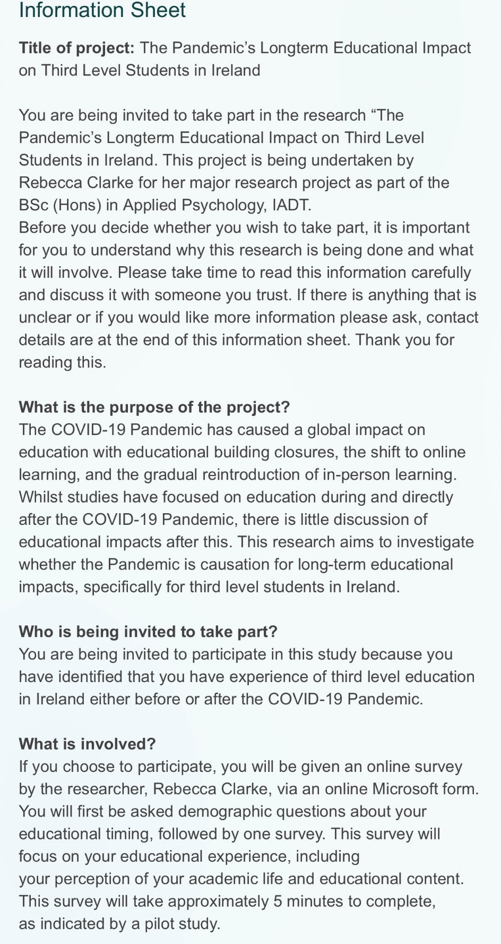
Appendix B: Information Sheet
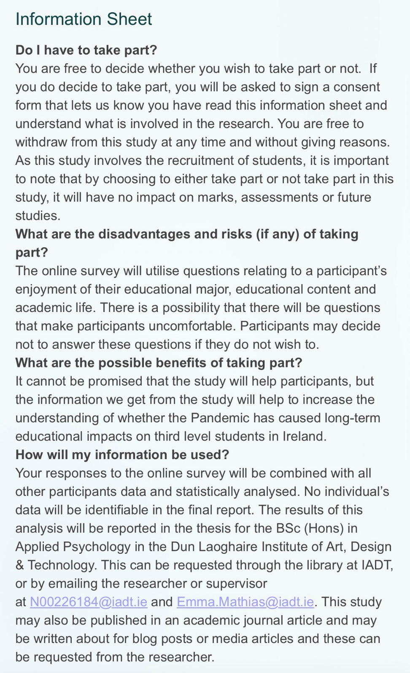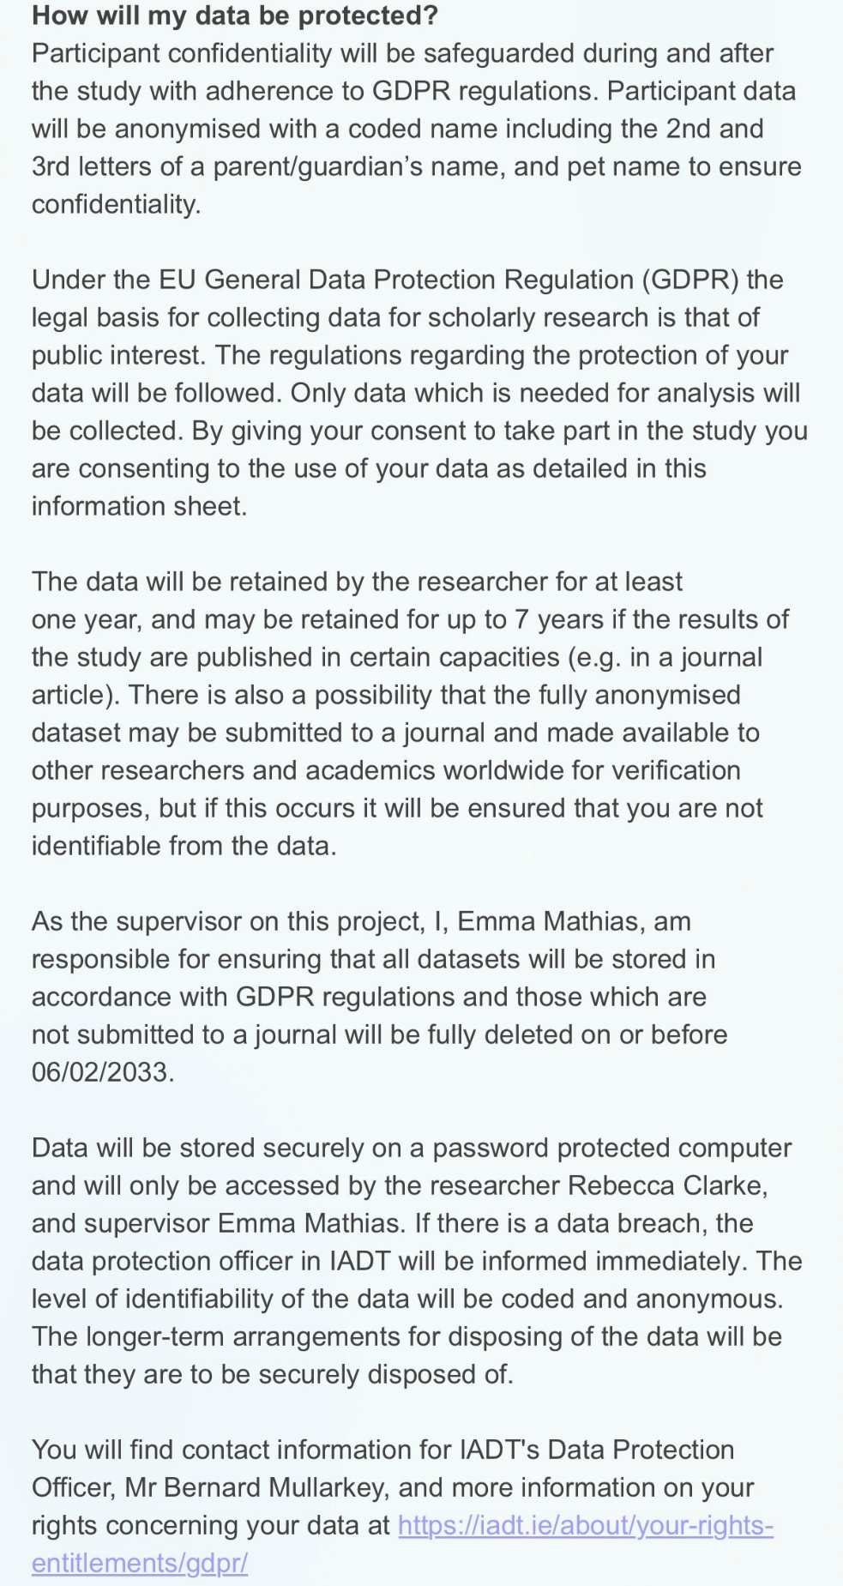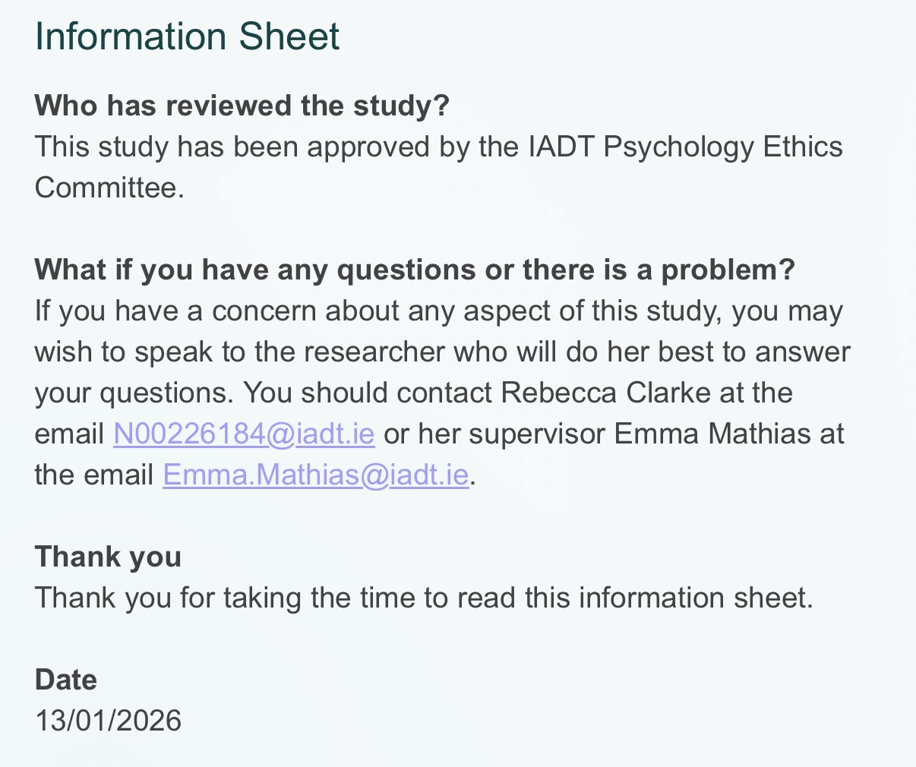

Appendix C: Consent Form
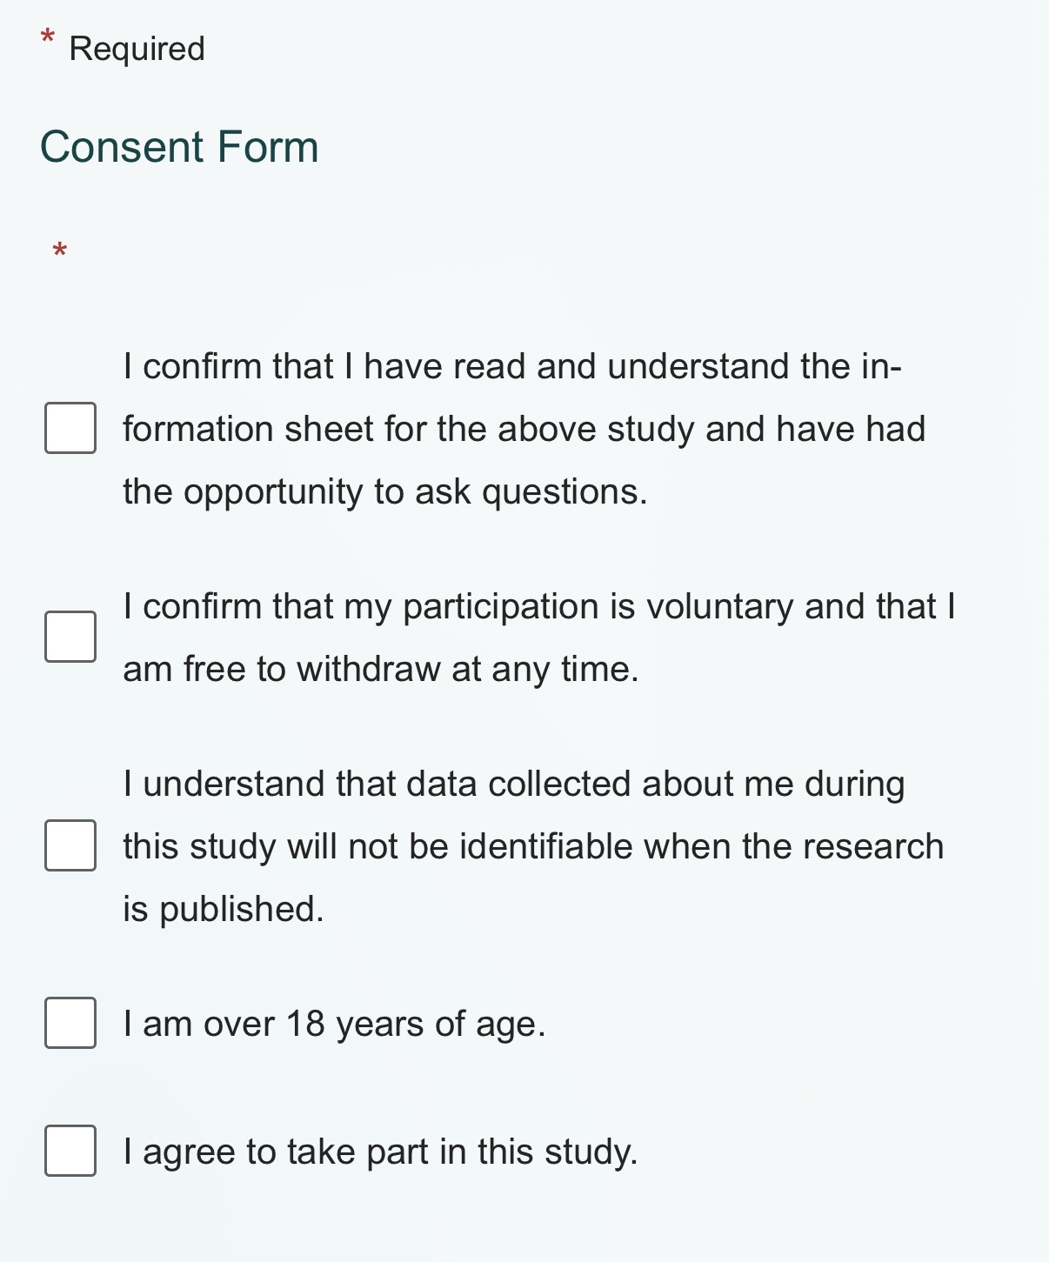

Appendix D: Participant Anonymising Code and Questionnaire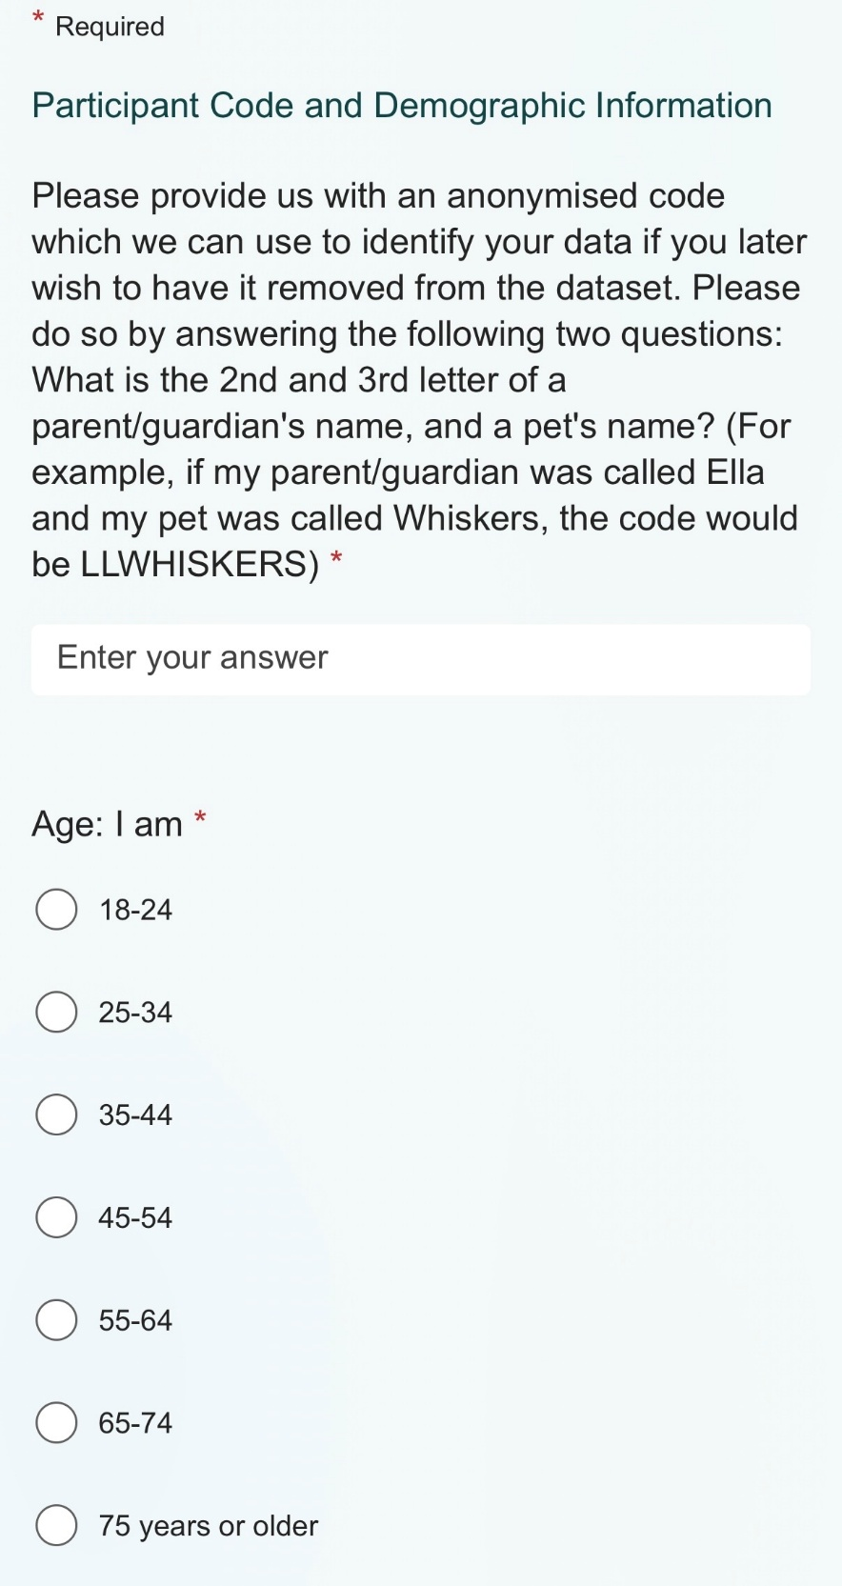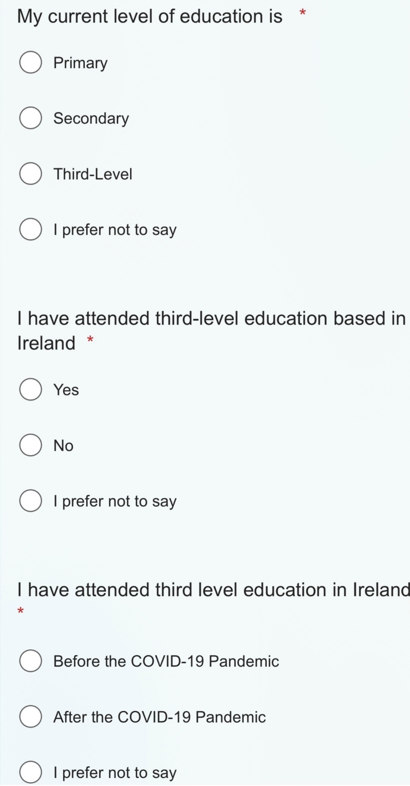

Appendix E: Academic Satisfaction Scale
I feel satisfied with the decision to major in my intended field. | Strongly Disagree | Disagree | Undecided | Agree | Strongly Agree
I am comfortable with the educational atmosphere in my major field. | Strongly Disagree | Disagree | Undecided | Agree | Strongly Agree
For the most part, I am enjoying my coursework. | Strongly Disagree | Disagree | Undecided | Agree | Strongly Agree
I am generally satisfied with my academic life. | Strongly Disagree | Disagree | Undecided | Agree | Strongly Agree
I enjoy the level of intellectual stimulation in my courses. | Strongly Disagree | Disagree | Undecided | Agree | Strongly Agree
I feel enthusiastic about the subject matter in my intended major. | Strongly Disagree | Disagree | Undecided | Agree | Strongly Agree
I like how much I have been learning in my classes. | Strongly Disagree | Disagree | Undecided | Agree | Strongly Agree

Appendix F: Confirmation of Consent and Debrief Form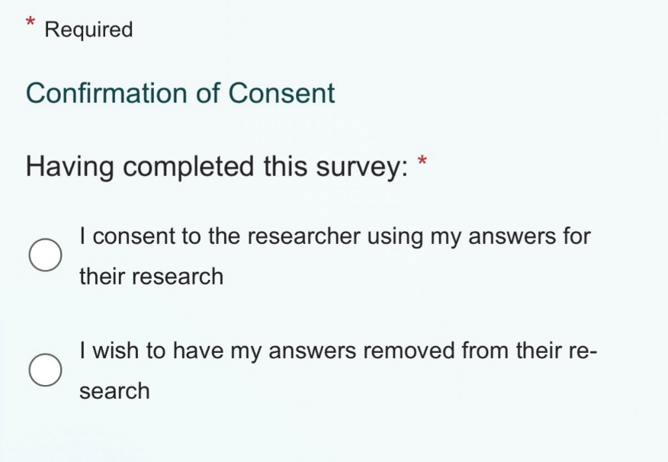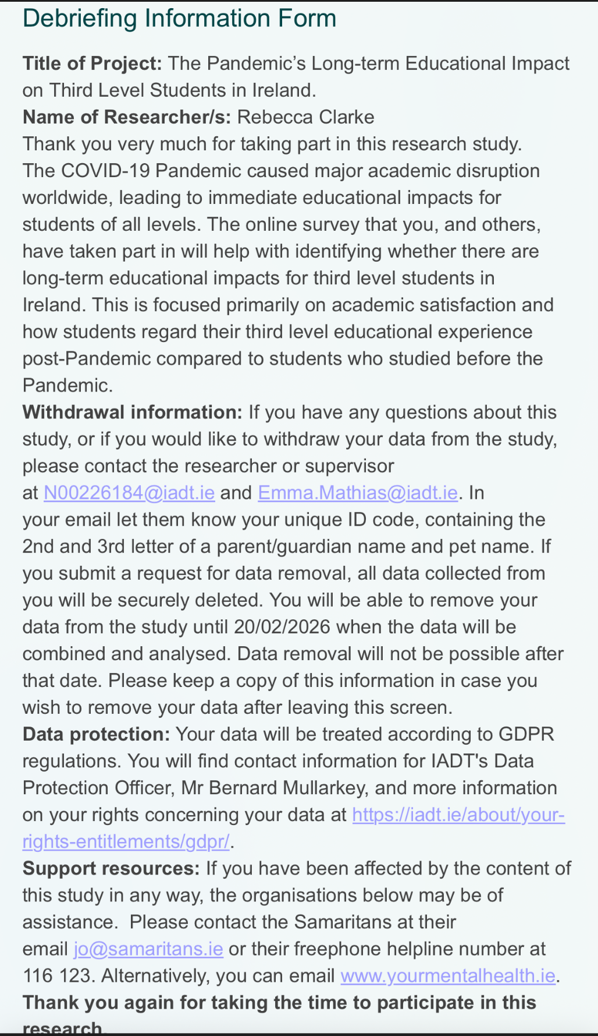 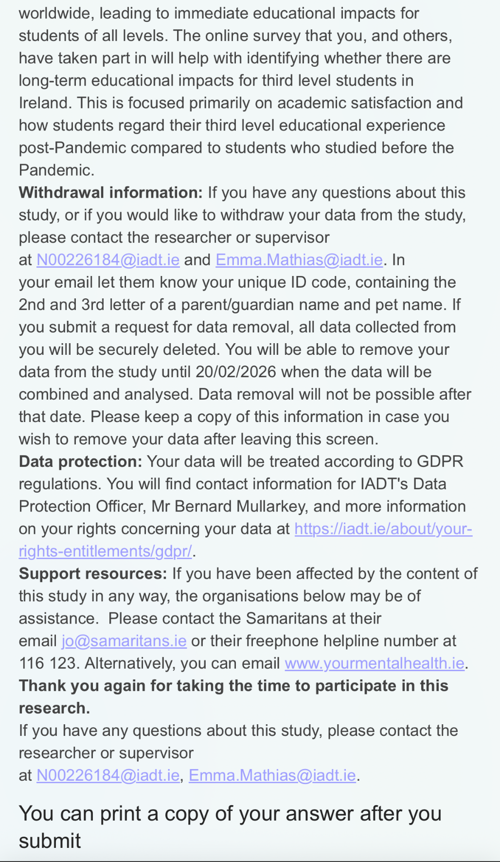

Appendix G: Thematic Analysis Visual Framework
Thematic Analysis Visual Framework
Raw Data Extract | Code | Subtheme | Initial Theme | Final Theme
We all know that some people excel in distance ed, but it is far from the norm especially when the delivery is by people who aren't trained to do it and using systems that were largely made up on the spot. | Lack of guidance from faculty members | Limited academic support | lack of amenities | Institutional resource and support limitations | 1
New students at my university seem a lot less helpless/hopeless/careless than the preceding 2 years that l've taught. | Difficulty in learning modality transition | Unpreparedness for in-person learning | Educational decline | Deterioration of academic engagement | 2
The Covid cohort I see as juniors and seniors have significantly higher levels of helplessness. | Difficulty in learning modality transition | Unpreparedness for in-person learning | educational decline | Deterioration of academic engagement | 3
articles are starting to appear that this generation has these behaviors in spades, making them struggle to stay employed. | Difficulty in learning modality transition | Unpreparedness for in-person learning | Educational decline | Deterioration of academic engagement | 4
My co teacher and I are planning some required videos they need to watch next quarter to try to stop some of this helpless behavior. Words are not being read. Lectures are not listened to. | Educational burnout | Academic fatigue | Lack of motivation | Declining academic motivation | 5
massive pushback on points reduction due to grade inflation in high school (itself due to the understanding that you need near-perfect grades to get into a good university). | Lacking knowledge of educational tools | Reduced academic performance | educational decline | Deterioration of academic engagement | 6
I have too many students that can't read and follow directions written in short declarative sentences and think that I am a verbal LMS. | Lacking knowledge of educational tools | Reduced academic performance | Educational decline | Deterioration of academic engagement | 7
Notetaking skills are somewhat non-existent for many students. | Lacking knowledge of educational tools | Reduced academic performance | Educational decline | Deterioration of academic engagement | 8
Eventually I had to start using PowerPoint because the students consistently requested it. | Closure of student spaces | Restricted access to campus facilities | Lack of amenities | Institutional resource and support limitations | 9
I really do think the worst of the true COVID impacts on student preparation for higher ed and attitudes toward learning that were shaped by terrible remote HS aren’t behind us. | Difficulty in learning modality transition | Unpreparedness for in-person learning | Educational decline | Deterioration of academic engagement | 10
With up to 45 students this level of clueless and helpless, we need to get aggressive. This 30% of helpless is a stable number now. | Difficulty in learning modality transition | Unpreparedness for in-person learning | Educational decline | Deterioration of academic engagement | 11
Post-secondary teachers too often rush to embrace the “newest technology” diminishing the ability of students to be prepared to use the technology and skills they need to use in college as well as after graduation. | Lack of guidance from faculty members | Limited academic support | Lack of amenities | Institutional resource and support limitations | 12
We're trying to cultivate specific skills and chopping things up into tiktok format doesnt do that. | Closure of student spaces | Restricted access to campus facilities | Lack of amenities | Institutional resource and support limitations | 13
Only way they’ll learn is by failing/getting lower grades than expected. | Poor grades | Reduced academic performance | Educational decline | Deterioration of academic engagement | 14
They’re just incapable of completing the task. | Educational burnout | Academic fatigue | Lack of motivation | Declining academic motivation | 15
Students are behind not only academically but professionally. | Poor grades | Reduced academic performance | Educational decline | Deterioration of academic engagement | 16
They can’t communicate appropriately to save their life. | Lack of communication | Peer relationship breakdown | Social decline | Social disconnection | 17
They’re behind in academics and professionalism. | Lack of communication | Peer relationship breakdown | Social decline | Social disconnection | 18
Huge apathy towards learning that I haven’t seen before. | Concentration difficulties | Decreased goal orientation and focus | Lack of motivation | Declining academic motivation | 19
COVID and the failure to effectively do online education has a major impact. | Closure of student spaces | Restricted access to campus facilities | Lack of amenities | Institutional resource and support limitations | 20
What, if anything, can we do about this at a postsecondary level? What possible outcome could fix educational neglect? | Lack of guidance from faculty members | Limited academic support | Lack of amenities | Institutional resource and support limitations | 21
The decades of neglect have come to a head via the extra gap in skills and knowledge that Covid produced. | Lacking knowledge of educational tools | Reduced academic performance | Educational decline | Deterioration of academic engagement | 22
The sheer unpreparedness of most college students makes creating the old college experience impossible. | Poor grades | Reduced academic performance | Educational decline | Deterioration of academic engagement | 23
“Meet students where they are and adapt”. It is not possible to lower the standards or adapt pedagogy enough to do that and still call what we do “college”. | Lacking knowledge of educational tools | Unpreparedness for in-person learning | Educational decline | Deterioration of academic engagement | 24
We can't lower standards for them; they will need to put in the hard work and extra time to catch up. | Poor grades | Reduced academic performance | Educational decline | Deterioration of academic engagement | 25
I'm trying to give them more help and resources than usual, but hardly any of them take it. | Difficulty in learning modality transition | Unpreparedness for in-person learning | Educational decline | Deterioration of academic engagement | 26
If something takes them more than two taps, they're just incapable of completing the task. | Educational burnout | Academic fatigue | Lack of motivation | Declining academic motivation | 27
They can't communicate apopriately to save their life. | Lack of communication | Peer relationship breakdown | Social decline | Social disconnection | 28
We can't lower standards for them | Lacking knowledge of educational tools | Unpreparedness for in-person learning | Educational decline | Deterioration of academic engagement | 29
the situation is simply impossible to solve without substantial buy in from the administrative purseholders | Closure of student spaces | Restricted access to campus facilities | Lack of amenities | Institutional resource and support limitations | 30
We need fundamental emergency rearrangement of the college pipeline to even begin to do anything about it | Lack of guidance from faculty members | Limited academic support | Lack of amenities | Institutional resource and support limitations | 31
I'm actually pretty shocked that my department and institution have done literally nothing to address this . | Lack of guidance from faculty members | Limited academic support | Lack of amenities | Institutional resource and support limitations | 32
I do think we need to adapt to what we're seeing. | Lack of guidance from faculty members | Limited academic support | Lack of amenities | Institutional resource and support limitations | 33
I had two brothers going through college at the time, I think they missed a lot of life experience that they're now 'catching up'. | Limited interaction with peers | Loss of academic community | Social decline | Social disconnection | 34
Who would have thought, closing centres of education, would negatively impact on education... | Closure of student spaces | Restricted access to campus facilities | Lack of amenities | Institutional resource and support limitations | 35
it's an almost global effect on their social development that will change who they are, could have been, likelihood of future relationships, friendships, even chance of a job etc. | Limited interaction with peers | Loss of academic community | Social decline | Social disconnection | 36
If we had left everything open, did not have lockdown, I doubt we'd be in the situation where we are now. | Closure of student spaces | Restricted access to campus facilities | Lack of amenities | Institutional resource and support limitations | 37
Schools shouldn't have closed for as long for children with additional needs. | Closure of student spaces | Restricted access to campus facilities | Lack of amenities | Institutional resource and support limitations | 38
Personally I will never forget nor forgive Gov or Teachers for how they abandoned children during Covid. | Lack of guidance from faculty members | Limited academic support | Lack of amenities | Institutional resource and support limitations | 39
My daughter missed the last 3 months of 6th class and a huge amount of 1st year. It definitely impacted her in terms of social growth. | Limited interaction with peers | Peer relationship breakdown | Social decline | Social disconnection | 40
She's still very withdrawn/sheltered (but exposed to much through the Internet) for a 17 year old. | Limited interaction with peers | Peer relationship breakdown | Social decline | Social disconnection | 41
There is absolutely no current mitigation other than a not well-publicized, but recent, offer of mRNA vaccines. | Lack of guidance from faculty members | Limited academic support | Lack of amenities | Institutional resource and support limitations | 42
No one speaks of covid and the Irish tend to shy away from speaking of uncomfortable things. | Lack of peer support | Peer relationship breakdown | Social Decline | Social disconnection | 43
Many of the Irish people have lost old friends and have tension with family members. | Lack of peer support | Peer relationship breakdown | Social decline | Social disconnection | 44
For the most part, almost everyone doesn’t want to talk about it here. | Lack of peer support | Peer relationship breakdown | Social decline | Social disconnection | 45
Many schools and preschools got hepa filters back in 2021, but no one is buying new filters for them anymore. | Closure of student spaces | Restricted access to campus facilities | Lack of amenities | Institutional resource and support limitations | 46
The kids are stunted and we need to know that and respond accordingly for the sake of our future health and infrastructure. | Lack of guidance from faculty members | Limited academic support | Lack of amenities | Institutional resource and support limitations | 47
Many universities ended developmental programs just when we needed them most. | Lack of guidance from faculty members | Limited academic support | Lack of amenities | Institutional resource and support limitations | 48
We will likely see deficits that vary based of the years that their adolescent development were affected. | Poor grades | Reduced academic performance | Educational decline | Deterioration of academic engagement | 49
Some years being more damaging to emotional regulation and communication with others being critical for language, and others for math and reasoning. | Lack of communication | Peer relationship breakdown | Social decline | Social disconnection | 50
The difference between folks who finished secondary before and after covid, is stark. | Educational burnout | Academic fatigue | Lack of motivation | Declining academic motivation | 51
The college aged students have no idea how to learn. | Difficulty in learning modality transition | Unpreparedness for in-person learning | Educational decline | Deterioration of academic engagement | 52
Right now, zero of my fresh out of hs students are in the top 20% grade wise. It's all older students who are top performers. | Poor grades | Reduced academic performance | Educational decline | Deterioration of academic engagement | 53
My kid's shitty 3rd and virtual 4th and 5th grades put her back tremendously. | Difficulty in learning modality transition | Unpreparedness for in-person learning | Educational decline | Deterioration of academic engagement | 54
It took more than a year to develop the study and time management skills, and she's still not where she should be. | Difficulty in learning modality transition | Unpreparedness for in-person learning | Educational decline | Deterioration of academic engagement | 55
I believe in their resilience. But I agree that we need to make targeted efforts to structure class with your concerns in mind. | Lack of guidance from faculty members | Limited academic support | Lack of amenities | Institutional resource and support limitations | 56
We should strive to create the ideal learning environment that they lacked during covid. | Difficulty accessing mental health facilities | Limited mental health support | Lack of amenities | Institutional resource and support limitations | 57
You would think they would actually be better at navigating and learning in online asynchronous classes then. Sadly, they are not. | Lacking knowledge of educational tools | Unpreparedness for in-person learning | Educational decline | Deterioration of academic engagement | 58
I think part of the issue stems from the way things were handled. | Lack of guidance from faculty members | Limited academic support | Lack of amenities | Institutional resource and support limitations | 59
They basically just said "we're online now, good luck" to both teachers and students. | Lack of guidance from faculty members | Limited academic support | Lack of amenities | Institutional resource and support limitations | 60
What has been far more uniform are changes through things like curricula (esp in association with College Board), underfunding/understaffing of schools, and at least one infection (typically multiple infections) with Covid. | Lack of guidance from faculty members | Limited academic support | Lack of amenities | Institutional resource and support limitations | 61
we will never get the supports needed to help students actually achieve at level. | Lack of guidance from faculty members | Limited academic support | Lack of amenities | Institutional resource and support limitations | 62
this group had both their educational and social development severely disrupted at a crucial point in it. | Difficulty in learning modality transition | Unpreparedness for in-person learning | Educational decline | Deterioration of academic engagement | 63
state exams are especially tough on some students and not having prior experience could be a real disadvantage for them. | Lack of guidance from faculty members | Limited academic support | Lack of amenities | Institutional resource and support limitations | 64
As someone who teaches maths grinds, it's because the impact of Covid will take a decade to wash through... | Difficulty in learning modality transition | Unpreparedness for in-person learning | Educational decline | Deterioration of academic engagement | 65
That year and a half of stunted learning has screwed a large chunk of a generation. | Poor grades | Reduced academic performance | Educational decline | Deterioration of academic engagement | 66
there were countless occasions where kids were kept home because they or someone else had covid and classes didn't get through material at anything like a normal rate. | Lack of guidance from faculty members | Limited academic support | Lack of amenities | Institutional resource and support limitations | 67
If you restrict the ability to practice -- you will simply see lower results. | Lack of guidance from faculty members | Limited academic support | Lack of amenities | Institutional resource and support limitations | 68
It should never have happened, and the snails pace they are going about reducing it is laughably bad. | Lack of guidance from faculty members | Limited academic support | Lack of amenities | Institutional resource and support limitations | 69
I honestly don't think that a LC student today would have an easy time of sitting a JC paper from 20 to 30 years ago | Poor grades | Reduced academic performance | Educational decline | Deterioration of academic engagement | 70
I heard from a friend who graduated in the last 3 years that Irish colleges are a bit dead nowadays when it comes to socialising (post COVID). | Reduced campus social life | Loss of academic community | Social decline | Social disconnection | 71
What I've heard from a few is that a lot of people go home between classes and there isn't the same party atmosphere. | Reduced campus social life | Peer relationship breakdown | Social decline | Social disconnection | 72
I was talking to a cousins kid who is 21 who went to the same college as me and the difference is night and day. | Lack of peer support | Loss of academic community | Social decline | Social disconnection | 73
I used to spend at least an hour on the bus both directions but still found time to skip all my lectures and spend the entire day in the student bar. | Reduced campus social life | Peer relationship breakdown | Social decline | Social disconnection | 74
I studied in dublin during/after covid and good god it was sad. | Limited interaction with peers | Loss of academic community | Social decline | Social disconnection | 75
knowing some arts students there it was also pretty muted for them because of the aftershocks of covid | Limited interaction with peers | Peer relationship breakdown | Social decline | Social disconnection | 76
Kinda feels like Stephens’ Day actually, everything is still “there” but the party’s been and gone. | Educational burnout | Academic fatigue | Lack of motivation | Declining academic motivation | 77
from my experience only 10% of students actually engage with anything on campus | Concentration difficulties | Decreased goal orientation and focus | Lack of motivation | Declining academic motivation | 78
a massive number just turn up, go to class, and go home again | Minimal academic participation | Peer relationship breakdown | Social decline | Social disconnection | 79
The government talked about contributing to the build cost but 18 months have come and gone and there’s no more talk about it so I guess it’s dead. | Lack of guidance from faculty members | Limited academic support | Lack of amenities | Institutional resource and support limitations | 80
Literally, all student pubs in my town have shut down over the past 10 years. | Reduced campus social life | Loss of academic cpmmunity | Social decline | Social disconnection | 81
There is one street that used to have 3 to 4 student pubs, and all would be packed, day and night. All 4 of them are gone. | Reduced campus social life | Loss of academic community | Social decline | Social disconnection | 82
Nitelife has died a death | Reduced campus social life | Loss of academic community | Social decline | Social disconnection | 83
people are massively missing out on the socialisation and independence that you’re meant to get in college. | Reduced campus social life | Peer relationship breakdown | Social decline | Social disconnection | 84
I’m a mature student and don’t really get involved but doesn’t seem lively | Educational burnout | Academic fatigue | Lack of motivation | Declining academic motivation | 85
Students seem to be getting less wild to be honest. | Minimal academic participation | Loss of academic community | Social decline | Social disconnection | 86
the college got rid of the dome bar on campus after covid and turned it into offices. | Closure of student spaces | Restricted access to campus facilities | Lack of amenities | Institutional resource and support limitations | 87
Young people apparently don't drink that much anymore | Reduced campus social life | Loss of academic community | Social decline | Social disconnection | 88
Being in college right now sounds like zéro craic. | Lack of communication | Peer relationship breakdown | Social decline | Social disconnection | 89
the social life is seemingly shite and a lot of the best pubs and certainly nightclubs in university cities / towns have closed or are practically empty. | Reduced campus social life | Loss of academic community | Social decline | Social disconnection | 90
after joining some clubs a lot of them left college so I went back to having a solitary lifestyle eventually | Limited interaction with peers | Loss of academic community | Social decline | Social disconnection | 91
they’re a lot quieter in the evenings than say 10 years ago. | Minimal academic participation | Loss of academic community | Social decline | Social disconnection | 92
Student nightlife has all but vanished. | Reduced campus social life | Loss of academic community | Social decline | Social disconnection | 93
young people drink way less than 20 years ago | Reduced campus social life | Loss of academic community | Social decline | Social disconnection | 94
they wouldnt and go to the pub just to drink pints on a Thursday . | Reduced campus social life | Loss of academic community | Social decline | Social disconnection | 95
haven't been out once since starting | Reduced campus social life | Loss of academic community | Social decline | Social disconnection | 96
they cant handle the pressure of their course | Educational burnout | Academic fatigue | Lack of motivation | Declining academic motivation | 97
their grades were inflated to beyond their capability in the subject. | Poor grades | Reduced academic performance | Educational decline | Deterioration of academic engagement | 98
I have 3rd and 4th year students right now who can’t even perform rudimentary maths. | Lacking knowledge of educational tools | Reduced academic performance | Educational decline | Deterioration of academic engagement | 99
During Covid we went to online assessment, which resulted in the average shooting up. We returned to a proctored exam last year, and the the average was 38% | Poor grades | Reduced academic performance | Educational decline | Deterioration of academic engagement | 100
A lot have failed other modules so will be deregistered. | Poor grades | Reduced academic performance | Educational decline | Deterioration of academic engagement | 101
Some have quit before they are pushed. | Concentration difficulties | Decreased goal orientation and focus | Lack of motivation | Declining academic motivation | 102
they never learnt how to study properly | Difficulty in learning modality transition | Unpreparedness for in-person learning | Educational decline | Deterioration of academic engagement | 103
I think the government will just forget about them. | Lack of guidance from faculty members | Limited academic support | Lack of amenities | Institutional resource and support limitations | 104
Year 2 thermodynamics module, average pre covid in the 60s. Jumped to 70s with online assessment dropped to 40s, this year with proper exam and 20% fail rate. | Poor grades | Reduced academic performance | Educational decline | Deterioration of academic engagement | 105
When I asked about his plan for the exam he told me he was going to use his phone… | Lacking knowledge of educational tools | Unpreparedness for in-person learning | Educational decline | Deterioration of academic engagement | 106
some of them got A-levels they couldn't have earned. Grade inflation with A-levels during covid was insanely high. | Poor grades | Reduced academic performance | Educational decline | Deterioration of academic engagement | 107
The lack of practice doesn't help at all | Lack of guidance from faculty members | Limited academic support | Lack of amenities | Institutional resource and support limitations | 108
university that are higher in the ranks tend to have less support | Difficulty accessing mental health facilities | Limited mental health support | Lack of amenities | Institutional resource and support limitations | 109
I'm surprised employers even look at people from that year. You don't know what you're gonna get as grade inflation was high | Poor grades | Reduced academic performance | Educational decline | Deterioration of academic engagement | 110
We all had to work alone, manage our own time and be expected to maintain the same high-standard of normal years with significantly less support. | Lack of guidance from faculty members | Limited academic support | Lack of amenities | Institutional resource and support limitations | 111
Young people being pushed to go to university when they (to be brutally honest) are just not intellectually suited to uni. | Difficulty in learning modality transition | Unpreparedness for in-person learning | Educational decline | Deterioration of academic engagement | 112
It's made me actually question whether I can continue as an academic | Concentration difficulties | Decreased goal orientation and focus | Lack of motivation | Declining academic motivation | 113

Appendix H: Ethical Approval
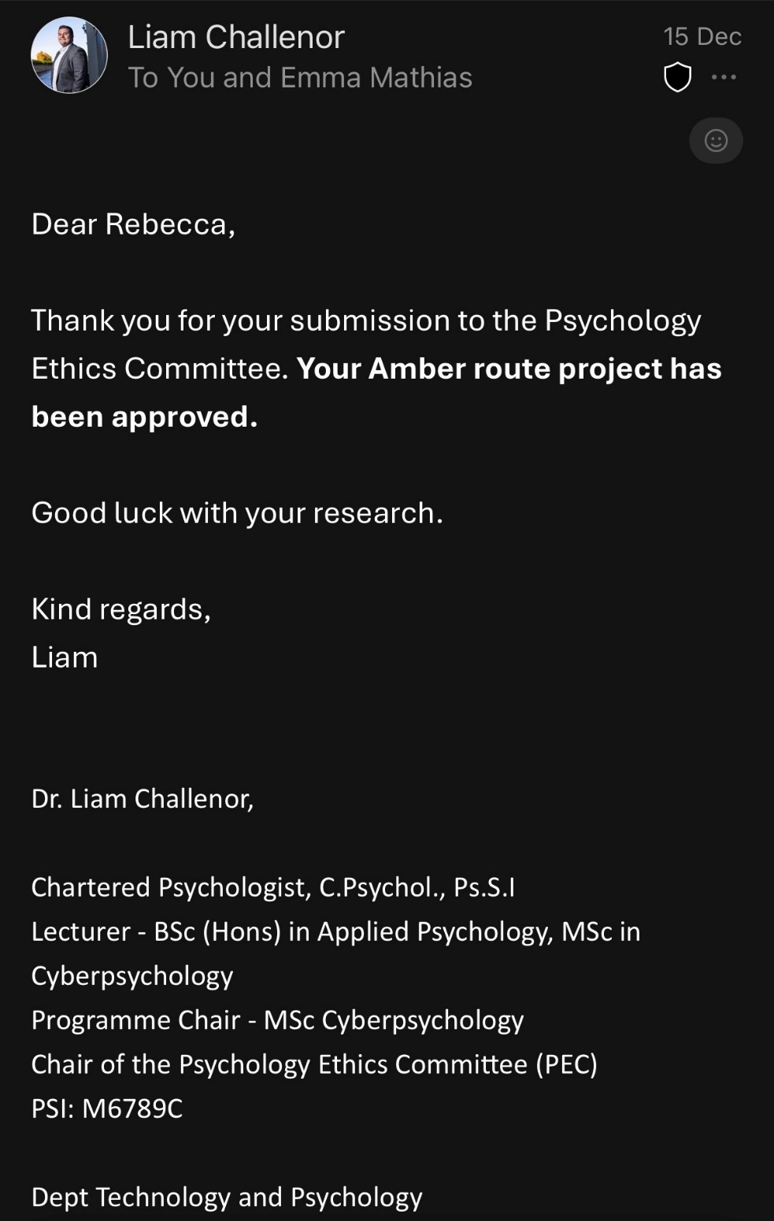

Appendix I: Ethical Approval Form
IADT Psychology Ethics Committee (PEC)
Application Form 2025-26

Instructions:
- Please read all sections carefully, include all of the information relevant to your project, and include all necessary appendices.
- All students must complete Sections 1, 2, 3, and 4. You will also need to complete at least one other section, depending on the type of research that you plan to do.
- Email the completed form to your supervisor for approval. They will then complete Section 0 below.
- Your supervisor will then forward the application to the ethics committee.
- If your application is under the Red Route, then you may also be required to submit four printed copies of your application (including all appendices). You will be advised closer to the deadline if this is necessary or not.
- If your study changes from how you have described it in this form then you will need to reapply for approval from the PEC. The PEC does not guarantee that a revised project will be approved, even if the original project was approved.
- All communication between students and the PEC will occur via the student’s project supervisor.
- The PEC will consider all of the information provided in the form when making their decision. Incomplete forms (including forms which do not include all of the necessary Appendices) will be rejected.
- If the PEC’s decision is that a revised application must be made then they will provide a list of required changes which are necessary to ensure participant wellbeing. Even if all of these are followed, the PEC makes no commitment to approve a revised application.
- It is highly recommended that ‘Red Route’ students continue to formulate ideas for projects which fit the criteria for ‘Green Route’ and ‘Amber Route’ submissions until they are advised that their application has been approved. This is to ensure that the student can still complete the module, even if their ‘Red Route’ project does not receive approval from the PEC.
- There is an obligation on the researcher to bring to the attention of the PEC any issues with ethical implications not clearly covered by the checklist in Section 6 of this form.
- If you are submitting a Red Route application you are required to submit an alternative Amber or Green Route project.
- Please be aware of the marking guidelines for the work associated with your submission and the ramifications of a breach in ethics if relevant in your programme handbook or CA guidelines.
- ‘Signatures’ may be typed, scanned in, or digitally signed.

Section 0: For Completion by the Supervisor
I confirm that this application to the PEC by _ (student name) accurately reflects all of the ethical implications in the project.
Application type (tick all that apply for mixed methods): Green Route _____
Amber Route
Red Route
Signed _______________________________ Date: ________________________
Section 1: Project Information

Student Name: Rebecca Clarke
Student Email Address: N00226184@iadt.ie
Supervisor Name: Emma Mathias
Working Project Title: The Pandemic’s Longterm Educational Impact on Third Level Students in Ireland.
Main Variables Being Investigated: A dependent variable being academic satisfaction, and an independent variable being educational timing.

Section 2: External Agencies
Does your project involve recruitment from any external agency (e.g. a school, sports club, medical centre, voluntary organisation, or any other organisation outside of the IADT)? | Yes* | No  
* You must include a letter from a senior manager of each organisation stating that you have approval to collect data within that organisation. Include copies of each of these letters in the Appendices to your application. If the organisation has its own ethical review board (which is very common in some settings, such as hospitals), then you are also required to get ethical approval from that board prior to starting data collection, and to submit notice of this approval to your supervisor so that it can be forwarded on to the ethics committee. Some online forums also require permission to post requests for participants – make sure to check the relevant forum/organisation’s code of conduct or terms and conditions. You do not need to include approval letters if you are conducting recruitment using mainstream social media routes (e.g., Twitter, Instagram, Facebook, Snapchat, TikTok) to your own followers, and/or snowball sampling/word of mouth recruitment.

Section 3: Project Methodology – Please tick which type of project you are seeking approval from the PEC for. If your project involves mixed methods, then tick all which apply.
Route Type | Methodology | Tick here
Green Route (no direct contact with participants required, and no data is collected/recorded which could identify participants) | Theoretical paper / systematic literature review / Rapid Structured Literature Review (RSLR)
 | Novel analysis of an existing dataset gathered by another researcher or group which you are certain has abided by appropriate ethical procedures for the relevant discipline
 | Observation of participants in a public place in which they could reasonably be expected to be observed by strangers or in an online space which does not require users to log in to access.
 | Content analysis of material which is publicly available and does not require users to log in to access content.
 | Other method without direct contact with participants **
Amber Route (direct contact with participants, but no additional ethical considerations beyond the minimum requirements) | Requirements gathering for and/or user testing of a prototype which is highly unlikely to cause any harm or distress to participants and which does not aim to collect data from a potentially vulnerable group
 | An experiment which is highly unlikely to cause any harm or distress to participants and which does not aim to collect data from a potentially vulnerable group
 | A survey/questionnaire design which is highly unlikely to cause any harm or distress to participants and which does not aim to collect data from a potentially vulnerable group
 | An observational study which is highly unlikely to cause any harm or distress to participants and which does not aim to collect data from a potentially vulnerable group
 | Content analysis research which is highly unlikely to cause any harm or distress to participants and which does not aim to collect data from a potentially vulnerable group
 | Interviews and/or focus groups which are highly unlikely to cause any harm or distress to participants and which do not aim to collect data from a potentially vulnerable group
 | Other method which is highly unlikely to cause any harm or distress to participants and which does not aim to collect data from a potentially vulnerable group **
Red Route (direct contact with participants, including one or more project aspects which require special ethical consideration) | Requirements gathering for and/or user testing of a prototype which may cause harm or distress to participants and/or which involves collecting data from any potentially vulnerable group
 | An experiment which may cause harm or distress to participants and/or which involves collecting data from any potentially vulnerable group
 | A survey/questionnaire design which may cause harm or distress to participants and/or which involves collecting data from any potentially vulnerable group
 | An observational study which may cause harm or distress to participants and/or which involves collecting data from any potentially vulnerable group
 | Content analysis research which may cause harm or distress to participants and/or which involves collecting data from any potentially vulnerable group
 | Interviews and/or focus groups which may cause harm or distress to participants and/or which involves collecting data from any potentially vulnerable group
 | Any project which includes use of any illegal materials or substances as part of the materials for the study, regardless of methodology employed.
 | Any project which includes use of any dangerous materials or substances as part of the materials for the study, regardless of methodology employed.
 | Any project employing ethnographic or autoethnographic methodologies.
 | Other method which may cause harm or distress to participants and/or which involves collecting data from any potentially vulnerable group **
A mixed-methods approach will be conducted, utilising an online survey which implements the Academic Satisfaction Scale, and thematic analysis of Reddit subgroups regarding individual’s opinions of the potential impacts of COVID-19 on academic satisfaction.

Section 4: Checklist of Attached Appendices and Other Completed Sections
Applicable Project Ethics Route Colour Guide |  |  |  |  | Section / Item | I have attached this item/completed this section | I have checked with my supervisor and we have agreed that this item/section is not relevant to my project
 |  |  |  | 1 | Section 1
 |  |  |  | 2 | Section 2
 |  |  |  | 3 | Section 3
 |  |  |  | 4 | Section 4
 |  |  |  | 5 | Letters of permission from any external agencies to be used for data collection |  | 
 |  |  |  | 6 | Statement of approval from ethical review boards in external agencies |  | 
 |  |  |  | 7 | Section 5 (Green Route Projects only)
 |  |  |  | 8 | Section 6 (Amber and Red Route Projects only)
 |  |  |  | 9 | Section 7 (Amber Route Projects only)
 |  |  |  | 10 | Section 8 (Red Route Projects only)
 |  |  |  | 11 | Section 9 (Red Route Projects only)
 |  |  |  | 12 | Evidence of why you need to complete a Red Route Project (see note in Section 8)
 |  |  |  | 13 | Project Information Sheet (Red Route Projects only) |  | 
 |  |  |  | 14 | Project Consent Form (Red Route Projects only)
 |  |  |  | 15 | Project Demographic Questionnaire (Red Route Projects only) |  | 
 |  |  |  | 16 | All Other Questionnaires and Data Collection Materials (Red Route Projects only) |  | 
 |  |  |  | 17 | Project Debrief (Red Route Projects only) |  | 
 |  |  |  | 18 | I have an alternative Amber or Green Route Project for Consideration (Red Route Projects only) |  | 

Section 5: Declaration of a Green Route project
I hereby declare that [all of / this aspect of (delete as appropriate)] my project involves no direct interaction between me and any research participants, and that having checked with my supervisor, that I do not need to seek informed consent from those whose data I use in my research. In addition, I will ensure that all data which I do gather is held in a manner which is compliant with GDPR, and will be deleted once it is no longer required (and definitely within 6 years of collection). At all times my study will be conducted in adherence to the ethical policies of the Psychological Society of Ireland and the British Psychological Society.
Student Signature: _________________________________ Date: _______________________

Section 6: Confirmation of Adherence to Basic Ethical Principles for Amber and Red Route Projects
Complete the Table below with guidance from your supervisor. If you need to tick any of the ‘red’ boxes, then your project must be submitted under the ‘Red Route’.
 |  | Yes | No | N/A
6.1 | I will describe the main research procedures to participants in advance so that they know what to expect. I will use the sample Information Sheet provided by PEC to do this.
6.2 | I will tell participants that their participation is voluntary.
6.3 | I will obtain written consent from participants using a ‘tick’ consent form which follows the current template provided by PEC prior to starting data collection.
6.4 | I will verify that participants still wish to include their data in online studies by including a final indicator of consent at the end of the questions.
6.5 | If my research involves content analysis or observation in any private or partially private setting then I will ensure to obtain informed consent prior to collecting data. |  |  | 
6.6 | I will explain to participants that they can withdraw from the study at any time and for any reason. | 
6.7 | I will ensure that participants know that they can refrain from answering any question that they don’t want to, even if this is part of a psychometric scale. | 
6.8 | If using an online data collection method I will ensure that the only questions which require answers in order to proceed are the questions relating to providing informed consent, and I will ensure that participants are provided with an option which indicates that they do not give their consent. | 
6.9 | I will inform participants that their data will be treated with full confidentiality, and that, if published, it will not be identifiable as theirs. | 
6.10 | I will debrief participants at the end of their participation (i.e. give them a brief explanation of the study, whether or not deception was involved) following the current template provided by PEC | 
6.11 | I will obtain passive consent from parents/guardians for studies involving people aged between 16 and 18 years, as well as active consent from the participant and their school/organisation |  |  | 
6.12 | I will obtain active consent from parents/guardians for studies involving people aged under 16 years. Where feasible I will also obtain active consent from the participant themselves. I will ensure that the parent/guardian or their nominee (e.g. a teacher) will be present throughout the data collection period.
6.13 | I will ensure that my project supervisor has full access to the data that I collect and will only use data collection software which permits this.
6.14 | I will ensure that my project supervisor retains full rights to the data collected, including the ability to delete all data at any time, and that third-parties (e.g., software companies) will not ‘own’ the data collected. | 
6.15 | I will ensure that participants in studies involving Virtual Reality (VR) are not susceptible to extreme motion sickness or other physical conditions which may result in harm to the participants. I will ensure that a chaperone is present during VR sessions, and that the participant has the option of also having a nominee of their choosing present as well.
6.16 | I will ensure that any equipment used in this study is cleaned and disinfected after each participant, and that appropriate hygienic barriers (e.g. masks) are used by all participants |  |  | 
6.17 | Is there any realistic risk of any participant experiencing either physical or psychological distress or discomfort?
6.18 | I plan to use animals as part of my research study
6.19 | I plan to tell participants their results on a task or scale which I am using in my research.
6.20 | I am researching a sensitive topic which may cause some participants distress (such as, but not limited to, religion, sexuality, alcohol, crime, drugs, mental health, physical health, parenting, family relationships) |  | 
6.21 | One or more aspects of my study is designed to change the mental state of participants in a negative way (such as inducing aggression, frustration, sadness, etc.)
6.22 | My study involves deception or deliberately misleading participants in some way.
6.23 | My target population includes people who have learning or communication difficulties
6.24 | My target population includes patients (either inpatient or outpatient)
6.25 | My target population includes people in custody
6.26 | My target population includes people who may feel under personal or professional pressure to take part in my research (for example, close friends; family; employees or staff of managers or school principals who may support the research).
6.27 | My project includes the use of any illegal materials or substances as part of the materials for the study, regardless of methodology employed.
6.28 | My project includes the use of any dangerous materials or substances as part of the materials for the study, regardless of methodology employed.
6.29 | My project employs ethnographic or autoethnographic methodologies.

Section 7: Declaration of an Amber Route project
I hereby declare all of my project involves no risk of physical, emotional, social or cognitive harm to participants; that I will obtain full informed consent from all participants and provide a full debrief afterwards (using the templates provided); that I will provide full anonymity and/or confidentiality to participants; and that my participants are not a potentially vulnerable population. In addition, I will ensure that all data which I gather is held in a manner which is compliant with GDPR, and will be deleted once it is no longer required (and definitely within 6 years of collection). At all times my study will be conducted in adherence to the ethical policies of the Psychological Society of Ireland and the British Psychological Society.
Student Signature: Date: 24/11/2025

Section 8: Additional Information For Red Route Projects
8.1 What are the aims of your research? Include your research question and hypotheses for all studies which are not exploratory in nature (Max. 100 words)

8.2 What is the specific reason(s) why this is a Red Route project? (Max. 100 words)

8.3 How will you ensure that participants are not harmed as a result of participation in your research, given your answer to 8.2 above (Max. 100 words)

8.4 Why do you need to do this project at this stage in your career? For example, is there a specific postgraduate programme which you wish to apply for which requires you to have completed research in this area? Do you have specific additional qualifications or experience which equip you to manage the additional ethical implications in this project? Bear in mind that if your main reason for wishing to do this research is because the area of study is important then your application is likely to be refused – in general it is better for research with important societal implications to be conducted at a time when you have more research experience. (Max. 100 words)

8.5 Provide rationale as to why other methodologies related to your chosen topic (such as a systematic review, RSLR, theoretical paper, content analysis, or analysis of an existing dataset) cannot be done in your case (Max. 100 words)

8.6 List supporting documentation which you have included in an Appendix to this application to justify the need for you to do a Red Route project (this might be: the list of entry requirements for a specific postgraduate programme which you are planning on applying for, along with the link to the website where you found this information; a transcript or certificate for a training course related to the area; a letter from your manager or supervisor where you are engaged in voluntary work related to the area, etc.).

1.
2.
3.
4.
5.
6.

8.7 List below the final grades that you received in each module in your most recent completed year of study in IADT (i.e. Fourth year students should provide their 3rd year end-of-year results; Third year students should provide their 2nd year end-of-year results; MSc students should provide their grades to date in each module, ‘provisional’ grades are acceptable when final grades are not yet available). A Red Route ethics project requires a very high level of competence and attention to detail which we have found often correlates with higher grades in earlier modules.

1.
2.
3.
4.
5.
6.
7.
8.

8.8 Planned Study Design (Max. 50 words)

8.9 Description of Planned Materials (Max. 200 words). All materials should be included as Appendices to this application. Materials include information sheets, consent forms, debriefs, demographic questionnaire, attitude or psychometric questionnaires, intervention materials, score sheets, technical equipment, and anything else that will be used during data collection. If you intend to use a video/game/app/other media, then you must provide the committee with full access to this through a video file or access to the game/app/media.

8.10 Planned Participant Population and Recruitment Method (Max. 100 words)

8.11 Planned Procedure (Max. 100 words)

Section 9: Declaration of a Red Route project
I hereby declare that [all of / this aspect of (delete as appropriate)] my project involves no ethical implications other than those listed and described in Section 8. It involves no risk of physical, emotional, social or cognitive harm to participants other than those outlined in Section 8. It involves no deception other than that indicated in Section 8. I will obtain full informed consent from all participants and provide a full debrief afterwards (using the templates provided) and I will provide full anonymity and/or confidentiality to participants, except where explicitly explained otherwise in Section 8. Unless stated otherwise in Section 8, my participants are not a potentially vulnerable population. In addition, I will ensure that all data which I gather is held in a manner which is compliant with GDPR, and will be deleted once it is no longer required (and definitely within 6 years of collection). At all times my study will be conducted in adherence to the ethical policies of the Psychological Society of Ireland and the British Psychological Society.

Student Signature: __ Date: _ _

