

Investigating the Impact of Stigma on the Social and Self-Identity of Individuals with Juvenile Idiopathic Arthritis: A Thematic Analysis.

Éabha Nic Lochlainn
N00221223

Research Supervisor:
Dr. Olivia A Hurley

Dissertation submitted as a requirement for the degree of BSc (Hons) in Applied Psychology, Dun Laoghaire Institute of Art, Design & Technology, 2026

Content Warning:
The following dissertation discusses content which some readers may find distressing, including topics of emotional distress and stigma.

Declaration

☒I, Éabha Nic Lochlainn hereby declare that the work that I have submitted for / contributed to the assessment specified above is entirely my own work. Where I have drawn from the work of others, including Generative AI systems, I have clearly indicated this within my submitted work. I recognise that Generative AI creations, no matter how small, may not be permissible within my submitted work and have checked this specific assessment brief for the admissible use of such software. I have read and comply with the IADT Academic Integrity Policy for this submission and recognise that breaches of this policy in my work may result in penalties, up to and including disqualification from IADT.
☒I, Éabha Nic Lochlainn, hereby declare that I recognise that IADT staff may provide feedback on assessment via a range of methods, depending on the nature of the assessment and the preference of the staff member. I recognise that any grades issued by a lecturer are provisional but are not negotiable. Final grades will be issued following the relevant exam board meeting and information on appeals procedures is available on the IADT website. I agree to abide by the IADT Mutual Respect Policy in all of my communications with and regarding all IADT staff members.

Word count: 6989

Signature:

Date:28/03/26

Acknowledgements

Firstly, I would like to thank and express my sincere gratitude to my supervisor Dr. Olivia Hurley for her continuous support, guidance, and valuable advice throughout the year. Without her, this major research project would not have been possible as she consistently reassured me of my abilities and provided me with valuable skills which I will continue to carry with me in the future. I am especially grateful for her unwavering patience and understanding as it helped me overcome challenges and remain motivated in times which felt impossible.
I would like to thank my Mam and inspiration, Susan Henderson, for her constant support, love, and reassurance during my degree. This milestone wouldn't have been possible without her constant encouragement and belief in me.
To all my college friends, thank you for all the laughs, advice, support, and the countless library trips we have shared over the past four years.
I would also like to give a special thank you to my best friend, Anna, for being my constant source of strength throughout this journey.

Table of Contents
Declaration ii
Acknowledgements iii
List of Figures vi
Abstract 1
Introduction 2
1.1 Juvenile Idiopathic Arthritis 2
1.2 Stigma associated with JIA 3
1.3 Social and self-identity 4
1.4 The present study 6
1.5 Research question 7
2. Method 8
2.1 Research Design 8
2.2 Data Source and Collection 8
2.3 Sample 9
2.4 Ethical Approval 9
3. Results 10
3.1 Overview of Results 10
3.2 Themes and Subthemes 11
Theme 1: Delegitimisation and Disbelief of JIA 11
Theme 2: Institutional and Relational Impact on Identity 13
Theme 3: Identity Protection 15
Theme 4: Disruption and Repair of Identity 16
4. Discussion 19
4.1 Overview 19
4.2 Delegitimisation and Disbelief of JIA 19
4.3 Institutional and Relational Impact on Identity 20
4.4 Identity Protection 20
4.5 Disruption and Repair of Identity 21
4.6 Strengths and Limitations 21
4.7 Theoretical and Practical Implications 22
4.8 Suggestions for Future Research 22
4.9 Conclusion 23
References 24
Appendices 30
Appendix A- Purpose of Each Subreddit 30
Appendix B- Ethics Application Form 31
Appendix C- Ethical approval 33
Appendix D-Inter-rater Agreement Test 34
Appendix E- Paraphrased Quotes Attached to Each Subtheme 36
Appendix F- Sample Codebook Process 40
Appendix G- Preliminary Thematic Map 42
Appendix H- Thematic Map Key 43
Appendix I- Positionality statement 44
44

List of Figures

Figure 1: Final Thematic Map.
Figure 2: Thematic Map of Theme Delegitimisation and Disbelief of JIA.
Figure 3: Thematic Map of Theme Institutional and Relational Impact on Identity.
Figure 4: Thematic Map of Theme Identity Protection.
Figure 5: Thematic Map of Theme Disruption and Repair of Identity.

Abstract
Juvenile idiopathic arthritis (JIA) is an autoimmune inflammatory condition characterised by chronic pain and inflammation, with onset before the age of sixteen. Due to JIA being an invisible condition, JIA individuals often experience stigma, which previous research has explored. However, there is limited research regarding the impact of stigma on the social and self-identity of JIA individuals. The present study aimed to investigate this by gathering publicly available data from the app Reddit, discussing the lived experiences of individuals with JIA. The present study adopted Braun and Clarke’s (2006, 2019) method of reflexive thematic analysis with an inductive approach. Four main themes emerged including: (i) delegitimisation and disbelief of JIA, (ii) institutional and relational impact on identity, (iii) identity protection, (iv) disruption and repair of identity. These findings demonstrate the diverse impact stigma may have on the social and self-identity of JIA individuals and support the social identity theory which highlights how negative societal values contribute to a distorted self-perception and social withdrawal. Practically, these findings illustrate the importance of supportive responses and promoting greater awareness of JIA. However, the small sample size (52 quotes) limits the depth of the findings.

Introduction
A child’s development includes a series of biological, emotional, and psychological changes that occur from the birth of a child till the end of their adolescence (Likhar et al., 2022). After building basic self-knowledge in childhood, adolescents begin exploring different aspects of their identity in ways that help them increase their independence and connection with others (Cheng et al., 2024). Identity development can be shaped by significant life changes or experiences with the growth of healthy identity being formed through supportive relationships with peers and family as they encourage positive reflection (Branje, 2021). Hendry et al. (2022) reported that people with disabilities frequently experience prejudice and highlighted that there appears to be a lack of research focusing on the experiences of individuals with invisible disabilities, with research primarily focusing on the experiences of visible disabilities. However, they emphasised that there are more cases of invisible disabilities in the global population.
Juvenile idiopathic arthritis (JIA) is one invisible condition that may significantly affect an individual's daily life. JIA can be defined as an autoimmune inflammatory condition marked by chronic pain, and is a collective term for a group of arthritis conditions with no known cause and starts before the age of 16 (Martini et al., 2022; Wakefield et al., 2023). It is estimated that JIA affects over 1000 individuals in Ireland (O’Sullivan et al., 2018). Despite this prevalence there appears to be a lack of research on the psychological effects of this condition, specifically the impact of stigma on the social and self-identity of JIA individuals.

1.1 Juvenile Idiopathic Arthritis
JIA individuals tend to experience more psychological challenges, resulting in lower confidence, negative self-image, increased anxiety, depression, and lower quality of life, compared to their peers (Bomba et al., 2013). Furthermore, Beaudoin et al. (2025) analysed the prevalence of documented mental health conditions in JIA adolescents and reported 16% of these individuals having a documented mental health condition. However, their study emphasised that this number likely underestimates the true prevalence, due to lack of documentation. Beaudoin et al. (2025) provided evidence of the psychological burdens that accompany JIA, however, due to the retrospective chart design it may lack reliability as the study was not aware of the timing of when adolescents were diagnosed with mental health conditions. Similarly, Fair et al. (2019) identified that depression and anxiety were significantly more common in JIA individuals in comparison with peers, with prevalence estimates ranging from 7-36% for depression, and 7-64% for anxiety. However, their study discontinued its search strategy in 2018, thereby excluding newer research on the psychosocial effects associated with JIA.
Correspondingly, Brandelli et al. (2024) explored “internalising symptoms” in youth with JIA and the relationship between youth and parent perfectionism. Their study reported positive relationships between perfectionism, negative self-evaluations, and “internalising symptoms”. Their study also identified that youth who masked their condition had an increased chance of experiencing “internalising symptoms”, emphasising the vulnerability of JIA individuals. Their use of validated scales strengthened the reliability of the study. However, due to the questionnaires being self-reported there may be a potential of social desirability bias, particularly given the element of perfectionism in their study. Their study highlighted the processes of internalised stigma such as self-concealment, and fear of imperfection, which represents ways JIA individuals may manage the societal perceptions of their condition. Furthermore, Brandelli et al. (2023) reported that pain in JIA was consistently linked with anxiety and depression, negative beliefs, and lower confidence in children and their parents. However, their study focused on quantitative studies which overlooked rich qualitative data that may highlight the identity and stigma processes.

1.2 Stigma associated with JIA
Stigma can be defined as the undermining, labelling and marginalization of a person due to the certain characteristics they possess (Subu et al., 2021). Many JIA children feel misunderstood or stigmatised, with their condition also undermining their feelings of normality, which impacts their ability in social engagement (Tong et al., 2012). Van Gulik et al. (2020) investigated how JIA adolescents perceive their schooling and anticipated work life. Their study identified JIA adolescents wanting to be treated like their peers, that they faced inconsistent support at school, and were uncertain about disclosing their condition to teachers or future employers. Additionally, JIA adolescents reported preferring not to disclose their JIA due to fear of stigma or lowered expectations of them from others. The analysis of their study was transparent, with clear coding and peer checking which enhanced its credibility. However, the sample was small (n=22), which limits the transferability of their findings.
Similarly, O’Sullivan et al. (2018) investigated the self-management needs of JIA individuals in Ireland. Their study reported that JIA individuals emphasised the importance of social support and their need for it to help manage their JIA. O’Sullivan et al. (2018) also reported how JIA individuals had mixed feelings regarding support from teachers as they reported feeling they were “singled out” from their peers. These findings are consistent with Currie et al. (2023) who conducted interviews with JIA individuals, with these individuals emphasising the importance of good relationships, marked by trust and respect, in supporting them and their JIA.
In addition, Irish et al. (2025) investigated how youth with JIA as well as their carers react to pain-related stigma and identified five overarching themes: counteracting the stigma and establishing authority, accommodating personal needs, avoidance behaviour linked to anticipatory stigma, significant influence on emotional health, and support and education. Their study focused on the experiences of both youth and their caregivers as well as both situational and enduring reactions which strengthened the credibility of their findings. However, the sample size was small(n=22), with most participants being in the older age bracket (15-19 years of age) and limits the generalisability of their findings.
Similarly, Wakefield et al. (2023) explored the nature of pain related stigma experienced by JIA adolescents and their parents. Their study sought to investigate how these individuals perceive and experience stigma related to JIA, while comparing their results to Wakefield et al. (2021) who explored stigma in adolescents with chronic pain conditions. Wakefield et al. (2023) reported that all participants were subject to pain-related stigma which four main categories emerged for adolescents and five for their parents: felt stigma, internalized stigma, concealment/anticipatory stigma, contributors to stigma, and lastly parent guilt which emerged for the parents only. Additionally, Wakefield et al. (2023) reported that controllability did not appear in the categories, unlike their previous study, which found it as a category in adolescents with chronic primary pain (Wakefield et al., 2021). However, Wakefield et al. (2023) employed convenience sampling, with a small sample size(n=29), which limits the generalisability of the findings.

1.3 Social and self-identity
The formation of self-identities is a central development stage of adolescence, however, the process is constantly evolving during this period and can be strongly impacted by a chronic condition (McDonagh et al., 2016). Social identity refers to how individuals recognise themselves as part of a group and the favourable, or unfavourable, values that are connected to that group belonging (Harwood, 2020). Social identity theory (Tajfel & Turner, 1979) is a useful framework for understanding how stigma can shape identity as it proposes that individuals gain part of their self-concept from the groups they belong to, with the status, or social value, of the group influencing the individual’s sense of belonging and self-identity. The theory also proposes how individuals position themselves within “in-groups” and exclude themselves from “out-groups” to enhance their self-esteem as they are motivated to maintain a positive identity which can lead to intergroup conflict (Tajfel & Turner, 1979). Social identity theory is relevant to the present study as JIA individuals may be placed within “out-groups” due to stigma, which may negatively impact the social and self-identity of these individuals.
Regarding the impact of stigma on the identity of JIA individuals, Nicola et al. (2019) investigated the effect of dismissing pain towards people with chronic pain from individuals themselves, peers, family, and doctors. Their study reported that individuals faced stigma, identity loss, and damage to their self-concept and additional challenges. The large scale of literature reviewed provides a broad understanding of the effects of pain invalidations. However, their research mainly consisted of western literature and, therefore, limits the generalisability of the results, as it may not represent other cultural contexts. Similarly, O’Donnell and Habenicht (2021) explored the relationship between different forms of stigma and illness identity in individuals with invisible chronic conditions and reported a positive relationship between all forms of stigma and illness identity. Their employment of validated stigma measures as well as the large sample size of 446 participants, enhanced the reliability of their results, however, there is a limitation in their employment of a self-report survey, as there may be a risk for social desirability bias.
In addition, Aussems et al. (2024) conducted a meta synthesis on three participatory action research projects focusing on different groups of disadvantaged young people, with one specifically on JIA. Their study was conducted by identifying themes and comparing them to Giddens’ (1991) theories of self-identity and politics. Aussems et al. (2024) reported that participants felt caught between being seen as self-sufficient and incapable which led to these individuals having difficulties managing how they present themselves. Regarding individuals with JIA, this may include them either minimising or concealing their symptoms to avoid being seen as “seeking attention” while also having to demonstrate their challenges to access support. Aussems et al. (2024) highlighted the tension JIA individuals feel when balancing the appearance of their condition and how it can cause a strain on their identity. A strength of their study is the use of Giddens’ (1991) theoretical concepts as it allowed Aussems et al. (2024) to connect the experiences of the disadvantaged individuals to a broader social context. However, the generalisability of their study may be restricted, as they focused on a small number of projects.
Similarly, Hanghøj et al. (2016) investigated how JIA individuals construct their identities during adolescence and reported that most portrayed a “normal identity” outside of their home and their “illness identity” at home. The individuals “normal identity” consisted of them trying to present themselves as healthy and partaking in social norms to avoid drawing attention to their JIA due to fear of being labelled as “boring”. Their study highlights how JIA individuals may be at risk of experiencing stigma if they draw attention to themselves when presenting their illness identity outside of their own home. However, their study had a small sample size (n=14) that consisted mostly of girls (n=11) which may limit the generalisability of their findings. Their findings are consistent with Cartwright et al. (2014) who conducted in depth interviews with JIA individuals regarding their lived experiences and identified how individuals with JIA experienced difficulties balancing the disclosure and concealment of their JIA. Furthermore, Cartwright et al. (2014) also reported how JIA individuals internalised the external perceptions of others regarding arthritis being associated with “older age” which negatively impacted their social and self-identity as they believed their sense of youth was lost.
Furthermore, Beneitez et al. (2020) investigated JIA adolescents social needs and their views about digital resources in accommodating them. Their study reported JIA adolescents frequently experienced disbelief and a lack of understanding from others regarding their JIA which influenced their decisions in whether or not to disclose their JIA due to fears that they would be seen as a “weirdo”. Overall, previous research highlights the vulnerability of JIA individuals and demonstrates the complex relationship between stigma and identity. However, there is limited research specifically examining how the stigma experienced by JIA individuals impacts their social and self-identity.

1.4 The present study
The present study aims to address the gaps in the literature regarding the impact of stigma on the social and self-identity of individuals with juvenile idiopathic arthritis. Hanghøj et al. (2016) and O’Donnell and Habenicht (2021) both reported how stigma may have an impact on the identity of individuals with invisible chronic conditions, however, they failed to investigate the impact of stigma on specific identities such as social and self-identity. The present study aims to investigate this through a qualitative analysis of publicly available narratives gathered from Reddit, with the employment of Braun and Clarke’s (2006, 2019) reflexive thematic analysis to identify themes from the data.

1.5 Research question
Does the stigma experienced by JIA individuals have an impact on their social and self-identity?

2. Method

2.1 Research Design
The present study employed a qualitative research design using reflexive thematic analysis to investigate how stigma impacts the social and self-identity of individuals with Juvenile Idiopathic Arthritis (JIA). Thematic analysis offers a systematic and flexible approach for the identification, analysis, and interpretation of patterns of meaning within qualitative data (Ahmed et al., 2025). The present study applied Braun and Clarke’s (2006, 2019) six phase steps for thematic analysis which includes (i) familiarisation with the dataset, (ii) generation of initial codes, (iii) searching for themes, (iv) refining and evaluating themes, (v) clarifying and labelling themes, (vi) and producing the final analysis. An inductive approach to thematic analysis was conducted by the researcher, which consists of themes being generated directly from the data (Proudfoot, 2023). The employment of the present research design was deemed appropriate as the study aimed to explore the lived experiences of JIA individuals, which reflexive thematic analysis allows, as it captures both explicit, and underlying meanings, within the participants’ narratives.

2.2 Data Source and Collection
The present study gathered publicly available data from Reddit, a publicly accessible web-based platform and app. Reddit was selected as the primary data source as it provides internally consistent data and facilitates access to a geographically diverse user base as it is not restricted by specific countries which some platforms are (Jamnik & Lane, 2017). Registration for Reddit is both free and anonymous with the ability to access and download publicly available data (Amaya et al., 2021). Due to this anonymity, individuals may be more likely to express their experiences more openly (Amaya et al., 2021). The present study identified narratives relevant to the research topic by searching for key words such as “JUVENILE IDIOPATHIC ARTHRITIS” or “STIGMA AND ARTHRITIS” or “IDENTITY AND JUVENILE IDIOPATHIC ARTHRITIS” or “JUVENILE IDIOPATHIC ARTHRITIS EXPERIENCES”. From this search process, three subreddits were identified as suitable sources to gather data from including: r/thritis, r/rheumatoid and r/rheumatoidarthritis. Subreddits are web-based communities on Reddit in which users can join, comment and post (Cauteruccio et al., 2020). Narratives that were deemed relevant, based on following the set of inclusion criteria, were compiled into tables on Microsoft Word to ensure that they were organised, and ready for analysis. Each table included a narrative, with an identifying label, and which subreddit it was drawn from. This structured format allowed the researcher to manage and analyse the data efficiently.

2.3 Sample
The present study employed purposive sampling, as it gathered publicly available data from Reddit. Data was collected from three subreddits which directly discussed the lived experiences of individuals with juvenile idiopathic arthritis and the impact of stigma on their social and self-identity. Within these subreddits, the individuals asked for advice, expressed their opinions, and shared detailed experiences. The researcher followed a set of exclusion and inclusion criteria to ensure the collection of strictly relevant and meaningful data related to the present study’s research topic and question. This process included focusing on narratives that strictly discussed stigma and JIA, JIA and identity, and the impact stigma experienced by JIA individuals had on their social and self-identity. A total of fifty-two quotes were gathered once data saturation had been reached. Data is deemed to be saturated when no new themes emerge from the data (Naeem et al., 2024). Narratives that lacked relevance to the present study’s research question were excluded, to ensure no unrelated data was included. The purpose of each subreddit is outlined by the moderators of the community as well as the community guidelines (See Appendix A).

2.4 Ethical Approval
As the study gathered publicly available data and had no direct contact with participants, a Green Route application was submitted to IADT Psychology Ethics Committee(PEC);(See Appendix B). Ethical approval for the present study was granted by the PEC (See Appendix C). As the study discussed sensitive topics, the researcher provided a content warning on the cover page, to ensure readers experienced no emotional distress. The researcher adhered to the British Psychological Society (BPS) (2021) ethical guidelines for internet mediated research regarding confidentiality and anonymity. The researcher met these guidelines by using pseudonyms and rephrasing narratives to preserve the user’s anonymity and privacy while maintaining the narratives’ original meaning.

3. Results

3.1 Overview of Results
The present study gathered publicly available data from Reddit, specifically focusing on the lived experiences of JIA individuals regarding the impact of stigma on their social and self-identity. Braun and Clarke’s (2006, 2019) reflexive thematic analysis was employed in the present study. It is notable that Braun and Clarke’s (2006, 2019) six phase steps for thematic analysis has been updated as they changed the term to “reflexive thematic analysis”. Braun and Clarke (2019) established how this qualitative approach requires a careful and informed application of both theory and method, with reflexive practice being essential for recognising and critically evaluating assumptions. Additionally, they note how identifying these underlying assumptions and questioning the relevance of them to the research question, or aims, is considered important for qualitative research. The researcher of the present study acknowledged this and maintained reflexive awareness throughout the analytical process to ensure the transparency and rigor of the present study’s method and results. An inter-rater agreement test (IRAT) was conducted (See Appendix D) to ensure the transparency and consistency for how the themes were developed from the data. This reduced the risk of the data being misinterpreted (Cole, 2023). The IRAT was 83.3%, indicating a strong level of agreement between the researcher and second coder.
The thematic analysis aimed to answer the research question of: Does the stigma experienced by JIA individuals have an impact on their social and self identity? Codes were applied to fifty-two quotes, gathered from Reddit, with four main themes emerging from the data set. All quotes have been paraphrased to preserve the anonymity of the JIA individuals, while maintaining the narratives' original meaning (See Appendix E). Pseudonyms have also been applied to promote anonymity, with a small sample of the codebook included in the Appendices (See Appendix F). A preliminary thematic map is provided in the Appendices (See Appendix G) along with a thematic map key (See Appendix H). The final thematic map is displayed in Figure 1 below with thematic maps of each individual theme displayed in Figure 2, 3, 4, and 5. Lastly, the findings from the reflexive thematic analysis are reported below.

Figure 1
Final Thematic Map
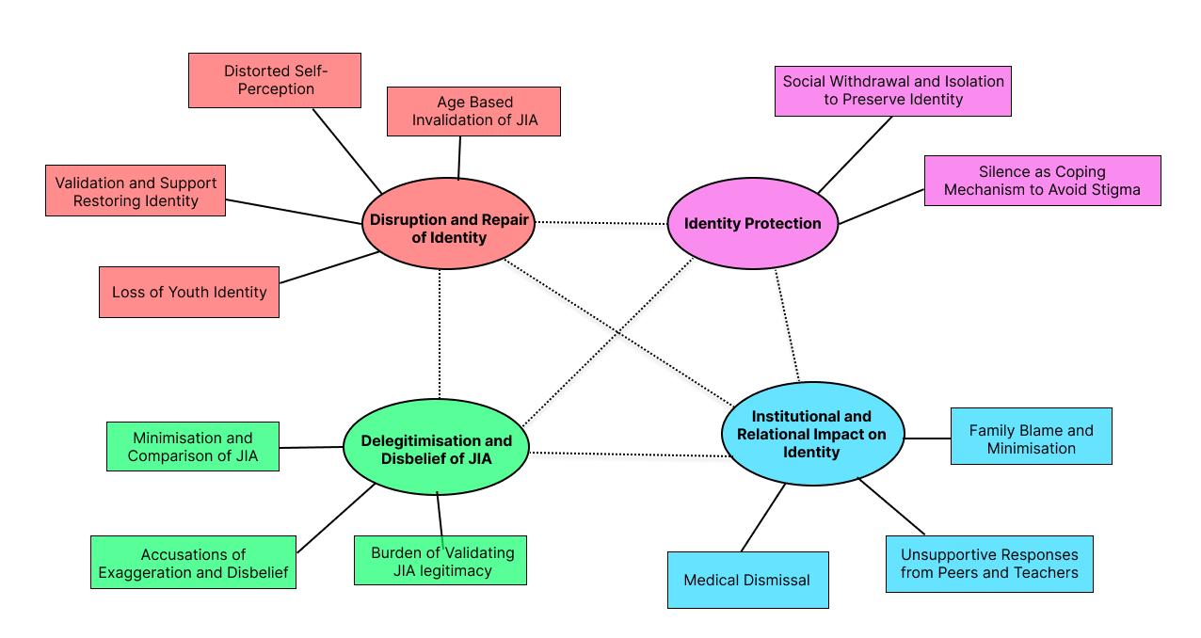

3.2 Themes and Subthemes
Figure 2.

Theme 1: Delegitimisation and Disbelief of JIA
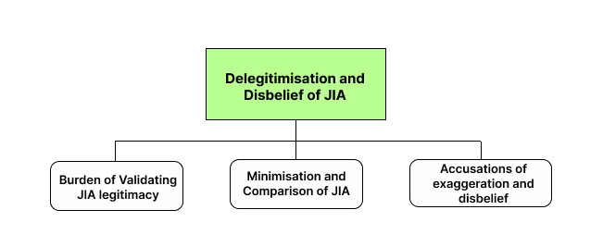

The first main theme, “delegitimisation and disbelief of JIA”, highlighted the ways JIA individuals experienced their condition as being minimised, questioned, or dismissed by others. Individuals reported others asking them to provide “proof” of their condition, with others comparing their condition to “regular” pain or minimising their condition, accusations of exaggeration and disbelief from others about their condition also were evident. Individuals who reported these experiences highlighted how their experiences led to feelings of exhaustion, isolation, invalidation, and frustration. This theme highlights how delegitmisation and disbelief of JIA impacts how JIA individuals perceive and present themselves in social situations, as their credibility seems to constantly be challenged.
Subtheme 1: Accusations of Exaggeration and Disbelief:
This subtheme captured individuals' experiences of being accused of exaggerating their JIA or disbelief from others. Many individuals reported emotional distress, frustration, and feeling demoralised due to the authenticity of their condition being challenged. For example, Reddit User 16 shared how a doctor did not believe they had JIA: “Seeing him made me cry intensely as it seemed like no one actually believed me”, while Reddit User 21 shared: “It demoralises me when others question how bad my condition actually effects me and having to validate my condition”. Individuals also reported how their experiences contributed to feelings of internal doubt and isolation, demonstrating how repeated accusations of exaggerations and disbelief from others can negatively impact the social and self-identity of JIA individuals.
Subtheme 2: Minimisation and Comparison of JIA:
This subtheme concentrated on individuals who reported their JIA being minimized, through others comparing their condition to common aches, or giving unsolicited advice neglecting the seriousness of their condition. For example, Reddit User 10 stated: “I hate listening to people compare my condition to common pains in their body, it isn't the same and they don't understand how I really feel”, while Reddit User 21 stated: “My precision skills are damaged and they wanted me to draw something and when I said I couldn’t they compared my condition to their mothers condition and said that their mother could draw okay”. This minimisation and comparison of JIA as described by the individuals, negatively affected their social identity, due to the seriousness of their condition being ignored. This resulted in such individuals often reporting feeling misunderstood within social interactions. Such individuals questioned whether their JIA is worthy of acknowledging due to others constantly comparing and minimising it. It appeared to influence the way in which the individuals present themselves.

Subtheme 3: Burden of Validating JIA Legitimacy:
This subtheme focused on individuals reports regarding pressure received from others to “prove” the legitimacy of their JIA. Many of these individuals described having to justify their condition to people, with some even providing physical evidence and still being dismissed by others. For example, Reddit User 4 stated “ I showed others my damaged joints and even after that they say mean and dismissive things”. Individuals also reported how constantly having to validate the legitimacy of their condition led to emotional exhaustion and distress. For example, Reddit User 5 stated “I’m so tired from having to tell everyone the history of my condition in order for them to maybe understand me”. The burden of validating JIA legitimacy captured how the stigma experienced by JIA individuals can negatively impact their self and social-identity, as they may internalise the doubt of others and feel pressure to form an identity that focused on proving their condition.
Figure 3.

Theme 2: Institutional and Relational Impact on Identity
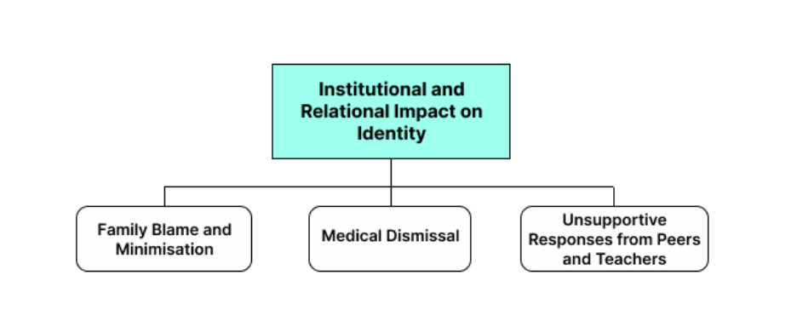
The second main theme identified in the analysis, “institutional and relational impact on identity”, explored how stigma experienced by JIA individuals in their interpersonal relationships, and institutional environments, impacted their social and self-identity. Individuals reported stigmatising and unsupportive responses from family, peers, teachers, and medical professionals. These experiences shaped their sense of belonging in social situations and appeared to impact their self-identity, as they reported feeling internalised shame and disbelief of their JIA, due to facing constant dismissal in social environments.
Subtheme 1: Family Blame and Minimisation:
This subtheme explored individuals' experiences of family blaming them for their condition, as if it was the individual’s fault they had developed it, as well as minimising comments from family. For example, Reddit User 17 stated: “I'm suffering as I feel like I'm at fault for getting JIA due to my family saying I'm to blame for developing it as I wasn’t more careful”, while Reddit User 9 shared: “it is extremely hard to receive minimising comments from family, especially when they are the ones we want the most support from”. These comments illustrate how the social and self-identity of JIA individuals can be impacted as they reported feeling misunderstood and isolated by the ones they most wanted support from, while internalising their families' negative comments.
Subtheme 2: Medical Dismissal:
This subtheme highlighted individuals' experiences of being dismissed within healthcare environments, specifically when medical professionals questioned and dismissed their JIA diagnosis due to age-based stigma. Individuals noted how dismissive experiences contributed to emotional exhaustion, and that internalised doubt caused them to question their JIA. For example, Reddit User 14 stated: “ I went to a healthcare professional and they told me that I was too young to have arthritis, I believed them and thought I made it all up”, while Reddit User 16 shared: “They made me think I was being dramatic as I wasn’t like their regular older clients”. These experiences convey how medical responses can impact the self-identity of individuals with JIA.
Subtheme 3: Unsupportive Responses from Peers and Teachers:
This subtheme explored how unsupportive responses from peers and teachers may impact the social identity of JIA individuals. Many of these individuals reported experiencing “mocking” in times of need, with peers and teachers seeming to fail to understand their JIA and provide support. For example, Reddit User 11 stated: “a group of people decided it would be funny to take a video of me struggling to pull my bag rather than coming to help me”, while Reddit User 7 stated “teachers informing the class to be kind didn’t help me at all and I don't understand how they thought that would”. These comments highlight what impact it may have had on their social identity, including the challenges and pressures associated with maintaining healthy peer relationships while having JIA.

Figure 4.

Theme 3: Identity Protection
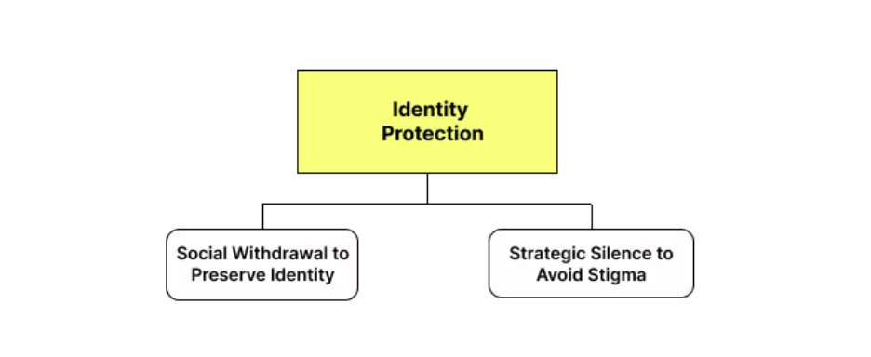
The third main theme of the present study, “identity protection”, illustrates strategies JIA individuals use to protect their identity from stigma. These individuals' frequent experiences of disbelief, age-based invalidation, minimisation, and dismissal seemed to have resulted in them adopting certain strategies to minimise their exposure to stigma. That said, while the individuals reported how these strategies helped them cope and manage apparent stigma, it impacted how they navigated their social identity, such as suppressing their thoughts in social situations and isolating themselves, which may have a negative impact on their self-identity.
Subtheme 1: Strategic Silence to Avoid Stigma:
This subtheme focused on the way individuals use strategic silence to avoid stigma. The strategic silence, adopted by these individuals, involved them choosing to not disclose their JIA or hold any conversations surrounding the topic, unless they were certain that the person they were speaking to would respond with compassion. For example, Reddit User 2 shared: “I stopped speaking about anything to do with my condition unless I was certain the person I was speaking to was kind and asking out of care”, while Reddit User 21 reported “ I have to constantly hold back my feelings and when I attempt to speak to others about my JIA they don't understand”. While limiting their disclosure of their JIA protected themselves from negative comments, this strategic silence highlighted that JIA individuals were often unable to express their “true selves”, illustrating how even protective strategies from stigma can shape individual social identity.

Subtheme 2: Social Withdrawal to Preserve Identity:
This subtheme explored how individuals chose to withdraw socially, in order to preserve their identity. JIA individuals' experiences of being misunderstood, judged, and minimised influenced how many of them withdraw from social interactions. They often seem to only associate with individuals with a condition like themselves and avoided certain environments. For example, Reddit User 26 shared: “I may only hang out with people who have conditions as well”, while Reddit User 12 discussed “I have to use the lift now if I feel like I have to after others had given out about me using the stairs too slow”. These comments demonstrate how JIA individuals often withdraw themselves from certain situations and people, as a strategy to protect their identity. However, it may impact their individual social identity, as it can lead them to being isolated from others.
Figure 5.

Theme 4: Disruption and Repair of Identity
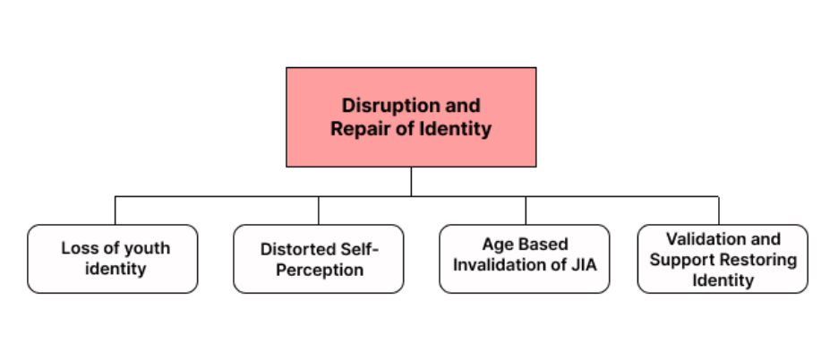
The 4th main theme, “disruption and repair of identity”, focused on various ways JIA individuals’ identity may have been damaged and how they may have repaired it. Such individuals reported how recurring experiences of stigma influenced the way they perceived themselves and how they presented themselves in social situations. These individuals discussed how their experiences caused loss of youth identity, distorted self-identity, isolation, and psychological distress. Despite this, JIA individuals highlighted experiences where they received validation and support from others, which helped restore aspects of their social and self-identity.
Subtheme 1: Distorted Self Perception:
This subtheme captured how stigma experienced by JIA individuals impacted the way they perceived themselves. These individuals discussed how frequent negative comments from others, such as saying they were at fault for developing JIA or that they were exaggerating, led them to internalise these negative comments and believe that they were the problem. For example, Reddit User 28 shared: “most colleagues didn't show empathy and told me that they wouldn’t give me the job as they see me as a liability, it really disrupted how I saw myself and it was weakening”, while Reddit User 17 discussed: “ I feel isolated and not the same as others my age”. These comments illustrate the impact of stigma on JIA individuals’ self-identity. These individuals discussed how others’ attitudes towards them began to impact their self-perception, such as lacking confidence and feelings like they do not belong.
Subtheme 2: Loss of Youth Identity:
This subtheme highlighted how many JIA individuals discussed feeling a lost sense of youth, due to being excluded from typical childhood activities and experiences which their peers were able to have. These exclusions led to the individuals reporting feelings of embarrasment, and that their youth had been “stolen from them”. For example, Reddit User 8 discussed: “I felt embarrassed having to quit sports when in school, my peers mocked the way I stood”, while Reddit User 21 shared: “I believe my youth was taken from me and it messed me up mentally and personally”. These comments demonstrate a negative impact on the social and self-identity of these individuals, as their sense of belonging in social situations was disrupted, and how it could alter their sense of who they were as a person.
Subtheme 3: Age-Based Invalidation of JIA:
Age-based invalidation of JIA was a prominent experience reported by JIA individuals. Individuals reported how they repeatedly received comments that they were “too young” to have JIA emphasising the stereotype that arthritis is only associated with “old age”. This societal stereotype could affect the individuals' social identity, as they reported feeling dismissed in social environments, that could lead to feelings of isolation and frustration. For example, Reddit User 1 shared: “It's so frustrating receiving the amount of negative comments I get due to being young with arthritis”. These individuals also internalised this societal stereotype which may negatively impact their self-identity, such as reporting feelings of embarrassment. For example, Reddit User 8 stated: “I felt ashamed when I had to walk to my home from my vehicle as I viewed it as an old person's condition and it made me feel so embarrassed and different from others”.

Subtheme 4: Validation and Support Restoring Identity:
Despite the previous subthemes discussing the different damages done to JIA individuals identity, this subtheme captured the individuals' discussions of experiences where they received validation and support from others, and how it helped restore aspects of their identity. These experiences included being accepted by friends and receiving support from others with similar experiences or from medical professionals. For example, Reddit User 19 shared: “My doctor told me that I did everything the right way and that I wasn’t to blame which helped the way I feel”, while Reddit User 21 noted: “It felt nice that they accepted me and my JIA”. These comments demonstrate how being supported and accepted for their JIA may help restore self-confidence in their identity and promote more positive feelings. Feeling understood by others seems to improve individuals' self-perception and sense of belonging in social situations, highlighting the importance of validation and support in restoring identity after it has been damaged from stigma.

4. Discussion

4.1 Overview
The present study aimed to investigate how the stigma experienced by JIA individuals can impact their social and self-identity, by employing reflexive thematic analysis of publicly available narratives on Reddit in order to identify recurring themes. Four main themes emerged from the data analysis: (1) Delegitimisation and disbelief of JIA, (2) Institutional and relational impact on identity, (3) Identity protection, (4) Disruption and repair of identity. Overall, the present study's findings illustrate that stigma experiences are commonly prevalent among JIA individuals, and that they may shape their social identity, including how they present themselves, how they navigate interactions with others, and their sense of belonging, as well as potentially shaping their self-identity, through internalising this external stigma, and that contributing to a distorted self-identity.

4.2 Delegitimisation and Disbelief of JIA
The theme of delegitimisation and disbelief of JIA focused on the numerous experiences identified by JIA individuals regarding their JIA being questioned, dismissed, minimised, and compared. This finding aligns Nicola et al. (2019) who demonstrated how individuals with chronic pain often experience disbelief and invalidation from others. This may increase the risk of identity loss (Nicola et al., 2019). Similarly, Wakefield et al. (2023) identified how JIA individuals often reported “felt stigma” including age-based stigma, accusations of exaggeration, disbelief, and dismissal from others. The theme of delegitimization and disbelief of JIA also highlights how these experiences may negatively impacted the self-identity of JIA individuals as it can influence the way in individuals perceive themselves, due to internalising others' doubts. This also aligns with Wakefield et al. (2023) who identified “internalised stigma” as commonly being reported as experienced by JIA individuals, further supporting the present study's findings.
The theme of delegitimization and disbelief of JIA demonstrates how accusations of exaggeration, disbelief, minimisation, and the burden of validating JIA may have an impact on the identity of JIA individuals. Individuals' reports of being accused of exaggerating, or lying, about their JIA illustrated how their credibility is often challenged in social environments, which may negatively impact their social and self-identity. They reported internalising these doubts and being left feeling isolated from others. This finding supports O’Donnell and Habenicht (2021) findings that indicate a positive relationship between stigma and illness identity, with the present study's findings providing a deeper insight into the relationship between stigma and identity of JIA individuals

4.3 Institutional and Relational Impact on Identity
The theme of institutional and relational impact on identity highlighted the important role peers, healthcare professionals, families, and teachers may have in shaping JIA individuals’ identity. Individuals discussed experiences of blame from family, dismissal from doctors, and unsupportive reactions from peers and teachers, aligning with Tong et al. (2012), who reported how JIA individuals emphasised the importance of support in social, institutional, and medical environments as their sense of normality was disrupted. Similarly, Van Gulik et al. (2020) identified how JIA individuals expressed wanting to be treated “the same as others” in their school and work environments. They expressed uncertainty about disclosing their JIA condition due to anticipated stigma. This further aligns with the present study’s findings regarding the role of institutional environments in shaping the social and self-identity of JIA individuals.

4.4 Identity Protection
The theme of identity protection highlighted the strategies JIA indivdiuals used to protect their identity from stigma. Some individuals described engaging in social withdrawal and strategic silence to limit their experiences of stigma from others. These present study’s findings align with Irish et al. (2025) who reported that individuals often engage in avoidance behaviour in order to avoid future stigma experiences. Similarly, Aussems et al. (2024) further support the present study’s findings. They identified that JIA individuals may conceal their symptoms in order to avoid the negative reactions of others. Strategic silence can restrict an individual's social identity, as it can limit the way in which they express themselves to others, while social withdrawal may cause isolation. These findings are consistent with Hanghoj et al. (2016), who report JIA individuals often present a “normal” identity in social environments and their “illness” identity at home, as a strategy to avoid stigma and to protect their social identity. The present study's findings add to the existing literature as they demonstrate the implications of these coping strategies on the social and self-identity of JIA individuals and how they may be motivated by the previous stigma they have experienced.

4.5 Disruption and Repair of Identity
The theme of disruption and repair of identity illustrated the extensive impact stigma has on the identity of individuals with JIA, as well as the potential to restore it. Individuals discussed experiences of ageism, lost sense of youth, disrupted self-identity, as well as helpful moments of validation and support. This finding regarding loss of youth identity aligns with McDonagh et al. (2016), who highlight how the formation of self-identities can be disrupted by chronic illnesses. Disrupted self-identity and age-based invalidation emphasised how individuals may internalise others’ negative beliefs of their JIA leading to a lack of confidence and internal doubt. These findings are consistent with Cartwright et al. (2014), who reported how JIA individuals associated their JIA with ageing due to others' perceptions. This can result in these individuals perceiving themselves as “different” from their peers and may contribute to fears of their youth being taken away from them forever.
These present study’s findings also highlights the importance of validation and support in restoring aspects of JIA individuals’ identity. Some individuals emphasised how their JIA being accepted, and hearing from others with similar experiences, helped restore their self-confidence and promoted positive feelings, which aligns with Irish et al. (2025) who discussed the significance of awareness of JIA in order to promote healing and prevent future stigma.

4.6 Strengths and Limitations
A strength of the present study is that it addressed a gap in the literature regarding the impact of stigma on the social and self-identity of JIA individuals. While previous research has explored stigma regarding JIA, there appears to be a lack of detailed qualitative literature investigating how stigma impacts the social and self-identity of JIA individuals. Reflexive thematic analysis, adopting an inductive approach, was employed as the chosen method for the present study. This provided the present study with rich descriptive findings, as the themes emerged directly from the raw data and captured the lived experiences of JIA individuals in depth. As the present study gathered publicly available data from Reddit, which is a platform that promotes anonymity, individuals may have been more likely to express their experiences openly, reducing the risk of social desirability bias. Quotes were paraphrased to preserve anonymity of JIA individuals whose narratives were gathered, with pseudonyms also being applied by giving individuals ID numbers (Ex. Reddit User 1). An IRAT was conducted, which had an 83.3% agreement level. This strengthened the present study, as it strengthened the credibility of the analysis and it minimised the risk of data being misinterpreted.
However, it is important to note several limitations of the present study. It involved gathering publicly available data online. Therefore, demographics of JIA individuals were unavailable, which limits the generalisability of the findings, as social and economic factors may have influenced individuals’ experiences of stigma (Link & Phelan, 2001). Additionally, the sample is not representative of all JIA individuals, as the present study only involved gathering English quotes, and only a small amount of JIA individuals may engage in online platforms such as Reddit. Another limitation of the present study is its small sample size. A total of fifty-two quotes were included based on the present study’s inclusion criteria, once data saturation had been reached.

4.7 Theoretical and Practical Implications
The present study has some theoretical implications in relation to social identity theory (Tajfel & Turner, 1979). It suggests that individuals obtain part of their self-identity from group membership, and that social value, associated with groups, influences both individual self-identity and self-worth. Additionally, it proposes that individuals categorise themselves into “in-groups” and “out-groups” leading to intergroup conflict. The findings of the present study support this theorys framework as many JIA individuals were placed in a negatively perceived social group which may negatively impact their social and self-identity, resulting in social withdrawal and a distorted self-perception.
Regarding practical implications, the findings of the present study emphasise the need for increased awareness of JIA, as a lack of understanding from others was consistently identified throughout data analysis. The results illustrate that much of the stigma experienced by JIA individuals appeared to be due to others being uneducated about JIA, due in part to stereotypes of arthritis being often associated with older people. These findings highlight the importance of creating interventions aimed at reducing stereotypes, in order to prevent future damage to the social and self-identity of JIA individuals. By promoting awareness, JIA individuals could experience a safer social environment, where they feel comfortable disclosing their condition without facing judgement from others.

4.8 Suggestions for Future Research
With the limitations of the present study noted, future research could aim to employ a larger and diverse sample, accounting for demographics, to improve the generalisability of the findings, and to explore if social and economic factors differed in stigma experiences and identity formation. Future research should also employ a mixed methods approach, using interviews combined with quantitative questionnaires, to investigate both the lived experiences of JIA individuals and to identify any patterns across these datasets. Future research could further focus on testing the effectiveness of education programmes in increasing awareness of JIA and improving people's understanding of JIA.

4.9 Conclusion
To conclude, the present study highlighted how stigma may play a significant role in shaping the social and self-identity of JIA individuals. Experiences of disbelief, comparison, age-based invalidation, and minimisation were consistently identified throughout the included data and may indicate a negative impact on identity, while strategies including silence and social withdrawal seemed to be used as an attempt to protect identity. While the present study had a number of acknowledged limitations, it did address a gap in the JIA literature and emphasised the importance of promoting a better understanding of JIA. Future research could explore the creation of awareness and education programmes to foster a safer environment in which JIA individuals can develop their confidence and a better sense of belonging in social environments.

References

Ahmed, S. K., Mohammed, R. A., Nashwan, A. J., Ibrahim, R. H., Abdalla, A. Q., Ameen, B. M. M., & Khdhir, R. M. (2025). Using thematic analysis in qualitative research. Journal of Medicine, Surgery, and Public Health, 6, Article 100198. https://doi.org/10.1016/j.glmedi.2025.100198
Amaya, A., Bach, R., Keusch, F., & Kreuter, F. (2021). New data sources in social science research: Things to know before working with Reddit data. Social Science Computer Review, 39(5), 943-960. https://doi.org/10.1177/0894439319893305
Aussems, K., Isarin, J., Niemeijer, A., & Dedding, C. (2024). Mastering Life Chances and Choices: A Metasynthesis of How Disadvantaged Young People Navigate Between Self-Identity and Stigma. Families in Society the Journal of Contemporary Social Services, 107(1), 26–44. https://doi.org/10.1177/10443894241245891
Beaudoin, K., Lo, J., Mewhinney, E., Bortolin, K., Cellucci, T., Dowhaniuk, J., Heale, L., Issenman, R., Pai, N., Sherlock, M., Zachos, M., Grant, C., Beattie, K., Prowse, K., & Batthish, M. (2025). Silent Struggles: Uncovering Mental Health Burdens in Adolescents with Inflammatory Bowel Disease and Juvenile Idiopathic Arthritis—A Retrospective Chart Review. Children, 12(8), Article 995. https://doi.org/10.3390/children12080995
Bomba, M., Meini, A., Molinaro, A., Cattalini, M., Oggiano, S., Fazzi, E., Neri, F., Plebani, A., & Nacinovich, R. (2013). Body experiences, emotional competence, and psychosocial functioning in juvenile idiopathic arthritis. Rheumatology International, 33(8), 2045–2052. https://doi.org/10.1007/s00296-013-2685-4
Brandelli, Y. N., Chambers, C. T., Mackinnon, S. P., Parker, J. A., Huber, A. M., Stinson, J. N., Wildeboer, E. M., Wilson, J. P., & Piccolo, O. (2023). A systematic review of the psychosocial factors associated with pain in children with juvenile idiopathic arthritis. Pediatric Rheumatology, 21(1), Article 57. https://doi.org/10.1186/s12969-023-00828-5
Brandelli, Y. N., Mackinnon, S. P., Chambers, C. T., Parker, J. A., Huber, A. M., Stinson, J. N., Johnson, S. A., & Wilson, J. P. (2024). Understanding the role of perfectionism in contributing to internalizing symptoms in youth with juvenile idiopathic arthritis. Journal of Pediatric Psychology, 50(2), 175–186. https://doi.org/10.1093/jpepsy/jsae100
Branje, S. (2021). Adolescent identity development in context. Current Opinion in Psychology, 45, 101286. https://doi.org/10.1016/j.copsyc.2021.11.006
Braun, V., & Clarke, V. (2006). Using thematic analysis in psychology. Qualitative Research in Psychology, 3(2), 77-101. https://doi.org/10.1191/1478088706qp063oa
Braun, V., & Clarke, V. (2019). Reflecting on reflexive thematic analysis. Qualitative Research in Sport Exercise and Health, 11(4), 589–597. https://doi.org/10.1080/2159676x.2019.1628806
British Psychological Society. (2021, June 7). Ethics guidelines for internet-mediated research - The British Psychological Society. Www.bps.org.uk. https://www.bps.org.uk/guideline/ethics-guidelines-internet-mediated-research
Cartwright, T., Fraser, E., Edmunds, S., Wilkinson, N., & Jacobs, K. (2014). Journeys of adjustment: the experiences of adolescents living with juvenile idiopathic arthritis. Child Care Health and Development, 41(5), 734–743. https://doi.org/10.1111/cch.12206
Cauteruccio, F., Corradini, E., Terracina, G., Ursino, D., & Virgili, L. (2020). Investigating Reddit to detect subreddit and author stereotypes and to evaluate author assortativity. Journal of Information Science, 48(6), 783–810. https://doi.org/10.1177/0165551520979869

Cheng, T. W., Mills, K. L., & Pfeifer, J. H. (2024). Revisiting adolescence as a sensitive period for sociocultural processing. Neuroscience & Biobehavioral Reviews, 164, Article 105820. https://doi.org/10.1016/j.neubiorev.2024.105820
Cole, R. (2023). Inter-Rater Reliability Methods in Qualitative Case Study Research. Sociological Methods & Research, 53(4), 1944-1975. https://doi.org/10.1177/00491241231156971
Currie, G. R., Kennedy, B. L., S. M., B., R. S. M., Y., J. F., S., S. J., V., N. M., W., M. M. A., K., MacKean, G., & Marshall, D. A. (2023). Managing juvenile idiopathic arthritis within the context of their life: What we learnt from children and youth living with juvenile idiopathic arthritis and their parents. Musculoskeletal Care, 21(4), 1248–1260. https://doi.org/10.1002/msc.1805
Fair, D. C., Rodriguez, M., Knight, A. M., & Rubinstein, T. B. (2019). Depression And Anxiety In Patients With Juvenile Idiopathic Arthritis: Current Insights And Impact On Quality Of Life, A Systematic Review. Open Access Rheumatology Research and Reviews, 11, 237–252. https://doi.org/10.2147/oarrr.s174408
Giddens, A. (1991). Modernity and self-identity:Self and society in the late modern age. Stanford, CA.
Hanghøj, S., Boisen, K. A., Schmiegelow, K., & Hølge-Hazelton, B. (2016). A photo elicitation Study on Chronically ill Adolescents’ identity constructions during transition. Global Qualitative Nursing Research, 3, Article 2333393616631678. https://doi.org/10.1177/2333393616631678
Harwood, J. (2020). Social Identity Theory. The International Encyclopedia of Media Psychology, 1–7. https://doi.org/10.1002/9781119011071.iemp0153
Hendry, G., Wilson, C., Orr, M., & Scullion, R. (2022). “I Just Stay in the House So I Don’t Need to Explain”: A Qualitative Investigation of Persons with Invisible Disabilities. Disabilities, 2(1), 145–163. https://doi.org/10.3390/disabilities2010012
Irish, B. N., Chambers, C. T., Dol, J., Parker, J. A., Huber, A. M., Brandelli, Y. N., Nichols, D., & Brause, J. (2025). “I’m in pain, and I’m not faking it”: A qualitative exploration of the reactions of youth with juvenile idiopathic arthritis and their caregivers to pain-related stigma. Arthritis Research & Therapy, 27(1), Article 191. https://doi.org/10.1186/s13075-025-03651-3
Jamnik, M. R., & Lane, D. J. (2017). The use of reddit as an inexpensive source for high-quality data. Practical Assessment, Research & Evaluation, 22(5), Article 5.
Likhar, A., Baghel, P., & Patil, M. (2022). Early Childhood Development and Social Determinants. Cureus, 14(9), e29500. https://doi.org/10.7759/cureus.29500
Link, B. G., & Phelan, J. C. (2001). Conceptualizing stigma. Annual Review of Sociology, 27, 363–385. https://doi.org/10.1146/annurev.soc.27.1.363
Martini, A., Lovell, D. J., Albani, S., Brunner, H. I., Hyrich, K. L., Thompson, S. D., & Ruperto, N. (2022). Juvenile idiopathic arthritis. Nature Reviews Disease Primers, 8(1), Article 5. https://doi.org/10.1038/s41572-021-00332-8
McDonagh, J. E., Shaw, K. L., Prescott, J., Smith, F. J., Roberts, R., & Gray, N. J. (2016). “Sometimes I feel like a pharmacist”: identity and medication use among adolescents with juvenile arthritis. Pediatric Rheumatology, 14(1), Article 57. https://doi.org/10.1186/s12969-016-0117-1
Min, M., Hancock, D. G., Aromataris, E., Crotti, T., & Boros, C. (2021). Experiences of living with juvenile idiopathic arthritis: a qualitative systematic review. JBI Evidence Synthesis, 20(1), 60–120. https://doi.org/10.11124/jbies-21-00139
Naeem, M., Ozuem, W., Howell, K., & Ranfagni, S. (2024). Demystification and actualisation of data saturation in qualitative research through thematic analysis. International Journal of Qualitative Methods, 23, Article 16094069241229777. https://doi.org/10.1177/16094069241229777?urlappend=%3Futm_source%3Dresearchgate.net%26utm_medium%3Darticle
Nicola, M., Correia, H., Ditchburn, G., & Drummond, P. (2019). Invalidation of chronic pain: a thematic analysis of pain narratives. Disability and Rehabilitation, 43(6), 861–869. https://doi.org/10.1080/09638288.2019.1636888
O’Donnell, A. T., & Habenicht, A. E. (2021). Stigma is associated with illness self‐concept in individuals with concealable chronic illnesses. British Journal of Health Psychology, 27(1), 136–158. https://doi.org/10.1111/bjhp.12534
O’Sullivan, G., O’Higgins, S., Caes, L., Saetes, S., McGuire, B. E., & Stinson, J. (2018). Self-management needs of Irish adolescents with Juvenile Idiopathic Arthritis (JIA): how can a Canadian web-based programme meet these needs? Pediatric Rheumatology, 16(1), 68. https://doi.org/10.1186/s12969-018-0287-0
Proudfoot, K. (2023). Inductive/deductive hybrid thematic analysis in mixed methods research. Journal of Mixed Methods Research, 17(3), 308-326. https://doi.org/10.1177/15586898221126816
Tajfel, H., & Turner, J. C. (1979). An integrative theory of intergroup conflict. In W. G. Austin, & S. Worchel (Eds.), The social psychology of intergroup relations (pp. 33-37). Monterey, CA: Brooks/Cole.
Tong, A., Jones, J., Craig, J. C., & Singh‐Grewal, D. (2012). Children’s experiences of living with juvenile idiopathic arthritis: A thematic synthesis of qualitative studies. Arthritis Care & Research, 64(9), 1392–1404. https://doi.org/10.1002/acr.21695
Van Gulik, E. C., Verkuil, F., Barendregt, A. M., Schonenberg-Meinema, D., Rashid, A. N., Kuijpers, T. W., Van Den Berg, J. M., & Hoving, J. L. (2020). Experiences, perspectives and expectations of adolescents with juvenile idiopathic arthritis regarding future work participation; a qualitative study. Pediatric Rheumatology, 18(1), 33. https://doi.org/10.1186/s12969-020-00429-6
Wakefield, E. O., Belamkar, V., Litt, M. D., Puhl, R. M., & Zempsky, W. T. (2021). “There’s nothing Wrong with you”: Pain-Related Stigma in Adolescents with Chronic Pain. Journal of Pediatric Psychology, 47(4), 456–468. https://doi.org/10.1093/jpepsy/jsab122
Wakefield, E. O., Belamkar, V., Sandoval, A., Puhl, R. M., Edelheit, B., Zempsky, W. T., Rodrigues, H. A., & Litt, M. D. (2023). Does Diagnostic Certainty Matter?: Pain-Related Stigma in Adolescents with Juvenile Idiopathic Arthritis. Journal of Pediatric Psychology, 48(4), 341–351. https://doi.org/10.1093/jpepsy/jsac092

Appendices

Appendix A- Purpose of Each Subreddit

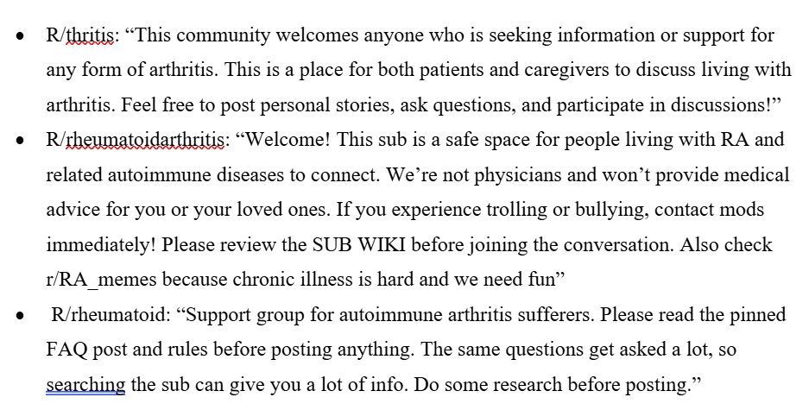

Appendix B- Ethics Application Form
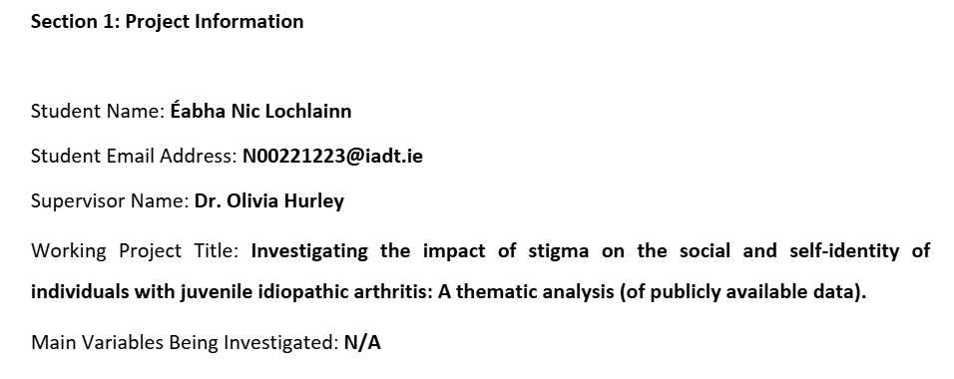
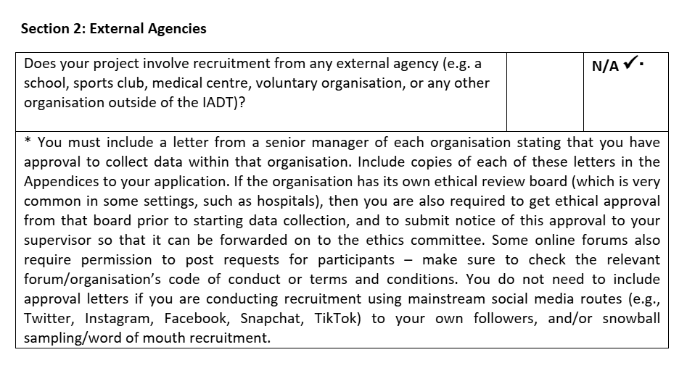
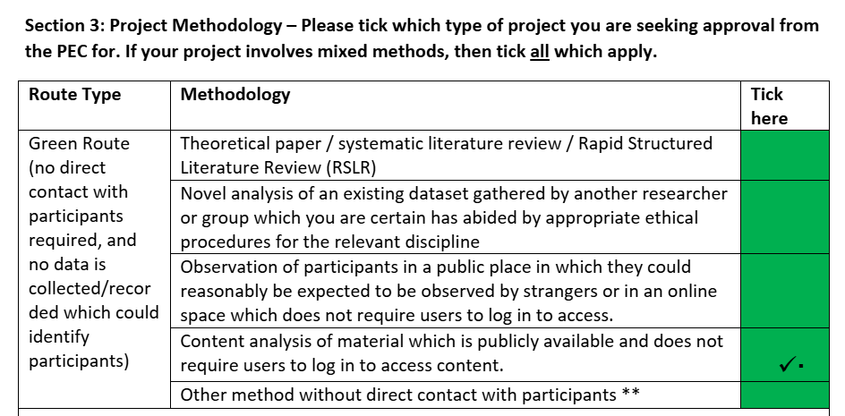
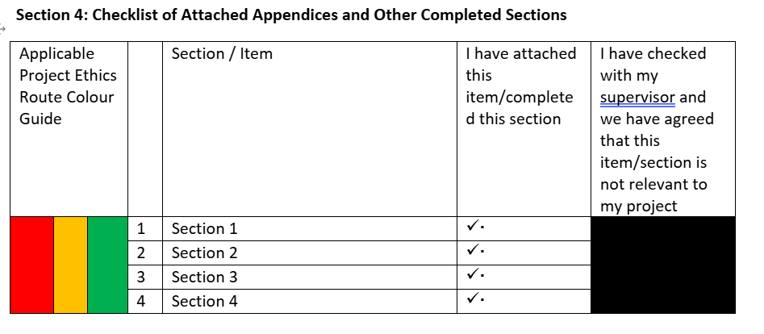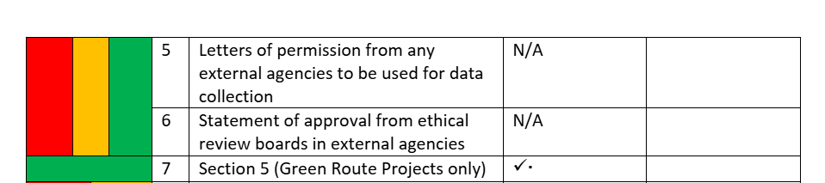
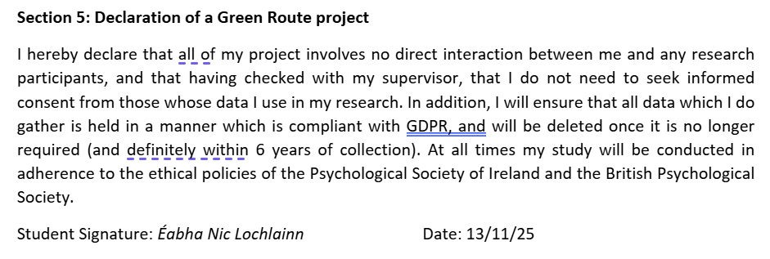

Appendix C- Ethical approval

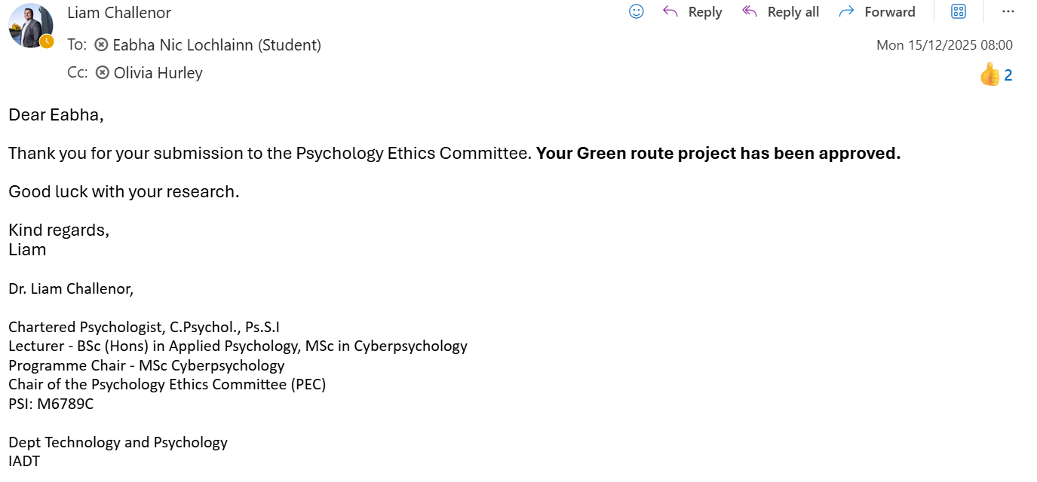

Appendix D-Inter-rater Agreement Test

Code | Description | 2nd coders assigned code | Agree/Disagree
Strategic silence to avoid stigma | Individual with JIA discloses information conditionally to protect themselves against stigma | Not Disclosing JIA to protect themselves | Agree
Burden of validating JIA Legitimacy | The burden of having to explain or prove their JIA to others | Burden of validating JIA legitimacy | Agree
Minimisation and Comparison of jia | Individuals JIA is compared to common aches and minimised | Dismissal of JIA through comparison and minimisation | Agree
Unsupportive responses from peers/teachers | Unsupportive responses from peers or teachers in social settings in times of support | Lack of supportive responses from society | Agree
Social withdrawal to preserve identity | Individual withdraws socially by avoiding certain environments and people to protect their identity | Burden of JIA | Disagree
Medical dismissal | Individuals with JIA diagnosis is dismissed by doctors | Lack of medical support | Agree
Distorted self-perception | Individuals with JIAs self-perception is disrupted from stigma | Distorted self-perception | Agree
Validation and support to restore identity | The role of validation and support in helping restore individual with JIAs identity | Impact of support systems for JIA | Agree
Loss of youth identity | Individuals sense of youth is lost due to JIA and stigma | Loss of youth identity | Agree
Accusations of exaggeration and disbelief | Individuals with JIA receive accusations of exaggeration and disbelief from others regarding their JIA | Lack of societal knowledge on JIA | Disagree
Family blame and minimisation | Individual with JIA receives comments from family that they are at fault for developing it and minimise their JIA. | Family blame and minimisation | Agree
Age based invalidation of JIA | Individual with JIA receive age based stigma comments regarding their JIA due to societal stereotypes of it being associated with older age | Age based invalidation of JIA | Agree

Appendix E- Paraphrased Quotes Attached to Each Subtheme
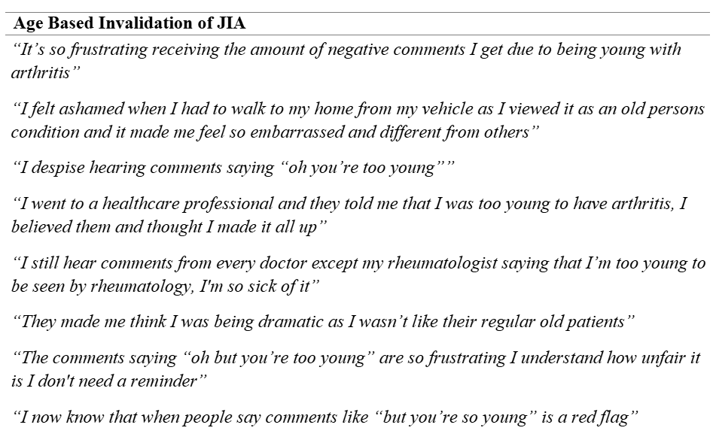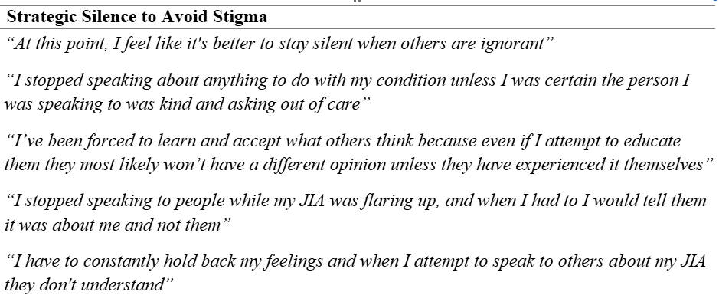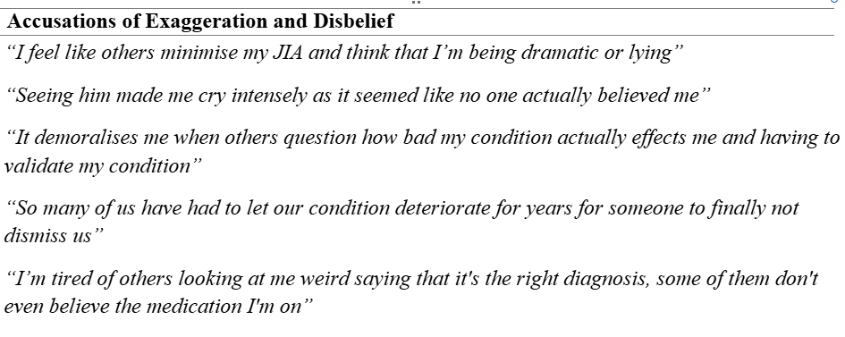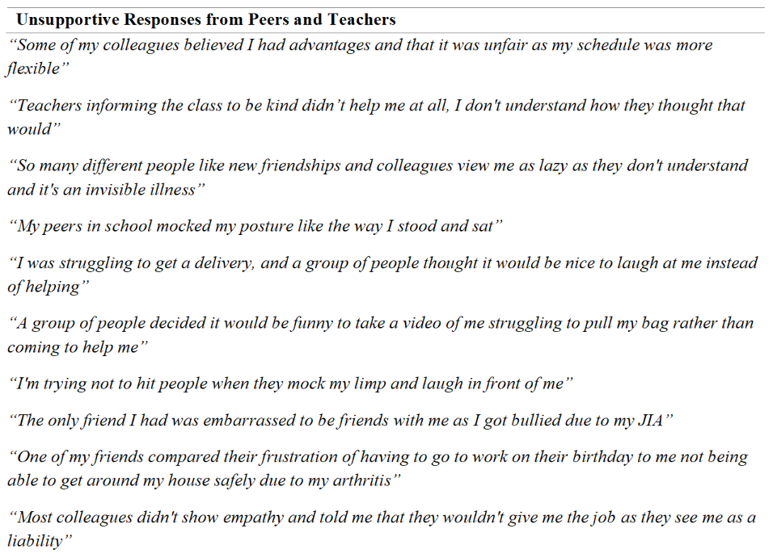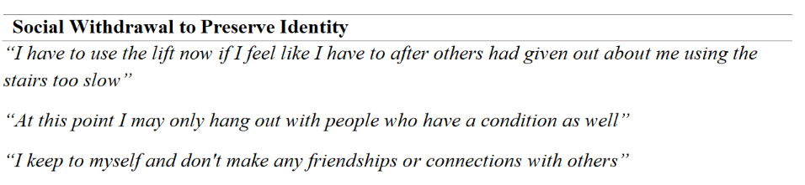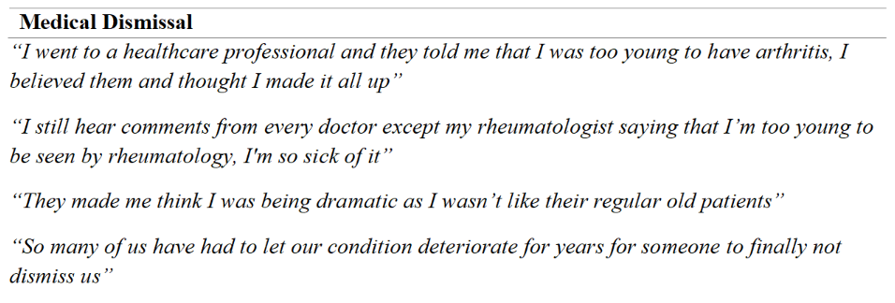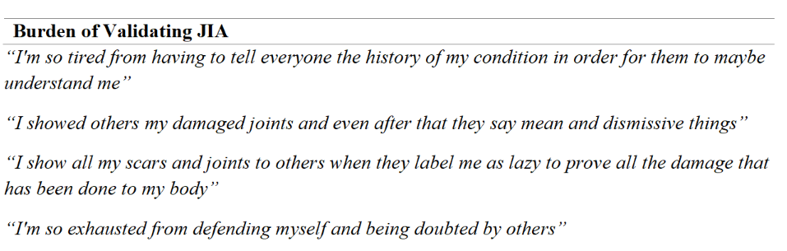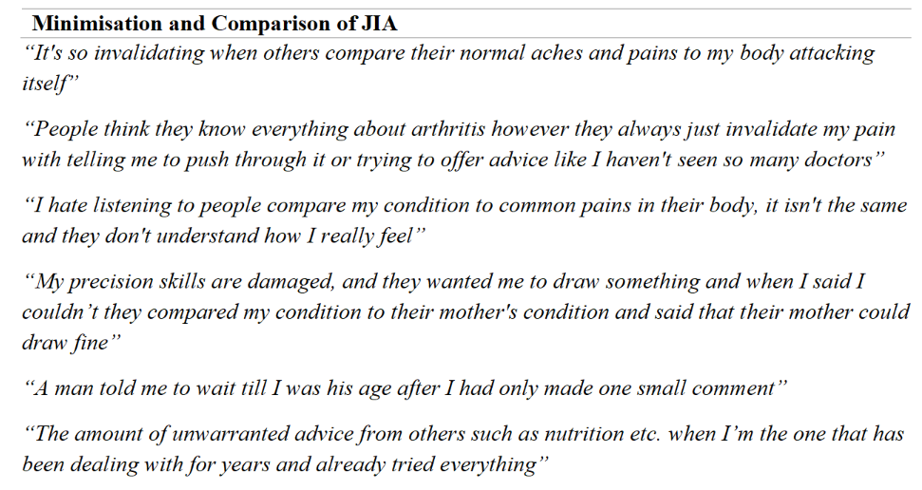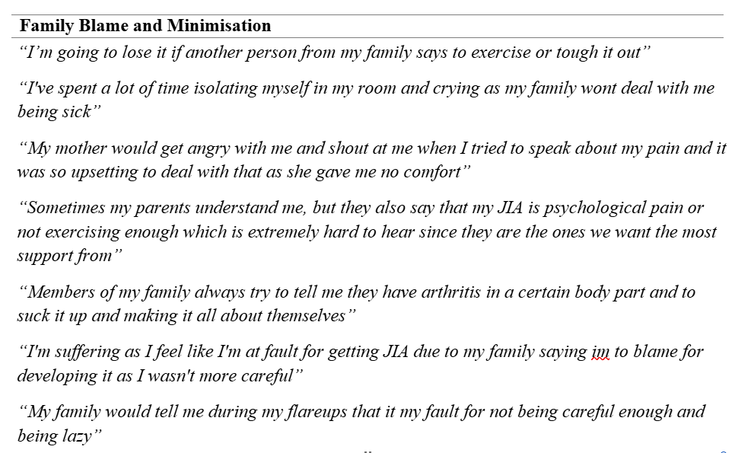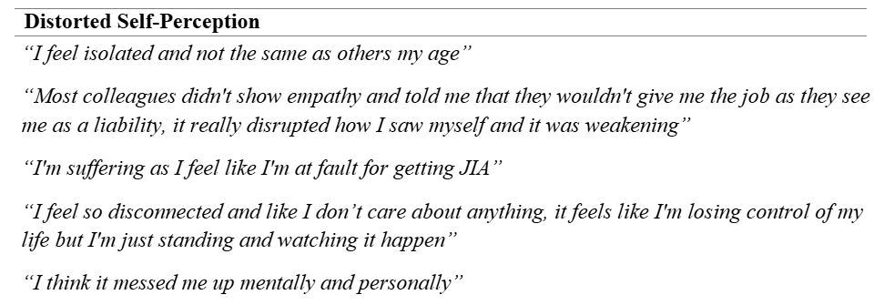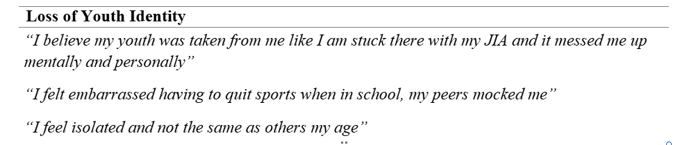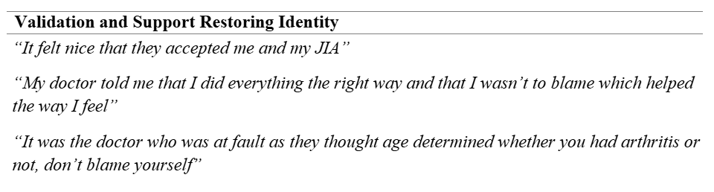

Appendix F- Sample Codebook Process

Data Extract Samples | Preliminary Coding | Semantic Coding | Latent Coding
Most colleagues didn't show empathy and told me that they wouldn't give me the job as they see me as a liability, it really disrupted how I saw myself and it was weakening  I now know that when people say comments like “but you’re so young” is a red flag | Being viewed as a liability due to illness which results in the participant affecting the way they see themselves.  Age based stigma and learning to notice when people make those comments that it is a red flag | Lack of understanding from others, self-perception affected,  Society stereotypes of arthritis associated with older age, age related stigma | Self-identity distorted due to illness being overlooked and receiving no support or understanding from others.  Social identity impacted as individual has learned to note when individuals aren’t being compassionate in social situations. Individual feels the need to spot certain characteristics of people in social situations in order to preserve their identity
“It demoralises me when others question how bad my condition actually effects me and having to validate my condition”  It felt nice that they accepted me and my JIA | Receiving comments minimising their illness results in them feeling discouraged and harder for them to cope.  Being accepted for their illness in their friendship helping them | Minimisation of JIA  Social validation and support | Social identity impacted as they feel they have to portray themselves a certain way to prove their illness and leads to them feeling isolated and demoralised  Participant receiving acceptance beneficially impacted their self and social identity
My doctor told me that I did everything the right way and that I wasn’t to blame which helped the way I feel | Struggling with self-blame, however, medical staff providing support that they did everything right helped. | Medical validation and support | Self-identity distorted as participant believed they were the cause of getting arthritis however receiving reassurance beneficially impacted their social and self-identity showing how much of an impact stigma/support has on the individual's social and self-identity
I'm suffering as I feel like I'm at fault for getting JIA due to my family saying I'm to blame for developing it as I wasn't more careful | Feeling distress and self-blame due to being told by family that it is their fault they got the illness | Family blame and internal blame | Participants self-identity distorted as they struggle internally with emotional distress and self-blame due to being told by others that they are at fault for getting JIA
(All quotes have been paraphrased to protect the anonymity and privacy of the users)

Appendix G- Preliminary Thematic Map

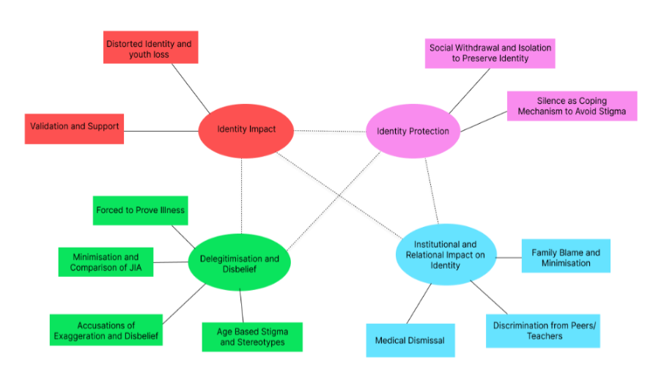

Appendix H- Thematic Map Key
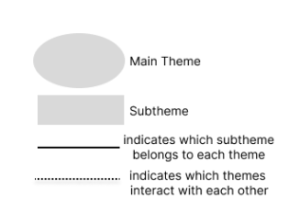

Appendix I- Positionality statement

