Institute of Art, Design and Technology, Dun Laoghaire
Faculty of Film, Art and Creative Technologies

More than a Streaming Service.
How Spotify influences Taste, Performance and Spectacle.

By Aoife Murphy
Submitted to the Department of Design and Visual Arts in candidacy for the
BA (Hons) in Graphic Design 2026
14/02/2026
Word Count: 9,977

Declaration of Originality

This thesis is submitted by the undersigned to the Institute of Art Design & Technology,
Dun Laoghaire in partial fulfilment of the examination for the BA (Hons) in Graphic Design.
It is entirely the author’s own work except where noted and has not been submitted for an award
from this or any other educational institution.

Signed _____________

Grammarly was used throughout this thesis to assist with grammar errors, spell checking
and clear phrasing.
Acknowledgements

I would like to thank my partner, family and friends for their ongoing support throughout the writing of this thesis. I would like to thank my supervisor, Dr Linda King, for her invaluable guidance throughout this process.

Abstract

This thesis examines how the renowned music streaming service, Spotify, influences music taste, disciplines performative behaviour and turns the practice of listening into a visual and social spectacle. This argument utilises Pierre Bourdieu’s theories of taste, habitus, and cultural capital; Marshall McLuhan’s insights into media; Erving Goffman’s theory of performance; Michel Foucault’s work on surveillance and discipline; Guy Debord’s theories on spectacle; and Jean Baudrillard’s work on simulation and hyperreality. Parallels are drawn between these ideas and Spotify’s algorithms, interface and campaigns, with a particular focus on Spotify Wrapped, to explain how listening to music has transformed from a private act of enjoyment to a visual, public-facing performance.

Table of Contents:

List of Plates 1
Introduction 4
Chapter 1: Taste 8
1.1: The Structuring of Taste 9
1.2 The Illusion of Choice 12
1.3 The Measurement of Taste 14
Chapter 2: Performance 19
2.1: The Presentation of Taste in Everyday Life. 21
2.2: Panopticon Algorithms 24
2.3 You Listened. We Counted. 26
Chapter 3: Spectacle 28
3.1 Visualising Listening 28
3.2 Representing Listening 33
3.3 Replacing Listening 35

Conclusion 38
Bibliography 41
List of plates

Fig. ,1 Screenshot of the Spotify Wrapped sharing slide. (Spotify, 2025). [Accessed: 03/12/2025].

Fig. 2, iTunes Data Visualisation. (MacRumors, 2012). Available at:
https://arstechnica.com/gadgets/2012/11/itunes-through-the-ages/. [Accessed: 03/10/2025].

Fig. 3, Screenshot of Spotify’s home screen. (Spotify, 2026). [Accessed: 28/01/2026].

Fig. 4, Screenshot of Spotify’s Discover Weekly playlist cover. (Spotify, 2025). [Accessed: 13/12/2025].

Fig. 5, Spotify’s Your Listening Personality, which featured in Spotify Wrapped 2022. (Engineering at Spotify, 2023). Available at: https://engineering.atspotify.com/2023/1/whats-a-listening-personality. [Accessed: 13/12/2025].

Fig. 6, Spotify’s descriptions of the 16 Listening Personalities within Spotify Wrapped 2022. (Engineering at Spotify, 2023). Available at: https://engineering.atspotify.com/2023/1/whats-a-listening-personality. [Accessed: 13/12/2025].

Fig. 7, Myers-Briggs Type Indicator personality type descriptions. (Simply Psychology, 2025). Available at: https://www.simplypsychology.org/the-myers-briggs-type-indicator.html. [Accessed: 07/02/2026].

Fig. 8, Screenshot of Spotify Wrapped Slide. (Spotify, 2025). [Accessed: 08/02/2026].

Fig. 9, Spotify Wrapped Sharing Slide. (Vogue, 2023). Available at:
https://www.vogue.in/content/i-love-spotify-wrapped-so-much-i-hate-it. [Accessed: 07/02/2026].

Fig. 10, Screenshot of Spotify’s Friend Activity section. (Spotify, 2026). [Accessed: 07/02/2026].

Fig. 11, Screenshot of a Spotify user’s public profile. (Spotify, 2026). [Accessed: 07/02/2026].

Fig. 12, Spotify Wrapped’s sharing option. (Reddit, 2024). Available at: https://www.reddit.com/r/Music/comments/186rhyt/normalize_sharing_spotify_wrapped/.
[Accessed: 07/02/2026].

Fig. 13, Screenshot of the number of minutes listened to on Spotify Wrapped 2025. (Spotify, 2025). [Accessed: 07/02/2026].

Fig. 14, Screenshot of a user’s top artist on Spotify Wrapped 2025. (Spotify, 2025).
[Accessed: 07/02/2026].

Fig. 15, Screenshot of Spotify Wrapped slide 2025. (Spotify, 2025). [Accessed: 07/02/2026].

Fig. 16, The Beatles’ Sgt. Pepper’s Lonely Hearts Club Band (1967) album cover. (Rare Records).
Available at: https://www.rarerecords.com.au/products/sgt-peppers-lonely-hearts-club-band-1?srsltid=AfmBOooIAhN8WBKrBostLPEnqQe-o7rQbxKN2Rd-9GrzzN3RD96g1QGQ.
[Accessed: 09/02/2026].

Fig. 17, Snapshot of Michael Jackson’s music video for Thriller (1982). (CNN, 2023). Available at: https://edition.cnn.com/interactive/2023/12/style/thriller-dance-video-40-year-anniversary/. [Accessed: 09/02/2026].

Fig. 18, Photograph of U2’s 2009- 2001 360° tour visuals. (U2, 2011). Available at: https://www.u2.com/news/title/how-was-it-for-you/6. [Accessed: 09/02/2026].

Fig. 19, Screenshot of Spotify’s interface displaying a currently playing song. (Spotify, 2025). [Accessed: 09/02/2026].

Fig. 20, Screenshot of daylist playlist cover ‘millennial indie 00s Sunday afternoon’. (Spotify, 2025).
[Accessed: 14/12/2025].

Fig. 21, Screenshot of daylist playlist cover ‘fresh bubblegrunge Monday morning.’ (Spotify, 2025).
[Accessed: 24/11/2025].

Fig. 22, Screenshot of daylist playlist cover ‘power ballad soft pop Tuesday night.’ (Spotify, 2025).
[Accessed: 18/11/2025].

Fig. 23, Screenshot of daylist playlist cover ‘main character pov: indie Monday late night.’ (Spotify, 2025).
[Accessed: 21/10/2025].

Fig. 24, Screenshot of the Spotify Wrapped sharing slide (Spotify, 2024). [Accessed: 04/12/2024].

Fig. 25, An advert for Spotify Wrapped featuring Olivia Rodrigo (2023). [Photograph: Spotify]. (The Guardian, 2023.) Available at https://www.theguardian.com/music/2023/nov/30/spotify-wrapped-is-creepy-meaningless-and-shows-just-how-much-data-big-tech-has-on-you. [Accessed: 13/12/2025].

Fig. 26, Screenshot of Spotify’s Discover Something New section. (Spotify, 2025). [Accessed: 15/12/2025].

Fig. 27, Screenshot of TikTok’s interface. (TikTok, 2026). [Accessed: 07/02/2026].

Introduction:

“He who is subjected to a field of visibility, and who knows it,
assumes responsibility for the constraints of power.”
(Foucault, 1977, p. 202).

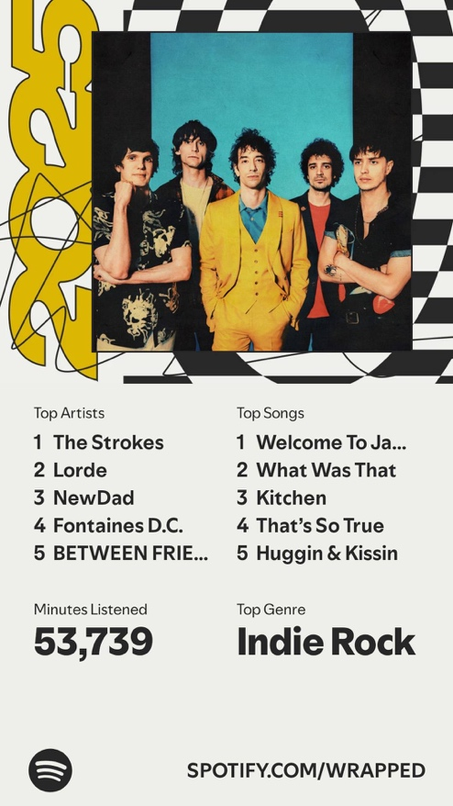

Fig. 1, Screenshot of the Spotify Wrapped sharing slide. (Spotify, 2025)
Music streaming platforms, like Spotify, have transformed how audiences access, experience and understand music. Spotify, a Swedish company founded by entrepreneur Daniel Ek in 2006
(Azzarah, 2024, p. 1), has gained worldwide notoriety and popularity over the last few years by providing millions of users with access to unlimited songs, genres and artists, setting the platform up
to be ideal for the unlimited discovery of music. “Spotify's rapid growth has driven significant changes in the music industry, giving musicians and listeners wider access and creating a new ecosystem in the entertainment business” (Azzarah, 2024, p. 1). Alongside competitors such as Apple Music, YouTube Music, and SoundCloud, Spotify has shaped a new way of listening built around algorithmic recommendation, data tracking and personalised interfaces. The continuous streaming of music has taken over ownership.

To stand out in a competitive market, Spotify developed an innovative marketing campaign that turned listening into an annual event rather than a passive hobby. This is Spotify Wrapped (fig. 1).
It is a yearly compilation of a user’s listening activity, showing their most-played songs, genres, artists and podcasts. The first iteration of Spotify Wrapped began in 2015, under the name ‘Year in Review’ and was in the form of a website. (Annabell, 2024, 1178). In 2016, it became the infamous Spotify Wrapped, which can be viewed through the Spotify app. Users look forward to this every December, so much so that it could be considered an annual event. Its portrait dimensions that fit an Instagram story and personalised quality make it perfect for sharing on social media. Every year, the popularity of this marketing scheme grows. For example, in 2022 alone, the “Wrapped campaign engaged 150 million monthly active users and grew 30% from 2021.” (Annabell, 2024, 1178). Spotify frames Wrapped as a celebration of individuality, calling it a “unique, personal way to reflect” (Spotify, 2024). Vice President of Spotify, Mark Hazan, describes it as “a global cultural phenomenon in its own right… celebrating the hundreds of millions of ways that (users have) streamed.” (Spotify, 2024). However, beneath its surface-level appeal, Wrapped exposes the platform's underlying systems, showing users how listening is tracked, categorised, and structured by algorithms.

This thesis argues that Spotify’s systems do not simply reflect musical taste, but actively organise how this taste is formed, performed and experienced. Instead of viewing streaming as a neutral tool for the discovery of music, this research examines how the private act of listening to music has shifted from deliberate choice to a highly visible, visual experience driven by algorithms. To investigate this transformation, historical sociological and media theories are applied to this contemporary digital platform to test whether these frameworks remain relevant in the age of algorithmic music streaming. Pierre Bourdieu’s theories of habitus and cultural capital are used for understanding how pre-existing taste continues to operate within algorithmically-driven platforms. Marshall McLuhan’s theory that “the medium is the message” (McLuhan, 1967, p. 10), frames how the platform itself reshapes user perception and behaviour. Erving Goffman’s concept of performance, alongside Michel Foucault’s theory of surveillance, highlights how data tracking and social visibility transform listening into a
self-monitored activity to be performed. The theories of Guy Debord and Jean Baudrillard illustrate how digital media convert the lived experience of listening to music into spectacle and representation. By testing these 20th century theories through Spotify’s interface, algorithms and marketing strategies, this thesis analyses how contemporary streaming restructures our engagement with listening.

Chapter 1 examines how music taste is socially constructed and influenced by the structure of Spotify. While Spotify provides unlimited access to music, this chapter argues that this doesn’t guarantee the expansion of taste. The first section introduces French sociologist Pierre Bourdieu’s theories of taste
as a social classifier, through Distinction: A Social Critique of the Judgement of Taste (1979), The Forms of Capital (1986), and Outline of a Theory of Practice (1977), establishing how preference is shaped by background and exposure rather than individual choice. The second section applies Canadian philosopher Marshall McLuhan’s theory of the medium from Understanding Media: The Extensions of Man (1964) and The Medium is the Massage (1967) to understand the transition from ownership-based platforms like iTunes to algorithmically driven platforms like Spotify. This shift is used to analyse how the structure of a streaming platform shapes and controls the behaviour of its users. There is also a focus on Spotify’s recommender system algorithms in this section. Playlists, like Discover Weekly,
are analysed as structures that reproduce habitus through repetition and familiarity. Psychological research on incidental listening is used to explain how algorithmic repetition increases preference.
The final section examines how taste is measured and categorised through Spotify Wrapped, using Pierre Bourdieu’s framework of cultural capital. This demonstrates how music taste becomes quantified and framed as identity. Together, these sections show that Spotify doesn’t simply reflect
a user’s music taste, but plays an active role in structuring how taste is formed and valued.

Chapter 2 examines how Spotify transforms listening from a private activity into a visible and monitored practice. Users are conditioned to share their taste on social media, while also constantly performing for the algorithms. The first section draws primarily from Canadian-American sociologist Erving Goffman’s analogy of the theatre in The Presentation of Self in Everyday Life (1959) to analyse how users manage the presentation of their musical identity through public profiles, playlists and shareable features. The second section expands this analysis through French philosopher Michel Foucault’s Discipline and Punish: The Birth of the Prison (1977). By applying his metaphor of the Panopticon to Spotify’s algorithmic observation, this section explores how users adjust their behaviour when they know they are being watched. The third section ties the previous sections together, showing the methods of control that Spotify utilises on its users.

Chapter 3 examines how Spotify has transformed listening into a visual and representational experience. The first section gives an overview of the historical relationship between music and visual culture. By drawing on French theorist Guy Debord’s Society of the Spectacle (1967), Spotify’s interface, branding, and playlists are analysed as a visual system that is prioritised over the lived experience
of listening to music. The second section examines Spotify Wrapped as a commodity that converts listening habits into a shareable representation of the act, extending the spectacle into both digital
and physical spaces. The final section introduces French sociologist and philosopher Jean Baudrillard’s theories of hyperreality and simulation in Simulacra and Simulation (1981), to argue that Wrapped moves beyond representation toward substitution. By producing over-simplified data and soundbites of songs, the act of listening is being replaced by visuals, and this defines how music
is listened to by Spotify’s users.

Chapter 1: Taste

Music streaming services, like Spotify, have normalised the unlimited access to every kind of music. Access to consuming music has become very affordable. Spotify has convinced users that it is the best platform for streaming as much music as possible for a low price (Feyre, 2020, p. i). According to music author Robert Strachan, “Democratisation in the digital age implicates specific elements: increased participation and access, a decentralisation of media organisations and technologies, equality in levels of reward and status for participants and the emergence of innovative and diverse forms of expression” (Strachan, 2017, p. 22, cited in Feyre, 2020, p. 10). This unlimited access suggests that listeners are free to explore music and develop taste according to their individual preferences. However, this chapter argues that Spotify reflects and reinforces users’ pre-existing tastes through its algorithms, preventing users from developing their preferences. Drawing on Pierre Bourdieu’s theories of taste, habitus and cultural capital alongside Marshall McLuhan’s insight that “the medium is the message” (McLuhan, 1967, p. 10, this chapter demonstrates that the democratisation of music does not necessarily equate to the democratisation of taste. This unlimited choice creates an illusion of freedom while subtly shaping how listeners enjoy and evaluate music.

1.1 The Structuring of Taste

Taste appears to be subjective and personal, and to align with an individual’s unique personality.
It seems spontaneous and something that we don’t have control over. “Bigger than boring notions
of so-called ‘good’ and ‘bad’ taste, our music tastes can feel foundational to our very selves.” (Hawthorne, 2022, np). However, French sociologist Pierre Bourdieu disagrees with this. He sees taste as a social classifier that, when voiced, can reveal an individual’s upbringing, class and education. Bourdieu’s Distinction: A Social Critique of the Judgement of Taste (1979) argues that “Taste classifies, and it classifies the classifier.” (Bourdieu, 1984, p.6). When a person classifies cultural objects, for example, deciding whether music is good or bad, Bourdieu believes that they are classifying themselves.
When an individual makes a classification, this preference is not neutral. They are positioning themselves within a social hierarchy and signalling distinction. Hua Hsu wrote in his Pulitzer
Prize-winning memoir, Stay True, that he defined himself by the music he didn’t like. “I defined who
I was by what I rejected.” (Hsu, 2022, cited in Hawthorne, para. 8). Bourdieu describes this notion by saying that “social subjects, classified by their classifications, distinguish themselves by the distinctions they make” (Bourdieu, 1984, p. 6). Taste is not just a personal preference. People experience their taste as random and spontaneous when, in fact, it represents social conditioning.

According to Bourdieu, people develop different tastes through internalised social structures.
He describes this through his concept of habitus. Habitus describes how the social norms that individuals have become accustomed to shape their behaviour and thinking patterns. “The habitus is both the generative principle of objectively classifiable judgements and the system of classification.” (Bourdieu, 1984, p. 170). This means that habitus generates a person’s process for determining what they like and don’t like. This shows that taste isn’t necessarily natural, and individuals don’t simply come up with what their taste is on a whim. Taste comes from internalised ways of thinking that are being shaped constantly by class, education, upbringing and past experiences. Therefore, habitus doesn’t produce taste; it creates the frameworks that judge and appreciate taste. In Outline of a Theory of Practice (1972), Bourdieu describes habitus as the “internalisation of externality and the externalisation of internality” (Bourdieu, 1977, p. 68, cited in Navarro, 2006, p. 16). This refers to how social structures like class and education shape taste over time and become internalised dispositions or qualities. Since habitus is what shapes a person's tastes internally, cultural capital is what allows those tastes to be seen and valued by others.

If habitus shapes listeners’ taste, Spotify’s interface reinforces and intensifies this taste. Canadian philosopher Marshall McLuhan’s Understanding Media: The Extensions of Man (1964) and The Medium is the Massage (1967) provide a framework for understanding how media platforms shape human experience. McLuhan’s famous argument of “the medium is the message” (McLuhan, 1967, p. 10) emphasises that the form through which information is communicated affects perception and behaviour more than the content itself. Instead of focusing on what is being communicated, McLuhan says we should pay attention to how the technology itself changes human experience. The ‘message’ of a medium
is not about what it communicates, but refers to “the change of scale or pace or pattern that it introduces into human affairs.” (McLuhan, 1964, p. 8). Applied to Spotify, McLuhan’s principle explains how this platform has transformed the external conditions under which individuals discover, interact with and experience their taste.

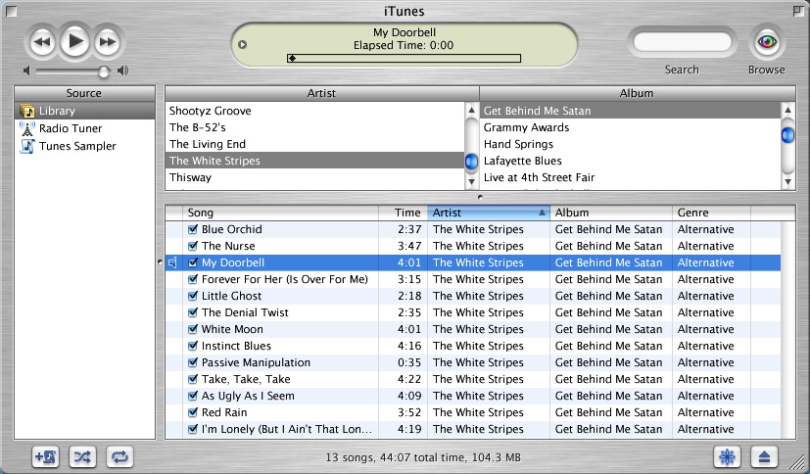

Fig. 2, iTunes Data Visualisation. (MacRumours, 2012).

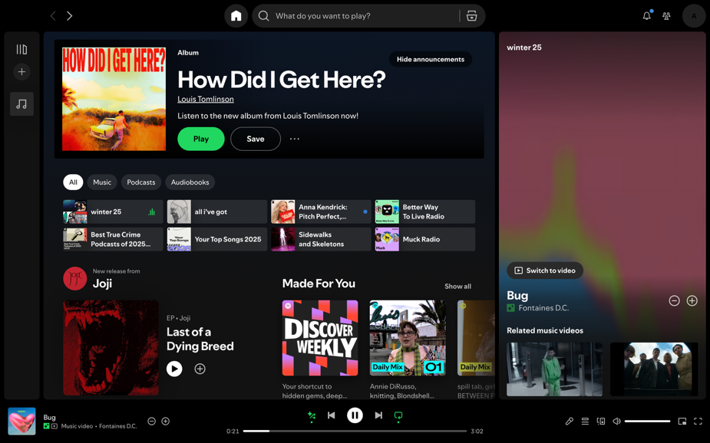

Fig. 3, Screenshot of Spotify’s home screen. (Spotify, 2026).

Earlier listening platforms, such as iTunes, were static, functional media. In fig. 2, the interface presents information in a clear, minimalist format. For example, the song name, length, artist name and genre are arranged in a table, allowing users to search and scroll through their library. The
pared-back design constructs iTunes as a neutral archive, emphasising a pattern of storage and ownership of music over discovery. Simple buttons are used, such as play, pause, skip and shuffle. Listening to a song requires deliberate selection: the user decides which songs to buy or download, creating a very controlled way of listening to music at a slow pace. iTunes users only have listening access to their personal library; this illustrates the small scale of the platform. This reinforces
pre-existing tastes and doesn’t attempt to reshape them. Therefore, iTunes acts as a neutral space instead of an active participant in taste formation.

This contrasts sharply with Spotify’s platform. Fig. 3 shows the Spotify homepage on a laptop. Spotify’s democratisation of music has exponentially expanded the scale of listening. Recent listening, playlists, radio stations, recommended albums, and algorithmically curated playlists such as Discover Weekly and Daily Mixes are all shown simultaneously, speeding up the pace of listening. Users can scroll through endless tailored recommendations and adjust their listening experience through functional buttons such as smart shuffle, queue and lyrics. The current song is fixed to the bottom
of the screen, accompanied by visuals on the right. A motion graphic is looped with the option to switch to a full-length music video. Related music videos and songs are continuously suggested, creating a pattern of constant exposure. Spotify anticipates the user’s choice of music, shifting the experience from self-directed to algorithm-guided.

The transition from iTunes to Spotify is a perfect illustration that “the medium is the message” (McLuhan, 1967, p. 10). Where iTunes served as an archive for users to curate their own music collections, Spotify operates as a social media platform in which algorithms recommend content and influence listening habits. The conditions under which taste is experienced have shifted; immediacy and algorithmic curation have taken over deliberate choice. Habitus explains why individuals are predisposed to certain tastes, and Spotify decides the conditions under which taste is reinforced.
Taste still “classifies the classifier” (Bourdieu, 1984, p. 6), yet classification is now done through Spotify’s interface, algorithms and personalised playlists. By replacing selection with prediction, Spotify does more than reflect taste; it shapes it, producing an environment where our preferences
are increasingly decided by the platform itself. This turns taste into both a social conditioning and
a product of the platform.

1.2 The Illusion of Choice

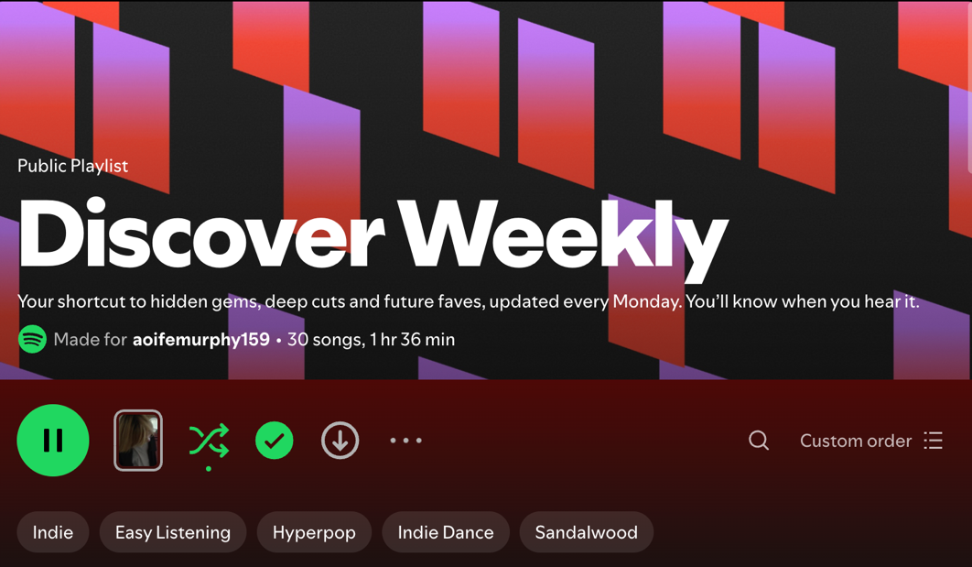

Fig. 4, Screenshot of Spotify’s Discover Weekly playlist cover (Spotify, 2025).

While McLuhan explains how Spotify shapes the environment of listening, it is the platform’s algorithms that actively reinforce users’ pre-existing preferences. Spotify’s algorithms are recommender systems and use “embeddings that encode latent representations between users and content” (Anderson, 2020, p. 2157). Based on listening patterns, algorithms tend to reinforce what listeners already listen to. Therefore, these algorithms learn users’ tastes shaped by class, education and upbringing, feeding them similar music and creating an echo chamber. Spotify’s recommender systems act as a digitalised extension of habitus, reinforcing and preventing dramatic shifts in their original tastes. An example of how habitus is perpetuated in Spotify is the Discover Weekly Playlist,
as seen in fig. 4 above. The playlist uses gradients and geometric graphics to grab the user’s attention. The word ‘discover’ draws the user in, leading them to believe that they are actively searching for new music, creating a narrative that the listener is curating their own taste. This masks the repetition of familiar music. Spotify personalises this playlist by adding the user’s name to the playlist description, creating the perception of an experience made just for the user, encouraging engagement. Displaying the user’s most-listened-to genres below the playlist description reinforces familiar listening habits and discovery of music within the bounds of pre-existing dispositions. It is updated every Monday with
30 new songs. While the playlist introduces new songs, it circulates familiar genres and artists,
limiting the expansion of taste. How algorithms reduce the diversity of consumption can be seen
in Ashton Anderson’s study on the Algorithmic Effects on the Diversity of Consumption on Spotify. “We also find that algorithmically-driven listening through recommendations is associated with reduced consumption diversity. Furthermore, we observe that when users become more diverse in their listening over time, they do so by shifting away from algorithmic consumption and increasing
their organic consumption.” (Anderson, 2020, p. 2155).

It can also be argued that recommender algorithms function as a subtle form of social control. Dr Antoinette Rouvroy, a researcher at the Belgian National Fund for Scientific Research, claims that the purpose of algorithms is to subtly influence users into behaving a certain way. “The aim is … not so much to tailor the offer to individuals’ spontaneous desires (assuming such a thing exists), as to adapt those desires to the offer by tailoring (strategies) to each person’s profile.” (Rouvroy, 2013, p. 13).
By making playlists tailored to each user and reducing the number of decisions that they have to make, recommender algorithms reduce the effort needed for users to listen to music they enjoy.
“The aim is therefore to prompt individuals to act without forming or formulating a desire”
(Rouvroy, 2013, p. 13). This encourages more engagement with the app through passive or incidental listening, while providing an illusion of autonomy. Rather than operating through direct persuasion, the algorithm utilises the psychological preference of familiarity to convert repetition into taste. Incidental listening, in psychology, usually refers to the unintentional learning due to exposure to sound or music in an individual’s environment (Nie, 2022, p. 2). Karl Szpunar, Glenn Schellenberg, and Patricia Pliner, from the University of Toronto, conducted three experiments examining the “changes in liking and memory for music as a function of number of previous exposures”
(Szpunar, 2004, p. 370). The results of these experiments found that “After incidental listening,
liking ratings were higher for music heard more often.” (Szpunar, 2004, p. 370). This demonstrates that repeated listening, even without the intent to focus on it, can build familiarity and fondness over time. Similarly, Zajonc, a social psychologist, found that “mere exposure is a sufficient condition for attitude enhancement” (Zajonc, 1968, p. 15, cited in Szpunar, 2004, p. 370). When algorithms repeatedly push particular genres, artists, and moods toward users, they increase preference by making certain music familiar. This results in reducing engagement with unfamiliar content.

Although users can skip tracks and search for other genres, music aligned with pre-existing tastes
will be highlighted, maintaining the illusion of choice while actually limiting opportunities for musical exploration. By promoting incidental listening, Spotify reduces the opportunities for the critical evaluation of music, allowing repeated exposure to shape musical preference. Spotify’s algorithms don’t dictate taste, they construct patterns of visibility and repetition that make certain sounds feel familiar, desirable and self-chosen, turning habitus into a continuous algorithmically guided process.

1.3 The Measurement of Taste

Taste is a valuable resource, and this has become particularly obvious on social media. It is no longer just an expression of self or a personal preference; it can be a subtle way in which individuals gain advantage in society. Bourdieu calls this invisible advantage cultural capital. In The Forms of Capital (1986), Bourdieu defines cultural capital as when capital extends beyond material assets to social, cultural and symbolic assets that are equally as important in defining social status as money. These could be education, skills, values or taste. Bourdieu argues that “cultural capital can exist in three forms: in the embodied state, … in the objectified state, … and in the institutionalised state.” (Bourdieu, 1986, p. 243). Cultural capital in the embodied state is “in the form of long-lasting dispositions of the mind and body” that are acquired by an individual through education and upbringing. (Bourdieu, 1986, p. 243). These long-lasting dispositions could include manners, language and complex musical appreciation. Objectified capital comes in the form of material and media objects, i.e., paintings, instruments and writings, through which social status is expressed. These objects become significant when “external wealth (is) converted into an integral part of the person, into a habitus.” (Bourdieu, 1986, p. 244). Although an individual can own objectified capital materially, they will need embodied capital to interpret it. “The possession of the means of ‘consuming’ a painting or using a machine … are nothing other than embodied capital.” (Bourdieu, 1986, p. 247). Embodied capital is valuable because skills and knowledge cannot be “transmitted instantaneously” (Bourdieu, 1986, p. 245), it must be internalised through practice. Institutionalised capital, in contrast, is “in the form of academic qualifications” (Bourdieu, 1986, p. 247). This provides socially recognised competency and legitimacy. Cultural Capital in these forms is how people recognise, value and legitimise certain tastes.

When capital shifts from being material and monetary to social and cultural, inequality becomes less visible. “Because the social conditions of its transmission and acquisition are more disguised than those of economic capital, it is predisposed to function as symbolic capital, i.e., to be unrecognised as capital and recognised as legitimate competence.” (Bourdieu, 1986, p. 245). This leads to the unconscious acceptance of social distinction because people mistake privilege for personal merit. Individuals who have been exposed to diverse music and cultural experiences from an early age may appear to possess superior or more refined taste. For example, familiarity with niche or historical genres such as baroque or classical music may be interpreted as evidence of intelligence and refined taste, when it
is usually the result of long-term exposure shaped by habitus. Because taste is seen as a personal preference, the social hierarchies embedded in it are normalised. By making distinctions between ‘high’ and ‘popular’ culture, for example, viewing classical music as sophisticated and pop music on the top charts as ‘basic’, social boundaries are reinforced.

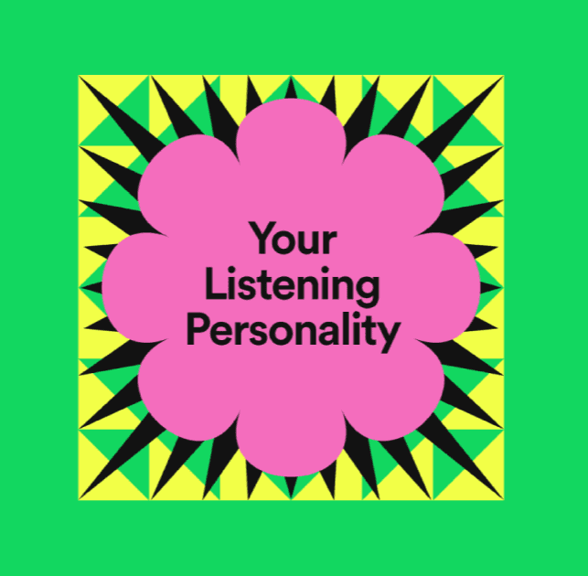

Fig. 5, Spotify’s Your Listening Personality, which featured in Spotify Wrapped 2022. (Engineering at Spotify, 2023).

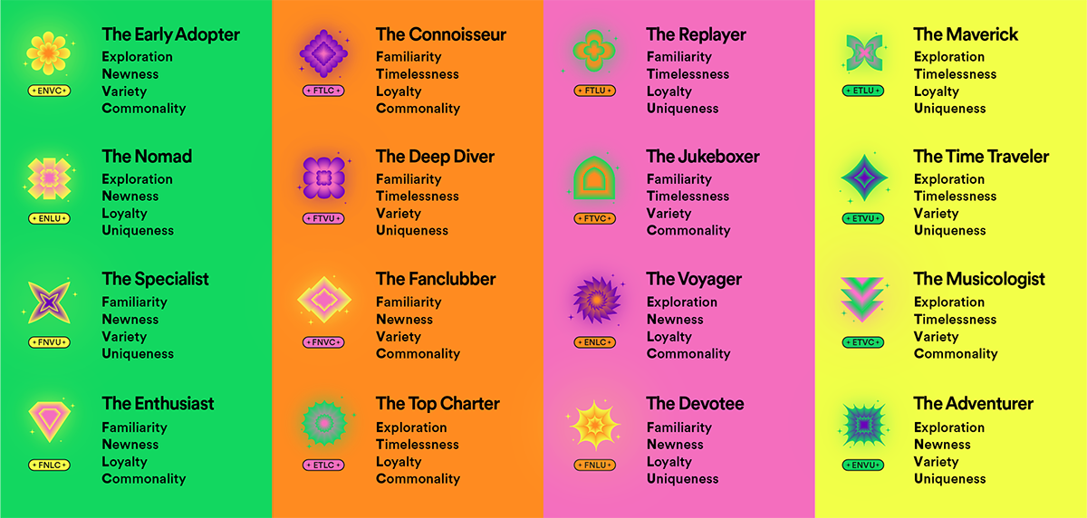

Fig. 6, Spotify’s descriptions of the 16 Listening Personalities within Spotify Wrapped 2022. (Engineering at Spotify, 2023).

Embodied cultural capital is made visible when Spotify ranks users’ genre fluency. In Spotify Wrapped 2022, users were categorised by their listening habits. Each listener was put into a category defined by the four-letter code underneath, as seen in fig. 6. The categories are all paired with different symbols and colours. Each Listening Personality is “a combination of four binary attributes that each try to measure and describe one aspect of how you listen to music.”(McDonald, 2023, np). It does not take into account what genre of music the user likes. These categories included ‘The Replayer’, ‘The Specialist’, ‘The Adventurer’ and ‘The Fanclubber’. The Adventurer would appear to have high musical literacy and a sophisticated taste because of their ability to appreciate a variety of unique genres. However, the Fanclubber might appear to have a narrower taste range and they are defined by the commonality of the music they listen to. This could allude to the user having lower embodied cultural capital.

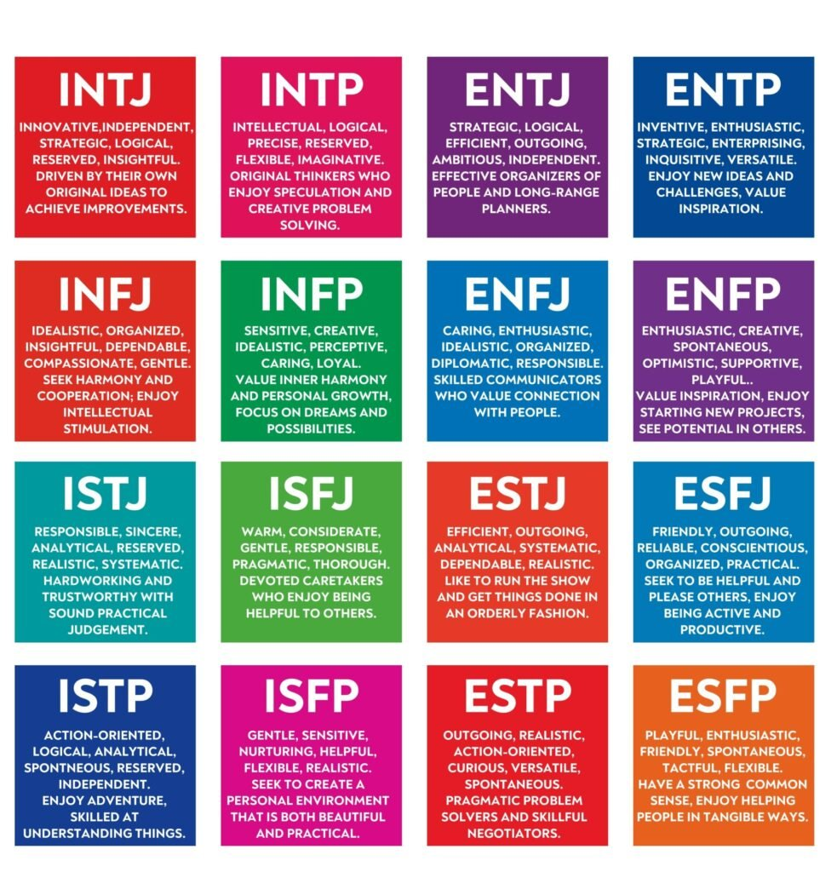

Fig. 7, Myers-Briggs Type Indicator personality type descriptions. (Simply Psychology, 2025).

Spotify’s Listening Personality resembles pseudo-psychological systems such as astrology or the
Myers-Briggs Type Indicator (MBTI) personality test. These both offer simple categories that feel personal despite being standardised, pre-made archetypes. The four-letter codes assigned to each listening personality type closely mirror the MBTI types, as seen in fig. 7. The MBTI was “developed by Isabel Myers during World War II” (Woods, 2022, np). It uses psychologist Carl Jung’s theories of ‘individual preference’ to assess people’s personality types. Jung’s theory states that “seemingly random variations in human behaviour stem from fundamental differences in mental and emotional functioning” (Woods, 2022, np). The MBTI groups these preferences in the following four categories: Energy, Perceiving, Judging and Orientation. The results of this test are delivered in a four-letter code, for example, INTJ. By mimicking this system of categorisation, Spotify makes each listening personality appear to be scientific and insightful. Spotify’s listening personalities feel accurate, just like the MBTI does, by giving vague descriptions of the user while emphasising the positives. However, David J. Pittenger, a researcher from the University of Tennessee at Chattanooga, criticises the system of the MBTI as an “overly simplistic account of complex personality dynamics (that leaves) the recipient with a false impression that there is little left to doubt.” (Pittenger, 2005, p. 219). Despite this over-simplification of listening habits, users may still project meaning onto these categories via the Barnum effect. “The Barnum effect, also known as the Forer effect, is a psychological phenomenon where individuals accept broad, vague generalisations as personally meaningful and accurate.
This tendency is particularly pronounced when the statements are positive and come from someone perceived as an authority figure” (Ungvarsky, 2024, np). Spotify users may see these categories as legitimate because they stem from real data collected by the algorithms. This assumption doesn’t give these systems real scientific depth. In reality, Spotify’s Listening Personality is presenting identity labels that feel psychologically meaningful but are scientifically shallow.

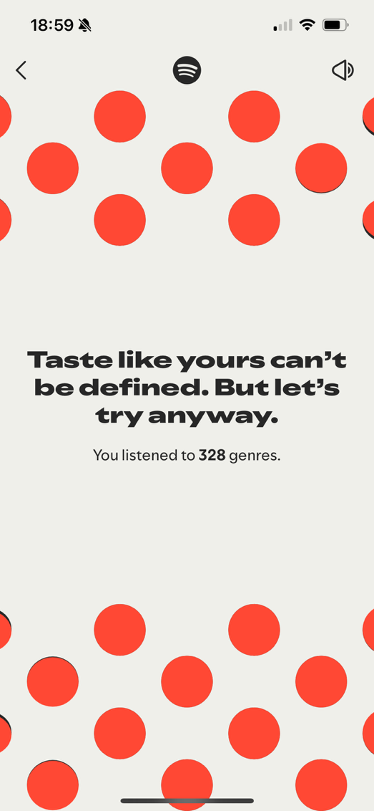

Fig. 8, Screenshot of Spotify Wrapped Slide. (Spotify, 2025).

Katie Hawthorne, an Edinburgh arts writer for the Guardian, states that this could be a “new tactic to persuade us of our uniqueness” (Hawthorne, 2022, np). This could be a way for Spotify to cover up the echo chamber of listening that their algorithms are creating. Spotify has continued this strategy of emphasising the uniqueness of its users every year in Spotify Wrapped. As seen in fig. 8, Wrapped uses copywriting such as “Taste like yours can’t be defined. But let’s try anyway.” This pushes the narrative that you, as a listener, are an individual with your own autonomy and choice over your listening. “Spotify’s emphasis on individuality could be a strategy to combat accusations that streaming platform algorithms … are corrupting influences on their listeners, encouraging homogeneity, and therefore detrimental to lesser-known musicians.” (Hawthorne, 2022, np). These algorithms are so good at matching the taste of listeners that they limit musical discovery. This type of algorithm can cause “the possibility of living in a sound bubble of your own creation, unable to break free.” (Hawthorne, 2022, np). Wrapped appears to be a celebration of individuality, which is actually a system that translates habitus into data, encouraging users to share their cultural capital as a form of identity.
Chapter 2: Performance

Having established that Spotify reinforces habitus through its platform and algorithms, this chapter shifts attention from the formation of taste to the performance of taste. This chapter does not look at taste as something that just belongs to someone; it looks at taste as something to be performed. It is shaped by visibility, audience and surveillance. Through Erving Goffman’s theory of performance (1959) and Michel Foucault’s work on surveillance and discipline (1977), this chapter discusses how Spotify not only reflects users’ tastes, but also provides them with a metaphorical stage, monitors their listening and conditions them into listening in a certain way.

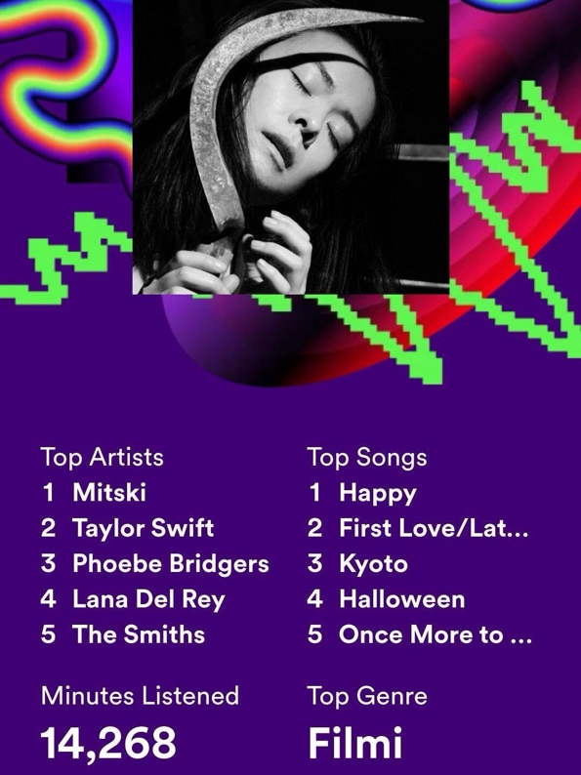

Fig. 9, Spotify Wrapped Sharing Slide. (Vogue, 2023).

Digital Platforms, like Spotify, make a user’s taste visible to a wide audience. Spotify Wrapped turns these taste distinctions into publicly shareable slides. Wrapped defines listeners based on their top
5 songs and top 5 artists of the year. When a listener shares their Wrapped on social media, they make
a statement about who they want to be seen as. For example, fig. 9 displays a Spotify Wrapped slide highlighting artists like Mitski, Lana del Rey and Phoebe Bridgers. These artists are known for their confessional, melancholic songwriting, signalling to an audience that this listener is introspective with emotional depth and is literate within the indie genre. Wrapped is not simply a display of musical preferences; it is a performance of the user’s taste distinction to make a public impression. This relates to Erving Goffman’s theory about front-stage performance and presenting certain data to an audience to maintain the impression you wish to make. “When an individual plays a part he implicitly requests his observers to take seriously the impression that is fostered before them” (Goffman, 1959, p. 17).

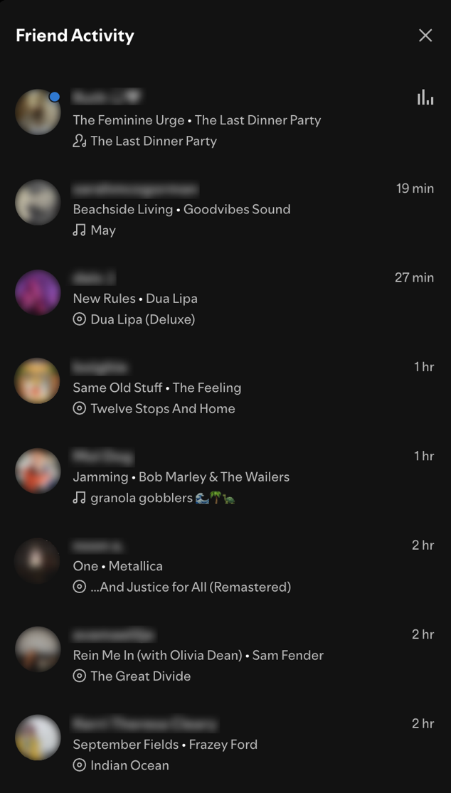

Fig. 10, Screenshot of Spotify’s Friend Activity section. (Spotify, 2026).

This moves listening from a private hobby to a public-facing activity. Users can create a profile, make public playlists, and post Spotify Wrapped. As seen in fig. 10, while using Spotify on a desktop, users can even see which song their friends are listening to at that very moment. These features, along with Spotify’s algorithms, prevent listening sessions in a private space. The algorithms are constantly tracking user data, and have become another audience that users have to perform for. Through Goffman, this chapter analyses Spotify as a ‘front stage’ for identity performance; through Foucault,
it reveals how this stage is built by surveillance and self-monitoring.

2.1: The Presentation of Taste in Everyday Life

Goffman’s view on everyday life is that social interactions are a series of performances that are actively managed by the individual to give off a certain impression to others. Interactions are not simply spontaneous but are more structured and calculated, like a theatrical performance. “When an individual appears before others, his actions will influence the definition of the situation, which they come to have. Sometimes the individual will act in a thoroughly calculating manner, expressing himself in a given way solely in order to give the kind of impression to others that is likely to evoke from them a specific response he is concerned to obtain.” (Goffman, 1959, p. 3). However, sometimes the calculated nature of interactions is unknown to the individual. “Sometimes the individual will be calculating in his activity but be relatively unaware that this is the case.” (Goffman, 1959, p. 3). Goffman believes that social interaction is built around the planned maintenance of an individual’s image and less on authenticity. “The ‘true’ or ‘real’ attitudes, beliefs, and emotions of the individual can be ascertained only indirectly, through his avowals or through what appears to be involuntary expressive behaviour.” (Goffman, 1959, p. 1). He avoids the idea of a person’s true self and focuses on how an individual’s identity can only be interpreted by an audience through actions that appear authentic; some are intentional to achieve a certain reaction, yet others are not.
Goffman compares the public-facing way of interacting with the concept of the front stage, where an actor stands in front of an audience and performs. It is a highly scripted, formal way of behaving that complements the setting and their appearance. For example, how people act at work in front of their manager or behave on social media. “The performance of an individual in a front region may be seen as an effort to give the appearance that his activity in the region maintains and embodies certain standards.” (Goffman, 1959, p. 67). To deliver a believable performance, actors must adhere to a script and behave in a manner that meets expectations. However, this doesn’t necessarily make it fake. In contrast, backstage is where performers can drop their front-stage exterior and behave more informally. The way they act on the front stage could be contradicted and revealed as a performance. “A back region or backstage may be defined as a place, relative to a given performance, where
the impression fostered by the performance is knowingly contradicted as a matter of course.” (Goffman, 1959, p. 69). Although backstage gives room for casual interactions to take place,
this doesn’t necessarily mean that this manner of behaving is the individual’s true self. It is another performance yet in a different context. Different rules and a different audience are leading to a different kind of performance.

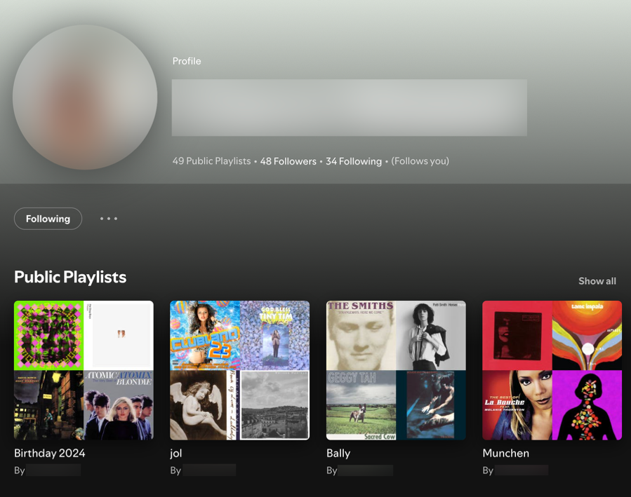

Fig. 11, Screenshot of a Spotify user’s public profile. (Spotify, 2026).

Actors have to work hard to give credibility to their performances and to avoid disruptions. The same is true for social interaction. Social psychologists call this process ‘impression management’, defined as “the process by which people control the impressions others form of them” (Leary, 1990, p. 34).
This requires a continuous process of presenting a desired image to an audience. This can be seen in theatrical performances in the active effort to keep the audience from seeing what is going on backstage. “We find that access to these regions is controlled in order to prevent the audience from seeing backstage and to prevent outsiders from coming into a performance that is not addressed to them.” (Goffman, 1959, p. 152). Goffman sees identity as what individuals choose to reveal to their audience. There is a definite notion of visibility that ties into his metaphor of performance. The idea of impression management can be seen in a Spotify user’s public profile (fig. 11). The profile displays curated public playlists, follower counts, along with a profile picture and username (in this case, they are redacted). There is an option to privatise playlists and listening habits behind this profile. This profile acts as a front stage where users can present a controlled insight into their musical identity to an online audience. By deciding which playlists remain private, Spotify users are actively managing visibility, creating a digitised version of Goffman’s backstage.

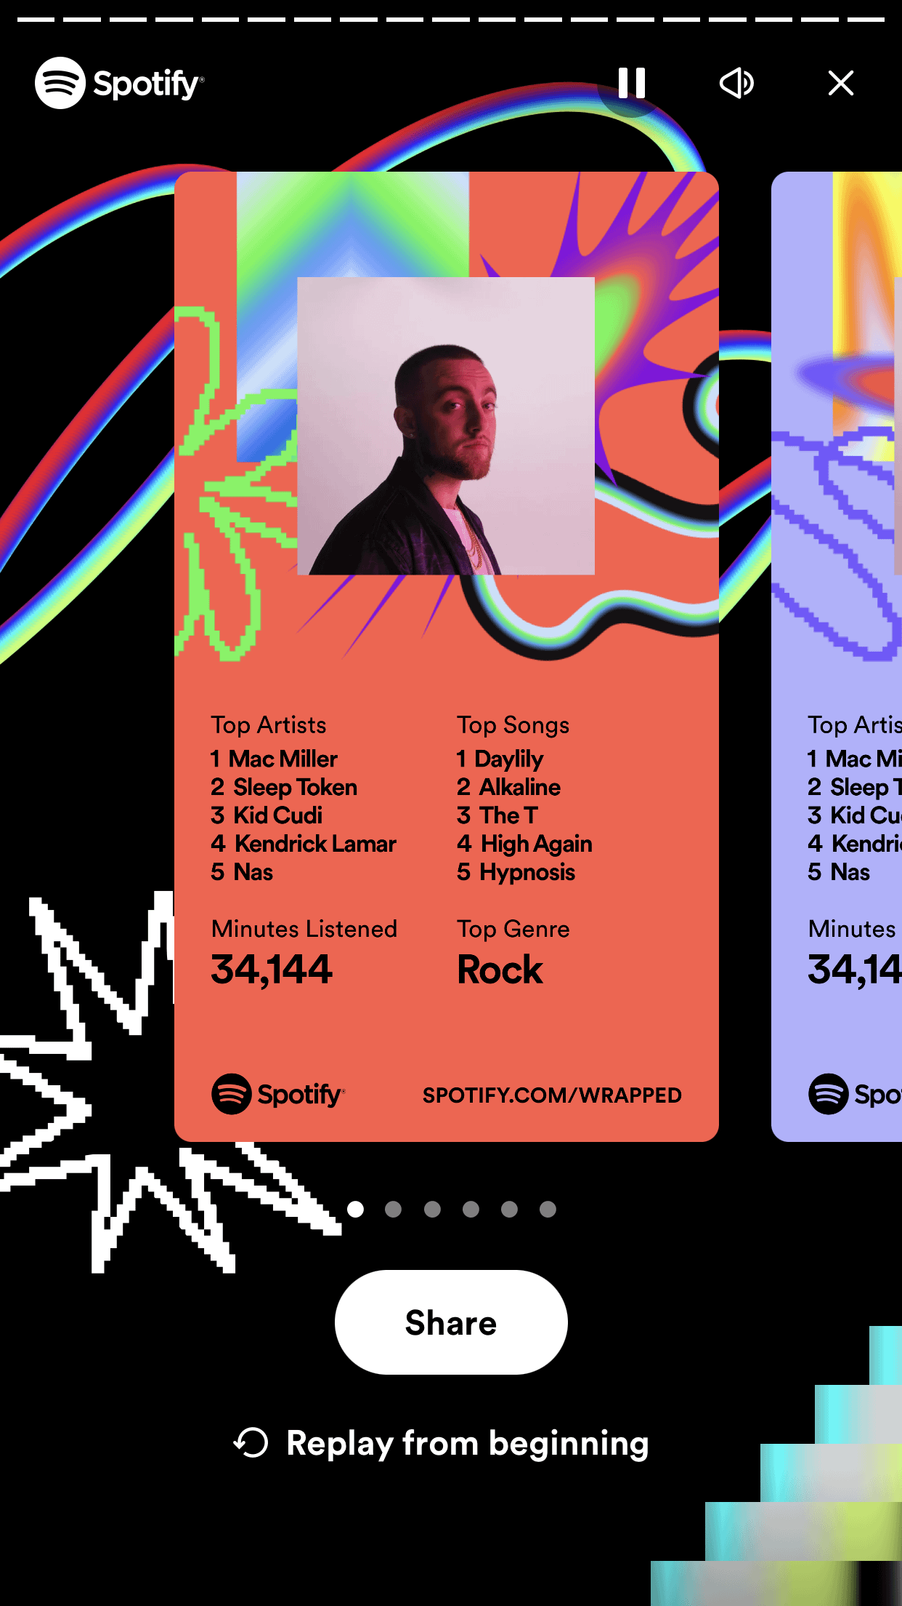

Fig. 12, Spotify Wrapped’s sharing option. (Reddit, 2024).
Spotify Wrapped has been designed with the intention of users sharing it on social media, or else it wouldn’t be a successful marketing tool. They have designed and laid out the listeners’ top 5 artists and songs with the dimensions to fit an Instagram story. Fig. 12 shows how Spotify Wrapped can be shared directly through the app. It is a snapshot of a user’s year of listening to music, and it gives them a good excuse to show that off to their followers. “It’s a savvy marketing scheme for a platform that otherwise makes headlines for paying musicians poorly, although it seems few of us can resist the opportunity to show off our exemplary choices.” (Hawthorne, 2022, np). However, due to the constant visibility that Spotify has imposed onto its users’ listening habits, users are not just performing when they post about their Spotify Wrapped; they are constantly performing throughout their everyday listening. This notion of performing when visible, which Goffman discusses, has become
a constant due to the algorithm’s continuous tracking. This has led to the blurring of lines between Goffmann’s concepts of the front stage and the backstage. “This pervasive observation challenges Goffman’s assumption that backstage spaces are private and protected.” (Jiang, 2025, p. 94).
What once functioned as a backstage, a space for unobserved, private listening, has been made
visible by Spotify, taking the users’ intimate moments with music away.

2.2 Panopticon Algorithms

Where Goffman focuses on performance for audiences, Foucault brings attention to the systems
of observation and discipline within Spotify. Foucault discusses the surveillance systems that are constantly in play through the metaphor of the Panopticon in Discipline and Punish: The Birth of the Prison (1977). The Panopticon is a circular prison with transparent cell walls. In the centre of these cells stands a surveillance tower with a guard watching over. “They are like so many cages, so many small theatres, in which each actor is alone, perfectly individualised and constantly visible” (Foucault, 1977, p. 200). The interesting thing about this is that the guard at the centre is invisible to the prisoners.
The prisoners then have to assume they are being monitored at all times. “The inmate must never know whether he is being looked at at any one moment; but he must be sure that he may always be so” (Foucault, 1977, p. 201). Due to the invisible omnipresence of a guard, the prisoners behave as if they are being watched at all times. “He who is subjected to a field of visibility, and who knows it, assumes responsibility for the constraints of power” (Foucault, 1977, p. 202). Theoretically, the prison could be unstaffed because of this invisible guard, and prisoners effectively guard themselves due to the internalisation of surveillance.

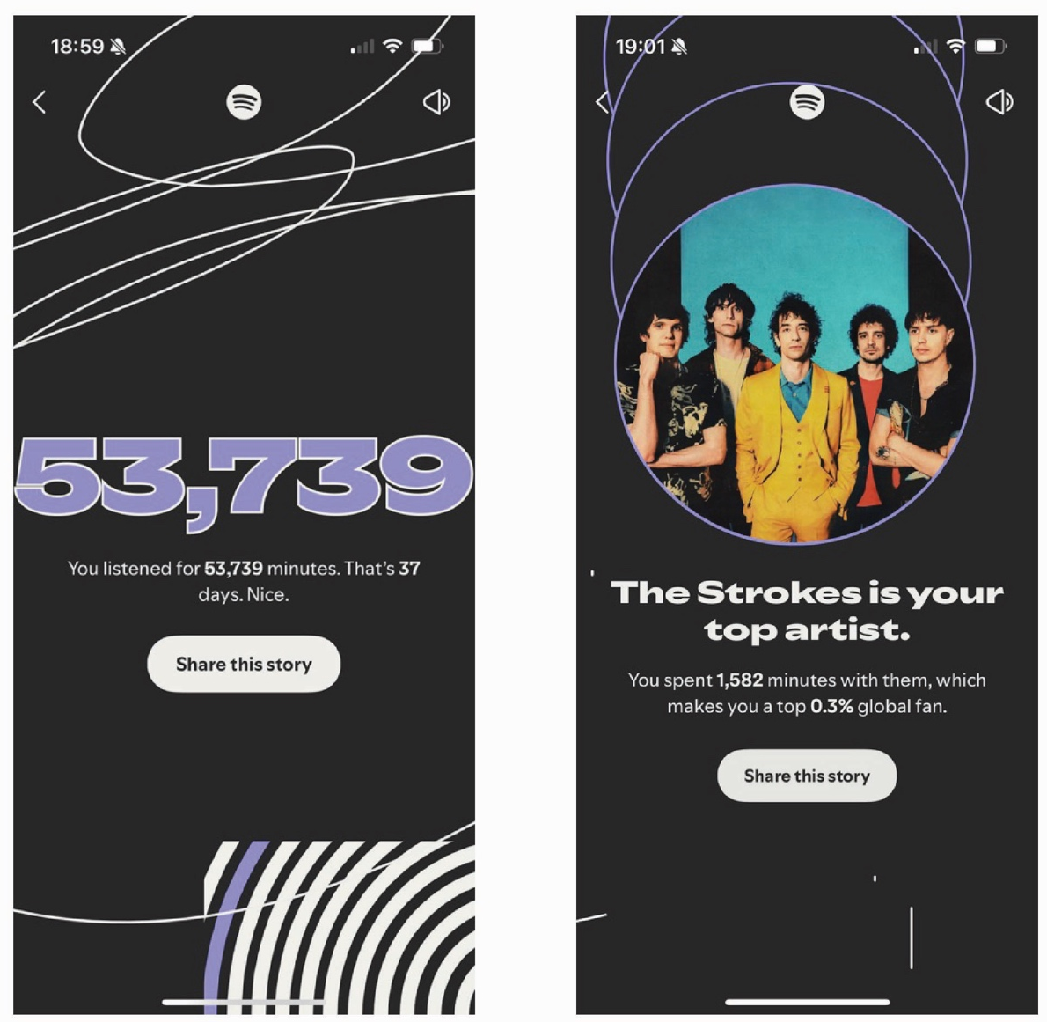

Fig. 13, Screenshot of the number of minutes listened Fig. 14, Screenshot of a user’s top artist on Spotify
on Spotify Wrapped 2025. (Spotify, 2025). Wrapped 2025. (Spotify, 2025).

Foucault’s metaphor of the Panopticon runs parallel to Spotify’s system of data tracking and algorithms. Spotify users are under a constant state of visibility. Every song played, skipped, saved
and streamed is recorded by Spotify. Similar to the Panopticon, the users never fully see how intently they are being watched, but they are very aware that data about them is being constantly collected. Spotify’s algorithms are the invisible guard in the centre tower. Despite the invisibility of the watcher, users know that they are being observed. The data being collected about listeners will be revealed at the end of the year in the form of Spotify Wrapped. Fig. 13 and fig. 14 show the high level of detail shared in Wrapped. The exact number of minutes an individual spends listening to music is shown.
It even ranks users’ listening times against all other fans of their top artist. This omnipresent awareness can impact how a Spotify user listens to music. Maybe they would skip their guilty pleasure after listening to it too many times. If an artist that a user enjoys goes against the image they want to present, they might stop listening to that artist. Users may spend more time on Spotify to ensure
they have a high number of minutes listened, which shows off their passion for music. In this way, control does not rely on force. The simple awareness of being tracked encourages users to adjust themselves, turning listening into a process of quiet self-regulation rather than free, private choice.

2.3 You Listened. We Counted

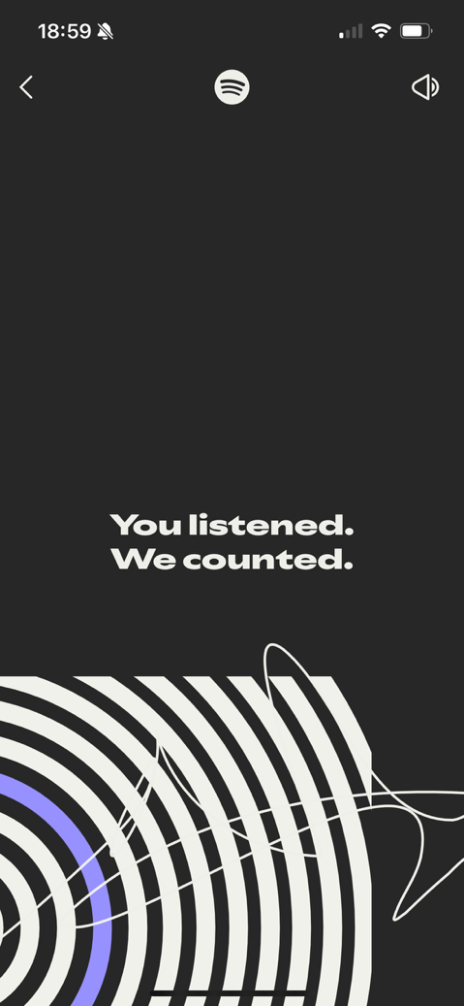

Fig. 15, Screenshot of Spotify Wrapped slide 2025. (Spotify, 2025).
When analysed together, Goffman’s theory on the performance of interactions and Foucault’s Panopticon metaphor on surveillance, reveal how Spotify has transformed listening from a hobby to a highly visible activity that is being monitored at all times. Goffman’s front stage is no longer just an audience of people. This new audience consists of algorithms. “The performer’s role is thus reframed: rather than crafting a performance solely for human perception, they must optimise for algorithmic logics such as engagement rates, click-throughs, and watch times” (Jiang, 2025, p. 95). The way that Spotify has brought constant front-stage visibility to our listening habits has moved listening away from personal enjoyment. This feeling of being watched is even perpetuated by Spotify Wrapped’s eerie copywriting in fig. 15; “You listened. We counted.” This illustrates the disintegration of the boundary between Goffman’s front and backstage. Listening has become like the Panopticon prison, with no privacy and the feeling of being watched at all times. “In Goffman’s model, audiences are identifiable and bounded: a theatregoer is physically present in a specific space. Online, the audience is potentially infinite, invisible, and unpredictable. Content can be consumed by strangers, employers, or automated surveillance systems. This ‘context collapse’ forces individuals to perform for multiple, often conflicting, audiences simultaneously” (Jiang, 2025, p. 96).

Goffman’s theory states that individuals might be unaware of this performance, “sometimes the individual will be calculating in his activity but be relatively unaware that this is the case” (Goffman, 1959, p. 3). Within Spotify’s environment, this notion by Goffman is intensified through Foucault’s discipline. Once an individual internalises the idea of being constantly monitored by an algorithm, they begin to monitor their own behaviour to keep their impression management consistent, sometimes without even realising they are doing so. What emerges is not simply a space where taste is displayed, but a system where listening itself is structured around the anticipation of being exposed and judged. Spotify gives listeners a stage and a disciplinary system. “The central question that emerges is whether users today are still managing impressions, or whether they are increasingly being managed” (Jiang, 2025, p. 97). Therefore, listeners perform their musical identity, but this performance is scripted, measured and directed by Spotify.

Chapter 3: Spectacle

While Chapter 2 analyses how Spotify encourages and disciplines the performance of identity, this chapter examines how Spotify transforms music listening from a lived, auditory experience into a visual and representational one. Drawing on Guy Debord’s Society of the Spectacle (1967) and Jean Baudrillard’s Simulacra and Simulation (1981), this chapter explores how Spotify’s visual culture, for example, playlists, interface design, and Spotify Wrapped, has replaced the authentic experience of listening to music. Music is no longer primarily interacted with as sound; music is now designed to be seen. This chapter demonstrates how the platform visually aestheticises music and collapses the distinction between representation and reality. Spotify doesn’t just visualise music, it replaces listening with image, data and simulations of taste.

3.1 Visualising Listening

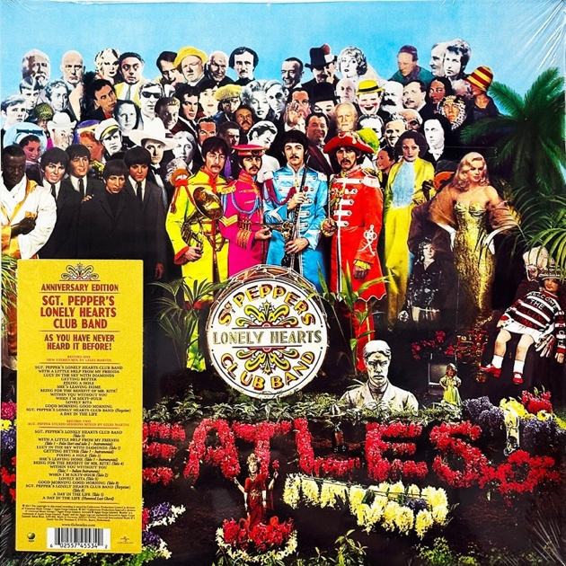

Fig. 16, The Beatles’ Sgt. Pepper’s Lonely Hearts Club Band (1967) album cover. (Rare Records).


Fig. 17, Snapshot of Michael Jackson’s music video for Thriller (1982). (CNN, 2023).



Fig. 18, Photograph of U2’s 2009- 2001 360° tour visuals. (U2, 2011).

Historically, music has always incorporated visual elements designed to support and enrich the listening experience rather than replace it. Album covers provide a first impression that “represent(s) the music contained inside them” (Vad, 2021, p. 11). Fig. 16, The Beatles’ Sgt. Pepper’s Lonely Hearts Club Band (1967) uses collaged famous figures and psychedelic colours to define an era and address the band’s experimental identity. Music videos similarly add visuals to sound. Michael Jackson’s Thriller (1982) in fig. 17 creates a cinematic narrative to go with this song, paired with choreography and horror imagery. Live music has always used visuals to enhance the artist’s performance. U2’s 360° tour (2009-2011) used a gigantic claw-like structure to create an immersive atmosphere. While these examples enhance the listening experience, music remains the primary medium. The visuals function as an extension to listening, not as a replacement.

Spotify, however, represents a radical shift in the relationship between sound and image. Unlike visuals that extend the artist’s vision, Spotify’s visuals are platform-led and are put at the centre of the listening experience. Instead of visuals emerging from the music, music is encountered through Spotify’s visual interface. This shift reflects what Debord describes in Society of the Spectacle (1967) that “everything that was directly lived has receded into a representation.” (Debord, 2014, p. 2). Debord is not simply speaking about images, but a “social relation between people that is mediated by images” (Debord, 2014, p. 2). On Spotify, listening is organised into a visual system through design, colour, reels, shareable slides, and access to friends’ profiles. This changes how users interact with, discover and choose music.

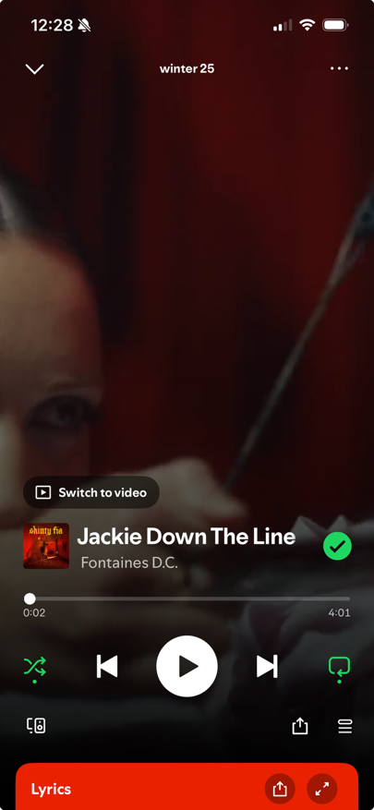

Fig. 19, Screenshot of Spotify’s interface displaying a currently playing song. (Spotify, 2025).
The platform’s interface exemplifies this shift from lived experience to representation. Fig. 19 shows a song currently playing on Spotify. The album cover is reduced to a small square. Visually, it is of lesser importance than the user interface (UI) buttons like play, skip and shuffle that dominate the screen. The user’s attention is guided toward the interface design over the current track. Earlier platforms, like iTunes, foregrounded the album artwork, but Spotify prioritises engagement with the interface first. The act of listening is now inseparable from the act of clicking UI buttons. Spotify’s green and black colour scheme and sans-serif typography have also become synonymous with the act of listening, making the experience itself branded. “The world of the commodity dominating all living experience.” (Debord, 2014, p. 14). This aligns with Debord’s theory that “the perceptible world is replaced by a selection of images which is projected above it, yet which at the same time succeeds in making itself regarded as the perceptible par excellence” (Debord, 2014, p. 14). This means that our perception of reality is determined through images rather than through actual lived experience. In this way, Spotify’s interface doesn’t just accompany music as an album cover or music video would do; it frames how music is experienced. The reduction of the album artwork to a small square encourages the user to interact with the interface rather than enjoy the music itself. Each press of a play, skip or shuffle button becomes a decision that feeds the recommendation system, tailoring its predictions to the individual over time. A user’s listening habits are tracked and harvested to be turned into a tool
for shaping the algorithm.

Debord argues that “wherever representation becomes independent, the spectacle regenerates itself.” (Debord, 2014, p. 14). This means that once a lived experience is replaced by representations, new representations that come after this don’t need real experience to back them up anymore. The spectacle will continuously repeat itself by creating more images that shape behaviour, and more representations will be generated as a result. The purpose of this is to alienate individuals from their autonomy over their lives “The spectacle’s social function is the concrete manufacture of alienation.” (Debord, 2014, p. 11). Modern digital systems, such as Spotify, promise users personalisation. Individuals are conditioned to think that this personalisation is a mirror, that it represents them and their choices. By using algorithmically designed playlists, for example, individuals are becoming less connected to their own agency and control over their listening. “The closer their life comes to being their own creation, the more they are excluded from that life.” (Debord, 2014, p. 11).

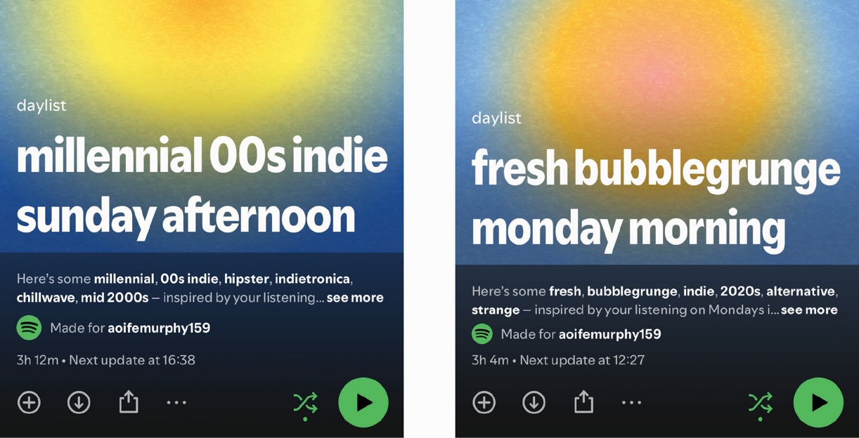

Fig. 20, daylist playlist cover ‘millenial indie 00s Sunday afternoon’. Fig. 21, daylist playlist cover ‘fresh bubblegrunge Monday morning.’
(Spotify, 2025). (Spotify, 2025).

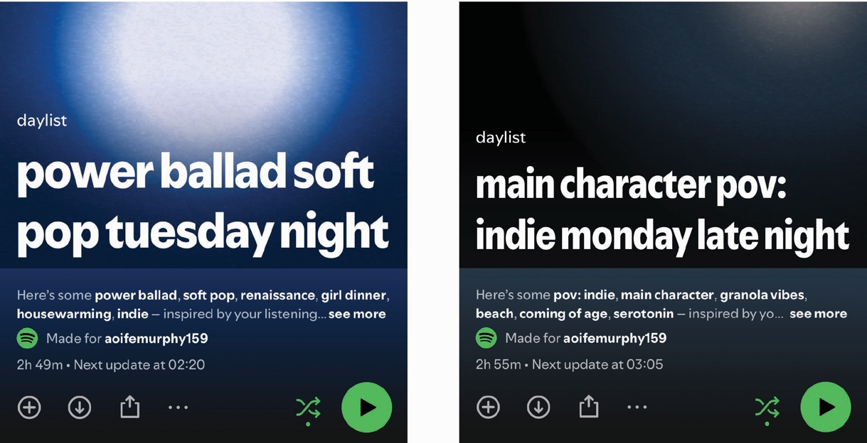

Fig. 22, daylist playlist cover ‘power ballad soft pop Tuesday night. Fig. 23, daylist playlist cover ‘indie Monday late night.’
(Spotify, 2025). (Spotify, 2025).

This can be seen in Spotify’s algorithmically made playlist, ‘daylist’. As seen in the varying versions in figs. 20-23 above, daylist updates automatically every few hours and generates a new atmosphere or type of music for each user that includes a mood, genre and time of day. Each time the playlist updates, it is given a new absurdly specific name in Spotify’s custom sans-serif font that coincides with the day and time. For example, ‘sad girl indie pop Tuesday morning’. The gradients and colours in the background align with the time of day the playlist is opened at and convey a mood to the listener, suggesting how a user should be feeling at this time. These specific titles suggest personalisation despite being mass-produced for every user. Daytime playlists have yellow, orange and blue gradients. At night, daylist is treated with a glowing orb of white against a dark background. This image is what users see first before they start listening to the music.

This false personalisation reflects Debord’s argument of the spectacle regenerating itself. Instead of users choosing music based on their mood, Spotify makes a playlist for the user before they even need to decide how they feel or what music they are in the mood for. Instead of streaming platforms reflecting a user’s mood, it creates and decides it. Direct emotional experience with music is being replaced with pre-made playlists. The algorithms use pattern recognition and specific titles to induce the illusion of intimate listening that almost makes the user feel like they chose it. Spotify promotes daylist using the slogan ‘your day, your playlist’, reinforcing the illusion of autonomy. However, this false intimacy creates “manufactured alienation” (Debord, 2014, p. 11). The more users believe that this ‘personalised playlist’ is a product of their autonomy over their listening, the more likely they are to be shaped by Spotify’s algorithms and lose control over their listening. Listening through Spotify has become a pre-structured experience defined by visuals and algorithmic control and branding instead of direct engagement with sound.

3.2 Representing Listening

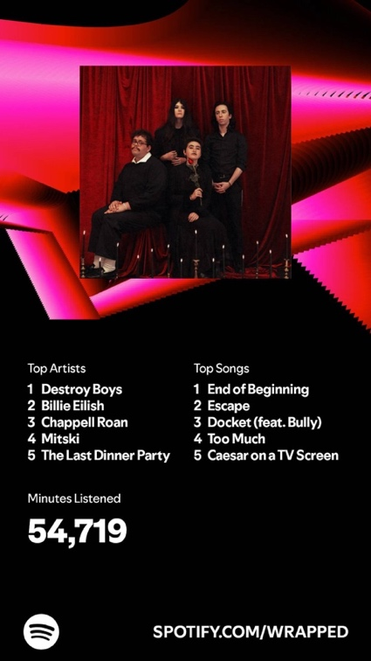

Fig.24, Screenshot of the Spotify Wrapped sharing slide (Spotify, 2024).
Spotify Wrapped demonstrates how listening is transformed into a visual representation designed to be shared. Debord argues that within the spectacle, “the commodity contemplates itself in a world of its own making” (Debord, 2014, p. 20). Digital platforms create environments in which their commodities are continuously reflected through images instead of through their actual use. Wrapped exemplifies this by summarising a year of listening into one shareable slide, as seen in Fig 24. Users are encouraged to share these slides across social media, turning them into willing promoters of Spotify’s brand. In this way, Spotify then looks at itself through the users to measure its own success and relevance. Users have now become active participants in the spectacle.

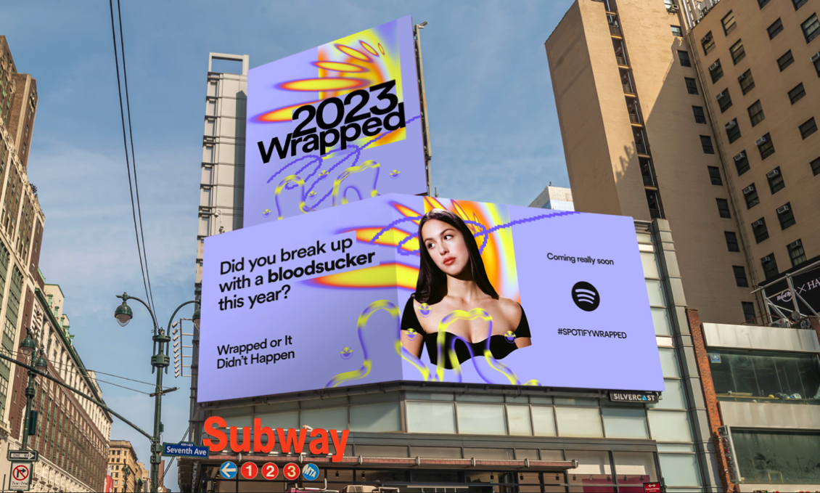

Fig. 25, An advert for Spotify Wrapped featuring Olivia Rodrigo

The spectacle of Wrapped extends into the physical space. Fig. 25 shows a billboard promoting Wrapped 2023 above the Seventh Avenue subway station in New York City. It features an image
of singer Olivia Rodrigo, a recognisable mainstream pop artist. The use of Rodrigo aims to root Wrapped in relatability. It displays a reference to one of her most-streamed songs, ‘vampire’, ‘Did you break up with a bloodsucker this year?’ This is a clear attempt to make sure that viewers understand that Spotify Wrapped is relevant and up to date with modern listening. The colour and patterns used match the identity of bright colour, digitised gradients and generative squiggles that represent Wrapped 2023, giving users a taster into what is ‘coming really soon’. It uses the phrase ‘Wrapped,
or it didn’t happen’, which is an exemplar of representation replacing lived experience. It frames Wrapped as a system that is needed to prove listening identity. It implies that listening can only have happened if there is a record of it that can be shared online. This relates to Debord’s theory that our perception of reality is determined through images rather than through actual lived experience, that visual proof of listening is positioned over the act itself.
3.3 Replacing Listening

While Debord is used to explain Wrapped as a spectacle, the feature moves beyond representation into simulation. Jean Baudrillard’s Simulacra and Simulation (1994) argues that modern culture is transforming reality into a simulation. “It is no longer a question of imitation, nor duplication, nor even parody. It is a question of substituting the signs of the real for the real” (Baudrillard, 1994, p. 2). This means that the media, such as Spotify, is no longer reflecting reality; it is replacing it. The distinction between what is real and what is a simulation is no longer discernible. Wrapped reduces
a user’s complex listening history to a mere 5 songs and artists. Such a condensed amount of data cannot represent a year of a user’s random listening history. Spotify Wrapped produces an oversimplified simulation of identity. Baudrillard describes four stages of simulation of how an image can evolve until it replaces reality.

“It is the reflection of a profound reality;
It masks and denatures a profound reality;
It masks the absence of a profound reality;
It has no relation to any reality whatsoever: it is its own pure simulacrum.” (Baudrillard, 1994, p. 2).

Spotify Wrapped occupies the later stages of a simulation by masking the absence of authentic musical experience behind data visualisation. This can be further understood by Baudrillard’s concept of simulacra. Baudrillard describes simulacra as a copy without an original and uses an example of a map and a territory to make sense of this. “It is the map that precedes the territory… it is the map that engenders the territory.” (Baudrillard, 1994, p. 2). Traditionally, a map is made to simplify a real territory and to help people navigate it. Baudrillard argues that this order has been reversed. Representations now come before reality and shape how reality is understood. People interact with this map as if it were the real territory. This territory could erode and change, but this doesn’t matter because we define it using this map. By designing Spotify Wrapped as a slide that can be shared on social media, it becomes a pure simulacrum. It is so far removed from the original act of listening to music that no sound even comes with it. Wrapped has even started to define how users listen to music by letting you know that your data is being recorded to be put in Spotify Wrapped at the end of the year. By listening with Wrapped in the back of the mind, this is an example of the simulation determining behaviour and reality.

Baudrillard’s concept of hyperreality explains how Wrapped becomes more convincing than lived experience itself. Hyperreality is “the generation by models of a real without origin or reality: a hyperreal” (Baudrillard, 1994, p. 1), where simulations appear more real than reality itself. Spotify creates a hyperreality by curating a story of musical identity through Wrapped. It utilises vibrant colours, motion graphics and energetic typography to mask the fact that it was once just data. By making Wrapped feel personal, users feel seen and will post this image to reveal a sliver of themselves on social media. This relates to what anthropologist Nick Seaver talks about in his book Computing Taste, “Humans are good at trying to find reflections of ourselves in anything … it’s important for us to understand how that mirror got made, and what kinds of distortion is going into that reflection … It’s not just showing you as you are. It’s shaped by all sorts of decisions that people who are not you are making.” (Hawthorne, 2022, np). While Wrapped transforms listening into a hyperreality, Spotify’s wider interface pushes this further by shifting music from something experienced over time into something consumed at a glance.

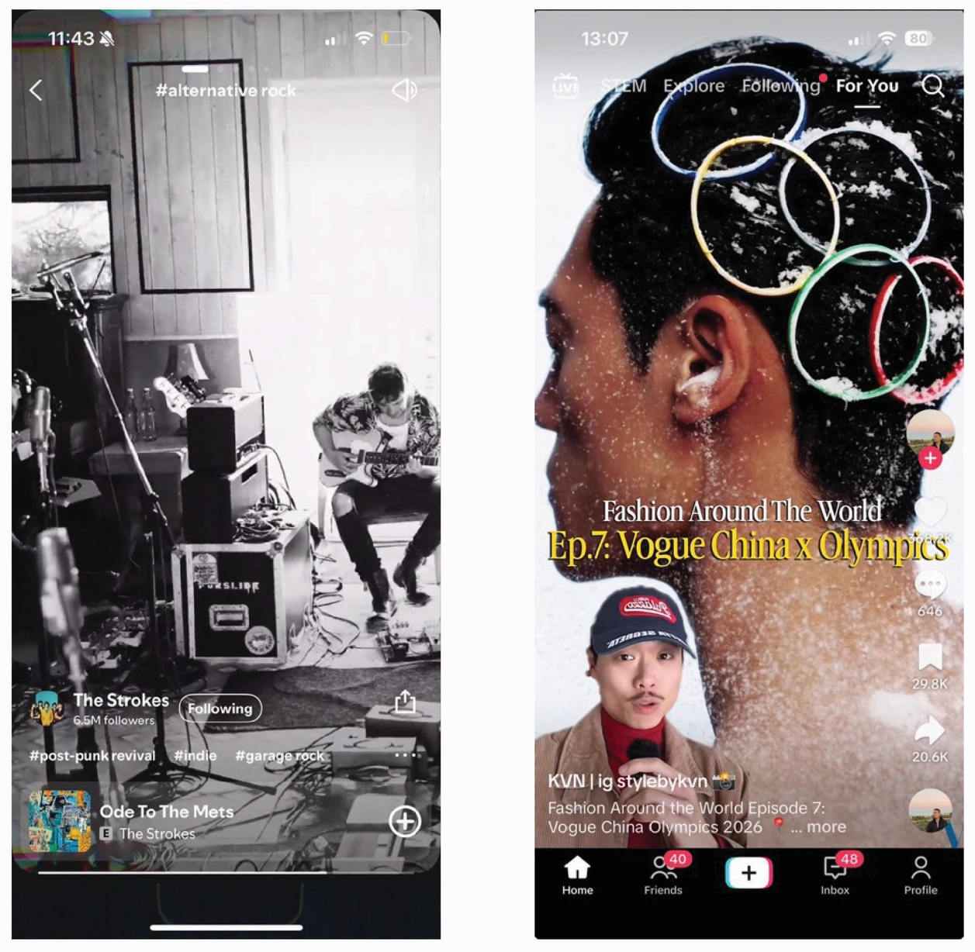

Fig. 26, Screenshot of Spotify’s Discover something new section. Fig. 27, Screenshot of TikTok’s interface. (TikTok, 2026).
(Spotify, 2025).

In Spotify’s search section, a user can now scroll through music as if they are on TikTok. Clips of songs, categorised by genre, as seen in fig. 26. The genre in play is #alternative rock and consists of short-form content designed to be scrolled through to discover music without the hassle of listening to the entire song. The similarity between Spotify’s scrolling discovery feature and TikTok’s interface is clear once they are compared side by side. Both platforms organise visual content vertically and autoplay short clips that encourage continuous scrolling driven by algorithms. Although TikTok is
a social media platform, Spotify has adapted this visual language to fit a music streaming context to increase engagement with its interface. Immediacy is prioritised, further intensifying the spectacle within Spotify. The discovery of music was once done through listening, but this short-form content draws listeners in with visuals, not just sound. The use of images and motion is what will initially draw in an audience in this format, not the audio. Instead of the user listening to an entire song the whole way through to decide if they like it or not, they can decide instantly by arriving straight to the chorus. Attentive listening is not encouraged in this format. This relates to Baudrillard’s theory that this visual representation of music precedes the actual reality of listening to music.

The addition of this TikTok format to Spotify has collapsed the barriers between streaming music
and using social media even further. Songs are now being interacted with as if they are commodified images. The artist’s name, branding and popularity through their following is shown, shaping the expectations of users about who this artist is and what kind of music they make in seconds, and will determine the further exploration of this artist based on this. These songs will either be scrolled past or saved based on how immediately engaging they are. From Baudrillard’s perspective, these clips do not represent a song as it is experienced through actual listening. It is merely a stylised snapshot that replaces it. This short-form method of discovering music will impact how artists go about making future music. Artists are pushed to make clips that make an immediate impression instead of focusing on depth and the song as a whole. “It’s not hard to imagine a future in which artists stop making full songs altogether, instead creating slivers of moments” (Dimchev, 2021, np). This is another example of Baudrillard’s concept of simulation determining reality. The song is no longer the starting point of the listening experience; the image is. Listening is now secondary to the act of scrolling. Spotify isn’t just visualising music; it restructures it into visual signs designed to be judged in seconds.

Conclusion
This thesis has examined how Spotify transforms music listening from a private, auditory experience into a performed, quantified, and curated activity, in which taste and identity are shaped by the platform. Beginning with the formation of taste, the platform does not merely provide access to music; it actively structures the conditions under which taste develops. Drawing on Pierre Bourdieu’s concepts of habitus and cultural capital, it has been shown that pre-existing dispositions continue to influence music taste, yet Spotify’s algorithms reinforce and amplify these tendencies. Discover Weekly, daylist, and repetitive exposure through incidental listening create an echo chamber, where choice feels unlimited, but in reality, users are guided toward music that they are already familiar with. The platform’s recommender algorithms convert habitus into a continuous, data-driven process, while features like Spotify Wrapped quantify taste and transform it into visualised embodied capital, making identity measurable and shareable.
Through analysis of features such as Discover Weekly, daylist, and Spotify Wrapped, it became clear that every click, skip, or save is not just encouraged to increase user engagement; it is harvested to improve algorithms, reinforcing the influence of the platform over users’ listening habits. Each choice a user makes is fed back into the system, guiding future behaviour. The wide variety of features within Spotify is itself a message; the act of listening is increasingly algorithmically guided. The more a user follows this guidance, the more their sense of individuality becomes a product rather than an expression of self. McLuhan’s insight that “the medium is the message” (McLuhan, 1967, p. 10) resonates powerfully here; Spotify is not just a music service; it reshapes the conditions under which taste is formed, experienced, and displayed. Spotify encourages users to see themselves as unique, but this individuality is formed and framed by the algorithm. Wrapped’s top 5 songs or daylist’s mood-specific playlists place users in tailored boxes, reflecting the identity or narrative that each user is to perform. Spotify convinces users that they are unique, even as millions scroll through identical slides, each claiming individuality in unison.
Goffman’s front stage and backstage metaphor remains relevant, but Spotify erodes its boundaries. The backstage was once a place for listening to music privately; now it has been disrupted by algorithmic surveillance. Spotify’s algorithms have become reminiscent of Foucault’s Panopticon system of observing individuals with an invisible omnipresent guard. This ensures that users internalise this constant visibility and regulate their listening to make sure they are keeping the impression of their musical identity consistent. Spotify users are constantly performing curated versions of themselves to multiple audiences through Wrapped and their public profile. It could be said that this curation creates an online ‘person’ that doesn’t actually exist beyond the digital realm. When looking at Goffman’s allegory of the theatre, today’s theatre appears to be empty. Despite not being able to see the audience and their reactions, it is essential that the actor must still perform.
Debord’s theories of spectacle and Baudrillard’s work on simulation and hyperreality explain how representations are taking over lived experience. Spotify’s interface does not mediate musical experience; it substitutes it. Personalised slides and curated playlists become more “real” than actual listening, creating a hyperreality in which taste, identity, and emotional states are packaged for virality and engagement. Daylist pre-determines the mood of its listeners, deciding what music is suitable for the situation before it has even occurred. This is simulation determining reality. Spotify’s use of formats inspired by TikTok is transforming the act of listening from an auditory experience to that of short soundbites and instant judgment. Although this increases engagement within the platform, it has made the act of listening secondary to interactions and visuals. This will, in turn, shape how artists make music. If they are incentivised to produce immediately engaging snippets of sound, they won’t put time into making a full-length, immersive song. Spotify isn’t just visualising music; it is shaping the quality and consumption of future music.
The historical theories from the 20th century used in this thesis have proven to be extremely vital to the understanding of contemporary digital media. Bourdieu’s theories on cultural capital and habitus show how much influence an individual’s surroundings have on their taste. McLuhan’s insight into the medium shaping human affairs shows the impact that Spotify’s interface has on its users’ listening habits. Goffman’s research on the performance of the self depicts the performative nature of interaction, especially when an individual is visible. Foucault clarifies how this visibility induces self-discipline through the metaphor of the Panopticon prison. Debord’s theory on spectacle is crucial for the understanding of the lived experience of music being replaced by representations. Baudrillard’s concept of simulation determining reality illustrates the impact this transformation of the act of listening will have on future music. Spotify demonstrates how these frameworks have intersected and evolved: this platform operates simultaneously as a classifier, a theatre, a Panopticon, a spectacle, and a hyperreality.
Ultimately, Spotify functions as a microcosm that reflects broader dynamics shaping the contemporary digital world. Users of all social media are encouraged to perform their identity and to feel unique, yet every expression of self online is shaped by the invisible observation of people and algorithms. When an individual posts on social media, they are monitoring themselves to ensure that the desired impression is made on this invisible audience. Every like, scroll and comment is recorded by the algorithms to curate feeds that feel personal to the user and to keep them engaged with the platform. The freedom of information and choice that social media appears to give to its users is
contradicted by the hyper-specific content pushed toward users, narrowing exposure and trapping them in a potentially dangerous echo-chamber of the same habits, opinions and beliefs. When algorithms structure discovery so intensely, guidance replaces autonomy, and representation replaces reality.

Bibliography:

Theoretical Texts:

Baudrillard, J., 2025. Simulacra and Simulation. Translated by Sheila Glaser ed. Ann Arbor, MI: University of Michigan Press.

Bourdieu, P. (1984) Distinction: A Social Critique of the Judgement of Taste. Translated by R. Nice. Cambridge, Massachusetts: Harvard University Press.

Bourdieu, P. (1977) Outline of a Theory of Practice. Translated by R. Nice. Cambridge, Massachusetts: Cambridge University Press.

Bourdieu, P. (1986) Forms of Capital. In Richardson, J. (ed.) Handbook of Theory and Research for the Sociology of Education. Westport, CT: Greenwood, pp. 241–258.

Debord, G., 2014. The Society of the Spectacle. Translated by Ken Knabb. Berkeley: Bureau of Public Secrets.

Goffmann, E., 1956. The Presentation of Self in Everyday Life. Edinburgh: University of Edinburgh Social Sciences Research Centre.

Foucault, M. (1977). Discipline and Punish. Translated by Alan Sheridan. New York: Random House.

McLuhan, M. (1964). Understanding Media: The Extensions of Man. California: LKondon and New York.

McLuhan, M. (1967). The Medium is the Massage. California: Ginko Press.

Theses, Journals, Articles and Websites:

Anderson, A., Maystre, L., Mehrotra, R., Anderson, I., Lalmas, M., 2020. ‘Algorithmic Effects on the Diversity of Consumption on Spotify’. In Proceedings of The Web Conference 2020 (WWW ’20), April 20–24, 2020, Taipei, Taiwan. ACM, New York, NY, USA, 11 pages. Available at: https://doi.org/10.1145/3366423.3380281. [Accessed: 19 November 2025].

Annabell, T., Vindum Rasmussen, N. (2024). ‘Spotify (Un)wrapped: how ordinary users critically reflect on Spotify’s datafication of the self within creative workshops.’ Journal of Gender Studies 2025, Vol. 34, 1177-1193. Available at: https://www.tandfonline.com/doi/epdf/10.1080/09589236.2024.2433674?needAccess=true. [Accessed: 15 December 2025].

Azzahrah, F. (2024). Unveiling the Magic: How Spotify Wrapped Casts a Spell on Its User, Jakarta: Bina Nusantara University.

Dimchev, I. (2021). ‘How TikTok is Changing the Music Industry?’ Stereofox.
Available at: https://www.stereofox.com/resources/how-tiktok-is-changing-the-music-industry/#. [Accessed: 15 December 2025].

Feyre, R. (2020). How the Democratisation of Music Changed the Industry. [Honours Thesis]. Salem State University.

Hawthorne, K. (2022). ‘Has Spotify really wrapped up the mystery of musical taste?’, The Guardian, 5 December. Available at https://www.theguardian.com/music/2022/dec/05/has-spotify-really-wrapped-up-the-mystery-of-musical-taste. [Accessed: 13 December 2025].

Jiang, T. (2025). ‘No More Backstage? Revisiting Goffman’s Dramaturgical Theory in the Age of Social Media’ Communications in Humanities Research. 95. Pp. 93-99. Available at: https://www.researchgate.net/publication/397312028_No_More_Backstage_Revisiting_Goffmans_Dramaturgical_Theory_in_the_Age_of_Social_Media. [Accessed: 15 December 2025].

Leary, M. R., Kowalski, R. M. (1990). “Impression Management: A Literature Review and Two-Component Model”. Psychological Bulletin. 107. pp. 34-47. Available at: http://www.communicationcache.com/uploads/1/0/8/8/10887248/impression_management-_a_literature_review_and_two-component_model.pdf. [Accessed: 8 February 2026].

McDonald, G. (2023). ‘What’s a Listening Personality?’ Spotify Engineering. Available at: https://engineering.atspotify.com/2023/1/whats-a-listening-personality. [Accessed: 13 December 2025].

Navarro, Z. (2006). In Search of a Cultural Interpretation of Power: The Contribution of Pierre Bourdieu
IDS Bulletin.

Nie, K., Fu, J., Rehman, H., Zaigham, G.H.K. (2022). ‘An Empirical Study of the Effects of Incidental Vocabulary Learning Through Listening to Songs.’ Frontiers in Psychology. 13. pp. 1-12. Available at:
https://www.frontiersin.org/journals/psychology/articles/10.3389/fpsyg.2022.891146/full. [Accessed: 6 February 2026].

Pittinger, D. (2005). ‘Cautionary Comments Regarding the Myers-Briggs Type Indicator’. Consulting Psychology Journal. 57. pp. 210-221. Available at: https://www.researchgate.net/publication/232494957_Cautionary_comments_regarding_the_Myers-Briggs_Type_Indicator. [Accessed: 5 February 2026].

Rouvroy, A., Berns, T. (2013). ‘Algorithmic governmentality and prospects of emancipation.’ Translated by Liz Carey-Libbrecht. Reseaux. 177. pp. 163-196. Available at: https://shs.cairn.info/article/E_RES_177_0163?lang=en#s2n4. [Accessed: 4 February 2026]

Spotify. (2024). ‘We’re Commemorating a Decade of Spotify Wrapped With Our Best and Boldest Wrapped Yet’. Spotify Engineering. Available at https://newsroom.spotify.com/2024-12-04/10-years-spotify-wrapped/. [Accessed: 15 December 2025].

Szpunar, K. K., Schellenberg, E. G., & Pliner, P. (2004). Liking and Memory for Musical Stimuli as a Function of Exposure. Journal of Experimental Psychology: Learning, Memory, and Cognition, 30(2), 370–381. Available at: https://doi.org/10.1037/0278-7393.30.2.370. [Accessed: 6 February 2026]

Ungvarsky, J. (2024). Barnum effect [online]. Available at: Ebsco Knowledge Advantage
https://www.ebsco.com/research-starters/psychology/barnum-effect. [Accessed: 7 February 2026].

Vad, M. (2021). ‘The Album Cover’. Journal of Popular Music Studies. 33 (3). 11-15. Available at: https://online.ucpress.edu/jpms/article/33/3/11/118548/The-Album-Cover. [Accessed: 9 February 2026].

Woods, R.A., Hill, P.B. (2022). Myers-Briggs Type Indicator. StatPearls. Available at: https://www.ncbi.nlm.nih.gov/books/NBK554596/. [Accessed: 7 February 2026]

Comprehension Resources:

Carefree Wandering, 2023. Guy Debord and The Society of the Spectacle. [YouTube]. Available at https://www.youtube.com/watch?v=8CTf4myAa9k. [Accessed 15/10/2025].

Morgan, T., Purje, L., (2016). An Illustrated Guide to Guy Debord’s ‘The Society of the Spectacle’, Hyperallergic [online]. Available at: https://hyperallergic.com/313435/an-illustrated-guide-to-guy-debords-the-society-of-the-spectacle/. [Accessed: 20/10/2025]

PHILO-notes, (2021). Pierre Bourdieu on Habitus, Capital, Fields, Doxa, and Reflexive Sociology [YouTube]. Available at
https://www.youtube.com/watch?v=rJAWhbSYMAE [Accessed 13/12/2025].

ThreatLocker, (2024). Jean Baudrillard’s Simulacra and Simulation: ‘Hyperreality: The Death of the Real’. [Reddit].
Available at:
https://www.reddit.com/r/Existentialism/comments/1hm0msg/jean_baudrillards_simulacra_and_simulation/. [Accessed 15/12/2025].

Magdalen Rose. (2024). ‘Simulacra Explained: Jean Baudrillard's Theory of Simulation’. [YouTube]. Available at https://www.youtube.com/watch?v=h7urGFiy_3g. [Accessed 15/12/2025].

Longtin, R. (2022). Marshall McLuhan, "The Medium is the Message". [YouTube]. Available at https://www.youtube.com/watch?v=UDooNNSs4Nc. [Accessed 27/01/2026].

Theory & Philosophy. (2021). The Medium is the Message, Marshall McLuhan, Keyword [YouTube]. Available at https://www.youtube.com/watch?v=j7qkTvCdAXM. [Accessed 27/01/2026].

