

Differences in Academic Self-Efficacy and Environmental Identity in Students using Artificial Intelligence for Academic Purposes
Daniel Kennedy
N00220297

Research Supervisors:
Louise Horan Gahan
Dr. Eva Garcia-Albarran

Dissertation submitted as a requirement for the degree of the BSc (Hons) in Applied Psychology, Dun Laoghaire Institute of Art, Design & Technology, 2026

Declaration

I, Daniel Kennedy, hereby declare that the work that I have submitted for / contributed to the assessment
specified above is entirely my own work. Where I have drawn from the work of others, including Generative AI systems, I have clearly indicated this within my submitted work. I recognise that Generative AI creations, no matter how small, may not be permissible within my submitted work and have checked this specific assessment brief for the admissible use of such software. I have read and complied with the IADT Academic Integrity Policy for this submission and recognise that breaches of this policy in my work may result in penalties, up to and including disqualification from IADT.

I, Daniel Kennedy, hereby declare that I recognise that IADT staff may provide feedback on assessment via a range of methods, depending on the nature of the assessment and the preference of the staff member. I recognise that any grades issued by a lecturer are provisional but are not negotiable. Final grades will be issued following the relevant exam board meeting and information on appeals procedures is available on the IADT website. I agree to abide by the IADT Mutual Respect Policy in all of my communications with and regarding all IADT staff members.

Word Count: 5,000
Signature: Daniel Kennedy
Date: 30th of March 2026

Acknowledgements
First and foremost, I would like to thank my supervisor Louise Horan Gahan for her supervision over the past few months. Thank you so much for taking me on halfway through the year, you have made working on this dissertation an enjoyable process and I am very grateful for the opportunity to have worked with you.
I would also like to thank Dr. Eva Garcia-Albarran for her supervision for the first half of the year and helping me to develop the ideas which led to the final dissertation.
Thank you to the lecturers of both the Applied Psychology and Creative Computing classes who gave me permission to collect participants during their lectures. To Dr. Sinead Meade, Dr. Andrew Magee, Louise Glynn, John Dempsey, and Anne Wright, though it may have seemed small, allowing me to collect participants in your lectures was integral to the completion of the dissertation. My thanks to all of you.
Congratulations to all my fellow classmates and friends in the Applied Psychology class of 2026.
Finally, I would like to thank my parents, Charlie and Maura, and sisters, Sarah and Grace, for continuously supporting me throughout this past academic year and all the years prior, thanks guys.

Table of Contents
Abstract..........................................................................................................................................1
1. Introduction...............................................................................................................................2
1.1 Environmental Impact of Artificial Intelligence.......................................................................2
1.2 Emergence of Artificial Intelligence in Third Level Education...............................................2
1.3 Academic Self-Efficacy............................................................................................................3
1.4 Impact of Artificial Intelligence on Academic Self-Efficacy..................................................3
1.5 Environmental Identity............................................................................................................4
1.6 Artificial Intelligence and the Environment............................................................................4
1.7 Social Cognitive Theory..........................................................................................................5
1.8 Artificial Intelligence, Academic Self-Efficacy, and Environmental Identity........................5
1.9 Rationale..................................................................................................................................6
2. Method......................................................................................................................................8
2.1 Design......................................................................................................................................8
2.2 Participants..............................................................................................................................8
2.3 Materials..................................................................................................................................8
2.3.1 General Academic Self-Efficacy Scale................................................................................9
2.3.2 Revised Environmental Identity Scale.................................................................................9
2.4 Procedure................................................................................................................................9
3. Results.....................................................................................................................................11
3.1 Overview of Results...............................................................................................................11
3.2 Descriptive Statistics..............................................................................................................11
3.3 Inferential Statistics................................................................................................................12
3.3.1 Assumption Testing.............................................................................................................12
3.3.2 Analysis 1: ANOVA for Course Type and Academic Self-Efficacy..................................14
3.3.3 Analysis 2: ANOVA for Course Type and Environmental Identity...................................14
3.3.4 Analysis 3: Academic Self-Efficacy and Environmental Identity......................................14
4. Discussion................................................................................................................................15
4.1 Summary of Findings.............................................................................................................15
4.2 Theoretical and Practical Implications...................................................................................15
4.3 Strengths and Limitations......................................................................................................17
4.4 Future Research.....................................................................................................................18
4.5 Conclusion.............................................................................................................................18
5. References...............................................................................................................................20
6. Appendices..............................................................................................................................28
Appendix A..................................................................................................................................28
Appendix B..................................................................................................................................34
Appendix C..................................................................................................................................35
Appendix D..................................................................................................................................36
Appendix E..................................................................................................................................37
Appendix F..................................................................................................................................38
Appendix G..................................................................................................................................39
Appendix H..................................................................................................................................40
Appendix I....................................................................................................................................41
Appendix J....................................................................................................................................42
Appendix K...................................................................................................................................43
Appendix L...................................................................................................................................44
Appendix M..................................................................................................................................45
Appendix N...................................................................................................................................46
Appendix O...................................................................................................................................47

List of Figures
Figure 1: Box Plot illustrating academic self-efficacy scores across students’ course.................12
Figure 2: Box Plot illustrating environmental identity score across students’ course..................13

List of Tables
Table 1: Descriptive statistics for academic self-efficacy by course type....................................11
Table 2: Descriptive statistics for environmental identity by course type....................................11

Abstract
This study investigated differences in academic self-efficacy (ASE) and environmental identity (EID) in Applied Psychology and Creative Computing students who use artificial intelligence (AI) for academic purposes in the Institute of Art, Design and Technology. Using a quantitative cross-sectional design, and utilizing purposive sampling, an online survey was distributed during lectures to Applied Psychology and Creative Computing students who had used AI for academic purposes at least once during their studies. Fifty-eight participants completed the General Academic-Self Efficacy Scale and the Revised-Environmental Identity Scale. Students across both courses reported high ASE and EID. Two one-way analyses of variance indicated that students’ course had no effect on their ASE or EID. However, poor statistical power may have affected the results. A Pearson’s correlation indicated no significant correlation between ASE and EID. The findings reveal that students who use AI for academic purposes, regardless of course, report high in both ASE and EID. The present study also highlights that ASE and EID are not significantly influenced by students’ course. The small sample size limited the reliability of the inferential tests. Future studies may benefit from including responses from participants who do not use AI in an academic context and comparing these datasets.
Keywords: academic self-efficacy, environmental identity, Applied Psychology, Creative Computing, artificial intelligence

1. Introduction
Artificial Intelligence (AI) has seen a rapid increase in accessibility and usage in recent years and is actively used globally (Chi, 2024). This AI adoption has forced industries adapt to this emerging technology. Research suggests an increase in AI usage amongst university students, a development which forces policy makers in universities to change their systems to account for ethical concerns which weren’t before present (Bearman et al., 2025; Irfan et al., 2023). Findings from an Irish survey on generative AI in higher education reveal a tone of uncertainty surrounding the emergence of AI with over 80% of students believing fundamental change to the education system is impendent (Quality and Qualifications Ireland, 2025). The literature concerning university students and AI use shows contradictory attitudes towards AI and a tone of uncertainty university students (Bearman et al., 2025; Johnson et al., 2024; Johnston et al., 2024). This perception of confusion surrounding AI in higher education calls for further research in this area.
1.1 Environmental Impact of Artificial Intelligence
Research investigating university students’ attitude towards the impact of AI on the environment is limited, however Dungo et al. (2025) report a minimal awareness of the environmental impact of AI amongst university students.
It has been highlighted that datacentres require mass amounts of water to operate the cooling towers used to decrease internal temperatures (Lee et al., 2023; McGrath & Alamamos, 2024) and generate electricity (Li et al., 2024). Large companies, such as Google, reported consuming roughly 23 billion litres of water through datacentres in 2023 (Google, Environmental Report, 2024; as cited in Li et al., 2024). Furthermore, the training of GPT-3 consumed over five million litres, with reports predicting an estimated six billion cubic metres of water consumed for AI datacentres in 2027 (Shehabi et al., 2024). These statistics stress the need to further investigate the environmental effects of AI.
1.2 Emergence of Artificial Intelligence in Third Level Education
Irish universities are at the forefront of facilitating research regarding AI, demonstrated through the AI Driven Digital Content Technology Centre, one of the leading centres for the development of AI technology in Europe, which includes researchers from many Dublin universities (O’Raghallaigh, 2025; Research Centres, 2021). National College of Ireland and University College Dublin are amongst the first universities globally to implement AI focused elements to the curriculum of courses, to educate their students in the matters of AI (National College of Ireland, 2025, as cited in O’Raghallaigh, 2025). This engagement with AI technology from Irish universities is pivotal to encourage the development of emerging technologies and preparing Irish students for an AI driven future (IDA Ireland, 2025, as cited in O’Raghallaigh, 2025).
Irish university students report high AI use for academic purposes (Irfan et al., 2023; O’Donnell et al., 2024). Irfan et al. (2023) reported familiarity with ChatGPT amongst all courses in the University of Limerick. Furthermore, computer science students reported highest familiarity with and use of AI tools, affirming Strzelecki & El Arabawy (2024) who suggest positive experiences using generative AI, such as ChatGPT, encourages further use of ChatGPT, and fosters positive attitudes towards ChatGPT and the use of generative AI.
University students report high AI use globally, share concerns regarding privacy, ethics and diminishing personal development due to AI use, but also share perceived benefits through personalised learning support and enhanced academic performance (Bearman et al., 2025; Chan & Hu, 2023; O’Donnell et al., 2024). Dungo et al. (2025) refutes reports of high AI use in university students citing a sparing utilisation.
1.3 Academic self-efficacy
Conceptualised by Albert Bandura (1977) and rooted in Bandura’s Social Cognitive Theory (SCT) (Bandura, 1999; Schunk & DiBenedetto, 2022), self-efficacy refers to an individual’s perception of their ability to complete tasks or achieve a desired performance. Academic self-efficacy (ASE) refers to an individual's perceived ability to complete tasks or achieve a desired performance in an academic context (Schunk & DiBenedetto, 2022). Research concerning ASE is invaluable and has increased with the development of AI.
1.4 Impact of Artificial Intelligence on Academic Self-Efficacy
Research regarding the relationship between AI usage and ASE reveals a positive correlation between the use of AI, particularly the use of generative AI chatbots, for academic purposes and university students’ ASE (Anierobi et al., 2025; Lee et al., 2022; Tanveer et al., 2024; Wang et al., 2022). Tanveer et al. (2024) reported high ASE in students who placed a high level of trust in AI chatbots, aligning with Țuclea & Poenaru (2026) who reported trust as an essential driver of AI use. Furthermore, Anierobi et al. (2025) reported AI usage as a determinant of high ASE. Research also shows a positive relationship between AI usage and general self-efficacy amongst university students (Rodríguez-Ruiz et al., 2024; Zhang & Xu, 2024).
Previous research shows a positive correlation between AI usage and ASE, inferring that AI has a positive effect on ASE. However, these studies don’t investigate whether the use of AI improves ASE in university students (Deng et al., 2024). Furthermore, Zhang & Xu (2024) report a positive correlation between increased level of AI dependency and increase level of AI usage.
1.5 Environmental Identity
Established in 2003 and cross-culturally validated in 2021, environmental identity (EID) refers to an individual’s connectedness with nature, an increasingly desirable social standing in modernity (Clayton, 2003; Clayton et al., 2021; Vesely & Klöckner, 2020). The EID scale combines an individual’s self-perceived EID and socially orientated EID, accounting for the cognitive, behavioural, and emotional elements of EID. The unification of these aspects measures an individual’s connection and interdependence with nature (Clayton, 2003; Clayton et al., 2021). Sawitri et al. (2015) validated the use of SCT to explain the development of PEB. There is a gap in the research concerning the relationship between the use of AI in university students and EID; however, research has investigated AI use and identities similar to EID.
1.6 Artificial Intelligence and the Environment
The rapid emergence and expansion of AI has rendered most industries adopters of this new technology (Chi, 2024). The literature provides opposing reports on the potential impact of AI on environmental issues. Whilst most researchers state the environmental damage caused by AI and the implicit bias within AI, some researchers remain optimistic towards the implementation of AI to solving environmental challenges (Damoah et al., 2021; Dungo et al., 2025). Van der Ven et al. (2024) posit that AI is changing individuals’ learning methodology. The literature suggests an implicit bias within AI chatbots, observed in an environmental context (Van der Ven et al., 2024; Qi et al., 2025). Although AI chatbots hold a pro-environmental orientation, implicit bias within chatbots, onset from value alignment training, inclines chatbots to suggest small changes to environmental policy rather than large changes to economic and social systems (Van der Ven et al., 2024; Qi et al., 2025).
AI chatbots tend to produce information with an objective tone which may lead individuals to accept statements posited by AI chatbots as truths. Despite AI’s environmental footprint, the increasing rate of information concerning environmental challenges obtained from AI chatbots is accepted, resulting in poor decision making when addressing environmental issues (Filho et al., 2024; Van der Ven et al., 2024). Where Qi et al. (2025) suggest a left leaning perspective observed in AI chatbots, regarding environmentalism, Van der Ven et al. (2024) suggest a right leaning perspective in AI chatbots and dangerous incrementalism in a diminishing window to act on environmental issues (Allan, 2019; Diffenbaugh & Barnes, 2023). Dungo et al. (2025) reported limited knowledge of the water footprint emitted by AI among university students. The study, involving over 2000 participants, universally reported that AI didn’t negatively impact the environment.
The reviewed literature reveals a gap concerning university students' EID and AI usage. Although there is research involving identities adjacent to EID, to the researcher’s knowledge, this will be the first study to assess EID in relation to AI usage in university students.
1.7 Social Cognitive Theory
Bandura established SCT in 1986 as a learning theory which emphasizes learning from an individual’s surrounding environment (Bandura 1986; Schunk & DiBenedetto, 2022). SCT posits that personal agency and self-identities, such as environmental identities, are manufactured through the combination of reciprocal interactions between personal factors, environmental influences, and behaviour (Erfanian et al., 2024; Schunk & DiBenedetto, 2022).
1.8 Artificial Intelligence, Academic Self-Efficacy, and Environmental Identity
Low et al. (2025) suggested AI use in service industry employees significantly enhanced environmental self-efficacy. AI applications provided a supportive environment which created a safe space for employees to consistently perform sustainable practices such as pro-environmental behaviour (PEB). Low et al. (2025) suggest a positive relationship between self-efficacy and PEB. This relationship infers an enhancement in self-efficacy and PEB, post intervention by AI application. PEB is encompassed by EID, with strong EID individuals more likely to engage in PEB (Clayton et al., 2021). Therefore, Low et al. (2025) suggest high self-efficacy and EID encompassing behaviour in individuals who engage with AI. The outcomes from this research reveal a gap in the literature concerning the use of AI, ASE, and EID. To the researcher’s knowledge, this will be the first study to investigate these variables simultaneously.
1.9 Rationale
Student’s perspective on the emergence of generative Artificial Intelligence (AI) is underexplored (Bearman et al., 2025). The reviewed literature reveals a gap concerning the relationship between ASE, EID, and AI use. To the researcher’s knowledge, the present study will be the first to investigate these variables simultaneously. Research exploring EID in university students is limited however, Prévot et al. (2016) suggest EID may be partly responsible for students’ choice of course, rather than students’ course determining students’ EID. Although Bearman et al. (2025) reported high engagement in university students with generative AI, the use of AI wasn’t widespread at the time of Prévot et al.’s study. The present study aims to further explore the relationship between students’ course and EID.
Li et al. (2023) found environmental education positively influenced PEB and that the presence of environmental education produces a perceived norm of pro-environmental orientation (Hansmann et al., 2020; Li et al., 2023). Applied Psychology (AP) students were chosen for this study as the Transpersonal Psychology module educates AP students in environmental psychology (Institute of Art, Design & Technology, n. d.). Creative Computing (CC) students were chosen for this study as Irfan et al. (2023) reported higher familiarity with and acceptance of ChatGPT amongst Computer Science students than other courses in the University of Limerick. The University of Limerick Computer Science course holds many similarities with the Creative Computing (CC) course in the Institute of Art, Design and Technology (IADT), both providing an introduction for students into computing, programming, software development, and games development (University of Limerick, n. d.; Institute of Art, Design & Technology, n. d.).
Self-efficacy holds import in SCT as self-efficacy drives motivation and a willingness to learn (Bandura, 1986). Robbins et al. (2004, as cited in Artino, 2012) suggest ASE is the greatest psychosocial predictor of academic achievement. EID is established through assessing individuals’ connectedness and interdependence with nature (Clayton, 2003). The self-reported nature of Clayton’s Revised EID scale requires introspective thought and produces a projection of an individual’s self-perception and beliefs (Clayton, 2003). The development of these self-perceptions and beliefs are integral to developing personal agency (Bandura, 1999). SCT will guide the present study as the theoretical framework. The research question, along with the hypotheses and theoretical framework will help guide the present study. The gap in the research will be addressed by investigating the relationship between ASE and EID in AP and CC students in IADT, who engage with AI for academic purposes.
H1: There will be a relationship between academic self-efficacy and environmental identity for students.
H2: There will be a multivariate difference in academic self-efficacy and environmental identity between students across both courses.
H3: There will be a significant difference in academic self-efficacy between students in Applied Psychology and Creative Computing.
H4: There will be a significant difference in environmental identity between students in Applied Psychology and Creative Computing.

2. Method
2.1 Design
The present study employed a between-subjects, quasi-experimental design. A cross-sectional online survey was used to collect quantitative data. The independent variable was course of study (AP or CC), and the two dependent variables were ASE and EID.
2.2 Participants
Students from the AP and CC undergraduate programmes at IADT Dun Laoghaire were invited to take part in this study. The data for the present study were collected from 80 participants. During data cleaning participants who hadn’t used AI in an academic context and participants who weren’t enrolled in either AP or CC were removed from the data set. Incomplete responses were removed from the data set. One participant requested for their data to be removed from the research. The final sample consisted of 58 participants.
Participants were recruited using purposive sampling, including snowball sampling. Participants were given the opportunity to take part in the online survey via QR code which was distributed during lectures. Ages of participants ranged from 18 to 34. 35 participants identified as female (60%), 20 participants identified as male (35%), 2 participants chose the other option (3%) and 1 participant chose the prefer not to say option (2%). Of the 58 participants, 36 were recruited from the Applied Psychology course (62%) and 22 from the Creative Computing course (38%). All participants recruited for this study were treated in accordance with the ethical standards established by the Psychological Society of Ireland. The present study received amber route ethical approval by the Psychology Ethic Committee of IADT.
2.3 Materials
The materials present in this study were all available within an online Microsoft Form. The Microsoft form included an information sheet (see Appendix B) which informed participants of the aim of the present study and their rights as participants. The information sheet provided the contact details of the researcher and the supervisor in the event a participant wished to have their data withdrawn from the study. The Microsoft Form included a consent form (see Appendix C), which asked the participants to confirm their consent in their partaking of the present study, and a debrief (Appendix J) which reiterated the purpose of the present study, the rights of the participants, the contact details for the researcher and supervisor, provided contact details for support resources, and thanked participants for partaking in the study.
2.3.1 General Academic Self-Efficacy Scale (GASE)
Participants were presented with the General Academic Self-Efficacy Scale (GASE) (see Appendix G), established by Nielsen et al. (2018) to measure ASE in individuals, and validated for university students in Western Europe and the USA by van Zyl et al. (2022). The GASE is a five-item scale which features a five-point Likert scale ranging from 1 “Strongly disagree” to 5 “Strongly disagree”. A higher score on the GASE reflects a higher ASE. An example of an item featured on this scale is “I know I can pass the exam if I put in enough work during the semester”. A Cronbach’s Alpha of the GASE was computed at 0.59 for the present study, revealing a poor level of internal reliability. Scales with few items generally report lower Cronbach’s Alphas which may have been observed in the present study (Tavakol & Dennick, 2011). However, Nielsen et al. (2018) reported the GASE to be reliable and Van Zyl et al. (2022) reported acceptable internal reliability in the GASE, holding a Cronbach’s alpha of 0.74 at the time of the first survey, and 0.78 at the time of the second survey.
2.3.2 Revised Environmental Identity Scale (EID)
The Revised Environmental Identity scale (see Appendix H) (Clayton et al., 2021) was also present in the Microsoft Form. The EID was developed to measure the extent to which an individual identifies with nature and considers themself to be a part of the natural environment, factoring cognitive and emotional elements into this identity. The EID consists of 14 items and is scored on a 7-point Likert scale ranging from 1 “Not at all true of me” to 7 “Completely true of me”. A higher score on the EID reflects a high EID. An example of an item included on the EID is “I think of myself as a part of nature, not separate from it”. A Cronbach’s Alpha of the EID was computed at 0.88 for the present study, revealing a good level of internal reliability. The original 24-item EID, and the revised 14-item EID reported high internal validity, with the original scale holding a Cronbach’s alpha of 0.90 (Clayton, 2003) and the revised scale holding a Cronbach’s alpha of 0.92.
2.4 Procedure
Participants were recruited via purposive sampling, on the IADT campus by scanning a QR code which brought them to an online Microsoft Form, where the first material presented was the information sheet. This detailed the present study’s aims and the rights of the participants. This was followed by the consent form which asked participants to provide consent for their data to be used in the present study. The participants were then asked to provide an anonymised code comprising of the second and third letters of a parent/guardian's name and their star sign. This was followed by the demographic questions, requesting age and gender. Participants were then asked which one of either the Applied Psychology or Creative Computing courses they were enrolled in, and whether they had ever used AI in an academic context. The demographic questions were followed by two psychometric scales, the GASE and the EID, the confirmation of consent for data use, and then finally the debrief form.

3. Results
3.1 Overview of results
Data from 58 participants were used to assess the effect of course type on ASE and EID in students who use AI for academic purposes. Preliminary assumption testing for a one-way MANOVA revealed the dependent variables to be insufficiently correlated. This finding, alongside the fact that the two dependent variables were conceptually distinct constructs, indicated the assumption of two related dependent variables was unmet. Therefore, two one-way between-groups analyses of variance (ANOVAs) and a Pearson’s correlation were conducted to test the hypotheses, excluding the second hypothesis, using IBM SPSS Version 31. The independent variable was students’ course type, and the dependent variables were ASE and EID.
3.2 Descriptive Statistics
Table 1 displays the N values, means and standard deviations for ASE scores according to the two grouping levels of the independent variable.
Table 1
Descriptive Statistics for Academic Self-Efficacy by Course Type
 | N | M | SD
Applied Psychology | 36 | 20.55 | 2.28
Creative Computing | 22 | 19.90 | 2.34
Total | 58 | 20.31 | 2.31

Table 2 displays the N values, means, and standard deviations for EID scores, according to the two grouping levels of the independent variable.
Table 2
Descriptive Statistics for Environmental Identity by Course Type
 | N | M | SD
Applied Psychology | 36 | 76.83 | 12.03
Creative Computing | 22 | 73.40 | 11.44
Total | 58 | 75.53 | 11.83

3.3 Inferential Statistics
Two one-way between-groups ANOVAs were conducted to assess the effect of student’s course type on ASE and EID. A Pearson’s correlation was conducted to investigate the relationship between ASE and EID.
3.3.1 Assumption Testing
Preliminary analyses were conducted to test if the assumptions of a one-way between-groups ANOVA were met. The assumption of normal distribution for both ANOVAs was assessed using the Shapiro-Wilk test. The dependent variables were normally distributed for both levels of the independent variable (see Appendix K). The assumption of homogeneity of variances was met for the dependent variable ASE, as assessed by Levene’s Test of Equality of Variances. F(1,56) = 0.000, p = 0.992. The assumption of homogeneity of variances was also met for the dependent variable EID, as assessed by Levene’s Test of Equality of Variances. F(1,56) = 0.002, p =0.969 (see Appendix L). A box plot was generated to assess for outliers in the data of the participants’ ASE. The box plot revealed one outlier for the AP group. Analysis of the raw data revealed the outlier’s responses to represent a true value rather than an error. This resulted in the inclusion of the outlier’s data. A second box plot was generated to assess for outliers in the data of the participants’ EID. The box plot didn’t reveal any outliers in either group.
Figure 1 displays the distribution of students’ ASE scores, according to students’ course.
Figure 1
Variation in Academic Self-Efficacy Scores Across Students’ Course
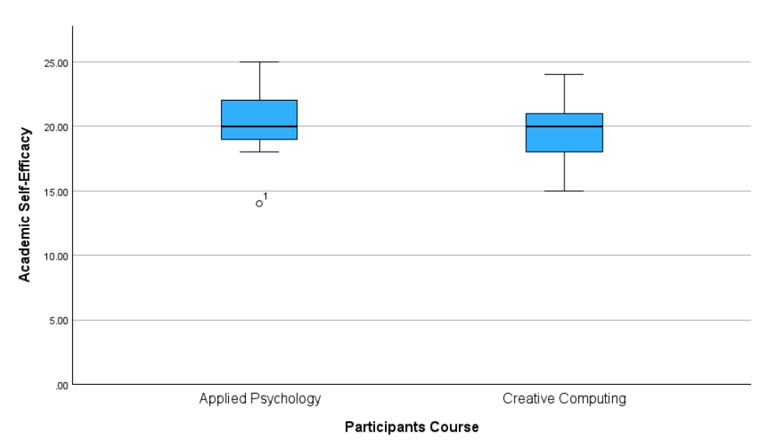
Figure 2 displays the distribution of students’ EID scores, according to students’ course.
Figure 2
Variation in Environmental Identity Scores Across Students’ Course
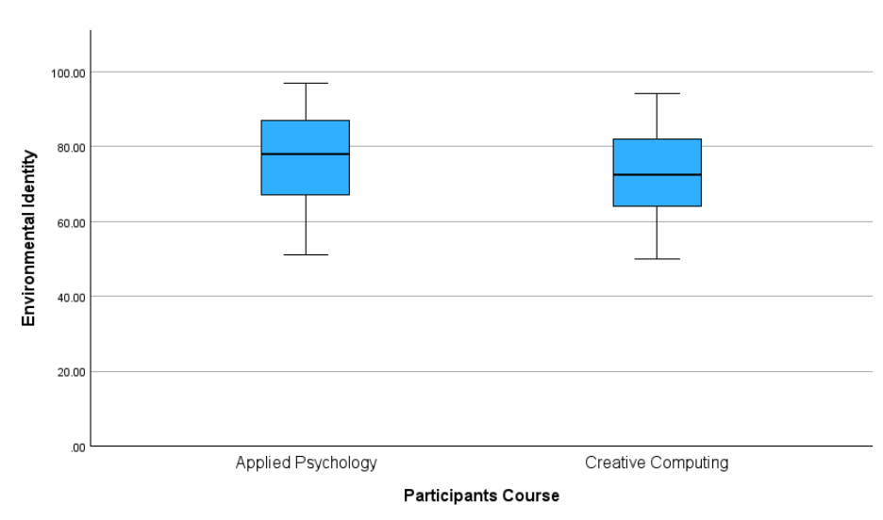3.3.2 Analysis 1: ANOVA for Course Type and Academic Self-Efficacy
Hypothesis 1, that there would be a statistically significant difference for students’ ASE based on their course type, wasn’t supported. A one-way between-groups ANOVA indicated no significant difference for students’ ASE based on their course type. F(1,56) = 1.07, p = 0.305 (see Appendix M). The analysis had low statistical power (0.174) (see Appendix N).
3.3.3 Analysis 2: ANOVA for Course Type and Environmental Identity
Hypothesis 2, that there would be a statistically significant difference for students’ EID based on their course type, wasn’t supported. A one-way between-groups ANOVA indicated no significant difference for students’ EID based on their course type, F(1,56) = 1.15, p = 0.289 (see Appendix M). The analysis had low statistical power (0.183) (see Appendix N).
3.3.4 Analysis 3: Academic Self-Efficacy and Environmental Identity
Hypothesis 3, that there would be a relationship between students’ ASE and EID, wasn’t supported. A Pearson’s correlation indicated no significant relationship between ASE and EID r(56) = 0.20, p = 0.135 (see Appendix O).
4. Discussion
4.1 Summary of findings
The present study investigated differences in ASE and EID based on students’ course. Hypothesis 1, that there would be a statistically significant difference for students’ ASE, based on their course wasn’t supported. The results indicated no significant difference in students’ ASE based on their course. However, the test was underpowered at 17.4%
Hypothesis 2, that there would be a statistically significant difference for students’ EID, based on their course wasn’t supported. The results indicated no significant difference in students’ EID based on their course. However, the test was underpowered at 18.3%.
Hypothesis 3, that there would be a relationship between ASE and EID in students’ who engage in AI for academic purposes, wasn’t supported. The results indicated no significant relationship between ASE and EID.
4.2 Theoretical and practical implications
The results of the present study align with previous research, in that students who use AI for academic purposes reported high ASE. Although the intensity of AI use wasn’t measured, the findings affirm previous literature which suggested a correlation between high trust in AI chatbots and high ASE (Lee et al., 2022; Tanveer et al., 2025; Wang et al., 2022), as trust is a key driver of AI use (Țuclea & Poenaru, 2026). Although the relationship between intensity of AI use and ASE wasn’t investigated, the present sample’s high ASE scores could be explained by Anierobi et al.’s (2025) research, which suggests high AI use to be a determinant of high ASE.
The findings provide information into, to the researcher’s knowledge, the first study to investigate ASE and EID in individuals who use AI for academic purposes. There is a gap in the literature concerning the effect of AI use on EID. However, Low et al. (2025) suggested a positive relationship between self-efficacy and PEB in service industry employees who engage with AI. The findings somewhat align with the findings of Low et al. (2025) in that both studies reported high EID in individuals using AI (PEB in Low et al. (2025) and high EID in the present study). Notably, the participants of Low et al. (2025) were service industry employees, whereas participants in the present study were university students, which may suggest high EID can be found in AI use in varying contexts.
The lack of a significant relationship between ASE and EID based on students’ course may be due to differences in students’ courses being too minimal to influence their identities and belief in their abilities. Previous research suggests AI positively influences ASE (Lee et al., 2022; Wang et al., 2022) however, the use of AI for academic purposes as inclusion criteria in the present study may have captured a high ASE subgroup of the larger population of AP and CC students. Despite research suggesting higher familiarity with and more positive attitudes towards AI amongst computing students (Irfan et al., 2023), the findings reveal this didn’t significantly influence students’ ASE. Although notably familiarity with and attitude towards AI weren’t measured in the present study, the lack of significant difference may have been due to the use of AI for academic purposes being inclusion criteria for the present study. Li et al. (2023) suggested environmental education positively influences PEB however, the findings highlights that the environmental psychology didn’t significantly influence students’ EID. This finding supports Prévot et al. (2016), who suggested students’ choice in course may partly be due to their EID rather than a causal relationship between students’ course and students' EID. The present study didn’t account for environmental education students may have experienced prior to their university studies which may have influenced their EID.
Interpreting these findings through the lens of SCT (Bandura, 1986), the lack of significant difference between ASE based on students’ course may be due to similar mastery experiences in the participants. Bandura (1997) emphasises mastery of experiences as the most influential determining factor of an individual's self-efficacy. Participants’ progression to university may have resulted in similar mastery experiences in the sample. Bandura (1997) describes reciprocal determinism as integral in the development of self-efficacy. The findings reveal differences between students’ course may not have significantly influenced participant’s ASE.
Similarly, the lack of significant difference between EID based on students’ course, interpreted through the lens of SCT, may be due to students’ course not significantly influencing participants’ identity. SCT stresses reciprocal determinism and the importance of observational learning in the development of an individual’s environmental behaviour and identity (Savari et al., 2022, as cited in Erfanian et al., 2024). The lack of significant difference may be due to the theoretical nature of the AP environmental psychology module which doesn’t allow for observational learning.
Drawing practical implications from the findings, universities should incorporate AI based curricula to educate students on using AI effectively and provide information regarding the environmental effects of using AI. These modules should seek to educate students on implicit bias within AI, concerning environmentalism and provide awareness into a subject of minimal awareness amongst university students (Dungo et al., 2025; Van der Ven et al., 2024). Although neither the direction of the relationship between AI use and ASE, nor causation, can be established, the findings report high ASE in individuals using AI for academic purposes. This has implications for future research, which could seek to further explore the relationship between AI use for academic purposes and ASE. The findings present a non-significant relationship between ASE and EID. Despite ASE and EID being interpreted by SCT, ASE as a psychological construct and EID as a psychological trait are conceptually distinct, as highlighted by the non-significant correlation outlined by Pearson’s correlation. This may explain the lack of previous research investigating these variables simultaneously.
4.3 Strengths and limitations
The present study featured 58 students which reduced the statistical power of the one-way ANOVAs employed to assess the impact of students’ course on ASE and EID. The sample featured IADT students from two courses, thus only representing a portion of the IADT population. The samples variability was limited with 93% of participants ages ranging from 18-24 and 60% identifying as female. This limits the generalisability of the findings.
A cross-sectional design was used, limiting the study’s findings as the effects of students’ course on ASE and EID were only measured over one moment of time. Social desirability and participant bias may have been observed due to the self-report nature of the survey and 62% of participants studying AP.
The GASE reported low internal reliability, likely due to the few items, as scales with few items generally report low Cronbach’s Alphas (Tavakol & Dennick, 2011). IADT students don’t sit exams, instead completing assignments. The items concerning exams may have confused participants.
Preliminary testing revealed the dependent variables to be insufficiently correlated to conduct a MANOVA test. Two separate one-way ANOVAs were conducted to assess the effect of students’ course on ASE and EID instead. However, this failure to conduct multivariate research as was initially intended could be considered a limitation. Additionally, neither the frequency of AI nor the extent of AI was measured.
Finally, the use of AI generated content isn’t permitted for AP students, and the use of AI in AP assignments must be declared. Failure to comply results in a breach of the IADT academic integrity policy. The question concerning the use of AI may have been answered falsely by AP students under fear they may be penalised for admitting to the use of AI for academic purposes, this despite the complete lack of academic penalty involved in participating in the present study, as outlined in the information sheet.
The EID reported high internal reliability, providing accurate representations of students’ EID. Additionally, to the researcher’s knowledge, the present study is the first to investigate the relationship between the concerned variables simultaneously, providing information in an under researched area. Another strength was the adherence to the Psychological Society of Ireland’s ethical standards, which provided a strong framework and guided the present study.
4.4 Future research
Future research may benefit by including more university courses, to provide holistic insight into ASE and EID in university students who use AI for academic purposes. Although the findings reveal high EID in students who use AI for academic purposes, Dungo et al. (2025) report minimal awareness of the environmental impact of AI use amongst university students. Future studies should aim to examine whether students’ awareness of the environmental of AI influences the use of and perceptions towards AI. Further studies should consider including data from participants who don’t use AI for academic purposes. The comparison of ASE and EID in individuals who use AI for academic purposes and individuals who don’t may provide further insight into the effects the use of AI may have on students’ ASE and EID.
4.5 Conclusion
The present study found students’ who use AI for academic purposes reported high ASE and EID, regardless of course. This may be explained by previous research which reports a correlation between the use of AI and enhanced ASE (Anierobi et al., 2025; Lee et al., 2022; Tanveer et al., 2025; Wang et al., 2022). The findings also provide insight the use of AI and EID, as, to the researchers’ knowledge, there is no previous critical analysis of the use of AI and EID. The findings highlight high EID in students’ who use AI for academic purposes. Although both of the one-way ANOVAs used to assess the effects of students’ course on ASE and EID were underpowered, the practical and theoretical findings concerning the development of individual’s ASE and EID, as interpreted through SCT, add to the literature concerning the use of AI and the how students’ course may affect ASE and EID. Future studies may benefit from measuring participants’ awareness of the environmental impact of AI and assessing the effect this may have on the use of AI.

5. References

Allan, J. I. (2019). Dangerous incrementalism of the Paris agreement. Global Environmental Politics, 19(1), 4–11. https://doi.org/10.1162/glep_a_00488
Anierobi, E. I., Amjad, A. I., Agogbua, V. U., Aslam, S., Fakhrou, A., Alanazi, A. A., Nwogbo, V. N., Eleje, L. I., Alshamsi, H., Khan, S., & Javaid, S. (2025). Artificial intelligence utilization: A determinant of academic self-efficacy, engagement, and satisfaction of university students. Environment and Social Psychology, 10(3). https://doi.org/10.59429/esp.v10i3.3504
Artino, A. R., Jr. (2012). Academic self-efficacy: from educational theory to instructional practice. Perspectives on Medical Education, 1(2), 76–85. https://doi.org/10.1007/s40037-012-0012-5
Bandura, A. (1977). Self-efficacy: Toward a unifying theory of behavioral change. Psychological Review, 84(2), 191–215. https://doi.org/10.1037/0033-295x.84.2.191
Bandura, A., & National Inst of Mental Health. (1986). Social foundations of thought and action: A social cognitive theory. Prentice-Hall, Inc.
Bandura, A. (1997). Self-efficacy: The exercise of control. W H Freeman/Times Books/ Henry Holt & Co.
Bandura, A. (1999). Social cognitive theory of personality. In L. A. Pervin & O. P. John (Eds.), Handbook of personality: Theory and research (2nd ed., pp. 154–196). Guilford Press
Bearman, M., Fawns, T., Corbin, T., Henderson, M., Liang, Y., Oberg, G., Walton, J., & Matthews, K. E. (2025). Time, emotions and moral judgements: how university students position GenAI within their study. Higher Education Research & Development, 1–15. https://doi.org/10.1080/07294360.2025.2580616
Chan, C. K. Y., & Hu, W. (2023). Students’ voices on generative AI: perceptions, benefits, and challenges in higher education. International Journal of Educational Technology in Higher Education, 20(1). https://doi.org/10.1186/s41239-023-00411-8
Chi, N. T. K. (2024). The effect of AI chatbots on pro-environment attitude and willingness to pay for environment protection. SAGE Open, 14(1). https://doi.org/10.1177/21582440231226001
Clayton, S. (2003). Environmental Identity: A conceptual and an operational definition. The MIT Press eBooks, 45–66. https://doi.org/10.7551/mitpress/3644.003.0005
Clayton, S., Czellar, S., Nartova-Bochaver, S., Skibins, J. C., Salazar, G., Tseng, Y., Irkhin, B., & Monge-Rodriguez, F. S. (2021). Cross-cultural validation of a revised environmental identity scale. Sustainability, 13(4), 2387. https://doi.org/10.3390/su13042387
Damoah, I. S., Ayakwah, A., & Tingbani, I. (2021). Artificial intelligence (AI)-enhanced medical drones in the healthcare supply chain (HSC) for sustainability development: A case study. Journal of Cleaner Production, 328, 129598. https://doi.org/10.1016/j.jclepro.2021.129598
Deng, R., Jiang, M., Yu, X., Lu, Y., & Liu, S. (2024). Does ChatGPT enhance student learning? A systematic review and meta-analysis of experimental studies. Computers & Education, 227, 105224. https://doi.org/10.1016/j.compedu.2024.105224
Diffenbaugh, N. S., & Barnes, E. A. (2023). Data-driven predictions of the time remaining until critical global warming thresholds are reached. Proceedings of the National Academy of Sciences, 120(6), e2207183120. https://doi.org/10.1073/pnas.2207183120
Dungo, C. a. B., Beltran, Z. L. E., Declaro, B. C., Dela-Cruz, J. J. C., & Viray, R. U. (2025). Students’ level of awareness on the environmental implications of generative AI. Journal of Education in Science Environment and Health, 11(2), 93–107. https://doi.org/10.55549/jeseh.777
Erfanian, S., Maleknia, R., & Halalisan, A. F. (2024). Application of social cognitive theory to determine shaping factors of environmental intention and behaviors of ecotourist in forest areas. Frontiers in Forests and Global Change, 7. https://doi.org/10.3389/ffgc.2024.1489170
Filho, W. L., Ribeiro, P. C. C., Mazutti, J., Salvia, A. L., Marcolin, C. B., Borsatto, J. M. L. S., Sharifi, A., Sierra, J., Luetz, J., Pretorius, R., & Trevisan, L. V. (2024). Using artificial intelligence to implement the UN sustainable development goals at higher education institutions. International Journal of Sustainable Development & World Ecology, 31(6), 726–745. https://doi.org/10.1080/13504509.2024.2327584
Hansmann, R., Laurenti, R., Mehdi, T., & Binder, C. R. (2020). Determinants of pro-environmental behavior: A comparison of university students and staff from diverse faculties at a Swiss University. Journal of Cleaner Production, 268, 121864. https://doi.org/10.1016/j.jclepro.2020.121864
Institute of Art, Design & Technology. (n. d.). Applied Psychology. https://iadt.ie/courses/applied-psychology/
Institute of Art, Design & Technology. (n. d.). Creative Computing. https://iadt.ie/courses/creative-computing/
Irfan, M., Murray, L., & Ali, S. (2023). Insights into student perceptions: Investigating artificial intelligence (AI) tool usability in Irish higher education at the University of Limerick. Global Digital & Print Media Review, VI(II), 48-63. https://doi.org/10.31703/gdpmr.2023(VI-II).05
Johnston, H., Wells, R. F., Shanks, E. M., Boey, T., & Parsons, B. N. (2024). Student perspectives on the use of generative artificial intelligence technologies in higher education. International Journal for Educational Integrity, 20(1). https://doi.org/10.1007/s40979-024-00149-4
Johnson, N., Seaman, J., & Seaman, J. (2024). The anticipated impact of artificial intelligence on US higher education: A national study. Online Learning, 28(3). https://doi.org/10.24059/olj.v28i3.4646
Lee, Y., Hwang, G., & Chen, P. (2022). Impacts of an AI-based chabot on college students’ after-class review, academic performance, self-efficacy, learning attitude, and motivation. Educational Technology Research and Development, 70(5), 1843–1865. https://doi.org/10.1007/s11423-022-10142-8
Lee, Y., Chen, K., Yan, W., Shih, Y., & Chao, C. (2023). Evaporative cooling method to improve energy management of overhead downward flow-type data center. Case Studies in Thermal Engineering, 45, 102998. https://doi.org/10.1016/j.csite.2023.102998
Li, P., Yang, J., Islam, M. A., & Ren, S. (2023). Making AI less “Thirsty”: Uncovering and addressing the secret water footprint of AI models. arXiv (Cornell University). https://doi.org/10.48550/arxiv.2304.03271
Li, Y., Yang, D., & Liu, S. (2024). The impact of environmental education at Chinese universities on college students’ environmental attitudes. PLoS ONE, 19(2), e0299231. https://doi.org/10.1371/journal.pone.0299231
Low, M. P., Rahim, F. A., & Wut, T. M. (2025). Leveraging artificial intelligence to foster pro-environmental and green behavior in organizations: insights from PLS-SEM and necessary condition analysis. Sustainable Futures, 9, 100786. https://doi.org/10.1016/j.sftr.2025.100786
McGrath, T., & Alamamos, A. (2024). Water use by data centres: An Irish context. The Water Forum https://thewaterforum.ie/app/uploads/2024/10/McGrath-2024-Data-Centre-Water-Use-in-Ireland-.pdf
O’Donnell, F., Porter, M., & Fitzgerald, D. S. (2024). The role of artificial intelligence in higher education: Higher education students use of AI in academic assignments. Irish Journal of Technology Enhanced Learning, 8(1). https://doi.org/10.22554/szwjfy54
O’Raghallaigh, E. (2025). Artificial Intelligence in higher education – Ireland and the EU. Digital Strategy Consultants. https://digitalstrategy.ie/insights/artificial-intelligence-in-higher-education-ireland-and-the-eu/
Prévot, A., Clayton, S., & Mathevet, R. (2016). The relationship of childhood upbringing and university degree program to environmental identity: experience in nature matters. Environmental Education Research, 24(2), 263–279. https://doi.org/10.1080/13504622.2016.1249456
Qi, Y., Fu, F., Tian, J., & Sun, Y. (2025). Can AI be Environmentally Responsible? A Comparative Study on the Pro-Environmental Portrait of ChatGPT and Chinese Respondents. In Proceedings of the 2024 international conference on artificial intelligence and teacher education (pp 43-49). Association for Computing Machinery. https://doi.org/10.1145/3702386.3702394
Quality and Qualifications Ireland. (2025). General Artificial Intelligence Survey Report. https://www.qqi.ie/sites/default/files/2025-08/generative-artificial-intelligence-survey-report-2025.pdf
Rodríguez-Ruiz, J., Marín-López, I., & Espejo-Siles, R. (2024). Is artificial intelligence use related to self-control, self-esteem and self-efficacy among university students? Education and Information Technologies, 30(2), 2507–2524. https://doi.org/10.1007/s10639-024-12906-6
Sawitri, D. R., Hadiyanto, H., & Hadi, S. P. (2015). Pro-environmental Behavior from a SocialCognitive Theory Perspective. Procedia Environmental Sciences, 23, 27–33. https://doi.org/10.1016/j.proenv.2015.01.005
Schunk, D. H., & DiBenedetto, M. K. (2022). Academic Self-Efficacy. In Handbook of positive psychology in schools: Supporting process and practice (pp. 268–282). https://doi.org/10.4324/9781003013778-21
Shehabi, A., Newkirk, A., Smith, S., Hubbard, A., Lei, N., & Siddik, M. (2024). 2024 United States Data Center Energy Usage Report (LBNL-2001637). Lawrence Berkeley National Laboratory. https://doi.org/10.71468/P1WC7Q
Strzelecki, A., & El Arabawy, S. (2024). Investigation of the moderation effect of gender and study level on the acceptance and use of generative AI by higher education students: Comparative evidence from Poland and Egypt. British Journal of Educational Technology, 55(3), 1209–1230. https://doi.org/10.1111/bjet.13425
Tanveer, I., Iqbal, S., & Hussain, A. (2024). Examining the impact of AI based chatbots on academic self-efficacy and self-regulation among university students. Journal of Development and Social Sciences, 5(2), 468-477. https://ojs.jdss.org.pk/journal/article/view/1082/1018
Tavakol, M., & Dennick, R. (2011). Making sense of Cronbach’s alpha. International Journal of Medical Education, 2, 53–55. https://doi.org/10.5116/ijme.4dfb.8dfd
Trinity College Dublin. (2021, February 10). Research centres. Trinity college Dublin. https://www.tcd.ie/stem/research/centres/
Țuclea, C., & Poenaru, L. (2026). Generation Z employees’ acceptance and AI use intensity: a moderated mediation model of psychological safety, technostress, and trust. Merits, 6(1), 7. https://doi.org/10.3390/merits6010007
University of Limerick. (n. d.). Computer Science common entry. https://www.ul.ie/courses/computer-science-common-entry
Van der Ven, H., Corry, D., Elnur, R., Provost, V. J., Syukron, M., & Tappauf, N. (2024). Does artificial intelligence bias perceptions of environmental challenges? Environmental Research Letters, 20(1), 014009. https://doi.org/10.1088/1748-9326/ad95a2
Van Zyl, L. E., Klibert, J., Shankland, R., See-To, E. W. K., & Rothmann, S. (2022). The general academic Self-Efficacy scale: psychometric properties, longitudinal invariance, and criterion validity. Journal of Psychoeducational Assessment, 40(6), 777–789. https://doi.org/10.1177/07342829221097174
Vesely, S., & Klöckner, C. A. (2020). Social desirability in environmental psychology research: Three meta-analyses. Frontiers in Psychology, 11, 1395. https://doi.org/10.3389/fpsyg.2020.01395
Wang, S., Sun, Z., & Chen, Y. (2022). Effects of higher education institutes’ artificial intelligence capability on students’ self-efficacy, creativity and learning performance. Education and Information Technologies, 28(5), 4919–4939. https://doi.org/10.1007/s10639-022-11338-4
Zhang, L., & Xu, J. (2024). The paradox of self-efficacy and technological dependence: Unraveling generative AI’s impact on university students’ task completion. The Internet and Higher Education, 65, 100978. https://doi.org/10.1016/j.iheduc.2024.100978

6. Appendices
Appendix A - Amber Ethics Form
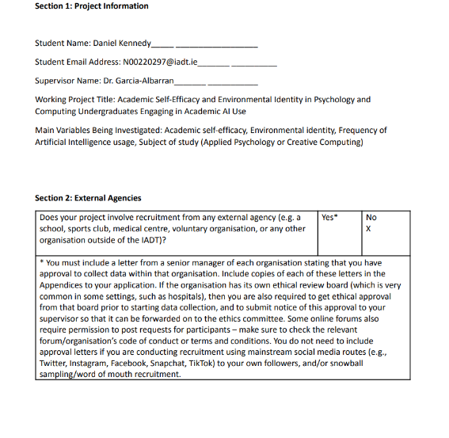
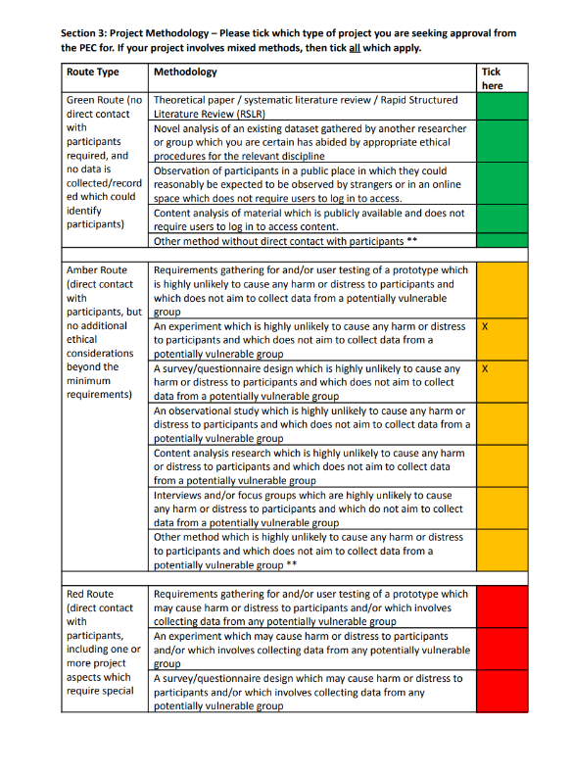
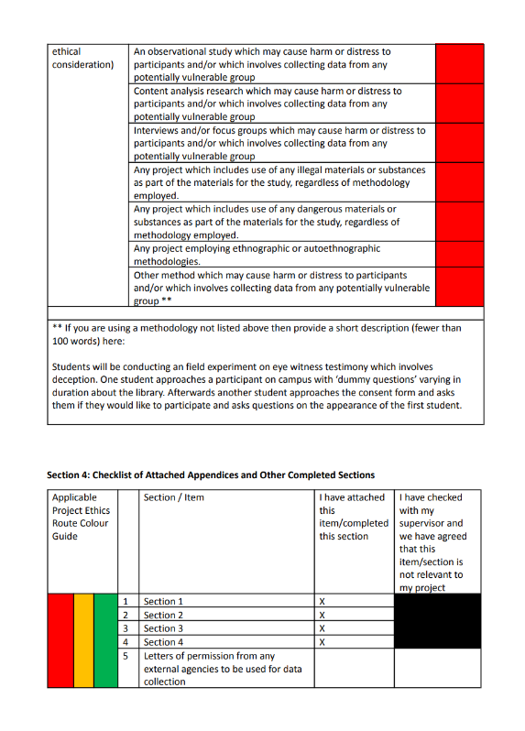
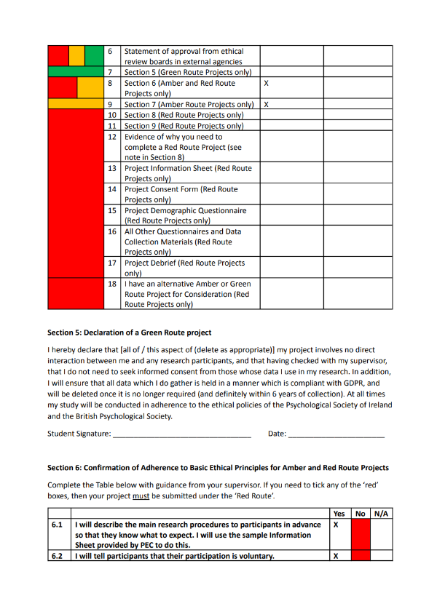
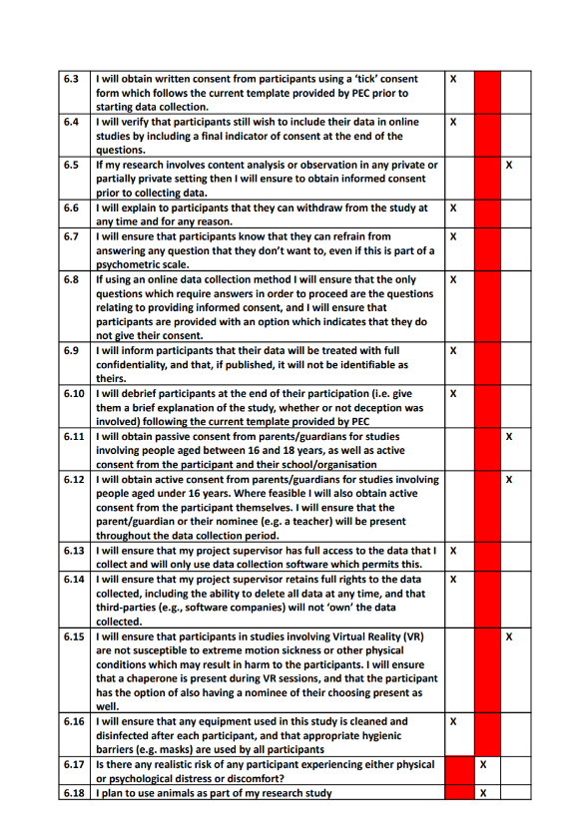
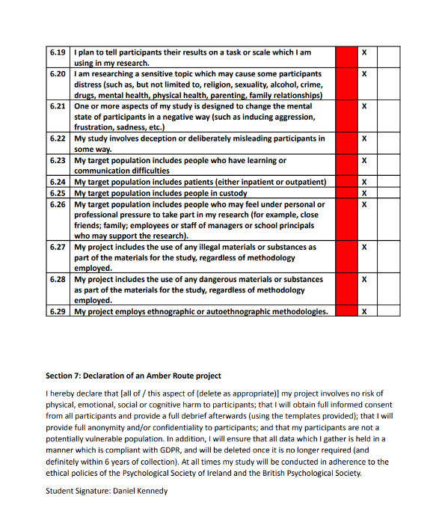

Appendix B - Information Sheet

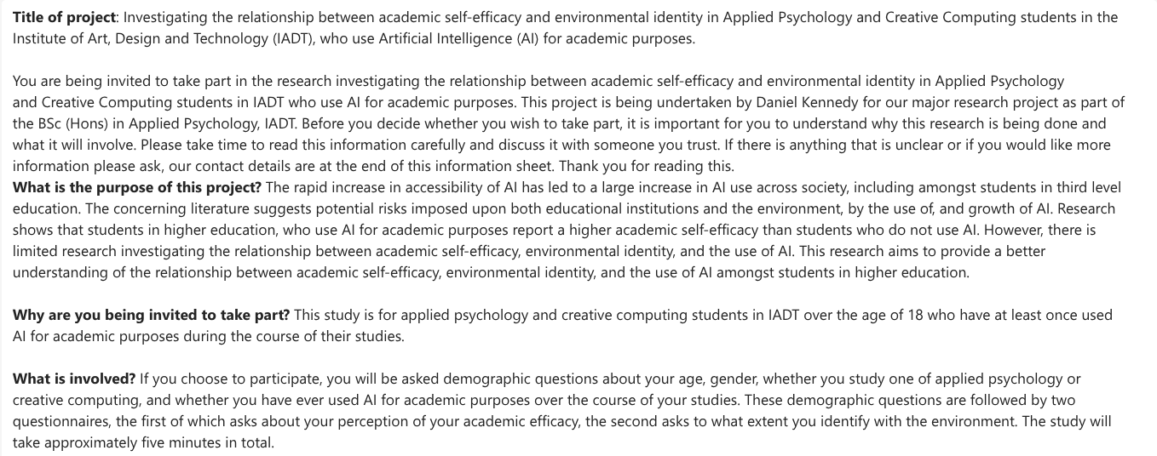
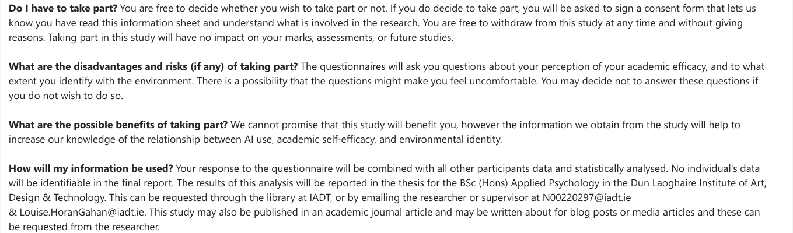
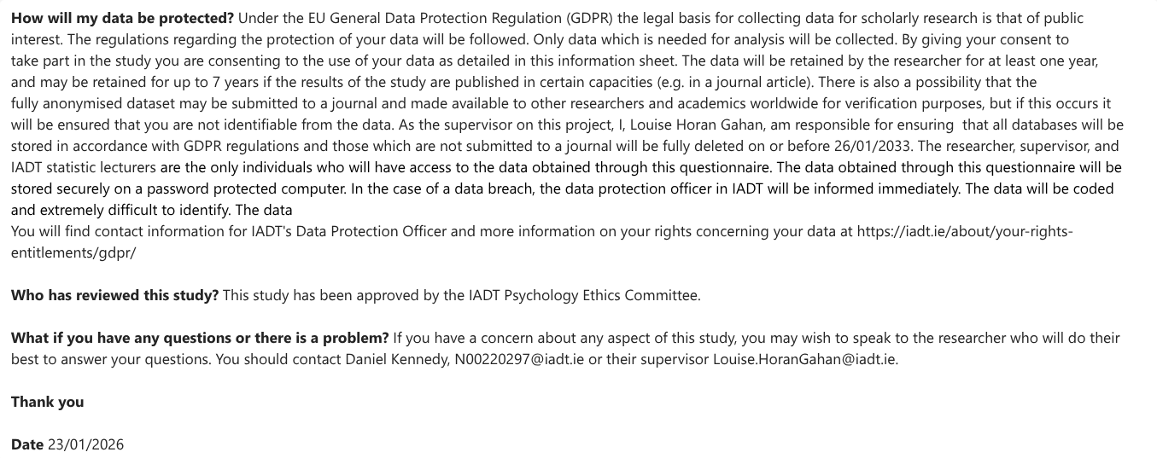
Appendix C - Consent Form
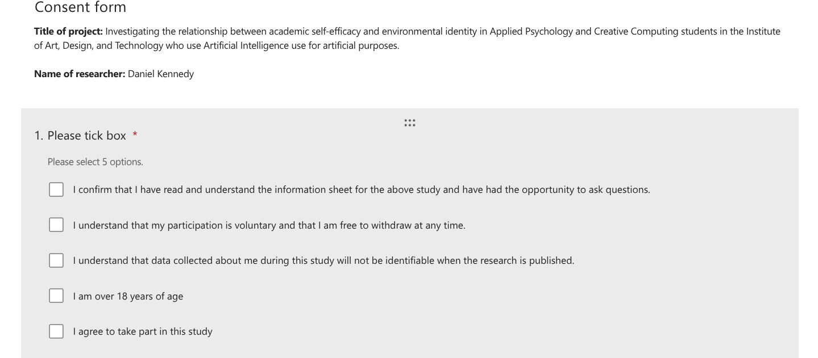

Appendix D - Unique Participant Identification Code
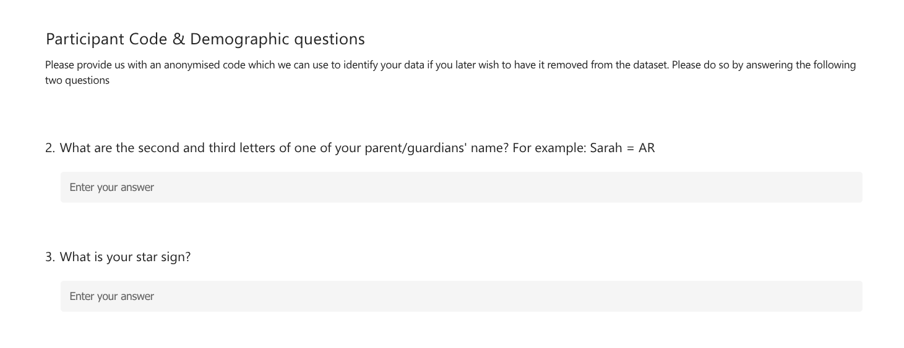

Appendix E - Demographic Questions


Appendix F - AI Use Question


Appendix G - General Academic Self-Efficacy Scale (Nielsen et al., 2018)
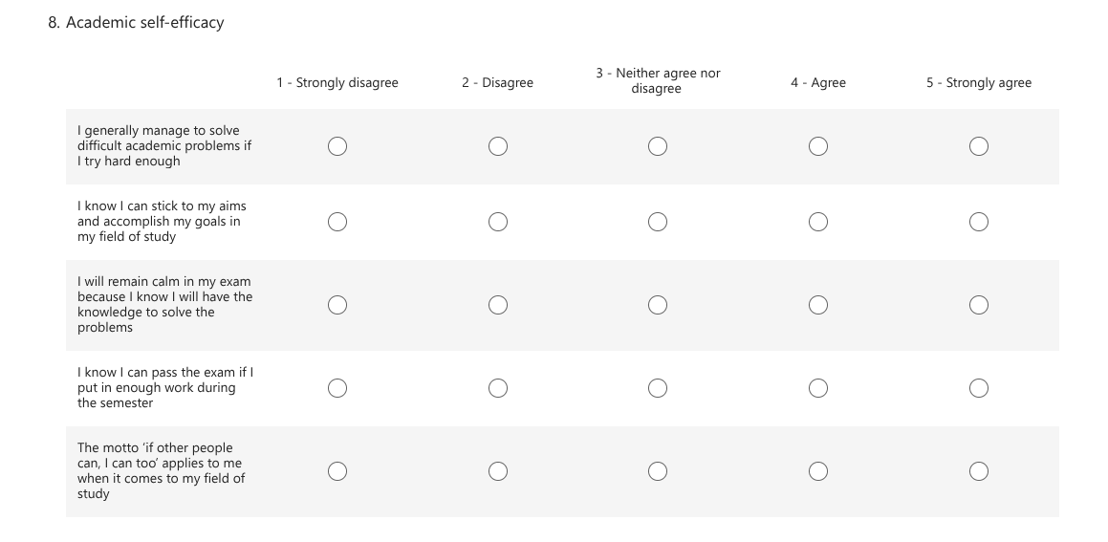

Appendix H - Revised Environmental Identity Scale (Clayton et al., 2021)
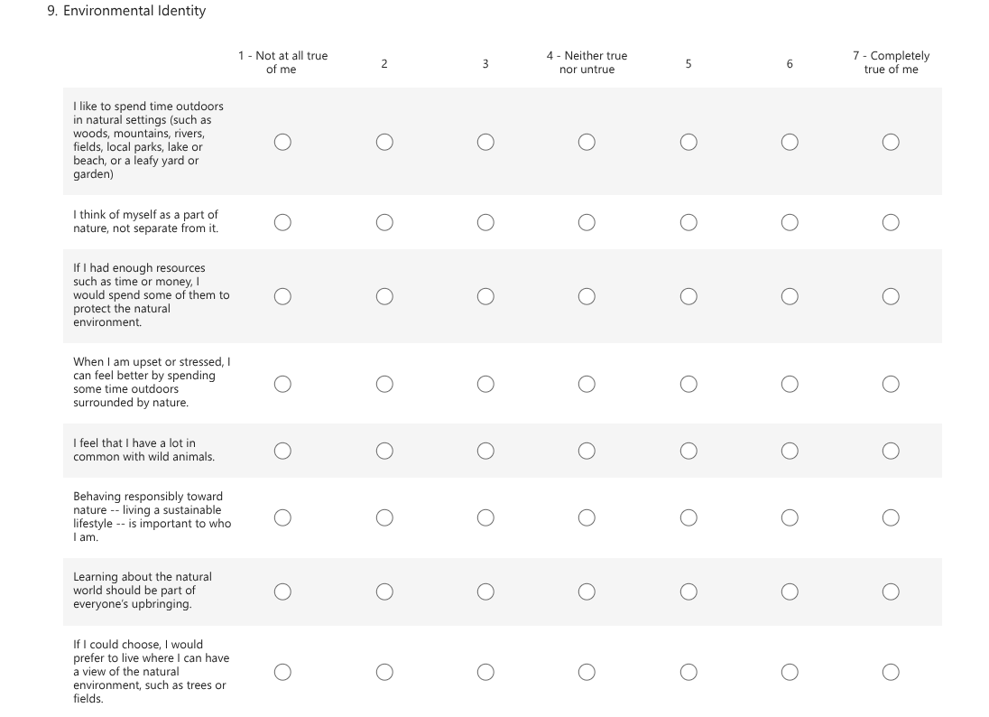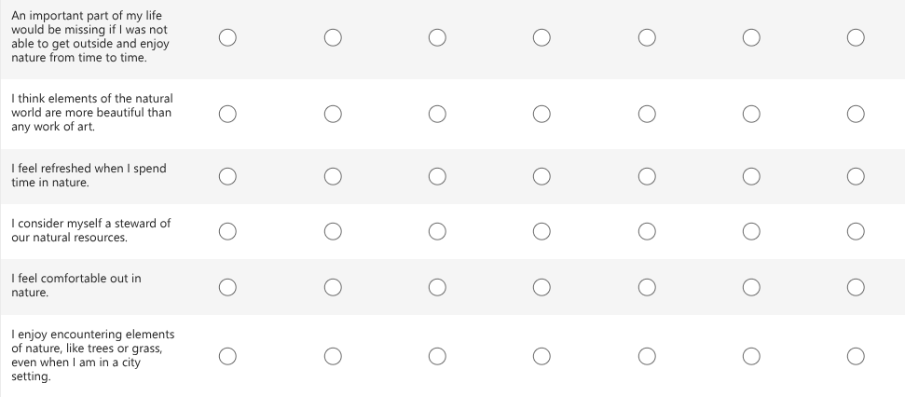

Appendix I - Confirmation of Consent
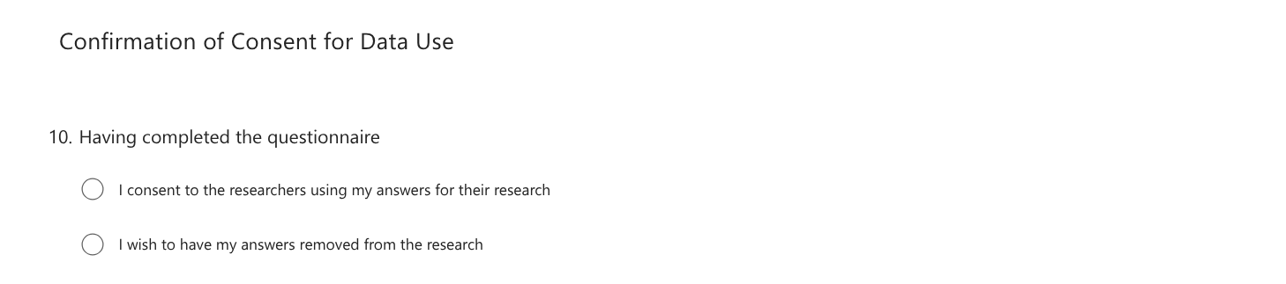

Appendix J - Debrief Information Form
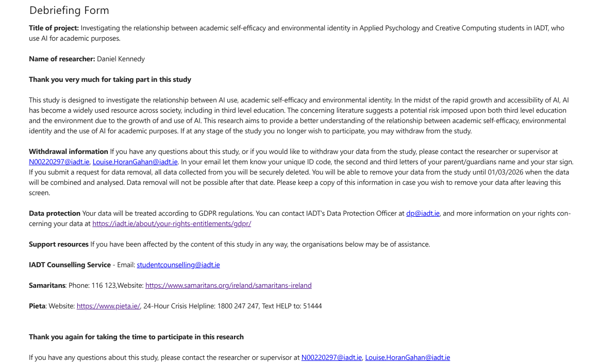

Appendix K - SPSS Output Tests of Normality
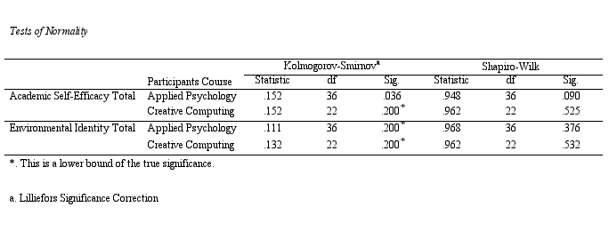

Appendix L - SPSS Output Levene’s Test of Equality of Error Variances
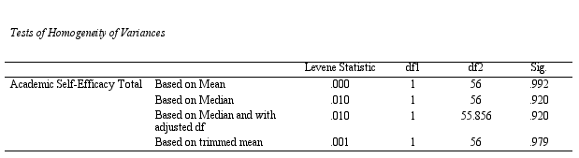
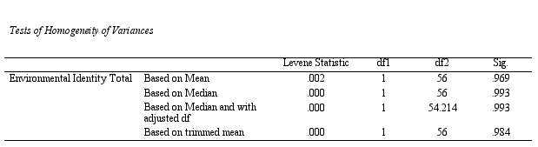

Appendix M - SPSS Output ANOVA
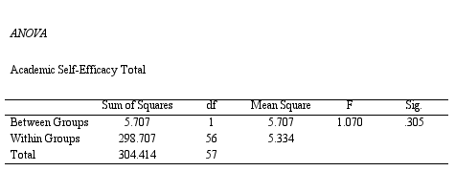
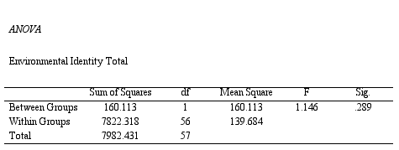

Appendix N - SPSS Output Power Analysis
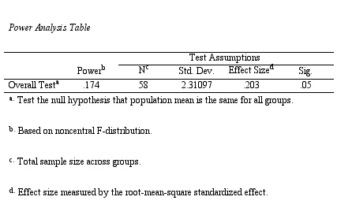
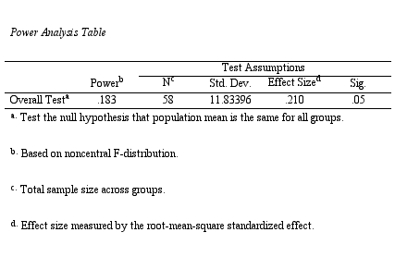

Appendix O - SPSS Output Pearson Correlations
