Evaluating the feasibility of consumer-grade EEG devices for use in undergraduate cognitive research.

Darragh McCusker
N00220961
Supervised by Dr. Andrew Magee

Thesis submitted as a requirement for the degree of BSc (Hons) in Applied Psychology, Dún Laoghaire Institute of Art, Design, and Technology, 2026

Declaration
I, Darragh McCusker, hereby declare that the work that I have submitted for / contributed to the assessment specified above is entirely my own work. Where I have drawn from the work of others, including Generative Al systems, I have clearly indicated this within my submitted work.
I recognize that Generative Al creations, no matter how small, may not be permissible within my submitted work and have checked this specific assessment brief for the admissible use of such software. I have read and complied with the IADT Academic Integrity Policy for this submission and recognize that breaches of this policy in my work may result in penalties, up to and including disqualification from lADT.
I, Darragh McCusker, hereby declare that I recognize that IADT staff may provide feedback on assessment via a range of methods, depending on the nature of the assessment and the preference of the staff member. I recognize that any grades issued by a lecturer are provisional but are not negotiable. Final grades will be issued following the relevant exam board meeting and information on appeals procedures is available on the IADT website. I agree to abide by the IADT Mutual Respect Policy in all of my communications with and regarding all IADT staff members.
Word count: 5,660

Signed by: Darragh McCusker
Signature:
Date: 30.03.2026

Acknowledgements
I would firstly like to thank Dr. Andrew Magee for his supervision throughout the course of this research project. His support and guidance were invaluable to the completion of this project, and I am extremely grateful for all of the help he has given. I would also like to thank Robert Griffin for his guidance in the early stages of this project, and Dr. Christine Horn for her assistance with the statistical analyses.
I would also like to thank Sean Henriques for his assistance with obtaining funding for, and purchasing, the EEG device and required software, and for his help throughout that entire process.
Finally, I would like to thank my Mam, Tracy, and my Dad, Patrick, for their continued support throughout the last four years. Their kindness has always been appreciated.

Table of Contents Page
Abstract 7
Introduction 8
1.1 Electroencephalography 8
1.2 Consumer-grade EEG Devices 8
1.3 Emotiv Insight 9
1.4 Validity and Reliability of the Emotiv Insight 10
1.5 Practical Feasibility Surrounding the use of Consumer-grade EEG Devices for Undergraduate Research 10
1.6 2-Back task and Rationale 11
1.7 EEG Markers of Attention 12
1.8 Cognitive Theories 12
1.9 Conclusion 13
1.10 Research Questions 14
Methodology 15
2.1 Design 15
2.2 Participants 15
2.3 Materials / Apparatus 15
2.4 Procedure 16
2.5 EEG Collection 17
Results 19
3.1 Attention-Tracking Capabilities 19
3.2 Relationship Between EEG and 2-back data 19
3.3 Differentiating Between Baseline and Task Conditions 19
3.4 Baseline Stability Over Time 20
Discussion 21
4.1 The Findings of the Present Study 21
4.2 Statistical Analyses 21
4.3 Semi-Dry Electrodes 22
4.4 Signal Quality Issues 22
4.5 Strengths of the Present Study 23
4.6 Limitations of the Present Study 24
4.7 Applications of the Present Study 25
4.8 Conclusion 25
References 26
Appendix A: Information Sheet 30
Appendix B: Consent Form 32
Appendix C: Anonymous Code and Demographics Form 33

Appendix D: Debrief and Confirmation of Consent Form 34

Appendix E: Baseline EEG Levels Presentation Slides 35

Appendix F: SPSS Output for Attention-Tracking Capabilities 38

Appendix G: SPSS Output Table for the Relationship Between the EEG and
2-back Data 39

Appendix H: SPSS Output for Differentiating Between Baseline and Task Conditions 40

Appendix I: SPSS Output for Baseline Stability Over Time 41

Appendix J: G*Power Output for Attention-Tracking Capabilities 42

Appendix K: G*Power Output for the Relationship Between the EEG and 2-back Data 43

Appendix L: G*Power Output for Differentiating Between Baseline and
Task Conditions 46

Appendix M: G*Power Output for Baseline Stability Over Time 50

Abstract
Consumer-grade EEG devices have risen in popularity over the last decade, due to their affordability and promises surrounding data quality. The current study aimed to examine the feasibility of consumer-grade EEG devices for use in undergraduate research, utilising a quantitative, within-groups, experimental design. The chosen device for this research was the Emotiv Insight EEG. Four research questions were explored to assess the feasibility of the chosen device: (i) Can this device detect changes in attention across different conditions?, (ii) Does the 2-back task data correlate with the EEG attention data?, (iii) Can this device detect differences between baseline waves and task waves?, (iv) Are baseline conditions stable over time? Participants completed a series of 2-back tests, with different genres of music playing during each. Raw EEG data was preprocessed using MNELAB through Python. Statistical analyses were conducted (Friedman tests, bivariate correlation, Wilcoxon signed-rank test). While mixed, results indicated that the presently available consumer-grade EEG devices are not feasible for use at undergraduate level. The current study’s strengths and limitations are discussed. The current study establishes guidelines for future consumer-grade EEG feasibility testing, and notes suggestions for future research.

- Introduction
1.1 Electroencephalography
The present study aims to investigate the feasibility of consumer-grade EEG devices for use in an undergraduate research setting, using a device called the Emotiv Insight (Emotiv, n.d.). Electroencephalography (EEG) refers to a non-invasive method for recording electrical activity from the brain, and does this through a series of electrodes placed on the scalp (Biasiucci et al., 2019). The first consumer-grade EEG device was released in 2007, and in the years since, there has been at least one new product every year. Some of these products are from the same manufacturer as the original device, and others are from competing companies aiming to earn their place in this growing industry (Sawangjai et al., 2020). Since their release, there has been increasing research into the use of these consumer-grade devices in research settings (e.g., Ratti et al., 2017; Sabio et al., 2024; Sawangjai et al., 2020), however, a severe lack in undergraduate-specific research was noted. This may be due to the fact that most undergraduate research projects are seen as pedagogical (Grønning et al., 2022), leading most researchers to focus on postgraduate or laboratory grade settings.
1.2 Consumer-grade EEG Devices
The research surrounding consumer-grade EEG devices in undergraduate settings has been evolving in recent years, with many attempting to determine if these devices are suitable for a range of tasks including laboratory research, control tasks, and even the control of wheelchairs (Sabio et al., 2024; Maskeliunas et al., 2016; Thwe et al., 2024). While older research papers have concluded that these devices are not fit for use in laboratory or professional settings (e.g., Maskeliunas et al., 2016), recent papers have stated that these devices can be useful as tools for research within neuropsychological and neuroscientific fields (e.g., Riedl et al., 2020; Sawangjai et al., 2020). The fact that the more recent research recommends the use of these devices is likely down to the advancements that have been made in recent years with this technology (He, 2025).

  - Emotiv Insight
As mentioned above, the device to be used in this study is the Emotiv Insight. This device includes a 5-channel electrode layout at AF3, AF4, T7, T8, and Pz locations on the scalp. It also has two common mode sense (CMS) and Driven Right Leg (DRL) reference sensors to ensure a stable baseline and reduce noise for EEG measurement (Emotiv, 2022). The Insight was chosen for a number reasons. Firstly, this specific device was due to its price falling within the consumer-grade range. Budgetary issues have been noted as a large obstacle for students in pursuit of careers in science, technology, engineering, and mathematics (STEM) (McClain, 2025). The use of a cheaper, consumer-grade device may be more attainable within a certain budgetary range when compared to medical-grade EEG systems, as was the case in this study. The second reason for this device being chosen was when compared to other devices within a similar price range on the market, both the hardware and software appeared to be more user-friendly and easier to understand. This is beneficial for undergraduates, as many will be unfamiliar with or only beginning to understand how to use this type of technology. The user manual is available publicly on Emotiv’s website (Emotiv, 2022), and a wide range of resources exist (e.g., Williams et al., 2023; Datta et al., 2024) that use the Emotiv Insight in conjunction with the EmotivPro EEG recording software (Emotiv, n.d.) to complete research and determine whether they are suitable for neurological-based research. Another advantage this device had over other ones within this price range was the quality of its electrodes. Another device that was considered was the BrainBit Headband (Brainbit, n.d.). This device is a smart headband that is also consumer-oriented, however it only has four channels and uses dry electrodes. Dry electrodes are commonly used in consumer settings due to their improved user-friendliness and quick setup time (Li et al., 2020), however, Wang et al. (2016) noted that they can have negative effects on electrode-skin impedance and signal stability. Wet electrodes have been the point of comparison for EEG recordings for years, however they would be too invasive for use in undergraduate research as they can increase user discomfort, and can be too difficult to implement without training (Li et al., 2020). The Emotiv Insight uses semi-dry electrodes (Emotiv, 2022), which do require a primer fluid, but leaves minimal to no residue on skin, and maintains the ionic conducting path created when using wet electrodes (Wang et al., 2016), thus making it the prime candidate for use in this study over the BrainBit device.
1.4 Validity and Reliability of the Emotiv Insight
When compared to research-grade EEG devices such as the Enobio 32, major differences appear that assist in understanding the differences between a consumer and a research-grade device. The Insight has a sampling rate of 128 Hz, while the Enobio’s sampling rate sits at 500 Hz. Furthermore, the Enobio has 32 channels compared to the Insight’s 5. However, this is unsurprising as the Insight is a consumer-focused device priced at $499.00, while the Enobio’s pricing is not publicly listed, and to receive an idea a quote must be requested from the manufacturer. It has however been roughly estimated to be within the $6,000 to $8,000 range, although prices may vary depending on the model of the device purchased, and the location from which the device is acquired. Furthermore, it should be noted that this value is based on publicly available data, and not direct quotes from the manufacturer (BioniChaos, n.d.). Due to the higher sampling rate and larger number of channels, the accuracy and quality of the data received from the Enobio would be far superior to that of the Insight. There are concerns surrounding signal quality with the Insight, due to the lower number of sensors, the use of semi-dry electrodes instead of wet ones, and frontal electrode placement, all of which increase the chance of artefacts (Sawangjai et al., 2020). However, as shown in Saeed et al. (2020), the Insight is a viable device for use in certain research settings, and when you consider the pedagogical nature of undergraduate research (Grønning et al., 2022), it is reasonable to assume that this device will be sufficient in gathering the data we require.
1.5 Practical Feasibility Surrounding the use of Consumer-grade EEG Devices in Undergraduate Research
Consumer-grade EEG devices are significantly simpler to set up when compared to research-grade devices, due to the lower number of electrodes, and the fact that most of these devices use either dry or semi-dry electrodes, both of which eliminate a lot of preparation time (Ratti et al., 2017). Consumer-grade devices are portable by design, as they are intended for use in everyday life, thus giving them an advantage over research-grade devices in this context, which can require a significant amount of time for the application process (Ratti et al., 2017). Due to this design, they are also designed with comfort in mind, although the use of dry electrodes in some devices have been reported to be uncomfortable for long periods of time (Ratti et al., 2017). However, there are other concerns with the use of dry electrodes, such as electrode misplacement leading to unstable EEG patterns (Maskeliunas et al., 2016). The Emotiv Insight comes with a ‘lite’ version of their EmotivPRO software, which allows users to view the raw EEG data. (Emotiv, n.d.). There is also a premium version, which allows users to build experiments and process, export, and analyse their data, directly within the app. This is a subscription-based service, but we deem it feasible for use in undergraduate research as institutions will be able to pay to access this software for the required amount of time. The inclusion of this type of software greatly reduces the learning curve surrounding EEG data analysis, and acts as an excellent gateway for beginners who are interested in this area of research. Maskeliunas et al. (2016) noted that brain-computer interface (BCI) illiteracy was a prominent issue with consumer devices, and could hinder the gathering and analysis of EEG data. They also recommended that improving the understanding of information surrounding BCIs should be a priority in this field of research, as doing so may make these devices more accessible. Segawa (2019) showcases the benefits of training undergraduate students to become familiar with this technology. They gathered student volunteers to partake in undergraduate research using consumer-grade EEG devices, and asked open-ended questions to gather qualitative information from the students about their experience. They reported increased learning surrounding the function of EEG devices, enjoyment of the practical element involved, and that it made the theory surrounding this topic ‘really concrete’, which further demonstrates the invaluable educational opportunities that the use of these devices can give to undergraduate students.
1.6 2-Back task and Rationale
N-back tasks are a commonly used measure to assess working memory in participants, in which they are asked to monitor a series of stimuli and respond (usually by pressing a button) when the presented stimulus is the same as the one that was presented n stimuli ago (Meule, 2017). There are several websites online that give users free access to n-back test software, such as PsyToolkit (Stoet, 2010, 2016) which we plan to use for this research. This type of task is suitable for this research not only due to the reliable behavioural measures it can produce, but also because it will allow for us to solely focus our EEG on participant attention. Furthermore, the data collected from this task will allow for correlation with the EEG data on attention, which will give us additional information surrounding the relationship between the EEG data and the task outputs, and allow for independent verification of the brainwave data
1.7 EEG Markers of Attention
We plan to identify markers of attention using our EEG device by analysing data obtained from electrodes in sites AF3, AF4, T7, T8, and Pz. Both AF (anterior frontal) sites are located between the frontal (F) and frontal pole (Fp) regions, which gather data from the cerebral cortex, an area of the brain has been associated with attentional processes (Liu et al., 2013). The Pz (parietal midline) electrode sits in the middle of the scalp. This region of the brain has been theorised to act as a saliency map, which is a theoretical model that primarily guides attention based on bottom-up inputs (Koch & Ullman, 1987). Bisley & Goldberg (2010) proposed that a priority map was a more accurate description, one that is built of both top-down and bottom-up signals. While neither frameworks imply precise signal identification using EEG, they do leave us with a valid conceptual basis for use of this device from a cognitive standpoint. The T (temporal) sites are situated just over the left and right temporal lobes. Attar (2023) noted that alpha waves disappear during sessions of attention, which validates previous work suggesting that alpha oscillations play a role in the control of attention as mentioned by Schneider et al. (2021). Deficient beta wave activity in different brain regions has also been linked to concentration challenges (Attar, 2023), however further research is needed with regards to both alpha and beta waves. Theta waves have been shown to act as a reliable metric for gauging user engagement, and can also act as an indicator for sustained attention during a task (Torabi et al., 2025). There are established limitations that are associated with using a device which has five electrodes (Emotiv, n.d.), such as the restricted spatial resolution and limited coverage of the scalp. These limitations prevent us from assuming that recorded activity represents isolated neural sources, and any observed changes shall be interpreted as indicators of attention and engagement with the task, rather than precise markers of cortical mapping.
1.8 Cognitive Theories
The current field of research recognises four main types of attention. Sustained attention refers to an individual maintaining their attention on a specific task for a period of time (Chung-Fat-Yim et al., 2022). Selective attention describes an individual’s ability to focus on whatever stimuli deemed relevant in the moment, while simultaneously filtering out irrelevant stimuli (Chung-Fat-Yim et al., 2022). An individual switching rapidly back and forth between two tasks is using their alternating attention (Chung-Fat-Yim et al., 2022), and divided attention involves the processing of more than one stimulus at the same time (Chung-Fat-Yim et al., 2022). Individuals participating in an n-back task would be making use of their sustained attention (Chung-Fat-Yim et al., 2022), as the task requires continuous focus to complete. The EmotivPRO software includes a feature that allows for experimenters to measure a participant’s attention level in real-time, however this is conducted by using algorithms to interpret the processed signals, and it is unclear which signals are being used towards this metric (Tran, 2025). The raw EEG data, alongside the behavioural data obtained from the 2-back task, will be our primary sources for data and statistical analysis. Cognitive load theory (CLT) describes how we process information through our working memory, and details the three types of cognitive load that exist (Clark & Kimmons, 2023). Intrinsic load relates to the degree of difficulty that exists within a learning event. Extraneous load can be described as additional irrelevant information that do not support the learning event at hand. The third type of cognitive load is germane load, which is unlike the other two types, as it is not considered an independent source of load. Instead, it describes the working memory resources that are available to deal with the transfer of short-term information to long-term knowledge and understanding (Clark & Kimmons, 2023). In instances where the 2-back test results show missed answers or slower reaction times from participants, we plan to compare the EEG data on attention to the 2-back test data, and if no clear lapse in attention is present, it may be consistent with the participant experiencing cognitive overload. Not all working memory performance failures are caused by complete lapses in attention (Adam et al., 2015); some may be better explained by variations in attentional control (Adam et al., 2015). Additionally, due to the lack of detail in the Insight’s frontal theta readings, working memory readings may be unclear, and fluctuations in attentional control may not be noticeable (Adam et al., 2015)
1.9 Conclusion
The review above has identified significant gaps in the current literature surrounding the use of consumer-grade EEG devices in undergraduate settings, and has clearly demonstrated the rationale for conducting a feasibility study on the topic. The lack of available research in undergraduate-specific settings justifies this study’s focus in this area. From detailed investigation of the current field, it appears that this research should be possible using the Insight combined with the EmotivPRO software, with additional data processing being completed using Python. Furthermore, if the device is deemed feasible, accessibility for EEG studies may be increased, the potential outcomes of which remain to be seen.

1.10 Research Questions:
- “Can this device detect changes in attention across different conditions?”
- “Does the 2-back task data correlate with the EEG attention data?”
- “Can this device detect differences between baseline waves and task waves?”
- “Are baseline conditions stable over time?”

- Methodology
2.1 Design
The present study was a feasibility study that utilised a quantitative, within-groups experimental design.
2.2 Participants
A total of 12 participants were gathered using convenience sampling across a range of locations, 11 of whom were male. Participant ages ranged from 18-30. 4 participants were excluded before the data filtering process began, three due to corrupt data files, and one due to EEG connectivity issues. Upon data processing, a further 2 participants were excluded due to a large volume of noise corrupting their EEG data. The treatment of participants was done in accordance with the Psychological Society of Ireland’s ethical standards, and the Psychological Ethics Committee in IADT, Dún Laoghaire, approved the study.
2.3 Materials / Apparatus
Participants read an online information sheet prior to participation, and were also asked to complete an online consent form. They were asked which age bracket they fell in (18-24, 24-30, 30-40, 40-50, 50+). They were asked to type their gender, or type ‘prefer not to say’ if they were not comfortable sharing such information.
Participants were given an online debrief form, and also completed an online confirmation of consent sheet once the research had concluded, which gave them the option to remove their answers from the study if they wished.
The main piece of equipment used in this study was an EEG device called the Emotiv Insight, a five-channel portable headset with electrodes that recorded activity from the frontal cortex (AF3-AF4), the parietal-temporal cortex (T7-T8), and the parietal-occipital cortex (Pz). This device was used to record electrical brain activity in participants.
Participants were asked to complete a 2-back task, which was run using a software called PsyToolkit (Stoet, 2010, 2016). Two songs were played during task conditions (Lukrembo, 2022; Pufino, 2023), which were both downloaded from the website Free To Use (freetouse.com/music).
A PowerPoint presentation was created, which gave participants information regarding the baseline reading process, and was used to acquire participants’ baseline EEG levels.
For data processing, the EmotivPRO software was used to download and export the raw EEG data. This was also used to conduct recordings, and to add event markers to the data stream. Anaconda and Jupyter notebook were used for the filtering and processing of the raw EEG data. Claude AI was utilised for the generation of Python code to assist with the data filtering process, and this study received a derogation to access this software as part of the research.
IBM SPSS statistics was used to conduct statistical analysis on the processed data. G*Power was used to conduct post-hoc power analysis on the data.
2.4 Procedure
Participants were gathered randomly using convenience sampling. Due to the portable nature of the EEG device, data collection took place in a number of different locations. Once a participant entered the room and sat down, they read the online information sheet, and filled out the consent form. The EEG device was set up prior to the participant entering the room. Once the consent form was completed, the device application process began. This process was timed. Once contact quality and EEG quality both read 100% on the EmotivPRO software’s interface, the timer was stopped and the baseline levels presentation was shown to participants. To gather baseline readings, participants were told to sit comfortably and stare at a black cross on a white background for 60 seconds. Event markers were added to the EEG data stream to indicate the beginning and conclusion of each baseline period. Participants then completed the first of three 2-back tasks. Event markers were also added to mark the beginning and end of the 2-back tasks. Upon completion of the first 2-back task, another baseline period began, after which followed the second 2-back task. During this condition, the first of two songs was played, with the first one being a calming, lo-fi instrumental song (Lukerembo, 2022). This song was played on a continuous loop, so if a participant had not completed the task before the song ended, it simply restarted. After the second 2-back was finished, a third and final baseline reading was obtained. The final 2-back task had a different song playing in the background, which was a louder, heavy-metal instrumental (Pufino, 2023). Once the final task had been completed, the device was removed, and participants read an online debrief sheet and a confirmation of consent form was given to ensure participants were given the opportunity to remove their data if they wished.
2.5 EEG Collection
The EEG data was recorded using the Emotiv Insight EEG device. Electrodes were set up with primer fluid, which increases conductivity and allows for better signal acquisition. The EmotivPRO software was used to record the data at a sampling rate of 128Hz. This data was then exported and saved as a csv file containing performance metrics, frequency bands, event markers, and motion data. The collected data was analysed for artefacts and any noise that may be affecting channel performance. 1 Hz high-pass and 50Hz low-pass finite impulse response (FIR) filters were applied to the collected data to remove artefacts and noise coming from the power grid. Claude, an AI tool, was used to develop python code to assist in this process. Upon the completion of data filtration, independent component analysis (ICA) was conducted on the data, however the Insight’s low number of electrodes significantly limited the quality of artefact rejection at this stage. Of the twelve total participants gathered, six datasets were within usable range of signal variability after filtering, and of those six, one dataset was subjectable to ICA. As a result, the five other datasets that were not subjected to ICA were still included in the statistical analysis using the channels’ signal variability values after filtration. Data was segmented and exported to IBM SPSS Statistics for statistical analysis.
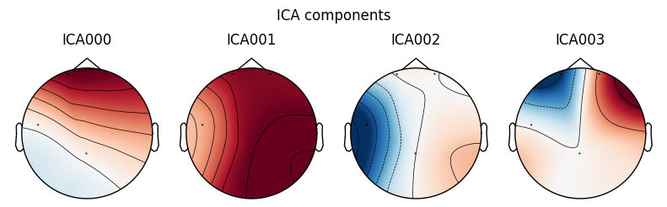
Figure 2.1: ICA Topographical Map

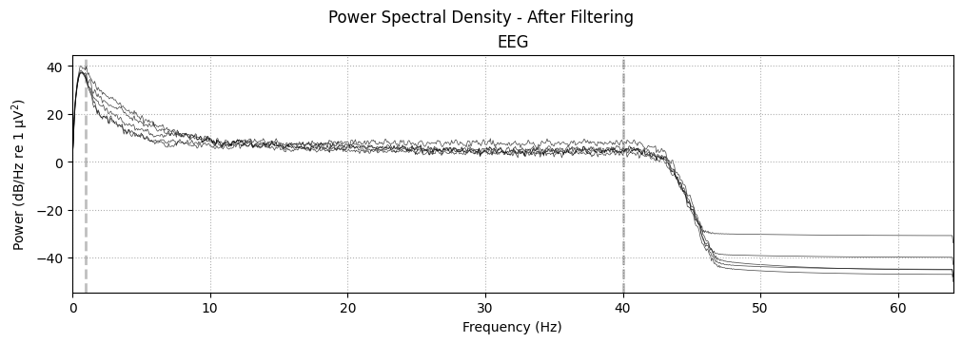
Figure 2.2: Power Spectral Density (PSD) Graph Post-Filtering

- Results
3.1 Attention-Tracking Capabilities
A Friedman test using the theta/alpha ratios from each condition revealed that there were no significant changes in attention detected by the device across conditions χ² (2, N = 6) = .333, p = .846. The theta/alpha ratio was highest during the rock condition (Md = 3.05), followed by the lo-fi condition (Md = 2.84), followed by the silent condition (Md = 2.81). A negligible effect size was observed (W = .028), and post-hoc analysis revealed low statistical power (1 – β = .113).
Table 3.1: Descriptive Statistics for Theta/Alpha Ratio Levels Across Tasks
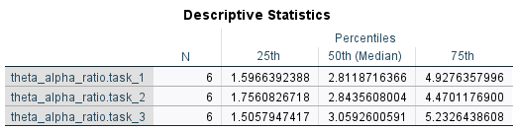
3.2 Relationship Between EEG and 2-back Data
Three Spearman’s rank-order correlations were run to examine the relationships between theta/alpha ratios and miss rate. There were two negative non-significant correlations between these variables on tasks one and two, r_{s} = -.200, -.348, n = 6, p = .704, .499. Post-hoc analysis was conducted, which indicated very low statistical power (1 – β = .064, .099). A significant positive correlation was found between these variables on task three, r_{s} = .880, n = 6, p = .021, which represented a large effect size. Post-hoc analysis displayed near-adequate statistical power (1 – β = .759).
3.3 Differentiating Between Baseline and Task Conditions
Wilcoxon signed-rank testing was conducted to assess the differences between baseline and task theta readings across the three musical conditions (silence, lo-fi, rock), which revealed varying results when comparing baseline conditions (Md = 3.67, 3.67, 3.87) and task conditions (Md = 5.72, 6.90, 6.56), z = -2.201, -2.201, -1.572, p = .028, .028, .116. Each of the three comparisons displayed large effect sizes (r = .899, .899, .642), however only the first two showcased statistical significance. Post-hoc analysis revealed low statistical power (1 – β = .405, .405, .236). No Bonferroni correction was applied due to the exploratory nature of the current study.
Table 3.2: Descriptive Statistics for Theta Readings from Baseline and Task Conditions
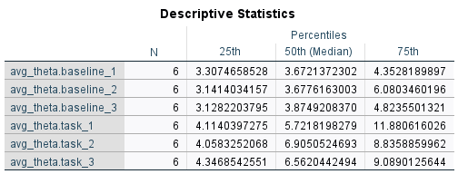
3.4 Baseline Stability Over Time
Three Friedman tests were conducted to investigate the stability of baseline segments over the course of the study. No significant differences were found in baseline theta readings χ² (2, N = 6) = .000, p = 1.000, W = .000, baseline alpha readings χ² (2, N = 6) = 1.333, p = .513, W = .111, or baseline readings of the theta/alpha ratio χ² (2, N = 6) = .333, p = .846, W = .028, over the three conditions. Post-hoc power analysis revealed low statistical power levels for alpha readings (1 – β = .354), and for the theta/alpha ratio data (1 – β = .113). The power analysis for the theta waves was not interpretable due to the null result.
Table 3.3: Descriptive Statistics for Baseline Levels of the Theta/Alpha Ratio
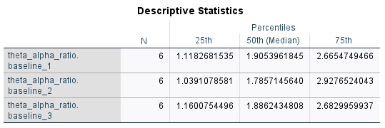

- Discussion
4.1 The Findings of the Present Study
The present study investigated four research questions which were designed to test the validity and reliability of the Emotiv Insight EEG, and the statistical analyses of the data provided mixed results. Despite the promising capabilities that the device displayed in certain aspects, the findings from the current study indicate that the device is not feasible for use in undergraduate research settings.
4.2 Statistical Analyses
The device’s ability to measure changes in participant attention across the different task conditions was found to be lacking, with no significant changes detected upon analysis. This may be due to the fact that the despite the different musical conditions, attention levels stayed similar due to the task remaining the same throughout each condition. However, low statistical power was revealed after post-hoc testing, making it more likely that the small sample size was not sufficient enough to allow the statistical analysis to detect any meaningful changes.
It was found that out of the three different datasets, there was no relationship between the data from the EEG recordings and the data from the 2-back task. However, there was a significant positive correlation noted between these datasets on task three, which had rock music playing while participants completed the 2-back task. This may be due to participant familiarity with the task increasing after completing it twice, which may have led to a lower miss rate. The rock music condition may also have increased the level of cognitive load, thus increasing the theta/alpha ratio scores (Klimesch, 1999). This, combined with the reduced miss rate, may have played a role in the positive correlation. We had originally planned to account for the lack of a correlation to increases in cognitive load, however due to the low statistical power of the study, it is not feasible to assume this as a conclusive answer for the lack of correlation between the first two conditions.
The device was capable of detecting differences between task and baseline conditions across participants; however, only during the silent and lo-fi conditions. The data from the rock condition did not display a significant difference from the baseline period data. This condition had the lowest statistical power out of the three, and the low sample size used in this study may have caused a type II error.
Baseline conditions were all found to be stable across time and across participants. This finding demonstrates the device’s reliability, demonstrating that it is capable of gathering data consistently within a suitable research setting. Alpha readings, theta readings, and the theta/alpha ratio readings were measured, and signal stability was noted, suggesting that all participants began the task without any major artefacts corrupting the data. Low power was noted for two of the baseline stability tests, however the negligible effect sizes suggest baseline stability across time.
4.3 Semi-dry Electrodes
The findings of this study were not consistent with those of Li et al., (2020), which claimed that semi-dry electrodes could collect EEG signals that were comparable to those collected using wet electrodes. Throughout the course of data collection, severe drops in signal quality were noted, and set-up procedure appeared notoriously inconsistent. The EmotivPRO software displayed a 100% contact and EEG signal rate within two-to-three minutes for some participants, while others took closer to ten minutes. In one case, a connection was attempted to be established for just under twenty minutes to no avail. This participant had long hair, and this may have affected the connection between electrodes and the scalp. While the various reductions in signal quality may have been a result of artefacts such as muscle movement or eye blinks, the inability to establish a connection is more likely due to the electrodes, or the device itself.
4.4 Signal Quality Issues
Certain data sets were deemed unusable due to noise corruption. Many artefacts were noted during data processing, with some channels having signal variability scores above 400 microvolts. For reference, to be included in the statistical analysis, variability had to be between 10 and 100 microvolts. It was not possible to conduct an ICA on the majority of the datasets, due to the low number of electrodes present. This led to the inclusion of data that may have contained artefacts to be present in the results output. Additionally, upon completion of ICA, kurtosis values were unusually high, in some cases reaching scores above 2,500, which was an extreme indicator of signal spikiness. To put this score into perspective, a kurtosis threshold was put in place with an upper limit of 10. The high values indicated a vast amount of noise and artefacts within the recording.
The aforementioned dips in signal quality were a notable issue during the course of this study. While the study would start with the EEG device at 100% signal quality, dips were a common occurrence, and this may have also caused noise within the data stream. Any slight movement appeared to cause artefacts, and it was unrealistic in a non-clinical setting to expect participants to sit completely still without moving at all for the duration of the sessions, which lasted approximately 30-40 minutes.
4.5 Strengths of the Present Study
The portability of this device made data collection an easier process, as participants could partake in the research once a quiet room with a computer was available. However, the use of multiple different rooms for data collection may have introduced covariates, as the layouts of each room were slightly different than the others. Nevertheless, given the focus on undergraduate research specifically, this study was conducted in a realistic setting, which benefitted ecological validity.
Previous studies conducted studies of this type in lab conditions with experienced researchers (e.g., Ratti et al., 2017, Sawangjai et al., 2020, Johnstone et al., 2012). This study addresses the lack of undergraduate-specific research by conducting this work in a location that undergraduate students generally have access to.
McClain (2025) discussed the impact that a lack of institutional finances can have on one’s ability to pursue a career in STEM. The low cost of this device in comparison to research-grade EEG devices allowed for funding to be acquired at an undergraduate level, hypothetically improving access to neuroscientific research.
Similar studies investigating this device did not utilise a preprocessing pipeline for the EEG data (e.g., Zabcikova et al., 2019), and used only the built-in metrics in the recording software. While this software does display live EEG data, without processing and the performing of statistical analyses, artefacts and noise can go unnoticed, and effects may be missed.
Set-up times were also notably shorter when compared to clinical EEG devices, which can take up to 30 minutes before data collection can begin (North Bristol NHS Trust, 2024). While there were some cases in which set-up took nearly 10 minutes, with inconsistencies in set-up time across participants, it was still far shorter than the time it takes clinical devices to be ready for use.
No participants reported discomfort when asked during the application process, and minimal to no residue was left from the primer solution used on the electrodes, ensuring that invasiveness was at a minimum.
4.6 Limitations of the Present Study
It should also be noted that only alpha, theta, and theta/alpha ratio readings were used for analysis. Beta waves also act as an indicator for attention during task conditions (Abhang et al., 2016). Future research should include beta waves in their statistical analyses to assist in obtaining a clearer picture of the results.
The small sample size used in this study may also have affected the generalisability and findings of the research, however, as this was a feasibility study a larger sample size had not been planned for. Non-parametric analysis had to be conducted due to the size, and low power was observed across a number of the statistical tests. In future research exploring feasibility of similar EEG devices, a larger, more diverse participant sample should be used, as this would allow for parametric analysis, and would also increase statistical power.
The findings of this study were consistent with studies similar to Maskeliunas et al. (2016), which claimed that consumer-grade EEG devices were not suitable for use in laboratory settings. However, it may be worthwhile for future researchers to investigate this further, as a laboratory setting combined with individuals who are more experienced in the field of EEG research may be able to overcome some of the obstacles that come with using a consumer-grade device.

4.7 Applications of the Present Study
As a practical application, devices similar to the Insight should not be used as tools for research. They may however be of benefit for those interested in learning about the basics of EEG research. While the data obtained from this device was lacking significance in a number of ways, data analysis was still possible, thus leading to the conclusion that these devices may be useful to educators interested in teaching students about this area of neuroscientific research, as the process of recording, processing, and analysing data stays the same regardless of data quality.
The current study has also established guidelines for assessing the feasibility of future consumer-grade EEG devices. Future researchers should consider the limitations and strengths mentioned in this study when conduct research of a similar nature, to ensure a thorough, empirical evaluation of future devices and their capabilities.
4.8 Conclusion
Based on the findings of this study, presently available consumer-grade EEG devices do not appear as feasible for use in undergraduate research. The large number of artefacts, dips in signal quality, and results from statistical analysis all indicate that there was simply not enough quality data recorded by the device. We believe the limited number of electrodes and lack of strap to keep the headset secure caused these artefacts, combined with participant movement throughout the tasks. However, there were promising results surrounding baseline stability, and the detection of differences between baseline and task conditions. A larger sample size may expand upon these results, and may also find significance for tracking attention across different states. Additionally, researchers with more experience and a professional laboratory may be able to utilise these devices to their full potential. However, from an undergraduate research standpoint, these devices leave a lot to be desired and are not currently feasible for use.

References
Abhang, P. A., Gawali, B. W., & Mehrotra, S. C. (2016). Introduction to EEG- and speech-based emotion recognition. Academic Press is an imprint of Elsevier.
Adam, K. C., Mance, I., Fukuda, K., & Vogel, E. K. (2015). The contribution of attentional lapses to individual differences in visual working memory capacity. Journal of Cognitive Neuroscience, 27(8), 1601–1616. https://doi.org/10.1162/jocn_a_00811
Attar, E. T. (2023). EEG waves studying intensively to recognize the human attention behavior. 2023 International Conference on Computing, Communication, and Intelligent Systems (ICCCIS), 1–5. https://doi.org/10.1109/icccis60361.2023.10425510
Biasiucci, A., Franceschiello, B., & Murray, M. M. (2019). Electroencephalography. Current Biology, 29(3). https://doi.org/10.1016/j.cub.2018.11.052
BioniChaos. (n.d.). EEG device comparison. https://bionichaos.com/EEGCompare/
Bisley, J. W., & Goldberg, M. E. (2010). Attention, intention, and priority in the parietal lobe. Annual Review of Neuroscience, 33(1), 1–21. https://doi.org/10.1146/annurev-neuro-060909-152823
BrainBit. (n.d.). Brainbit headband. BrainBit. https://store.brainbit.com/products/brainbit-sdk?srsltid=AfmBOorisUvQBIExNfetmgAMPi40SlhyfydIdEG9DU3n3iYp_45bNPU3
Chung-Fat-Yim, A., Calvo, N., & Grundy, J. G. (2022). The multifaceted nature of bilingualism and attention. Frontiers in Psychology, 13. https://doi.org/10.3389/fpsyg.2022.910382
Clark, C., & Kimmons, R. (2023). Cognitive load theory. EdTechnica. https://doi.org/10.59668/371.12980
Datta, P., Kaur, A., Sassi, N., Gulzar, Y., & Jaziri, W. (2024). An evaluation of intelligent and immersive digital applications in eliciting cognitive states in humans through the utilization of Emotiv Insight. MethodsX, 12, 102748. https://doi.org/10.1016/j.mex.2024.102748
Emotiv. (n.d.). Emotiv Insight: 5-channel wireless EEG headset for BCI & research. https://www.emotiv.com/insight
Emotiv. (n.d.). EmotivPRO. Retrieved March 30, 2026, from https://www.emotiv.com/emotivpro
Emotiv. (2022). Introduction to Insight 2. https://emotiv.gitbook.io/insight-2-user-manual/introduction/introduction-to-insight-2
Faul, F., Erdfelder, E., Buchner, A., & Lang, A.-G. (2009). Statistical Power analyses using G*Power 3.1: Tests for correlation and regression analyses. Behavior Research Methods, 41(4), 1149–1160. https://doi.org/10.3758/brm.41.4.1149
Faul, F., Erdfelder, E., Lang, A.-G., & Buchner, A. (2007). G*Power 3: A flexible statistical power analysis program for the social, Behavioral, and Biomedical Sciences. Behavior Research Methods, 39(2), 175–191. https://doi.org/10.3758/bf03193146
Free To Use Music. (n.d.). Free music for creators. https://freetouse.com/music
Grønning, K., Karlsholm, G., & André, B. (2022). Undergraduate nursing students’ experiences of conducting clinical research projects in their bachelor theses – a qualitative study. SAGE Open Nursing, 8. https://doi.org/10.1177/23779608221094537
He, Q. (2025). Advances in the application of consumer-grade electroencephalography (EEG) headbands to attention-training games (20192025). Theoretical and Natural Science, 144(1), 165–170. https://doi.org/10.54254/2753-8818/2025.au28727
Johnstone, S. J., Blackman, R., & Bruggemann, J. M. (2012). EEG from a single-channel dry-sensor recording device. Clinical EEG and Neuroscience, 43(2), 112–120. https://doi.org/10.1177/1550059411435857
Klimesch, W. (1999). Eeg Alpha and theta oscillations reflect cognitive and memory performance: A review and analysis. Brain Research Reviews, 29(2–3), 169–195. https://doi.org/10.1016/s0165-0173(98)00056-3
Koch, C., & Ullman, S. (1987). Shifts in selective visual attention: Towards the underlying neural circuitry. Matters of Intelligence, 115–141. https://doi.org/10.1007/978-94-009-3833-5_5
Li, G.-L., Wu, J.-T., Xia, Y.-H., He, Q.-G., & Jin, H.-G. (2020). Review of semi-dry electrodes for EEG recording. Journal of Neural Engineering, 17(5), 051004. https://doi.org/10.1088/1741-2552/abbd50
Liu, N.-H., Chiang, C.-Y., & Chu, H.-C. (2013). Recognizing the degree of human attention using EEG signals from mobile sensors. Sensors, 13(8), 10273–10286. https://doi.org/10.3390/s130810273
Lukrembo. (2022). This is for you [Song]. Free To Use Music. https://freetouse.com/music
Maskeliunas, R., Damasevicius, R., Martisius, I., & Vasiljevas, M. (2016). Consumer grade EEG devices: Are they usable for control tasks? PeerJ, 4. https://doi.org/10.7717/peerj.1746
McClain, C. R. (2025). Too poor to science: How wealth determines who succeeds in Stem. PLOS Biology, 23(6). https://doi.org/10.1371/journal.pbio.3003243
Meule, A. (2017). Reporting and interpreting working memory performance in N-back tasks. Frontiers in Psychology, 8. https://doi.org/10.3389/fpsyg.2017.00352
North Bristol NHS Trust. (2024). Electroencephalography (EEG). https://www.nbt.nhs.uk/our-services/a-z-services/neurophysiology/neurophysiology-patient-information/electroencephalography-eeg
Pufino. (2023). Metal is trash [Song]. Free To Use Music. https://freetouse.com/music
Ratti, E., Waninger, S., Berka, C., Ruffini, G., & Verma, A. (2017). Comparison of medical and consumer wireless EEG systems for use in clinical trials. Frontiers in Human Neuroscience, 11. https://doi.org/10.3389/fnhum.2017.00398
Riedl, R., Minas, R. K., Dennis, A. R., & Müller-Putz, G. R. (2020). Consumer-grade EEG instruments: Insights on the measurement quality based on a literature review and implications for neurois research. Lecture Notes in Information Systems and Organisation, 350–361. https://doi.org/10.1007/978-3-030-60073-0_41
Rimal, R. N., & Real, K. (2003). Perceived risk and efficacy beliefs as motivators of change. Human Communication Research, 29(3), 370–399. https://doi.org/10.1111/j.1468-2958.2003.tb00844.x
Sabio, J., Williams, N. S., McArthur, G. M., & Badcock, N. A. (2024). A scoping review on the use of consumer-grade EEG devices for Research. PLOS ONE, 19(3). https://doi.org/10.1371/journal.pone.0291186
Saeed, S. M., Anwar, S. M., Khalid, H., Majid, M., & Bagci, U. (2020). EEG based classification of long-term stress using psychological labeling. Sensors, 20(7), 1886. https://doi.org/10.3390/s20071886
Sawangjai, P., Hompoonsup, S., Leelaarporn, P., Kongwudhikunakorn, S., & Wilaiprasitporn, T. (2020). Consumer grade EEG measuring sensors as research tools: A Review. IEEE Sensors Journal, 20(8), 3996–4024. https://doi.org/10.1109/jsen.2019.2962874
Schneider, D., Herbst, S. K., Klatt, L., & Wöstmann, M. (2021). Target enhancement or distractor suppression? functionally distinct alpha oscillations form the basis of attention. European Journal of Neuroscience, 55(11–12), 3256–3265. https://doi.org/10.1111/ejn.15309
Segawa, J. A. (2019). Hands-on undergraduate experiences using low-cost electroencephalography (EEG) devices. Journal of Undergraduate Neuroscience Education, 17(2), A119–A124. https://www.ncbi.nlm.nih.gov/pmc/articles/PMC6650260/
Stoet, G. (2010). PsyToolkit: A software package for programming psychological experiments using linux. Behavior Research Methods, 42(4), 1096–1104. https://doi.org/10.3758/brm.42.4.1096
Stoet, G. (2016). PsyToolkit. Teaching of Psychology, 44(1), 24–31. https://doi.org/10.1177/0098628316677643
Thwe, Y., Maneetham, D., & Crisnapati, P. N. (2024). Review of applications in wheelchair control using Emotiv Insight and Emotiv EPOC headsets. 2024 6th International Conference on Cybernetics and Intelligent System (ICORIS), 1–6. https://doi.org/10.1109/icoris63540.2024.10903829
Torabi, M., Mirzabeigi, M., Abbaspour, J., Hadianfard, H., & Moshfeghi, Y. (2025). Comparison of theta waves during different stages of web search: An indicator for sustained attention. Iranian Journal of Information Processing and Management, 40(3), 757–793. https://doi.org/10.22034/jipm.2024.2032612.1663
Tran, D. (2025, November 13). EmotivPRO EEG Analysis Platform: A beginner’s guide. EmotivPRO EEG Analysis Platform: A Beginner’s Guide. https://www.emotiv.com/blogs/news/emotivpro-eeg-analysis-platform?srsltid=AfmBOormLMvuvrcxsE162YFQHnuPSEeSvGSJP1H7G9uJISQ4e4gD08Mm
Wang, F., Li, G., Chen, J., Duan, Y., & Zhang, D. (2016). Novel semi-dry electrodes for Brain–computer interface applications. Journal of Neural Engineering, 13(4), 046021. https://doi.org/10.1088/1741-2560/13/4/046021
Williams, N. S., King, W., Mackellar, G., Randeniya, R., McCormick, A., & Badcock, N. A. (2023). Crowdsourced EEG experiments: A proof of concept for remote EEG acquisition using emotivpro builder and emotivlabs. Heliyon, 9(8). https://doi.org/10.1016/j.heliyon.2023.e18433
Zabcikova et al 2019 - Zabcikova, M., Koudelkova, Z., & Jasek, R. (2019). Examining the efficiency of Emotiv Insight headset by measuring different stimuli. WSEAS Transactions on Applied and Theoretical Mechanics, 14, 1–6. https://www.wseas.org/multimedia/journals/mechanics/2019/a123703-083.pdf

Appendix A: Information Sheet
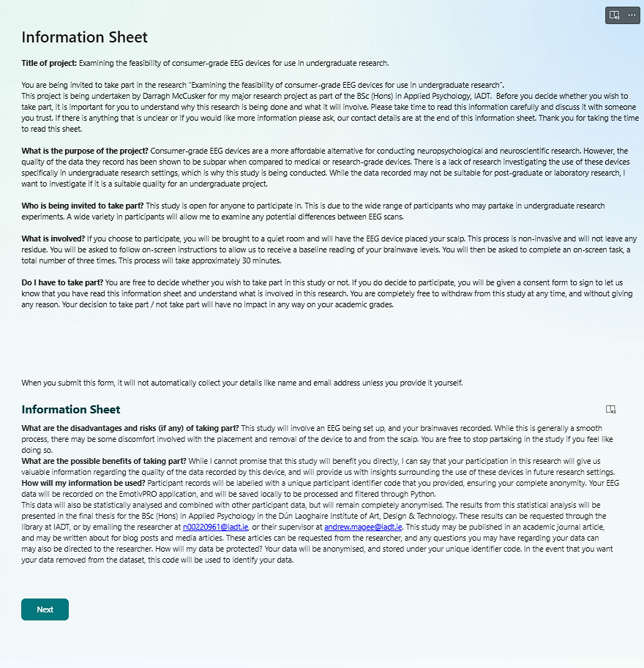
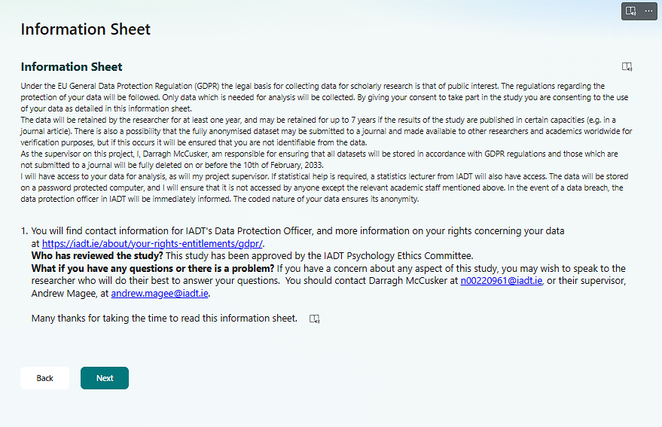

Appendix B: Consent Form
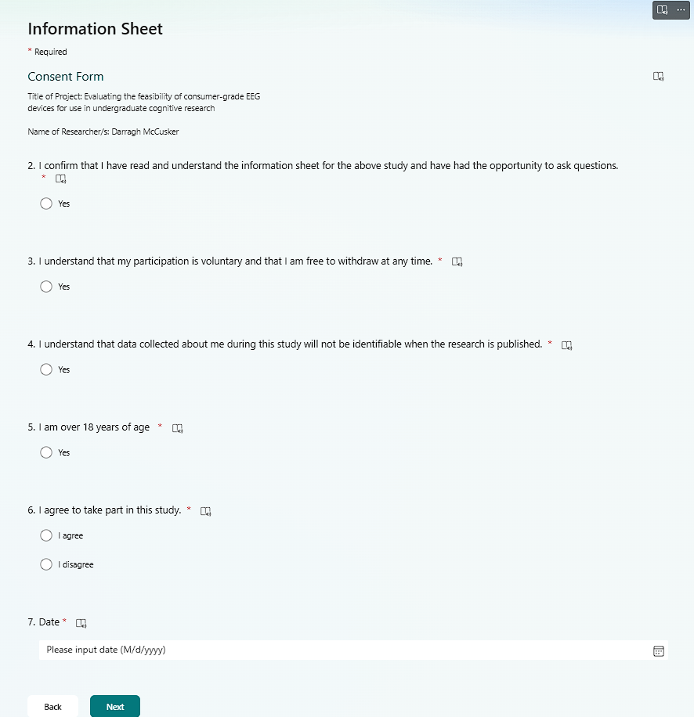

Appendix C: Anonymous Code and Demographics Form
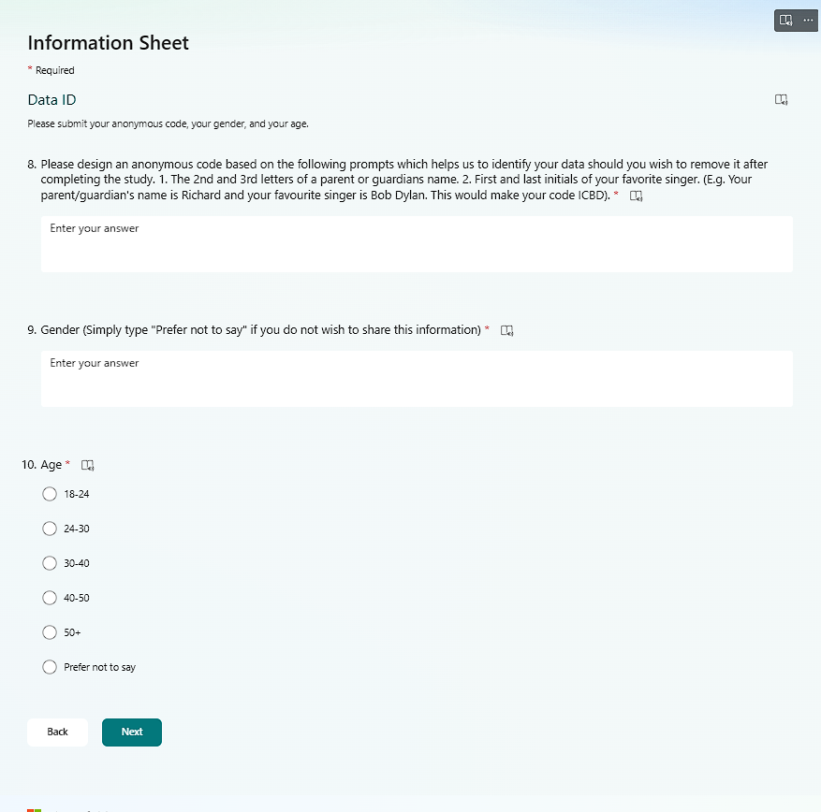

Appendix D: Debrief and Confirmation of Consent Form


Appendix E: Baseline EEG Levels Presentation Slides

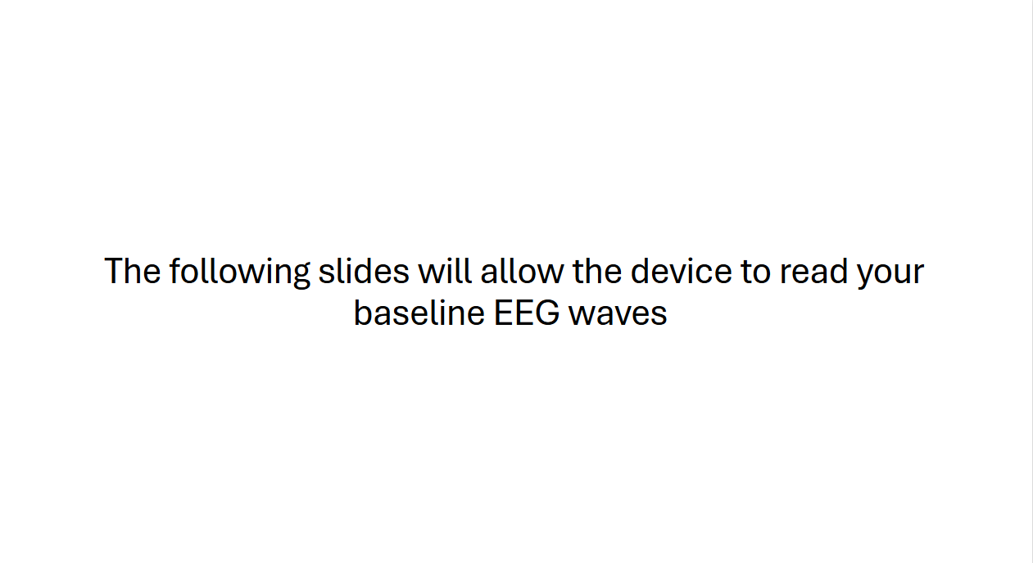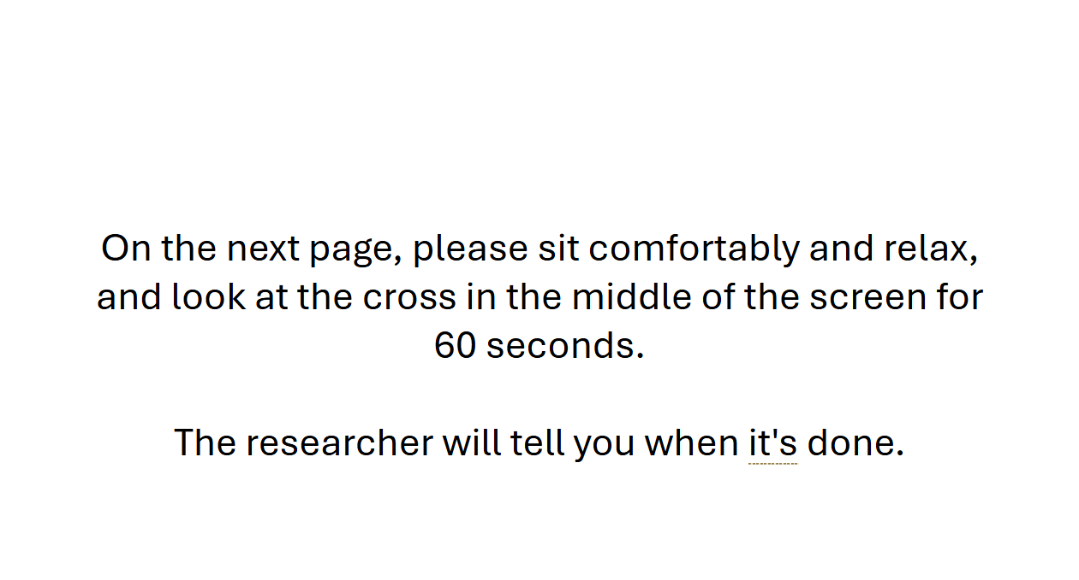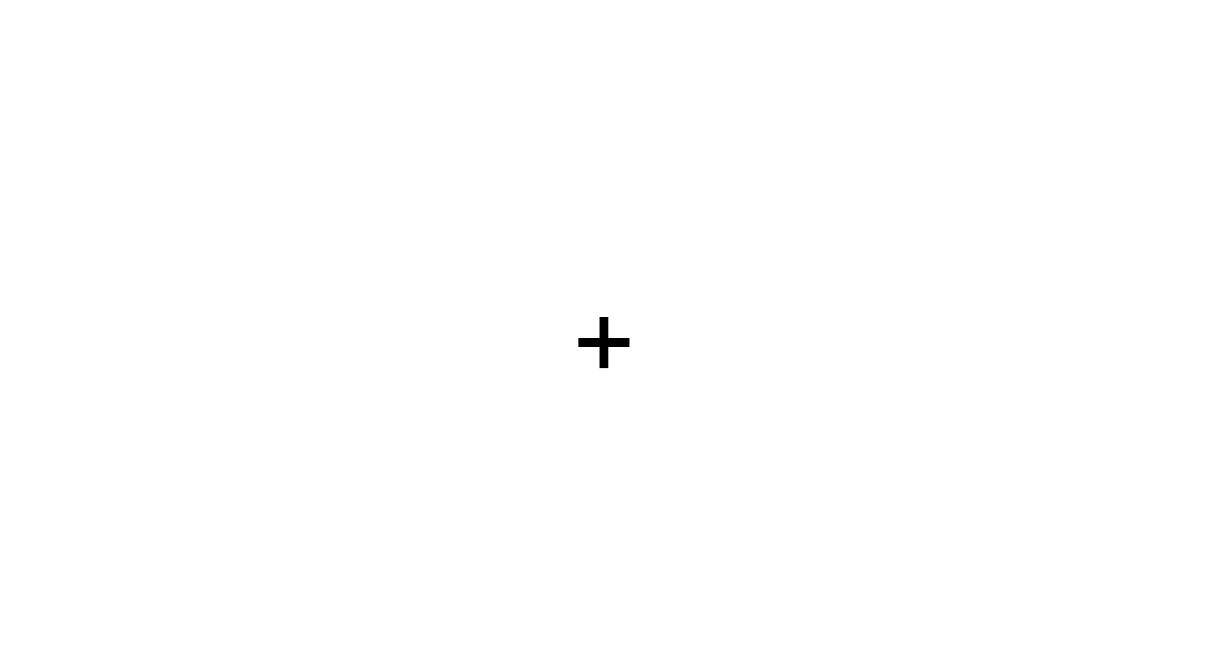

Appendix F: SPSS Output for Attention-Tracking Capabilities
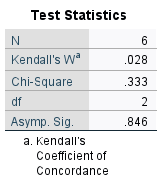

Appendix G: SPSS Output Table for the Relationship Between the EEG and 2-back Data
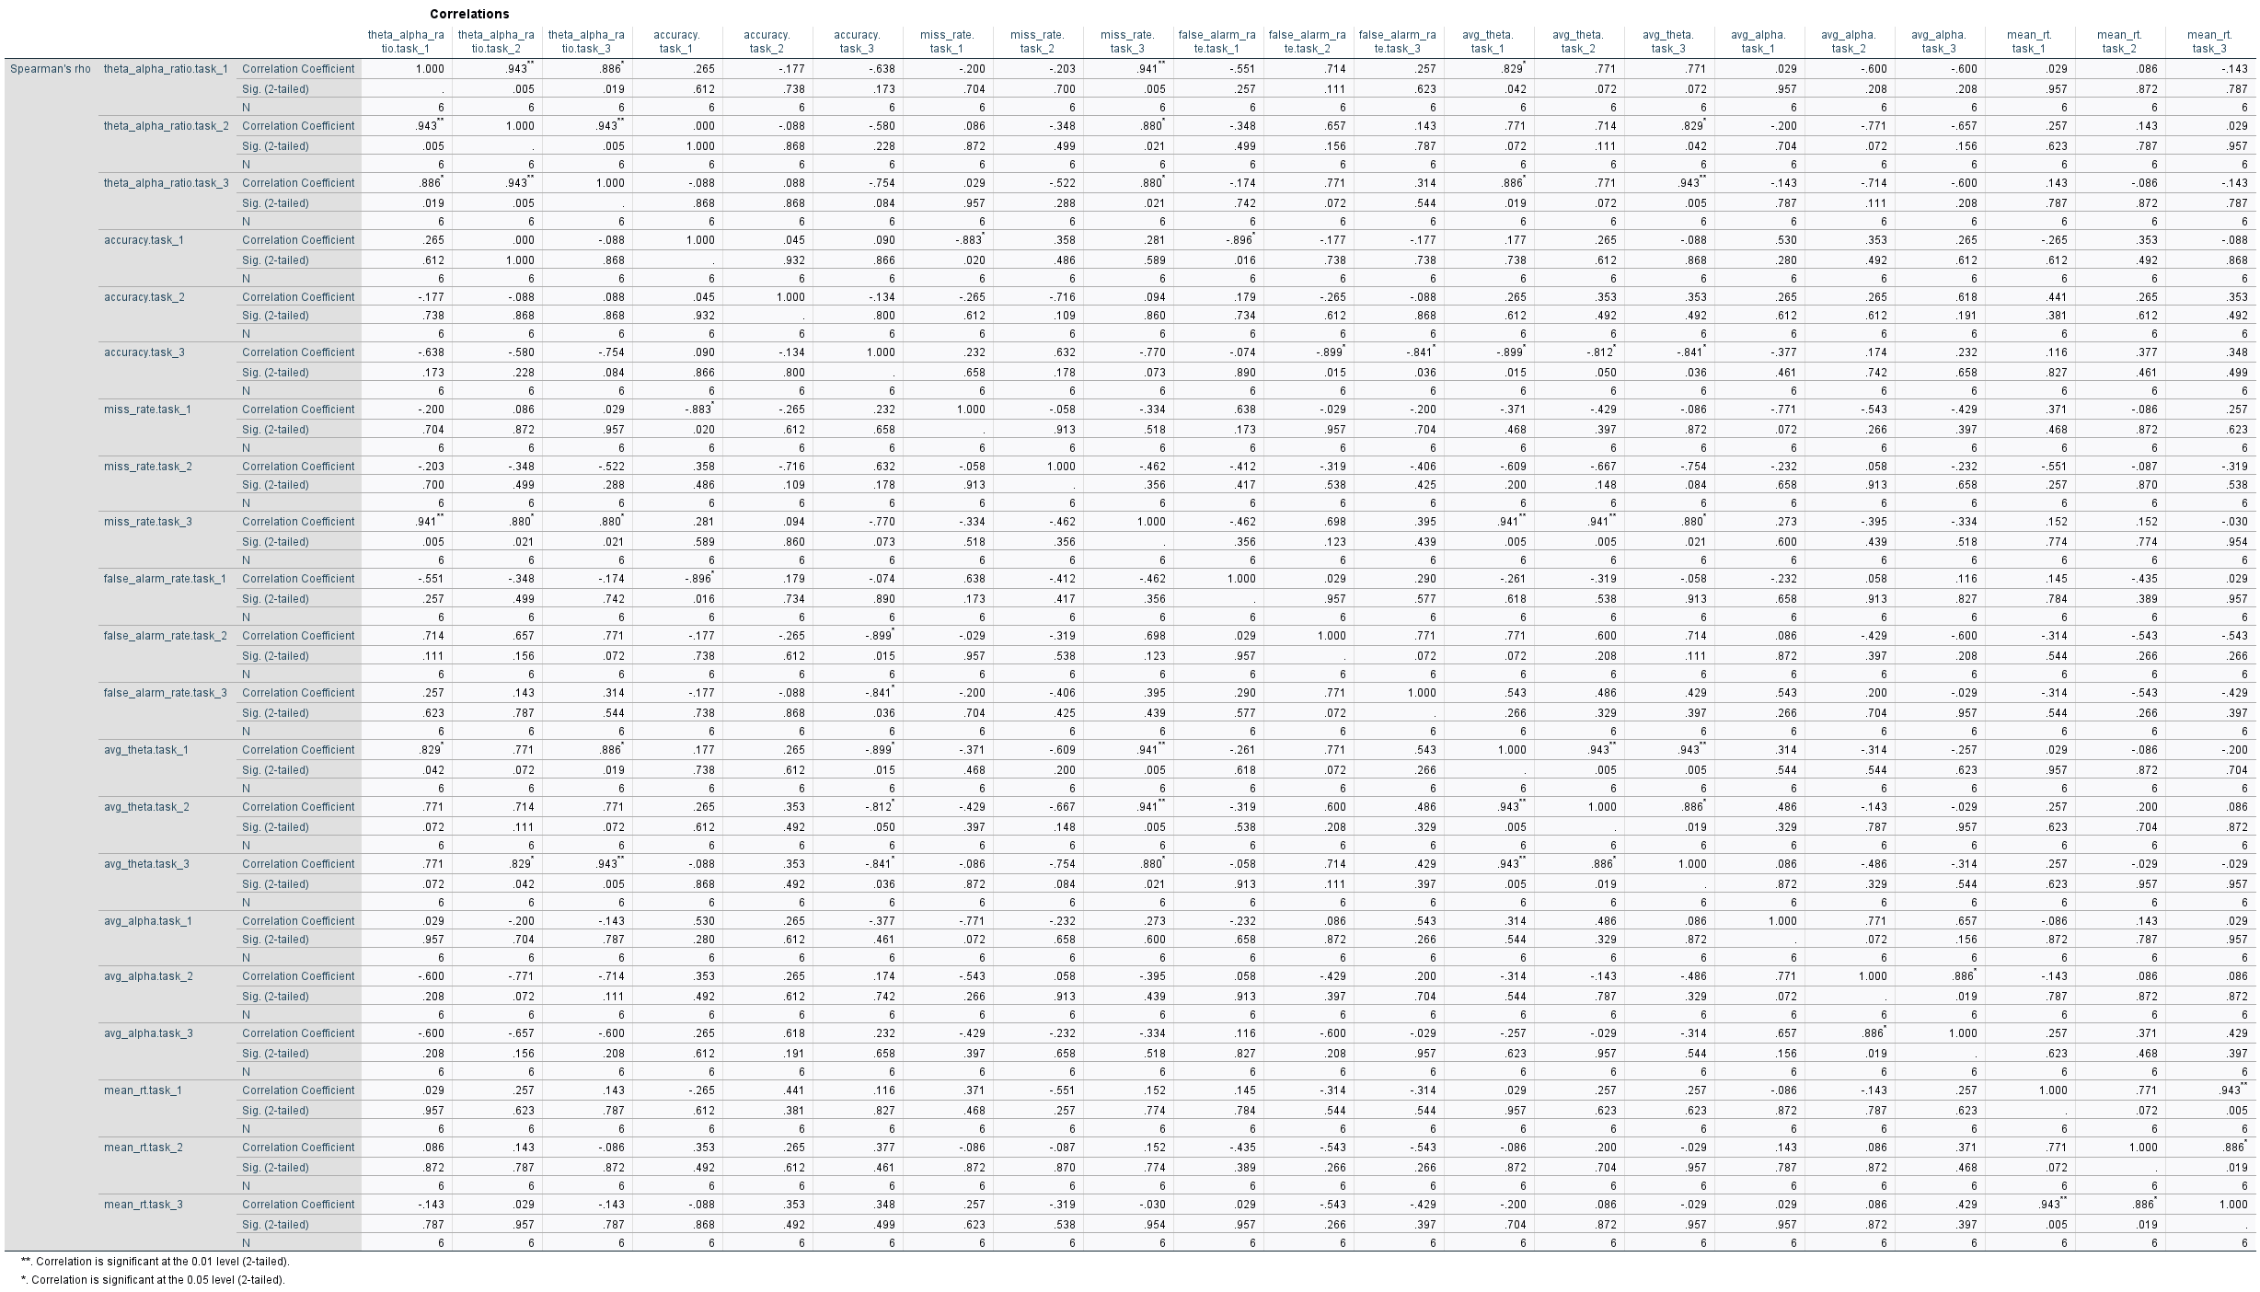

Appendix H: SPSS Output for Differentiating Between Baseline and Task Conditions

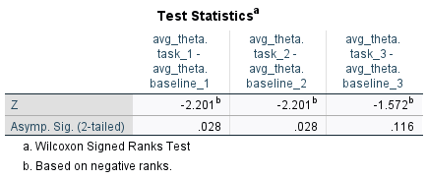

Appendix I: SPSS Output for Baseline Stability Over Time

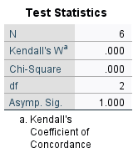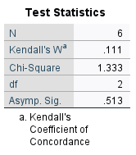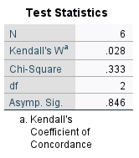
Appendix J: G*Power Output for Attention-Tracking Capabilities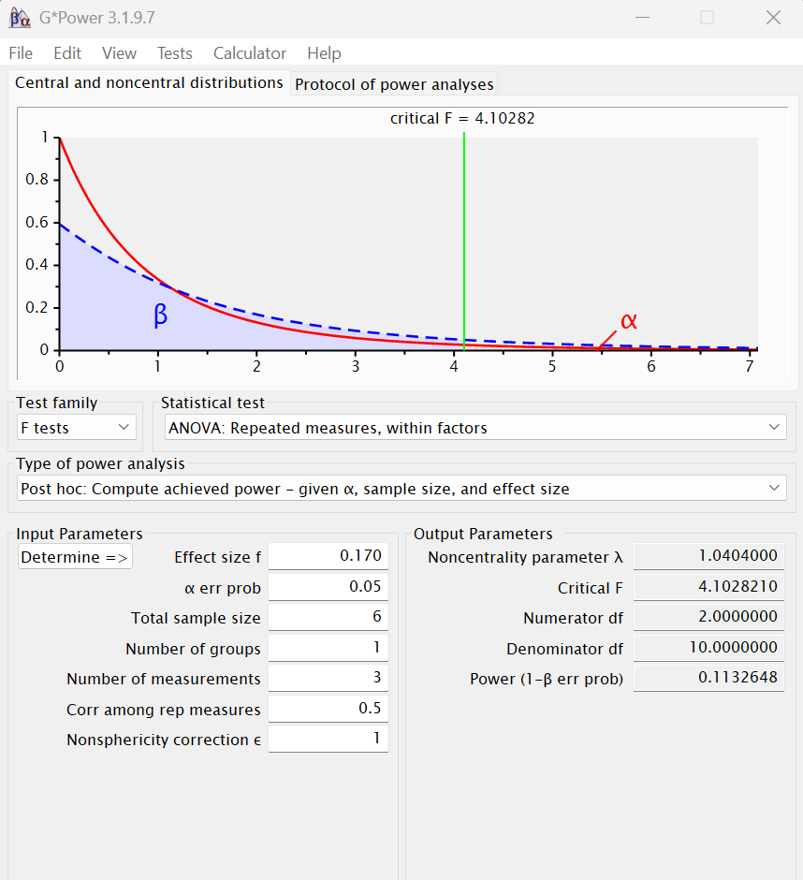

Appendix K: G*Power Output for the Relationship Between the EEG and 2-back Data
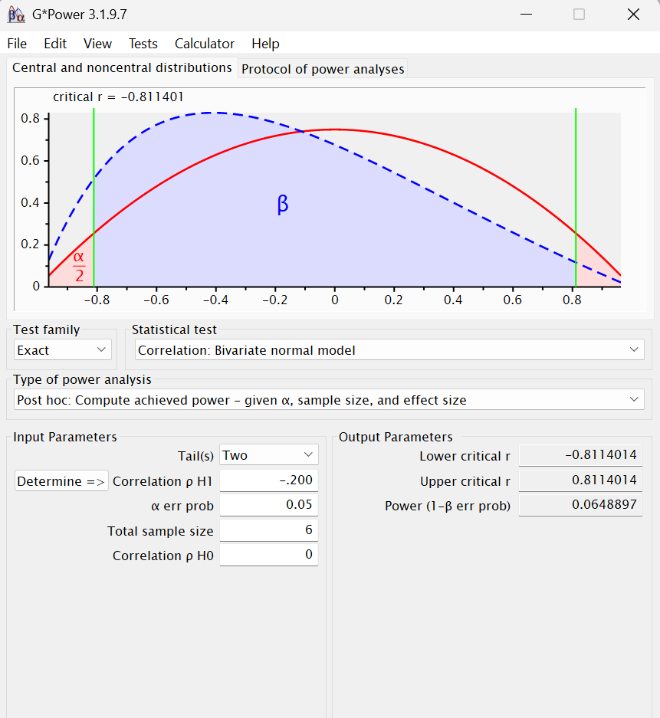
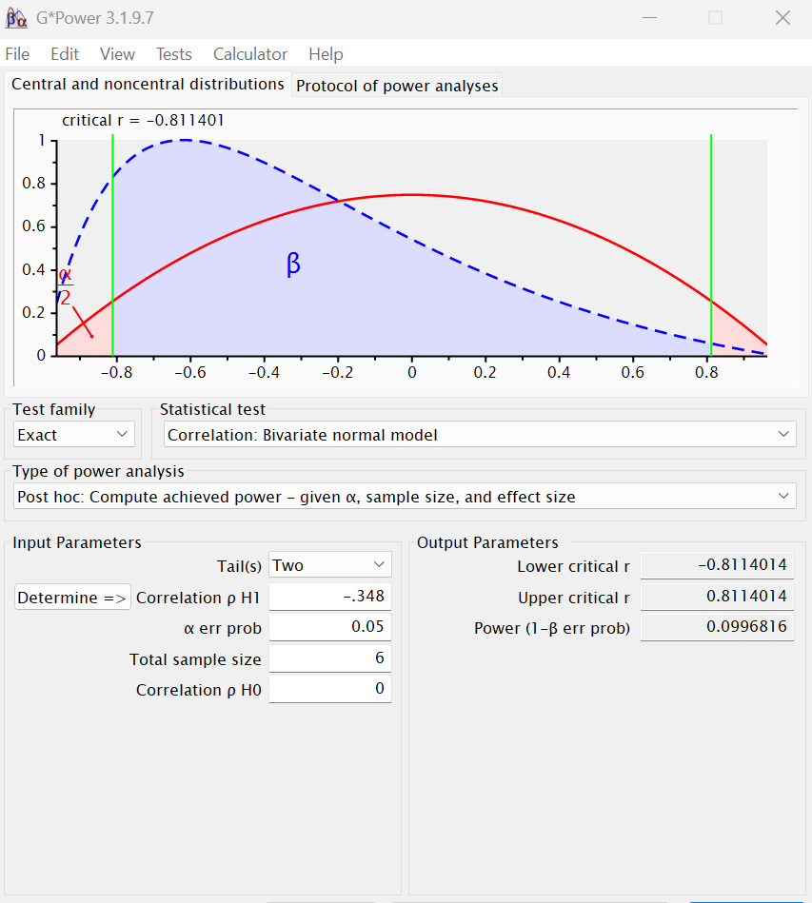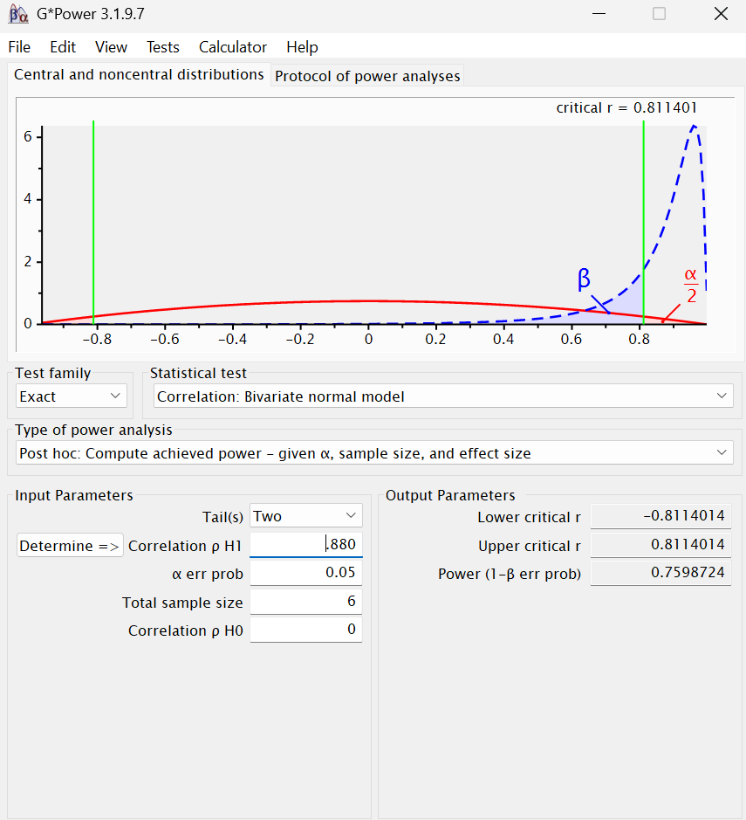

Appendix L: G*Power Output for Differentiating Between Baseline and Task Conditions
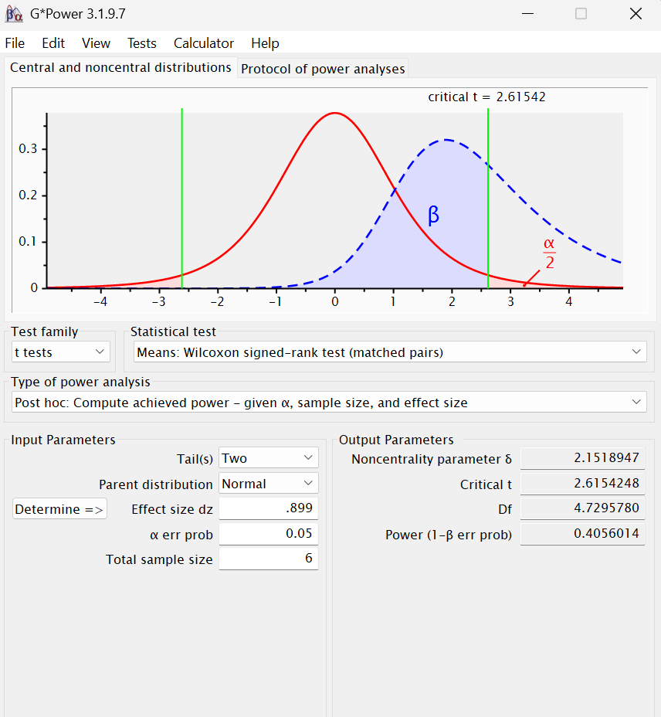
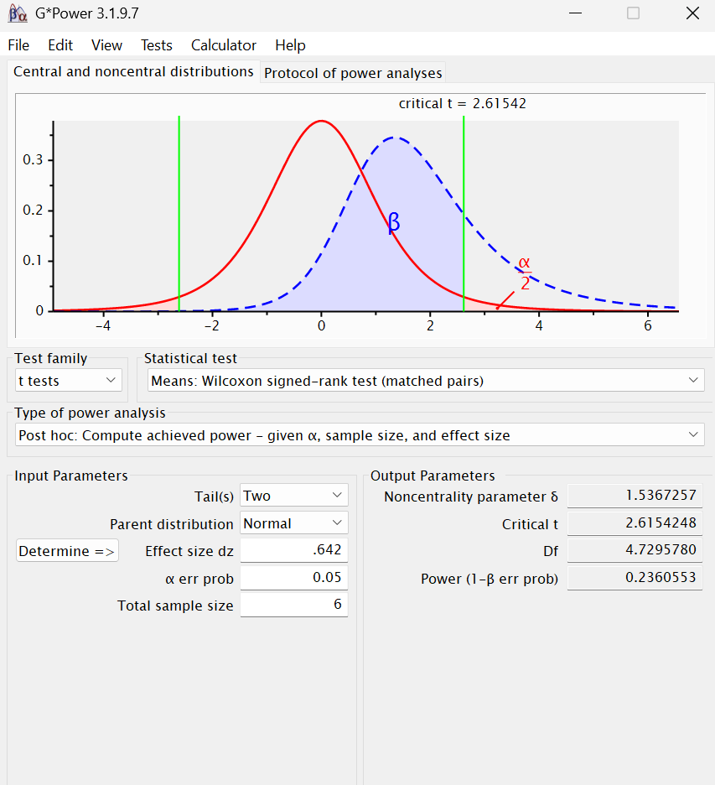

Appendix M: G*Power Output for Baseline Stability Over Time
