
Academic Motivation in Mature and Traditional Students: The Role of Personality Traits

Rachel Tyrrell
N00221097

Research Supervisor: Dr Irene Connolly

Dissertation submitted as a requirement for the degree of BSc (Hons) in Applied Psychology, Dun Laoghaire Institute of Art, Design & Technology, 2026.

Declaration
I, Rachel Tyrrell, hereby declare that the work I have submitted for/ contributed to the assessment specified above is entirely my own work. Where I have drawn from the work of others, including Generative AI systems, I have clearly indicated this within my submitted work. I recognise that Generative AI creations, no matter how small, may not be permissible within my submitted work and have checked this specific assessment brief for the admissible use of such software. I have read and complied with the IADT Academic Integrity Policy for this submission and recognise that breaches of this policy in my work may result in penalties, up to and including disqualification from IADT.
I, Rachel Tyrrell, hereby declare that I recognise IADT staff may provide feedback on assessment via a range of methods, depending on the nature of the assessment and the preference of the staff member. I recognise that any grades issued by a lecturer are provisional but are not negotiable. Final grades will be issued following the relevant exam board meeting and information on appeals procedures is available on the IADT website. I agree to abide by the IADT Mutual Respect Policy in all of my communications with and regarding all IADT staff members.

Word count: 4,607

Acknowledgements
Firstly, I would like to thank my wonderful supervisor Dr Irene Connolly, for all her support though this year and the years past. Her kindness, patience and supportive nature did not go unnoticed. I could not have completed this project without her help.
I extend this thanks, to Dr Christine Horn, our statistics lecturer and support this year. Her help alongside Dr Cyril Connolly enabled me to complete statistical analyses for my results which I could not have done alone. I would also like to thank all the lectures I have had over the last four years. You all provided great support through the years and I would not be at the end of this journey without you. Thank you.
I would like to thank my family for always believing in me. Mam, Dad, Louise, Grace, and now little Ellie too. Without your constant support I would not be where I am today. You have always believed in me more than I have in myself, and I am so grateful for you all.
To my boyfriend Brandon. You have been with me through this whole journey. You have kept me going when I did not think I could. You supported me, loved me and made me laugh when I wanted to cry though statistics. Without you I would not be who I am today. Over the last four years we have grown so much together and I cannot wait to see what comes next for us.
Finally, to my best friend though all of this, Ena. You saved me so many times though these four years. I truly do not believe I could have made it here without you. You keep me in check when I need it and make me laugh when I definitely need it. You are an inspiration to me. You’ve been through so much over the years and yet you never stopped going. I have no idea how you do it. Though this journey you have been my lecturer, therapist, life coach, doctor, but most importantly you’ve been my friend. I am so happy we randomly picked the same course and met all those years ago. I really could not have done it without you. I don’t know how I am supposed to go to a new college without you.

Table of Contents
Abstract 1
Introduction 3
1. Review of Literature 4
1.1 Personality 4
1.2 Motivation 4
1.3 Academic Motivation and Personality 4
1.4 Student Type 6
1.5 Conscientiousness and Neuroticism 7
1.6 Present Study 7
1.7 Research questions 8
1.8 Hypotheses 8
Method 9
2.1 Design 10
2.2 Participants 10
2.3 Materials 11
2.4 Procedure 11
Results 13
3.1 Overview 14
3.2 Descriptive statistics 14
3.3 Inferential Statistics 14
Discussion 20
4.1 Overview of the findings 21
4.2 Strengths and limitations 22
4.3 Theoretical Implications 22
4.4 Practical Implications 23
4.5 Future Research 23
4.6 Conclusion 24
References 25
Appendices 29
Appendix A 30
Appendix B 31
Appendix C 34
Appendix D 35
Appendix E 36
Appendix F 37
Appendix G 38
Appendix H 39
Appendix I 40
Appendix J 41
Appendix K 42
Appendix L 43

List of tables and figures

Tables
Table 1: Age distribution……………………………………………………………………10
Table 2: Descriptive statistics……………………………………………………………….14
Table 3: Unstandardised and standardised regression coefficients, significant values and part and partial correlations………………………………………………………………………16
Table 4: Unstandardised and standardised regression coefficients, significant values and part and partial correlations………………………………………………………………………17
Figures
Figure 1: P-P Plot demonstrating normal distribution………………………………………15
Figure 2: The relationship between intrinsic motivation and conscientiousness……………16
Figure 3: The relationship between extrinsic motivation and conscientiousness…………....17
Figure 4: Intrinsic motivation based on student status…………………...………………….18
Figure 5: Extrinsic motivation based on student status………………………………………19

Abstract

Abstract

Academic motivation is a concept that has been widely discussed amongst the literature within the context of personality however, has not been deeply investigated in terms of student status (mature and traditional). Research has shown that conscientiousness often predicts academic motivation, however the research in the area of the mature student demographic is lacking. The current study aims to identify if personality and student status predict academic motivation, specifically in the context of conscientiousness and neuroticism as the focus for personality and intrinsic and extrinsic for motivation. An online survey design was distributed to students across Ireland with the Ten Item Personality Inventory and the Shortened Academic Motivation Scale. Following the data collection, 115 participants were gathered and two multiple regression analyses and two independent samples t-tests were conducted. The analyses did not demonstrate any statistical significance for each hypotheses. This result suggests that personality and student status were not significant predictors of academic motivation in this sample and student status does not appear to impact academic motivation in this sample.

Introduction

1. Review of Literature

1.1 Personality
Personality is an important source of individual difference that can determine how each individual will respond to new information and situations (Bozanoğlu & Spanci, 2015). It is about the lifelong ability of coping, relating, behaving, thinking and feeling. Costa and McCrae (1992), are known for what they reported about a five-factor personality model design. This model, known as the Big-5, includes extroversion, agreeableness, openness, conscientiousness and neuroticism. Within these five traits, two are widely discussed in the literature, those are conscientiousness and neuroticism. Conscientiousness can be identified by individuals who appear to be organised, disciplined and determined. Neuroticism on the other hand, is a trait defined by emotional imbalance, anxiety, fear and guilt (Bozanoğlu & Spanci, 2015). This research will focus on these specific traits mentioned.

1.2 Motivation
The Big-5 model has been described as operationalising the Self Determination Theory (SDT). SDT explains personality and motivation and it investigates the reasons beneath our behaviour. Motivation is an internal state that pushes individuals to perform goal directed actions (Feurtes et al., 2020). Motivation can be intrinsic or extrinsic, in other words, it can be an internal driving factor or an external factor. More specifically, Muntean et al. (2022) and Atalay et al (2016) described academic motivation as the relationship between motivation and academic success which has multiple factors that impact it, such as the student expectations, teacher attitudes, teaching conditions and personal structure. Niemiec and Ryan (2009), discuss intrinsic motivation within schools. The researchers evaluate the benefits of a less controlling classroom environments and instead a more autonomous one. This promotes creativity and motivation. Lo et al. (2022), also evaluated the effects of positive reinforcement on intrinsic motivation. The results show that increased positive reinforcement can lead to higher intrinsic motivation.

1.3 Academic Motivation and Personality
Bozanoğlu and Spanci (2015) conducted a correlational study with 353 student participants from a Turkish University. The Personality Test Based on Adjectives (PTBA) was used which has a 7-point Likert scale and 40 adjectives in pairs. To measure academic motivation, the researchers used the Academic Motivation Scale (AMS) which is a 28-item scale. Using a multiple regression analysis, they reported academic motivation is positively correlated to conscientiousness. The researchers also reported that there was a significant negative relationship between neuroticism and academic motivation. It was reported overall that there are significant relationships between all the sub-categories within the Big-5 personality scale and academic motivation. The researchers suggested a replication of the study across other countries, schools and disciplines to further generalise the findings, however this research is in line with the current research. The literature suggests that personality traits from the Big Five, specifically conscientiousness, can predict academic motivation and achievement Komarraju and Karau (2005). Zaidi and Amjad (2026) also supported these findings with conscientiousness being a predictor and neuroticism having a negative correlation.
A number of studies have reported similar findings surrounding those two specific traits in relation to academic motivation amongst students. Fuertes at al. (2020), did a similar study with participants from a university in Spain. There were 514 participants across four courses within the education sector. The Neuroticism Extraversion Openness- Five Factor Inventory (NEO-FFI) was used in the Spanish version, and for academic motivation the researchers used an alternative scale which is a learning and motivation strategies questionnaire also in Spanish. The results from this correlational design are in line with the previously mentioned study, there is a strong positive correlation between personality and academic motivation. The results are also limited in generalisability as the sample was only taken from one university in one country. The researchers suggested conducting this study again in other countries to understand if the results are generalisable. It was also suggested looking at the research question across other courses or disciplines as this sample was taken from various teaching courses. Other research supports this study using the NEO-FFI as it is a larger scale with more in depth questions (Daud et al., 2026).
Similarly, a study in Iran had consistent results with the previous research with a sample of 183 students. Ahmadi et al. (2021), did use a different academic motivation scale. The Valrand Academic Motivation Scale was used alongside the NEO-FFI. Regardless of the variation with measurements, the results did not vary and showed the same results as before. The researchers also suggested that the current study be addressed in other cultures and across different fields of study. The researchers additionally discuss how the grades used as measurement of academic achievement were not standardized which led to a skew in the data and advise against this in future research. Rani Bhattacharjee and Ramkumar (2025) also had this result with conscientiousness being a strong predictor of academic motivation.

1.4 Student Type
Another factor to consider within the research is participant demographic or student type. The sample for most of the studies mentioned above, have recruited participants from undergraduate degrees with an age range from 18 to 25. Urban and Jirsáková (2021) researched personality and motivation in adult learners in undergraduate study. There were 6 groups divided into 3 and 3 groups. One group had a mean age of 33 years, while the other group had a mean age of 21 years. The researchers used a scale that has 210 items and a 6-point Likert scale. The results showed that the traits between adult learners and traditional students were different and adult learners leaned into their experience and age. Traditional students lacked the motivation towards career advancement as that was seen to be more of a goal to the adult learners. It was also reported that the adult learners or mature students had a higher self-report of intrinsic motivation than the traditional students. However, a limitation of this study is the lack of a measurement for academic motivation, as they reported the students ‘self-reported’, but no scale is listed amongst the materials. Self-reported scales also have the potential to result in socially desirable answers for fear of judgement and embarrassment (Bernardi & Nash., 2022).
As reported by Murphy and Roopchand (2003), there is an immense pressure on traditional students to perform to the best of their ability however, this was reported in the study to undermine the student’s intrinsic motivation. It was also reported that in the research conducted with 160 participants, the mature students were more academically successful and typically performed better than traditional students. The researchers reported that the mature students were more inclined to study topics they found to be interesting and challenging and took more enjoyment from the studies as there was a lack of pressure to obtain a qualification, unlike the traditional students who said that there was more pressure on them to receive a qualification. As such, traditional students were less motivated as the studies were primarily for extrinsic purposes, for example, teacher or parent approval (Murphy & Roopchand., 2003).
A classic study within this research topic is one by Komarraju and Karau (2005). This was one of the earliest studies within the field of academic motivation and personality. The researchers discuss individual differences within learning styles and motivation and how whether a student in intrinsically or extrinsically motivated, is the result of individual difference. The sample was 172 undergraduate students. The NEO-FFI and Academic Motivation Inventory (AMI) was used during this research. The correlational analysis reported that personality is strongly related to academic motivation. However, the results also discussed that neuroticism which is discussed above as being negatively associated with academic motivation, is positively associated with debilitating anxiety and withdrawal. The researchers concluded that a more representative sample would be beneficial to the findings and they also did not account for learning styles or ability. A similar study suggests that in addition to learning styles and abilities, learner autonomy is also crucial to improving academic motivation among students. Jehanghir et al. (2024) discuss the importance of autonomy in education and how autonomy can increase academic motivation in students.

1.5 Conscientiousness and Neuroticism
Apostolov and Geldenhuys (2022), discussed the role of neuroticism and conscientiousness in academic motivation. They concluded that conscientiousness was the strongest predictor of academic performance based on grade point averages. However, the remaining three personality traits did not report a significant relationship. As mentioned above, neuroticism has a negative correlation with academic motivation. Academic motivation considers study habits, strategies and perceived internal value of study. Komarraju and Karau (2005) speculated that the anxiety associated with neuroticism may actually also be a motivator for individuals to engage in compulsive preparation for examinations. This is also in line with Norem and Chang (2002) which suggest that defensive pessimism predicted higher academic achievement than those who did not prepare for the worst alternative outcomes. In the study conducted by Apostolov and Geldenhuys (2022), they used a sample of 285 psychology students from 18 to 25 years with 219 female, 53 male and 5 non-binary or prefer not to say. Personality was measured with the International Personality Item Pool (IPIP), which includes 120 items that measures the five personality traits on a 5-point Likert scale. Academic motivation was measured using the Motivated Strategies for Learning Questionnaire which has 81 items and a 7-point Likert scale. The results from the correlational analysis were in line with the previous results stated however, they also reported that anxiety is a motivational factor for some when individual differences are considered and depression was reported to make motivation difficult for some individuals. A limitation to this study was the gender skew within the sample as there was a significant difference within the groups. The researchers suggest that other academic courses be looked at in terms of this research.

1.6 Present Study
The present study aims to identify if academic motivation can be predicted by personality and student type, traditional student (18 years-24 years) and mature student (24 years and above). There is a gap in the research regarding representation for mature students as there is a plethora of data based on undergraduates who went the traditional route from second level into third level. However, in the present day there are many individuals who for a variety of reasons, they do not progress into third level education until a later age. This researcher aims to add to the research by filling this gap regarding mature students. There is also a lack of research in the area from an Irish sample. Many of the studies mentioned above are conducted in Eastern Europe, the United States, or Asia. This in turn means, the results from all previous studies become more generalisable if the study is replicated in a variety of countries and cultures. This researcher plans to close this gap by using an Irish sample for the present study. Multiple studies refer to using a more diverse range of courses as part of the sample criteria as many studies focused on one discipline at a time. The researcher intends to collect participants from the entire cohort in IADT and will aim to achieve a diverse and varied sample from many different backgrounds.
The Ten Item Personality Inventory (TIPI) Gosling et al. (2003), and the Shortened Academic Motivation Scale (SAMS) Kotera et al. (2020), will be used to measure each variable.

1.7 Research questions
RQ1: Do conscientiousness and student status predict intrinsic motivation?
RQ2: Do neuroticism and student status predict extrinsic motivation?
RQ3: Is there an impact for intrinsic and extrinsic motivation based on student status?

1.8 Hypotheses
H1: Conscientiousness and student status will predict intrinsic motivation.
H1a: Neuroticism will predict extrinsic motivation.
H2: There will be a difference for intrinsic motivation based on student status.
H2a: there will be a difference for extrinsic motivation based on student status.

Method

2. Method

2.1 Design
The current study used a quantitative correlational between groups survey design. A questionnaire- based survey was used to measure the variables. The independent variables were personality traits (conscientiousness and neuroticism) and student type (traditional student or mature student). The dependent variable was academic motivation. Two multiple regression analyses were conducted to investigate if personality and student status predict academic motivation alongside two independent samples t-tests to investigate the impact of student status on academic motivation.

2.2 Participants
The sample was collected using random convenience sampling. The recruitment took place from the 27th of January. A total of 116 participants took part in the survey that was presented during the data collection fair and via a link on social media. 7 participants had to be removed due to consent and missing information. Table 1 shows the distribution between the age groups of the participants. The participants were treated according to the ethical guidelines provided by the Psychological Society of Ireland (Psychological Society of Ireland, 2025) and the British Psychological Society Ethical Guidelines for Internet-Mediated Research (British Psychological Society, 2021). Additionally, this study was approved by the Institute of Art, Design, and Technology Psychology Ethics Committee (PEC) before the participants were recruited (Appendix A).
Table 1:
Age distribution among participants
Age Group | N
18-24 | 90
25-34 | 17
35-44 | 3
45-54 | 3
55-64 | 2

2.3 Materials
An information sheet (Appendix B) was presented to the participants to provide an overview of the study’s aims and objectives and detailing what their participation would include. A consent form (Appendix C) was then shown to the participants before the questionnaire to ensure the participants consented to participating and providing their data. Before the questionnaire began, there were a couple of questions regarding the unique identifier code and demographic questions including the participants age, gender and student status. Following this, were the two questionnaires, the Shortened Academic Motivation Scale (SAMS) (Appendix D) and the Ten Item Personality Inventory (TIPI) (Appendix E).
The SAMS was included to measure the academic motivation of the participants. It is a 14-item scale measure using a 7-point Likert scale, measured from ‘does not correspond at all’ to ‘corresponds exactly’. The participants were instructed to answer the questions under the context of ‘why do you go to college’. For example, ‘in order to have a better salary later on’. Kotera et al, (2020) reported the Cronbach’s alpha value was 0.84. The current study reported the alpha value for intrinsic motivation as 0.88 and extrinsic motivation as 0.73.
The TIPI is a ten item scale used to identify personality traits. The participants were instructed to give each question a number based off the 7-point Likert scale where 1 is ‘disagree strongly’ and 7 is ‘agree strongly’ while answering to the context of ‘I see myself as:’. For example, ‘reserved, quiet’. The TIPI has been reported to have a lower alpha value due to each trait being assessed by only two items however, Gosling et al, (2003) reported the alpha for conscientiousness to be 0.50 and neuroticism 0.73. The current study reported the alpha for conscientiousness to be 0.51 and neuroticism 0.33.

2.4 Procedure
Before the data was collected, a pilot study was conducted (N=2). The pilot study was conducted in order to test that the instructions were clear and the survey was easy to understand, and to time the full length of the study to ensure it was not too long. One participant noted a spelling error and once that was corrected, the survey was ready for data collection.
Recruitment collection was conducted at the Data Fair on IADT campus, via social media and by word of mouth. The participants completed an online survey which was used to maximise participation and participants being reached. The participants began by clicking a link or by scanning a QR code. This immediately took them to an information sheet followed by a consent form. There was then a prompt to create a unique identifier code using the first and last initials of their favourite singer and their Star sign. The participants completed a range of demographic questions considering age, gender and student status. The participants then completed the questionnaires (SAMS and TIPI). The participants were given a debrief once the survey was completed, provided with the researcher’s contact information should they require it and a variety of support services. Finally, the participants were reminded they have full rights to withdraw at anytime after completing the survey until the data will be combined and analysed and they were thanked for their participation.

Results

3. Results

3.1 Overview
IBM statistics version 30 (2026) was used to conduct a standard multiple regression analysis for the current study. The predictor variables for the study were personality traits (conscientiousness and neuroticism) and student type (mature and traditional). The dependent variable was academic motivation. The current study employed two standard multiple regression analysis which was done to investigate if academic motivation can be predicted by personality traits and student type and independent samples t-tests to investigate if there is a difference for academic motivation based on student status.

3.2 Descriptive statistics
Table 2 displays the minimum and maximum values, the standard deviation and mean for the scores. The group sizes for student type were unequal.
Table 2
Descriptive Statistics
Variable | N | M | SD | Min | Max
Intrinsic motivation | 109 | 4.29 | 1.40 | 1.17 | 7.00
Extrinsic motivation | 109 | 5.46 | 1.11 | 2.40 | 7.00
Conscientiousness | 108 | 4.94 | 1.35 | 1.50 | 7.00
Neuroticism | 108 | 4.21 | 1.34 | 1.50 | 7.00
Student status | 108 | 1.30 | 0.46 | 1 | 2

3.3 Inferential Statistics
Two multiple regression analyses and an independent samples t-test were conducted to evaluate if conscientiousness, neuroticism and student status predicted intrinsic and extrinsic motivation, and to determine if motivation differed by student status.
Assumptions
Prior to conducting the regression analyses, the assumptions had to be checked. The assumptions of multicollinearity, singularity, overall collinearity and normality of residuals were not violated. Therefore, the analyses were able to proceed. There were no outliers identified by Mahalanobis and Cooks distances. Visual inspection showed that normality and homoscedasticity were not violated, see figure 1.
Figure 1:
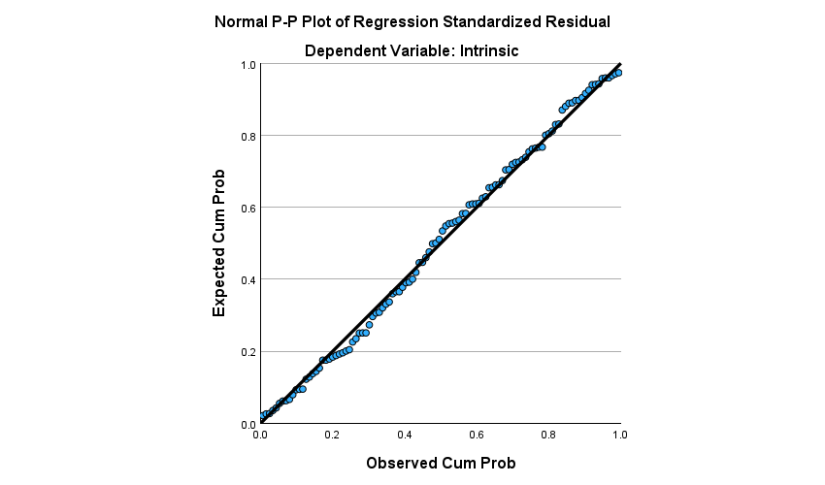
P-P Plot demonstrating normal distribution

Intrinsic motivation
A multiple regression analysis was conducted to determine whether conscientiousness, neuroticism and student status predict intrinsic motivation. The overall regression model was not statistically significant F(3, 104) = 1.408, p= .245 (see Appendix J) which explains approximately 3.9% of the variance in intrinsic motivation (r square = .039) (see Appendix K). Table 3 below shows the unstandardised and standardised coefficients, the significant values and the part and partial correlations.
Table 3
Unstandardised and standardised regression coefficients, significant values and part and partial correlations.

Variable | B | β | Sig | Partial Correlations | Part Correlations
Constant | 3.613 | - | <.001 | - | -
Conscientiousness | .206 | .198 | .054 | .188 | .188
Neuroticism | -.114 | -.109 | .288 | -.104 | -.103
Student status | .111 | .036 | .712 | .036 | .036

Note: B = Unstandardised regression coefficient and β = Standardised coefficient
Note: - = Data not available
Figure 2 below demonstrates the relationship between intrinsic motivation and conscientiousness
Figure 2
The relationship between intrinsic motivation and conscientiousness
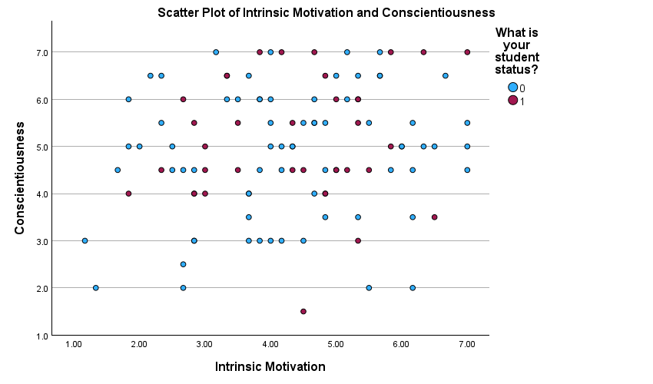
Note: 0 = Traditional student and 1 = Mature student
Extrinsic motivation
The second regression analysis was conducted to examine if conscientiousness, neuroticism and student status predicted extrinsic motivation. The overall regression model did not reach statistical significance F(3, 104) = 2.548, p= 0.60 (see Appendix L) which explains approximately 6.8% of the variance in extrinsic motivation (r square = .068) (see Appendix M). See table 4 below which states the unstandardised and standardised coefficients, the significant values and the part and partial correlations.
Table 4
Unstandardised and standardised regression coefficients, significant values and part and partial correlations.
Variable | B | β | Sig | Partial Correlations | Part Correlations
Constant | 4.163 | - | <.001 | - | -
Conscientiousness | .162 | .197 | .052 | .190 | .186
Neuroticism | .009 | .011 | .912 | .011 | .011
Student status | .356 | .147 | .130 | .148 | .144

Figure 3 below shows the relationship between extrinsic motivation and conscientiousness.
Figure 3
The relationship between extrinsic motivation and conscientiousness.
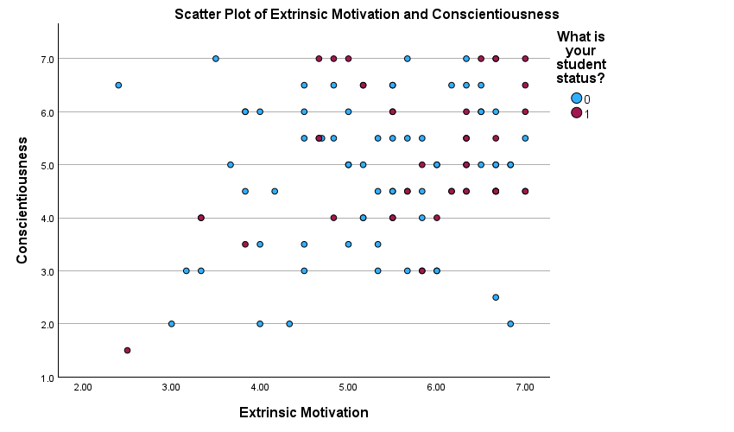

Independent samples t-test
Independent samples t-tests were conducted to examine whether intrinsic sand extrinsic motivation differenced based on student status. Levene’s test for equal variance was not violated for the intrinsic motivation F(106) = 0.580, p=.448 and for extrinsic motivation F(106) = .138, p = .711 (see Appendix N).
The results indicated that neither intrinsic motivation t(106) = -0.40, p = .692, or in extrinsic motivation t(106) = -1.77,p= .079 (see Appendix N) differed by student status. Figures 4 and 5 below show the difference in intrinsic and extrinsic motivation for each student status.
Figure 4
Intrinsic motivation based on student status
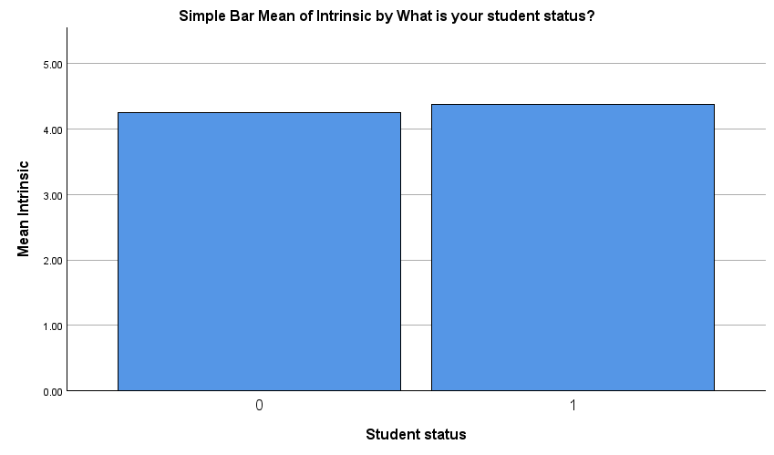

Figure 5
Extrinsic motivation based on student status
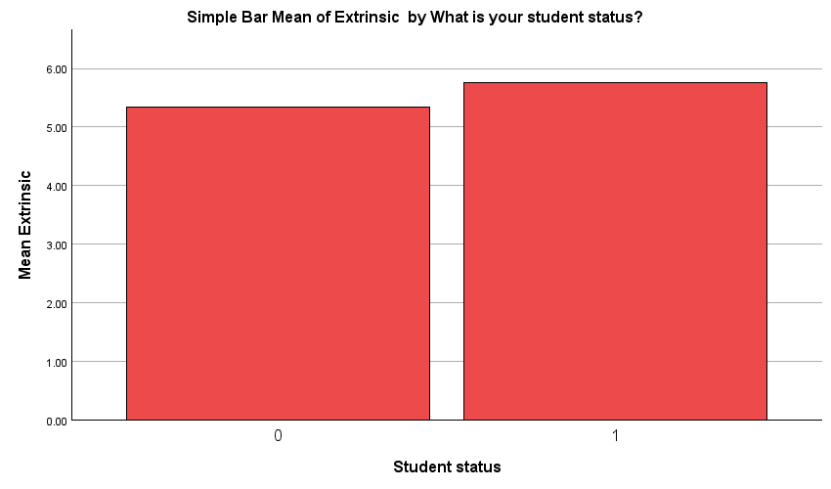

Discussion

4. Discussion

4.1 Overview of the findings
The purpose of the current study was to explore if personality and student status predict academic motivation in students studying in Ireland. This study did not find any statistical significance between the variables mentioned above.
Hypothesis 1 stated that conscientiousness and student status will predict intrinsic motivation. This hypothesis was not supported as the regression model did not show conscientiousness and student status as a significant predictor of intrinsic motivation. This is a contradiction to Komarraju and Karau’s. (2005) study. This result may differ to the previous study due to the use of a different, smaller scale than the other research. Previous research (Daud et al., 2026) used the NEO-FFI which is a bigger scale with more detailed invasive questions. The TIPI that the current study employed is a smaller 10 item scale with more broad questions which potentially led to the contrasting results.
Hypothesis 1a stated that neuroticism and student status will predict extrinsic motivation. This hypothesis was also not supported by the regression model. This result is also in contrast to the previous research. This result could potentially be as a result of self-reporting bias as it is widely known that social desirability has the potential to impact scales of this measure.
Hypothesis 2 stated that there will be an impact on intrinsic motivation based on student status. The result was also unsupported by the analysis as the independent samples t-test did not provide a significant value. However, the mature students did provide a slightly higher intrinsic motivation score than the traditional students. This is in line with previous research that states mature students tend to have more internal driving factors towards goals than traditional students (Urban & Jirsáková 2021).
Hypothesis 2b stated that there will be an impact on extrinsic motivation based on student status. The result was also insignificant. As before, the mature students scored slightly higher on the extrinsic motivation than the traditional students. This result is interesting as the study by Urban and Jirsáková, (2021), states that mature students self-reported higher levels of intrinsic motivation, but the current study shows that mature students have higher levels of both intrinsic and extrinsic motivation than traditional students.

4.2 Strengths and limitations
Strengths
A number of strengths can be identified from the current study. The first strength identified is that two shorter scales were used instead of two larger scales. This had the advantage of an overall shorter completion time, which potentially reduced drop-out rates. This gave the current study a greater chance of obtaining a bigger sample size.
The second strength of the study is that the survey was distributed digitally which allowed for a wider reach across the country. This was also in attempt of achieving a larger sample size and to reach the required demographic of students necessary for the study.
Finally, the third strength is how the current study attempted to address a gap in the literature by using demographic properties to explain motivation in students. It is evident from the current study, that within an Irish context using the TIPI and SAMS, personality and student status do not follow the predictive pattern that was anticipated for academic motivation. This challenges the assumptions from previous research (Komarraju & Karau, 2005).

Limitations
Some limitations of the current study have been identified in addition to the strengths. Firstly, the current study used self-reporting scales. This is a limitation due to the possibility of self-bias in answers and for social desirability. While the scales were anonymous, in accordance with ethics guidelines (Psychological Society of Ireland, 2025), individuals can sometimes still feel embarrassed or scared to answer a survey of this nature honestly for fear of feeling judged (Bernardi & Nash., 2022).
The second limitation from the present study is that a number of participants had to be removed from the study due to missing information or withdrawal of consent. This impacted the final sample size and potentially contributed to the contradicting results (Dahal, 2024).

4.3 Theoretical Implications
Despite the above mentioned limitations, the current study has still contributed to the areas of personality and motivation within psychology. The self-determination theory (SDT) investigates personality and motivation and why we behave in certain ways (Feurtes et al., 2020). The SDT explains the difference in intrinsic and extrinsic motivation in educational settings. Niemiec and Ryan. (2009), discuss the value of intrinsic motivation in school. Autonomy is a key factor in maintaining intrinsic motivation in education. Reports have suggested that teachers who maintain a more autonomous classroom versus a controlling one, promote more creativity and independent study. Controlling classrooms have an adverse effect. The present study can add to this body of literature as this theory is being added and adapted constantly and while the research just presented discusses primary students, the current study looked at third level and even more specifically mature students who often get overlooked in research.

4.4 Practical Implications
Academic support is an integral part of education in Ireland. It is essential for students to have the knowledge and skills to take on challenging projects alongside the support of teachers. As discussed students learn best when intrinsic motivation is the cause. If lecturers have the tools and strategies to support students and increase the students self-efficacy, intrinsic motivation will take over and students will recognise the importance of the hard-work and reinforce the capability component. This has the potential to strengthen engagement and belief systems and positively reinforce intrinsic motivation (Lo et al, 2022).

4.5 Future Research
While the current study has addressed a gap in the research surrounding personality and motivation there are a number of ways to contribute to this area further. One suggestion for future research could be to look at the area within second level education. There is great potential in identifying problems within education in younger ages. If the research is looked at in a younger demographic, the above-mentioned strategies could potentially be more effective. This could also enhance generalisability to other populations.
Additionally, a mixed methods approach to the research could potentially be beneficial. As the current study used solely quantitative research, the data was limited to short answers. However, if a mixed method approach is used, the researchers could use quantitative for one aspect such as personality and after conduct an interview to address motivation which gives the participant more opportunity to elaborate on the topic further.
Finally, the researchers suggest using more robust scales. As mentioned before, the current study used two shorter scales for the purpose of time purposes and ethics. However, the TIPI has a lower Cronbach’s alpha value than typically accepted due to each item being scored with only two questions. As this lowered the validity, the results of the analysis were impacted. The researchers suggest using two bigger scales with higher validity for example, the NEO-FII and the AMS.

4.6 Conclusion
To conclude, the current study contributed to the area of personality and motivation within psychology. It followed the direction of previous research and attempted to close a gap within the literature. The findings suggest that conscientiousness and neuroticism do not predict academic motivation. Nor does student type have an impact on academic motivation. While the current study did not reach statistical significance, this research was still valuable to the area. Further research is required to address additional concerns around second level education and the younger demographic.

References

References

Ahmadi, A., Ziapour, A., lebni, J. Y., & Mehedi, N. (2021). Prediction of academic motivation based on variables of personality traits, academic self-efficacy, academic alienation and social support in paramedical students. International Quarterly of Community Health Education, 43(2). https://doi.org/10.1177/0272684x211004948

Apostolov, N., & Geldenhuys, M. (2022). The role of neuroticism and conscientious facets in academic motivation. Brain and Behavior, 12(8). https://doi.org/10.1002/brb3.2673

Bernardi, R. A., & Nash, J. (2022). The importance and efficacy of controlling for social desirability response bias. Ethics & Behavior, 33(5), 413–429. https://doi.org/10.1080/10508422.2022.2093201

Bozanoğlu, İ., & Sapancı, A. (2015). The relationships between the big five personality traits and academic motivation levels of Turkish university students. International Journal of Human and Behavioral Science, 1(1), 1-7. https://doi.org/10.19148/ijhbs.38361

British Psychological Society. (2021). Ethics Guidelines for Internet-Mediated Research. https://doi.org/10.53841/bpsrep.2021.rep155

Costa Jr, P. T., & McCrae, R. R. (1992). The five-factor model of personality and its relevance to personality disorders. Journal of personality disorders, 6(4), 343-359. https://www.researchgate.net/publication/248617484_The_Five- Factor_Model_of_Personality_and_Its_Relevance_to_Personality_Disorders

Dahal, B. (2024). Participants’ Right to Withdraw from Research: Researchers’ Lived Experiences on Ethics of Withdrawal. Journal of Academic Ethics, 22(1), 191–209. https://link.springer.com/article/10.1007/s10805-024-09513-y

Daud, S., Maqbool, S., Ibnerasa, S. N., & Idrees, A. (2026). Role of personality trait, age, and year of study as predictors of academic motivation in students of a private sector medical college: A cross-sectional study. Life and Science, 7(1), 7. https://doi.org/10.37185/lns.1.1.1049

Fuertes, A. M. de C., Blanco Fernández, J., García Mata, M. de los Á., Rebaque Gómez, A., & Pascual, R. G. (2020). Relationship between personality and academic motivation in education degrees students. Education Sciences, 10(11), 327. https://doi.org/10.3390/educsci10110327

Gosling, S. D., Rentfrow, P. J., & Swann, W. B. (2003). A very brief measure of the big-five personality domains. Journal of Research in Personality, 37(6), 504–528. https://doi.org/10.1016/S0092-6566(03)00046-1

Jehanghir, M., Ishaq, K. & Akbar, R.A. (2024). Effect of learners’ autonomy on academic motivation and university students’ grit. Education and Information Technologies, 29, 4159–4196. https://doi.org/10.1007/s10639-023-11976-2

Komarraju, M., & Karau, S. J. (2005). The relationship between the big five personality traits and academic motivation. Personality and Individual Differences, 39(3), 557–567. https://doi.org/10.1016/j.paid.2005.02.013

Kotera, Y., Conway, E. & Green, P. (2020). Construction and factorial validation of a short version of the academic motivation scale (SAMS). British Journal of Guidance and Counselling. https://doi.org/10.1080/03069885.2021.1903387

Muntean, L. M., Nireștean, A., Sima-Comaniciu, A., Mărușteri, M., Zăgan, C. A., & Lukacs, E. (2022). The Relationship between personality, motivation and academic performance at medical students from Romania. International Journal of Environmental Research and Public Health, 19(15), 8993. https://doi.org/10.3390/ijerph19158993

Psychological Society of Ireland. (2025). Code of Professional Ethics. https://www.psychologicalsociety.ie/footer/Code-of-Ethics-1

Rani Bhattacharjee, R., & Ramkumar, A. (2025). Effect of big five personality dimensions on the academic performance of college students. Frontiers in Psychology, 16. https://doi.org/10.3389/fpsyg.2025.1490427

Urban, K., & Jirsáková, J. (2021). Motivation and personality traits in adult learners. Journal of Adult and Continuing Education, 28(1), 151-166. https://doi.org/10.1177/14779714211000361

Zaidi, S. M. I. H., & Amjad, M. (2026). The struggle behind success: How personality traits and procrastination shape academic achievement. Social Science Review Archives, 4(1), 611-626. https://doi.org/10.70670/sra.v4i1.1576

Appendices

Appendix A
Ethical approval from the Psychology Ethics Committee IADT


Appendix B
Information Sheet
Title of project: Academic Motivation in Traditional and Mature Students: The Role of Conscientiousness and Neuroticism. You are being invited to take part in the research Academic Motivation in Traditional and Mature Students: The Role of Conscientiousness and Neuroticism. This project is being undertaken by Rachel Tyrrell for our major research project as part of the BSc (Hons) in Applied Psychology, IADT. Before you decide whether you wish to take part, it is important for you to understand why this research is being done and what it will involve. Please take time to read this information carefully and discuss it with someone you trust. If there is anything that is unclear or if you would like more information please ask, our contact details are at the end of this information sheet. Thank you for reading this.
What is the purpose of the project? Personality is a well-studied area within psychology and important for understanding individual differences. Motivation is also significant for understanding personality and individual differences. However, it is unclear whether the two areas are related to the rising number of mature students and students taking gap years in between second level education and third. This research aims to understand how personality traits inform academic motivation in different types of students and whether there is a relationship between them.
Who is/Why are you being invited to take part? You are being invited to take part in this study as you are either a traditional student (a student who entered third level education directly after second level education or before you turned 23) or a mature student (entered third level education when 23 years or older) studying in Ireland.
What is involved? If you decided to participate in this study, you will be asked to complete some demographic questionnaires regarding your age and gender, followed by two questionnaires. The first questionnaire asks about your academic motivation in college. The second questionnaire asks about your personality traits. The study will take approximately 7 minutes.
Do I have to take part? You are free to decide whether you wish to take part or not. If you do decide to take part, you will be asked to sign a consent form that lets us know you have read this information sheet and understand what is involved in the research. You are free to withdraw from this study at any time and without giving reasons. Choosing to take part or not to take part will have no impact on your grades, assessments or future studies.
What are the disadvantages and risks (if any) of taking part? This survey will include questions regarding personality traits and academic motivation, and it is possible that you may experience some discomfort during the survey. You may choose to not answer any questions you do not wish to.
What are the possible benefits of taking part? While there is no guarantee of benefit from taking part in this study, the information received from the study will help to add to the growing body of research surrounding academic motivation and personality traits.
How will my information be used? Your responses to the questionnaire will be combined with all other participants data and statistically analysed. No data will be identifiable in the final study. The results of the analysis will be reported in the thesis for the BSc (Hons) in Applied Psychology in the Dun Laoghaire Institute of Art, Design & Technology. This can be requested through the library at IADT or by emailing the researcher at N00221097@iadt.ie or the supervisor at Irene.Connolly@iadt.ie. This study may also be published in an academic journal article and may be written about for blog posts or media articles and can be requested from the researcher.
How will my data be protected? Under the EU General Data Protection Regulation (GDPR) the legal basis for collecting data for scholarly research is that of public interest. The regulations regarding the protection of your data will be followed. Only data which is needed for analysis will be collected. By giving your consent to take part in the study you are consenting to the use of your data as detailed in this information sheet.
The data will be retained by the researcher for at least one year, and may be retained for up to 7 years if the results of the study are published in certain capacities (e.g. in a journal article). There is also a possibility that the fully anonymised dataset may be submitted to a journal and made available to other researchers and academics worldwide for verification purposes, but if this occurs it will be ensured that you are not identifiable from the data.
As the supervisor on this project, I, Dr. Irene Connolly am responsible for ensuring that all datasets will be stored in accordance with GDPR regulations and those which are not submitted to a journal will be fully deleted on or before 27/01/2031
The researcher, supervisor and statistics lecturer will have access to the data. The data will be stored safely and securely in a locked filing cabinet and/or on a password protected computer. If there should be a data breach the data protection officer in IADT will be informed immediately. The data will be encoded and anonymous and will be destroyed on or before the date mentioned above.
You will find contact information for IADT's Data Protection Officer and more information on your rights concerning your data at https://iadt.ie/about/your-rights-entitlements/gdpr/
Who has reviewed the study? This study has been approved by the IADT Psychology Ethics Committee.
What if you have any questions or there is a problem? If you have a concern about any aspect of this study, you may wish to speak to the researcher(s) who will do their best to answer your questions. You should contact Rachel Tyrrell at N00221097@iadt.ie or their supervisor Irene.Connolly@iadt.ie (01) 239 4963
Thank you Thank you for taking the time to read this information sheet and for taking part in this study.

Appendix C
Consent Form
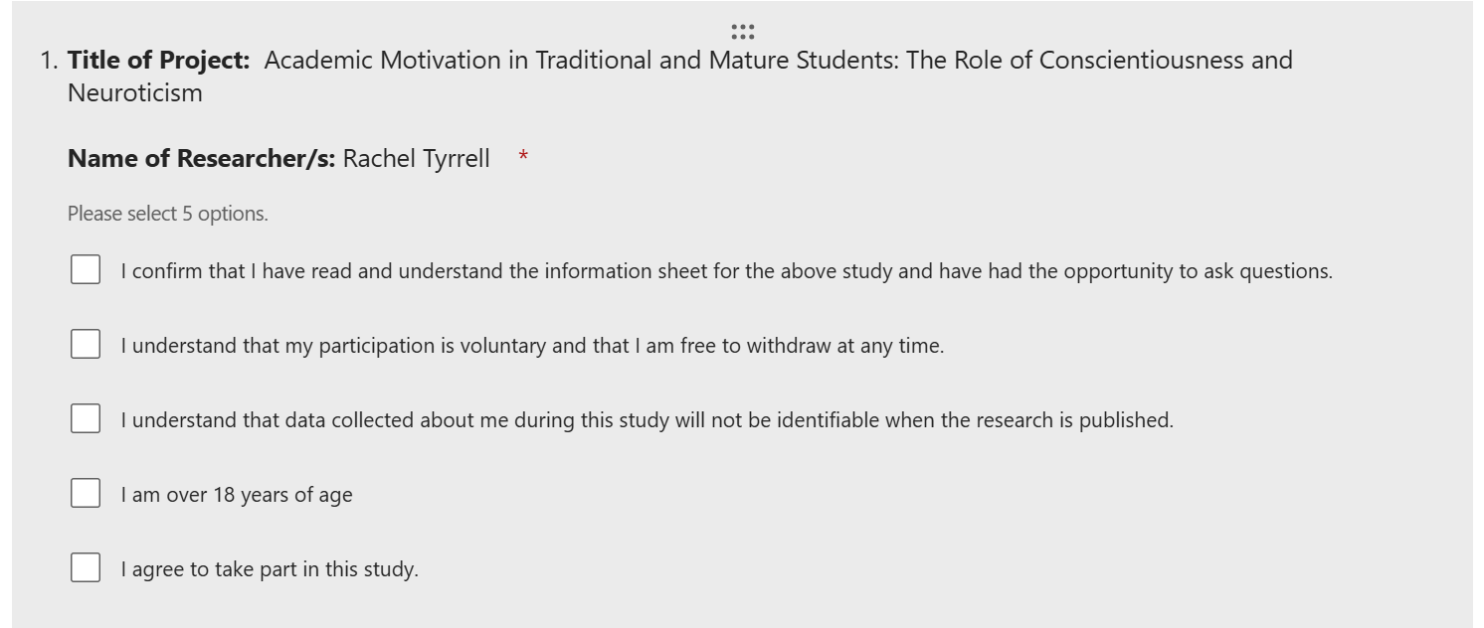

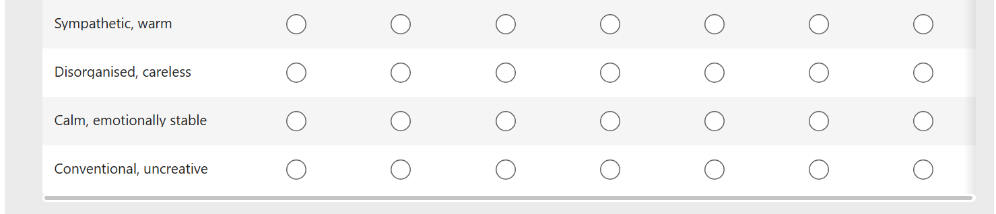
Appendix D
Ten Item Personality Inventory
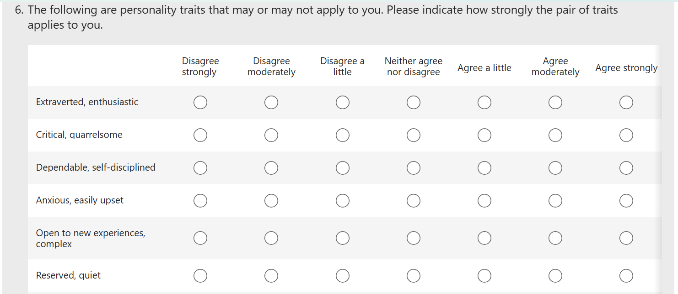

Appendix E
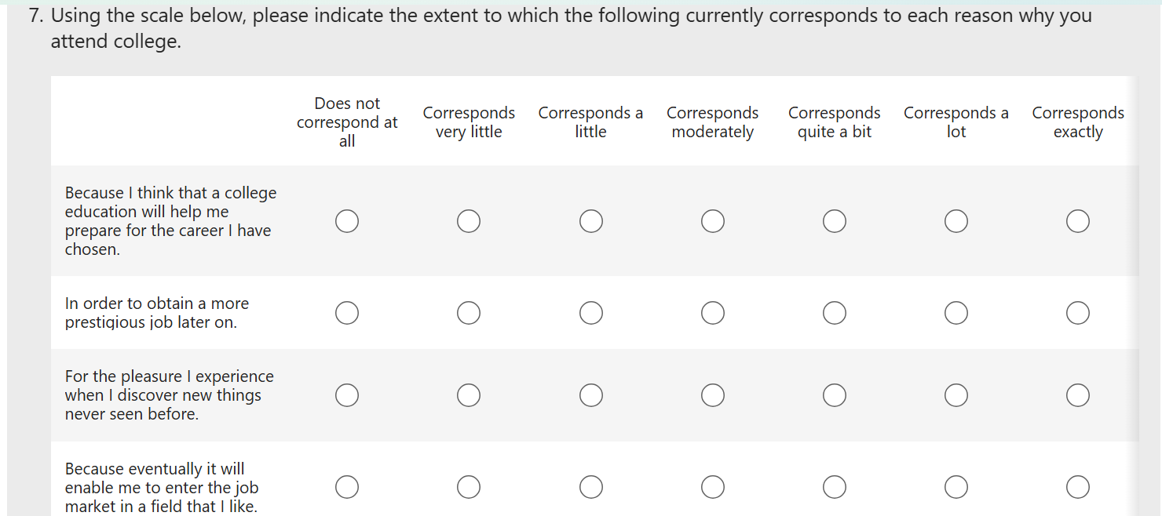
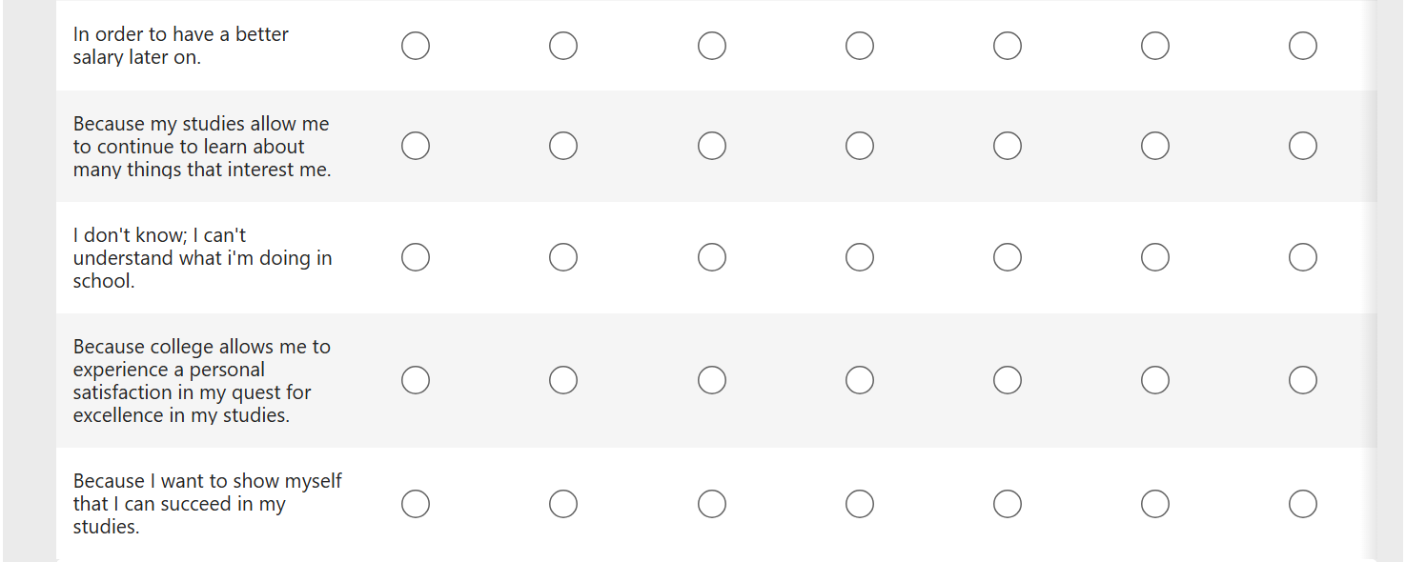
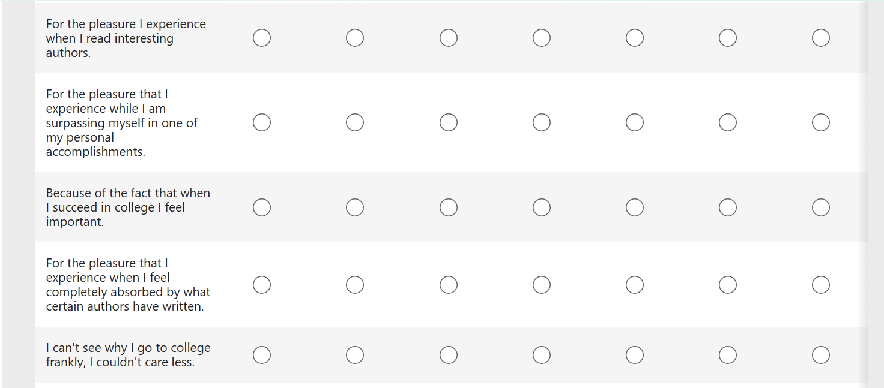
Shortened Academic Motivation Scale

Appendix F
Debrief Form
Title of Project: Academic Motivation in Traditional and Mature Students: The Role of Conscientiousness and Neuroticism
Name of Researcher/s: Rachel Tyrrell
Thank you very much for taking part in this research study. This study is designed to investigate Personality traits and academic motivation and their relationship with student type either traditional or mature students. The survey you completed will help to understand the potential relationship between the variables.
Withdrawal information
If you have any questions about this study, or if you would like to withdraw your data from the study, please contact the researcher or supervisor at N00221097@iadt.ie and Irene.Connolly@iadt.ie. In your email let them know your unique ID code you created using the second and third letters of your address and the last three digits of your Eircode. If you submit a request for data removal, all data collected from you will be securely deleted. You will be able to remove your data from the study until February 14th 2026 when the data will be combined and analysed. Data removal will not be possible after that date. Please keep a copy of this information in case you wish to remove your data after leaving this screen.
Data protection
Your data will be treated according to GDPR regulations. You can contact IADT's Data Protection Officer at dp@iadt.ie, and more information on your rights concerning your data at https://iadt.ie/about/your-rights-entitlements/gdpr/
Support resources If you have been affected by the content of this study in any way, the organisations below may be of assistance.
IADT student counselling: studentcounselling@iadt.ie Samaritans: jo@samaritans.ie Aware: supportmail@aware.ie
Thank you again for taking the time to participate in this research. If you have any questions about this study, please contact the researcher or supervisor at N00221097@iadt.ie or Irene.Connolly@iadt.ie

Appendix G
Conscientiousness and Neuroticism reliability scores
Conscientiousness reliability
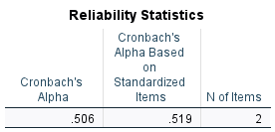

Neuroticism reliability

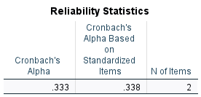

Appendix H
Intrinsic and extrinsic reliability scores

Intrinsic
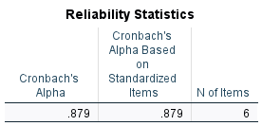

Extrinsic

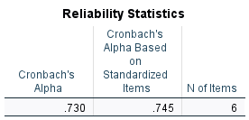

Appendix I
Intrinsic Multiple Regression Analysis Output
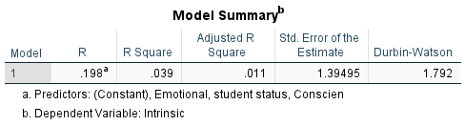
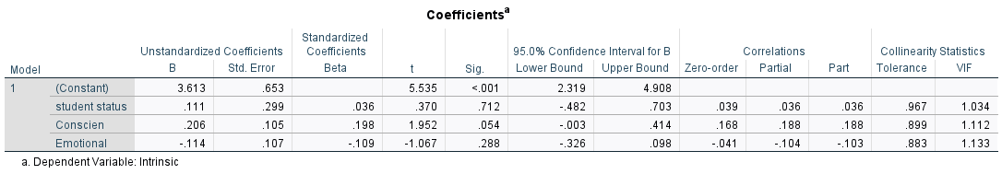
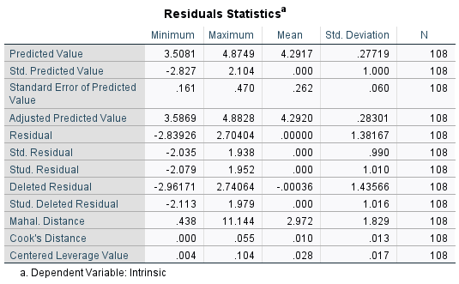
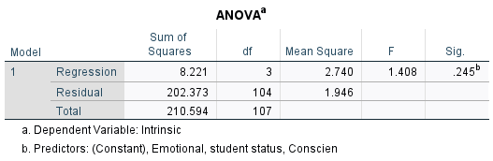

Appendix J
Extrinsic multiple regression analysis output
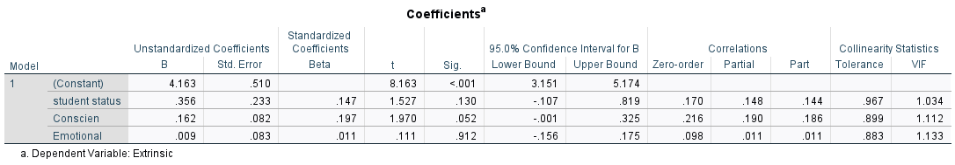
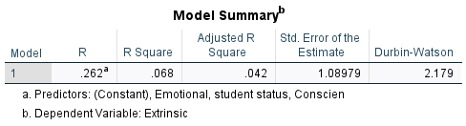
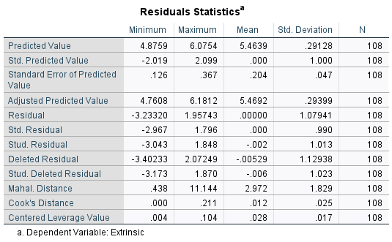
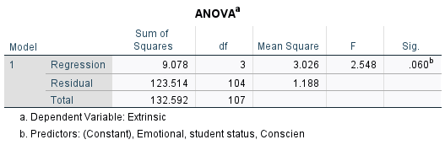

Appendix K
Independent samples t-test output

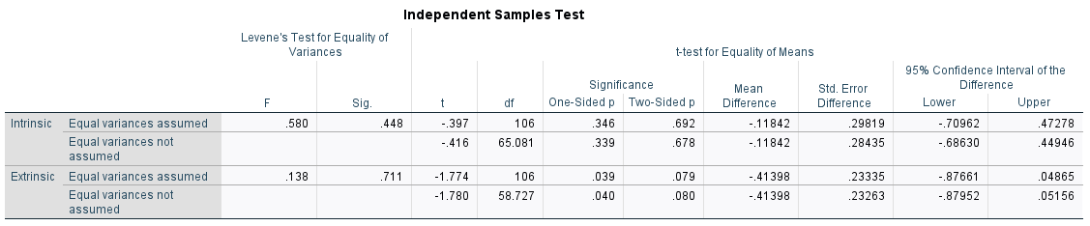

Appendix L
Poster to distribute survey
