

Investigating the impact of current competitive sport status and participation in (past) organised youth sport on adult athletes’ grit

Luke Hardy
N00220491

Research Supervisor: Dr Olivia Hurley

Dissertation submitted as a requirement for the degree of BSc (Hons) in Applied Psychology, Dun Laoghaire Institute of Art, Design & Technology, 2026

Declaration
☐ I, Luke Hardy, hereby declare that the work that I have submitted for / contributed to the assessment specified above is entirely my own work. Where I have drawn from the work of others, including Generative AI systems, I have clearly indicated this within my submission
work. I recognise that Generative AI creations, no matter how small, may not be permissible within my submitted work and have checked this specific assessment brief for the admissible
use of such software. I have read and complied with the IADT Academic Integrity Policy for this submission and recognise that breaches of this policy in my work may result in penalties, up to and including disqualification from IADT.
☐ I, Luke Hardy, hereby declare that I recognise that IADT staff may provide feedback on assessment via a range of methods, depending on the nature of the assessment and the preference of the staff member. I recognise that any grades issued by a lecturer are provisional but are not negotiable. Final grades will be issued following the relevant exam board meeting and information on appeals procedures is available on the IADT website. I agree to abide by the IADT Mutual Respect Policy in all of my communications with and regarding all IADT staff members.

Word Count: 4988

Signed: Luke Hardy Date: 31/03/2026

Acknowledgements
Firstly, I would like to thank my research supervisor, Dr Olivia Hurley. Your guidance, support and encouragement throughout the process of my major research project has been a huge driving force behind my enjoyment of the project and final year. I am massively thankful for all the time and knowledge you have provided me with throughout the year, and I hope to carry the bits of knowledge and dedication you have shown me throughout my future studies and career.
I would like to thank all the lecturers I have had the privilege of working with throughout my time in IADT. Their love and enthusiasm for the modules they teach make attending so much more enjoyable, as you always know you will learn something from a lab or lecture. And I would like to thank my friends who also made college so enjoyable and always offered to help and guide me when I may have been stuck on an assignment.
Finally, I would like to thank my parents, Lorcan and Nicola, siblings and my partner Ciara for their constant support and encouragement in everything I did this year, as it was so encouraging to always be told to just go for it and give it your absolute all, and if you give it 100%, there’s no more you can give.

Table of Contents

Abstract……………………………………………………………………………….. 1
- Introduction…………………………………………………………………… 2
1.1 Literature review ……………………………………………………… 2
1.2 Current competitive sport status ………………………………………. 3
1.3 Participation in organised youth sport ………………………………… 5
1.4 The present study ……………………………………………………… 6
1.5 Research question ……………………………………………………... 7
1.6 Hypothesis ……………………………………………………………... 7

- Methodology ………………………………………………………………. 9
2.1 Design ………………………………………………………………….. 9
2.2 Participants …………………………………………………………….. 9
2.3 Materials ……………………………………………………………….. 9
2.4 Procedure ………………………………………………………………. 10
2.4.1 Pilot Test ……………………………………………………... 10
2.4.2 Main Data Collection ………………………………………… 11

- Results ……………………………………………………………………… 12
3.1 Overview of results ……………………………………………………... 12
3.2 Analysis 1: The analysis of grit across current competitive sport status (CCSS)
3.2.1 Descriptive Statistics ………………………………………….. 12
3.2.2 Inferential Statistics …………………………………………… 13
3.3 Analysis 2: The analysis of grit across past participation in organised youth sport (OYS)
3.3.1 Descriptive Statistics ………………………………………….. 13
3.3.2 Inferential Statistics …………………………………………… 14
3.4 Analysis 3: The interaction effect between the adult athletes' current competitive sport status and participation in organised youth sport for Grit.
3.4.1 Descriptive Statistics …………………………………………. 15
3.4.2 Inferential Statistics …………………………………………... 15
- Discussion ………………………………………………………………….. 17
4.1 Overview of Findings …………………………………………………... 17
4.2 Strengths and Limitations ………………………………………………. 18
4.3 Theoretical and Practical Implications …………………………………. 18
4.4 Future Research ………………………………………………………… 19
4.5 Conclusion ……………………………………………………………… 20
- References …………………………………………………………………. 21
Appendices …………………………………………………………………….. 25
Appendix A: Information Sheet ……………………………………………. 26
Appendix B: Consent Form ………………………………………………... 29
Appendix C: Demographic Questionnaire ………………………....………. 30
Appendix D: Grit Scale …………………………………………………….. 31
Appendix E: Data Consent Form …………………………………………... 33
Appendix F: Debrief Document ……………………………………………. 34
Appendix G: Cronbach Alpha ……………………………………………… 36
Appendix H: The Assumptions of a Two-Way ANOVA ………………….. 37
Appendix I: SPSS Output ……………………………………………....…... 38

List of Tables and Figures
Tables
Table 1: Summary of adult athletes’ mean grit scores based on current competitive sport status …………………………………………………………………… 12
Table 2: Summary of adult athletes' mean grit scores based on past participation in organised youth sport ……………………………………………………………... 14
Table 3: Summary of adult athletes’ CCSS and OYS for their corresponding mean grit scores
………………………………………………………………………………….. 15

Figures
Figure 1: Display of the Adult Athletes’ grit scores across each CCSS group …. 13
Figure 2: Display of Adult Athletes' grit scores based on their past participation in OYS
………………………………………………………………………………….. 14
Figure 3: Display of the interaction between (IV1) CCSS and (IV2) past participation in OYS, based on adult athletes’ grit score ……………………………..... 16

Abstract
The present study aimed to examine the impact of Current Competitive Sport Status (CCSS) and participation in Organised Youth Sport (OYS) on adult athletes' grit. The participants in this present study were adults over the age of 18 years (N=95). The grit scale developed by Duckworth and Quinn (2009) was used to measure adult athletes' grit. The adult athletes' CCSS and OYS were measured using a demographic questionnaire section of the questionnaire. A two-way ANOVA reported no significant difference in adult athletes' grit, based on CCSS and OYS. Potential explanations for these results were discussed. Addressing the strengths of the present study included the addition of combat sports to the grit research and addressing limited research on the variables. Limitations of the present study, such as its generalizability to a wider population and its uneven distribution of participants within variables, were presented. Practical implications and suggestions for further research, such as a longitudinal design being employed and the inclusion of variables such as psychological needs satisfaction against sporting variables, were outlined.

1. Introduction
  - Literature Review
Grit is a tenacity and strong will to accomplish long-term objectives (Mendizabal, 2024). Grit is a widely studied construct and is not limited to research within sport. Lam and Zhou (2021) reported that grit had a weak to moderate correlation with academic achievement. Further research investigating Grit has reported it to be an influencing factor in health. Lee et al. (2021) reported that while grit has yielded inconclusive results in influencing performance metrics in medicine, a positive correlation exists between grit and psychological well-being.

In terms of understanding the factors that contribute to success in sports, D’Isanto et al. (2019) examined the factors that influence sport performances and reported psychological factors as an indicator of performance. The extensive body of research on psychological factors examines resilience as an indicator of performance (Mendizabal, 2024; Vipin Sehrawat et al., 2024). Among these studies, Mendizabal (2024) reported that grit is an indicator of resilience. These findings are supported by Shen et al. (2025), who reported that grit predicted competition readiness. Their study identified a limitation in their research as the use of Korean student athletes. Shen et al. (2025) recommend further research using a different population sample and investigating other types of sport. The present study aims to address this by investigating the effect of current competitive sport status (CCSS) on the grit of adult athletes.

As pointed out above, grit is the primary focus of the present study. Cocić et al. (2024) reported that grit serves as a motivational mechanism that shapes talent development. The main components of grit are reported to be the influence of training at different stages (Cocić et al., 2024), indicating that personality can significantly alter the development of grit, even among elite athletes. However, Cocić et al. (2024) reported a limitation of their research as its reliance on data from elite soccer players aged between 13 and 15 years. As Sutter et al. (2022) reported, grit increases strongly with age. This limitation could result in skewed data.

In addition to the above research, Duckworth et al. (2007) investigated grit among military cadets and reported that those who succeeded, specifically the Beast Barracks, which is cadet basic training, possessed higher levels of grit. Duckworth and Quinn (2009) then developed a scale to measure grit (See Appendix A), which the present study will utilise to assess the grit of adult athletes. Research on grit has yielded a variety of findings. Garris et al. (2024) reported on the role of grit in moderating the relationship between stress, anxiety and depression. They reported a link between stress and outcomes of anxiety and depression, which were moderated by grit, meaning that the level of grit determines the direction of the relationship between stress, anxiety and depression.
The findings of Garris et al. (2024) enhance the understanding of the role grit plays in the stressor-stress-mental health pathway, as individuals with high grit are less affected by stress, which means their anxiety and depression levels are less impacted by stress. However, Garris et al. (2024) results were correlational and, as such, do not support a causal inference. This highlights an association between stress and grit, but it is not possible to determine whether one affects the other. Additionally, their study was conducted during the COVID-19 pandemic, which may have influenced the results, as the data was collected during a time of uncertainty. This aligns with Kienzler et al.'s (2024) research, which reported that there are higher stress levels during times of uncertainty. As a result, the reported results of Garris et al. (2024) could be skewed.
Although grit is often described as a trait-like construct (Duckworth et al., 2007). Trait theory research (Wright & Jackson, 2023) discusses that personality characteristics show stability while allowing for the context of the situation to shape. This supports the idea that grit may remain relatively stable across adulthood, yet can be influenced by environments that demand sustained effort, such as sport. Self-Determination Theory (Ryan & Deci, 2000) further supports the concept that sport environments support autonomy, competence, and relatedness. Taken together, these theoretical perspectives suggest that both CCSS and early involvement in OYS may provide conditions that reinforce or express grit, providing a meaningful reason for examining their relationship with adult athletes’ grit.
  - Current Competitive Sport Status
A variable which has been investigated to determine its impact on grit is the current competitive sport status (CCSS). While it is not explicitly defined in recent research (Blanco-García et al., 2021; Lorenço-Lima, 2024; Wei et al., 2025); competitive sport is defined as “all forms of physical activity which, through organised participation, are aimed at — (a) expressing or improving physical fitness, and (b) obtaining improved results in competition at all levels.” (Sport Ireland, 2022, p. 6). In the context of the present study, status will refer to whether the participants are in one of four groups: team sport, individual non-combat sport, individual combat sport, or no current competitive sport status.

In addition to the CCSS definition discussed above, to date, much of the literature examining sports played has often investigated team and individual sports in comparison to each other in terms of resilience (Blanco-García et al., 2021). There appears to be a lack of research examining the effects the type of sport has on grit. However, research by Wei et al. (2025) investigated how individual, versus team, sport participation influenced adolescent psychological resilience through emotional regulation, social support, and self-efficacy. Wei et al. (2025) reported that team sport participation resilience is supported by social support and self-efficacy, whereas individual sport adopts resilience through self-efficacy. Wei et al. (2025) reported limitations in their examination of sport types and recommended that further research incorporate training level and participation metrics, to enhance the ability to draw causal conclusions on how resilience is adopted, thereby improving the generalizability of the findings and providing more definitive answers. Wei et al. (2025) suggested that further studies employ larger sample sizes and include more sport types. Their research can inform studies on grit, as resilience is an indicator of grit (Mendizabal, 2024).

Conversely, much of the research investigating sport status has neglected to examine combat sports separately and has grouped them with individual sports, as is common in existing literature (Blanco-García et al., 2021). Blanco-García et al. (2021) grouped combat sports with individual sports and reported no relationship between the type of sport played and the level of resilience. However, Guo et al. (2025) investigated combat sports independently and reported that combat sports foster different psychological characteristics such as emotional regulation, discipline and resilience. Guo et al. (2025) reported limitations to their study, including the reliance on self-report measures for assessing their variables, which could result in social desirability bias or inaccurate reporting.

Additionally, past literature has investigated various types of sports, suggesting that individual grit has yielded significant results. Lorenço-Lima (2024) investigated the correlation between grit and combat sport and reported a positive correlation between grit and combat sport experience. However, these results warrant further investigation, as the significance reported was not as substantial and did not account for other external variables, which may have skewed the data due to factors not considered within the research. In contrast to these findings, De Lorenço-Lima et al. (2025) reported no relationship between grit and a judo athlete's competitive or non-competitive status. De Lorenço-Lima et al. (2025) reported limitations of their study included a cross-sectional design being employed and the self-selection of participants for the study. This resulted in their findings being less applicable to the population, as the data was collected with only specific participants being selected.

  - Participation in Organised Youth Sport
Another variable examined for its impact on grit has been participation in organised youth sport (OYS). Organised youth sport is defined as “physical activity that is directed by adult or youth leaders and involves rules and formal practice and competition” (Logan & Cuff, 2019, p. 1). OYS research has reported a number of results. Bengtsson et al. (2025) reported that participation in youth sport was associated with long-term physical health, well-being and reduced mental ill-being. Similarly, Chen et al. (2025) reported that sport participation in adolescence predicted later improvements in self-control and mental health.

Research by Nothnagle and Knoester (2022) examined participation in youth sports and its relationship to the development of grit. They reported that participation in sport during childhood and adulthood is typically associated with higher levels of adult grit. Nothnagle and Knoester (2022) reported their limitations to include the use of volunteer participants and the self-report measure of participation in youth sport, as details could be misremembered and reported inaccurately. Nothnagle and Knoesters' (2022) findings are supported by Rhodes and Giovannetti (2021), who also reported that grit is defined as the perseverance of effort, which aligns with Nothnagle and Knoester's (2022) results, as it shows that persistence in sport participation, no matter the difficulty, aligns with higher grit.

Moreover, Nothnagle and Knoester's (2022) research is further developed by Ciaccioni et al. (2025), who reported that adolescents who regularly engage in structured sport show enhanced levels of psychological resilience and exercise motivation. Two psychological characteristics that potentially explain the perseverance and continued effort characteristic of grit (Hu et al., 2025). The findings of Ciaccioni et al. (2025) strengthen research and proposes that long-term involvement in organised youth sport plays a contributing role in the development of psychological traits such as grit.

In addition to previous research, Cormier et al. (2024) investigated the development and outcomes of long-term passion and consistency in competitive sport, aiming to construct a theory of grit. They reported that grit is formed over time, as athletes collect sport experience. Cormier et al. (2024) reported limitations of their study, as their participants lacked a diverse sample, with the majority being Caucasian in Westernised countries. Due to the potential for self-report biases outside the researcher's control, the action of self-report should be accounted for.

Similarly, Kovács (2025) reported that consistent and persistent athletes were characterised by high sport persistence and grit, whereas those who stopped playing sport had lower levels of grit. They identified limitations in their study of snowball sampling, which could lead to a lack of generalizability (Kovács, 2025). Additionally, they included the use of questionnaires that are not validated measures. As a result, certain influencing factors, such as peer support or social values, were not measured. No replication of clusters was attempted on a different group of participants, which may have provided further insight.

In line with previously discussed research, the findings of Cormier et al. (2024) and Kovacs (2025) support those of De Lorenço-Lima et al. (2025), who reported that grit was significantly impacted by experience, training frequency, training volume, and competitive participation in the past 12 months in sport. De Lorenço-Lima et al. (2025) reported that the results of their study showed that the more experience a judo athlete has, regardless of their competitive status, the more likely they are to exhibit higher levels of grit. The findings of these three studies (Cormier et al., 2024; De Lorenço-Lima et al., 2025; Kovacs, 2025) support one another, indicating that more experienced individuals have higher grit levels. De Lorenço-Lima et al. (2025) highlighted their limitations of employing a self-selection sampling process, which may result in social desirability response bias, which is the tendency to give socially acceptable answers to align with societal expectations (Bergen & Labonté, 2020).

  - The Present Study
The present study aims to address the gaps in the literature cited above regarding the associations between CCSS, OYS, and grit. Nothnagle and Knoester (2022) reported that participation in sports contributes to the development of grit. However, they neglected to investigate whether this is due to the type of sport played or participation in youth sport. Similarly, Blanco-García et al. (2021) investigated if the type of sport performed influenced resilience; the results reported no significant difference in resilience across the type of sport performed. They, however, neglected to investigate external factors, such as prior participation in youth sports, and they reported their study was not generalizable. Additionally, their research is contradicted by Guo et al. (2025), who reported that combat sports foster different psychological constructs, thus warranting further investigation into the varying status of these sports in relation to grit. The present study aims to address these limitations by investigating whether current competitive sport status and participation in organised youth sport affect adult athletes' grit.

Cocić et al. (2024) reported that grit serves as a motivational mechanism that shapes talent development. However, their study acknowledged several limitations, including its reliance on data from elite soccer players aged from 13 to 15 years. The current study aims to address this by measuring whether adults actively competed in organised sport throughout their childhood (not just in a particular age range). Similarly, Garris et al. (2024) reported grit as a moderating link between stress, anxiety and depression. A limitation of their study was that their results were correlational, which the current study aims to address by employing a between-groups design. Kovacs (2025) also reported that a limitation of their study was the use of unvalidated measures. The present study will address the limitation by employing a validated measure (the short grit scale; Rumbold et al., 2022).

Hypothesis 1 is developed using research that indicates competitive sport participation fosters psychological characteristics (Cocić et al., 2024; Guo et al., 2025; Mendizabal, 2024). Hypothesis 2 is developed by research, which suggests that sustained participation in sport during childhood and adolescence leads to the development of grit (Nothnagle & Knoester, 2022; Cormier et al., 2024; Sutter et al., 2022). Hypothesis 3 proposed an interaction, as research indicated early structured sport participation established grit, which is further supported by continued exposure to competitive sport types in adults (Cormier et al., 2024; Wei et al., 2025).

  - Research Questions
The present study aims to answer the following research question: Does adult athletes current competitive sport status and participation in organised youth sports affect their grit.
  - Hypotheses
Hypothesis 1. There will be a difference for adult athletes on their grit, based on their current competitive sport status (Team Sport/Individual Non-Combat/Individual Combat/Not currently involved in competitive sport)
Hypothesis 2. There will be a difference, for adult athletes, on their grit, based on their (past) participation in organised youth sport. (Yes/No)
Hypothesis 3. There will be a significant interaction between current competitive sport status and participation in organised youth sport, for adult athletes' grit.

2. Method
2.1 Design
The present research employed a 4x2 between-groups design. The first independent variable was “current competitive sport status” (CCSS) (team sport/individual non-combat/individual combat/not currently involved in competitive sport). The second independent variable was participation in organised youth sport (OYS) with two levels (yes/no). The dependent variable was grit.

2.2 Participants
95 adults (over 18 years old) were recruited using convenience sampling. Participants were recruited from the local demographic of South County Dublin in the present study by being asked to scan a QR code, a data collection fair, WhatsApp messages, and view a poster in a local business. Recruitment was both online and in person. No exclusion criterion for the study was needed. Consent for participation and the collection of data was obtained through a ticked box (see Appendix B). The treatment of participants was in accordance with the ethical standards as stated by the Psychology Society of Ireland (PSI) and the Department of Technology and Psychology Ethics Committee (DTPEC).

2.3 Materials
The study’s documents were embedded into an online Microsoft Forms questionnaire. The information sheet (see Appendix A) informed participants of the study's nature and what they would be asked to do throughout the study. The information sheet highlighted that participation in the study was completely voluntary. The consent form (see Appendix B) was used for participants to indicate their consent to participate in the study and to acknowledge that their data collected could be attributed to the study. Consent was obtained before participants could progress in the study. A demographic questionnaire (see Appendix C) was compiled to ask participants questions related to the independent variables. This consisted of a demographic code question compiled from the second and third letters of a participant's parent/guardian and the first and last initial of their favourite band, their CCSS and their past participation in OYS.
A short grit scale, (Duckworth and Quinn (2009; see Appendix D), was used to measure participants' Grit. This scale is an 8-item questionnaire with questions such as ‘I finish whatever I begin’ and ‘Setbacks don’t discourage me’. The scale is answered using a 5-point Likert scale, ranging from ‘very much like me’ to ‘not like me at all’. All answers provided by the participants are submitted via Microsoft Forms. The questionnaire was scored by assigning points to each question, which were then added together and divided by the total number of questions (8). The highest score per question is a ‘5’, and the minimum is a ‘1’. Individuals who receive a higher score are said to have more grit. The participants were not informed of their overall score. Duckworth and Quinn (2009) reported a Cronbach alpha ranging from .73 to .82, which places the scale within the acceptable range of validity and consistency (Tavakol & Dennick, 2011). This is supported by the SPSS output (Appendix G) reporting a Cronbach's alpha of .802.
Before being debriefed, the participants confirmed their consent for their data use (see Appendix E). After this, the participants received a debriefing document (see Appendix F). The document contained contact information for the researcher, his supervisor, and various supports the participant could contact if they were distressed by the content of the present research. The debriefing document thanked participants for their time and participation in the study.
2.4 Procedure
2.4.1 Pilot Test –
A pilot test was conducted to determine the average time (6 Minutes) required to participate in the present study and to identify any issues with the explanation and execution of the present study. Ten participants took part in the pilot study prior to the main study. Due to feedback from participants of the pilot study, further explanation was placed in the information sheet and demographic questionnaire on the definition of the independent variables and the creation of participant codes.

2.4.2 Main Data Collection –
Participants who wished to participate in the study were provided with a link or QR code to a Microsoft Form to take part in the research. The participants were greeted with the information sheet (see Appendix A). The information sheet outlined the purpose of the study, what was involved in participating, informed participants of their rights to take part in the study and how their participation was completely voluntary. If they wished to withdraw from the study, the researcher and supervisor’s contact details were provided. They were informed they must do so before data analysis began on the 23rd of February 2026. After the participants had read the information sheet, they were taken to a consent form (see Appendix B), which they had to agree to by ticking the box to indicate consent before further progression in the research.

After giving their consent, the participants were directed to the demographic questionnaire (see Appendix C), which asked for a participant code, their current competitive sport status and if they participated in organised youth sport. After the participants completed the demographic questionnaire, they were directed to the short grit scale (Duckworth and Quinn, 2009, see Appendix D). Following the completion of the grit scale, the participants were directed to a final data consent form (see Appendix E), which asked whether they still wished to have their data used in the present study.

Finally, the participants were fully debriefed using the debrief form (see Appendix F) and thanked for their participation in the present study. The participants were provided with support resources if they required them. The researcher’s and supervisor’s contact information were outlined in this document, also, so that they would be easily contactable, if any issues arose after completion of the present study.

3. Results
3.1 Overview of results
The independent variables for the present study were:
- Adult Current Competitive Sport Status (Individual Non-Combat/Individual Combat/ Team Sport/ No Current Competitive Sport Status)
- Past Participation in Organised Youth Sport (Yes/No)
The dependent variable for the present study was
- Grit
An exploration of data was carried out pre-analyses to assess the assumptions of the two-way analysis of variance between groups. The Levene’s test for equality of variance was not violated (F(5,87)=1.568,p=.177). The assumption of normality was met (see Appendix G). The grit scale developed by Duckworth and Quinn (2009) appeared to have a robust Cronbach alpha of .804 (see Appendix G).
3.2 Analysis 1 for IV: The analysis of grit across current competitive sport status (CCSS).
3.2.1 Descriptive Statistics
The data collected for analysis 1 is summarised in Table 1 below. The mean (M), n value and standard deviation (SD) for each CCSS (Individual Non-Combat, Individual Combat, Team Sport, No Current Competitive Sport Status) are presented.
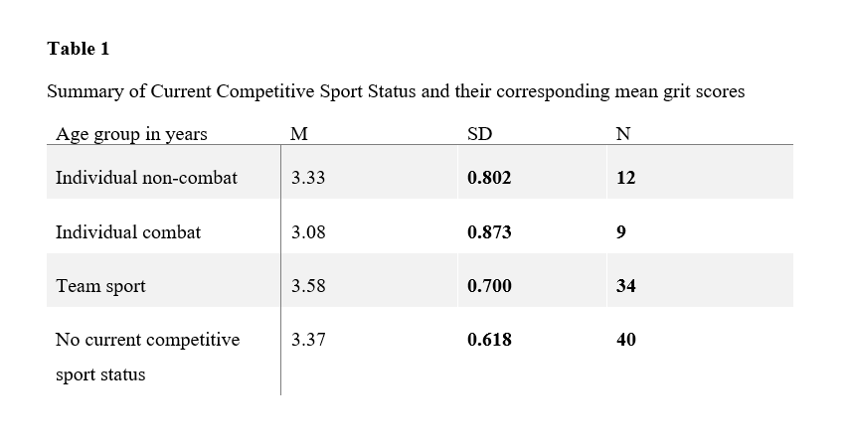
3.2.2 Inferential Statistics
Hypothesis 1 stated there would be a difference in participants' grit, based on CCSS. Hypothesis 1 was not supported. (F(3,87) = .321, p=.110). The observed power was 0.276. There appeared to be no difference for adult athletes in the grit based on CCSS. Figure 1 shows adult athletes grit scores across each CCSS group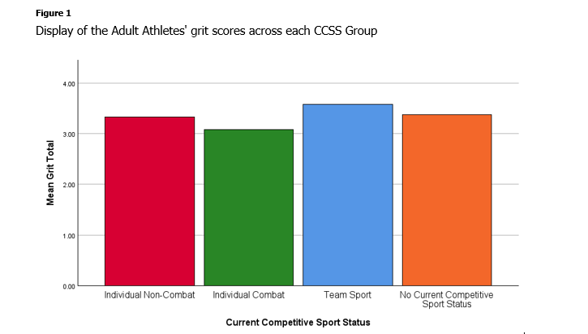

3.3 Analysis 2 for IV: The analysis of Grit across past participation in Organised Youth Sport (OYS).
3.3.1 Descriptive Statistics
The data collected for analysis 2 is summarised in Table 2 below. The mean (M), n value and standard deviation (SD) for past participation in OYS (Yes/No) are presented.
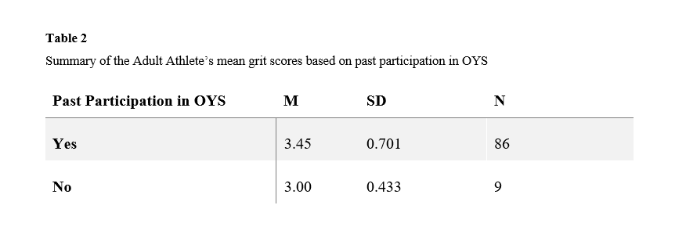
3.3.2 Inferential Statistics
Hypothesis 2 stated there would be a difference, for adult athletes on their grit, based on their past participation in OYS. Hypothesis 2 was not supported (F(1,87) = 1.842, p=.269). The observed power was .225. There appeared to be no significant difference in adult athletes' grit based on past participation in OYS (Yes/No). Figure 2 displays adult athletes' grit scores based on their past participation in OYS.
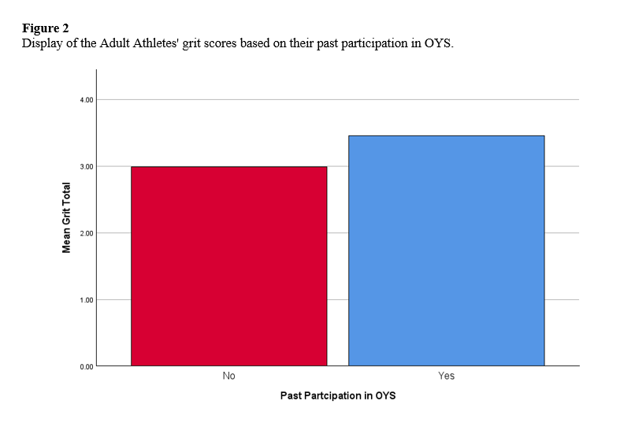
3.4 Analysis 3: The interaction effect between the adult athletes' current competitive sport status and participation in organised youth sport for Grit.
3.4.1 Descriptive Statistics
The data collected for analysis 3 is summarised in Table 3 below. The mean (M), n value and standard deviation (SD) of each CCSS and OYS are presented.
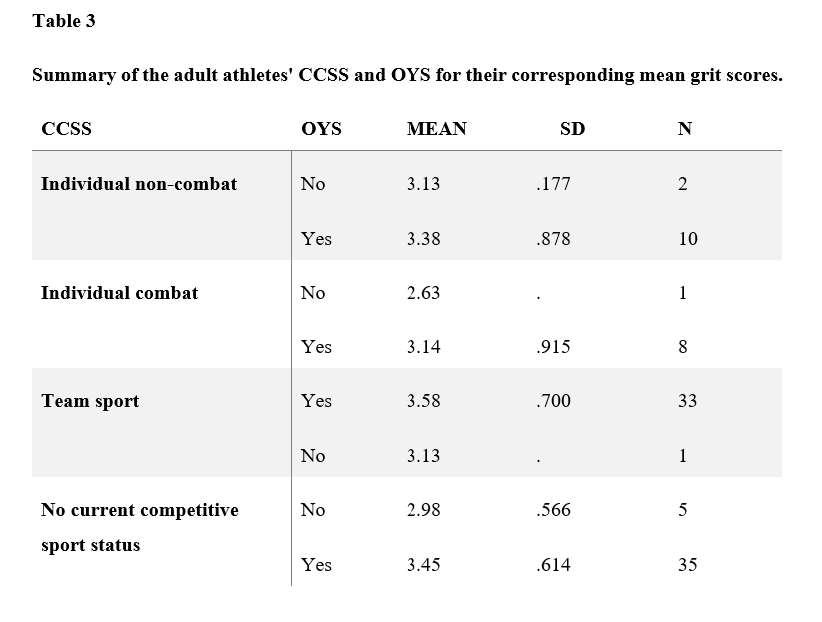
3.4.2 Inferential Statistics
Hypothesis 3 stated there would be a significant interaction between CCSS and OYS for adult athletes' grit. Hypothesis 3 was not supported (F(3,87) =..037, p=.990). The observed power was .056. There appeared to be no significant interaction between the two independent variables. Figure 3 displays the interaction between (IV1) CCSS and (IV2) past participation in OYS, based on the adult athletes' grit effect.

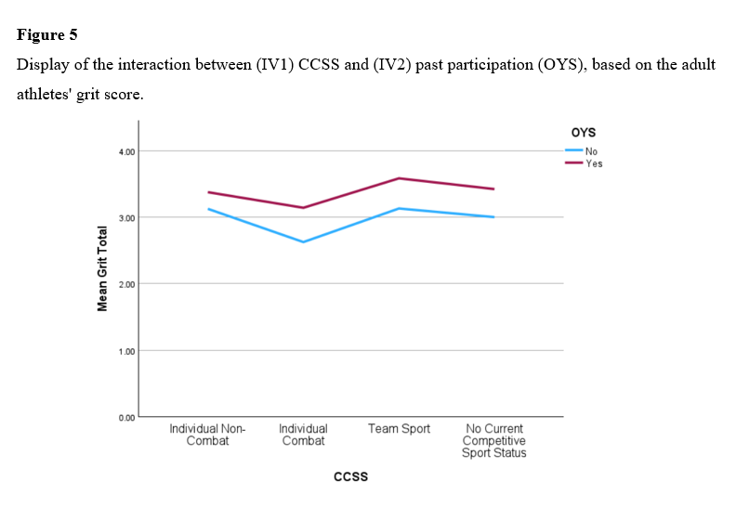

4. Discussion

4.1 Overview of Findings
The present study investigated the impact of Current Competitive Sport Status (CCSS) and past participation in Organised Youth Sport (OYS) on adult athletes' grit. Hypothesis 1 stated there would be a difference for adult athletes, on their grit, based on their CCSS. Hypothesis 1 was not supported. This finding supported Blanco-Garciá (2021), who reported no significant difference between the type of sport played and resilience. Conversely, Guo et al. (2025) reported that combat sports foster resilience, which is in contrast to the findings of the present study, where no significant difference was found for any of the sport status levels measured against grit.
Hypothesis 2 stated there would be a difference for adult athletes, on their grit, based on past participation in OYS. Hypothesis 2 was also not supported. This result contrasts Nothnagle and Knoester (2022), who reported that people who participated in organised youth sport possess higher grit than people who have not participated in organised youth sport. This result also contrasts with the findings of Cormier et al. (2024), who reported that grit is formed over time, as athletes gain sport experiences. These findings are in contrast to the present study, as there was no significant difference between those who have and have not participated in organised youth sport. A possible explanation for the lack of differences in grit between OYS could be that grit was measured on those over 18 years, and external factors such as experience, training frequency and training volume (De Lorenco-Lima et al., 2025) may have affected their grit as they have matured.
Hypothesis 3 stated there would be a significant interaction between CCSS and past participation in OYS for adult athletes' grit. This hypothesis was not supported, contrasting Wei et al. (2025), who reported that sport status fosters resilience. It is also in contrast to Sutter et al. (2022), who reported that sustained participation in sport during childhood develops grit. Overall, the findings of the present study suggest that neither the current competitive sport status nor participation in organised youth sport influences adult grit.
Overall, a consistent pattern which emerged from the present study is that grit did not differ based on sport type or youth sport participation. This suggests that grit may be relatively stable in adulthood and is less influenced by sport involvement as previously reported by Nothnagle and Knoester (2022).

4.2 Strengths and Limitations
Having presented a review of the present study’s results, the study’s strengths and limitations will now be presented. A strength of the present study was its contribution to the existing sport psychology literature on the impact of sport status on grit, as the study included combat sports within the CCSS, which previously had not been focused on. Due to the lack of research investigating factors which could affect an athlete’s grit, Nothnagle and Knoester (2022) suggested that more research should be conducted to understand if the type of sport played or participation in youth sport affects grit development. The present study addressed this gap by examining grit, adult athletes' current competitive sport status, and participation in organised youth sport.
However, the sample size (N=95) and convenience sampling used in the present study are a limitation, as the sample size does not take into account a wider population, and the participants were convenient to the study and recruited within the local demographic. As a result of this, the study's results lack application to the wider population. The reliance on self-report measures for CCSS and participation in OYS could also potentially result in social desirability bias or inaccurate reporting, which could further impact the results of the present study. Another limitation of the present study is the uneven distribution of participants across the four sport categories, in particular, the small number of participants who represented combat sports. This imbalance reduces statistical power and may have skewed the differences of the variables. Considering all the limitations of the present study, they reduce the extent to which the findings can be generalised and suggest that the results should be interpreted with caution.
4.3 Theoretical and Practical Implications
The present study has several theoretical and practical implications. Cormier et al. (2024) discussed grit theory, outlining that grit is developed by the experiences athletes gather over time, which creates the foundation for the increase of grit. Similarly, Kovács (2025) supports the concept of grit theory as consistent and persistent athletes were characterised by higher grit. Grit theory is closely linked to Self-Determination Theory (SDT; Ryan & Deci, 2000), SDT proposes that long-term motivation and perseverance emerge when the psychological needs of autonomy, competence and relatedness are supported. The environments of OYS and the different levels of CCSS could foster these needs. While there were no significant differences reported in grit across CCSS and OYS, the present study's results still contribute towards grit theory and self-determination theory by implying that grit may be a more consistent factor across different sporting contexts than has been previously reported, and that factors such as training level, competitive level and training intensity are beyond sport participation and may play a greater role in grit development.
The present study also offers practical implications for coaches, youth sport organisations and those involved in sport. While no significant difference was reported for grit across CCSS and OYS, the present study's results suggest that grit may be a characteristic that is not altered by sport type or consistent participation in youth sport. Instead, targeted psychological skills training, such as goal setting (Kailash Jandu & Pradhan, 2025), may be more effective in developing grit. These findings highlight the importance of youth sport environments focusing on creating environments for support of grit rather than expecting grit to develop through participation alone.

4.4 Future Research
Having outlined the limitations of the present study, future research could implement a longitudinal design to examine grit development over time. Sporting context could also be further investigated to differentiate if grit differs depending on competitive level, training intensity and playing environment. Future research on what impacts grit could research non-sport contributions to grit, such as education, work, and social class. For future research comparing sport versus non-sport developmental pathways, a mixed methods approach would also be recommended to explore potential subjective experiences of grit. Future research investigating whether psychological need satisfaction, such as autonomy, competence, and relatedness, mediates the relationship between grit and one of the variables suggested above could be an area for further research to focus on.

4.5 Conclusion
The present study reported that adult athletes’ grit did not differ across current competitive sport status and past participation in organised youth sport. These findings are in contrast to those of Guo et al. (2025), Nothnagle and Knoester (2022), and Wei et al. (2025). There were positive aspects to the present study, such as being one of the first studies to include combat sport participation among the CCSS groups, as well as considering past participation in organised youth sport, which had also not been considered by past researchers. The present study findings suggest that grit may be a characteristic that is not shaped by sport type or youth sport participation, and highlights the need for alternative development pathways to be considered for Grit enhancement.

References
Bengtsson, D., Svensson, J., Wiman, V., Stenling, A., Lundkvist, E., & Ivarsson, A. (2025). Health-related outcomes of youth sport participation: a systematic review and meta-analysis. International Journal of Behavioral Nutrition and Physical Activity, 22(1). https://doi.org/10.1186/s12966-025-01792-x
Bergen, N., & Labonté, R. (2020). “Everything Is Perfect, and We Have No Problems”: Detecting and Limiting Social Desirability Bias in Qualitative Research. Qualitative Health Research, 30(5), 783–792. https://doi.org/10.1177/1049732319889354
Blanco-García, C., Acebes-Sánchez, J., Rodriguez-Romo, G., & Mon-López, D. (2021). Resilience in sports: Sport type, gender, age and sport level differences. International Journal of Environmental Research and Public Health, 18(15), 8196. https://doi.org/10.3390/ijerph18158196
Chen, W., Peng, B., Hu, H., Yu, L., & Li, L. (2025). A study on the cross-lagged relationships between adolescents’ sport participation and self-control ability and mental health. Scientific Reports, 15(1). https://doi.org/10.1038/s41598-025-19457-x
Ciaccioni, S., Guidotti, F., Pocecco, E., Stankovic, N., & Izzicupo, P. (2025). Editorial: Combat sports and wellbeing: advancing health and inclusion in athletes and practitioners. Frontiers in Psychology, 16(16). https://doi.org/10.3389/fpsyg.2025.1715508
Cocić, D., Larkin, P., Hendry, D. T., Williams, A. M., O’Connor, D., & Bilalić, M. (2024). How small differences grow over time – the snowball effect of grit on practice in sport. International Journal of Sport and Exercise Psychology, 23(5), 1–23. https://doi.org/10.1080/1612197x.2024.2359476
Cormier, D. L., Ferguson, L. J., Gyurcsik, N. C., Briere, J. L., Mosewich, A. D., & Kowalski, K. C. (2024). A quantitative assessment of the predictive utility of grit in sport. Psychology of Sport and Exercise, 70(70), 102540–102540. https://doi.org/10.1016/j.psychsport.2023.102540
Cormier, D. L., Jørgensen, H., Ferguson, L. J., Gyurcsik, N. C., Briere, J. L., & Kowalski, K. C. (2024). Constructing a grounded theory of grit in sport: understanding the development and outcomes of long-term passion and perseverance in competitive athletes. Qualitative Research in Sport, Exercise and Health, 17(2), 1–17. https://doi.org/10.1080/2159676x.2024.2432653
De Lorenco-Lima, L., Rosario , D., & Gaines, S. (2025). Comparative analyses of psychological and training comparative analyses of psychological and training characteristics in judo competitors and non-competitors: Mental strength, self-efficacy, grit, resilience, self-control, aggression, strength, self-efficacy, grit, resilience, self-control, aggression, mental health, and life satisfaction mental health, and life satisfaction. Journal of Physical Education and Sport, 25(7). https://doi.org/10.7752/jpes.2025.07147
D’Isanto, T., D’Elia, F., Raiola, G., & Altavilla, G. (2019). Assessment of sport performance: Theoretical aspects and practical indications. Sport Mont, 17(1), 79–82. https://doi.org/10.26773/smj.190214
Dong, Y., Tang, J., Chawla, N., Lou, T., Yang, Y., & Wang, B. (2014). Inferring Social Status and Rich Club Effects in Enterprise Communication Networks. ArXiv (Cornell University), 10(3). https://doi.org/10.48550/arxiv.1404.3708
Duckworth, A. L., Peterson, C., Matthews, M. D., & Kelly, D. R. (2007). Grit: Perseverance and passion for long-term goals. Journal of Personality and Social Psychology, 92(6), 1087–1101. https://doi.org/10.1037/0022-3514.92.6.1087
Duckworth, A. L., & Quinn, P. D. (2009). Development and validation of the short grit scale (grit-s). Journal of Personality Assessment, 91(2), 166–174. https://doi.org/10.1080/00223890802634290
Garris, B. R., Ko, K., & Novotny, B. A. (2024). The nitty gritty of stress and mental health: The role of grit in moderating the relationship between stress, anxiety, and depression. Journal of College Student Mental Health, 1–17. https://doi.org/10.1080/28367138.2024.2405942
Guo, C., Chen, F., & Wang, Y. (2025). The Psychological Impact of Competitive Sports Participation on Adolescent Athletes: an Analysis of Coping Mechanisms and Performance Outcomes. Journal of Rational-Emotive & Cognitive-Behavior Therapy, 43(2). https://doi.org/10.1007/s10942-025-00587-0
Hu, H., Peng, B., Chen, W., Wang, H., & Yu, T. (2025). How psychological resilience shapes adolescents’ sports participation: the mediating effect of exercise motivation. Frontiers in Psychology, 16(16). https://doi.org/10.3389/fpsyg.2025.1546754
Kailash Jandu, & Pradhan, R. K. (2025). Inquiring long-term goal achievement and grit in a collectivist culture: a qualitative content analysis. Cogent Psychology, 12(1). https://doi.org/10.1080/23311908.2025.2454090
Kienzler, H., Massazza, A., Kuykendall, R., Tamimi, N., Hammoudeh, W., & Giacaman, R. (2024). Uncertainty and Mental Health: A Qualitative Scoping Review. SSM - Qualitative Research in Health, 7, 100521. https://doi.org/10.1016/j.ssmqr.2024.100521
Kovács, K. E. (2025). Athlete profiles along grit, sport orientation and sport persistence based on a quantitative research on hungarian athletes. Frontiers in Sports and Active Living, 7(7), 1594365. https://doi.org/10.3389/fspor.2025.1594365
Lam, K. K. L., & Zhou, M. (2021). Grit and academic achievement: A comparative cross-cultural meta-analysis. Journal of Educational Psychology, 114(3). https://doi.org/10.1037/edu0000699
Lee, D. H., Reasoner, K., & Lee, D. (2021). Grit: what is it and why does it matter in medicine? Postgraduate Medical Journal, 99(1172), postgradmedj-2021-140806. https://doi.org/10.1136/postgradmedj-2021-140806
Logan, K., & Cuff, S. (2019). Organized sports for children, preadolescents, and adolescents. Pediatrics, 143(6), e20190997. https://doi.org/10.1542/peds.2019-0997
Lorenço-Lima, L. (2024). The effect of combat sports experience, competition engagement, sex, and age on grit. Journal of Human Sport and Exercise, 19(1). https://doi.org/10.14198/jhse.2024.191.11
Mendizabal, B. (2024). The relationship between athletes’ grit, mental toughness, and sport resilience. Physical Education of Students, 28(4), 188–194. https://doi.org/10.15561/20755279.2024.0401
Nothnagle, E. A., & Knoester, C. (2022). Sport participation and the development of grit. Leisure Sciences, 47(2), 1–18. https://doi.org/10.1080/01490400.2022.2090037
Rhodes, E., & Giovannetti, T. (2021). Grit and successful aging in older adults. Aging & Mental Health, 26(6), 1–8. https://doi.org/10.1080/13607863.2021.1919990
Rumbold, J. L., Dunn, J. G. H., & Olusoga, P. (2022). Examining the Predictive Validity of the Grit Scale-Short (Grit-S) Using Domain-General and Domain-Specific Approaches With Student-Athletes. Frontiers in Psychology, 13(837321). https://doi.org/10.3389/fpsyg.2022.837321
Ryan, R. M., & Deci, E. L. (2000). Self-determination Theory and the Facilitation of Intrinsic Motivation, Social Development, and Well-being. American Psychologist, 55(1), 68–78. https://doi.org/10.1037/0003-066X.55.1.68 sdt
Shen, Y.-Q., Sim, Y.-K., Bae, J., Bang, I.-J., & Seo, J.-P. (2025). Differences in the relationship among grit, self-regulation, competition preparation, and sport confidence across performance levels: a multi-group analysis. Scientific Reports, 15(1). https://doi.org/10.1038/s41598-025-16448-w
Sport Ireland. (2022). Irish Sports Monitor: Annual report 2022. Sport Ireland. https://www.sportireland.ie/
Sutter, M., Untertrifaller, A., & Zoller, C. (2022). Grit increases strongly in early childhood and is related to parental background. Scientific Reports, 12(1), 3561. https://doi.org/10.1038/s41598-022-07542-4
Tavakol, M., & Dennick, R. (2011). Making Sense of Cronbach’s Alpha. International Journal of Medical Education, 2(2), 53–55. https://doi.org/10.5116/ijme.4dfb.8dfd
Vipin Sehrawat, Kumari, B., & Nara, K. (2024). Role of optimism and resilience in determining sports performance. Sports Science & Health Advances, 2(1), 240–246. https://doi.org/10.60081/SSHA.2.1.2024.240-246
Wei, D., Xue, J., & Sun, B. (2025). Team vs. individual sports in adolescence: Gendered mechanisms linking emotion regulation, social support, and self-efficacy to psychological resilience. Frontiers in Psychology, 16(16). https://doi.org/10.3389/fpsyg.2025.1636707
Wright, A. J., & Jackson, J. J. (2023). Are some people more consistent? Examining the stability and underlying processes of personality profile consistency. Journal of personality and social psychology, 124(6), 1314–1337. https://doi.org/10.1037/pspp0000429

Appendix A
Information Sheet
Title of project: Investigating the impact of current competitive sport status (CCSS) and past participation in organised youth sport (OYS) on adult athletes' grit.

You are being invited to participate in research investigating the effect of current competitive sport status and past participation in organised youth sport on adult athletes' grit. This project is being undertaken by Luke Hardy as part of his major research project for the BSc (Hons) in Applied Psychology at IADT.

Before deciding whether to participate, it is essential to understand the purpose of this research and what it entails. Please take time to read this information carefully and discuss it with someone you trust. If anything is unclear or if you would like more information, please don't hesitate to ask. Our contact details are at the end of this information sheet. Thank you for reading this.

What is the purpose of the project?

The status and participation in competitive sports, as well as their impact on the development of certain psychological constructs, have been widely researched. Previous studies often grouped certain competitive sports together; however, they did not take into account past participation in sport. The aim of this study is to investigate if CCSS and past participation in OYS affect adult athletes' grit.

Who is being invited to take part?

This study is open to everyone over the age of 18 years old.

What is involved?
If you choose to participate, you will:
- Answer a brief demographic questionnaire about your age, gender, and current competitive sport status and past participation in youth sport
- Complete an 8-Item Questionnaire about Grit
Participation within the study will take approximately 2 to 3 minutes

Do I have to take part?
You are free to decide whether you wish to take part or not. If you decide to participate, you will be asked to tick a consent form that confirms you have read this information sheet and understand the research involved. You are free to withdraw from this study at any time, without providing reasons, until data analysis is carried out on the 28th of February.

What are the disadvantages and risks (if any) of taking part?
The study is anticipated to involve no risks or discomforts. However, you are not required to answer any questions or complete tasks that make you uncomfortable.
What are the possible benefits of taking part?
By taking part in this study, you could help expand the literature in the field of sport psychology. Your participation could increase the understanding of the effects that current competitive sport status and past participation in organised youth sport have on grit. It is not guaranteed that your participation in this study will increase grit.

How will my information be used?
Your responses to the demographic questions and grit questionnaire will be combined with all other participants’ data and will be statistically analysed. Individual data will not be identifiable in the final report. During the demographic questionnaire, you will be asked to create a unique identification code. The researcher will only need to know this code if you wish to withdraw your data from the study.

The results of the statistical analysis will be reported in the thesis for the BSc (Hons) in Applied Psychology in the Dun Laoghaire Institute of Art, Design + Technology. This can be requested through the library at IADT, or by emailing the researcher Luke Hardy (N00220491@iadt.ie) or his supervisor, Dr Olivia Hurley (Olivia.Hurley@iadt.ie). This study may also be published in an academic journal article and may be referenced in blog posts or media articles. These can be requested from the researcher.

How will my data be protected?
Under the EU General Data Protection Regulation (GDPR) the legal basis for collecting data for scholarly research is that of public interest. The regulations regarding the protection of your data will be followed. Only data which is needed for analysis will be collected. By giving your consent to take part in the study, you are consenting to the use of your data as detailed in this information sheet.

The data will be retained by the researcher for at least one year and may be retained for up to 7 years if the study results are published in certain capacities (e.g., in a journal article). There is also a possibility that the fully anonymised dataset may be submitted to a journal and made available to other researchers and academics worldwide for verification purposes, but if this occurs, it will be ensured that you are not identifiable from the data.

As the supervisor on this project, Dr Olivia Hurley, is responsible for ensuring that all datasets are stored in accordance with GDPR regulations. Those that are not submitted to a journal will be fully deleted on or before the date 7 years from the date of data collection.

- Luke Hardy (the researcher), Dr Olivia Hurley (thesis supervisor) and Dr Christine Horn ( statistics lecturer) will have access to the collected data.
- The data will be stored securely on my laptop, which is protected by a password.
- If at any point there is a data breach, the data protection officer in IADT will be informed immediately.
- Participants will remain anonymous, and their data will be coded uniquely by the participant.
- Data will be fully discarded on the 28th of February 2033 by deleting the data from my laptop

You will find contact information for IADT's Data Protection Officer, Mr Bernard Mullarkey, and more information on your rights concerning your data at https://iadt.ie/about/your-rights-entitlements/gdpr/

Who has reviewed the study?
This study has been approved by the IADT Psychology Ethics Committee.
What if you have any questions or there is a problem?
If you have a concern about any aspect of this study, you may wish to speak to the researcher(s) who will do their best to answer your questions. You should contact Luke Hardy (N00220491@iadt.ie) or his supervisor, Dr Olivia Hurley (olivia.Hurley@iadt.ie).

Thank you for reading this information sheet

Luke Hardy Date: 27th of January 2026

Appendix B

Consent Form

Title of Project: Investigating the impact of the Current Competitive Sport Status (CCSS) and participation in (past) Organised Youth Sport (OYS) on adult athletes’ grit?

Name of Researcher/s: Luke Hardy

Please tick box

1 | I confirm that I have read and understand the information sheet for the above study and have had the opportunity to ask questions. | □
2 | I understand that my participation is voluntary and that I am free to withdraw at any time. | □
3 | I understand that data collected about me during this study will not be identifiable when the research is published. | □
4 | I am over 18 years of age | □
5 | I agree to take part in this study. | □

Appendix C
Demographic Questionnaire
Participant Code and Demographic Information Form
- Please provide us with an anonymised code which we can use to identify your data if you later wish to have it removed from our dataset. Please do so by answering the following two questions
  - What are the second and third letters of a parent/guardian's name (For example, if your parent/guardian's name is David, these letters would be "AV")
  - First and last initials of your favourite band (For example, if your favourite band is Coldplay, the letters would be 'CY')
  - Your anonymised code would be AVCY
- Gender: I am
  - Male
  - Female
  - Prefer not to say
- What is your current competitive sport status? Your current competitive sport status is the sport you play most frequently and in a competitive environment
  - Team Sport
  - Individual Non-Combat
  - Individual Combat
  - No Current Competitive Sport Status
- Did you participate in Organised youth sport? Organised Youth Sport is defined as “a physical activity that is directed by adult or youth leaders and involves rules and formal practice, and competition” (Logan & Cuff, 2019, p. 1)."
  - Yes
  - No

Appendix D
Grit Scale developed by Duckworth and Quinn (2009)
- New ideas and projects sometimes distract me from previous ones.
  - Very much like me
  - Mostly like me
  - Somewhat like me
  - Not much like me
  - Not like me at all
- Setbacks don’t discourage me
  - Very much like me
  - Mostly like me
  - Somewhat like me
  - Not much like me
  - Not like me at all
- I have been obsessed with a certain idea or project for a short time but later lost interest
  - Very much like me
  - Mostly like me
  - Somewhat like me
  - Not much like me
  - Not like me at all
- I am a hard worker
  - Very much like me
  - Mostly like me
  - Somewhat like me
  - Not much like me
  - Not like me at all
- I often set a goal but later choose to pursue a different one
  - Very much like me
  - Mostly like me
  - Somewhat like me
  - Not much like me
  - Not like me at all
- I have difficulty maintaining my focus on projects that take more than a few months to complete
  - Very much like me
  - Mostly like me
  - Somewhat like me
  - Not much like me
  - Not like me at all
- I finish whatever I begin
  - Very much like me
  - Mostly like me
  - Somewhat like me
  - Not much like me
  - Not like me at all
- I am diligent
  - Very much like me
  - Mostly like me
  - Somewhat like me
  - Not much like me
  - Not like me at all

Appendix E
Data Consent Form
Having CONFIRMATION OF CONSENT FOR DATA USE
- Having completed the questionnaire:
  - I consent to the researchers using my answers for their research
  - I wish to have my answers removed from the research

Appendix F
Debriefing Document
DEBRIEFING INFORMATION FORM

Title of Project: Investigating the impact of the current competitive sport status (CCSS) and participation in (past) organised youth sport (OYS) on adult athletes' grit?

Name of Researcher/s: Luke Hardy
Thank you very much for taking part in this research study.
This study aims to investigate the effect of current competitive sport status and past participation in organised youth sport on the grit of adult athletes. Although research on grit has investigated the relationship between sport status and participation, it has yet to compare these variables. The purpose of this study is to expand the knowledge of variables that affect grit and contribute to the field of research. It is important to note that you are free to withdraw from this study at any point, without reason, until data analysis takes place on the 28th of February.
Withdrawal information
If you have any questions about this study or would like to withdraw your data from it, please contact the researcher, Luke Hardy (N00220491@iadt.ie) or his supervisor, Dr Olivia Hurley (Olivia.hurley@iadt.ie). In your email, please include your unique ID code, which you created by combining the second and third letters of your address with the last two digits of your Eircode. If you submit a request for data removal, all data collected from you will be securely deleted. You will be able to remove your data from the study until (Specify Date), when the data will be combined and analysed. Data removal will not be possible after that date. Please keep a copy of this information in case you wish to remove your data after leaving this screen.
Data protection
Your data will be treated according to GDPR regulations. You will find contact information for IADT's Data Protection Officer, Mr Bernard Mullarkey, and more information on your rights concerning your data at https://iadt.ie/about/your-rights-entitlements/gdpr/
Support resources
If you have been affected by the content of this study in any way, the organisations below may be of assistance.

Thank you again for taking the time to participate in this research.
If you have any questions about this study, please contact the researcher, Luke Hardy (N00220491@iadt.ie) or his supervisor, Dr Olivia Hurley (Olivia.Hurley@iadt.ie).

Appendix G
Cronbach Alpha
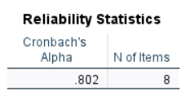

Appendix H
The Assumptions of the Two-Way Anova
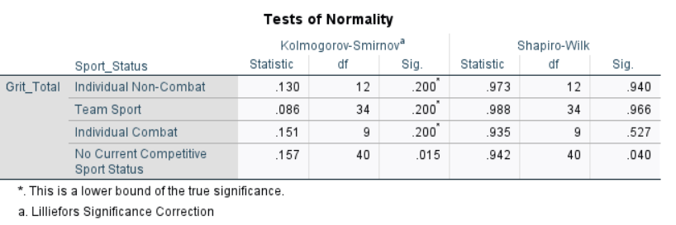
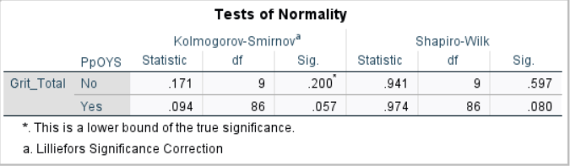
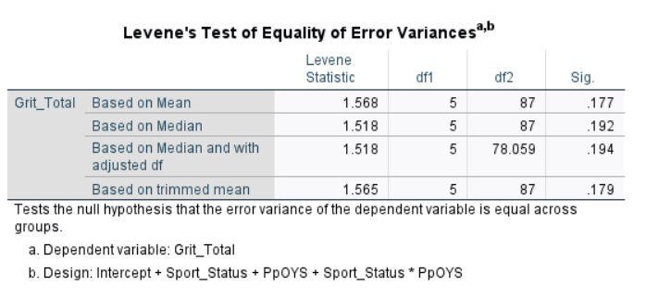

Appendix I
SPSS Output
