

Differences in Visual Attention and Recognition Accuracy Between Human and AI Faces

Evie Hannigan
N00220358

Research supervisors: Louise Horan Gahan + Eva Garcia-Albarran

Dissertation submitted as a requirement for the degree of BSc (Hons) in Applied Psychology, Dun Laoghaire Institute of Art, Design & Technology, 2026

Declaration

⊠ I, Evie Hannigan, hereby declare that the work that I have submitted for / contributed to the assessment specified above is entirely my own work. Where I have drawn from the work of others, including Generative AI systems, I have clearly indicated this within my submitted work. I recognise that Generative AI creations, no matter how small, may not be permissible within my submitted work and have checked this specific assessment brief for the admissible use of such software. I have read and complied with the IADT Academic Integrity Policy for this submission and recognise that breaches of this policy in my work may result in penalties, up to and including disqualification from IADT.
⊠ I, Evie Hannigan, hereby declare that I recognise that IADT staff may provide feedback on assessment via a range of methods, depending on the nature of the assessment and the preference of the staff member. I recognise that any grades issued by a lecturer are provisional but are not negotiable. Final grades will be issued following the relevant exam board meeting and information on appeals procedures is available on the IADT website. I agree to abide by the IADT Mutual Respect Policy in all of my communications with and regarding all IADT staff members.

Word count:5123

Signature:


Acknowledgments

I want to thank my supervisor, Louise Horan Gahan, first and foremost, for the amount of time she has put into supporting and advising me. I would also like to thank Eva Garcia-Albarran, even though she was only my supervisor for half a year, she was so helpful and kind. I would also like to thank the other IADT staff who helped make this experience manageable, Dr Christian Horen, who helped with statistics, and both Sean Henriques and Carmel Mueller in the psych lab studio. The help I received learning about the eye tracker will stay with me as a valuable asset for my future career. To thank all the participants who made this experiment possible, and finally to thank my friends and family who were with me for this whole experience, and are the only reason I've gotten this far, your encouragement and kindness have made this project possible.

Table of Contents

Declaration 2
Acknowledgments 3
Abstract 5
1. Introduction 6
1.2 Face Perception 6
1.3 Visual attention 7
1.4 The Impact of AI on Facial Processing 8
1.5 Interaction of Face Type and Emotion 9
1.6 Present Study 10
2. Methodology 12
2.1 Design 12
2.2 Participants 12
2.3 Materials 13
2.4 Procedure 14
3. Results 16
3.1 Overview 16
3.2 Analysis 1: Two-way Repeated-Measures ANOVA 16
3.3 Analysis 2: Paired Samples T-Test 18
3.4 Analysis 3: One-way repeated-measures ANOVA 19
4. Discussion 20
4.1 Overview 20
4.2 Theoretical and Practical implications of the findings 21
4.3 Strengths and Limitations of the Study 23
4.4 Future research 24
4.5 Conclusion 24
Reference 25
Appendices 31

Abstract

Generative AI modules continually aim to create increasingly hyperrealistic faces, creating a challenge for human detection ability. This eye-tracking experiment examined how face type (human and AI-generated) and emotion category (positive, negative, neutral) affect visual attention and recognition accuracy. A total of 33 participants were recruited via convenience sampling (27.3% male, 69.7% female, 3% gender diverse) with a mean age of 22.06 (SD = 1.69 ). Participants were presented with 12 facial images (including six AI and six human faces, comprising two of each emotion category). This study identified the eyes and mouth as diagnostic features for extracting social signals. Their combined fixation durations, captured by the eye-tracker, were used to measure cognitive load as participants extracted information about the facial images. The results from the 2x2 within-groups experiment (N=33) indicated no significant difference in fixation durations between face types. This result suggested indistinguishability between face types at a pre-attentive level. However, the emotion category significantly influenced gaze patterns as there were longer fixations on positive expressions. Furthermore, participants demonstrated higher recognition accuracy for human faces compared to AI-generated ones.
These findings indicate that while AI hyperrealism avoids early attentional mechanisms, it is still impaired by higher social cognitive pathways.

Keywords: Eye-tracking, AI-generated faces, Emotion recognition, Uncanny Valley, GAN-AI, Visual attention

Introduction

The current developments in Generative AI models represent a shift in the production of digital media. An example of a leading AI network is the Generative Adversarial Network (GAN), an artificial neural network comprising two networks that produce images, sounds and texts (Michelutti et al., 2024). The generator attempts to create a realistic data sample that will not be detected by the discriminator. While the discriminator tries to differentiate between the fake and real data samples (Al-Yaari & Deng, 2026). This system is known as the “zero-sum game”, and the use of this technique creates what humans observe as superficially authentic images and faces (Michelutti et al., 2024). GAN can be used to deceive the viewer into believing the synthetic faces are real. These are known as deepfakes. A key measure of the successful realism of deepfake faces is their ability to overcome ​the uncanny valley effect​ (Caci et al., 2024). The uncanny valley theory states that if an artificial entity has an almost human-like appearance or behaviours, it can inflict a feeling of unease and overall negative emotion for the onlooker (Lay et al., 2016). However, this theory only applies if humans are not able to differentiate ​between AI and real faces.​ When an AI face is not just indistinguishable from a human face but often perceived as more human, it’s referred to as hyperrealist (Nightingale & Farid, 2022). Due to the rise in AI hyperrealism, there is an increase in mistaken deception by AI faces, this poses risks for fraud, election tampering (Park et al., 2024), disinformation and blackmail (Mukta et al., 2023). This highlights ​the importance of​ further research in AI facial recognition. Using fixation duration as a marker of cognitive load, this paper will investigate how face type (human and AI-generated) and emotion category interact to influence visual attention and recognition accuracy.

1.2 Face Perception

The understanding of AI hyperrealism first requires an examination of the human baseline for facial processing. The human face relies on its sensitivity to the recognition of diagnostic features in facial stimuli to allow for quick identification during social interaction (Hadders-Algra, 2022). Scanning patterns found that during visual processing, the triangular area marked by the eyes and mouth was important for emotion recognition (Sheu et al., 2014). This study focuses exclusively on these Areas of Interest (AOIs) rather than the whole face to reduce the variability of stimuli and low-level feature noise (Alkan, 2025). While this focus provides methodological control, it is important to reason why these specific regions are chosen.
The exploration of emotion-specific diagnostic regions contributes to a more efficient and accurate recognition processing (Kim et al., 2022).
Research found that different emotions relied on different parts of the face. Positive emotions concentrated on the bottom half of the face, the mouth and nose, whereas negative emotions used facial cues from the top half of the face, the eyes and brows (Alkan, 2025). The reliability of these cues is further highlighted when observing disruptions; when these facial muscles are restricted, as seen in individuals with Botox, it was found to reduce emotion recognition to the eye region (Neal & Chartrand, 2011). This information is relevant to how small changes in facial cues can disrupt emotion decoding. However, it must be acknowledged that this embodied emotion theory is often criticised for its small effect sizes and the difficulty in replicating the specific dampening effect across different emotional categories. Nevertheless, this framework remains the most viable for this study as Gonzalez-Acosta et al. (2025) found that a focus on these landmarks aligns with biometric models that identify the eyes and mouth as the most critical points for AI emotion recognition systems.

1.3 Visual attention

Visual attention is a cognitive process that focuses on certain features of information while ignoring others, enabling efficient processing through active, selective awareness (Xu et al., 2023). Visual attention is commonly measured using eye-tracking metrics such as fixation duration (Negi & Mitra, 2020). The longer the fixation durations generally reflect an increased cognitive load, uncertainty, or difficulty in the brain when extracting information from a stimulus (Luo et al., 2025).
A limitation in visual attention research is the conflicting interpretation of fixation duration. The majority of research agrees with the cognitive load explanation (Liu et al., 2022; Luo et al., 2025; Sweller, 2011).
However, a user experience study suggested that longer fixations can also result from aesthetic engagement or emotional engagement (Sun & Jiang, 2025). Furthermore, Tal Nahari et al. (2024) argue that fixation length on familiar items may be longer due to a decrease in exploration rather than difficulty in processing. While Suslow et al. (2022) discussed how positive attentional bias occurs for long fixation durations, where humans focus longer on positive stimuli for social reward value.
These conflicting definitions affect how fixation duration is translated as a measure of cognitive difficulty.
Despite these contrasting views, the current study uses the cognitive load explanation. While aesthetic engagement is a relevant consideration, the greater volume of empirical research in facial recognition agrees with the processing difficulty model. Furthermore, this study is specifically investigating the indistinguishability and mistaken deception of AI hyperrealism. Fixation duration is viewed as a measure of the cognitive effort that is required to break down AI faces or emotional cues. By specifying this definition, this study can identify where AI-generated faces disrupt the standard human visual processing.

1.4 The Impact of AI on Facial Processing

A main objective of modern AI hyperrealism is to overcome the Uncanny Valley, meaning AI becomes so realistic that it is perceived as authentic rather than eerie (Caci et al., 2024). The Uncanny Valley theory states that beings that appear almost humanlike can cause psychological distress (Lay et al., 2016). Whether this distress occurs depends on the nature of face perception. Face perception requires a balance between bottom-up sensory input and top-down output (Ming et al., 2025). If GAN-generated input is advanced, it may mimic the brain’s internal face prototype so effectively that no uncanny valley effect occurs (Wallraven et al., 2005).
By eliminating the perceptual mismatch between realistic and unrealistic features, AI resolves the perceptual tension that typically triggers the uncanny valley (Kätsyri et al., 2015). Consequently, if AI successfully mimics human geometry, participants may exhibit similar initial behavioural responses to both human and synthetic faces. If AI hyperrealism successfully mimics human geometry, participants may exhibit similar behavioural responses to both human and computer-generated faces. However, recent studies suggest that highly humanlike AI faces can still disrupt visual attention if inhumane imperfections or unnatural boundaries between the features and skin are detected (Soker-Elimaliah et al., 2024). This study is further informed by neural research highlighting discrepancies between real and AI stimuli.
Despite the hyperrealism in the static AI images, neural markers have indicated that artificial expressions are processed differently from organic ones. Ziereis and Schacht (2024) found that emotional expression and image size modulate Event-Related Potential components, neural markers representing different stages of face processing, for real versus artificial faces. Specifically, deepfake smiles have been found to create lower emotional responses in early neural stages compared to genuine human smiles (Eiserbeck et al., 2023). However, negative emotions appear to be processed similarly regardless of the viewer's belief about the face's authenticity (Eiserbeck et al., 2023). These neural findings suggest that AI replicates the static facial shapes (Ekman, 2003), but it may fail to recreate the fluid muscle interactions that are necessary to signal true emotional intent. This research provides a strong rationale for exploring fixation duration as an indicator of the boundary between AI and Human faces.

1.5 Interaction of Face Type and Emotion

Participants' cognitive systems will recognise AI stimuli even if their eyes treat AI and human faces equally (Gerlich, 2025). The evidence for this is found in Nightingale and Farid (2022), who reported that human accuracy for AI faces was at a near-chance level of 48.2%. This percentage may be explained by the brain’s hierarchy shifts.
Vaitonytė et al. (2023) state that the cognitive system will avoid traditional social-emotional processing when processing AI faces.
Rather than activating the mentalising circuitry that is typical for human-to-human engagement, instead the brain shifts toward the ventromedial prefrontal cortex, treating the interaction as an abstract evaluative task rather than a social one. As a result, the eyes fixate on AOI to extract data, but the brain struggles to turn these AI signals into emotional categories. This recognition accuracy can differ depending on the emotion.
Research suggests that the human recognition of AI emotions is dependent on the type of expression. Pagán et al. (2025) found that the human recognition of AI emotions depended on the emotion expressed. Sadness had a high recognition accuracy of 87% and anger with 73%, but disgust had a low accuracy (14%). This change in recognition shows that AI might have trouble figuring out the exact emotions needed for accurate human recognition.

1.6 Present Study
The present study aims to explore differences in visual attention and recognition accuracy when viewing AI and human faces. Hyperrealistic AI faces can copy human facial geometry so precisely that they may avoid the uncanny valley effect. The faces often lead to a recognition deficit where humans struggle to differentiate between real and AI stimuli. This study aims to understand what drives this cognitive disconnect. Because human emotion recognition relies on the scanning of specific AOIs in the eyes and mouth, and any disruption in these fluid muscle interactions may impair the emotional interpretation. At the same time, fixation patterns show how people process these faces, with longer durations indicating the cognitive effort required to make out uncertainty features.
While previous literature has examined emotion recognition and visual attention in isolation, there is a clear gap in evidence regarding how gaze patterns directly contribute to the ability to recognise AI hyperrealism. Furthermore, this study includes multiple emotional categories (positive, negative, and neutral) to determine if these effects are universal because AI emotion expressions can differ a lot in their accuracy. This research aims to identify whether AI-generated faces disrupt human visual attention by combining eye-tracking with recognition accuracy.

Research Questions:
RQ1: Does the type of face (human vs AI-generated) change the visual attention in the AOI (eyes and mouth)?
RQ2: Does the specific emotion being shown (positive, negative, or neutral) change the visual attention in the AOI (eyes and mouth)?
RQ3: How do face type and emotional category interact to influence visual attention?
RQ4: Is there a difference in the recognition accuracy of emotions on human faces compared to AI-generated faces?
RQ5: Does the accuracy of identifying AI faces change depending on whether the expression is positive, negative, or neutral?

Hypotheses:
- Hypothesis 1: There will be a significant difference in fixation durations of facial features (eyes, mouth) based on face types viewed (AI-generated faces or human faces).
- Hypothesis 2: There will be a significant difference in fixation durations based on the emotion category viewed (positive, negative, or neutral).
- Hypothesis 3: There will be a significant interaction between face type and emotion category on fixation duration of facial features.
- Hypothesis 4: Participants will demonstrate a significantly higher recognition accuracy for human faces compared to AI-generated faces.
- Hypothesis 5: The recognition accuracy ratio for AI-generated faces will significantly vary depending on the emotional expression presented (positive/negative/neutral)

2. Methodology

2.1 Design

This study employed a quantitative, within-groups experimental design. The research used a 2x2 factorial design. Two independent variables were used in the study: face type (AI-generated and human) and emotion category (positive, negative, and neutral).
Two dependent variables were used to measure participant responses: recognition accuracy (ratio) and fixation duration (milliseconds) measured within a specific AOI.

2.2 Participants

Convenience sampling was used to recruit current students from Dún Laoghaire Institute of Art, Design and Technology (IADT). Potential participants were handed a sign-up sheet where they wrote their name and contact information, and were invited to choose a day and time that suited them. To find the sample size, a power analysis was conducted using G*Power. For a 2 x2 within-subjects ANOVA to detect a medium effect size (f = 0.3) with a power of 0.80 and an alpha of 0.05, a minimum sample size of 14 participants was required. A total of 34 participants were recruited for the current study. One participant was excluded from the final analysis due to incomplete responses on information forms, resulting in a final sample of 33. Of these participants, 27.3% identified as male, 69.7% as female, and 3% as gender diverse. Participants’ ages ranged from 19 to 27 years, with a mean age of 22.06 (SD = 1.69 ), and were recruited via convenience sampling at IADT.

Before research began, an amber ethics application was submitted to and granted by the Department of Technology and Psychology Ethics Committee at IADT. In accordance with the Psychological Society of Ireland (PSI, 2025), a declaration of the ethical standards that govern psychology.

2.3 Materials

The recruitment phase of the experiment used a physical sign-in sheet (Appendix A) split into five-minute experiment sessions. Participants provided their name and email address. The personal data was processed in accordance with GDPR.
The email sent to participants (Appendix B) contained the date and time the participant chose, brief information about the experiment, and directions to the experiment location. The instruction sheet (Appendix C) at the beginning of the eye-tracking experiment outlined how to begin the experiment and where to enter their unique identifier code. This code was used to maintain data anonymity while allowing the participants to withdraw their data until data analysis commenced. On the computer, an online information sheet using Microsoft Forms (Appendix D) was provided, detailing the study’s purpose, the possible benefits and disadvantages of the study, data protection, how the information will be used, and a thank you to the participants who took part. A consent form (Appendix E) was used to confirm participants had read and understood the information sheet, knew that participation was voluntary, and agreed to take part in the study, ensured they were over the age of 18, asked basic demographic questions and consented to them using the data. To link their responses across all the consent forms, information forms, and experiments, participants had to re-enter their unique identifier code on each form.
When preparing the data for analysis, each score was put into a binary scoring system. If the answer was correct, the classifications were coded as 1, and incorrect classifications as 0. Then these values were used to calculate the mean accuracy ratio, which represents the ratio of correct responses per condition. This made up the dependent variable for recognition accuracy The experimental apparatus consisted of a computer system with a Tobii Pro Spark (60 Hz) screen-based eye tracker. The computer had a keyboard and a mouse to move, click and control throughout the experiment.
Participants tested the calibration by following moving dots across the computer screen to confirm its gaze pattern accuracy. The computer then displayed instructions that key "A" should be used to display AI-generated faces and key "H" for human faces.
The stimulus set comprised 12 high-resolution facial images, categorised by face type and emotion category. Human stimuli were sourced from the Karolinska Directed Emotional Faces database (Lundqvist et al., 1998) (Appendix F).
AI-generated stimuli were from the Marsden et al. (2025) database (Appendix G), which used Generative Adversarial Networks (GANs) to produce facial expressions.
The 6 human and 6 AI faces displayed an equal distribution of positive, negative, and neutral expressions (i.e., two of each emotion category per face type condition). All images had a grey background and were cropped to include only the head and shoulders. The debriefing form on Microsoft Forms (Appendix H) was given immediately after the task. This provided the researcher's and supervisor's contact information in case they have questions or wish to dispose of their data. The participants' results were stored in the computer after they agreed to their results being used, and the data were later exported to Excel and SPSS.
The present study reported a Cronbach’s alpha at .776 (Appendix I). The data was cleaned in Excel by removing participants who didn’t finish the experiment or complete forms, as well as organising the layout so that it could be moved to SPSS.

2.4 Procedure

A pilot test was conducted (N=5), and changes were made to improve the clarity of the experiment instructions. The test took approximately four minutes to complete.
Participants were recruited via convenience sampling. The participants were approached on campus and asked to sign up for individual testing slots (Appendix A). Participants provided their name and email address and received a standardised email (Appendix B) 24 hours prior to their time slot.

For the experiment, participants were seated at a computer with a 60 Hz Tobii Pro Spark eye tracker. The seat was set at approximately 65 cm for reliable gaze measurements. Participants received verbal instructions and a physical instruction sheet (Appendix C). An eye-tracking calibration was performed before the experiment began. Participants followed a moving dot across the screen. If the calibration percentage was below 10%, the participant continued to the next stage. If it was above 10%, they repeated the calibration until the score was sufficient. Following the calibration, an on-screen information sheet was displayed detailing the study’s purpose and consent form. The participants had to re-enter their unique identifier code on the consent form.
After completing the information sheet (Appendix D) and consent form (Appendix E), the task began with an instruction slide. Participants were asked to press the ‘A’ key for AI-generated faces (Appendix G) and the ‘H’ key for human faces (Appendix F). Twelve images were presented individually (6 AI, 6 human), each expressing a different emotion (2 AI negative, 2 human negative, 2 AI neutral, etc.). Images were presented in a randomised order for each participant. No time limit was imposed on the decision-making process.
After the experiment was completed, a debriefing form (Appendix H) was displayed. Participants entered their identifier code a final time to ensure all data points (eye-tracking and survey responses) were correctly synchronised. Data collection took place for 4 weeks, concluding on 19th February 2026.

3. Results

3.1 Overview
The independent variables in this study were:
- Face type (AI/Human)
- Emotion recognition (Positive/Neutral/Negative)
The dependent variables present in this study were:
- Mean recognition accuracy
- Fixation duration of facial features (milliseconds)

Three statistical analyses were conducted using IBM SPSS Statistics Version 26: a repeated-measures 2x2 analysis of variance (ANOVA), a one-way repeated-measures ANOVA, and a paired-samples t-test, all with an alpha value of .05.

3.2 Analysis 1: Two-way Repeated-Measures ANOVA

Descriptive Statistics

The means, n values, and standard deviations for fixation durations across face types and emotions are presented in Table 1 below.
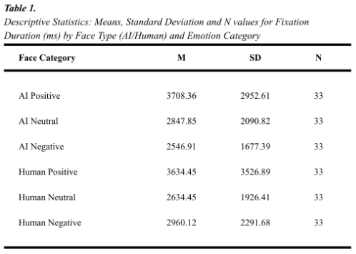

Inferential Statistics

A two-way repeated-measures ANOVA was conducted to evaluate the effects of face type and emotion category on fixation duration for facial features. Preliminary analyses were conducted to check the assumptions. Mauchly’s Test for sphericity indicated the assumption of sphericity was violated for the main effect of emotion, χ² (2) = 8.21, p = .017, and the interaction between face type and emotion, χ² (2) = 12.51, p = .002. Therefore, Greenhouse-Geisser corrections were applied. The assumption of normality was considered, with mild deviations being observed. The Two-way ANOVA remained appropriate, given that the sample size ( N = 33 ) was statistically robust to such violations.

Hypothesis 1, that there would be a difference in fixation duration based on face type viewed, was not supported. The results indicated no statistically significant main effect for face type on fixation duration, F ( 1,32 ) = .035, p = .854, observed power ( .054 ).

Hypothesis 2, that there would be a significant difference in fixation durations based on which emotion category was viewed, was supported. The analysis indicated a significant main effect for emotion category on fixation duration. F ( 1.62, 51.92 ) = 5.54, p = .010 with a strong effect size (partial eta squared = .148). Post hoc pairwise comparisons with Bonferroni correction indicated that fixation durations were significantly longer for positive emotions than for negative emotions (MD = 939.03, SE = 334.74, p =.025). No significant differences were found between positive and neutral emotions (p = .059) or between neutral and negative emotions ( p = 1.00 ).

Hypothesis 3, that there would be a significant interaction between face type and emotion category on fixation duration, was not supported. The results indicated that there was no significant interaction between face type and emotion category on fixation duration, F(1.5, 48.04) = .751, p = .442, observed power = .154.

Figure 1 displays the fixation duration for emotion category and face type in an interaction plot.
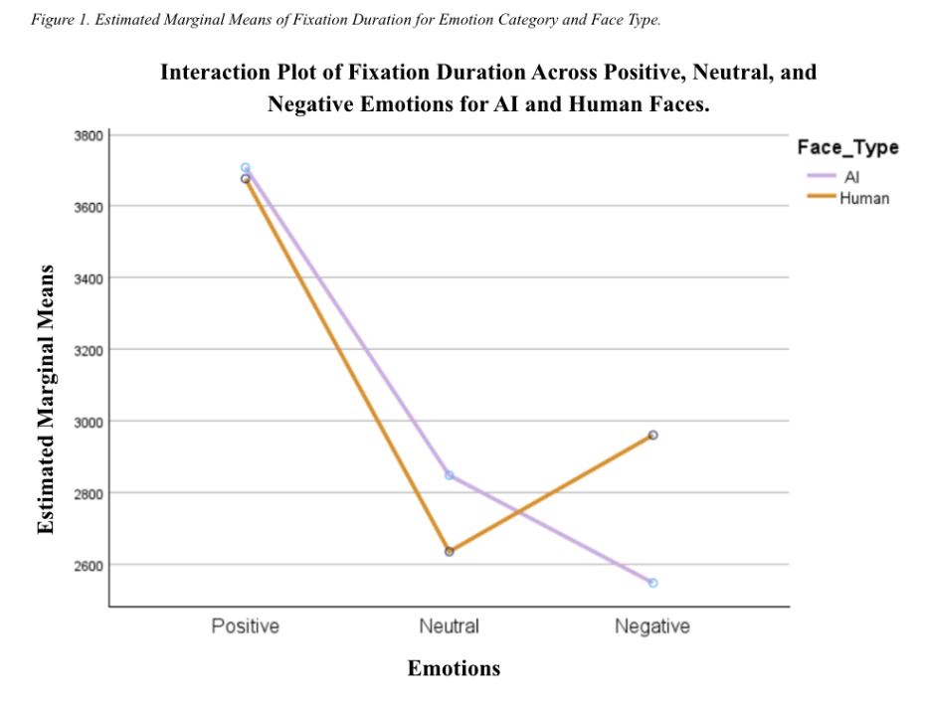

3.3 Analysis 2: Paired Samples T-Test

Inferential Statistics

A paired samples t-test was conducted to evaluate differences in recognition accuracy for human faces compared to AI-generated faces. Preliminary analyses were used to check the assumptions of the test, which indicated that normality was not violated. Hypothesis 4, that recognition accuracy for human faces would be higher than for AI-generated faces, was supported. Recognition accuracy was higher for human faces ( M =. 621 , SD = .229 ) compared to AI faces ( M = .409 , SD = .250 ), t ( 32 ) = 3.67 p < .001. The mean difference in facial accuracy between human and AI faces was .212, with a 95% confidence interval of .095 to .329. Cohen’s d indicated a medium to large effect size ( .640, CI [ .261 - 1.01 ]).

3.4 Analysis 3: One-way repeated-measures ANOVA

Descriptive Statistics

The means and standard deviations for mean AI face accuracy are displayed in Table 2 below.
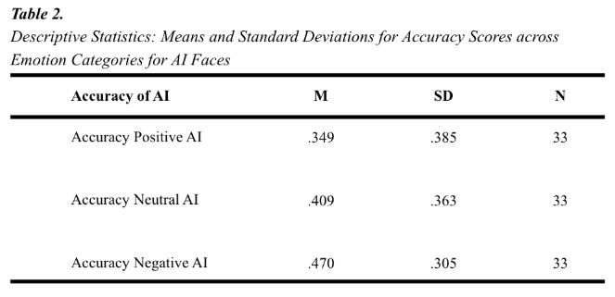

Inferential Statistics
A one-way repeated-measures ANOVA was conducted to evaluate how recognition accuracy would vary in AI faces depending on the emotional expression. The preliminary assumptions were tested, and mild deviations from normality were observed; the test remains robust given the sample size ( N = 33 ). Mauchly’s Test for sphericity was not violated.

Hypothesis 5, that recognition accuracy for AI-generated faces would differ depending on emotional expression, was not supported.
The results indicated no significant difference in recognition accuracy for AI-generated faces across emotional expressions, F ( 2, 64 ) = 1.31, p = .277, observed power ( .273 ).

4. Discussion

4.1 Overview

The aim of the present study was to investigate how face type (human/AI-generated) and emotional category (positive, negative, and neutral) interact to affect visual attention patterns and the accuracy of facial emotion recognition. The study identified two significant findings from the experiment: Hypotheses 2 and 5.

Hypothesis 1, that there would be a significant difference in overall fixation durations of facial features based on the face types viewed, was not supported. Nor was Hypothesis 3, that there would be a significant interaction between face type and emotion category on fixation duration. Results suggest recognition accuracy for AI faces does not significantly vary across the three emotional categories.

However, Hypothesis 2 was accepted, as there was a significant difference in fixation durations based on the emotion category viewed. Participants were fixating significantly longer on positive expressions than on negative ones. Hypothesis 4, that participants would demonstrate significantly higher recognition accuracy for human faces than for AI-generated faces, was not supported, as emotion recognition accuracy did not vary significantly across face types.

Finally, Hypothesis 5 was supported, and the results indicate that emotion recognition accuracy for AI-generated faces varies significantly by emotional expression. Participants demonstrated significantly higher emotion recognition accuracy for human faces compared to AI-generated faces.

4.2 Theoretical and Practical implications of the findings

The rejection of both hypotheses 1 and 3 suggests that the human visual system treats GAN-generated faces similarly to human faces at a pre-attentive level. The study found no significant difference in fixation duration. This lack of a significant difference in fixation duration suggests that newer AI hyperrealism may have avoided the immediate 'perceptual mismatch' that usually triggers the Uncanny Valley according to Kätsyri et al. (2015).
The eye-tracking data show that humans' early visual attention treats AI and human facial geometry as equal, but the lack of statistical significance in recognition accuracy suggests that this social processing is not certain. It is likely that AI replicates the static facial shape well enough to avoid early detection. However, it appears to fail in coping with the muscle interactions and micro cues that are important for humans to be able to achieve recognition of emotions accurately.

The support for Hypothesis 2 confirms that emotional categories are a primary motivator for attention, whether the face is human or AI-generated. Participants displayed significantly longer fixation durations for positive emotions compared to negative ones.
This study initially used the Cognitive Load Theory to interpret and explain that the length of fixation duration was due to processing difficulty (Tal Nahari et al., 2024). Later, it was found that the results were more closely related to the Positivity Attentional Bias (Suslow et al., 2022). This suggests that humans naturally focus on happy faces for their social reward value. Since this bias occurred for both human and AI faces, it suggests that GAN AI may have successfully figured out the human social reward systems, even when the human brain cannot accurately decode the specific emotion.

The acceptance of Hypothesis 4 shows that there is a difference in recognition accuracy of emotions on human faces compared to AI.
While participants' eyes may treat AI and human faces similarly for fixation duration. It is their cognitive systems that have a significant inability to recognise AI stimuli. The finding shows this gap in recognition, with emotion recognition accuracy for human faces outperforming accuracy for AI faces. This supports the findings of Nightingale and Farid (2022), who found that humans have a fault in detecting small differences in AI visuals reliably. The findings showed almost equal chances (48%) for participants to guess.
Sheu et al. (2014) describe how modern systems use triangular geometric deformation to copy human facial geometry. However, this process often requires additional correction points to prevent unnatural boundaries between AI features and the surrounding skin. If these corrections are not seamless, they may disrupt the processing for emotion recognition. While participants fixated on the AOI, their cognitive systems are simultaneously processing the entire facial structure. AI inconsistencies may unintentionally disrupt the integration that is required for accurate emotion recognition. AI often fails to copy the micro-cues and muscle interactions that are necessary to show emotional intent. (Ghafarfaraji, 2025) despite being able to identify the static facial shapes (Ekman, 2003).

The rejection of Hypothesis 5 suggests that this failure to recognise emotion in AI faces is the same across different emotion categories.These findings contradict previous work that found higher recognition accuracy for specific emotions, like sadness (Pagán et al., 2025). This contrast may occur due to the use of static images in this study, as they lack the proper micro-cues. The current study's results can also be explained by the Dual Process Theory. This is when humans experience the familiarity of the emotion without the recollection that is necessary for understanding the emotion (Xiao & Nie, 2023).
The present study’s findings have both theoretical and practical implications. The findings add to existing research on visual attention and AI. They provide further understanding of the interaction between visual attention patterns and the accuracy of facial emotion recognition across face types and emotion categories. The results challenge traditional theories, such as the Uncanny Valley theory, that suggest that hyperrealism can trick our visual attention systems even when our cognitive recognition systems don't believe it.
In practice, the fact that humans fixate on AI faces like they were human shows the risks of AI deception. If humans treat deepfakes with the same social attention as real people, it may make people more susceptible to the deception that fuels fraud and disinformation (Park et al., 2024). Hence, solutions like transparency laws and further research into detection are necessary to make sure that AI acts as a beneficial technology.

4.3 Strengths and Limitations of the Study

A main strength of this study was its empirical design, which used the biometric eye tracker to collect data. This eye-tracking technology allowed the study to go past the passive viewing found in previous research. By isolating specific areas of AOIs, such as the eyes and mouth, the study controlled for stimulus variability and low-level feature noise. The experimental design allowed for control over variables and how they enhance the validity/reliability of the findings.

However, a limitation of the study may be the use of AI-generated images. The images were static, and research found that deepfake smiles are processed differently in a dynamic context (Eiserbeck et al., 2023). This research implies that static images may not trigger the Uncanny Valley effect to the same extent as dynamic clips, the findings may not be generalisable to other media types. The Lab experiments may also lack ecological validity. The experiment asked participants to specifically focus on and identify the faces they were shown, and this may not be applicable to real-world settings with lots of other variables in the mix. For example, while processing other visual input (e.g., social media feed).

4.4 Future research

Future studies should investigate the role of micro-expressions by using video stimuli as well as static images. This may help researchers understand whether the recognition gap narrows or widens when temporal cues are present. Additionally, adding a physiological measure (pupil dilation) could provide insights into subconscious cognitive distress or emotional arousal, which may provide further understanding of subconscious cognitive distress or emotional arousal.
Future researchers should also aim to increase the sample size to increase the validity and generalisability of findings.
Additionally, A lot of current research relies on convenience sampling of students or young populations; there is a significant gap in the literature on how these findings generalise across different age groups.
Future studies should try to obtain a wider range of participants. Specifically, older adults whose familiarity and ability to use technology may differ, giving more accurate results.

4.5 Conclusion

This study investigated the complex relationship between visual attention and recognition accuracy in human and AI-generated facial expressions. The rejection of Hypotheses 1 and 3 and the support for Hypothesis 2 showed that humans' pre-attentive visual systems treat AI and human facial geometry as very similar. However, the recognition detection issue in AI faces shows that higher-order social cognitive pathways are not easily deceived. This failure is attributed to the AI's inability to replicate fluid muscle interactions and micro-cues.
These results highlight the risks of AI deception worldwide. Because humans fixate on deepfakes with the same social attention as real people, individuals are highly susceptible to mistaken deception. Future research must solve current literature gaps by moving toward dynamic video stimuli. Ultimately, while AI is mastering the static human face, it has yet to replicate the authentic human connection seen in videos.

Reference

Al-Yaari, A., & Deng, Y. (2026). Generative adversarial networks: A comprehensive survey. Systems and Soft Computing, 8, 200460. https://doi.org/10.1016/j.sasc.2026.200460

​​Alkan, N. (2025). Recognition and Misclassification Patterns of Basic​ ​Emotional Facial Expressions: An Eye-Tracking Study in Young Healthy​ ​Adults​. ​Journal of Eye Movement Research, 18(5), 53–53​. https://doi.org/10.3390/jemr18050053

Caci, B., Giordano, G., Alesi, M., Gentile, A., Agnello, C., Presti, L. L., Cascia, M. L., Ingoglia, S., Cristiano Inguglia, Volpes, A., & Monzani, D. (2024). The public mental representations of deepfake technology: An in-depth qualitative exploration through Quora text data analysis. PLoS ONE, 19(12), e0313605–e0313605. https://doi.org/10.1371/journal.pone.0313605

​​Eiserbeck, A., Maier, M., Baum, J., & Rahman, R​. A. (2023). Deepfake ​smiles matter less - the psychological and neural impact of presumed AI-​​generated faces. Scientific Reports, 13. https://doi.org/10.1038/s41598-​​023-42802-x​

​​Ekman, P​. (​2003). Emotions revealed: Recognizing faces and feelings to​ improve ​communication and emotional life. Times Books/Henry Holt​ and Co.

Gerlich, M. (2025). AI Tools in Society: Impacts on Cognitive Offloading and the Future of Critical Thinking. Societies, 15(1), 6. https://doi.org/10.3390/soc15010006

Gonzalez-Acosta AMS, Vargas-Treviño M, Batres-Mendoza P, Guerra-Hernandez EI, Gutierrez-Gutierrez J, Cano-Perez JL, Solis-Arrazola MA and Rostro-Gonzalez H (2025) The first look: a biometric analysis of emotion recognition using key facial features. Front. Comput. Sci. 7:1554320. doi: 10.3389/fcomp.2025.1554320

​​Hadders-Algra, M. (2022). Human face and gaze perception is highly​ ​context specific and involves bottom-up and top-down neural processing.​ ​Neuroscience & Biobehavioral Reviews, 132(132), 304–323. https://doi.org/10.1016/j.neubiorev.2021.11.042

Ince, S., Steward, T., Harrison, B. J., Jamieson, A. J., Davey, C. G., Agathos, J. A., Moffat, B. A., Glarin, R. K., & Felmingham, K. L. (2023). Subcortical contributions to salience network functioning during negative emotional processing. NeuroImage, 270, 119964–119964. https://doi.org/10.1016/j.neuroimage.2023.119964

Kätsyri, J., Förger, K., Mäkäräinen, M., & Takala, T. (2015). A Review of Empirical Evidence on Different Uncanny Valley Hypotheses: Support for Perceptual Mismatch as One Road to the Valley of Eeriness. Frontiers in Psychology, 6(1). https://doi.org/10.3389/fpsyg.2015.00390

Kim, M., Cho, Y., & Kim, S.-Y. (2022). Effects of diagnostic regions on facial emotion recognition: The moving window technique. Frontiers in Psychology, 13. https://doi.org/10.3389/fpsyg.2022.966623

​​Lay, S., Brace, N., Pike, G., & Pollick, F. (2016). Circling Around the​ ​Uncanny Valley: Design Principles for Research Into the Relation Between​ ​Human Likeness and Eeriness. I-Perception, 7(6), 204166951668130.​ ​https://doi.org/10.1177/2041669516681309​

Liu, J.-C., Li, K.-A., Yeh, S.-L., & Chien, S.-Y. (2022). Assessing Perceptual Load and Cognitive Load by Fixation-Related Information of Eye Movements. Sensors, 22(3), 1187. https://doi.org/10.3390/s22031187

​​LoBue, V., & Ogren, M. (2021). How the Emotional Environment Shapes the​ ​Emotional Life of the Child. Policy Insights from the Behavioral and​ ​Brain Sciences, 9(1), 237273222110672​. https://doi.org/10.1177/23727322211067264

Lockhofen, D. E. L., & Mulert, C. (2021). Neurochemistry of Visual Attention. Frontiers in Neuroscience, 15. https://doi.org/10.3389/fnins.2021.643597

Lundqvist, D., Flykt, A., & Öhman, A. (1998). The Karolinska Directed Emotional Faces - KDEF, CD ROM from Department of Clinical Neuroscience, Psychology section, Karolinska Institutet, ISBN 91-630-7164-9

​​Luo, Y., Seo, J., & Hasanzadeh, S. (2025). Understanding Hazard​ ​Recognition Behavior Using Eye-tracking Metrics in a VR-Simulated​ ​Environment: Learning from Successful and Failed Conditions. KSCE Journal​ ​of Civil Engineering, 100173. https://doi.org/10.1016/j.kscej.2025.100173​

​​Michelutti, L., Tel, A., Zeppieri, M., Ius, T., Agosti, E., Sembronio,​ ​S., & Robiony, M. (2024). Generative Adversarial Networks (GANs) in the​ ​Field of Head and Neck Surgery: Current Evidence and Prospects for the​ ​Future—A Systematic Review. Journal of Clinical Medicine, 13(12), 3556.​ ​https://doi.org/10.3390/jcm13123556​

​​Miller, E. J., Foo, Y. Z., Mewton, P., & Dawel, A. (2023). How do people​ ​respond to computer-generated versus human faces? A systematic review and​ ​meta-analyses. Computers in Human Behavior Reports, 10, 100283.​ ​https://doi.org/10.1016/j.chbr.2023.100283​

Ming, X., Huang, G., Liao, M., Jiang, P., & Liu, L. (2025). Psychophysical assessment of face perception deficits in adults with amblyopia through top-down and bottom-up visual processing pathways. Frontiers in Neuroscience, 19. https://doi.org/10.3389/fnins.2025.1548243

​​Moshel, M. L., Robinson, A. K., Carlson, T. A., & Grootswagers, T.​ ​(2022). Are you for real? Decoding realistic AI-generated faces from​ ​neural activity. Vision Research, 199, 108079.​ ​https://doi.org/10.1016/j.visres.2022.108079​

​​Mukta, M. S. H., Ahmad, J., Raiaan, M. A. K., Islam, S., Azam, S., Ali,​ ​M. E., & Jonkman, M. (2023). An Investigation of the Effectiveness of​ ​Deepfake Models and Tools. Journal of Sensor and Actuator Networks,​ ​12(4), 61. https://doi.org/10.3390/jsan12040061​

Neal, D. ​T., & Chartrand, T. L. (2011). Embodied Emotion Perception:​ ​Amplifying and Dampening Facial Feedback Modulates Emotion Perception​ ​Accuracy. Social Psychological and Personality Science, 2(6), 673–678​. https://doi.org/10.1177/1948550611406138

​​Negi, S., & Mitra, R. (2020). Fixation duration and the learning process:​ ​an eye tracking study with subtitled videos. Journal of Eye Movement​ ​Research, 13(6). https://doi.org/10.16910/jemr.13.6.1​

​​Nightingale, S. J., & Farid, H. (2022). AI-synthesized faces are​ ​indistinguishable from real faces and more trustworthy. Proceedings of​ ​the National Academy of Sciences, 119(8).​ ​https://doi.org/10.1073/pnas.2120481119​

Pagán, A., Loveland, K. A., & Acierno, R. (​2025). Evaluating the​ ​emotional accuracy of AI-generated facial expressions in neurotypical​ ​individuals. Discover Computing, 28(1). https://doi.org/10.1007/s10791-​​025-09630-1​

​​Park, P. S., Goldstein, S., O’Gara, A., Chen, M., & Hendrycks, D. (2024).​ ​AI deception: a Survey of examples, risks, and Potential Solutions.​ ​Patterns, 5(5). https://doi.org/10.1016/j.patter.2024.100988​

​​Sheu, J.-S., Hsieh, T.-S., & Shou, H.-N. (2014). Automatic Generation of​ ​Facial Expression Using Triangular Geometric Deformation. Journal of​ ​Applied Research and Technology, 12(6), 1115–1130.​ ​https://doi.org/10.1016/s1665-6423(14)71671-2​

​​Soker-Elimaliah, S., Rajpersaud, A., Bragerton-Nasert, S., Soker, D., &​ ​Wagner, J. B. (2024). Visual Attention and Cardiac Response to Faces in​ ​Relation to Emotion Recognition. Journal of Psychophysiology, 38(3), 147–​​160. https://doi.org/10.1027/0269-8803/a000336​

​​Sun, N., & Jiang, Y. (2025). Eye movements and user emotional experience:​ ​a study in interface design. Frontiers in Psychology, 16.​ ​https://doi.org/10.3389/fpsyg.2025.1455177​

Suslow, T., Hoepfel, D., Günther, V., Kersting, A., & Bodenschatz, C. M. (2022). Positive attentional bias mediates the relationship between trait emotional intelligence and trait affect. Scientific Reports, 12(1). https://doi.org/10.1038/s41598-022-25317-9

Sweller, J. (2011). Cognitive Load Theory. Psychology of Learning and Motivation, 55(1), 37–76. https://doi.org/10.1016/B978-0-12-387691-1.00002-8

​​Tal Nahari, Eran Eldar, & Yoni Pertzov. (2024). Fixation durations on familiar items are longer due to attenuation of exploration. Cognitive Research Principles and Implications, 9(1). https://doi.org/10.1186/s41235-024-00602-5

Vaitonytė, J., Alimardani, M., & Louwerse, M. M. (2023). Scoping review of the neural evidence on the uncanny valley. Computers in Human Behavior Reports, 9, 100263. https://doi.org/10.1016/j.chbr.2022.100263

Wallraven, C., Schwaninger, A., & BÜlthoff, H. H. (2005). Learning from humans: Computational modeling of face recognition. Network: Computation in Neural Systems, 16(4), 401–418. https://doi.org/10.1080/09548980500508844

Xiao, Y., & Nie, A. (2023). Does Expecting Matter? The Impact of Experimentally Established Expectations on Subsequent Memory Retrieval of Emotional Words. Journal of Intelligence, 11(7), 130–130. https://doi.org/10.3390/jintelligence11070130

Xu, Q., Liu, Q., & Ye, C. (2023). Editorial: Cognitive mechanisms of visual attention, working memory, emotion, and their interactions. Frontiers in Neuroscience, 17. https://doi.org/10.3389/fnins.2023.1259002

Ziereis, A., & Schacht, A. (2024). Additive effects of emotional expression and stimulus size on the perception of genuine and artificial facial expressions: an ERP study. Scientific Reports, 14(1). https://doi.org/10.1038/s41598-024-55678-2

Appendices

Appendix A – Sign up sheet


Appendix B – Email to participants

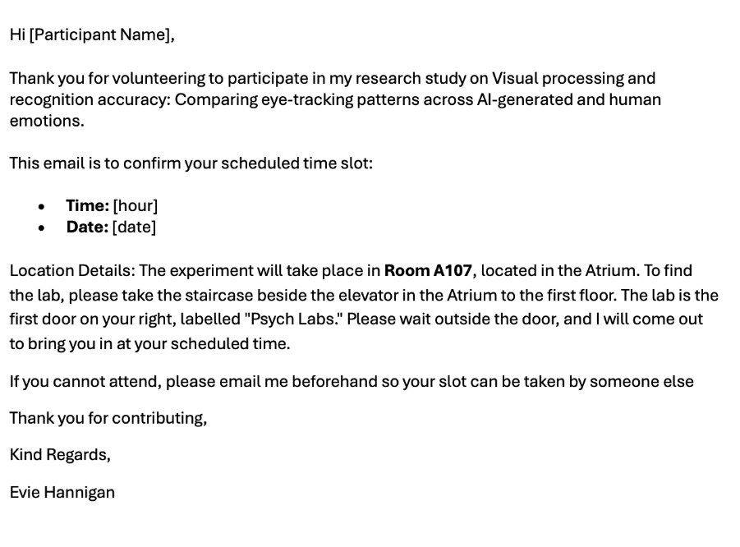

Appendix C – Instruction Sheet
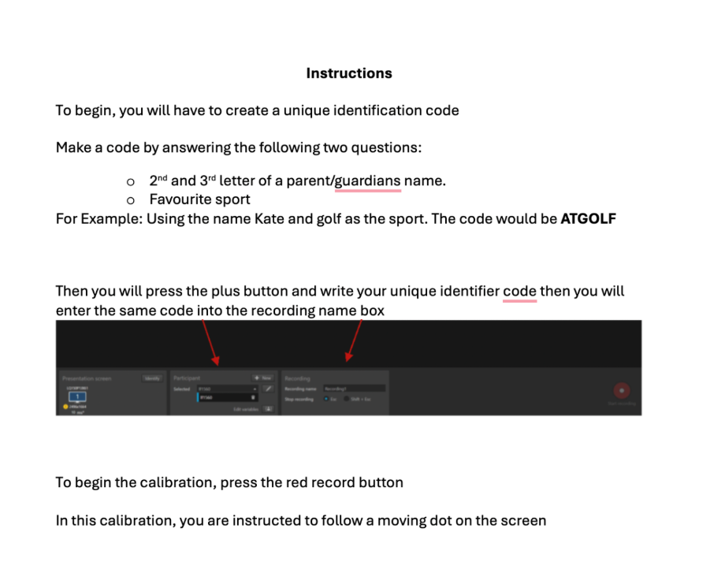

Appendix D -Information sheet and Demographic Questions




Appendix E- Consent form




Appendix F – Human dataset

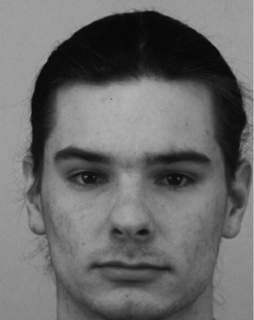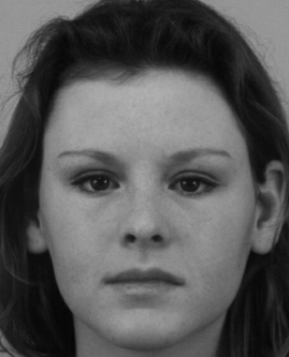
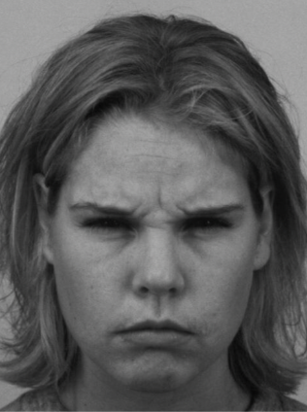


Appendix G – AI dataset

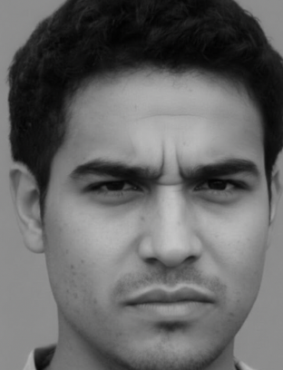
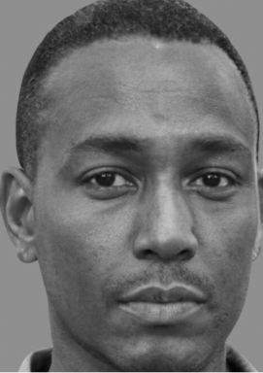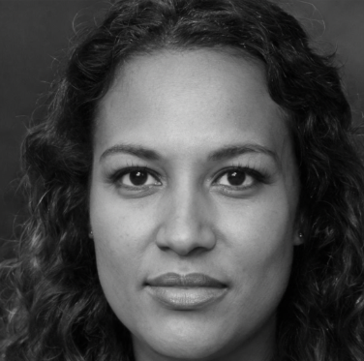


Appendix H- Debrief form

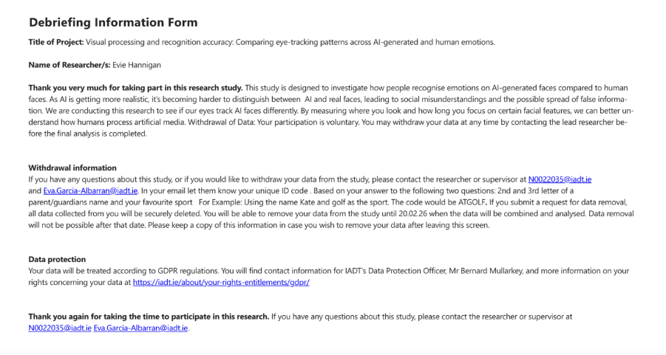

Appendix I- Cronbach's alpha
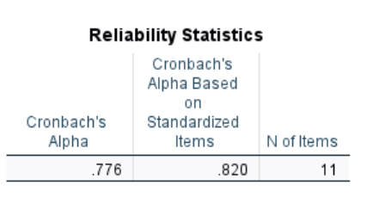

Appendix J – Two-Way Repeated-Measures ANOVA - Test for Sphericity
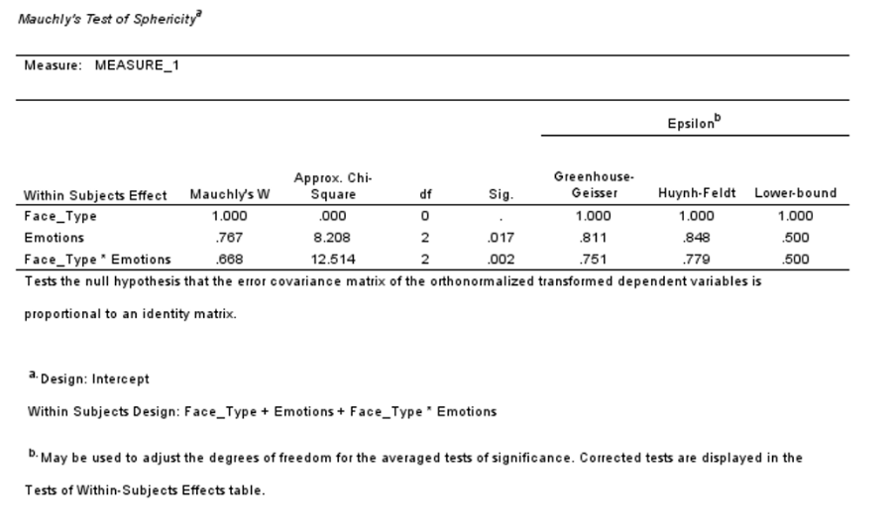

Appendix K – Two-Way Repeated-Measures ANOVA - Test of Within-Subjects Effects

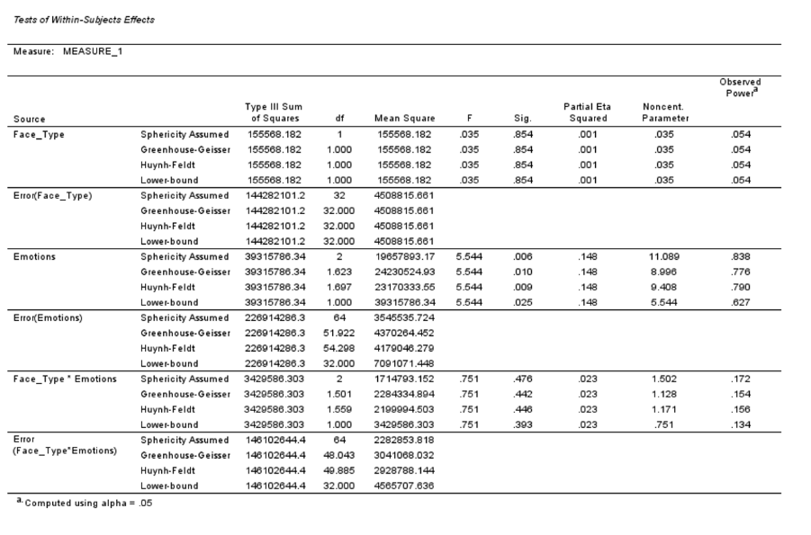

Appendix L – Two-Way Repeated-Measures ANOVA – Bonferroni Post Hoc Test

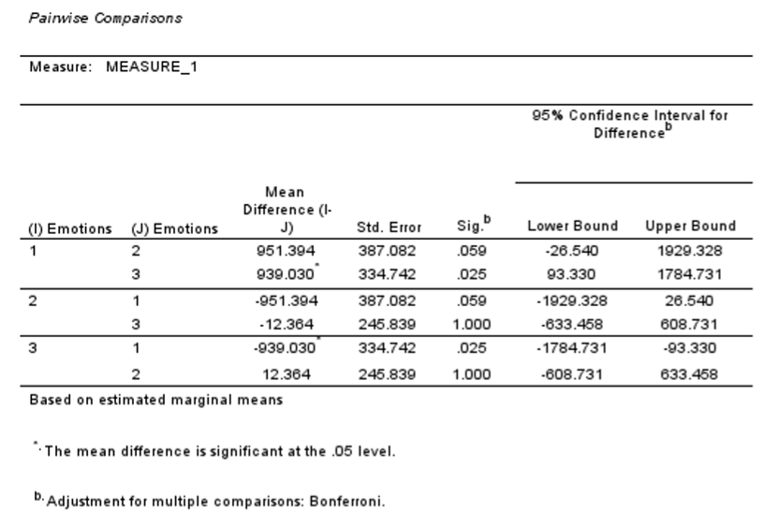

Appendix M – One-Way Repeated-Measures ANOVA - Test of Within-Subjects Effects

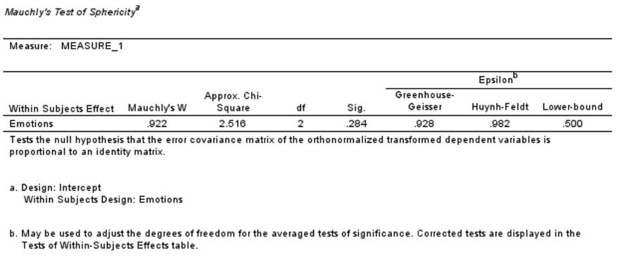

Appendix N – One-Way Repeated-Measures ANOVA - Test of Within-Subjects Effects

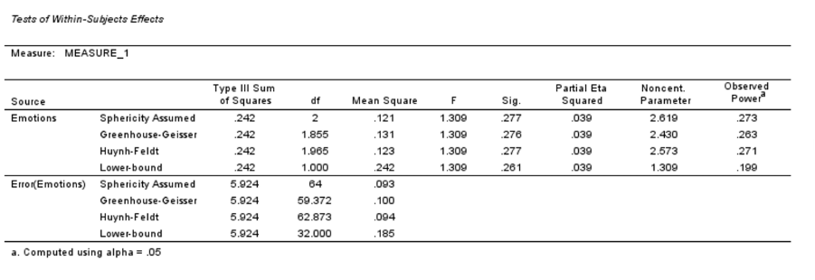

Appendix O – Paired Sample T-Test

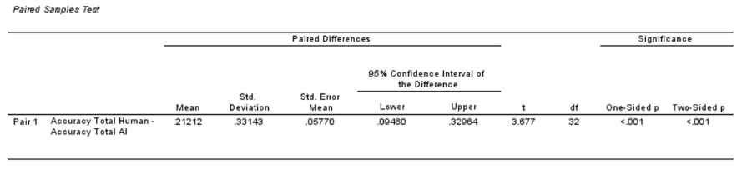

Appendix P – Paired Sample T-Test - Correlation

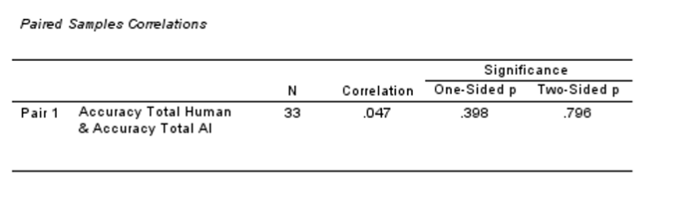

Appendix Q– Paired Sample T-Test – Effect size

