Identification with the Dimensions of Emerging Adulthood as a predictor for Cognitive Flexibility with respect to Age.

Emma N. Doolan
Student Number: N00220012
Supervisor: Dr Irene Connolly

DL825: Applied Psychology
Dissertation submitted as requirement for the degree of BSc (Hons) in Applied Psychology, Dun Laoghaire Institute of Art, Design & Technology, 2026

Declaration
I, Emma Doolan, hereby declare that the work that I have submitted for / contributed to the assessment specified above is entirely my own work. Where I have drawn from the work of others, including Generative AI systems, I have clearly indicated this within my submitted work. I recognise that Generative AI creations, no matter how small, may not be permissible within my submitted work and have checked this specific assessment brief for the admissible use of such software. I have read and complied with the IADT Academic Integrity Policy for this submission and recognise that breaches of this policy in my work may result in penalties, up to and including disqualification from IADT.
I, Emma Doolan, hereby declare that I recognise that IADT staff may provide feedback on assessment via a range of methods, depending on the nature of the assessment and the preference of the staff member. I recognise that any grades issued by a lecturer are provisional but are not negotiable. Final grades will be issued following the relevant exam board meeting and information on appeals procedures is available on the IADT website. I agree to abide by the IADT Mutual Respect Policy in all of my communications with and regarding all IADT staff members.

Date: 30th of March 2026

Word Count: 4,995

Acknowledgements
I would like to extend my sincerest gratitude to my supervisor, Dr Irene Connolly, for her continuous support and guidance that reassured me greatly throughout the development of this dissertation. Her insight and encouragement were a significant contribution, to which I am very thankful for.
I wish to thank Dr Christine Horn and Cyril Connolly for their expertise and support in the statistical design and analysis portion of this project. I would also like to acknowledge Fred Walsh for creating a motivating space and extending additional support making the process far more enjoyable.
My sincere thanks to all the staff in the Psychology Department in IADT and other groups outside of the Applied Psychology course, for their unwavering support and assistance making this project possible for myself and other students. Their passion and ability to create an inspiring environment truly has made this experience an honor and a pleasure. With that, I would like to thank all the participants who took the time to participate in my project, many of whom were IADT students, I’m extremely grateful.
I would like to extend my special to thanks to my friends and family, whose support, encouragement and understanding has been a pillar to the completion of this work. I owe my deepest thanks to my mother, Brenda, whose love patience and constant support have carried me through every challenge along the way. She has been my greatest supporter and my greatest inspiration, and this accomplishment is as much hers as it is mine.

Table of Contents
Abstract 1
Introduction 2
Emerging Adulthood 2
The Defining Dimensions of Emerging Adulthood 2
The Role of Age in Emerging Adulthood 4
Cognitive Flexibility 4
Developmental Neural Basis of Cognitive Flexibility 4
Cognitive Flexibility in Emerging Adulthood 5
The Present Study 6
Research Question 6
Methodology 7
Design 7
Participants 7
Materials 9
The Inventory of the Dimensions of Emerging Adulthood (IDEA) Scale 9
The Cognitive Flexibility Scale 9
Procedure 10
Data Analysis 10
Results 11
Overview of Results 11
Descriptive Statistics 11
Inferential Statistics 11
Regression Assumptions 13
Multiple Regression Analyses 14
Regression Model 1: Identification with Dimensions of Emerging Adulthood 14
Regression Model 2: Emerging Adulthood Subscales 14
Summary of Results 15
References 21
Appendices 25
Appendix A: Ethical Approval Email from the IADT Psychology Ethics Committee 25
Appendix B: Information Sheet 26
Appendix C: Consent Form 29
Appendix E: The Inventory of Dimensions of Emerging Adulthood 31
Appendix F: Adjusted Inventory of the Dimensions of Emerging Adulthood Reliability Analysis 34
Appendix G: The Cognitive Flexibility Scale 36
Appendix H: Confirmation of Consent for Data Use 38
Appendix I: Debriefing Information Form 38
Appendix J: LinkedIn Post for Participant Recruitment 40
Appendix K: Participant Recruitment Flyer 41
Appendix L: Assumption SPSS Output for Regression 1 42
Appendix M: Assumption SPSS Output for Multiple Regression 2 47
Appendix O: Regression 2 SPSS Output 54

List of Tables

Table 1: Descriptive Statistics 11
Table 2: Correlations among Age, Identity Exploration, Experimentation and Possibilities, Self-Focus, Feeling “In-Between” and Cognitive Flexibility. 13
Table 3: Multiple Regression Predicting Cognitive Flexibility from Identification with the Dimensions of Emerging Adulthood and Age. 14

List of Figures

Figure 1: Participant Age Distribution 8
Figure 2: Participant Gender Distribution 8
Figure 3: Scatterplot showing the linear positive correlation between Cognitive Flexibility and Identification with the dimensions of Emerging Adulthood. 12

List of Abbreviations
EA – Emerging Adulthood
CF – Cognitive Flexibility
IDEA – Inventory of the Dimensions of Emerging Adulthood
CFS – Cognitive Flexibility Scale

Abstract
Emerging adulthood is characterised by identity exploration, experimentation, and increased autonomy; however, the cognitive processes supporting successful navigation of this developmental stage remain underexplored. The present study examined whether identification with the dimensions of emerging adulthood predicts cognitive flexibility while controlling for age. A cross-sectional design was employed with a sample of 122 participants. Participants were recruited via convenience sampling and completed self-report measures, including the Inventory of the Dimensions of Emerging Adulthood and the Cognitive Flexibility Scale. Correlational analyses revealed significant positive associations between cognitive flexibility and identification with the dimensions of emerging adulthood. A multiple regression analysis indicated that identification with emerging adulthood significantly predicted cognitive flexibility, even when controlling for age, which was not a significant predictor. A second regression model including individual subdimensions was significant overall; however, no single dimension uniquely predicted cognitive flexibility. The findings suggest that the broader experience of emerging adulthood, rather than specific dimensions or chronological age, is associated with greater cognitive flexibility. The study contributes to emerging adulthood theory by highlighting cognitive flexibility as a potential cognitive mechanism supporting adaptive functioning during this developmental stage. Limitations and directions for future research are discussed.

Introduction

Emerging Adulthood
Emerging Adulthood (EA), originally proposed by Arnett (2000), developmental stage typically spanning between ages 18-29 years. The original age inclusion criteria set by Arnett defined EA as occurring between ages 18 and 25, which were later extended to 29 years to reflect current demographic changes, including prolonged participation in third-level education, residence in the parental home, and the postponement of marriage and parenthood (Arnett et al., 2014). This stage emerged as a response to cultural and societal changes, in particular changes in educational trajectories, employment patterns, romantic relationships, and the navigation of self and worldview (Arnett, 2024). EA is comprised several defining characteristics, such as experimentation and possibilities, self-focus, feeling in-between, with identity exploration considered the central feature. Negativity/instability is also identified as a core feature; however, it will be excluded from the scope of this study due to ethical considerations. Developed employing a mixed-methodological approach including surveys and interviews, Arnett (2024), offers a rich and multifaceted understanding of developmental processes that occur during this period. However, as a largely descriptive and conceptual framework, the theory does not establish causal or structural factors and is limited in generalisability due to the predominance of the western populations examined. Despite these limitations, Arnett’s work has been highly influential in reframing the transition to adulthood as a prolonged and distinct developmental period.

The Defining Dimensions of Emerging Adulthood
Identity exploration refers to the evaluation of a person’s different roles, values with increased autonomy, relationships and career paths to form a coherent sense of self. Derived from Erikson’s (1968) stage of Identity vs. Role confusion, Arnett proposed that the transition to adulthood has evolved to occur later due to industrialisation in Western countries, due to the increased need for education, labour market instability (Bynner, 2005), and delayed role commitments.
Intertwined with identity exploration is the subdimension of experimentation and possibilities, which refers to the behavioural expression of exploration through concrete actions. While identity exploration represents a cognitive and psychological process, experimentation reflects observable trial-and-error behaviours, such as engaging in new roles, relationships, lifestyles or worldviews. This distinction clarifies identity exploration as a developmental, psychological and cognitive process, and experimentation is behavioural and situational (Luyckx et al., 2023). Experimentation does not always lead to changes in identity and is not always required for exploration. In effect, these processes are both essential but are analytically separable components of EA that contribute differently to identity formation (Schwartz et al., 2021).
As this newfound independence necessitates increased cognitive and evaluative processing, another core dimension at play within EA is self-focus. Arising from increased independence alongside the absence of enduring significant adult responsibilities such as marriage, parenthood or long-term career commitments, this phase allows for the priority of personal development. This self-focus is viewed as developmentally appropriate and opposed to selfishness, allowing emerging adults to engage in identity exploration and experimentation of possibilities (Arnett, 2024). Thus, reflecting a temporary window of autonomy between the constraints of adolescence and obligations of full adulthood.
This transitional period and ambiguous development of the fully formed self-concept is defined as the subjective feeling of being ‘in-between’, that is not an adolescent but not yet fully adult. Arnett’s research shows emerging adults frequently report feeling ‘almost’ adult due to increased autonomy, such as independent decision making and partial or full financial responsibility yet have not fully achieved the traditional markers of adulthood, including stable careers, long-term partnerships or complete economic independence. This reflects the broader cultural shift toward delayed transitions in education, work and family formation, and as a result represents a liminal developmental state that distinguishes emerging adulthood from both adolescence and young adulthood as a gradual process rather than a discrete milestone (Wood et al., 2017).
Although this theory has been discussed as being western-centric (Hendry & Kloep, 2010), the participants targeted for this study reside in the industrialised society of Ireland. Arnett discusses the focus on industrialised countries being a causal factor for this developmental period and does state this theory is not applicable to all cultures. A further critique and limitation in applying this theory is its lack of accounting for the control of the variable of socioeconomic status and other cultural influences (Côté, 2014). Furthermore, this assumption of homogeneous experience overlooks gender, ethnicity, migration status, as well as disability; certain minority groups may navigate transitions and responsibilities differently (Bynner, 2005). However, this study aims to focus on the role of cognitive processes and developmental factors rather than psychosocial correlates (Reifman & Niehuis, 2023).

The Role of Age in Emerging Adulthood
While there are a myriad of conditioning factors influencing EA, age is seen as a principal moderating factor (Nice et al., 2023) which emphasises the notable decrease seen in dimension identification at the beginning and end of EA. Using survey design, Arnett and Mitra (2020) measured the items of EA to determine if they were developmentally distinctive by comparing individuals between the ages of 18-60 years. While a segment of adults in the older ages groups did agree with some elements in EA, except feeling ‘in-between’, the results present reassurance that these features typically appear among the ages 18-25 years. This finding although supporting the original theory creates questions that warrant further investigation such as what is predictive role that age plays in the specific dimensions of EA.

Cognitive Flexibility
While EA encompasses a variety of psychological transitions and demands, biological developments such as cognitive flexibility (CF) may support these developmental processes. One key developmental feature of this period is the continued maturation of the prefrontal cortex into the mid-twenties, which is strongly associated with CF (Kupis & Uddin, 2023; Luna et al., 2015). CF is a core component of executive functioning (Cristofori et al., 2019) and refers to the capacity to adapt one’s thinking in response to changing demands and task-switching (Martin & Rubin, 1995). This enables an individual to mentally shift to consider alternative strategies and modify approaches when current ones prove ineffective.

Developmental Neural Basis of Cognitive Flexibility
Although, Kupis and Uddin (2023) noted the challenging nature of assessing CF through neuroimaging, they noted that varying cognitive flexibility tasks activate distinct neural regions depending on task complexity. Additionally, Hohl and Dolcos (2024) emphasise the inconsistent definition and assessment of cognitive flexibility, reflecting the need for further empirical clarity. However, across the literature, the prefrontal cortical regions and networks, particularly the dorsolateral prefrontal cortex, orbitofrontal cortex, anterior cingulate cortex and frontoparietal network are consistently identified as central supports for CF development (Cristofori et al., 2019). This continuous neural refinement and variability (Parr et al., 2025) enhance executive functioning in areas of self-regulation, problem-solving and goal setting, all of which are critical for managing the developmental tasks of emerging adulthood.

Cognitive Flexibility in Emerging Adulthood
Despite the relatively limited research base, existing studies provide empirical support linking cognitive flexibility to adaptive functioning in emerging adults. Demirtaş and Kara (2022) revealed that cognitive flexibility, specifically appraisal, played a predictive role in the career adaptability of emerging adults in a cross-sectional study. Appraisal refers to cognitive appraisal theory, which involves interpretations of events, although its own concept is supported by cognitive flexibility. When cognitive flexibility is ‘low’, an individual may possess rigid appraisals (Westhoff et al., 2024) or cognitive ‘inflexibility’ which can lead to stress as they find it difficult to adapt and cope with changing situations, this is associated within neurodivergent individuals (Gabrys et al., 2018; Uddin, 2021). Karakuş (2024) examined the relationship between cognitive flexibility and critical thinking tendencies in university students. The study employed a cross-sectional design using self-report measures, enabling efficient data collection but limiting causal inference. Additionally, the reliance on a university sample restricts the generalisability of findings to broader emerging adult populations, particularly those not engaged in higher education. Despite this, the study provides evidence supporting the role of cognitive flexibility in higher-order cognitive processes. This suggests the relevance of CF in navigation the complex decision-making demands characteristic of emerging adulthood.
As emerging adults navigate identity exploration, increasing autonomy and perceive ever-changing life possibilities, higher levels of cognitive flexibility may facilitate adaptive decision-making and psychological adjustment. The developmental tasks of EA require advanced cognitive skills such as abstract reasoning, future-oriented planning and emotion regulation. Given that identity exploration requires the evaluation and revision of self-concepts, cognitive flexibility may function as a core cognitive function underpinning adaptive identity development. These skills continue to develop alongside the prefrontal cortex maturation into the mid-twenties likely contributing to the development of CF and thus making age a considerable factor (Casey et al., 2008; Kupis & Uddin, 2023). CF enables individuals to tolerate ambiguity, evaluate competing identity options and adapt accordingly. Therefore, CF may assist emerging adults evaluate and incorporate diverse identity options, fostering a more adaptive and optimistic outlook on emerging adulthood. In turn, this supports the implementation of educational or social interventions that promote CF within EA groups to enhance overall wellbeing and management with the uncertainty within this period.

The Present Study
EA has been widely used as a developmental framework, however much of the existing literature treats emerging adulthood as a demographic grouping variable rather than examining the extent to which individuals actively identify with its defining dimensions. Furthermore, this grouping reduces the precision of examination across ages within EA and the extent of the role of age among the identification.
Simultaneously, the existing literature on CF has largely examined its role in relation to external outcome variables, such as career adaptability and stress regulation (e.g., Demirtas & Kara, 2022). While this research demonstrates the functional importance of CF, it does not situate it within the broader developmental context of EA. Thus, CF is often seen as an isolated cognitive trait.
Therefore, the present study seeks to evolve beyond the typical categorical use of EA and instead examine the extent to which identification with the dimensions of EA predicts CF. By integrating a developmental framework with a cognitive construct and consideration to age, the research aims to provide nuanced understanding of this developmental period and the interrelation to cognitive processing.

Research Question
Does identification with the dimensions of emerging adulthood predict cognitive flexibility beyond the effect of age?
Hypotheses
Hypothesis 1: Stronger identification with the dimensions of emerging adulthood will be associated with higher levels of cognitive flexibility.
Hypothesis 2: Age will be significantly associated with cognitive flexibility.
Hypothesis 3: Individual dimensions of emerging adulthood will significantly predict cognitive flexibility after controlling for age.

Methodology

Design
This study employed a quantitative, cross-sectional correlational design to examine whether identification with the dimensions of emerging adulthood predicted cognitive flexibility after accounting for age. This design was appropriate given the aim of examining naturally occurring individual differences in emerging adulthood and cognitive flexibility without experimental manipulation. Data was collected via an online questionnaire, and analyses were conducted using multiple regression, as it allows for the examination of the predictive role of each variable.

Participants
A total of 135 responses were initially collected (N=135). However, participants aged between 26 and 29 years (n=13) were excluded from the final analysis due to the small subgroup size, which limited meaningful statistical representation. The final sample therefore consisted of 122 participants aged between 18 and 25 years (N=122, M= 21.23, SD= 1.685) (See Figure 1 & 2 for further detail below). This decision is also consistent with the earlier conceptualisations of emerging adulthood, which defined the developmental period primarily with the age range of 18 and 25 years (Arnett, 2000) prior to later extensions of the age boundary to 29. Restricting the sample to the range of 18-25 years also ensured a further developmentally homogenous group for analysis. Participants were recruited using convenience and snowball sampling following approval from the IADT Psychology Ethics Committee (PEC) (See Appendix A). All participants were treated in accordance with the ethical standards of the Psychological Society of Ireland. Inclusion criteria required participants to be within the specified age range and fluent in English.
Figure 1
Participant Age Distribution
Note: N = 122
Figure 2
Participant Gender Distribution

Note: N = 122, Female N=72, Male N=46, Non-binary/Other N=4.

Materials
All materials described were distributed via Microsoft Forms. Beginning with an information sheet (See Appendix B) detailing the area of research and what is involved in participation. Following is a consent form (See Appendix C) confirming the participant understands the questionnaire, the voluntary nature of participation and their agreement to proceed. The survey proceeded only if consent is given. A demographic questionnaire (See Appendix D) collected age and gender and instruct participants to create an anonymised code should they wish to remove their data later.

The Inventory of the Dimensions of Emerging Adulthood (IDEA) Scale
The Inventory of Dimensions of Emerging Adulthood (IDEA) Scale (Reifman et al., 2007) is a self-report measure (See Appendix E) assess the core psychological features of EA as a developmental stage. The IDEA scale was selected as it directly operationalises Arnett’s (2000) theoretical model, which aligned with the study’s aim of examining subjective identification with this developmental period. The IDEA Scale has demonstrated good internal reliability and validity with Cronbach’s α values ranging from .70-.86 (Reifman et al., 2007). Participants answer the question “is this period of your life...” following with the item e.g. “a time of independence?” using a 4-point Likert Scale from 1 (strongly disagree) to 4 (strongly agree). All questions are categorised into corresponding subscales (i.e. the dimensions of EA) with one reversed scoring subscale (i.e. Other-focused) to combat response bias. Due to ethical considerations, the instability/negativity subscale was removed from this questionnaire due to its potentially sensitive nature, making it a 24-item scale. This modification prioritised participant wellbeing while retaining theoretically central dimensions of emerging adulthood. To ensure sustained reliability after removing these items an independent reliability test was conducted (See Appendix F). Despite removal of the instability/negativity subscale the scale continually maintained acceptable internal consistence (Cronbach’s α = .73).

The Cognitive Flexibility Scale
The Cognitive Flexibility Scale (CFS) is a self-report measure widely used to assess a person’s perceived ability to adapt their thinking to situational demands (Martin & Rubin, 1995). Measured on a 6-point Likert scale from 1 (strongly disagree) to 6 (strongly agree), 12 items are answered with higher scores reflecting higher CF. The scale has demonstrated acceptable internal reliability in early evaluations (Cronbach’s α=.73) and more recent (Cronbach’s α=.83) (Zagaria et al., 2024) and good construct validity in university student samples. As a brief and accessible measure, it is a practical tool for examining individual differences in cognitive flexibility within developmental contexts such as emerging adulthood (See Appendix G).

Participants confirm their consent for data use (Appendix H) followed with debrief from (Appendix I) followed which outlining the study, withdrawal process, and support services. The participants are also thanked for their time and participation.

Procedure
The questionnaire was drafted online using Microsoft Forms. A pilot study took place with 3 individuals to evaluate user-experience and rectify any issues. Participants were recruited via convenience and snowball sampling. This included sharing the survey online via social media accounts (See Appendix J), asking acquaintances to also share it online, distributing posters (See Appendix K) containing the QR to complete the questionnaire across the IADT campus and contacting lecturers to share the questionnaire with students. After viewing an information sheet and providing consent, participants completed a short demographic questionnaire. Participants then completed the IDEA Scale, the CFS and were subsequently debriefed. The survey took approximately 6 minutes to complete, as determined by a pilot study. All survey responses were stored securely on a password-protected computer on a personal IADT student Microsoft account. The researcher, supervisor and statisticians were the only individuals with access to the data.

Data Analysis
Using G*Power, an a priori power analysis (f² = .15; α = .05; power = .80) for multiple regression with five predictors and one control variable indicated a required sample of 97 participants which was exceeded in the present study.
Following data screening and the exclusion of the small subgroup (N=13) further categorisation was employed to clarify statistical analysis. For specific analyses examining variation within emerging adulthood, participants were categorised into two groups: 18-21 years and 22-25 years. This classification has been used previously by Driver et al. (2022) to distinguish earlier and later phases of emerging adulthood and allowed for meaningful comparison between developmental stages.

Results

Overview of Results
The dependent variable investigated in this study was cognitive flexibility (CF). The predictor variables were age and identification with the themes of emerging adulthood (IDEA) with detail to the five subscales. Analyses were conducted using IBM SPSS Statistics Version 25.

Descriptive Statistics
Descriptive statistics for all study variables are presented in Table 1. Please refer to the Method section for further information of participants demographics.

Table 1
Descriptive Statistics
Variable | M | SD
Age | 21.23 | 1.685
Cognitive Flexibility | 51.93 | 6.346
Identification with the Themes of Emerging Adulthood | 78.88 | 6.094
Identity Exploration | 26.64 | 2.872
Experimentation/Possibilities | 14.33 | 1.561
Self-Focused | 19.75 | 2.455
Feeling “In-Between” | 10.60 | 1.346
Other-Focused | 7.61 | 1.770
Note: N= 122 (n=122 for responses to each scale and subscale).

Inferential Statistics
A multiple linear regression was conducted to examine whether stronger identification with emerging adulthood would be significantly associated with and predict higher levels of cognitive flexibility; also, to examine whether age would be significantly associated with cognitive flexibility.
Furthermore, a second multiple linear regression examined the relationship of the different areas that comprise emerging adulthood and their relationship with cognitive flexibility and age. These areas include Identity Exploration, Experimentation and Possibility, Self-Focus, Feeling “In-between” and Other-focused.

Correlation Analysis
Two Pearson correlation analyses were conducted to examine relationships among the variables. The first examined identification with the dimensions of emerging adulthood in its entirety, CF and age, which is displayed visually in a scatterplot below (Figure 3). Identification with the dimensions of emerging adulthood was positively correlated with cognitive flexibility, r = .356, p < .001, while age was not significantly associated with either variable (Please see Appendix L for SPSS output).

Figure 3
Scatterplot showing the linear positive correlation between Cognitive Flexibility and Identification with the dimensions of Emerging Adulthood.
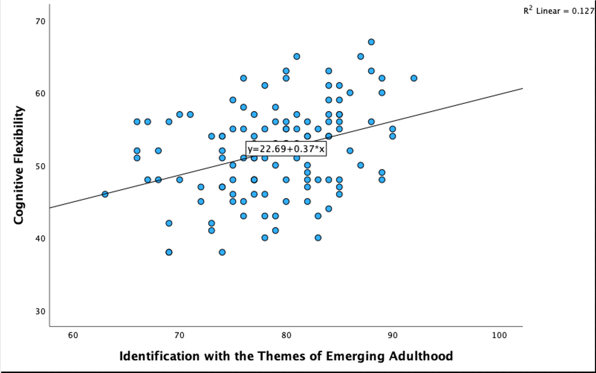

A second Pearson correlation analysis were conducted to examine relationships among age, cognitive flexibility and the individual dimensions of emerging adulthood (See Table 2 and Appendix M for entire SPSS output). Identity exploration was positively correlated with cognitive flexibility, r = .308, p < .001. Experimentation and possibilities were positively correlated with cognitive flexibility, r = .245, p = .007. Self-focused was positively correlated with cognitive flexibility, r = .195, p = .032 and feeling “in-between” was also positively correlated with cognitive flexibility, r = .280, p = .002 Age and other-focused were not significantly correlated with cognitive flexibility.

Table 2
Correlations among Age, Identity Exploration, Experimentation and Possibilities, Self-Focus, Feeling “In-Between” and Cognitive Flexibility.
Variable | 1 | 2 | 3 | 4 | 5 | 6 | 7
1. Age
2. Identity Exploration | -.005
3. Experimentation/ Possibilities | .003 | .338**
4. Self-Focused | -.014 | .437** | .630**
5. Feeling “In-Between” | .179 | .475** | .209* | .189*
6. Other-Focused | .083 | -.095 | -.219** | -.381* | -.043
7. Cognitive Flexibility | .088 | .308** | .245** | .195* | .280* | .090
**Correlation is significant at the 0.01 level (2 tailed)
*Correlation is significant at the 0.05 level (2-tailed)

Regression Assumptions
Prior to conducting the regression analysis, variables were examined to ensure assumptions were met to ensure the production of accurate results (See Appendix M and N) for further outline and SPSS output). Following the outline of Fields (2018), the following assumptions of regression were evaluated. Collinearity diagnostics indicated there was no evidence of multicollinearity (VIF =1.001, tolerance =.999). The Durbin-Watson statistic indicated independence of residuals (Durbin-Watson= 1.846) Visual inspection of the residual scatterplot suggested homoscedasticity, and residuals were approximately normally distributed based on the histogram and normal probability plots. No influential cases were identified, as Cook’s distance values were below 1 (Cook’s Distance Maximum= .05).

Multiple Regression Analyses

Regression Model 1: Identification with Dimensions of Emerging Adulthood
A multiple regression analysis was conducted to evaluate whether identification with emerging adulthood could significantly predict cognitive flexibility while controlling for age. The overall model was significant (See Table 3 & Appendix N), F (2, 120) = 8.850, p <.001, accounting for 12.9% of variance in cognitive flexibility (R² = .129, Adjusted R² = .115).
Identification with the dimensions of emerging adulthood significantly predicted cognitive flexibility, β= .357, t (119) = 4.176, p= .001, indicating that higher identification with the dimensions of emerging adulthood was associated with greater cognitive flexibility.
Age did not significantly predict cognitive flexibility indicating that cognitive flexibility did not differ between the age groups after controlling for identification of emerging adulthood.

Table 3
Multiple Regression Predicting Cognitive Flexibility from Identification with the Dimensions of Emerging Adulthood and Age.
Predictor | B | SEB | β | t | p | 95% CI
(Constant) | 21.565 | 7.277 |  | 2.964 | .004 | [7.157,35.974]
Age | .673 | 1.082 | .053 | .622 | .535 | [-1.469,2.816]
IDEA | .372 | .089 | .357 | 4.176 | .001 | [.196,.549]
Note. B = unstandardized coefficient; SE = standard error; CI = confidence interval.

Regression Model 2: Emerging Adulthood Subscales
A second multiple regression analysis was conducted to further analyse what specific dimensions of emerging adulthood predict cognitive flexibility while accounting for age. The predictors included identity exploration, experimentation/possibilities, self-focus, feeling in-between, other-focus, and age.
The overall regression model was significant, F (6, 115) = 3.684, p = .002, explaining 16.1% of the variance in cognitive flexibility (R² = .161). However, none of the individual predictors made a statistically significant unique contribution to the model when included simultaneously (See Appendix O for SPSS output).

Summary of Results
Hypothesis 1 stated that stronger identification with the dimensions of emerging adulthood would be associated with higher levels of cognitive flexibility. This hypothesis was supported. The model was reported as statistically significant, F (2, 120) = 8.850, p <.001, R² = .129).
Hypothesis 2 stated that age would be significantly associated with cognitive flexibility. A Pearson correlation reported there was not a statistically significant relationship between age and cognitive flexibility both before grouping (r = .098, p = .283) and after grouping (r = .044, p = .630). Therefore, H2 is not supported.
Hypothesis 3 stated that individual dimensions of emerging adulthood will significantly predict cognitive flexibility after controlling for age. This hypothesis was not supported. Although the overall regression was statistically significant, F (6, 115) = 3.68, p = .002, R² = .161, none of the individual dimensions of emerging adulthood significantly predicted cognitive flexibility when entered simultaneously into the model.

Discussion
The Present Study’s Findings
The present study aimed to address the research question: Does identification with the dimensions of emerging adulthood predict cognitive flexibility beyond the effect of age? The findings suggest that identification with emerging adulthood is a significant predictor of cognitive flexibility, even when controlling for age, thereby providing support for the central research question.
Consistent with this, regression analyses demonstrated that identification with the dimensions of EA significantly predicted CF, while age did not. This suggests that the relationship between EA and CF cannot be attributed solely to age but rather reflects the influence of psychological and developmental variables associated with this life stage. From this perspective, the findings highlight the importance of subjective developmental experience over chronological age, supporting Reifman and Niehuis' (2023) outline of the importance of psychosocial correlates.
In line with Hypothesis 1, a positive association was found between identification with EA and CF, suggesting that actively navigating the challenges and opportunities of this developmental period may promote more adaptive and flexible thinking styles. In contrast, Hypothesis 2 was not supported, as age was not significantly associated with CF. This may reflect the relatively narrow age range of the sample which limit variability in developmental differences. This is also consistent with the literature suggesting that core components of executive functioning, such as CF reach a relative level of stability by young adulthood (Parr et al., 2025)
Although the dimensions of EA were individually positively correlated with CF, Hypothesis 3 was not supported, as none uniquely predicted CF when considered simultaneously. This suggests that these dimensions appear to operate as interrelated aspects of a broader developmental theory, rather than as independent predictors, as defined by Arnett (2000). This complements Karakuş’ (2024) findings, suggesting engagement with complex cognitive processes facilitates further CF.
The present findings extend this theoretical relationship by providing empirical support for the link between identification with EA and CF. This further suggests the developmental demands of this period (such as career establishment and identity commitments) require flexible thinking. The continued maturation of prefrontal brain regions during this period may further facilitate the functioning of CF as previously noted in existing literature (Kupis & Uddin, 2023; Luna et al., 2015). The findings display the complex nature between cognitive and psychosocial development and presents the idea that cognitive exercise may be as important as biological maturation.
Despite these significant findings, the models explained a modest proportion of variance (13–16%), indicating that cognitive flexibility is influenced by multiple factors. The lack of unique predictors may also reflect shared variance among subdimensions, limited their independent explanatory power. This highlights the challenges of measuring frameworks that overlap conceptually, potentially attenuating distinct effects. As such, while emerging adulthood is a meaningful predictor, the results should be interpreted cautiously due to the partial nature of its explanatory power.

Theoretical Contribution
The present study makes an important contribution by integrating EA theory with cognitive psychology, demonstrating that developmental identity processes are associated with cognitive flexibility. This extends Arnett’s framework by suggesting that emerging adulthood is not only a psychosocial stage but also linked to adaptive cognitive functioning.
Furthermore, the findings challenge age-based models of development by emphasising the role of subjective developmental identification such as Hohl and Dolcos (2024). This supports a more nuanced understanding of development as a dynamic interaction between psychological experience and cognitive processes. Furthermore, this supports the note of the inconsistent and challenging process of assessing CF and its development neurologically (Kupis & Uddin, 2023; Hohl & Dolcos, 2024).

Practical Implications
The findings have implications for educational and well-being interventions targeting emerging adults. Interventions that support engagement with developmental processes, such as identity exploration and openness to new experiences, may help foster adaptive cognitive functioning. For example, educational settings could incorporate reflective learning, career exploration opportunities, and problem-based learning approaches that encourage students to evaluate multiple perspectives and adapt to uncertainty. The findings also reinforce the importance of proactive frameworks that have already been applied such as the Universal Design for Learning.
Similarly, well-being interventions may benefit from focusing on helping individuals navigate ambiguity and developmental transitions, particularly the experience of feeling “in-between.” Supporting emerging adults in reframing uncertainty as a normative and potentially beneficial aspect of development may promote more flexible thinking patterns and reduce maladaptive responses to stress such as emotional dysregulation (Gabrys et al., 2018). This further supports the beneficial nature of psychoeducation not just for individuals experiencing mental health difficulties but the wider population also. However, given the modest effect sizes observed, such applications should be viewed as complementary rather than definitive, and integrated within broader, evidence-based approaches to cognitive and psychological development.

Strengths and Limitations
A key strength of the present study is the strong theoretical grounding, as it is directly informed by established frameworks of EA (Arnett, 2000, 2024). By explicitly linking the dimensions of EA to CF, the study moves beyond descriptive and qualitative accounts of this life stage and instead offers a theory-informed examination of underlying cognitive relations. This strengthens the internal coherence of the research and enhances its contribution to both developmental and cognitive psychology.
A further strength is that the study addresses a gap in the literature by empirically examining the relationship between the dimensions EA and CF. While previous research has independently explored both constructs, the present study integrates these areas and contributes to a more interdisciplinary understanding of development, bridging psychosocial theory with cognitive functioning. This follows direction within the literature for more integrative approaches to understanding EA (Arnett & Mirta, 2020; Luyckx et al., 2023).
The inclusion of age as a control variable represents a further strength, enabling the study to isolate the unique contribution of EA. Thus, strengthening internal validity of findings and allowing for more precise interpretation of results.
Finally, the study employs methodological rigour in its statistical approach, including the testing and confirmation of regression assumptions. The use of multiple regression analysis allows for predictive examination extending beyond correlational analysis. This aids in support of the findings and the overall validity of the conclusions drawn.
However, several limitations must be considered. The generalisability of the study is limited given the small and somewhat homogenous sample size. The difficulty of acquiring participants between ages 26 and 29 further restricts generalisability, as it may not reflect accurate age ranges in current literature regarding emerging adulthood. Causal inference is also limited given the cross-sectional design. The reliance on self-report measures introduces potential biases, such as social desirability bias (Grimm, 2010), and may not fully capture cognitive flexibility, which is often assessed behaviorally in experimental settings. Furthermore, the exclusion of the instability/negativity subscale, while ethically justified, may have limited the comprehensiveness of the emerging adulthood construct.

Future Research
Future research should build on the present findings by addressing both conceptual and methodological limitations. A key recommendation would be a thorough analysis of the fully extended updated age group of ages 18-29. This could better reflect current literature and perhaps identify differences more clearly. Including the previously excluded instability/negativity subscale would also provide a more comprehensive assessment of emerging adulthood, particularly given its theoretical importance within Arnett’s (2024) framework, should it be deemed ethically appropriate.
Additionally, future studies should incorporate behavioural measures of CF, such as task-switching paradigms, to complement self-report data and improve construct validity. Examples of valid and widely used behavioural measures of cognitive flexibility would be the Wisconsin Card Sorting Test and Task-Switching Paradigm (Hohl & Dolcos, 2024).
The use of longitudinal designs would allow for the examination of developmental trajectories and help determine the directionality of the relationship between emerging adulthood and cognitive flexibility. This would clarify whether engagement with emerging adulthood fosters cognitive flexibility or whether individuals with higher cognitive flexibility are more likely to engage in identity exploration.
The inclusion of qualitative methodologies may further enhance understanding by capturing the lived experiences of emerging adults, particularly how they interpret and navigate identity exploration and uncertainty. Such approaches would provide depth and context that cannot be captured through quantitative measures alone.
Finally, expanding research to include more diverse samples, including neurodivergent individuals who typically have challenges with CF (Lage et al., 2024; Uddin, 2021) as well as those from varied cultural and socioeconomic backgrounds, would improve the generalisability of findings. Including measures of psychosocial correlates (Reifman & Neihuis, 2023) could further outline significant direct influences that contribute to levels of identification. As highlighted in the introduction, emerging adulthood is not a universal experience, and future research should continue to critically examine its applicability across different populations.

Conclusion
In conclusion, the present study demonstrates that identification with the dimensions of emerging adulthood predicts cognitive flexibility beyond the effect of age. The findings emphasise the role of developmental experience and psychosocial engagement in promoting cognitive flexibility.
Although the findings should be interpreted with consideration of the present study’s limitations, they provide a meaningful contribution to the literature by linking developmental theory and cognitive processes. Overall, the study suggests that differences in cognitive flexibility are better related to how individuals engage with emerging adulthood as a stage of development than to age alone.

References

Arnett, J. J. (2000). Emerging adulthood: A theory of development from the late teens through the twenties. American Psychologist, 55(5), 469–480. https://doi.org/10.1037/0003-066X.55.5.469

Arnett, J. J. (2024). Emerging adulthood: The winding road from the late teens through the twenties (3rd ed.). Oxford University Press. https://doi.org/10.1093/oso/9780197695937.001.0001

Arnett, J. J., & Mitra, D. (2020). Are the features of emerging adulthood developmentally distinctive? A comparison of ages 18–60 in the United States. Emerging Adulthood, 8(5), 412–419. https://doi.org/10.1177/2167696818810073
Arnett, J. J., Žukauskienė, R., & Sugimura, K. (2014). The new life stage of emerging adulthood at ages 18–29 years: implications for mental health. The Lancet Psychiatry, 1(7), 569–576. https://doi.org/10.1016/s2215-0366(14)00080-7
Bynner, J. (2005). Rethinking the youth phase of the life-course: The case for emerging adulthood? Journal of Youth Studies, 8(4), 367–384. https://doi.org/10.1080/13676260500431628
Casey, B. J., Jones, R. M., & Hare, T. A. (2008). The adolescent brain. Annals of the New York Academy of Sciences, 1124(1), 111–126. https://doi.org/10.1196/annals.1440.010
Côté, J. E. (2014). The dangerous myth of emerging adulthood. Child Development Perspectives, 8(4), 221–225. https://doi.org/10.1080/10888691.2014.954451
Cristofori, I., Cohen-Zimerman, S., & Grafman, J. (2019). Executive functions. Handbook of Clinical Neurology, 163(3), 197–219. https://doi.org/10.1016/B978-0-12-804281-6.00011-2
Demirtas, A. S., & Kara, A. (2022). Cognitive Control and Flexibility as Predictor of Career Adaptability in Emerging Adults. Kastamonu Education Journal, 30(2), 390–397. https://doi.org/10.24106/kefdergi.803515
Erikson, E. H. (1968). Identity: Youth and crisis. New York, NY: Norton. https://doi.org/10.1002/bs.3830140209
Field, A. (2018). Discovering statistics using IBM SPSS statistics (5th ed.). Sage Publications. https://uk.sagepub.com/en-gb/eur/discovering-statistics-using-ibm-spss-statistics/book285130#description
Gabrys, R. L., Tabri, N., Anisman, H., & Matheson, K. (2018). Cognitive Control and Flexibility in the Context of Stress and Depressive Symptoms: The Cognitive Control and Flexibility Questionnaire. Frontiers in Psychology, 9(1). https://doi.org/10.3389/fpsyg.2018.02219
Grimm, P. (2010). Social Desirability Bias. Wiley International Encyclopaedia of Marketing, 2(1). https://doi.org/10.1002/9781444316568.wiem02057
Hendry, L. B., & Kloep, M. (2010). How universal is emerging adulthood? An empirical example. Journal of Youth Studies, 13(2), 169–179. https://doi.org/10.1080/13676260903295067
Hohl, K., & Dolcos, S. (2024). Measuring cognitive flexibility: A brief review of neuropsychological, self-report, and neuroscientific approaches. Frontiers in Human Neuroscience, 18. https://doi.org/10.3389/fnhum.2024.1331960
Karakuş, İ. (2024). University students’ cognitive flexibility and critical thinking dispositions. Frontiers in Psychology, 15. https://doi.org/10.3389/fpsyg.2024.1420272
Kupis, L., & Uddin, L. Q. (2023). Developmental Neuroimaging of Cognitive Flexibility: Update and Future Directions. Annual Review of Developmental Psychology, 5(1). https://doi.org/10.1146/annurev-devpsych-120221-035310
Lage, C., Smith, E. S., & Lawson, R. P. (2024). A meta-analysis of cognitive flexibility in autism spectrum disorder. Neuroscience and biobehavioral reviews, 157, 105511. https://doi.org/10.1016/j.neubiorev.2023.105511
Luna, B., Marek, S., Larsen, B., Tervo-Clemmens, B., & Chahal, R. (2015). An Integrative Model of the Maturation of Cognitive Control. Annual Review of Neuroscience, 38(1), 151–170. https://doi.org/10.1146/annurev-neuro-071714-034054

Luyckx, K., Vanderhaegen, J., Raemen, L., & Claes, L. (2025). Identity formation in adolescence and emerging adulthood: a process-oriented and applied perspective. European Journal of Developmental Psychology, 22(2), 168–187. https://doi.org/10.1080/17405629.2023.2250128
Nice, M. L., & Joseph, M. (2023). The Features of Emerging Adulthood and Individuation: Relations and Differences by College-Going Status, Age, and Living Situation. Emerging Adulthood, 11(2), 271-287. https://doi.org/10.1177/21676968221116545
Martin, M. M., & Rubin, R. B. (1995). A new measure of cognitive flexibility. Psychological Reports, 76(2), 623–626. https://doi.org/10.2466/pr0.1995.76.2.623
Parr, A. C., Perica, M. I., Calabro, F. J., Foran, W., Moon, C. H., Hetherington, H., & Luna, B. (2025). Adolescent maturation of dorsolateral prefrontal cortex glutamate: GABA and cognitive function is supported by dopamine-related neurobiology. Molecular psychiatry, 30(6), 2558–2572. https://doi.org/10.1038/s41380-024-02860-7
Reifman, A., Arnett, J. J., & Colwell, M. J. (2007). Emerging Adulthood: Theory, Assessment and Application. Journal of Youth Development, 2(1), 37–48. https://doi.org/10.5195/jyd.2007.359
Reifman, A. & Niehuis, S., (2023). Extending the Five Psychological Features of Emerging Adulthood into Established Adulthood. Journal of Adult Development, 30, 6–20. https://doi.org/10.1007/s10804-022-09412-9
Schwartz, S. J., Petrova, M., & Kim, S. Y. (2021). Identity development in emerging adulthood: A decade update. Child Development Perspectives, 15(2), 71–78. https://doi.org/10.1177/2167696813479781
Uddin, L. Q. (2021). Brain Mechanisms Supporting Flexible Cognition and Behavior in Adolescents with Autism Spectrum Disorder. Biological psychiatry, 89(2), 172–183. https://doi.org/10.1016/j.biopsych.2020.05.010

Westhoff, M., Heshmati, S., Siepe, B., Vogelbacher, C., Ciarrochi, J., Hayes, S. C., & Hofmann, S. G. (2024). Psychological flexibility and cognitive-affective processes in young adults' daily lives. Scientific reports, 14(1), 8182. https://doi.org/10.1038/s41598-024-58598-3

Wood, D., Crapnell, T., Lau, L., Bennett, A., Lotstein, D., Ferris, M., & Kuo, A. (2017). Emerging adulthood as a critical stage in the life course. Handbook of Life Course Health Development, 1(1), 123–143. https://doi.org/10.1007/978-3-319-47143-3_7
Zagaria, A., D'Amico, M., Cerolini, S., Mocini, E., & Lombardo, C. (2024). A psychometric examination of the cognitive flexibility scale and its association with Orthorexia Nervosa. BMC psychology, 12(1), 724. https://doi.org/10.1186/s40359-024-02179-6

Appendices

Appendix A: Ethical Approval Email from the IADT Psychology Ethics Committee



Appendix B: Information Sheet
Information Sheet

Title of Project: Exploring Cognitive Flexibility across Emerging Adulthood
You are being invited to take part in the research, Exploring Cognitive Flexibility across Emerging Adulthood. This project is being undertaken by Emma Doolan for our major research project as part of the BSc (Hons) in Applied Psychology, IADT.
Before you decide whether you wish to take part, it is important for you to understand why this research is being done and what it will involve. Please take time to read this information carefully and discuss it with someone you trust. If there is anything that is unclear or if you would like more information, please ask. Our contact details are at the end of this information sheet. Thank you for reading this.

What is the purpose of the project?
Cognitive flexibility is your brain's ability to switch between tasks, behaviours and adapt different thinking styles. Typically, this ability peaks during the ages of 18-25 as the brain fully develops. This age group has been characterised as 'emerging adulthood' as an in-between stage of development and extended to ages 18-29 due to modern postponement of traditional milestones like marriage or parenthood. This project aims explore the relationship between cognitive flexibility and identification with the dimensions of emerging adulthood.

Who is/Why are you being invited to take part?
This study invites any individual between the ages of 18 and 29 years.
These are the defined ages of emerging adulthood and include the ages where cognitive flexibility develops and peaks.
What is involved?
If you choose to participate, you will be asked to complete a questionnaire in a Microsoft Form format. There will be three sections to the questionnaire: the first demographic questions asking your age, gender and current occupation, then two sections; one regarding emerging adulthood dimensions and the other regarding cognitive flexibility. The study will take approximately 7 minutes.

Do I have to take part?
You are free to decide whether you wish to take part or not. If you do decide to take part, you will be asked to sign a consent form that lets us know you have read this information sheet and understand what is involved in the research. You are free to withdraw from this study at any time and without giving reasons. Choosing to take part in the study or not will have no impact on your marks, assessments or future studies should you be a student at IADT.
What are the disadvantages and risks of taking part?
The questionnaire will include brief and general questions about your management of situations and how you manage them, and through scales. The questionnaire will also ask you how much you identify with statements regarding your life at present. You will not have to explicitly write anything but should any of the questions make you feel uncomfortable, you may choose not to answer them or withdraw from the study. If any of the contents of the questionnaire upsets you, contact IADT Counselling Services at studentcounselling@iadt.ie. If you are not an IADT student, you can call Samaritans Ireland at 116 123.

What are the possible benefits of taking part?
This study may not benefit you directly, but the information we obtain from the study will help add to the understanding of cognitive flexibility among emerging adults.

How will my data be protected?
Under the EU General Data Protection Regulation (GDPR), the legal basis for collecting data for scholarly research is that of public interest. The regulations regarding the protection of your data will be followed. Only data which is needed for analysis will be collected. By giving your consent to take part in the study, you are consenting to the use of your data as detailed in this information sheet. The data will be retained by the researcher for at least one year and may be retained for up to 7 years if the results of the study are published in certain capacities (e.g. in a journal article). There is also a possibility that the fully anonymised dataset may be submitted to a journal and made available to other researchers and academics worldwide for verification purposes, but if this occurs, it will be ensured that you are not identifiable from the data. As the supervisor on this project, I, Dr Irene Connolly, am responsible for ensuring that all datasets will be stored in accordance with GDPR regulations and those which are not submitted to a journal will be fully deleted on or before 31st January 2033. The researcher, Emma Doolan and Supervisor, Dr Irene Connolly, will have access to the data collected. This data will be stored on a password-protected computer. In the unlikely event of a data breach, the data protection officer in IADT will be informed immediately. The data will not be identifiable to you, and each participant will be assigned a unique identifying code (e.g. MO503). You will find contact information for IADT's Data Protection Officer and more information on your rights concerning your data at https://iadt.ie/about/your-rights-entitlements/gdpr/

Who has reviewed the study?
This study has been approved by the IADT Psychology Ethics Committee.
What if you have any questions or there is a problem?
If you have a concern about any aspect of this study, you may wish to speak to the researcher, who will do their best to answer your questions. You should contact Emma Doolan at n00220012@iadt.ie or their supervisor Irene Connolly at irene.connolly@iadt.ie.

Thank you for taking the time to read the information sheet.
Date
21st January 2026

Appendix C: Consent Form
Consent Form

Please tick the box

- I confirm that I have read and understand the information sheet for the above study and have had the opportunity to ask questions.

- I understand that my participation is voluntary and that I am free to withdraw at any time.

- I understand that data collected about me during this study will not be identifiable when the research is published.

- I am over 18 years of age

- I agree to take part in this study

Appendix D: Demographic Questionnaire

Demographic Questionnaire and Participant Code
Please provide us with an anonymised code which we can use to identify your data if you later wish to have it removed from our dataset. Please do so by answering the following two questions:
16. Please select two from this list
Please select at most 2 options.
- 2nd and 3rd letter of a parent/guardian's name
- Pets name
- Favourite Author
- First and last initials of your favourite band
- First and last initials of favourite singer
- Favourite food genre
- Star sign
- Favourite game (PC/Board Game)
- Favourite Sport

Please enter the relevant letters of words from the above list and enter them below:
_____________________

Gender: I identify as:
If you do not wish to share this information, simply type 'I prefer not to say'
_____________________

Age: I am
If you do not wish to share this information, simply type 'I prefer not to say'. If you are 30 years or older, please click out of the survey. Thank you for your time.
_________________________________

Appendix E: The Inventory of Dimensions of Emerging Adulthood

Views of Life Survey
- First, please think about this time in your life. By “time in your life,” we are referring to the present time, plus the last few years that have gone by, and the next few years to come, as you see them. In short, you should think about a roughly five-year period, with the present time right in the middle.
- For each phrase shown below, please place a check mark in one of the columns to indicate the degree to which you agree or disagree that the phrase describes this time in your life. For example, if you “Somewhat Agree” that this is a “time of exploration,” then on the same line as the phrase, you would put a check mark in the column headed by “Somewhat Agree”.
- Be sure to put only one check mark per line.

Is this period of your life a… | Strongly disagree | Somewhat Disagree | Somewhat Agree | Strongly Agree
  - Time of many possibilities?
  - Time of exploration?
  - Time of experimentation?
  - Time of personal freedom?
  - Time of responsibility for yourself?
  - Time of optimism?
  - Time of finding out who you are?
  - Time of settling down?
  - Time of responsibility for others?
  - Time of independence?
  - Time of open choices?
  - Time of commitments to others
  - Time of self-sufficiency?
  - Time of trying out new things?
  - Time of focusing on yourself?
  - Time of separating from parents?
  - Time of defining yourself?
  - Time of planning for the future?
  - Time of seeking a sense of meaning?
  - Time of deciding on your own beliefs and values?
  - Time of learning to think for yourself?
  - Time of feeling adult in some ways but not others?
  - Time of gradually becoming an adult?
  - Time of not being sure whether you have reached full adulthood?

Subscale | Items to Average
Identity Exploration | 7, 16, 17, 18, 19, 20, 21
Experimentation/ Possibilities | 1, 2, 3, 11, 14
Other-Focused (Reversed Scoring) | 8, 9, 12
Self-focused | 4, 5, 6, 10, 13, 15
Feeling “In-Between” | 22, 23, 24

Appendix F: Adjusted Inventory of the Dimensions of Emerging Adulthood Reliability Analysis

Appendix Table F1
Case Processing Summary
 |  | N | %
Cases | Valid | 133 | 98.5
Cases | Excludedª | 2 | 1.5
Cases | Total | 135 | 100.0
a. Listwise deletion based on all variables in the procedure.

Appendix Table F2
Reliability Statistics
Cronbach's Alpha | Cronbach's Alpha Based on Standardized Items | N of Items
.728 | .759 | 24

Appendix Table F3

Item Statistics
 | Mean | Std. Deviation | N
Q1 Experimentation | 3.67 | .488 | 133
Q2 Experimentation | 3.68 | .528 | 133
Q3 Experimentation | 3.50 | .670 | 133
Q4 Self-Focused | 3.21 | .749 | 133
Q5 Self-Focused | 3.60 | .536 | 133
Q6 Self-Focused | 3.14 | .698 | 133
Q7 Identity Ex. | 3.53 | .610 | 133
Q8 RS Other-Focused | 3.04 | .924 | 133
Q9 RS Other-Focused | 2.44 | .820 | 133
Q10 Self-Focused | 3.46 | .597 | 133
Q11 Experimentation | 3.38 | .670 | 133
Q12 RS Other-Focused | 2.07 | .709 | 133
Q13 Self-Focused | 3.25 | .722 | 133
Q14 Experimentation | 3.58 | .593 | 133
Q15 Self-Focused | 3.44 | .644 | 133
Q16 Identity Ex | 2.85 | .839 | 133
Q17 Identity Ex | 3.32 | .700 | 133
Q18 Identity Ex | 3.33 | .600 | 133
Q19 Identity Ex | 3.23 | .717 | 133
Q20 Identity Ex. | 3.43 | .619 | 133
Q21 Identity Ex. | 3.53 | .646 | 133
Q22 Inbetween | 3.59 | .552 | 133
Q23 InBetween | 3.50 | .598 | 133
Q24 InBetween | 3.36 | .791 | 133

Appendix Table F4
Scale Statistics
Mean | Variance | Std. Deviation | N of Items
79.13 | 36.249 | 6.021 | 24

Appendix G: The Cognitive Flexibility Scale
The following statements deal with your beliefs and feelings about your own behaviour. Read each statement and respond by ticking the statement that best represents your agreement with each statement.
 | Strongly Disagree | Disagree | Slightly Disagree | Slightly Agree | Agree | Strongly Agree
1. I can communicate an idea in many different ways.
2. I avoid new and unusual situations.
3. I feel like I never get to make decisions.
4. I can find workable solutions to seemingly unsolvable problems.
5. I seldom have choices when deciding how to behave.
6. I am willing to work at creative solutions to problems.
7. In any given situation, I am able to act appropriately.
8. My behaviour is a result of conscious decisions that I make.
9. I have many possible ways of behaving in any given situation.
10. I have difficulty using my knowledge on a given topic in real life situations.
11. I am willing to listen and consider alternatives for handling a problem.
12. I have the self-confidence necessary to try different ways of behaving.

Appendix H: Confirmation of Consent for Data Use

Having completed the questionnaire:
  - I consent to the researchers using my answers for their research
  - I wish to have my answers removed from the research

Appendix I: Debriefing Information Form

Title of Project: Exploring Cognitive Flexibility in Emerging Adulthood
Name of Researcher: Emma Doolan
Thank you very much for taking part in this research study.

This study is designed to investigate cognitive flexibility or flexibility in thinking processes among emerging adulthood. Emerging adulthood is a new theorised stage of development due to the modern postponement of traditional milestones (e.g. marriage, parenthood). Cognitive flexibility also develops and peaks within the defined ages of emerging adulthood (18-29 years).

Withdrawal information
If you have any questions about this study, or if you would like to withdraw your data from the study, please contact the researcher Emma Doolan at n00220012@iadt.ie or their supervisor Irene Connolly at irene.connolly@iadt.ie. In your email, let them know your unique ID code created, e.g. by the second letters of their parent’s name and star sign.
If you submit a request for data removal, all data collected from you will be securely deleted. You will be able to remove your data from the study until 3rd March 2026, when the data will be combined and analysed. Data removal will not be possible after that date. Please keep a copy of this information in case you wish to remove your data after leaving this screen.

Data protection
Your data will be treated according to GDPR regulations. You will find contact information for IADT's Data Protection Officer and more information on your rights concerning your data at https://iadt.ie/about/your-rights-entitlements/gdpr/

Support Resources
If you have been affected by the content of this study in any way, the organisations below may be of assistance.
Spun Out: https://spunout.ie/;Text HELLO to 50808 for free
Samaritans Ireland: https://www.samaritans.org/ireland/samaritans-ireland/ Call: 116 123
Pieta: https://www.pieta.ie/ Call 24-hour Crisis Helpline: 1800 247 247 or text HELP to 51444
Thank you again for taking the time to participate in this research.
If you have any questions about this study, please contact the researcher Emma Doolan at n00220012@iadt.ie or their supervisor Irene Connolly at irene.connolly@iadt.ie

Appendix J: LinkedIn Post for Participant Recruitment
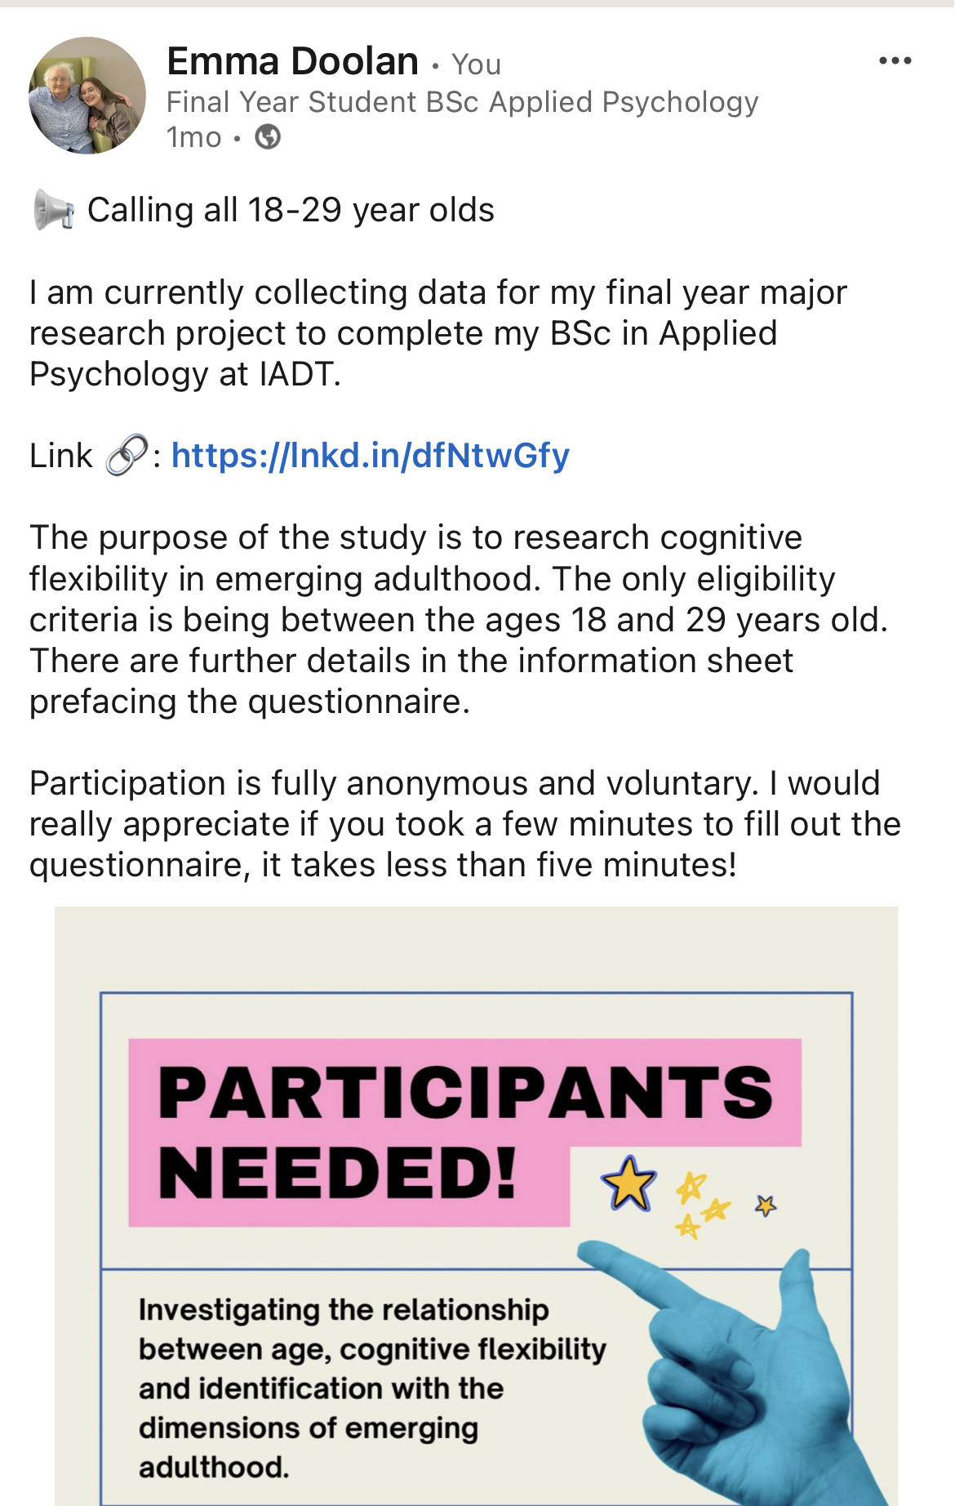

Appendix K: Participant Recruitment Flyer

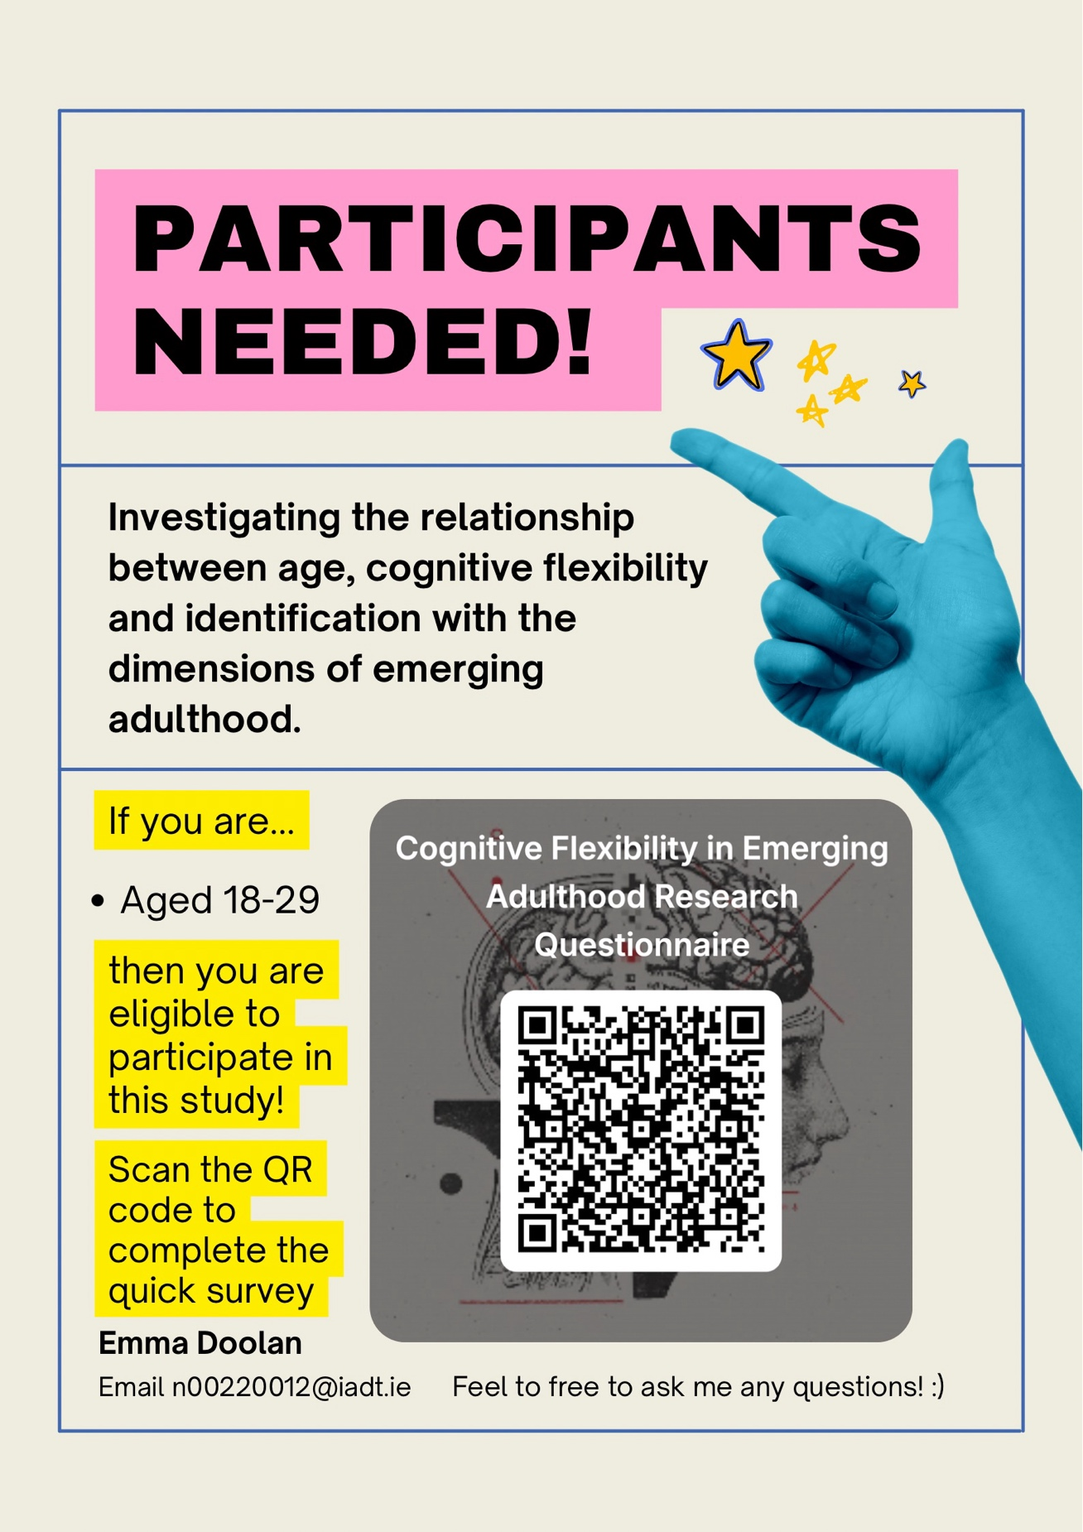

Appendix L: Assumption SPSS Output for Regression 1

Assumption #1: Correlations

The relationship between the Independent Variables and Dependent Variable is linear. Scatterplots show that this assumption has been met. Pearson correlations were conducted to examine relationships among the variable. Identification with emerging adulthood was positively correlated with cognitive flexibility, r = .356, p < .001, while age was not significantly associated with either variable.

Appendix Table L1
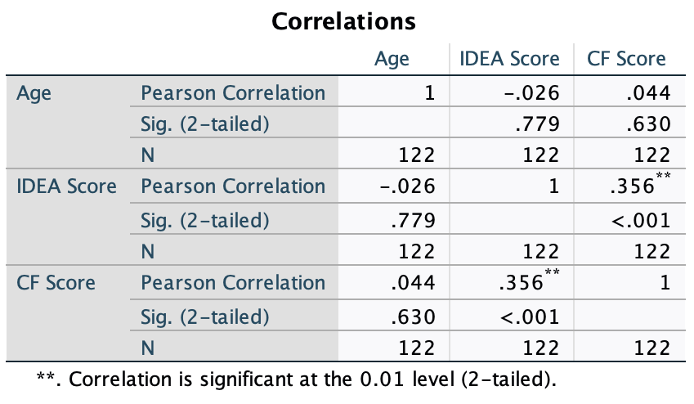

Assumption #2: Multicollinearity

There is no multicollinearity within the data. Analysis of collinearity statistics show this assumption has been met, as VIF scores were far below 10 and tolerances scores above 0.2 (statistics = 1.001 and .999 respectively)

Appendix Table L2

Coefficientsª
Model |  | Unstandardized Coefficients |  | Standardized Coefficients | t | Sig. | Collinearity Statistics
 |  | B | Std. Error | Beta | t | Sig. | Tolerance | VIF
1 | (Constant) | 21.565 | 7.277 |  | 2.964 | .004
1 | IDEA Score | .372 | .089 | .357 | 4.176 | <.001 | .999 | 1.001
1 | Age | .673 | 1.082 | .053 | .622 | .535 | .999 | 1.001
a. Dependent Variable: CF Score

Assumption #3: Independence of Residuals

The values of the residuals are independent. The Durbin-Watson statistic showed that this assumption has been met, as the obtained value was close to 2 (Durbin-Watson = 1.846)

Appendix Table L3

Model Summary^{b}
Model | R | R Square | Adjusted R Square | Std. Error of the Estimate | Durbin-Watson
1 | .360ª | .129 | .115 | 5.973 | 1.846
a. Predictors: (Constant), Age, IDEA Score
b. Dependent Variable: CF Score

Assumption #4: Constant Variance of Residuals

The variance of the residuals is constant. The plot of standardised residuals vs standardised predicted values showed no obvious signs of funnelling. This suggests the assumption of homoscedasticity has been met.
Appendix Figure L1

Assumption #5: Residual values are normally distributed

The values of the residuals are normally distributed. The P-P plot for the model suggests that the assumption of normality of the residuals has not been violated.

Appendix Figure L2
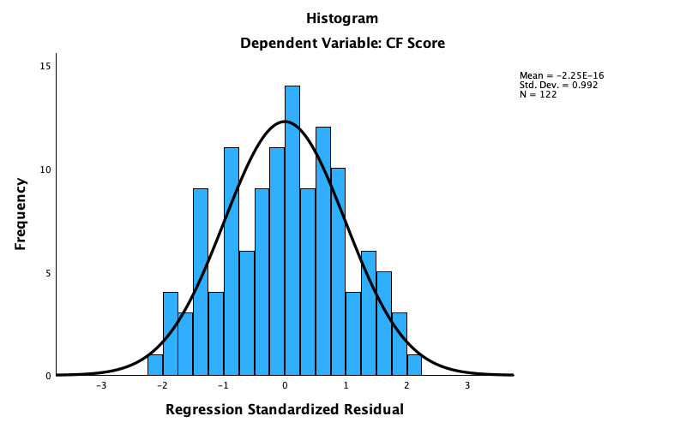

Appendix Figure L3

Assumption #6: No influential cases biasing.

There are no influential cases biasing the model. Cook’s Distance values were all below 1. This indicates individual cases were not unduly influencing the model.

Appendix Table L4
Residuals Statisticsª
 | Minimum | Maximum | Mean | Std. Deviation | N
Predicted Value | 46.36 | 57.16 | 51.93 | 2.285 | 122
Std. Predicted Value | -2.439 | 2.285 | .000 | 1.000 | 122
Standard Error of Predicted Value | .765 | 1.597 | .920 | .179 | 122
Adjusted Predicted Value | 46.28 | 56.87 | 51.93 | 2.298 | 122
Residual | -13.132 | 12.007 | .000 | 5.924 | 122
Std. Residual | -2.199 | 2.010 | .000 | .992 | 122
Stud. Residual | -2.221 | 2.045 | .001 | 1.004 | 122
Deleted Residual | -13.399 | 12.433 | .009 | 6.076 | 122
Stud. Deleted Residual | -2.259 | 2.074 | .000 | 1.010 | 122
Mahal. Distance | .992 | 7.652 | 1.984 | 1.279 | 122
Cook's Distance | .000 | .050 | .009 | .011 | 122
Centered Leverage Value | .008 | .063 | .016 | .011 | 122
a. Dependent Variable: CF Score

Appendix M: Assumption SPSS Output for Multiple Regression 2

Assumption #1: The relationship between the Independent Variables and Dependent Variable is linear. Scatterplots show that this assumption has been met.

Appendix Table M1
Correlations
 |  | Identity Exploration | Experimentation/Possibilities | Self-Focused | Feeling "In-Between" | Other-Focused (Reversed Scoring) | CF Total | Age
Identity Exploration | Pearson Correlation | 1 | .388** | .437** | .475** | -.095 | .308** | -.005
Identity Exploration | Sig. (2-tailed) |  | <.001 | <.001 | <.001 | .299 | <.001 | .957
Identity Exploration | N | 122 | 122 | 122 | 122 | 122 | 122 | 122
Experimentation/Possibilities | Pearson Correlation | .388** | 1 | .630** | .209* | -.219* | .245** | .003
Experimentation/Possibilities | Sig. (2-tailed) | <.001 |  | <.001 | .021 | .015 | .007 | .978
Experimentation/Possibilities | N | 122 | 122 | 122 | 122 | 122 | 122 | 122
Self-Focused | Pearson Correlation | .437** | .630** | 1 | .189* | -.381** | .195* | -.014
Self-Focused | Sig. (2-tailed) | <.001 | <.001 |  | .037 | <.001 | .032 | .880
Self-Focused | N | 122 | 122 | 122 | 122 | 122 | 122 | 122
Feeling "In-Between" | Pearson Correlation | .475** | .209* | .189* | 1 | -.043 | .280** | .179*
Feeling "In-Between" | Sig. (2-tailed) | <.001 | .021 | .037 |  | .641 | .002 | .048
Feeling "In-Between" | N | 122 | 122 | 122 | 122 | 122 | 122 | 122
Other-Focused (Reversed Scoring) | Pearson Correlation | -.095 | -.219* | -.381** | -.043 | 1 | .090 | -.083
Other-Focused (Reversed Scoring) | Sig. (2-tailed) | .299 | .015 | <.001 | .641 |  | .326 | .363
Other-Focused (Reversed Scoring) | N | 122 | 122 | 122 | 122 | 122 | 122 | 122
CF Total | Pearson Correlation | .308** | .245** | .195* | .280** | .090 | 1 | .098
CF Total | Sig. (2-tailed) | <.001 | .007 | .032 | .002 | .326 |  | .283
CF Total | N | 122 | 122 | 122 | 122 | 122 | 122 | 122
Age | Pearson Correlation | -.005 | .003 | -.014 | .179* | -.083 | .098 | 1
Age | Sig. (2-tailed) | .957 | .978 | .880 | .048 | .363 | .283
Age | N | 122 | 122 | 122 | 122 | 122 | 122 | 122
**. Correlation is significant at the 0.01 level (2-tailed).
*. Correlation is significant at the 0.05 level (2-tailed).

Assumption #2: There is no multicollinearity within the data. Analysis of collinearity statistics show this assumption has been met, as VIF scores were far below 10 and tolerances scores above 0.2 as seen below in the table.

Appendix Table M2
Coefficientsª
Model |  | Unstandardized Coefficients |  | Standardized Coefficients | t | Sig. | Collinearity Statistics
 |  | B | Std. Error | Beta | t | Sig. | Tolerance | VIF
1 | (Constant) | 16.880 | 7.787 |  | 2.168 | .032
1 | Age | .532 | 1.119 | .042 | .475 | .635 | .932 | 1.073
1 | Identity Exploration | .362 | .238 | .164 | 1.522 | .131 | .630 | 1.587
1 | Experimentation/Possibilities | .552 | .457 | .136 | 1.208 | .230 | .578 | 1.732
1 | Self-Focused | .191 | .315 | .074 | .606 | .546 | .492 | 2.031
1 | Feeling "In-Between" | .765 | .464 | .162 | 1.649 | .102 | .754 | 1.327
1 | Other-Focused (Reversed Scoring) | .635 | .338 | .177 | 1.877 | .063 | .821 | 1.218
a. Dependent Variable: CF Score

Assumption #3: The values of the residuals are independent. The Durbin-Watson statistic showed that this assumption has been met, as the obtained value was close to 2 (Durbin-Watson = 1.889)

Appendix Table M3

Model Summary^{b}
Model | R | R Square | Adjusted R Square | Std. Error of the Estimate | Durbin-Watson
1 | .402ª | .161 | .117 | 5.964 | 1.889
a. Predictors: (Constant), Other-Focused (Reversed Scoring), Feeling "In-Between", Age, Experimentation/Possibilities, Identity Exploration, Self-Focused
b. Dependent Variable: CF Score

Assumption 4: The variance of the residuals is constant. The plot of standardised residuals vs standardised predicted values showed no obvious signs of funnelling. This suggests the assumption of homoscedasticity has been met.

Appendix Figure M1

Assumption #5: The values of the residuals are normally distributed. The P-P plot for the model suggests that the assumption of normality of the residuals has not been violated.
Appendix Figure M2

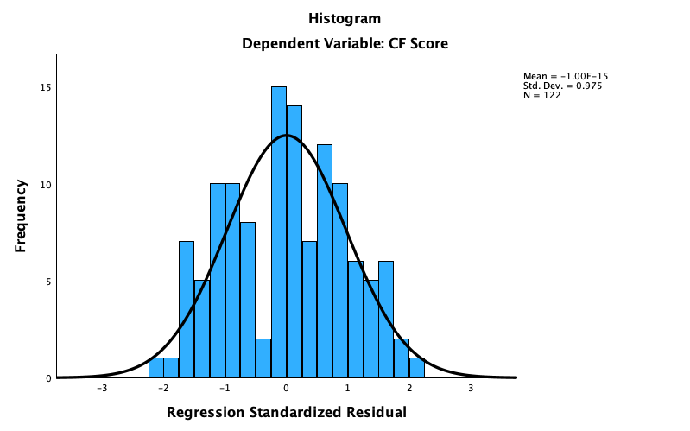

Appendix Figure M3

Assumption #6: There are no influential cases biasing the model. Cook’s Distance values were all below 1. This indicates individual cases were not unduly influencing the model.

Appendix Table M4
Residuals Statisticsª
 | Minimum | Maximum | Mean | Std. Deviation | N
Predicted Value | 45.55 | 57.20 | 51.93 | 2.549 | 122
Std. Predicted Value | -2.506 | 2.065 | .000 | 1.000 | 122
Standard Error of Predicted Value | .904 | 2.165 | 1.401 | .283 | 122
Adjusted Predicted Value | 44.60 | 56.87 | 51.90 | 2.611 | 122
Residual | -12.072 | 12.055 | .000 | 5.815 | 122
Std. Residual | -2.024 | 2.021 | .000 | .975 | 122
Stud. Residual | -2.085 | 2.116 | .003 | 1.006 | 122
Deleted Residual | -12.813 | 13.217 | .031 | 6.188 | 122
Stud. Deleted Residual | -2.116 | 2.149 | .002 | 1.011 | 122
Mahal. Distance | 1.787 | 14.948 | 5.951 | 2.874 | 122
Cook's Distance | .000 | .062 | .009 | .012 | 122
Centered Leverage Value | .015 | .124 | .049 | .024 | 122
a. Dependent Variable: CF Score
Appendix N: Regression 1 SPSS Output

Appendix Table N1

Model Summary
Model | R | R Square | Adjusted R Square | Std. Error of the Estimate
1 | .360ª | .129 | .115 | 5.973
a. Predictors: (Constant), Age, IDEA Score

Appendix Table N2

ANOVAª
Model |  | Sum of Squares | df | Mean Square | F | Sig.
1 | Regression | 631.560 | 2 | 315.780 | 8.850 | <.001^{b}
1 | Residual | 4245.915 | 119 | 35.680
1 | Total | 4877.475 | 121
a. Dependent Variable: CF Score
b. Predictors: (Constant), Age, IDEA Score

Appendix Table N3

Coefficientsª
Model |  | Unstandardized Coefficients |  | Standardized Coefficients | t | Sig. | 95.0% Confidence Interval for B
 |  | B | Std. Error | Beta | t | Sig. | Lower Bound | Upper Bound
1 | (Constant) | 21.565 | 7.277 |  | 2.964 | .004 | 7.157 | 35.974
1 | IDEA Score | .372 | .089 | .357 | 4.176 | <.001 | .196 | .549
1 | Age | .673 | 1.082 | .053 | .622 | .535 | -1.469 | 2.816
a. Dependent Variable: CF Score

Appendix O: Regression 2 SPSS Output

Appendix Table O1
Model Summary
Model | R | R Square | Adjusted R Square | Std. Error of the Estimate
1 | .402ª | .161 | .117 | 5.964
a. Predictors: (Constant), Other-Focused (Reversed Scoring), Feeling "In-Between", Age, Experimentation/Possibilities, Identity Exploration, Self-Focused

Appendix Table O2

ANOVAª
Model |  | Sum of Squares | df | Mean Square | F | Sig.
1 | Regression | 786.403 | 6 | 131.067 | 3.684 | .002^{b}
1 | Residual | 4091.073 | 115 | 35.575
1 | Total | 4877.475 | 121
a. Dependent Variable: CF Score
b. Predictors: (Constant), Other-Focused (Reversed Scoring), Feeling "In-Between", Age, Experimentation/Possibilities, Identity Exploration, Self-Focused

Appendix Table O3
Coefficientsª
Model |  | Unstandardized Coefficients |  | Standardized Coefficients | t | Sig. | 95.0% Confidence Interval for B
 |  | B | Std. Error | Beta | t | Sig. | Lower Bound | Upper Bound
1 | (Constant) | 16.880 | 7.787 |  | 2.168 | .032 | 1.455 | 32.304
1 | Age | .532 | 1.119 | .042 | .475 | .635 | -1.685 | 2.748
1 | Identity Exploration | .362 | .238 | .164 | 1.522 | .131 | -.109 | .833
1 | Experimentation/Possibilities | .552 | .457 | .136 | 1.208 | .230 | -.353 | 1.457
1 | Self-Focused | .191 | .315 | .074 | .606 | .546 | -.433 | .814
1 | Feeling "In-Between" | .765 | .464 | .162 | 1.649 | .102 | -.154 | 1.684
1 | Other-Focused (Reversed Scoring) | .635 | .338 | .177 | 1.877 | .063 | -.035 | 1.304
a. Dependent Variable: CF Score

