Institute of Art, Design & Technology – Dun Laoghaire
Department of Design and Visual Arts

Beyond the Ad : Understanding the Impact of Cultural Insensitivity in Advertisements, focusing on Pepsi, Burger King, and Balenciaga.

By Tianna Moore
N00202191

Submitted to the Faculty of Film, Art and Creative Technologies in candidacy for the BA (hons) in Visual Communication 2025.
Declaration of Originality:

This dissertation is submitted by the undersigned to the Institute of Art Design and Technology, Dún Laoghaire in partial fulfilment of the examination for the BA [Honours] in Visual Communication. It is entirely the author’s own work except where noted and has not been submitted for an award from this or any other educational institution.

Signed

Acknowledgments:

I would like to express gratitude to my supervisor, Dr. Linda King, for her support and guidance throughout the completion of my thesis. I would also like to extend my thanks to my parents and friends for their endless support throughout my thesis and my time at IADT, I could not have done it without you.

Abstract

This thesis explores the critical role of cultural sensitivity in modern advertising through an in-depth analysis of three global company case studies: Pepsi's 2017 “Live for Now Moments Anthem” campaign featuring Kendall Jenner, Burger King's 2021 "Women Belong in the Kitchen" ad, and Balenciaga's 2022 controversial holiday campaign. By examining these campaigns, this study investigates how the failure to understand and respect cultural norms and values can have significant social and reputational repercussions for brands. This thesis will highlight how controversial subject matter and oversights in advertising campaigns can provoke strong reactions and harmful biases and launch social media outrage. By evaluating the semiotics, representation, and societal effects of these campaigns, this research will show the consequences of overlooking cultural sensitivity in major brand advertisements. Ultimately, this investigation will provide an insight into the importance of why brands must ingrain cultural awareness in their advertisement campaigns to maintain creditability and prevent defamation of their brand in an era of rising social awareness.

Table of Contents

List of Plates page 6

Introduction page 8

Approach and Methodologies page 11

Chapter 1 Cultural Sensitivity in Advertising page 13
1.1 The Importance of Cultural Sensitivity in Advertising page 14
1.2 Nike Campaign “You Can’t Stop Us” page 15
1.3 The Adaptation of New Advertising Methodologies page 17

Chapter 2 Case Study “Live for Now Moment Anthems” Pepsi page 19

Chapter 3 Case Study “Women Belong in the Kitchen” Burger King page 29

Chapter 4 Case Study Balenciaga’s Controversial Campaigns page 36

Conclusion page 41

Bibliography page 47

List of Plates

Fig 1 “A screenshot of the Share a Coke Campaign” 2011, https://joannamoraisblog.wordpress.com/2014/10/15/share-a-coke-campaign-a-success/

Fig 2 “A screenshot from You Can’t Stop Us” Nike Campaign 2020
https://www.youtube.com/watch?v=pcXTnyCmQbg

Fig 3 “ A screenshot from the Live for Now Moments Anthem Campaign” ,2017
https://www.google.com/search?q=kendall+jenner+pepsi+ad&oq=kendall+&gs_lcrp=EgZjaHJvbWUqDggAEEUYJxg7GIAEGIoFMg4IABBFGCcYOxiABBiKBTIMCAEQLhhDGIAEGIoFMgYIAhBFGDkyBwgDEAAYgAQyBwgEEC4YgAQyBggFEEUYPDIGCAYQRRg8MgYIBxBFGD3SAQgyMTgwajBqN6gCALACAA&sourceid=chrome&ie=UTF-8#fpstate=ive&vld=cid:440e4156,vid:uwvAgDCOdU4,st:0

Fig 4 “Taking a Stand at Baton Rogue” Jonathan Bachman, 2016
https://en.wikipedia.org/wiki/Taking_a_Stand_in_Baton_Rouge

Fig 5 “Statistics from Brandwatch” 2017 https://www.brandwatch.com/blog/react-kendall-jenner-pepsi-ad/

Fig 6 “Pepsi Apology” 2017www.nbcnews.com/news/nbcblk/pepsi-ad-kendall-jenner-echoes-black-lives-matter-sparks-anger-n742811.

Fig 7 “Glossiser BLM Tweet” 2022 https://marketingsociety.com/blog-post/black-lives-matter-brands-who-are-doing-it-right

Fig 8 “Tweet about Glossier” 2020 https://x.com/theeecitygurl/status/1266895610038362119?s=20

Fig.9 “ Consumers Tweet about Burger King” 2021 https://x.com/kendallybrown/status/1368959876966342662?ref_src=twsrc%5Etfw%7Ctwcamp%5Etweetembed%7Ctwterm%5E1368959876966342662%7Ctwgr%5E97f7909a1a9c2e9fef98ed8c344dfc68baf7291b%7Ctwcon%5Es1_&ref_url=https%3A%2F%2Fembedly.forbes.com%2Fwidgets%2Fmedia.html%3Ftype%3Dtext2Fhtmlkey%3D3ce26dc7e3454db5820ba084d28b4935schema%3Dtwitterurl%3Dhttps3A%2F%2Ftwitter.com%2Fkendallybrown%2Fstatus%2F1368959876966342662image%3Dhttps3A%2F%2Fi.embed.ly%2F1%2Fimage3Furl3Dhttps253A252F252Fabs.twimg.com252Ferrors252Flogo46x38.png26key3D3ce26dc7e3454db5820ba084d28b4935

Fig 10 “Burger King Apology” 2021https://x.com/BurgerKingUK/status/1369036021925638154?ref_src=twsrc%5Etfw%7Ctwcamp%5Etweetembed%7Ctwterm%5E1369036021925638154%7Ctwgr%5Eea1d7b1f8ba5726f8b28302158865ba05e1feae5%7Ctwcon%5Es1_&ref_url=https%3A%2F%2Fembedly.forbes.com%2Fwidgets%2Fmedia.html%3Ftype%3Dtext2Fhtmlkey%3D3ce26dc7e3454db5820ba084d28b4935schema%3Dtwitterurl%3Dhttps3A%2F%2Ftwitter.com%2Fburgerkinguk%2Fstatus%2F1369036021925638154image%3Dhttps3A%2F%2Fi.embed.ly%2F1%2Fimage3Furl3Dhttps253A252F252Fabs.twimg.com252Ferrors252Flogo46x38.png26key3D3ce26dc7e3454db5820ba084d28b4935

Fig 11. “Balenciaga Child Controversy Campaign” 2022 https://www.euronews.com/culture/2022/11/23/fashion-label-balenciaga-pulls-ads-featuring-children-with-bondage-teddy

Introduction

In the modern-day world, advertising is more than just a means for companies to sell their products; it is a powerful tool that can shape societal values, influence popular opinions, and drive cultural narratives. Advertisements are unavoidable. Strategically speaking companies are consistently aiming for brand awareness within society. In 2025, society is inundated with these campaigns. Society is constantly targeted with marketing strategies by these large companies. Subconsciously society consume advertisements. Radio adverts, billboards and social media platforms increase advertising consumption within society. Studies have proven a direct link between the increase in consumption of advertising from both macro and micro perspectives. With the number of advertisements growing steadily along with the growth of social media consumption, companies are forced to produce more distinct and memorable advertisements to distinguish them from other companies. Research suggests the market expansion effect disappears and the increase in the consumption of advertised products occurs mainly at the expense of other products in the same category. The way in which a brand chooses to market their products undoubtedly influences how the consumers, perceive the brand and the overall opinion on the reputability of the company.

As a 23-year-old who grew up in the social media age, I can state with confidence that the influence of advertising has a firm grip on me. Advertising is deeply embedded in my digital usage, and it constantly shapes my perceptions and influences my opinions on brands. With technology in the digital world constantly evolving, brands have an advantage to effectively reach us as consumers through personalised advertisements and targeted campaigns based on our preferences and online behaviours. These personalised advertisements are stretched across all of our digital platforms and social media accounts. These advancements have sparked an interest to research and evaluate to start the content of these advertisements at academic level and to further evaluate the lack of cultural awareness in brands advertising methodology. On evaluating prior thoughts, one can find themselves subconsciously influenced by advertising methodology, I aim to find focus the factors that lead to an adverting campaign having a remarkable effect on society.

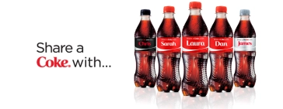
Fig 1. “A screenshot of the Share a Coke Campaign” 2011, https://joannamoraisblog.wordpress.com/2014/10/15/share-a-coke-campaign-a-success/

Remarkable campaigns such as Coca-Cola's ‘Share a Coke’ (Fig 1) strategy are examples of effective advertising that create a lasting effect on society. This campaign first took to the shelves in Australia in 2011 and influenced consumers to search for their names amongst the 150 most popular Australian names printed on the bottles. The “Share a Coke” campaign was a resounding success. The campaign saw young adult consumption rise by 7% which made 2011 the most successful summer that the company has ever seen. The campaign generated more than 18 million media impressions. Traffic on Coca-Colas Facebook page saw an impressive increase of 870% whilst also experiencing a 39% increase in followers and became the most talked about Facebook page in Australia and 23rd globally. This campaign improved young adults opinion of their brand with consumers stating it gave them a highly positive impression of Coke due to the innovative ideas of the brand.

As companies and brands expand their reach across diverse markets through the use of social media, the importance of cultural awareness in advertising is more critical than it has ever been before. Whilst campaigns such as “Share a Coke” were undeniably successful and impactful, it is the negative advertisement campaigns, such as Pepsi’s “Live for Now Moments Anthem” featuring Kendall Jenner, Burger King’s insensitive “Women Belong in the Kitchen” strategy, and Balenciaga's controversial Spring/Summer ad campaign that have stuck with me more. These campaigns provoked heated debates and created long-lasting effects due to the criticism they sparked. A lack of cultural awareness has been shown in these examples, which has caused a negative mindset amongst advertising professional and society. Thus, creating customer mistrust, and brand damage as further discussed in case study number one. Society has created an era of heightened social consciousness. Consumers are ready to criticize brands when flaws arise. Which therefore results in the failure to grasp cultural nuances having serious repercussions and severe consequences. This thesis will explore how major companies advertising campaigns lack cultural awareness. This thesis will investigate major global companies Pepsi, Balenciaga, and Burger King and research how there lack of cultural awareness within the subject matter of their large-scale advertising campaigns. I will discuss how the lack of cultural awareness can cause considerable damage and compromise the brand's reputation. By analysing the case studies from Pepsi, Balenciaga, and Burger King this research will explore how culturally insensitive advertising campaigns have negatively impacted these company’s brand awareness. Resulting in these companies facing public backlash, financial repercussions, and lasting harm to their brands credibility. I will view these case studies through a critical lens to highlight the importance of brands curating a culturally informed approach through the design and strategy in their messaging in advertising campaigns.

Approach and Methodologies

The first chapter of my thesis will explore the importance of cultural sensitivity in advertising and focus on how brands that integrate awareness of cultural issues into their global advertisement campaigns can achieve considerable gains. I will examine how companies can build stronger connections with a diverse range of audiences and avoid the risks associated with cultural insensitivity in their campaigns. Additionally, I will provide a brief case study of Nike’s “You Can’t Stop Us” campaign in 2020. This campaign successfully integrated cultural sensitivity during the COVID 19 pandemic. By embracing unity, resilience, and social justice, Nike was able to align with cultural narratives that resonated with a broad audience in a time of uncertainty. Ultimately this campaign strengthened the brands image whilst boosting customer loyalty. This chapter with highlight how such campaigns can have a positive impact on the brand perception demonstrating the advantages of being culturally conscious in today’s global marketplace. Using Social Communication in Advertising: Consumption in the Mediated Marketplace 1990 by William Leiss, Stephen Klein, and Sut Jhally to argue that advertising is not just a tool for driving sales but a transformative force that shapes and influences the media landscape. The authors highlight how advertising goes beyond promoting products, instead affecting cultural values and shaping public discourse by influencing consumer behaviour and social norms. I will explore how advertising plays a pivotal role setting cultural standards, and shaping the media footprint of modern society.

In the second chapter of my thesis, I will conduct a case study on Pepsi’s “Live for Now Moment Anthem” campaign featuring Kendall Jenner. I will analyse the cultural insensitivity that led to the widespread backlash received from the campaign. I will apply Marshall McLuhan’s theory of Global Village from his book The Gutenberg galaxy: The making of typographic man (1962). Using McLuhan’s theories I will explore how the campaigns failure to consider cultural sensitivity led to its large receival of criticism. McLuhan’s concept highlights how media and advertising are not isolated but deeply interconnected within a global village. I will demonstrate how Pepsi’s campaign in failing to acknowledge the importance of cultural sensitivity underestimated the power of the global village theorised by McLuhan.

In the third chapter of my thesis, I will conduct a second case study on Burger Kings insensitive “ Women belong in the Kitchen” campaign and examine how the lack of cultural sensitivity resulted in the campaign receiving repercussions from the consumer. I will use Karl Marx’s theory of commodity fetishism from his book A Critique of Political Economy Vol 1 (1859 )to analyse how the campaign commodified women’s roles in the society and turned a serious issue into a humorous online tweet and demonstrate how this led to a misinterpretation of the greater campaign the brand was aiming to promote.

In my fourth chapter I will provide a final case study on Balenciaga’s controversial campaign exploring the brands failure to recognise the importance of the imagery used in their campaigns and how society may perceive it. I will again draw on the theories of commodity fetishism by Karl Marx, and Marshall McLuhan’s global village to highlight how the campaign failed to incorporate cultural sensitivity and in turn damaged the reputation of the brand. I will also incorporate Émile Durkheim’s theory of collective consciousness from his book The Divisions of Labour in Society (1893) to emphasise how the campaigns failure to align with shared societal values led to public outrage.

Chapter 1 Cultural Sensitivity in Advertising

1.1 The Importance of Cultural Sensitivity in Advertising

Cultural sensitivity has always been important. What's changed is the impact that coming to that realisation has. The increasing buying power of minority groups globally, alongside the rapid growth of an ethically aware consumer base, demands that businesses tune into diverse cultures' languages, customs, values, and beliefs. It is, of course, crucial for so many reasons that we adapt practices to better align with these needs. And when it happens, we see positive outcomes for the customer as well as employees. - Nick Livermore, Senior Marketing Manager, Adapt World Wide, 2022.

The above quote emphasises the importance of cultural sensitivity in advertising, highlighting that as consumer demographics shift and ethical awareness rises it is critical for brands to adapt their advertising strategies to align with diverse audiences. Cultural sensitivity is essential when developing advertisement campaigns that effectively engage a wide range of audiences. By acknowledging and valuing cultural differences, brands can develop deeper connections with their target markets. It is vital that companies be aware of cultural practices, ideologies, and community interactions to prevent any misinterpretations that could harm the companies reputability or create a negative impact on their brand. Additionally, these strategies demonstrate a clear understanding of how cultural values can shape consumer behaviour, primarily in areas where traditions and ideologies have a significant impact on purchasing decisions. The integration of cultural sensitivity into advertisement campaigns not only strengthens a brand’s reputation but also cultivates long-term consumer loyalty. Companies that actively attempt to identify and value local cultures have a much greater chance to build trust and meaningful connections with their target audiences. To achieve the incorporation of cultural sensitivity, companies must be mindful that their campaign messages align with cultural values. To ensure this, they can utilise regionally relevant visuals, choose cultural themes or subject matters, and engage in community-driven initiatives that resonate with the target audience. By placing a focus on cultural awareness in their campaigns, companies can elevate their appeal while demonstrating a commitment to ethical and socially responsible advertising strategies. By prioritizing cultural sensitivity, the brand not only mitigates the risk of misinterpretation or backlash but also reinforces a strong brand authenticity and relevance in a rapidly expanding marketplace.

1.2 Nike Campaign “You Can’t Stop Us”
A brand that has successfully demonstrated cultural awareness using relevant imagery as its subject matter in advertising campaigns is Nike. Nike's mission is to "bring inspiration and innovation to every athlete in the world," this is demonstrated clearly as the brand consistently uses powerful storytelling and culturally relevant messaging to motivate and connect with diverse audiences globally. Nike is a reputable and recognisable brand in the sports industry and is known for their innovative and captivating advertisement campaigns. Nike’s “You Can’t Stop Us” campaign was released in July 2020 and made in partnership with Wieden+Kennedy Portland a creative company that builds and transforms brands. The campaign was released during the COVID 19 pandemic global restrictions were placed on sporting events and the closure of sporting facilities. The campaign portrays resilience and unity through impactful imagery in a time where communities faced unprecedented challenges through a worldwide pandemic.

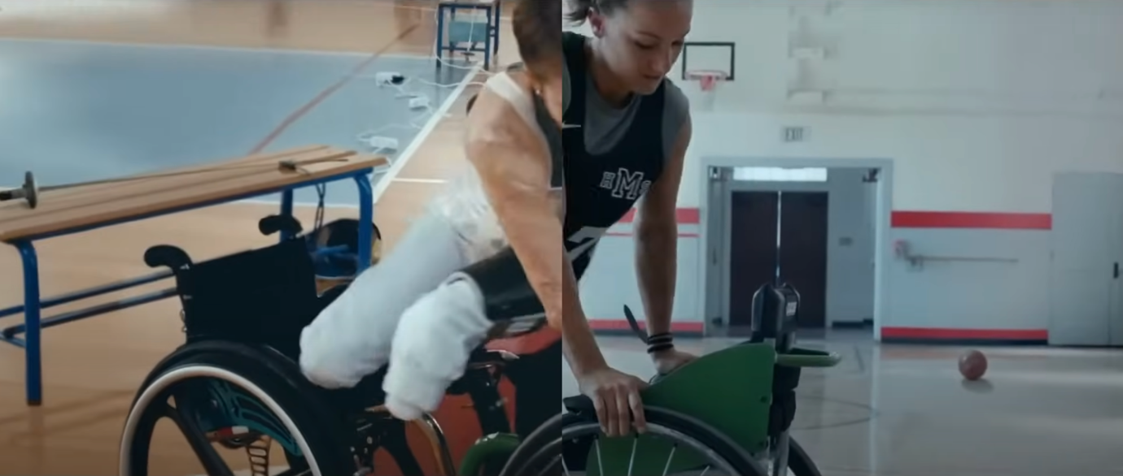
Fig 2 “A screenshot from You Can’t Stop Us” Nike Campaign 2020 https://www.youtube.com/watch?v=pcXTnyCmQbg

The campaign consists of a split screen (Fig 2) that contrasts disabled and able-bodied athletes, as well as male and female athletes across a variety of cultural backgrounds and an array of different sports. Over the course of the 90-second ad, one athlete on one side of the screen mirrors the movements of another on the opposite side, creating the illusion that they are the same person through seamless transitions. The advertisement features both every day and elite athletes, including Megan Rapinoe, LeBron James, Naomi Osaka, Eliud Kipchoge, and Serena Williams focusing on their shared experiences through sports bringing innovation and inspiration to all that view the advertisement. The advertisement is inspirational in a time of uncertainty with ad narrator, women’s soccer star and equal-pay activist Megan Rapinoe stating “We’re never alone, and that is our strength,” . The use of the split screen in this campaign created a sense of hope, despite the physical separation of society during the launch of the campaign Nike was able to visually create a sense of unity, resilience and perseverance through their captivating storytelling and use of powerful imagery. The use of both elite and everyday athletes reinforced the idea that community could prevail even in difficult times. Nike needed a campaign that could reinforce their brand mission and that is exactly what they did. The “You Can’t Stop Us” campaign demonstrated cultural awareness by focusing on the global impact of the pandemic and emphasised the importance of strength and optimism in these difficult times. Nike went beyond just inspiring athletes. The campaign resonated with a broader audience by tackling the issue of the global pandemic and approaching it from a place of comfort and encouragement. The emotional connection that Nike was able to build with consumers through their use of cultural awareness in this campaign worked in their favour. Just one month after the launch of the campaign Nike had accumulated over 36 million views on their YouTube channel for the “You Can’t Stop Us” campaign , a survey revealed that 46% of viewers were more likely to purchase a Nike product after viewing the advertisement and despite economic challenges due to the pandemic Nike reported an evident increase in the sales on their athletic wear and footwear products. This is an example of positive and innovative advertising. Through the brands awareness of cultural sensitivity the brand created a relationship with the consumer, this is a useful tool of comparison which Pepsi, Balenciaga and burger king lacked due to poor cultural awareness. Had these companies understood cultural sensitivity they may not have faced economic and social downfalls. The dissolution of the commission system in the 1980s saw a new model of advertising.

1.3 The Adaptation of New Advertising Methodologies
In the book Social Communication in advertising : Consumption in the Mediated Marketplace 1990 by, William Leiss, Stephen Klein, and Sut Jhally it argues that advertising plays a crucial role in connecting the of product sales with broader communication methods. Highlighting how advertising became more than just a sales tool but rather transformative source that shapes the media footprint. The dissolution of the commission system in the 1980s saw a new model of advertising. A model where advertisers now fund media and advertising separately. Which is further highlighted in studies which suggest advertising can increase sales through different channels that reflect perspectives on advertising whether it be consumption or changing preferences to cause shift in product demand. However, these new practices have not eliminated the powerful subsidies advertising provides to the media. As a result, the media adapted and evolve new dynamic, shifting focus from editorial content to revenue-driven services like market research, which in turn influenced the nature of advertising itself.

This structural shift has profound implications for cultural insensitivity in advertising. By intertwining money, influence, and information, advertisers have a direct role in shaping media content, which can perpetuate harmful stereotypes or reinforce dominant cultural narratives. As suggested by the Darwinian theory of survival of the fittest brands have placed profit economically over editorial integrity often leads to the oversimplification or misrepresentation of cultural groups, thus highlighting the importance of cultural sensitivity in advertising. Leiss, Klein, and Jhally’s work emphasises how advertising, when not critically examined, can be a tool for reinforcing cultural insensitivity, shaping public perception, and influencing societal norms.
Focusing on the lack of cultural sensitivity and how it shapes public opinions advertising campaigns such as Pepsi, Burger King and Balenciaga are examples of how theories outlined above effect advertisements effectiveness within society.

Chapter 2 Case Study “Live for Now Moment Anthems” Pepsi

On Tuesday, April 4th 2017, globally recognised soft drink company PepsiCo, released an advertisement campaign titled “Live for Now Moments Anthem” featuring American model and social media personality Kendall Jenner. The campaign was met with remarkable backlash due to lack of cultural awareness surrounding the social justice movements depicted in the advertisement. The advertisement begins with the opening of a Pepsi can and swiftly transitions to a shot of a musician playing a cello on a rooftop. As the camera pans the view switches to a scene showcasing a protest unfolding in the streets, setting the narrative to follow. The activists represent a diverse range of ethnic and racial backgrounds, primarily consisting of young participants with a clean cut appearance. The protestors can be seen carrying signs, most are illegible, some gesturing symbols of peace and one that clearly says “Join the Conversation”. The scene turns our attention to a woman wearing a hijab, who appears to be a photographer marking her photographs with a red marker, she grows frustrated and scatters her photos around the room in what seems to be a fit of rage then notices the protest outside, she takes her camera and exits into the protest. Our attention is then directed to Kendall Jenner who is positioned on a side street viewing the protest as she engages in a photoshoot styled in a blonder wig accompanied with dark lipstick. As Jenner observes the protest unfolding in front of her, her interest peaks. As the protest passes by they can be seen cheering, holding signs and playing instruments. Passerby’s on the street notice the protest and join in. Jenner drastically removes her wig, smudges off her dark lipstick and steps onto the streets and into the protest. Jenner becomes the focal point of the advertisement from this point forward and leads the protest through the streets until they are met with a row of police officers, bringing the protest to a halt. In a moment of climax, Jenner can be seen reaching into a cooler and retrieving a can of Pepsi as she fearlessly approaches one of the officers facing her and gestures for him to take it from her hand. (Fig 3)
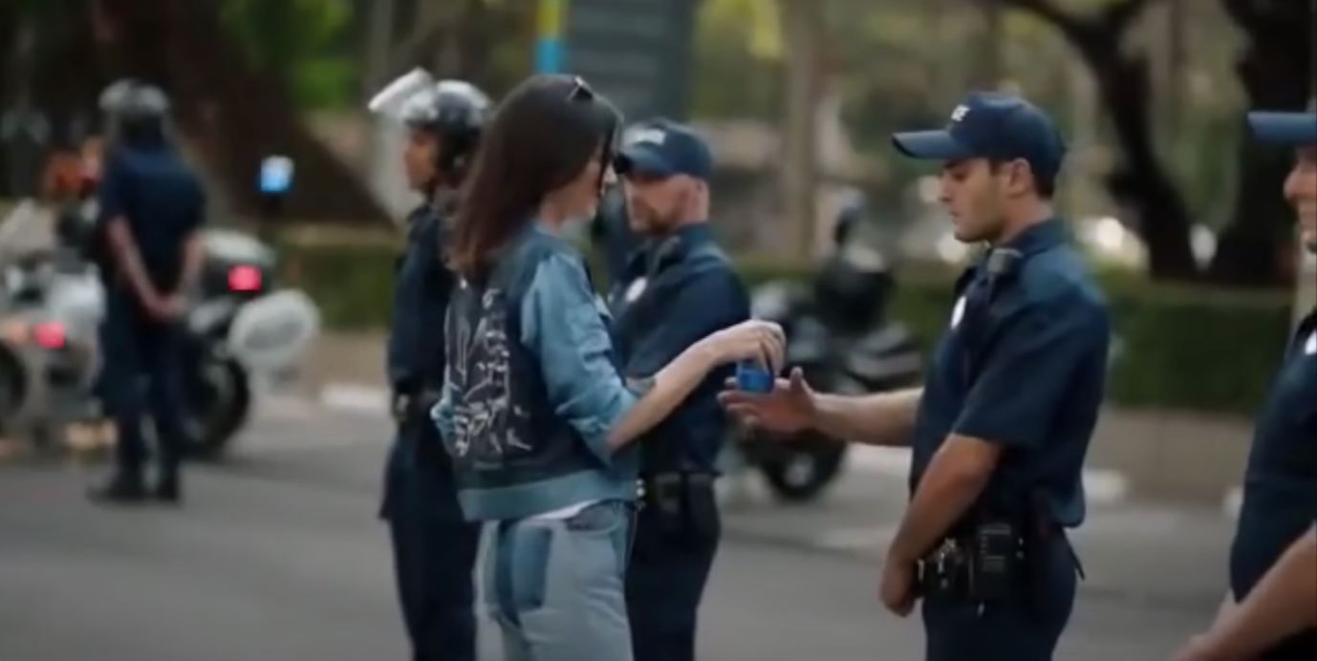
Fig 3 “ A screenshot from the Live for Now Moments Anthem Campaign” ,2017
https://www.google.com/search?q=kendall+jenner+pepsi+ad&oq=kendall+&gs_lcrp=EgZjaHJvbWUqDggAEEUYJxg7GIAEGIoFMg4IABBFGCcYOxiABBiKBTIMCAEQLhhDGIAEGIoFMgYIAhBFGDkyBwgDEAAYgAQyBwgEEC4YgAQyBggFEEUYPDIGCAYQRRg8MgYIBxBFGD3SAQgyMTgwajBqN6gCALACAA&sourceid=chrome&ie=UTF-8#fpstate=ive&vld=cid:440e4156,vid:uwvAgDCOdU4,st:0

As she does this the photographer from earlier in the advertisement can be seen photographing the exchange. As the police officer takes a sip of the Pepsi, Jenner rejoins the protest behind her as the protestors break into celebration high-fiving and hugging each other. The advertisement concludes with the words “Live Bolder”, “Live Louder, “Live for Now” filling the screen. Within 48 hours, the video accumulated nearly 1.6 million views on YouTube, simultaneously gaining mass attention on Twitter as it began to be criticised for the downplaying serious cultural issues. The exchange of the Pepsi can between Jenner and the police officer strikes an undeniable resemblance to the photo of Iesha Evans, a female protester, who was pictured in the same angle standing face to face with a line of Baton Rouge Police Officers during protests after a police shooting of Alton Sterling in Baton Rouge (Fig 4)

The picture was taken at Evans first protest against police brutality where officers in riot gear are stood facing her. Evans was later arrested after her act of courage, it is clear to see Pepsi’s attempt to replicate this exchange in their advertisement. Users of twitter immediately began to compare Jenner with Evans iconic photograph. One user stated ‘Iesha Evans did it better. #PEPSI’ . Consumers criticised the disconnect on Pepsi’s behalf, noting the stark contrast between their portrayal of an ideal protest and the reality of the Black Live’s Matter protests and the racial tension between Black Americans and police that was ongoing at the time of the campaign.

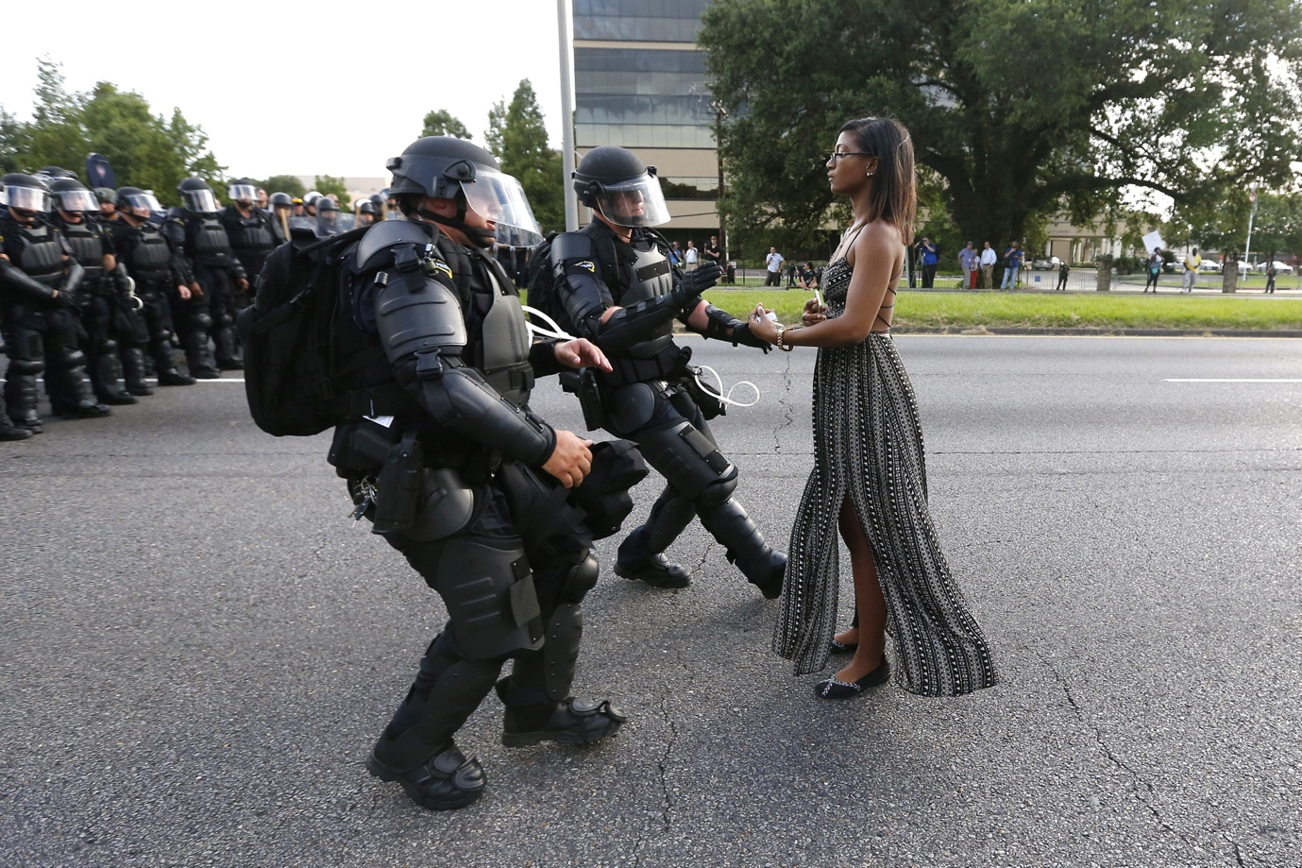
Fig 4 “Taking a Stand at Baton Rogue” Jonathan Bachman, 2016
https://en.wikipedia.org/wiki/Taking_a_Stand_in_Baton_Rouge

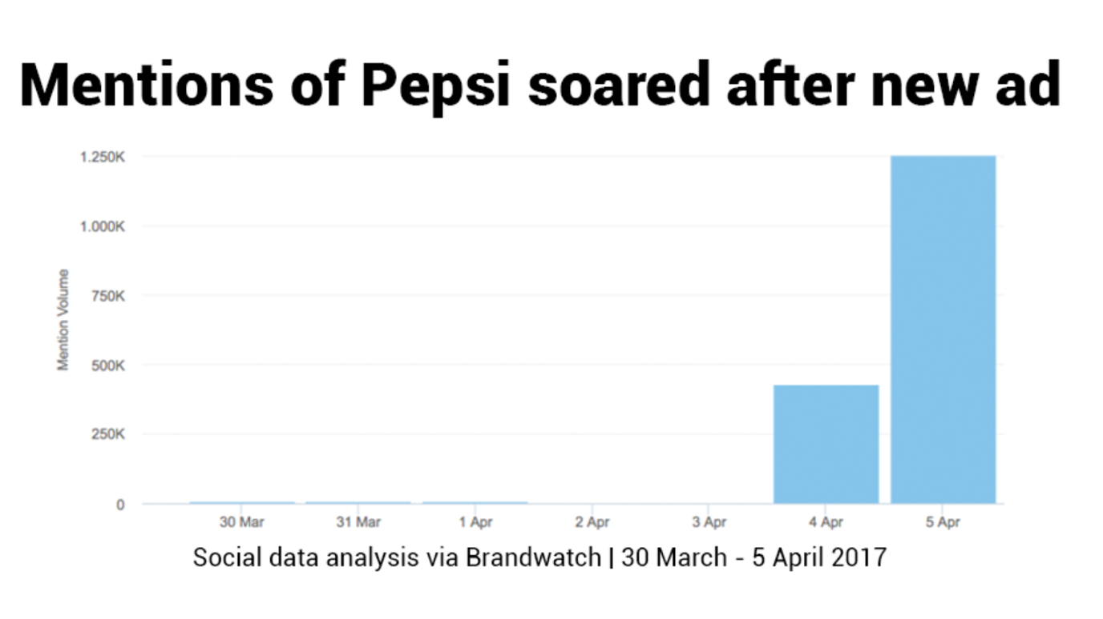
Fig 5“Statistics from Brandwatch” 2017 https://www.brandwatch.com/blog/react-kendall-jenner-pepsi-ad/

According to data from social media monitoring company, Brandwatch (Fig 5) Pepsi’s day-over-day social mentions increased by over 7.300% between April 3rd and 4th following the launch of the campaign. The percentage increase from April 3rd to April 5th was an enormous 21,675% increase. The data collected by Brandwatch concluded that Pepsi drew 1.25 million reactions on Twitter, Facebook and Instagram, and 58.6 percents were negative. The launch of this advertisement lined up with the 49th anniversary of Martin Luther King Juniors assassination, heightening the backlash.

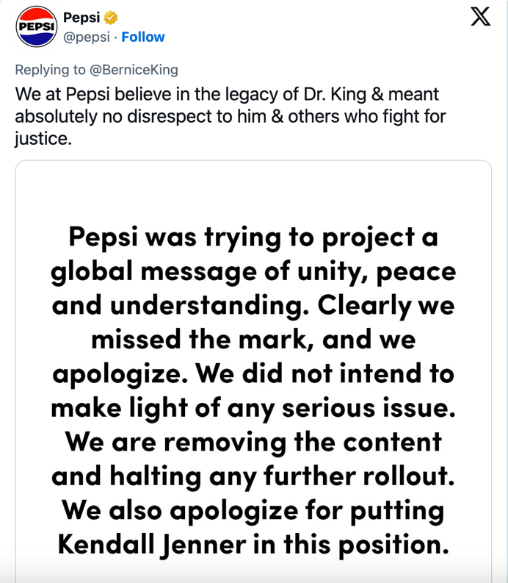
Fig 6 “Pepsi Apology” 2017www.nbcnews.com/news/nbcblk/pepsi-ad-kendall-jenner-echoes-black-lives-matter-sparks-anger-n742811.

Within 24 hours of the advertisement being launched Pepsi published an apology on their social media platforms. see fig The company claimed they were attempting to “project a global message of unity, peace and understanding” confirming they “clearly missed the mark” (Fig 6). The advertisement was then pulled.

On the contrary, 3 years later we see Glossier, a beauty brand honouring the importance of the Black Lives Matter campaign. The beauty brand pledged to donate one million dollars to black resistance causes and black-owned beauty brands as protests were still ongoing following on from George Floyd’s death in May 2022 who was victim of
police brutality.

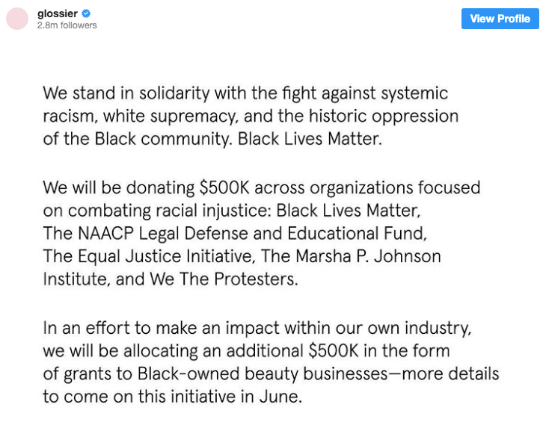

Fig 7 “Glossiser BLM Tweet” 2022 https://marketingsociety.com/blog-post/black-lives-matter-brands-who-are-doing-it-right

Glossier went as far as delaying the launch of a new product in attempt to poor focus and attention into the fight against racial injustice.

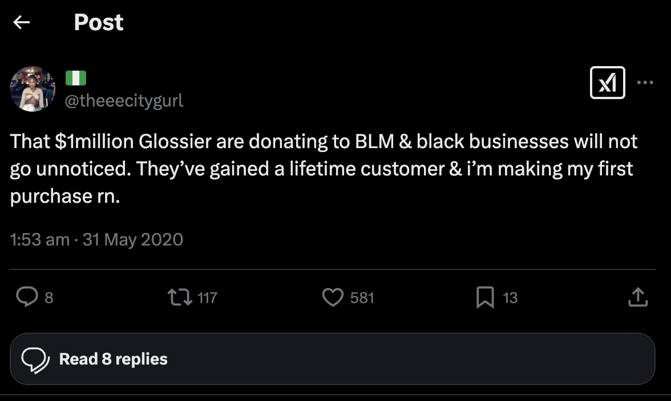
Fig 8 “Tweet about Glossier” 2020 https://x.com/theeecitygurl/status/1266895610038362119?s=20

Glossier was one of the first brands major beauty brands to make these efforts and fight against police brutality. Consumers were quick to notice their impact and took to social media to praise the company for their efforts. Here we can see a clear contrast between how a company approached a situation with cultural sensitivity, Glossier and a company who lacked cultural sensitivity in their campaign, Pepsi.

The Canadian media theorist and philosopher Marshall McLuhan introduced the term “Global Village” in his book The Gutenberg galaxy: The making of typographic man. New York: McGraw-Hill 1962. McLuhan predicted that we would live in a world that would become interconnected through mass media and technology “Such is the character of a village or, since electric media, such is also the character of global village. And it is the advertising and PR community that is most aware of this basic new dimension of global interdependence” This theory proves the interconnectedness of society through technology and underscores the importance of cultural sensitivity in brand advertisement campaigns due to the worldwide reach these campaigns can have proven by McLuhan. With the interconnectedness of society from a wide range of ethnic backgrounds, a culturally insensitive advertisement can cause considerable damage to a brand which can be clearly seen with the Pepsi “Live for Now Moments Anthem” advertisement. It is vital for companies to have an increased cultural awareness when producing an advertisement campaign. If Pepsi had implemented a heightened cultural awareness and incorporated McLuhan’s global village theory to recognise the interconnected nature of their audience, they may have been able to anticipate and predict the backlash their advertisement would receive, thus ensuring they would be able to produce a campaign that resonated with society as a whole rather than an advertisement that felt exploitive and “tone deaf”. The thinkings of McLuhan correlates further with the next case study on Burger King.

Chapter 3 Case Study “Women Belong in the Kitchen” Burger King

On Monday, March 8th 2021, fast food chain Burger King UK published a tweet which read, “Women belong in the kitchen”. This tweet was launched onto social media on International Women’s Day. Burger King’s decision to play on the phrase “women belong in the kitchen” created a major backlash to the company’s efforts to support International Women’s Day. The play on words was an out of touch approach to address the gender inequality in the culinary industry and lacked cultural sensitivity. The campaign for International Women’s Day was aimed at highlighting the underrepresentation of women in the restaurant industry with an emphasis on professional kitchens. The campaign intended to promote the brands launch of an initiative to help increase the number of women in head chef roles and help more women become professional chefs. However due to the lack of cultural awareness the attempt to support the representation of women in the work place fell flat. The execution relied on a provocative and historically loaded stereotype. Burger King tweeted the opening statement before providing any follow up context on their new initiative to increase the number of women in the work place. Burger King inadvertently allowed for their initial tweet to be interpreted as an endorsement of outdated gender roles which is the opposite of what the brand aimed to achieve. The follow up tweets from burger king put the first tweet into context reading “ If they want to, of course, Yet only 20% of our chefs are women. We’re on a mission to change the gender ratio”.

Due to the lack of cultural sensitivity many consumers became fixated on the initial tweet and took to social media to voice their opinions. One user wrote ‘The engagement on your original tweet—which, again, is literally just a sexist trope—is 527% *higher* than the tweet announcing the scholarship program. Way more people are seeing you validate sexism on #InternationalWomensDay than are learning about your scholarship program.”

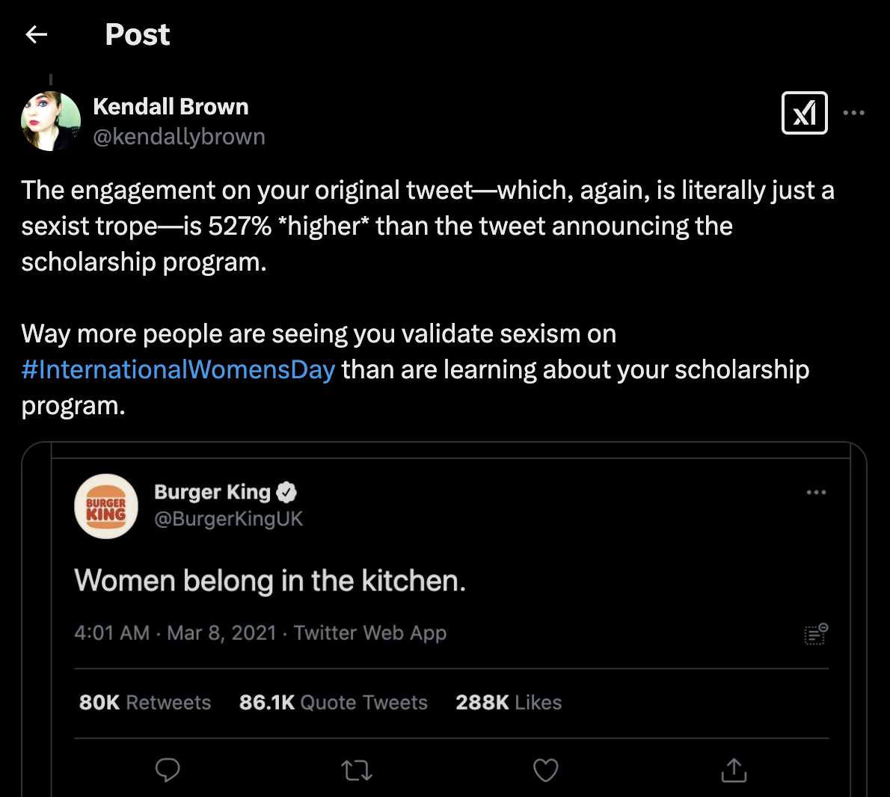
Fig.9 “ Consumers Tweet about Burger King” 2021 https://x.com/kendallybrown/status/1368959876966342662?ref_src=twsrc%5Etfw%7Ctwcamp%5Etweetembed%7Ctwterm%5E1368959876966342662%7Ctwgr%5E97f7909a1a9c2e9fef98ed8c344dfc68baf7291b%7Ctwcon%5Es1_&ref_url=https%3A%2F%2Fembedly.forbes.com%2Fwidgets%2Fmedia.html%3Ftype%3Dtext2Fhtmlkey%3D3ce26dc7e3454db5820ba084d28b4935schema%3Dtwitterurl%3Dhttps3A%2F%2Ftwitter.com%2Fkendallybrown%2Fstatus%2F1368959876966342662image%3Dhttps3A%2F%2Fi.embed.ly%2F1%2Fimage3Furl3Dhttps253A252F252Fabs.twimg.com252Ferrors252Flogo46x38.png26key3D3ce26dc7e3454db5820ba084d28b4935

The reactions online proved that many people were disappointed by the brands ignorance to cultural awareness and the place of women in the workplace. Burger King can often be seen using humorous marketing strategies in their social media posts see fig. but the brand missed the mark with the campaign by isolating the initial tweet without providing context for the broader initiative of the campaign. Burger King received more that 251,000 mentions on twitter before mid-day after the publication of their tweet, nearly matching the 323,000 mentions they had accumulated over a 2 week period previously. The consumer sentiment was largely negative towards the campaign with a remarkable 71% of mentions coming from men. Following on from the backlash the company received, the social media team spent the rest of the day issuing explanations and finally 12 hours later, an apology see fig. This reflects the expectation that the consumer now has on brands, where consumers expect socially correct messaging but also authenticity and accountability from these brands.

that the consumer now has on brands, where consumers expect socially correct messaging but also authenticity and accountability from these brands.
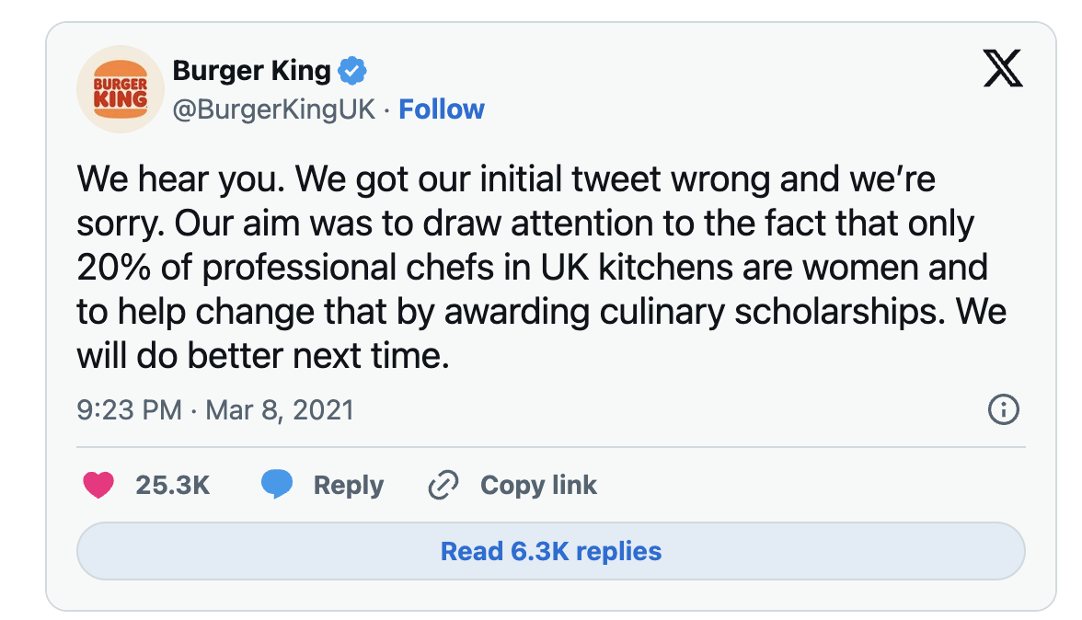
Fig. 10 “Burger King Apology” 2021https://x.com/BurgerKingUK/status/1369036021925638154?ref_src=twsrc%5Etfw%7Ctwcamp%5Etweetembed%7Ctwterm%5E1369036021925638154%7Ctwgr%5Eea1d7b1f8ba5726f8b28302158865ba05e1feae5%7Ctwcon%5Es1_&ref_url=https%3A%2F%2Fembedly.forbes.com%2Fwidgets%2Fmedia.html%3Ftype%3Dtext2Fhtmlkey%3D3ce26dc7e3454db5820ba084d28b4935schema%3Dtwitterurl%3Dhttps3A%2F%2Ftwitter.com%2Fburgerkinguk%2Fstatus%2F1369036021925638154image%3Dhttps3A%2F%2Fi.embed.ly%2F1%2Fimage3Furl3Dhttps253A252F252Fabs.twimg.com252Ferrors252Flogo46x38.png26key3D3ce26dc7e3454db5820ba084d28b4935

The campaign was also published in the New York Times as a full page advertisement. The “Women belong in the kitchen” text is large with accompanying text providing full details regarding the Burger King Foundation Scholarship programme stating “Fine dining kitchens, food truck kitchens, award-winning kitchens, casual dining kitchens, ghost kitchens, Burger King kitchens. If there’s a professional kitchen, women belong there.”When used in context the campaign can be quite impactful and positive. The company lacked cultural sensitivity on their social media platforms and in turn created an opportunity for consumers to scrutinise their lack of awareness surrounding women in the workplace. The brands lack of context on line and the isolation of the first tweet transformed the importance and significance of their worthy campaign into a spectacle and shifted the focus from the underrepresentation of women in the workplace to the brand’s ability to generate discussion online.

As researched in the Pepsi “Live for Now Moments Anthem” Case study this incident can also link to the concepts highlighted by Marshall McLuhan in his book The Gutenberg galaxy: The making of typographic man. McLuhan theorised that we would live in an technology driven, interconnected world where messages have the capability to spread rapidly making cultural sensitivity more crucial than ever. The failure of burger kings campaign illustrates how a message that may have been intended as attention grabbing in one cultural context can then become widely misinterpreted when dispensed throughout a large global scale. Had Burger King integrated the concept of McLuhan’s Global village into their campaign they may have been able to articulate a more refined understanding on the importance of cultural sensitivity when advertising to global communities. Burger King would have been able to effectively exercise their message without isolating their audience. The backlash the company received serves as proof that the importance of cultural sensitivity in advertising is crucial.

German philosopher and political economist Karl Marx speaks about the term commodity as fetishism in his book A Critique of Political Economy Vol1 1859. "A commodity appears at first sight an extremely obvious, trivial thing. But its analysis brings out that it is a very strange thing, abounding in metaphysical subtleties and theological niceties" In his theory, Marx suggests that commodities in their everyday use, can carry cultural and ideological meanings that can extend beyond their physical attributes or functional values. These meanings can often be concealed which gives the commodity the appearance of being natural when in reality they are shaped by social relations and power dynamics. Relating Marx theory to the burger king campaign, one could argue that the campaign commodifies women’s roles in society, concealing underlying gender dynamics. The campaign at surface level attempted to be humorous but deepening this campaign, it reinforces harmful stereotypes about women’s place in the kitchen. This aligns fully with Marx’s theory of how commodities can take on an ideological significance, even when their true meaning are hidden or fetishised in the public perception.

By acknowledging the complexities of the global village theorised by Marshall McLuhan and the progressing past the theory of commodity fetishism by Karl Marx, companies can create a stronger and more loyal relationship with consumers whilst avoiding the reputational damage that can occur from the lack of cultural sensitivity in advertising campaigns.

Chapter 4 Case Study Balenciaga’s Controversial Campaigns

November 16th, 2022 luxury fashion brand Balenciaga launched its new holiday gifting campaign, the campaign featured a controversial set of images. The image that resulted in the most influential backlash to the company includes a child holding a teddy bear dressed in bondage style clothing. The child is standing on a bed in a children’s room wearing Balenciaga clothing, holding the teddy bear while the rest of the bed is scattered with Balenciaga products arranged almost representing toys. The campaign was photographed by Gabriele Galimberti who is commonly known for her images of people surrounded by their personal collections, including toys, guns and medicines. After a few days of minimal public reaction, the campaign began to attract intense criticism for the images featuring children alongside the bondage inspired teddy bears. The disturbing juxtaposition of innocence with adult, controversial themes sparked outrage on social media. This controversial campaign raised serious accusations about Balenciaga sexualising children.

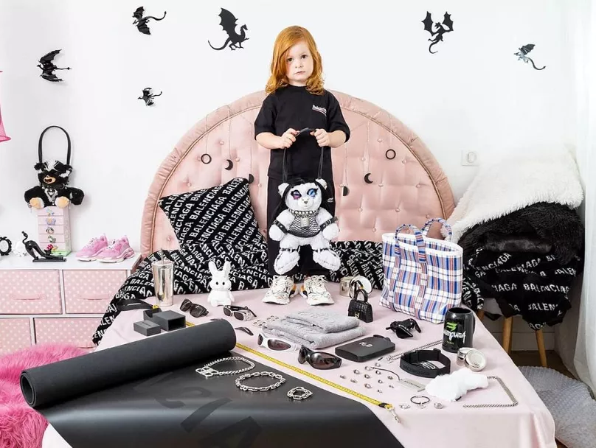
Fig 11 “Balenciaga Child Controversy Campaign” 2022 https://www.euronews.com/culture/2022/11/23/fashion-label-balenciaga-pulls-ads-featuring-children-with-bondage-teddy

The company was accused of sexualising minors through the use of props in their campaign whilst also being accused of promoting paedophilia. Following the accusations made against Balenciaga on social media, consumers began to analyse the company’s previous campaigns more closely. Upon inspection social media users identified paedophilic messages in a campaign from the brands Spring/Summer 2023 collection, which had been published just weeks earlier. The campaign featured French actress Isabelle Huppert, in an office settling accompanied with legal documents in her bag that coincidentally aligned with a Supreme Court decision on child pornography. On November 21st, the crisis escalated rapidly when a tweet by social media user @shoe0nhead that read “the brand “Balenciaga” just did a uh….. Interesting…Photoshoot for their new products recently which included a very purposely poorly hidden court document about ‘virtual child porn’…normal stuff ” went viral with the hash-tags #burnbalenciaga and #cancelbalenciaga. In February 2025 this tweet has currently accumulated 39,000 retweets and 112,000 likes. November 22nd saw the first day that the Balenciaga campaign was picked up by media outlets. Tucker Carlson, a commentator on Fox news publicly accused the brand of promoting child pornography. Within 24 hours Balenciaga released their first apology which has now been deleted. It read “We sincerely apologize for any offense our holiday campaign may have caused. Our plush bear bags should not have been featured with children in this campaign. We apologize for displaying unsettling documents in our campaign”. November 25th 2022, Balenciaga filed a lawsuit to sue the production company North Six Inc. and Nicholas Des Jardins, the set designer of the photoshoot for 25 million dollars for the inclusion of the documents in their campaign stating they had no knowledge, but agree to taking accountability for their lack of oversight and control of the campaign images.

The backlash progressed to physical vandalization of 2 Balenciaga stores in Los Angeles’ Rodeo Drive and London’s Bond Street, consumers took to social media posting videos of them destroying products they owned from the brand. November 27th, 11 days after the initial campaign launch, Kim Kardashian was the only celebrity linked to Balenciaga that spoke out on the crisis. Kim Kardashian tweeted “I am currently re-evaluating my relationship with the brand, basing it off their willingness to accept accountability for something that should have never happened to begin with - & the actions I am expecting to see them take to protect children” . Kim Kardashians statement marked the pinnacle controversy surrounding this campaign. The day following on from her statement saw the most Google searches for ‘Balenciaga Scandal’. Research shows that the united states, Balenciagas second largest market, generating 34% of its annual income accounted for the highest volume of searches following on from the controversy. As a response to the vandalism of their stores, November 28th, Balenciaga issued a statement admitting “a series of grievous errors for which Balenciaga takes responsibility”, and announced ongoing “internal and external investigations” as well as reaching out to “organizations who specialize in child protection and aim at ending child abuse and exploitation”

After another period of silence, on December 2nd, Demna, Balenciaga’s creative director and President and CEO Cédric Charbit broke the company’s silence by releasing separate statements following on from the campaign. Creative director Demna, took responsibility by apologising and stating “As much as I would sometimes like to provoke a thought through my work, I would NEVER have an intention to do that with such an awful subject as child abuse that I condemn. Period.’ President and CEO Charbit outlined the extensive set of actions that the company plans to take to rectify and learn from their mistakes such as new control instances for content validation, a reorganization of their image department, dropping the lawsuit against the third parties involved in the campaign, and donations to organizations that care for children safety.
He reiterated Demna’s statement by saying “my sincere apologies for the offense caused and take my responsibility”. Following on from the scandal Balenciaga suspended all posts on their social media platforms. Posts were ceased and all comments were muted. The consequences of the Balenciaga advertising scandal were severe and had a lasting impact on the brand’s reputation and public image. The ill-conceived advertisement campaign led to widespread fallout, particularly within the celebrity community. Prominent figures distanced themselves from the brand, signaling their disapproval. Dua Lipa, for instance, made the decision to cancel all future plans involving Balenciaga, including the outfits she had chosen for her upcoming tour. Bella Hadid followed suit, removing all traces of her collaborations with Balenciaga from her Instagram account. This high-profile backlash marked the beginning of a larger, more systemic loss of support for the brand.
In addition to the celebrity disapproval, Balenciaga’s social media presence suffered a significant blow. The brand experienced a loss of approximately 100,000 followers in the wake of the scandal, with the most substantial drop occurring on November 28th, following Kim Kardashian's critical tweet. On that single day, the brand lost a staggering 34,730 followers, underscoring the intense public reaction to the campaign and the subsequent controversy. The negative response was particularly pronounced on platforms such as TikTok, which has become an essential tool for brands like Balenciaga to engage with and target their Gen Z audience. TikTok's viral nature exacerbated the situation, with hashtags such as #CancelBalenciaga quickly gaining traction and generating over 180 million views.
The scale of the backlash on TikTok was immense, with a combined total of approximately 600 million views on content that criticized the brand. The viral nature of the backlash demonstrated how swiftly and powerfully consumer sentiment could be shaped and spread, particularly in the digital age where brands are heavily reliant on social media to connect with their audiences. In this case, the scandal highlighted the risks brands face when their advertising fails to align with maintain cultural sensitivity of their target demographic and the broader public, resulting in a significant loss of trust and engagement.
Similar to Pepsi’s “Live for Now Moment Anthem” and Burger Kings “Women belong in the Kitchen” campaign, the Balenciaga advertising campaigns further highlights and proves the importance of cultural sensitivity in advertising. Balenciaga’s campaign highlights how the commodification of brand image as previously explained using Karl Marx’s concept of commodity fetishism, can quickly become damaged in Marshall McLuhans global village, where the consumers backlash is amplified at large scales and spread globally. Much like Pepsi and Burger King, Balenciaga must take heightened awareness when tackling cultural sensitivity focusing on Marx’s theory of commodity fetishism and McLuhans notion of a global village and use these theories to be aware of the impact lack of cultural sensitivity can have on their brand.

French sociologist, Émile Durkheim explains his concept of collective consciousness in his book The Divisions of Labour in Society (1893) The concept of collective consciousness explains how societies share a set of moral values and beliefs that exceed individual perspectives, shaping social order and cohesion. He states :
The totality of beliefs and sentiments common to average citizens of the same society forms a determinate system which has its own life; one may call it the collective or common conscience. No doubt, it has not a specific organ as a substratum; it is, by definition, diffuse in every reach of society. Nevertheless, it has specific characteristics which make it a distinct reality. It is, in effect, independent of the particular conditions in which individuals are placed; they pass on and it remains. Moreover, it does not change with each generation, but, on the contrary, it connects successive generations with one another. It is thus an entirely different thing from particular consciences, although it can be realised only through them.
This theory is relevant when analysing the backlash against Balenciaga’s controversial campaigns. The backlash the campaign received was not just a single consumers assumption. Rather the lack of cultural sensitivity ignited a collective moral response driven by deeply embedded social values in relation to child protection and brand responsibility. The campaign was viewed as crossing important ethical lines, leading to widespread criticism as society worked to reinforce and protect shared moral values.

Durkheim also insists that collective consciousness is integrated across generations linking past and present moral frameworks. This is clear to see from the above case studies where Pepsi, Burger King and Balenciaga have faced backlash for their controversial advertising campaigns that clashed with society’s views and values surrounding cultural sensitivity. Balenciaga’s campaign reinforces Durkheim’s idea of collective consciousness and highlights how shared beliefs shape what society view as acceptable and reinforces the importance of cultural sensitivity within campaigns

Conclusion

The purpose of this thesis is to provide a comprehensive examination of the ways in which a lack of cultural awareness in advertising affects not only the reputation of brands but also the social status of other businesses. I have proven, via the use of case studies involving the Kendall Jenner advertisement for Pepsi, the "Women Belong in the Kitchen" campaign for Burger King, and the provocative campaign for Balenciaga, how the incapacity of each company to take into consideration cultural sensitivity resulted in significant public reaction and widespread criticism. This study examines the implications of these advertising efforts and applies the theoretical frameworks of Durkheim, Marx, and McLuhan in order to demonstrate the substantial influence that cultural sensitivity—or the lack thereof—has on brands and the relationships that they have with consumers.
This thesis contains a number of research that have demonstrated an important fact: the public's perception of a brand is directly proportional to the degree to which advertising fails to demonstrate cultural sensitivity. Consumers in today's society are extremely sensitive to cultural issues; hence, when businesses fail to represent the values and norms of the societies in which they operate, the reaction may be swift and forceful. These consequences, in addition to being social ones, have an impact on the public image of a company as well as the loyalty of its customers. Reputational damage to a brand can result in a number of negative outcomes, including decreased consumer trust, decreased brand loyalty, and lost consumer loyalty. According to the case studies, Pepsi, Burger King, and Balenciaga all experienced significant damage to their reputations as a result of the culturally inappropriate advertisements they ran. In addition to highlighting the fact that contemporary advertising must acknowledge the intricate connection that exists between cultural awareness and brand performance, these losses extended beyond issues pertaining to public relations and showed a broader rejection of their messaging by mainstream culture.
The primary argument that is being made in this thesis is that the lack of cultural sensitivity in advertising has a significant and detrimental impact on the public's confidence in brands. The contributions of sociologists such as Émile Durkheim, Karl Marx, and Marshall McLuhan are extremely valuable when it comes to developing a theoretical framework for understanding how advertising influences public opinion. By incorporating these theories into the discussion, I was able to gain a better understanding of the more widespread repercussions of advertising that is insensitive to cultural norms and how it has the potential to disrupt the delicate balance that exists between the message of a business and the values of society.
A better understanding of the societal repercussions of advertising that are culturally insensitive can be gained through the concept of the "global village" proposed by Marshall McLuhan. The interdependence of the planet was brought to light by McLuhan, who emphasised the role that the media plays in facilitating the quick transmission of messages across national boundaries and reaching audiences all over the world. The ads for Pepsi, Burger King, and Balenciaga failed to take into account the significant cultural differences and differing levels of sensitivity that their respective audiences represented. By disregarding these differences, the businesses alienated a significant portion of their client base, which resulted in outrage all around the world. In light of the fact that messages can instantly spread across the globe and have far-reaching impacts in a society that is becoming more interconnected by the day, McLuhan's theory suggests that contemporary enterprises need to place a greater emphasis on the cultural context in which they communicate. If these businesses had been aware of the cultural repercussions of their actions, they would have been able to steer clear of the widespread criticism and keep a tighter relationship with their customers all over the world.
The idea of commodity fetishism, which was developed by Karl Marx, provides an insight of how businesses commercialise cultural symbols and social issues in an effort to benefit from societal trends. Burger King's "Women Belong in the Kitchen" campaign was designed to shock and stimulate attention by commodifying gender inequality as a marketing tool. As a result, the campaign completely ignored the cultural repercussions of its actions. Marx's theory serves to remind us that brands run the risk of trivialising crucial cultural discussions and encouraging negative stereotypes by reducing serious social problems to the level of mere commodities. A technique that would have been more culturally appropriate would have been to leverage advertising in order to create awareness or push societal change. This would have been accomplished rather than using sensitive themes for shock value. If Burger King had given Marx's theory of commodity fetishism more careful consideration, they could have been able to develop a campaign that truly engaged their target market and promoted a more positive response from them.
In addition, when considering the campaign for Pepsi Kendall Jenner, McLuhan's theory of the global village is extremely relevant to the situation. McLuhan argued that the proliferation of electronic media had transformed the world into a "global village," in which information is rapidly disseminated across national boundaries. Due to the interdependence of these factors, advertising campaigns have the potential to nearly immediately reach people all over the world, and any mistake might have significant consequences. In a short amount of time, the Pepsi campaign became a viral hot issue and quickly garnered popularity on social media. This was accomplished by trivialising social justice movements. McLuhan's thesis asserts that contemporary advertising cannot function in a vacuum; rather, it must take into account the various cultural debates that are taking place all over the world as well as the various perspectives of its target audience. If Pepsi had taken into consideration McLuhan's notion of the global village, the company might have realised that the message conveyed by their advertisement would be rather different depending on the civilisations and civilisations that were being utilised, particularly those that were working towards achieving social justice.
Taking into consideration the importance of cultural sensitivity in marketing, the theories of Durkheim, Marx, and McLuhan provide a solid foundation for understanding the necessity of such sensitivity. The theories presented here demonstrate that advertising is not merely a business instrument but rather a social force that has the ability to influence public opinion, support common values, and thus have an impact on the culture of the entire world. In the event that businesses fail to take into account the cultural aspects of their marketing, they face the risk of alienating their target audience and suffering damage to their reputation. On the other side, businesses that incorporate cultural awareness into their advertising not only conform to the standards of society, but they also benefit from maintaining a customer base that is more engaged and committed to their brand.
As someone who works in the field of research, I strongly recommend that businesses cultivate their awareness of cultural sensitivity before beginning an advertising campaign. Because of the interconnected nature of the modern world, it is essential for businesses to be conscious of the cultural impact of their communications, in addition to the economic or market trend focus they may have. It will be easier for businesses to build trust with their customers, deepen their relationships with them, and avoid the negative consequences that commercials that lack cultural sensitivity can have if they incorporate cultural understanding into their public relations initiatives. Furthermore, businesses that place a high focus on cultural sensitivity are more likely to cultivate long-term customer loyalty and strengthen their reputation, which ultimately results in an increase in both their social standing and their commercial influence.
It is my recommendation that businesses adopt a paradigm that incorporates cultural understanding into their marketing strategies, free from the constraints of ignorance or insensitivity for the purpose of marketing. Whether through Durkheim's community consciousness, Marx's commodity fetishism, or McLuhan's global village, marketers have the ability to select significant lessons on the manner in which their advertising influences the perceptions and values of society. Businesses may be able to design more successful and relevant ads if they are aware of the cultural environment in which they operate. These campaigns not only appeal to the consumers they are trying to reach, but they also contribute to the strengthening of the social fabric of society. In addition to enhancing their social presence, this technique will be of assistance to brands on a global scale.
Essentially, the purpose of this thesis has been to demonstrate that cultural sensitivity is not merely a passing fad or a transient problem; rather, it is an essential component of contemporary advertising that has social as well as cultural implications for business branding. They will be able to avoid the risks of controversy, enhance their relationship with customers, and have a positive impact on society that will continue for a long time if they adopt a more intentional and culturally sensitive approach to advertising. According to the findings of the research, disregarding cultural sensitivity has potentially far-reaching consequences not only for the image of a brand but also for the greater cultural environment. In the global village that is the connected world of today, brands have to come to the realisation that their advertising efforts contribute to the ongoing cultural dialogue that has an effect on our society, rather than simply promoting products.

Bibliography
Electronic Material/Websites

“About WK | Wieden+Kennedy.” Www.wk.com, www.wk.com/about/.
Akshat Singh Bisht. “How Nike You Can’t Stop Us Performed 30% Sales.” Digital Marketing Consultant & Expert Akshat Singh Bisht | Digital Marketing Expert , Consultant & Advisor, Digital Marketing Consultant & Expert Akshat Singh Bisht, 28 Feb. 2024, akshatsinghbisht.com/how-nike-you-cant-stop-us-performed-30-sales/?srsltid=AfmBOoo263MwKNTBrCsT3KTpEBpA6DIer3ehhTLYdq8IqmUtYhX9QC1V. Accessed 13 Feb. 2025.
Alcorn, Chauncey. “Nike’s Viral ‘You Can’t Stop Us’ Ad Is Winning Big on Social Media.” CNN, 1 Aug. 2020, edition.cnn.com/2020/07/31/business/nike-video-ad-you-cant-stop-us/index.html.
“Audio and Video - Sut Jhally Website.” Sutjhally.com, 2025, www.sutjhally.com/audiovideo. Accessed 13 Feb. 2025.
Betancourt, Bianca. “Glossier Is Donating $1 Million to Black Lives Matter and Black-Owned Beauty Brands.” Harper’s BAZAAR, 1 June 2020, www.harpersbazaar.com/beauty/makeup/a32731503/glossier-donates-one-million-dollars-to-black-causes/.
“Black Lives Matter: Brands Who Are Doing It Right | the Marketing Society.” Marketingsociety.com, 2025, marketingsociety.com/blog-post/black-lives-matter-brands-who-are-doing-it-right. Accessed 13 Feb. 2025.
Bonis, Francesca. “Not an Option: Cultural Sensitivity in Advertising | Adapt.” Adapt, 27 May 2022, www.adaptworldwide.com/insights/2022/what-is-cultural-sensitivity-in-advertising.
Bouzida, Feyrouz. “THE SEMIOLOGY ANALYSIS in MEDIA STUDIES -ROLAND BARTHES APPROACH.” THE SEMIOLOGY ANALYSIS in MEDIA STUDIES - ROLAND BARTHES APPROACH -, vol. 8, no. 10, 2014, p. 1002, www.ocerints.org/Socioint14_e-publication/papers/293.pdf.
Brown, Lee. “Balenciaga Stores Targeted by Vandals: ‘Children R Not Sexual Objects.’” New York Post, 30 Nov. 2022, nypost.com/2022/11/30/vandals-target-balenciaga-stores-children-r-not-sexual-objects/.
“Burger King Foundation.” Www.burgerkingfoundation.org, www.burgerkingfoundation.org/programs/burger-king-sm-scholars.
CNN, Parija Kavilanz, CNN Business | Lianne Kolirin, CNN and Toyin Owoseje. “Balenciaga Suing Production Company for $25 Million over Controversial Campaign.” CNN, 2022, edition.cnn.com/style/article/balenciaga-lawsuit-controversial-campaign/index.html.
Constantin, Elena Claudia, et al. “Developing Cultural Awareness.” Procedia - Social and Behavioral Sciences, vol. 191, no. 1, June 2015, pp. 696–99, https://doi.org/10.1016/j.sbspro.2015.04.228.
Dag, Veysi. “The Politics of Cultural Production.” Diaspora Studies, Aug. 2022, pp. 1–26, https://doi.org/10.1163/09763457-bja10019.
Dailey, Natasha. “Burger King’s ‘Women Belong in the Kitchen’ Tweet, Meant to Critique the Male-Dominated Cooking Industry, Receives Backlash on International Women’s Day.” Business Insider, 9 Mar. 2021, www.businessinsider.com/burger-king-women-belong-in-kitchen-tweet-international-womens-day-2021-3.
Desktop, Noble. “Understanding Cultural Sensitivity in Global Marketing Strategies.” Nobledesktop.com, 4 June 2024, www.nobledesktop.com/learn/digital-marketing/understanding-cultural-sensitivity-in-global-marketing-strategies.
Dozé, Mariah. “Kendall Jenner and Pepsi.” Young Scholars in Writing, vol. 15, July 2019, pp. 116–22, youngscholarsinwriting.org/index.php/ysiw/article/view/267/288.
Durkheim, Émile. The Division of Labour in Society. Palgrave Macmillan, 1893.
Elliot, Josh. “Burger King Gets Grilled for ‘Women Belong in the Kitchen’ Tweet.” Global News, 8 Mar. 2021, globalnews.ca/news/7683800/burger-king-womens-day-kitchen-tweet/.
“Equality, Diversity and Inclusion | Cultural Awareness.” Www.ucd.ie, 20 July 2022, www.ucd.ie/equality/support/multiculturalism/culturalawareness/.
“Extracts from Emile Durkheim.” Studymore.org.uk, studymore.org.uk/xdur.htm.
Fields, Stanley, and Mark Johnston. “The Law of Evolution: Darwin, Wallace, and the Survival of the Fittest.” Www.ncbi.nlm.nih.gov, MIT Press, 2010, www.ncbi.nlm.nih.gov/books/NBK559908/.
Flynn, Patrick. “Nike Marketing Strategy: A Company to Imitate.” Accounting, May 2015, scholarsarchive.library.albany.edu/honorscollege_accounting/14/.
---. Nike Marketing Strategy: A Company to Imitate. May 2018, scholarsarchive.library.albany.edu/cgi/viewcontent.cgi?article=1013&context=honorscollege_accounting.
Gárgoles, Paula, and Gabriela Ambás. “The Power of Consumers on Social Media: A Case Study of Balenciaga’s Crisis Communication.” Springer Proceedings in Business and Economics, Jan. 2023, pp. 3–13, https://doi.org/10.1007/978-3-031-38541-4_1.
Hanak-Hammerl, Martin, and David Newby. SECOND LANGUAGE ACQUISITION: THE INTERFACE between THEORY and PRACTICE Summary of Findings of a Project-Based Linguistics Seminar Held at the GRAZ SECOND LANGUAGE ACQUISITION: THE INTERFACE between THEORY and PRACTICE 1 Contents. 2002, citeseerx.ist.psu.edu/document?repid=rep1&type=pdf&doi=a9e3f2800f466858e3432b79b20cd17a414c19da#page=49.
Hayat, Noor. “LinkedIn.” Linkedin.com, 20 Nov. 2024, www.linkedin.com/pulse/how-nikes-you-cant-stop-us-inspired-global-movement-noor-hayat-lnsff/.
“Ieshia Evans, Woman in Iconic Baton Rouge Police Protest Photo, Speaks Out.” Cbsnews.com, CBS News, 15 July 2016, www.cbsnews.com/news/ieshia-evans-woman-iconic-baton-rouge-police-protests-photo-speaks-out. Accessed 13 Feb. 2025.
Jhally, Sut. The Codes of Advertising. Routledge, 2014, https://doi.org/10.4324/9780203873079.
Joyce, Gemma. “Data on the Extent of the Backlash to the Kendall Jenner Pepsi Ad.” Brandwatch, 7 Apr. 2017, www.brandwatch.com/blog/react-kendall-jenner-pepsi-ad/.
Kelleher, Suzanne Rowan. “‘Women Belong in the Kitchen’: Burger King’s International Women’s Day Tweet Goes down in Flames.” Forbes, 9 Mar. 2021, www.forbes.com/sites/suzannerowankelleher/2021/03/09/women-belong-in-the-kitchen-burger-kings-international-womens-day-tweet-goes-up-in-flames/.
Kintan, Rismawati. “SIGNS and THEIR MEANINGS on PEPSI ADVERTISEMENT TITLED KENDALL JENNER: LIVE BOLDER, LIVE LOUDER, LIVE for NOW (a SEMIOTIC STUDY) - Repository UNSADA.” Unsada.ac.id, 2020, http://repository.unsada.ac.id/2074/1/COVER.pdf. Accessed 13 Feb. 2025.
Leiss, William, et al. “60 ‘Social Communication in Advertising.’” Media Studies, Edinburgh University Press, Dec. 2009, pp. 772–85, https://doi.org/10.1515/9781474473231-082. Accessed 13 Feb. 2025.
Liffreing, Ilyse, and Jessica Wohl. “Burger King Deletes International Women’s Day Tweet after Getting Grilled as Its Intent Is Misinterpreted.” Ad Age, 8 Mar. 2021, adage.com/article/marketing-news-strategy/burger-king-deletes-international-womens-day-tweet-after-getting-grilled-its-intent-misinterpreted/2320086.
“MakeMake.” MakeMake, 27 Aug. 2021, makemakeentertainment.com/news/a52/p/behind-the-making-of-nikes-you-cant-stop-us-campaign/.
Marketing Mag. “Share a Coke Campaign Post-Analysis.” Marketing Mag, 22 June 2012, www.marketingmag.com.au/news/share-a-coke-campaign-post-analysis/.
Martin, Leah Asmelash,Jill. “NBA Players Took a Knee before Kicking off the League’s Reopened Season.” CNN, 30 July 2020, edition.cnn.com/2020/07/30/us/pelicans-jazz-blm-tribute-nba-spt-trnd/index.html.
Misztal, Barbara A. “Durkheim on Collective Memory.” Journal of Classical Sociology, vol. 3, no. 2, July 2003, pp. 123–43, https://doi.org/10.1177/1468795x030032002.
Morrais, Joanna. “‘Share a Coke’ Campaign a Success.” Social Media Marketing Blog, 15 Oct. 2014, joannamoraisblog.wordpress.com/2014/10/15/share-a-coke-campaign-a-success/. Accessed 2 Feb. 2025.
Moye, Jay. “Share a Coke: Bigger and Better than Ever - Coca-Cola UNITED.” Coca-Cola UNITED, 18 May 2015, cocacolaunited.com/blog/2015/05/18/share-coke-bigger-better-ever/.
Nast, Condé. “Glossier Is Donating $1 Million to Support Black Lives Matter and Other Organizations.” Teen Vogue, 31 May 2020, www.teenvogue.com/story/glossier-donation-black-lives-matter.
Nguyen, Thy, and Thuan Nguyen. Factors That Make a Marketing Cam- Paign Go Viral Case Study: Campaign “Share a Coke” by Coca Cola in Vietnam. 17 Apr. 2015, www.theseus.fi/bitstream/handle/10024/92051/thesis%20final%20report.pdf?sequence=1&isAllowed=y. Accessed 13 Feb. 2025.
Nike. “What Is Nike’s Mission? .” Nike, 2025, www.nike.com/help/a/nikeinc-mission.
NIKE JAPAN. “You Can’t Stop Us | Nike.” YouTube, 31 July 2020, www.youtube.com/watch?v=GbQomqb28os.
“Nike: You Can’t Stop Us | Wieden+Kennedy.” Www.wk.com, July 2020, www.wk.com/work/nike-you-cant-stop-us/.
Olorunnipa, Toluse. “George Floyd | American Citizen.” Encyclopedia Britannica, 2 Aug. 2023, www.britannica.com/biography/George-Floyd.
Ong, Grace. “Analysis: Nike’s Latest Viral Ad Goes Way beyond Brilliant Editing.” Www.marketing-Interactive.com, 3 Aug. 2020, www.marketing-interactive.com/analysis-nikes-viral-ad-goes-way-beyond-brilliant-editing.
Paton, Elizabeth, et al. “When High Fashion and QAnon Collide.” The New York Times, 28 Nov. 2022, www.nytimes.com/2022/11/28/style/balenciaga-campaign-controversy.html.
Pereira Petrucci , Inês. The Impact of Consumer Perceptions of Personalised Advertising on Purchase Intention. studenttheses.uu.nl/bitstream/handle/20.500.12932/47446/Petrucci%2C%20I.P._1608703.pdf?sequence=1&isAllowed=y.
Pires, Guilherme, and John Stanton. Ethnic Marketing. Dec. 2014, https://doi.org/10.4324/9780203362075.
Retail, Modern. “The Importance of Cultural Sensitivity for Global Brands and Retailers | Modern Retail.” Modernretail.co.uk, 12 May 2020, modernretail.co.uk/the-importance-of-cultural-sensitivity-for-global-brands-and-retailers/.
Robertson, Graham. “Nike’s You Can’t Stop Us Is a Masterclass in Advertising.” Beloved Brands, 31 July 2020, beloved-brands.com/nike-you-cant-stop-us/.
Sanders, Kurt. “What Really Makes the You Can’t Stop Us Campaign from Nike One of Their Best? - the Slice.” The Slice, 13 Sept. 2020, theslice.thecontentdivision.com.au/case-studies/what-really-makes-the-you-cant-stop-us-campaign-from-nike-one-of-their-best/.
Smith, Alexander. “Pepsi Pulls Controversial Kendall Jenner Ad after Outcry.” NBC News, 5 Apr. 2017, www.nbcnews.com/news/nbcblk/pepsi-ad-kendall-jenner-echoes-black-lives-matter-sparks-anger-n742811.
Socha, Miles. “Balenciaga CEO, Demna Apologize for ‘Disturbing’ Ads.” WWD, 2 Dec. 2022, wwd.com/fashion-news/designer-luxury/demna-apology-balenciaga-ad-campaign-children-1235435961/.
T.M. Nguyen, Trang, and Tho Dinh Nguyen. “The Impact of Cultural Sensitivity and Information Exchange on Relationship Quality.” Marketing Intelligence & Planning, vol. 32, no. 7, Sept. 2014, pp. 754–68, https://doi.org/10.1108/mip-12-2012-0140.
The Minority. 2007, lushdigital.com/publications/titlenews/07/PDF/04-03.pdf.
Tremblay, Gaëtan. “From Marshall McLuhan to Harold Innis, or from the Global Village to the World Empire.” Canadian Journal of Communication, vol. 37, no. 4, Dec. 2012, https://doi.org/10.22230/cjc.2012v37n4a2662.
Tsai, Julie. “Nike Data Analysis: ‘You Can’t Stop Us’ Campaign Drives $8.95M in MIV®.” Launchmetrics, 24 Sept. 2020, www.launchmetrics.com/resources/blog/nike-data-analysis.
“Twitter Blasts Kendall Jenner’s Cringeworthy Pepsi Commercial.” HuffPost, 5 Apr. 2017, www.huffpost.com/entry/twitter-kendall-jenner-pepsi-commercial_n_58e44334e4b03a26a367577e.
Virvilaitė, Regina, and Miglė Matulevičienė. “THE IMPACT of SHOCKING ADVERTISING to CONSUMER BUYING BEHAVIOR.” ECONOMICS and MANAGEMENT, vol. 18, no. 1, June 2013, https://doi.org/10.5755/j01.em.18.1.3643.
Vision, Madame. “Nike’s ‘Can’t Stop Us’ Marketing Campaign - Madame Vision - Medium.” Medium, Medium, 30 Oct. 2023, medium.com/@madamevision/nikes-can-t-stop-us-marketing-campaign-e00a1104e129.

Journals

Dekimpe, Marnik G., and Dominique M. Hanssens. “Sustained Spending and Persistent Response: A New Look at Long-Term Marketing Profitability.” Journal of Marketing Research, vol. 36, no. 4, Nov. 1999, pp. 397–412, https://doi.org/10.1177/002224379903600401.
Dwivedi, Yogesh K., et al. “Setting the Future of Digital and Social Media Marketing Research: Perspectives and Research Propositions.” International Journal of Information Management, vol. 59, no. 1, 2021, pp. 1–37, https://doi.org/10.1016/j.ijinfomgt.2020.102168. Sciencedirect.
Saqina, Arnez Dikayani. “The Impact of Crisis Situation and Communication Strategies: Pepsi Controversial Kendall Jenner Advertisement Turns to Racism.” Dynamic Media, Communications, and Culture: Conference Proceedings, vol. 2, no. 0, June 2021, e-journal.president.ac.id/presunivojs/index.php/DIMCC/article/view/1525/870.

Books
Marx, Karl. A Contribution to the Critique of Political Economy. 1859.
Mcluhan, Marshall, et al. The Gutenberg Galaxy : The Making of Typographic Man. University Of Toronto Press, 2017.

Articles
Wang, Tong, and Marco Gambaro. The Relationship between Advertising and Consumption. May 2023, pp. 1–3, https://doi.org/10.21203/rs.3.rs-2918693/v1. Accessed 20 Nov. 2024.

Wang, Tong, and Marco Gambaro. The Relationship between Advertising and Consumption. 23 May 2023, p1-3. Accessed 20th Nov. 2024.
Ibid, p.2 .
Vitalis, Perpetua Ogechi, Timothy Ekeledirichukwu Onyejelem, and Ademolu Patrick Okuneye. "Understanding advertising in the era of social media." Information System and Smart City 3.1 (2023): 502-502. p.4. Accessed 12th Dec. 2024
Dekimpe, Marnik G., and Dominique M. Hanssens. “Sustained Spending and Persistent Response: A New Look at Long-Term Marketing Profitability.” Journal of Marketing Research, vol. 36, no. 4, Nov. 1999. Accessed 1st Feb 2025.
Dwivedi, Yogesh K., et al. “Setting the Future of Digital and Social Media Marketing Research: Perspectives and Research Propositions.” International Journal of Information Management, vol. 59, no. 1, 2021, p2. Accessed 12th Dec 2024.
Nguyen, Thy, and Thuan Nguyen. Factors That Make a Marketing Cam- Paign Go Viral Case Study: Campaign “Share a Coke” by Coca Cola in Vietnam. 17 Apr. 2015, p.10-11. Accessed 4th Feb. 2025.
Marketing Mag. “Share a Coke Campaign Post-Analysis.” Marketing Mag, 22 June 2012, www.marketingmag.com.au/news/share-a-coke-campaign-post-analysis/. Accessed 4th Feb 2025.
Lakshmanan, D., and S. Rabiyathul Basariya. "The role of social media on enhancing advertising effectiveness." International Journal of Civil Engineering and Technology 8.9 (2017). Accessed 25th Jan.2025.
KroNe, MiChAel P. "Diversity marketing & cultural awareness." Title News (2007). Accessed 25th Jan 2025.
Bonis, Francesca. “Not an Option: Cultural Sensitivity in Advertising | Adapt.” Adapt, 27 May 2022, www.adaptworldwide.com/insights/2022/what-is-cultural-sensitivity-in-advertising. Accessed 22nd Jan.2025.
Desktop, Noble. “Understanding Cultural Sensitivity in Global Marketing Strategies.” Nobledesktop.com, 4 June 2024, www.nobledesktop.com/learn/digital-marketing/understanding-cultural-sensitivity-in-global-marketing-strategies. Accessed 22nd Jan.2025
Ibid
Nike. “What Is Nike’s Mission? .” Nike, 2025, www.nike.com/help/a/nikeinc-mission. Accessed 20th Jan 2025.
“Nike: You Can’t Stop Us | Wieden+Kennedy.” Www.wk.com, July 2020, www.wk.com/work/nike-you-cant-stop-us/. Accessed 20th Jan 2025.
“About WK | Wieden+Kennedy.” Www.wk.com, www.wk.com/about/. Accessed 20th Jan 2025.
Ong, Grace. “Analysis: Nike’s Latest Viral Ad Goes Way beyond Brilliant Editing.” Www.marketing-Interactive.com, 3 Aug. 2020, www.marketing-interactive.com/analysis-nikes-viral-ad-goes-way-beyond-brilliant-editing Accessed 25th Jan 2025.
Alcorn, Chauncey. “Nike’s Viral ‘You Can’t Stop Us’ Ad Is Winning Big on Social Media.” CNN, 1 Aug. 2020, edition.cnn.com/2020/07/31/business/nike-video-ad-you-cant-stop-us/index.html. Accessed 25th Jan 2025.
Ong, Grace. op.cit
Hayat, Noor. “LinkedIn.” Linkedin.com, 20 Nov. 2024, www.linkedin.com/pulse/how-nikes-you-cant-stop-us-inspired-global-movement-noor-hayat-lnsff/. Accessed 6th Feb 2025.
Leiss, William, Stephen Kline, and Sut Jhally. Social communication in advertising: Persons, products & images of well-being. Psychology press, 1990. P.21 Accessed 24th November 2024.
Leiss, William, Stephen Kline, and Sut Jhally. Op.cit
Fields, Stanley, and Mark Johnston. “The Law of Evolution: Darwin, Wallace, and the Survival of the Fittest.” Www.ncbi.nlm.nih.gov, MIT Press, 2010, www.ncbi.nlm.nih.gov/books/NBK559908/. Accessed 1st Feb 2025.
Leiss, William, Stephen Kline, and Sut Jhally. Op.cit
Dozé, Mariah. “Kendall Jenner and Pepsi.” Young Scholars in Writing, vol. 15, July 2019, pp. 116–22, youngscholarsinwriting.org/index.php/ysiw/article/view/267/288. Accessed 7th Oct 2024.
Kintan, Rismawati. “SIGNS and THEIR MEANINGS on PEPSI ADVERTISEMENT TITLED KENDALL JENNER: LIVE BOLDER, LIVE LOUDER, LIVE for NOW (a SEMIOTIC STUDY) - Repository UNSADA.” Unsada.ac.id, 2020, http://repository.unsada.ac.id/2074/1/COVER.pdf. Accessed 20th Oct. 2024.
Saqina, Arnez Dikayani. “The Impact of Crisis Situation and Communication Strategies: Pepsi Controversial Kendall Jenner Advertisement Turns to Racism.” Dynamic Media, Communications, and Culture: Conference Proceedings, vol. 2, no. 0, June 2021, p. 6-10. Accessed 14th Oct.2024.
“Ieshia Evans, Woman in Iconic Baton Rouge Police Protest Photo, Speaks Out.” Cbsnews.com, CBS News, 15 July 2016, www.cbsnews.com/news/ieshia-evans-woman-iconic-baton-rouge-police-protests-photo-speaks-out. Accessed 15th Oct.2025.
@everywhereresist ‘Iesha Evans did it better. #PEPSI’ https://x.com/everywhereist/status/849397289139490816 Accessed 25th October 2024.
Saqina, Arnez Dikayani. Op.cit
Joyce, Gemma. “Data on the Extent of the Backlash to the Kendall Jenner Pepsi Ad.” Brandwatch, 7 Apr. 2017, www.brandwatch.com/blog/react-kendall-jenner-pepsi-ad/. Accessed 20th Oct 2024.
“Twitter Blasts Kendall Jenner’s Cringeworthy Pepsi Commercial.” HuffPost, 5 Apr. 2017, www.huffpost.com/entry/twitter-kendall-jenner-pepsi-commercial_n_58e44334e4b03a26a367577e. Accessed 22nd October 2024.
Betancourt, Bianca. “Glossier Is Donating $1 Million to Black Lives Matter and Black-Owned Beauty Brands.” Harper’s BAZAAR, 1 June 2020, www.harpersbazaar.com/beauty/makeup/a32731503/glossier-donates-one-million-dollars-to-black-causes/. Accessed 1st Feb 2025.
Olorunnipa, Toluse. “George Floyd | American Citizen.” Encyclopedia Britannica, 2 Aug. 2023, www.britannica.com/biography/George-Floyd. Accessed 1st Feb 2025.
“Black Lives Matter: Brands Who Are Doing It Right | the Marketing Society.” Marketingsociety.com, 2025, marketingsociety.com/blog-post/black-lives-matter-brands-who-are-doing-it-right. Accessed 1st Feb. 2025.
Nast, Condé. “Glossier Is Donating $1 Million to Support Black Lives Matter and Other Organizations.” Teen Vogue, 31 May 2020, www.teenvogue.com/story/glossier-donation-black-lives-matter. Accessed 1st Feb 2025.
Mcluhan, Marshall, et al. The Gutenberg Galaxy : The Making of Typographic Man. University Of Toronto Press, 2017. P.36 Accessed 1st November 2024.
Joyce, Gemma. Op.cit
Dailey, Natasha. “Burger King’s ‘Women Belong in the Kitchen’ Tweet, Meant to Critique the Male-Dominated Cooking Industry, Receives Backlash on International Women’s Day.” Business Insider, 9 Mar. 2021, www.businessinsider.com/burger-king-women-belong-in-kitchen-tweet-international-womens-day-2021-3. Accessed December 1st 2024.
Ibid
Kelleher, Suzanne Rowan. “‘Women Belong in the Kitchen’: Burger King’s International Women’s Day Tweet Goes down in Flames.” Forbes, 9 Mar. 2021, www.forbes.com/sites/suzannerowankelleher/2021/03/09/women-belong-in-the-kitchen-burger-kings-international-womens-day-tweet-goes-up-in-flames/. Accessed 2nd December 2024.
Ibid
Liffreing, Ilyse, and Jessica Wohl. “Burger King Deletes International Women’s Day Tweet after Getting Grilled as Its Intent Is Misinterpreted.” Ad Age, 8 Mar. 2021, adage.com/article/marketing-news-strategy/burger-king-deletes-international-womens-day-tweet-after-getting-grilled-its-intent-misinterpreted/2320086. Accessed 20th November 2024
Ibid
Marx, Karl. A Contribution to the Critique of Political Economy. 1859. Accessed 12th Jan 2025.
Gárgoles, Paula, and Gabriela Ambás. “The Power of Consumers on Social Media: A Case Study of Balenciaga’s Crisis Communication.” Springer Proceedings in Business and Economics, Jan. 2023, pp. 3–13, https://doi.org/10.1007/978-3-031-38541-4_1. Accessed October 21st 2024.
ibid
https://x.com/shoe0nhead/status/1594532715126202368 Accessed 10th February 2025.
Brown, Lee. “Balenciaga Stores Targeted by Vandals: ‘Children R Not Sexual Objects.’” New York Post, 30 Nov. 2022, nypost.com/2022/11/30/vandals-target-balenciaga-stores-children-r-not-sexual-objects/. Accessed 20th Jan 2025.
CNN, Parija Kavilanz, CNN Business | Lianne Kolirin, CNN and Toyin Owoseje. “Balenciaga Suing Production Company for $25 Million over Controversial Campaign.” CNN, 2022, edition.cnn.com/style/article/balenciaga-lawsuit-controversial-campaign/index.html. Accessed 21st Jan 2025.
ibid
Gárgoles, Paula, and Gabriela Ambás. Op.cit
Paton, Elizabeth, et al. “When High Fashion and QAnon Collide.” The New York Times, 28 Nov. 2022, www.nytimes.com/2022/11/28/style/balenciaga-campaign-controversy.html. Accessed 22nd Jan 2025.
Gárgoles, Paula, and Gabriela Ambás. Op.cit op.cit
Durkheim, Émile. The Division of Labour in Society. Palgrave Macmillan, 1893. Accessed Feb 1st 2025.

