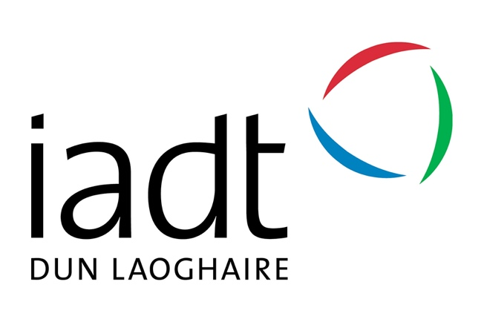

Examining The Effects of FoMO, Age, and Gender on Social Media Screen Time
Jessica Toale
N00212420

This dissertation is submitted to
Institute of Art, Design and Technology
Dún Laoghaire
In fulfilment of the requirements for the degree of

Bachelor of Science (Hons)
In Applied Psychology

Research Supervisor:
Dr. Nicola Fox-Hamilton

Declaration

P☐ I, Jessica Toale, hereby declare that the work that I have submitted for / contributed to the assessment specified above is entirely my own work. Where I have drawn from the work of others, including Generative AI systems, I have clearly indicated this within my submitted work. I recognise that Generative AI creations, no matter how small, may not be permissible within my submitted work and have checked this specific assessment brief for the admissible use of such software. I have read and complied with the IADT Academic Integrity Policy for this submission and recognise that breaches of this policy in my work may result in penalties, up to and including disqualification from IADT.

P☐ I, Jessica Toale, hereby declare that I recognise that IADT staff may provide feedback on assessment via a range of methods, depending on the nature of the assessment and the preference of the staff member. I recognise that any grades issued by a lecturer are provisional but are not negotiable. Final grades will be issued following the relevant exam board meeting and information on appeals procedures is available on the IADT website. I agree to abide by the IADT Mutual Respect Policy in all of my communications with and regarding all IADT staff members.

Date: 11th April 2025

Word count: 4,986

Acknowledgments

I would like to sincerely thank my research supervisor, Dr. Nicola Fox-Hamilton for her invaluable support, guidance, patience, and constructive feedback throughout this project. Nicola’s positivity, reassurance, and encouragement made a considerable impact in keeping me motivated and focused throughout this project. I am also very grateful to Dr. Christine Horn and Dr. Gráinne Kirwan for their amazing expertise and insightful advice regarding advanced research methods and statistical analysis. Additionally, I wish to thank Dr. Sinéad Meade and Dr. Hannah Barton for kindly allowing me to recruit participants during their classes and for their support during the data collection process.

I would also like to take this opportunity to express my appreciation and extend my gratitude to all the members of the Department of Psychology for their continuous support and guidance throughout the past four years of my degree.

I would like to thank my friends and family for their unwavering support throughout this entire journey, you have all been truly incredible. Finally, I am deeply grateful to all the participants who took part in my study. I sincerely appreciate the time and thoughtfulness you dedicated to contributing to my research.

Table of Contents
Abstract 1
1. Introduction 2
1.1 Self-determination Theory and FoMO 2
1.2 The Dual Nature of FoMO and its Connection to Screen Time and Social Media 2
1.3 FoMO as a Motivator of Social Media Screen Time 3
1.4 Age and Gender Variations in FoMO and Social Media Use 4
1.5 Current Study 5
1.6 Research Question 5
1.7 Hypotheses 6
2. Methodology 7
2.1 Design 7
2.2 Participants 7
2.3 Pilot Study 8
2.4 Materials 8
2.5 Procedure 9
3. Results 11
3.1 Overview of Results 11
3.2 Descriptive Statistics 11
3.3 Assumptions 12
3.4 Inferential Statistics 12
4. Discussion 14
4.1 Overview of Findings 14
4.2 Practical Implications and Theoretical Implications of The Study 16
4.3 Future Research 16
4.4 Strengths and Limitations 16
4.5 Conclusion 18
5. References 19
6. Appendices 23
Appendix A – Information Sheet 23
Appendix B – Consent Form 25
Appendix C – Debrief Form 26
Appendix D – FoMO Scale 27
Appendix E – iPhone Social Media Screen Time Instructions 28
Appendix F – Android Social Media Screen Time Instructions and Questions 29
Appendix G – Mean-Split Groupings 32
Appendix H – Normality Tests 33
Appendix I – Levene's Test and Outliers 34
Appendix J – Reliability 36
Appendix K – 3-way Anova SPSS Output 37
Appendix L – G*Power 39

Abstract

Previous research has linked fear of missing out (FoMO) with increased social media use. This study examined the effects of FoMO, age groups (< 23 and >23), and gender on social media screen time. Using a cross-sectional between-groups design, data was collected from a sample consisting of both students and older adults. Participants reported their weekly average social media usage using logged app-based tracking from their smartphone settings and then indicated their FoMO levels using Przybylski et al’s scale. A three-way ANOVA was conducted to analyse the data. Results indicated that there was a significant effect of FoMO on time spent on social media, where higher FoMO scores related to higher social media time. However, no other main or interaction effects were significant. These findings suggest that gender, age, and FoMO together do not significantly impact time spent on social media. The significant effect of FoMO supports previous literature, reinforcing the self-determination framework for understanding FoMO. Limitations include differences in how smartphone operating systems (Android/iOS) record social media use. Future research could explore qualitative approaches to understand the complexity between FoMO and social media use, particularly in understanding the motivations of individuals who use social media and their experiences of FoMO.

- Introduction

The emergence of smartphones has revolutionised human behaviour and interaction, offering unprecedented opportunities to gratify social needs. This study explores the relationship between social media screen time, fear of missing out (FoMO), age, and gender, aiming to uncover how these variables interact and impact individuals across different demographics. The term fear of missing out (FoMO) refers to the perception that others are engaging in more rewarding or enjoyable experiences in your absence (Roberts & David, 2019).
This concept was first introduced by marketing strategist Dan Herman in 1996, who used the acronym to describe consumers sense of anxiety about missing out on new products or experiences (Rahmah et al., 2024). In recent years, FoMO has garnered significant attention in academic research, with Przybylski et al. (2013) popularising the term through their systematic study of FoMO within the context of social media. Gupta and Sharma (2021) identified two distinct processes within FoMO: 1. perceiving that one is missing out and 2. engaging in compulsive behaviours to maintain social connections.

1.1 Self-determination Theory and FoMO

Self-determination theory (SDT) is a psychological framework that highlights the role of intrinsic motivation in driving human behaviour, supporting well-being and life satisfaction (Ryan & Deci, 2022). The theory identifies three basic psychological needs essential for psychological health. Autonomy, referring to a sense of control over one’s actions and decisions. Competence, the capability to effectively act on one’s pursuits, and Relatedness, feeling connected and valued in relationships (Manninen et al., 2022). This framework offers insights into how social media use can either fulfil or diminish basic psychological needs. Deficits in need satisfaction may drive individuals to use social media to address unmet needs, such as building social connections. These unfulfilled needs can also heighten sensitivity to FoMO, further increasing social media engagement.

1.2 The Dual Nature of FoMO and its Connection to Screen Time and Social Media
Previous studies have linked FoMO with increased social media use (Roberts & David, 2019; Li et al., 2024). Social media platforms often serve as a primary context of fulfilling the basic psychological needs. For example, social media can enhance relatedness by fostering connection through interactions, such as likes, comments, and direct messages (Stsiampkouskaya et al., 2021). However, it can simultaneously create a comparative environment where users perceive others as living more fulfilling or exciting lives, leading to feelings of inadequacy (Dhir et al., 2018). These dynamics are particularly relevant to FoMO, as social media provides a constant stream of real-time updates that may emphasise what individuals are missing out on, intensifying sensitivity to unmet psychological needs. This, in turn, drives habitual engagement with smartphones and social media, perpetuating a cycle where the promise of need satisfaction may fall short, amplifying FoMO further.
Despite the well-documented negative effects of social media on an individual’s general well-being, there is evidence suggesting that social media engagement can have the opposite effect, particularly in relation to FoMO. Kim and Kim (2017) explored how social media usage influences college students' involvement in various social networks and how their participation in these groups relates to satisfaction and well-being. The findings indicate that social media use is positively associated with an expanded social network, which is correspondingly linked to higher levels of social capital and psychological well-being. This suggests that, for some individuals, active social media engagement may alleviate FoMO by enhancing their sense of connection and belonging, potentially leading to greater happiness and life satisfaction.
Literature highlights that FoMO may contribute to social media and smartphone dependency, particularly in the context of phubbing – the act of disregarding one’s physical companion to focus on a phone or other mobile device (Chatterjee, 2020; Ostic et al., 2021). However, some researchers argue that such claims oversimplify the complex interplay between FoMO and social media use. For instance, opposing views suggest that not all instances of phubbing stem from FoMO, as other factors, such as a need for social inclusion, obligations, and habitual checking behaviours, may also play a role (David & Roberts, 2017).

1.3 FoMO as a Motivator of Social Media Screen Time

The growing use of communication technologies and social media platforms appears to play a role in the rising prevalence of FoMO, which has been linked to frequent and maladaptive smartphone use (Elhai et al., 2018). Fear of missing out (FoMO) is a key motivator for social media use in today’s culture. Many people feel a constant need to know what others are doing, driving their frequent and often excessive engagement with social media (Lee et al., 2021). The latest data calls attention to the global reach of smartphones, with 5.22 billion users worldwide. Among these, smartphone usage is most prevalent among younger adults, with 96% of those aged 18 to 29 and 92% of those aged 30 to 49 actively using these devices (Machado et al., 2023). In 2023, internet usage in Ireland revealed that nearly all (96%) users accessed the internet via smartphones or mobile phones, with significant variations across other devices. Usage remained high across age groups, including 92% of those aged 60–74 years (Central Statistics Office, 2023).

Recent research highlights the growing positive benefits of smartphone use as a tool for communication, with regular engagement linked to greater psychological well-being (Roos & Wrzus, 2023). Song and Kim (2022) discovered a positive association between social media use, FoMO, and increased smartphone screen time, highlighting the significant role FoMO plays in driving prolonged engagement with digital devices. Przybylski et al. (2013) found that FoMO is significantly associated with high social media engagement, particularly among younger individuals, and is negatively correlated with mood and life satisfaction. However, it remains unclear whether FoMO stems primarily from generational differences or individual variability. The present study explores potential age-related differences in FoMO. Notably, FoMO can also foster social connection through social media use (Roberts & David, 2019), potentially driving increased smartphone screen time through communication apps like WhatsApp, as people strive to strengthen social bonds and a sense of belonging.

1.4 Age and Gender Variations in FoMO and Social Media Use
Alshakshi et al. (2023) highlight the role of FoMO in mediating problematic social media use (PSMU), with gender and age influencing these patterns differently across cultural contexts. These findings reinforce the importance of considering both individual differences like age and gender and the attention-capturing design of social media platforms when examining the relationship between smartphone screen time and FoMO in the current study.
Barry and Wong's (2020) findings suggest that FoMO may not differ significantly across age cohorts or between genders, which challenges assumptions of demographic-based variability in FoMO. However, the association between high FoMO, low self-esteem, loneliness, and elevated social media activity highlights the importance of focusing on psychological factors rather than demographic characteristics alone. Emphasising the importance of exploring how individual psychological traits, in conjunction with age and gender, interact with social media use and smartphone screen time to shape the experience of FoMO.
Reer et al. (2019) examined the psychosocial well-being of German internet users aged 14–39 years, focusing on the interplay between social media use, FoMO, and social comparison orientation (SCO). Rather than solely exploring the direct relationships between social media use and decreases in well-being, the study analysed FoMO and SCO as key mediators. Their findings revealed that higher levels of loneliness, depression, and anxiety were associated with increased social media use, emphasising the role of FoMO and social comparison in amplifying these effects.

Hodes and Thomas (2021) suggested that smartphone use tends to increase during weekends and times of sociopolitical or environmental upheaval, such as the COVID-19 pandemic, with screen time influenced by individual differences. Moreover, smartphone attachment mediates the relationship between screen time and depression but not anxiety. In the current study these findings assert the significance of considering both individual and contextual factors, when examining the relationship between smartphone use, FoMO, and social media use across different age groups and genders.

1.5 Current Study

The present study aims to address a gap in the literature by investigating how social media screen time connects to the experience of fear of missing out (FoMO) across different genders and age groups. While much of the existing research focuses on younger populations, this study explores age-related differences in greater depth. The following research question guides the study:

1.6 Research Question

How does social media screen time relate to the experience of fear of missing out (FoMO) across different genders and age groups?

Based on the literature review, the study proposes the following hypotheses:

1.7 Hypotheses

H1: There will be a difference in the main effect of age group on social media screen time, younger participants will report higher social media time compared to older participants.
H2: There will be a difference in the main effect of gender on social media screen time, with differences across gender groups.
H3: There will be a difference in the main effect of FoMO level on social media screen time, individuals with higher FoMO will report greater social time than those with lower FoMO.
H4: There will be a difference in the interaction between age group and gender, the effect of age on social media screen time will differ based on gender.
H5: There will be a difference in the interaction between age groups and FoMO, the relationship between FoMO and social media screen time will vary across age groups.
H6: There will be a difference in the interaction between gender and FoMO, the effect of FoMO on social media screen time will be different depending on gender.
H7: There will be an interaction between age group, gender, and FoMO, the combined effect of these variables will influence social media screen time.

- Methodology

2.1 Design
This study employed a quantitative cross-sectional between-groups design to examine the effect of fear of missing out (FoMO), age, and gender based on social media screen time. The independent variable, fear of missing out (FoMO), is measured using the FoMO scale developed by Przybylski et al. (2013). The independent variables age and gender were answered as demographic questions by participants on the survey. The dependent variable social media use is measured through logged app-based tracking on a smartphone device’s settings to report the weekly average (in hours) for time spent on social media. A three-way between participants ANOVA was utilised, where IV1 (age) has two levels (k= 2, younger < 23 years/older ≥ 23 years), IV2 (gender) has two levels (k= 2, male/female), and IV3 (FoMO) has two levels (k=2, low/high). A priori analysis was conducted using G*Power which was used to estimate the required sample for power at 0.80 size, the analysis indicated a required sample size of N= 237.

2.2 Participants
In total, 110 responses were received on the survey. Five participants requested to withdraw their data from the study and six of the participants identified as non-binary – however, this number was not sufficient to include in the three-way ANOVA data analysis due to insufficient size for statistical significance. As a result, these responses were removed. The final sample for the current study consisted of 99 participants, recruited through IADT and social media platforms, including Facebook, Instagram, and LinkedIn. This approach ensured access to a diverse audience of individuals actively engaged with social media use and given that the participants are social media users, recruiting them using social networking sites was appropriate. Participants ranged from 18 – 57 years of age (M= 28.21 years, SD= 9.66), 64 (64.6%) of the participants were female and 35 (35.4%) were male. Participants were selected using convenience sampling and snowball sampling, whereby individuals who complete the study may refer friends or acquaintances interested in participating. Participants were treated in accordance with the ethical standards of the Psychological Society of Ireland (PSI). The study was approved by the Psychology Ethics Committee (PEC) at IADT.

2.3 Pilot Study
A pilot study with two participants was carried out to evaluate the feasibility of the study and estimate the completion time for the online survey. Both participants indicated that completing the questionnaires took roughly seven minutes and reported no challenges during the process. However, one participant suggested that the social media screen time question could be clearer. Initially, the survey question asked, “How much time do you spend using social media?”. This was revised to explicitly instruct participants to input their screen time hours and minutes, as the original wording was unclear. Feedback from the pilot study was valuable in refining the clarity of the social media use question.

2.4 Materials
Information Sheet
Materials for the present study included an online Microsoft Forms survey used to collect participants' data as advertised on social media. An information sheet (Appendix A) for the survey was used to outline the study’s purpose, how the data would be used, and the benefits and potential drawbacks of participation.
Consent Form
A consent form (Appendix B) was provided to obtain participants' permission to use their data for the study.
Demographics
Demographic questions were transcribed to the survey. Participants were asked to input their age in number, and to input their gender.
Debrief Form
Finally, a debrief form (Appendix C) was used to provide the researcher’s contact details and information on how to withdraw from the study. Additional resources were provided including links to mental health services in the event that participation caused any distress. Participants were also thanked for their valuable contribution to the research.
Measures
Fear of Missing Out Scale (Appendix D)
FoMO was measured using Przybylski’s ten-item FoMO scale (Przybylski et al., 2013). This five-point Likert scale evaluates individuals' levels of fear of missing out based on their daily experiences (e.g., I fear others have more rewarding experiences than me) and (e.g., I get anxious when I don’t know what my friends are up to). The scale is measured using a five-point Likert from zero to five, with one representing “Not at all true of me” and five representing “Extremely true of me”. The scale has demonstrated good internal consistency and reliability with Cronbach’s α = 0.89 (Przybylski et al., 2013). The current study found a Cronbach’s alpha of .907. The scale is scored by computing individual scores and averaging the responses to all ten items. Scores can range from 10 to 50, with higher scores indicating higher FoMO (Chashmi et al., 2023).
Social Media Screen Time
The dependent variable, social media screen time, was measured in hours per week using logged app-based tracking, providing a more accurate and reliable method of assessing the variable compared to relying on self-reported estimates of social media usage (Parry et al., 2021). Due to the differences in the smartphone settings operating systems, participants were given instructions depending on the type of smartphone they had. For iPhone users, participants were asked to follow the instructions listed in the questionnaire (Appendix E) and then input their weekly average social media screen time in hours and minutes. For Android users, participants were asked to follow the listed instructions (Appendix F) and to then input their average time in hours and minutes on each social media app (e.g., Facebook, Instagram, Messenger, WhatsApp, etc.). The hours and minutes were then calculated to get the full scope of time spent on social media. The questions were slightly longer for Android users as the screen time settings on Android do not provide a full weekly overview of time spent using social media.

2.5 Procedure
After obtaining ethical approval and completing a pilot study, the Microsoft Forms questionnaire was published online. The survey link was advertised on social media platforms like Facebook, Instagram, and LinkedIn. After reviewing the information sheet and consent form, participants were asked to create an anonymised participant ID. This ID would allow their data to be identified if they chose to withdraw from the study. Following this, participants were prompted to answer two demographic questions regarding their age and gender, they were then instructed to input their weekly average for social media use, they were then asked to complete the questions for the FoMO scale and then agree that their data can be used in the study. Finally, participants were debriefed, with support resources provided.

- Results

3.1 Overview of Results

A three-way analysis of variance (ANOVA) was conducted using IBM SPSS Statistics (Version 29). The independent variables were age (k= 2, younger < 23 years, older ≥ 23 years), gender (k=2, male, female), and FoMO (k=2, low, high). With time spent on social media as the dependent variable. This section will present an overview of the key descriptive and inferential statistical findings.

3.2 Descriptive Statistics
A total of 99 participants took part in the study, categorised by gender, age, and FoMO level. The sample was evenly distributed by age, with 51.5% (N = 51) classified as younger (≤ 23 years) and 48.5% (N = 48) classified as older (> 23 years). Regarding gender, the majority of participants identified as female (64.6%, N= 64), followed by male participants (35.4%, N= 35). The sample was evenly distributed in terms of FoMO levels, with 51 participants (51.5%) categorised as having low FoMO and 48 participants (48.5%) classified as having high FoMO. The total mean (M) and standard deviations (SD) for each variable for the participants are outlined in Table 1.
Participants were divided into two levels for each of the independent variables age group and FoMO level using a Median Split approach. For age group participants were categorised as either younger (≤ 23 years) or older (>23 years) based on the median value calculated from the age distribution. For FoMO level, participants were classified as having low or high FoMO using the same method, with the median score serving as the cutoff point. Frequencies and percentiles were examined to determine the median values for each variable.

Table 1: Descriptive Statistics for Social Media Use by Gender, Age Group, and FoMO Level
Group | N | M | SD | Min | Max
Gender: Male | 35 | 900.14 | 864.150 | 70 | 3600
Gender: Female | 64 | 1043.23 | 827.44 | 47 | 3610
Low FoMO | 51 | 848.84 | 759.58 | 76 | 3608
High FoMO | 48 | 1145.44 | 899.199 | 47 | 3610
Younger (≤ 23) | 51 | 1048.29 | 841.528 | 57 | 3610
Older (> 23) | 48 | 933.2 | 841.121 | 47 | 3608
Total | 99 | 992.5 | 843.43 | 47 | 3610

Note. M = Mean; SD = Standard Deviation.

3.3 Assumptions

Assumptions for a three-way between-groups ANOVA were tested. The assumption of normality was tested using the Shapiro-Wilk test across each combination of the three independent variables. Results indicated that the assumption of normality was violated for all groups (p ≤ .001). Given that ANOVA is robust to moderate violations of normality, particularly when sizes across groups are relatively balanced, the analysis proceeded. The Levene’s test showed that the variances of the groups were unequal (F (7, 91) = 2.411, p = .026), indicating that the assumption of homogeneity of variance was violated. Boxplots were inspected to assess the presence of outliers. A small number of outliers were identified (e.g., cases 1, 74, and 92), they were not extreme and retained for the analysis as an ANOVA is generally robust to mild deviations of normality.

3.4 Inferential Statistics

A three-way 2×2×2 factorial ANOVA was conducted to examine the effects of age group, gender, and FoMO level on social media screen time. The results showed that the main effect of gender was not significant, (F (1, 91) = 0.002, p = .968, partial η²= .000). Similarly, the main effect of age group was not significant, (F (1, 91) = 0.172, p = .679, partial η²= .002). However, the main effect of FoMO level was significant, (F (1, 91) = 5.092, p = .026, partial η²= .053). Estimated Marginal Means showed that participants with high FoMO reported significantly higher social media screen time (M= 1242.73, SE= 142.84) than those with low FoMO (M= 813.57, SE= 125. 58). The Bonferroni-adjusted pairwise comparison verified this difference was statistically significant, (M= 429.16, p= .026, 95% CI [51.38, 806.94].
Regarding interaction effects, the interaction between gender and age group was not significant, (F (1, 91) = 1.229, p = .271, partial η²= .013), neither was the interaction between age group and FoMO level, (F (1, 91) = 0.830, p = .365, partial η²= .009). The interaction between gender and FoMO level approached significance, (F (1, 91) = 3.678, p = .058, partial η²= .039). The three-way interaction between gender, age group, and FoMO level was not significant, (F (1, 91) = 1.659, p = .201, partial η²= .018). These results indicate that gender, age, and FoMO do not significantly impact social media screen time. No strong interactions were found between gender, age, and FoMO. The overall model explained only 8.7% of the variation in social media use, suggesting that other factors may play a larger role.

- Discussion

4.1 Overview of Findings
The aim of the present study was to investigate the connection between age, gender, and the experience of FoMO on social media screen time. FoMO was assessed using the validated FoMO scale (Przybylski et al., 2013), which measures participants’ agreement or disagreement with statements reflecting concerns about missing out on experiences. .Results indicated that there was a significant effect of FoMO on time spent on social media, where higher FoMO scores linked to higher social media time. However, no other main or interaction effects were significant. These findings suggest that gender, age, and FoMO together do not significantly impact time spent on social media.
Hypothesis one proposed that there would be a difference in the effect of age group based on social media screen time. However, this hypothesis was rejected, aligning with prior research on the connection between age and social media use (Barry & Wong, 2020; Groenestein et al., 2024). Groenestein et al. (2024) had relatively diverse spread of age (18-70 years), however, social media use was self-reported by participants which may account for inconsistent findings. However, this finding contradicts previous studies that observed a reverse effect (Kim & Kim, 2017; Song & Kim, 2022). This inconsistency suggests that the association between age and social media use may be more complex than previously understood. Future research with a larger sample size could help clarify this connection and account for potential confounding variables.

Hypothesis two was also not supported. This hypothesis stated that there would be a difference in the effect of gender on social media screen time. This finding is inconsistent with previous research, Servidio et al. (2024) reported that females scored higher than males on social media use on their study about FoMO and problematic social media use. However, females accounted for 74.4% of participants in the study, possibly influencing this result. Similarly, Alnjadat et al. (2019), discovered that males scored higher on social media use compared to females, highlighting the complexity of gender differences. This was attributed to cultural factors in the sample, where males in the Middle East are more inclined to build social connections online, while females are more likely to conceal their identity. However, the study refers to social media as an addiction, which is controversial, as it is not officially recognised by The World Health Organisation as an addiction.

Hypothesis three was supported, which stated that there would be a significant effect of FoMO level on social media screen time. This result aligns with previous research that has established a relationship between FoMO and increased social media engagement (Przybylski et al., 2013). The significant effect reported in this study suggests that individuals with higher FoMO levels may be more likely to use social media platforms in an attempt to stay connected and avoid feeling left out.

Hypothesis four was rejected, stating that there will be a significant interaction between age group and gender. This finding contradicts prior studies, which have suggested that age and gender may mutually influence social media use (Alshakhsi et al., 2023). The absence of an interaction in the present study may indicate that age and gender may not work together in determining social media use, or that other factors, like individual differences or cultural influences, which could pose greater insights than demographic variables alone. Notably, Alshakhsi et al. (2023) examined cultural differences and personality traits in their research, highlighting the potential for greater insights when considering other factors.

Hypothesis five was not supported, stating that there would be a significant interaction between age groups and FoMO. Although previous research has indicated that younger individuals are more prone to FoMO, prompting greater social media use (Brailovskaia & Margraf, 2024; Przybylski et al., 2013) the lack of an interaction in the current study may suggest that the relationship between age and FoMO may not be as prominent as anticipated. This may point to other variables such as personality traits that may play a more significant role in the development of FoMO across different age groups.

Hypothesis six was rejected, however, slightly approached significance. This hypothesis stated that there would be a significant interaction between gender and FoMO. While the interaction did not reach full significance, the observed trend suggests that gender may play a role in how FoMO influences social media use. However, since females comprised 64.6% of the sample in the present study, the results may be influenced by this imbalance. Future research with larger, more balanced samples is needed to further explore and confirm this trend.

Finally, the seventh hypothesis was not supported. It was hypothesised that there would be an interaction between age group, gender, and FoMO. However, the results from the current study indicated no significant interaction between these variables.

4.2 Practical Implications and Theoretical Implications of The Study

The present study contributes to the literature on how FoMO influences social media screen time across different demographics. Unlike previous research, the current study observed that age, gender, and FoMO do not significantly impact social media screen time. However, the significant effect of FoMO level supports previous literature and may suggest that FoMO is a motivational driver of social media engagement. Supporting the self-determination theory perspective and framework for understanding FoMO. In particular, the need for relatedness is perceived in online environments (e.g., social media works as a resource to deepen social bonds and keep in touch with others).

4.3 Future Research

There are several directions future research could take such as exploring platform-specific effects. This could yield more precise findings by investigating whether certain platforms (e.g., Instagram vs. LinkedIn) exacerbate or reduce FoMO. Additionally, incorporating qualitative approaches in the area of FoMO and social media use could provide deeper, more nuanced insights, particularly as the majority of existing research in this area relies on quantitative methods. Qualitative data could represent the lived experiences and motivations of individuals who use social media and their corresponding feelings of FoMO, which might be difficult to express through numerical data alone. Furthermore, employing a longitudinal design in the future could assist with determining causal relationships between social media use and FoMO. Finally, recruiting larger gender balanced samples to strengthen statistical power could enhance the findings and generalisability of future studies.

4.4 Strengths and Limitations

Strengths

One of the potential strengths of the present study is its measurement of social media screen time. Unlike self-reported estimates, which are susceptible to recall bias and social desirability effects (Parry et al., 2021) this study utilised screen-based tracking data, providing a more accurate and reliable assessment of participants' social media use. Another strength of the present study is the reliability of the FoMO scale, which scored high on reliability. Additionally, the study benefits from a wide age range among participants (18 to 57 years old), allowing for a more comprehensive examination of age-related differences in social media use and FoMO. Finally, the study contributes to the literature by investigating multiple demographic factors which have not been widely explored before, by analysing the interplay between age, gender, and FoMO, the study provides a more nuanced understanding of how these variables relate to social media use. The three-way analysis of variance (ANOVA) approach allows for the consideration of potential interaction effects that may not be captured in simpler models.

Limitations

One limitation of the present study is the presence of technology-based biases encountered during data collection. Since social media use was tracked digitally, differences in how smartphone operating systems (Android and iOS) record screen time affected the consistency of the data. Additionally, variations in how participants interact with different platforms may not be fully reflected in screen time measurements alone, potentially limiting the accuracy of social media usage assessment (e.g., passively scrolling on social media for an hour compared to actively engaging by commenting, messaging, and liking posts for the same duration). Due to these differences, measuring social media use through screen-time alone may not fully capture the quality or nature of engagement.
Another limitation of the study is its small sample size. Despite considerable recruitment efforts, the study did not reach the required power size of participants (N=237). A priori power analysis indicated that 237 participants were required to detect medium effects, the present study recruited 99 participants. This may have restricted the power of the analysis and reduced the possibility of detecting significant interaction effects. To ensure and maximise participation, the researcher actively engaged in multiple recruitment strategies, including attending the data collection fair held at IADT, reaching out to lecturers for permission to present the study in their classes, and sharing the survey link across various social networking platforms such as Facebook, Instagram, and LinkedIn. While this facilitated broadening the outreach, the final sample size may limit the generalisability of the findings.

4.5 Conclusion

In conclusion, the present study examined the effect of age, gender, and FoMO based on social media screen time. Most of the hypotheses did not reach statistical significance at the .05 level, except for the effect of FoMO level on social media screen time, where higher FoMO scores were linked to higher social media screen time. Overall, the results highlight the complexity of social media use and highlight the need for future research to explore additional factors like individual differences, cultural influences, and platform-specific effects, which may contribute to social media use patterns.

- References
Alshakhsi, S., Babiker, A., Montag, C., & Ali, R. (2023). Association between personality, FoMO, and problematic social media use tendencies in European and Arabian samples. Acta Psychologica, 240, 104206. https://dx.doi.org/10.1016/j.actpsy.2023.104026
Alnjadat, R., Hmaidi, M. M., Samha, T. E., Kilani, M. M., & Hasswan, A. M. (2019). Gender variations in social media usage and academic performance among the students of university of sharjah. Journal of Taibah University Medical Sciences, 14(4), 390-394. https://doi.org/10.1016/j.jtumed.2019.05.002
Barry, C. T., & Wong, M. Y. (2020). Fear of missing out (FoMO): A generational phenomenon or an individual difference?. Journal of Social and Personal Relationships, 37(12), 2952 – 2966. https://doi.org/10.1177/0265407520945394
Brailovskaia, J., & Margraf, J. (2024). From fear of missing out (FoMO) to addictive social media use: The tole of social media flow and mindfulness. Computers in Human Behavior, 150, 107984. https://doi.org/10.1016/j.chb.2023.107984
Central Statistics Office. (2023, November 24). Internet coverage and usage in Ireland. Retrieved 2nd January from https://www.cso.ie/en/releasesandpublications/ep/p-isshict/internetcoverageandusageinireland2023/devicesused/
Chatterjee, S. (2020). Antecedents of phubbing: from technological and psychological perspectives. Journal of Systems and Information Technology, 22(2), 161–181. https://doi.org/10.1108/JSIT-05-2019-0089
Chashmi, S. J. E., Aruguete, M., Sadri, M., Montag, C., & Shahrajabian, F. (2023). Psychometric properties of the fear of missing out (FOMO) scale in iranian students: Reliability, validity, factor structure, and measurement invariance. Telematics and Infomatics Reports, 10, 100066. https://doi.org/10.1016/j.teler.2023.100066.
David, M. E., & Roberts, J. A. (2017). Phubbed and alone: Phone snubbing, social exclusion, and attachment to social media. Journal of the Association for Consumer Research, 2(2), 155–163. http://dx.doi.org/10.1086/690940
Dhir, A., Yossatorn, Y., Kaur, P., & Chen, S. (2018). Online social media fatigue and psychological wellbeing: A study of compulsive use, fear of missing out, fatigue, anxiety and depression. International Journal of Information Management. 40, 141 – 152. https://doi.org/10.1016/j.ijinfomgt.2018.01.012
Elhai, J. D., Levine, J. C., Alghraibeh, A. M., Alafnan, A. A., Aldraiweesh, A. A., & Hall, B. J. (2018). Fear of missing out: Testing relationships with negative affectivity, onlie social egagement, and problematic smartphone use. Computers in Human Behaviour, 89, 289–298. https://doi.org/10.1016/j.chb.2018.08.020
Groenestein, E., Willemsen, L., & Kerkhof, P. (2024). Fear of missing out and social media use: A three-wave longitudinal study on the interplay with psychological need satisfaction and psychological well-being. New Media & Society, 0(0). https://doi.org/10.1177/14614448241235935
Gupta, M., & Sharma, A. (2021). Fear of missing out: A brief overview of origin, theoretical underpinnings and relationship with mental health. World Journal of Clinical Cases, 9(19), 4881–4889. 10.12998/wjcc.v9.i19.4881
Hodes, L. N., & Thomas, G. F. (2021). Smartphone screen time: Inaccuracy of self-reports and influence of psychological and contextual factors. Computers in Human Behaviour, 115(106616), 1 – 8. https://doi.org/10.1016/j.chb.2020.106616
Kim, B. & Kim, Y. (2017). College students’ social media use and communication network heterogeneity: Implications for social capital and subjective well-being. Computers in Human Behavior, 73, 620 – 628. https://doi.org/10.1016/j.chb.2017.03.033

Lee, J. A., Bright, L. F., & Eastin, M.S. (2021). Fear of missing out and consumer happiness on Instagram: A serial mediation of social media influencer-related activities. Cyberpsychology, Behavior, and Social Networking, 24(11), 762-766. https://doi.org/10.1089/cyber.2020.0431

Li, Y. Y., Koning, I. M., Frinkenauer, C., Boer, M., Van den Eijnden, R. J. (2024). The bidirectional relationships between fear of missing out, problematic social media use and adolescents’ well-being: A random intercept cross-lagged panel model. Computers in Human Behavior, 154(108160). https://doi.org/10.1016/j.chb.2024.108160
Machado, J., Pai, Radhika, R., & Kotian, R. (2023). The pattern of smartphone usage, smartphone addiction, and associated subjective health problems associated with smartphone use among undergraduate nursing students. Journal of Education and Health Promotion, 12(1), 1 – 8. DOI: 10.4103/jehp.jehp_981_22
Manninen, M., Dishman, R., Hwang, Y., Magrum, E., Deng, Y., & Yli-Piipari, S. (2022). Self-determination theory based instructional interventions and motivational regulations in organized physical activity: A systematic review and multivariate meta-analysis. Psychology of Sport and Exercise, 62, 102248). https://doi.org/10.1016/j.psychsport.2022.102248
Ostic, D., Qalati, S. A., Barbosa, B., Shah, S. M., Vela, E. G., Herzallah, A. M., & Liu, F. (2021). Effects of social media use on psychological well-being: A mediated model. Frontiers in Psychology, 12, 678766. https://doi.org/10.3389/fpsyg.2021.678766
Parry, D. A., Davidson, B. L., Sewall, C. J. R., Fisher, J. T., Mieczkowski, H., & Quintana, D. S. (2021). A systematic review and meta-analysis of discrepancies between logged and self-reported digital media use. Nature Human Behaviour, 5, 1535 – 1547. https://doi.org/10.1038/s41562-021-01117-5
Przybylski, A. K., Murayama, K., DeHaan, C. R., & Gladwell, V. (2013). Motivational, emotional, and behavioural correlates of fear of missing out. Computers in Human Behavior, 29, 1841–1848. https://doi.org/10.1016/j.chb.2013.02.014.
Reer, F., Tang, W. Y., & Quandt, T. (2019). Psychosocial well-being and social media engagement: The mediating roles of social comparison orientation and fear of missing out. New Media & Society, 21(7), 1486–1505. https://doi.org/10.1177/1461444818823719
Roberts, J. A., & David, M. E. (2019). The social media party: Fear of missing out (FoMO), social media intensity, connection, and well-being. International Journal of Human-Computer Interaction, 36(4), 385 - 392. https://doi.org/10.1080/10447318.2019.1646517.
Roos, Y., & Wrzus, C. (2023). Is the smartphone friend and foe? benefits and costs of self-reported smartphone use for important life domains in a representative German sample. Current Psychology, 42, 24717–24731https://doi.org/10.1007/s12144-022-03593-y
Ryan, R. M., & Deci, E. L. (2022). Self-determination theory. Encyclopaedia of Quality of Life and Well-Being Research, Springer, 1 – 7. https://doi.org/10.1007/978-3-319-69909-7_2630-2
Servidio, R., Soraci, P., Griffiths, M. D., Boca, S., & Demetrovics, Z. (2024). Fear of missing out and problematic social media use: A serial mediation model of social comparison and self-esteem. Addictive Behaviors Reports, 19, 100536. https://doi.org/10.1016/j.abrep.2024.100536.
Stsiampkouskaya, K., Joinson, A., Piwek, L., & Ahlbom, C. P. (2021). Emotional responses to likes and comments regulate posting frequency and content change behaviour on social media: An experimental study and mediation model. Computers in Human Behavior, 124, 106940. https://doi.org/10.1016/j.chb.2021.106940
Song, H. Y., & Kim, J. H. (2022). Smartphone use type, fear of missing out, social support, and smartphone screen time among adolescents in Korea: Interactive effects. Frontiers in Public Health, 10, 822741. https://doi.org/10.3389/fpubh.2022.822741

6. Appendices

Appendix A – Information Sheet
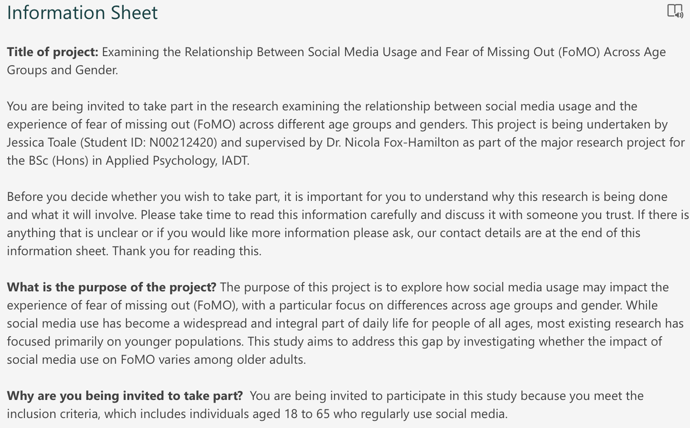

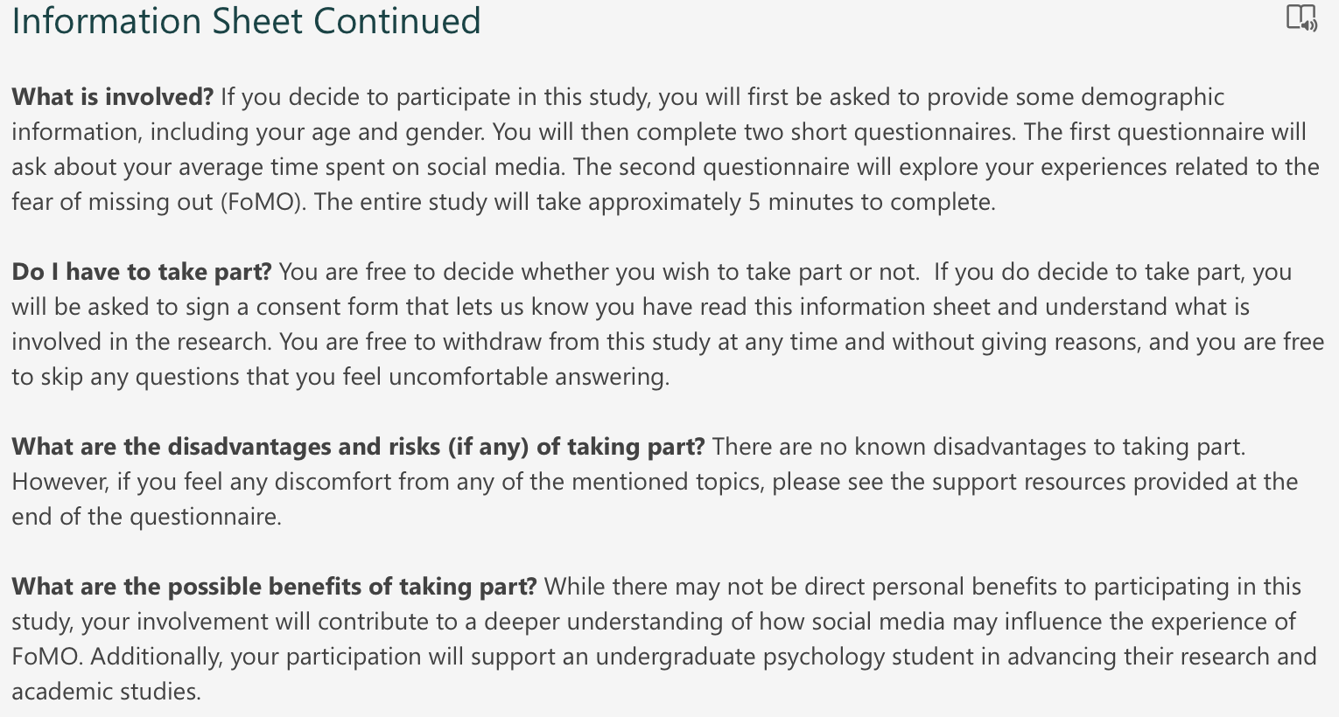

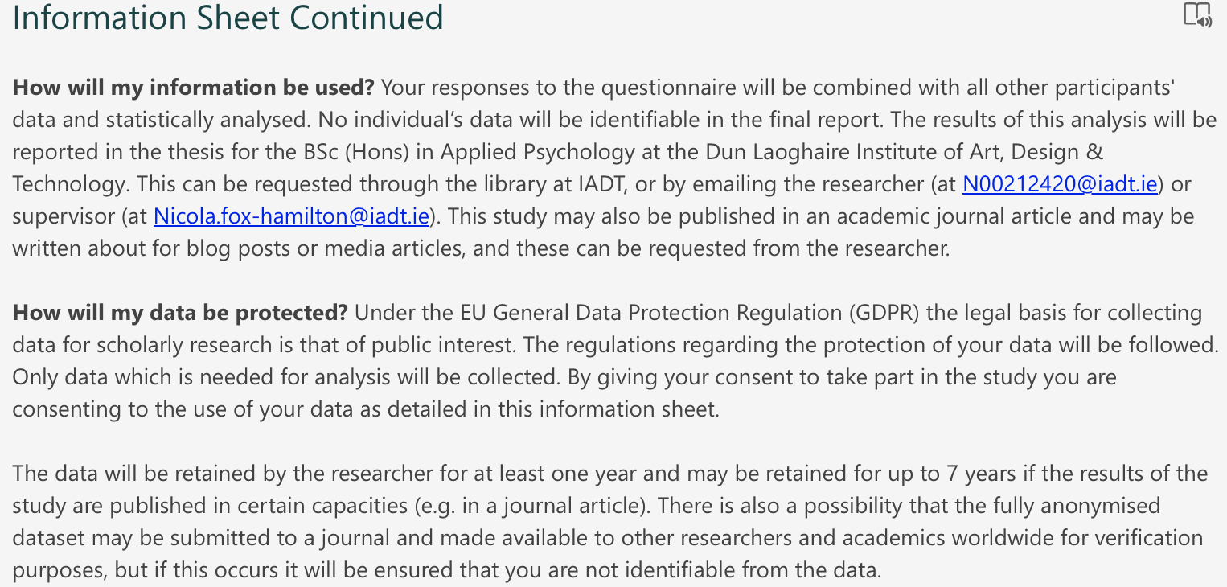

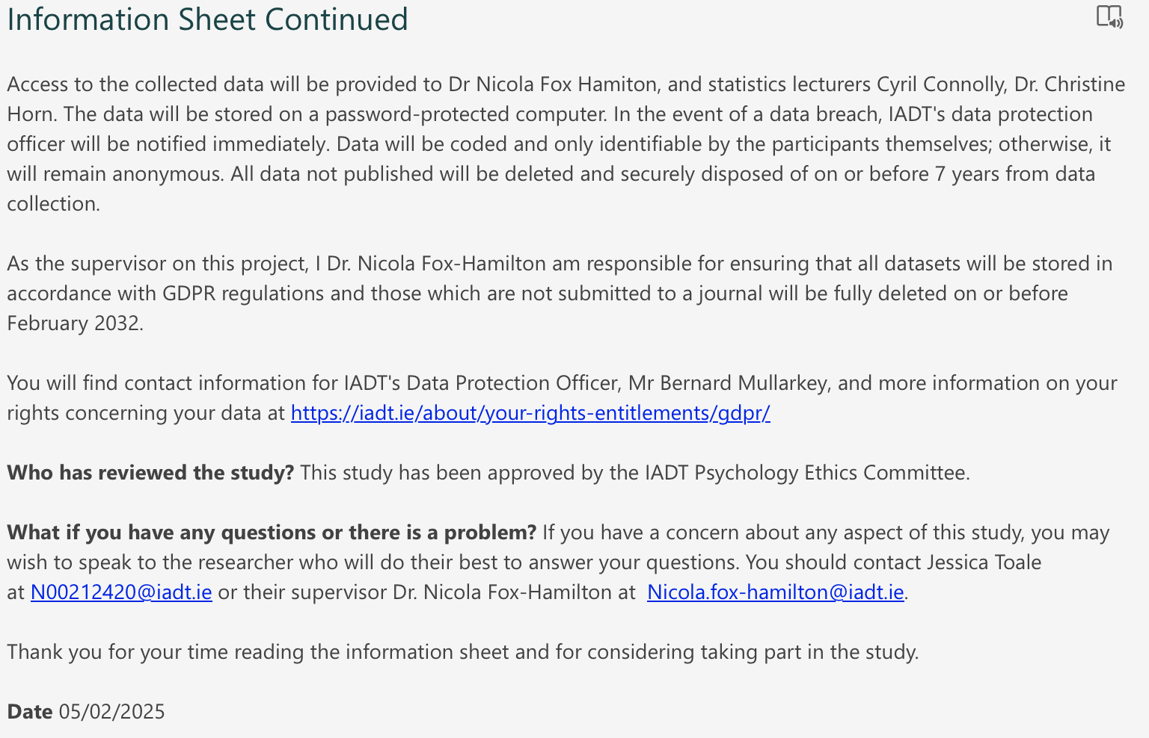

Appendix B – Consent Form
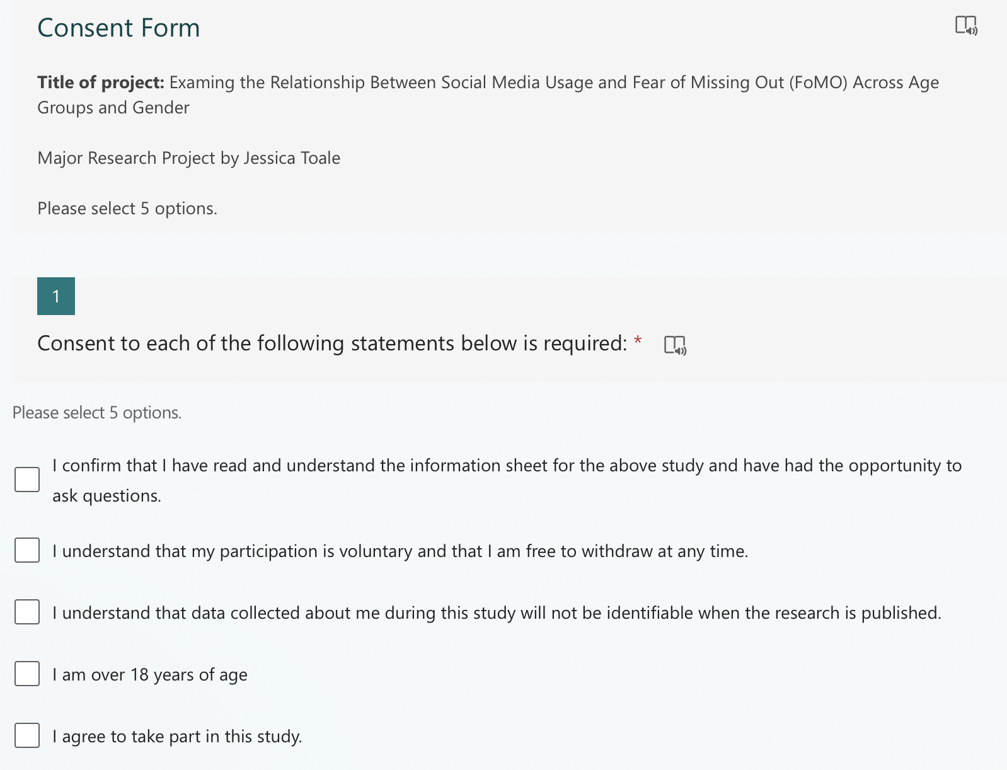

Appendix C – Debrief Form
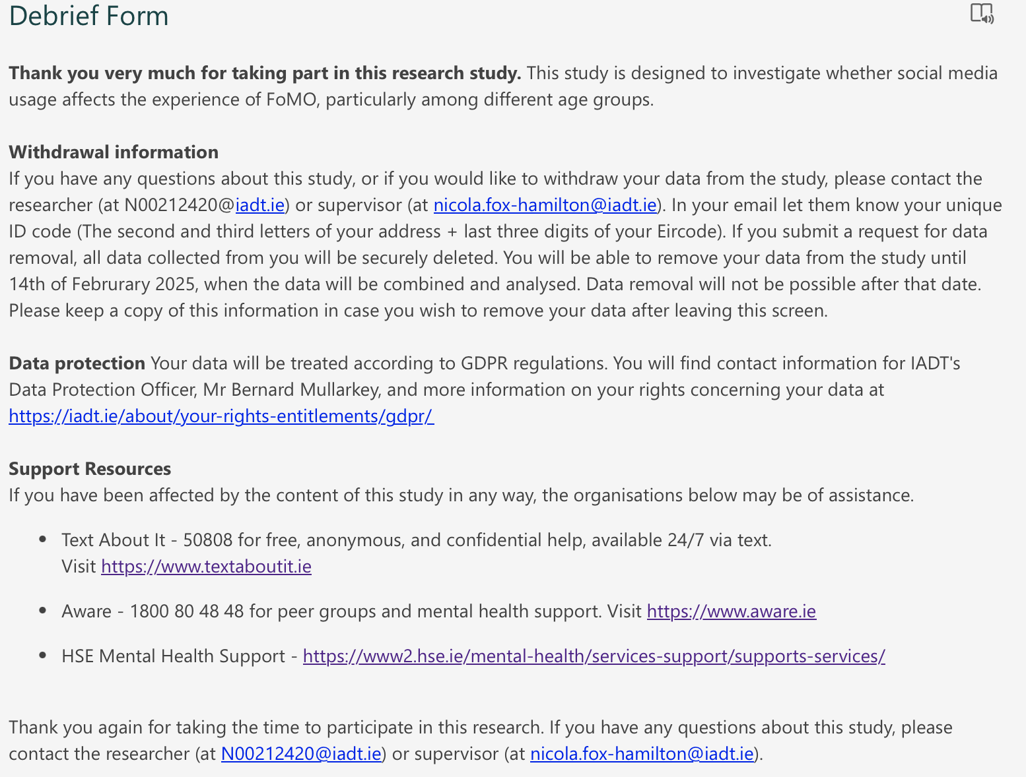

Appendix D – FoMO Scale
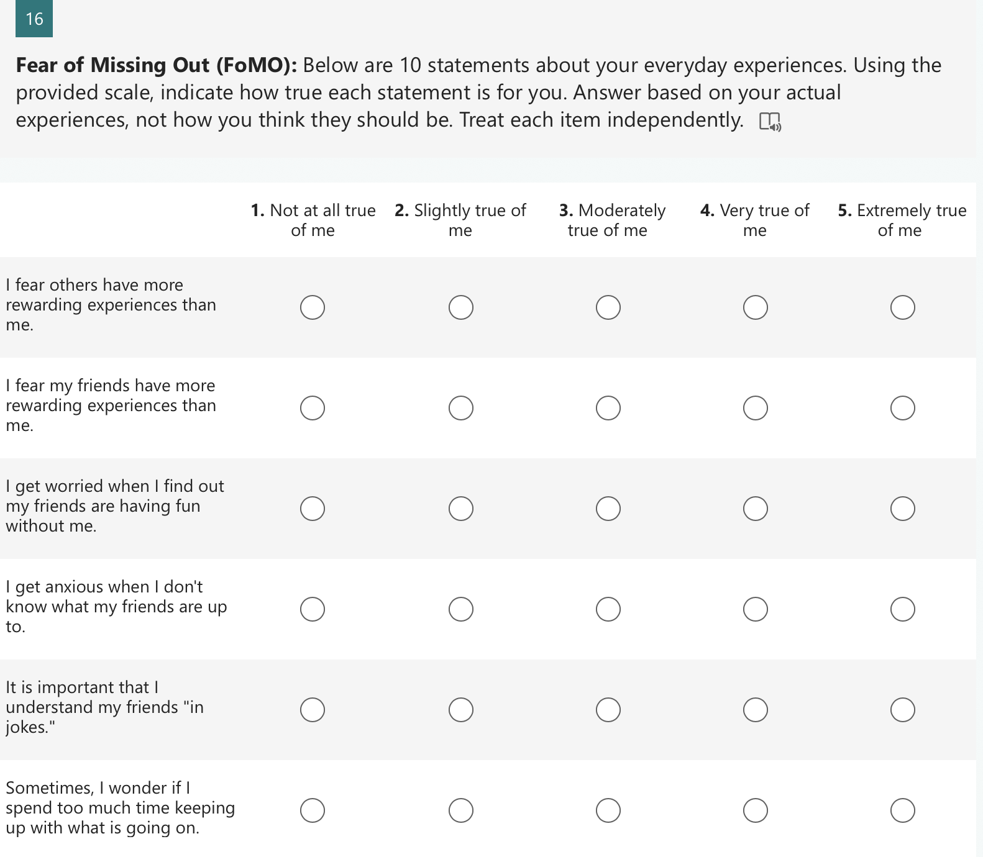

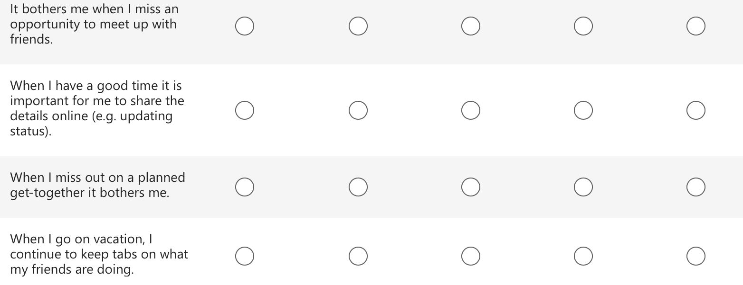

Appendix E – iPhone Social Media Screen Time Instructions

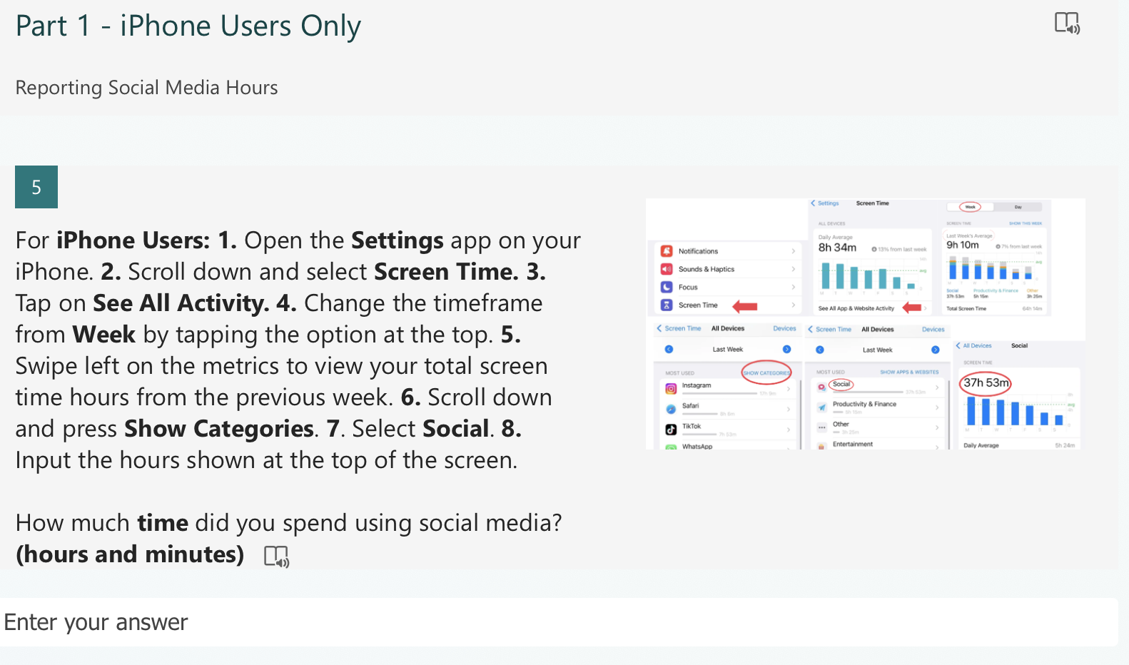

Appendix F – Android Social Media Screen Time Instructions and Questions

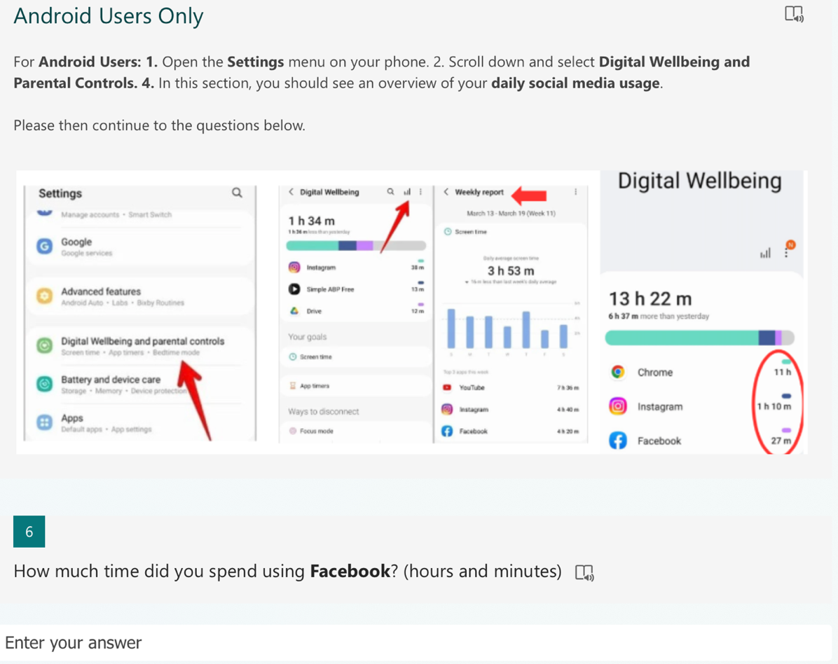

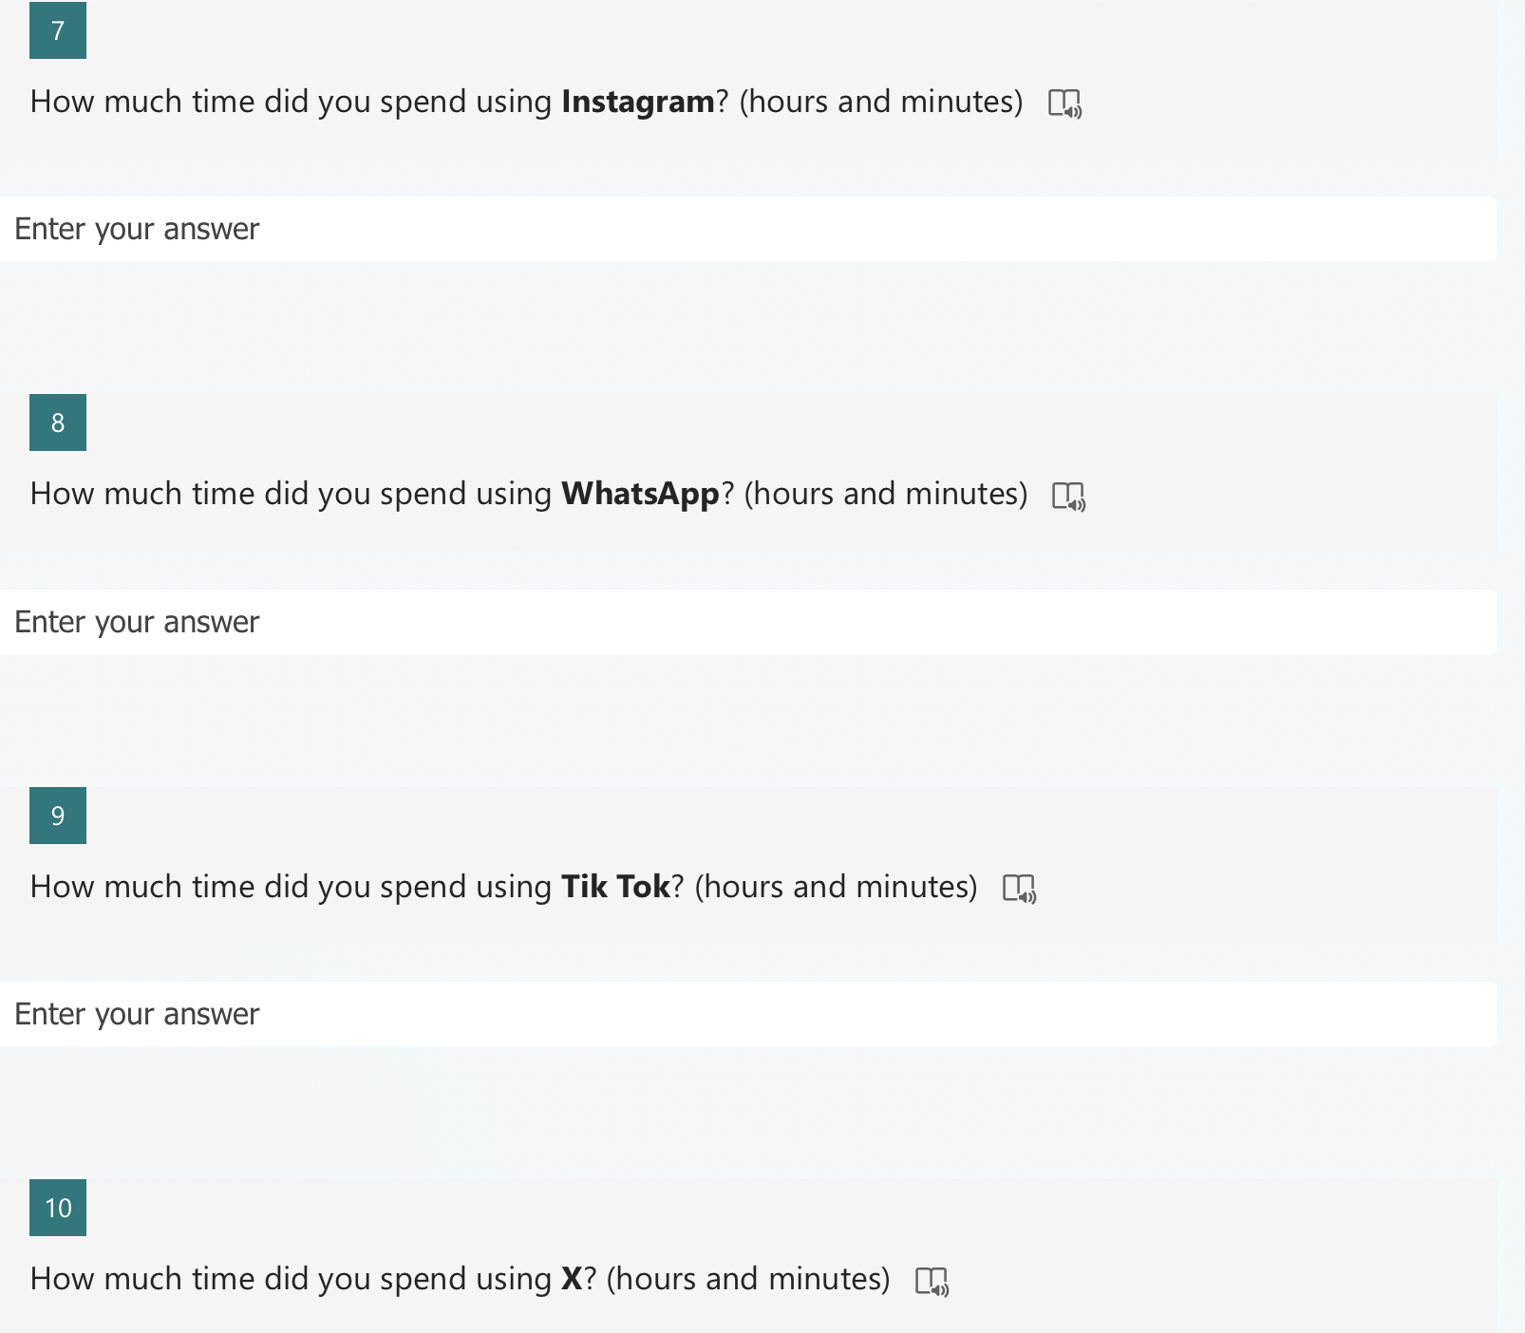

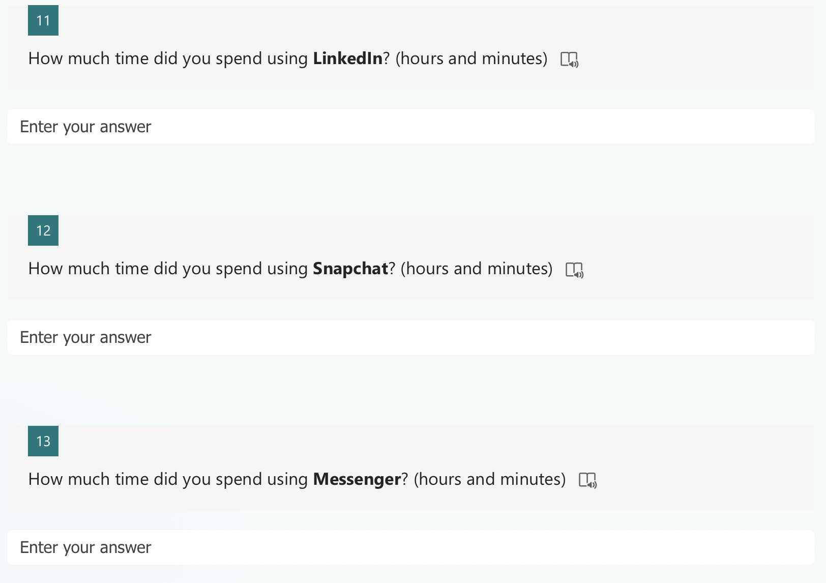

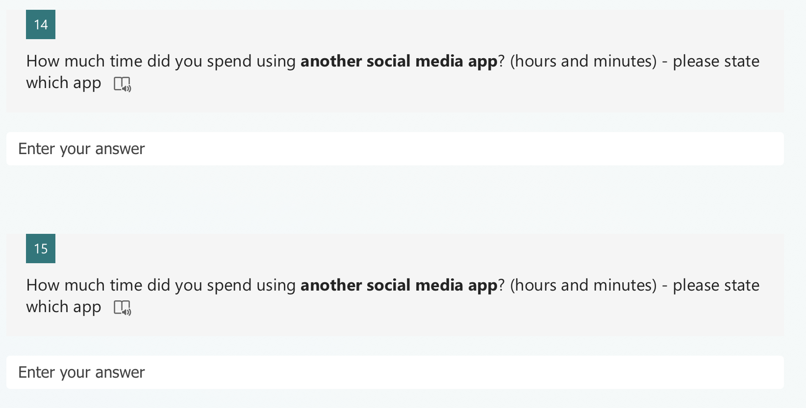

Appendix G – Mean-Split Groupings
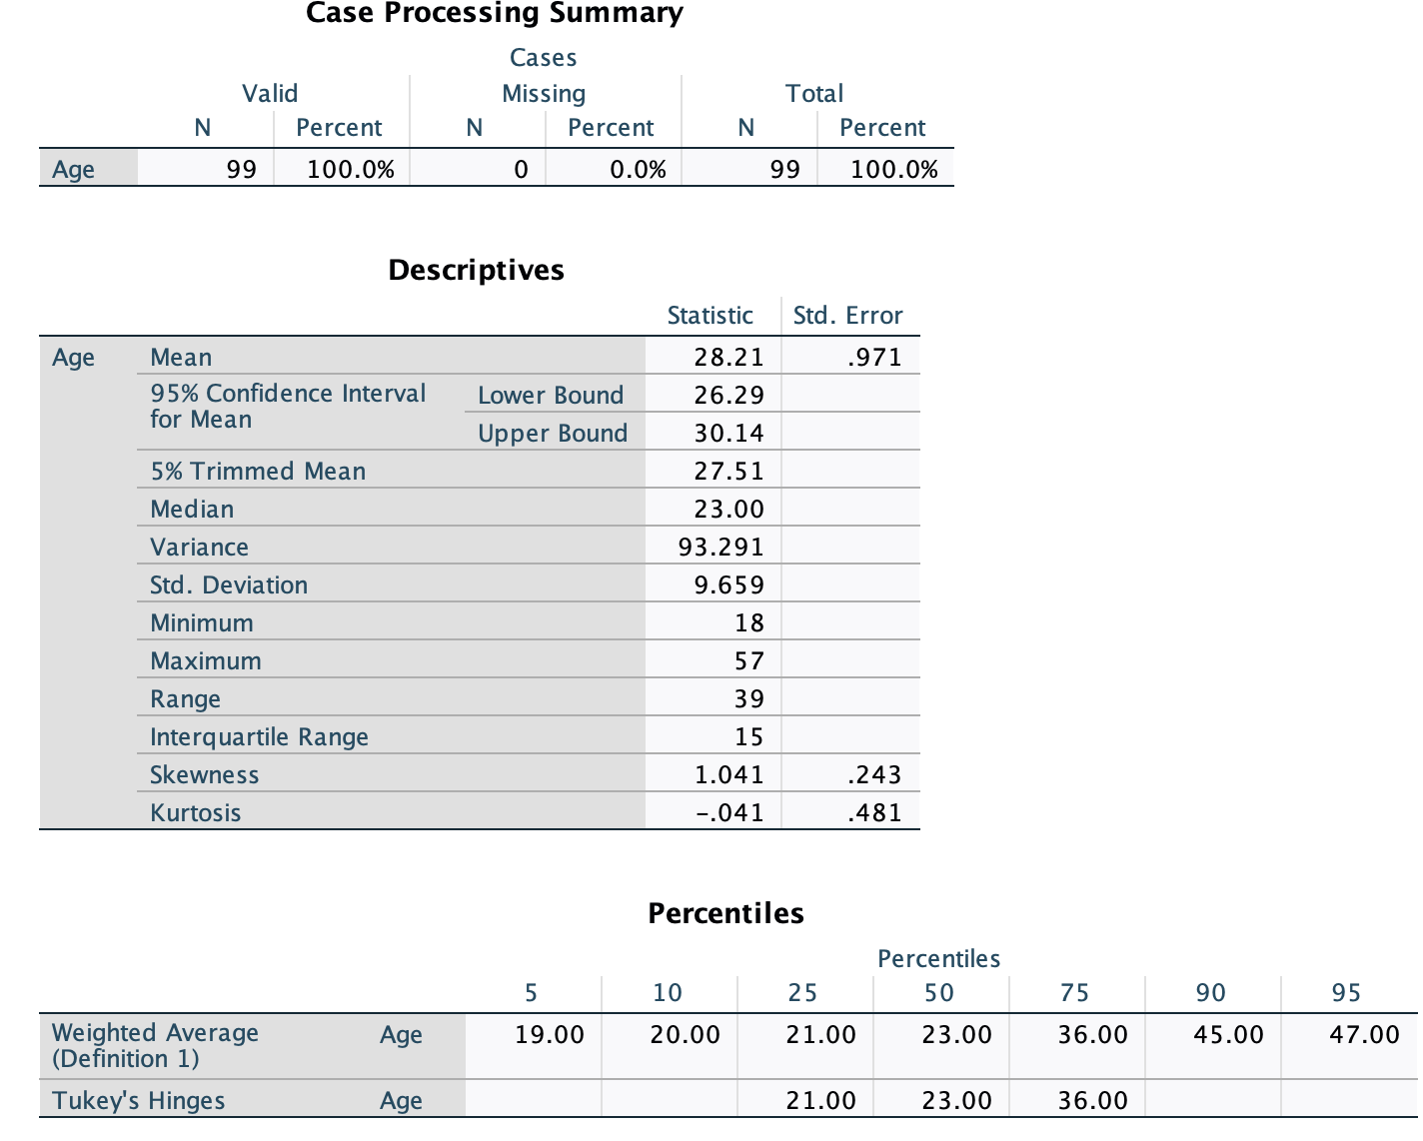
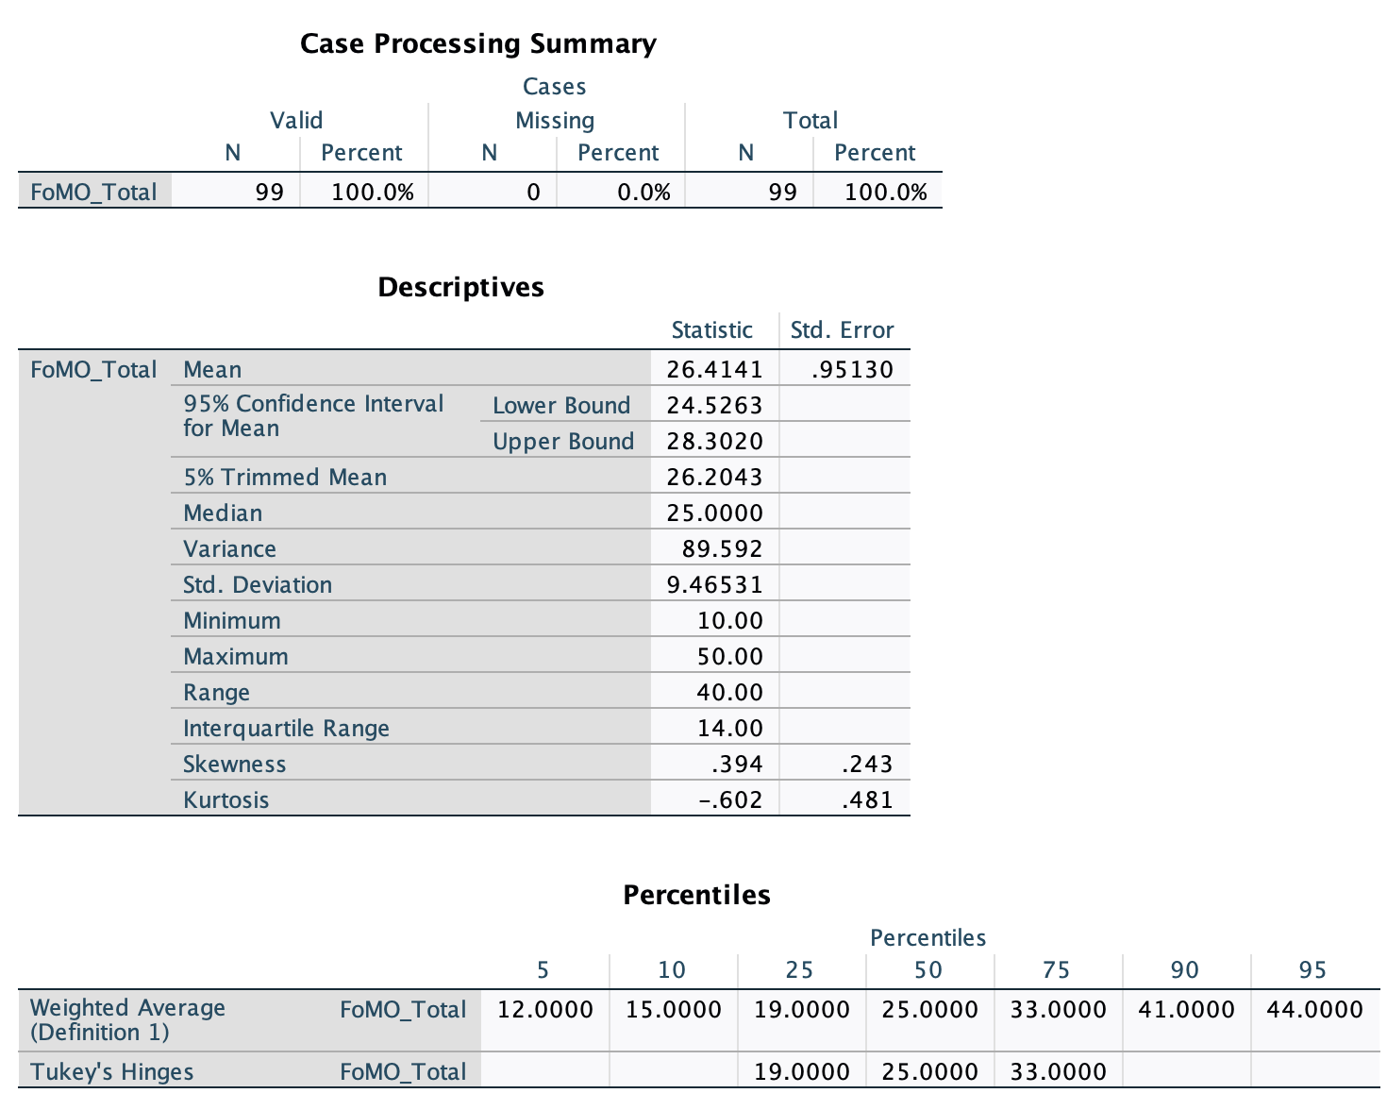

Appendix H – Normality Tests

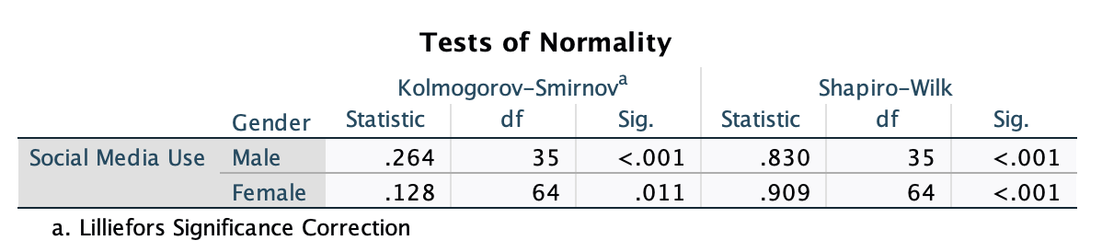

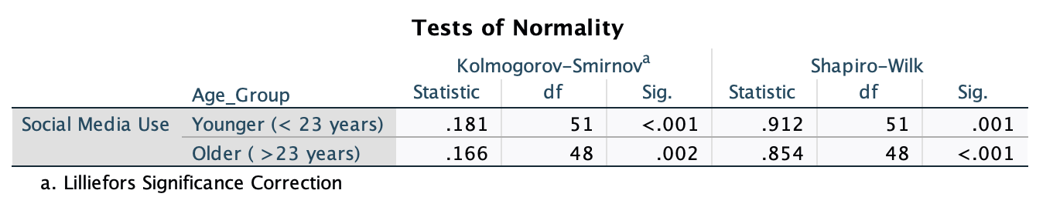

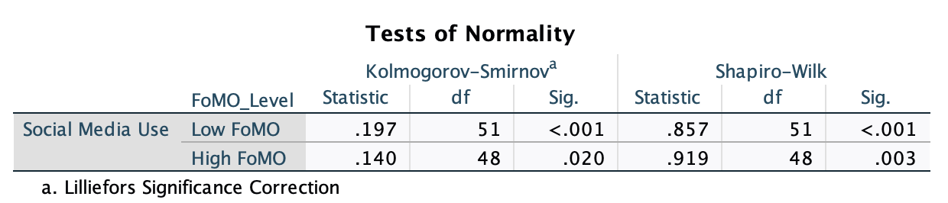

Appendix I – Levene's Test and Outliers

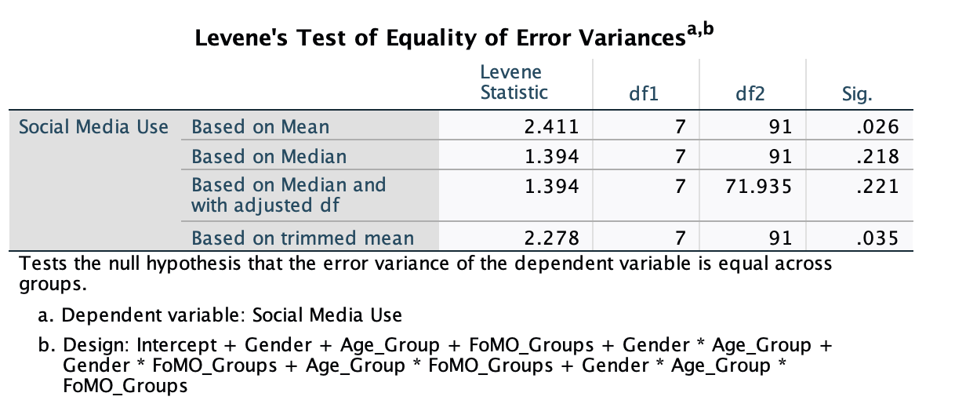

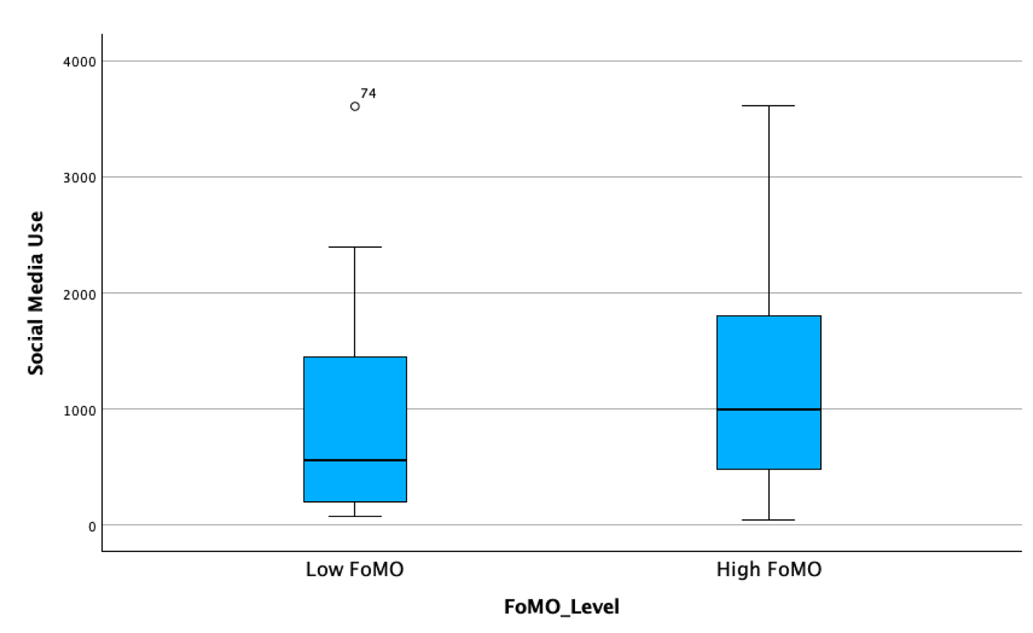
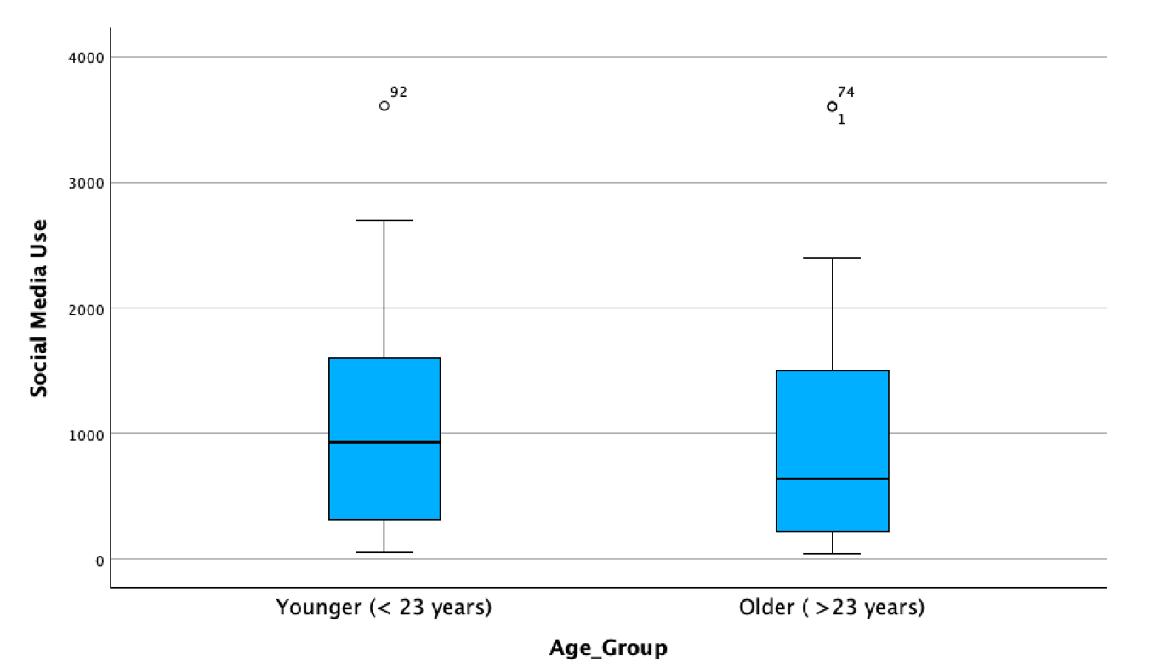

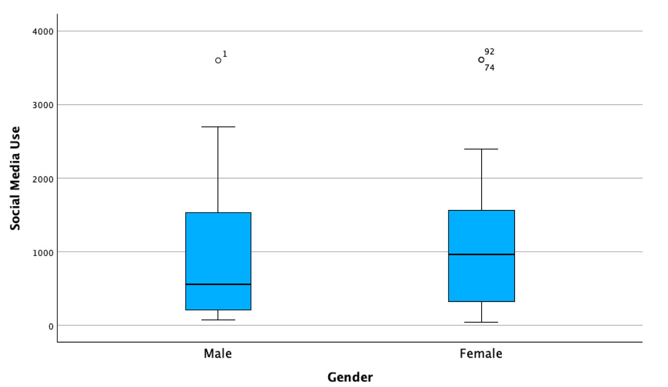

Appendix J – Reliability
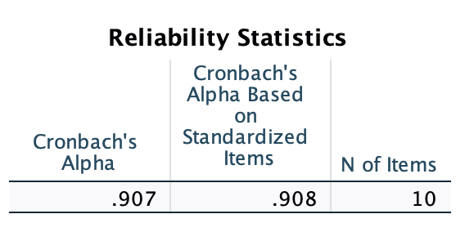
Fear of Missing Out
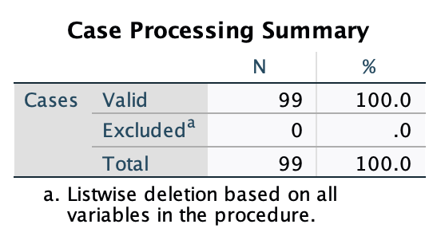

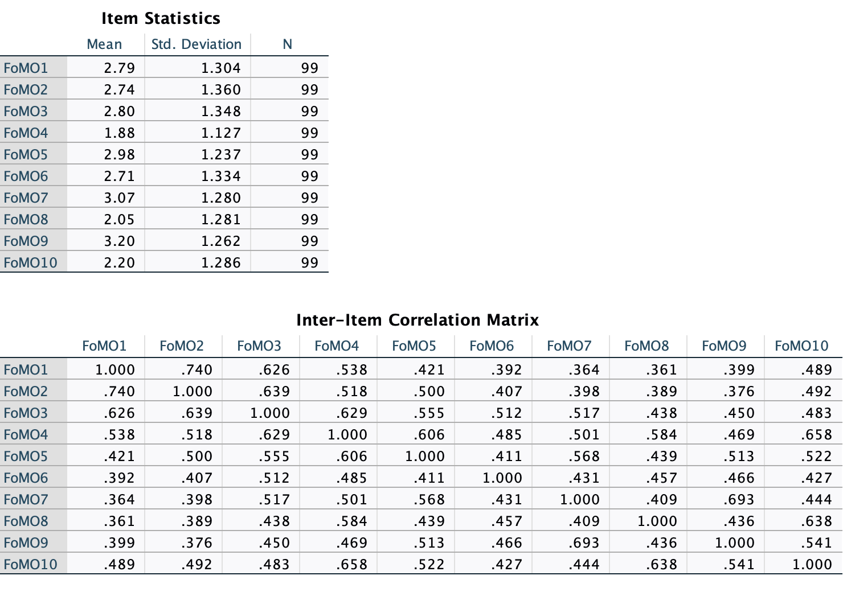

Appendix K – 3-way Anova SPSS Output
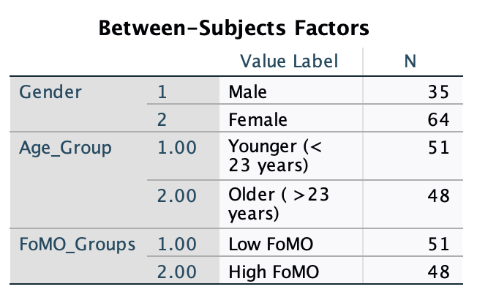

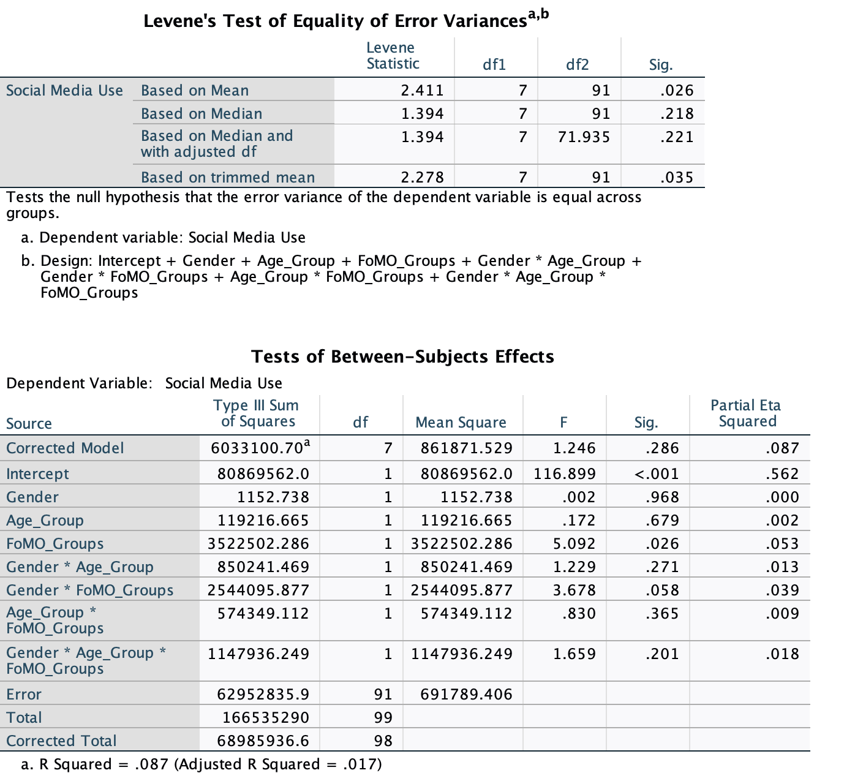

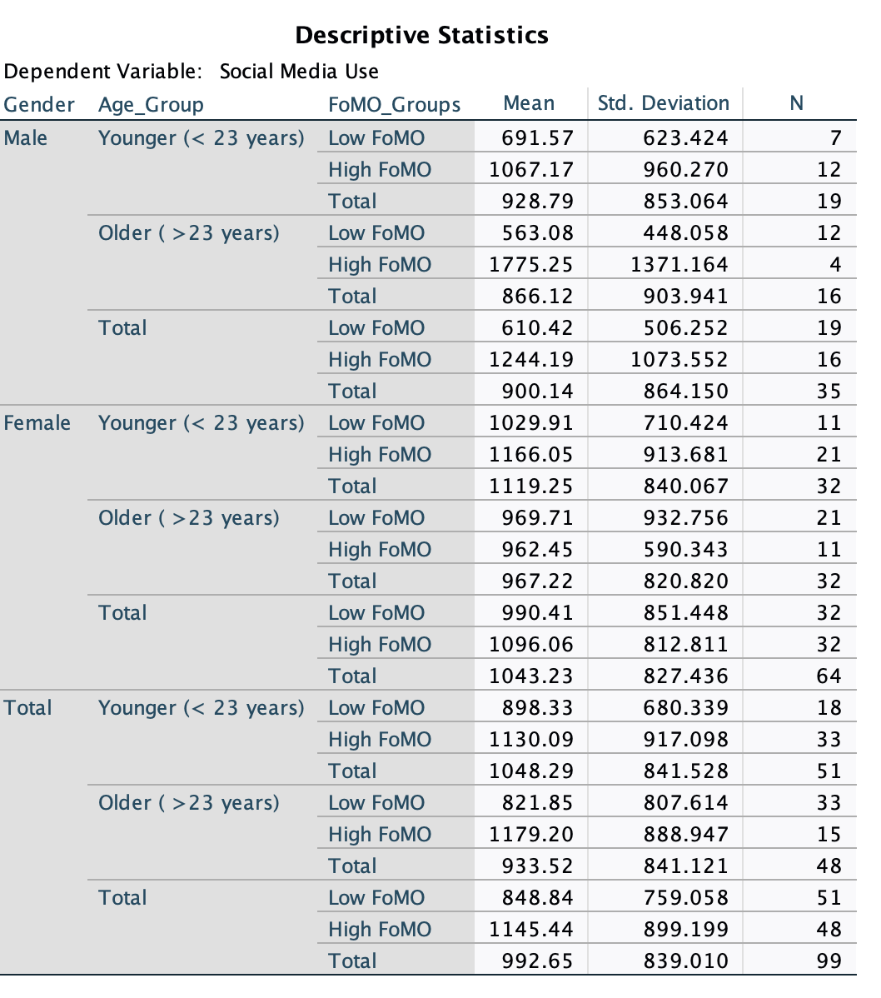

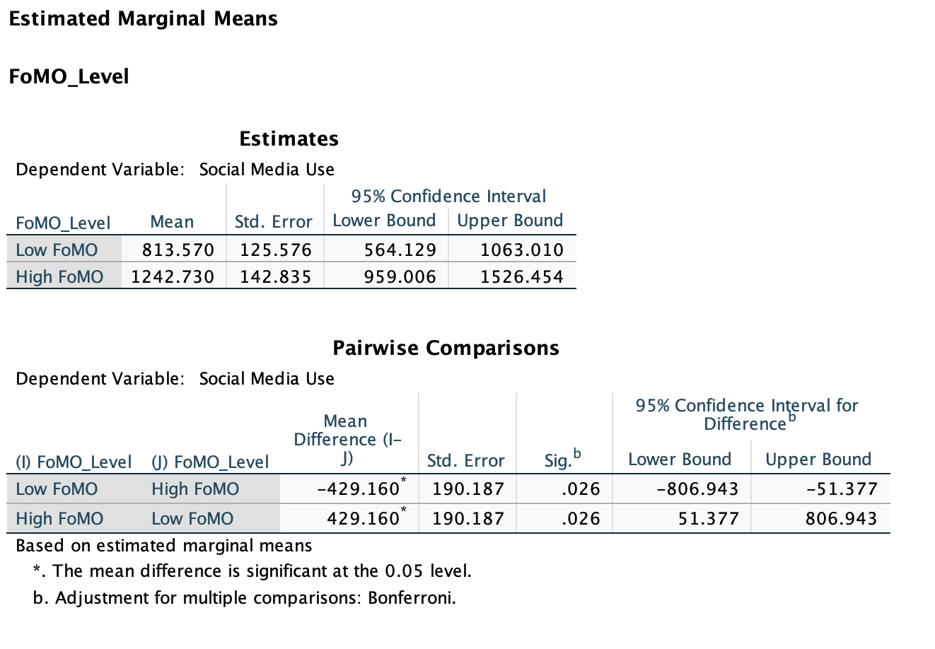
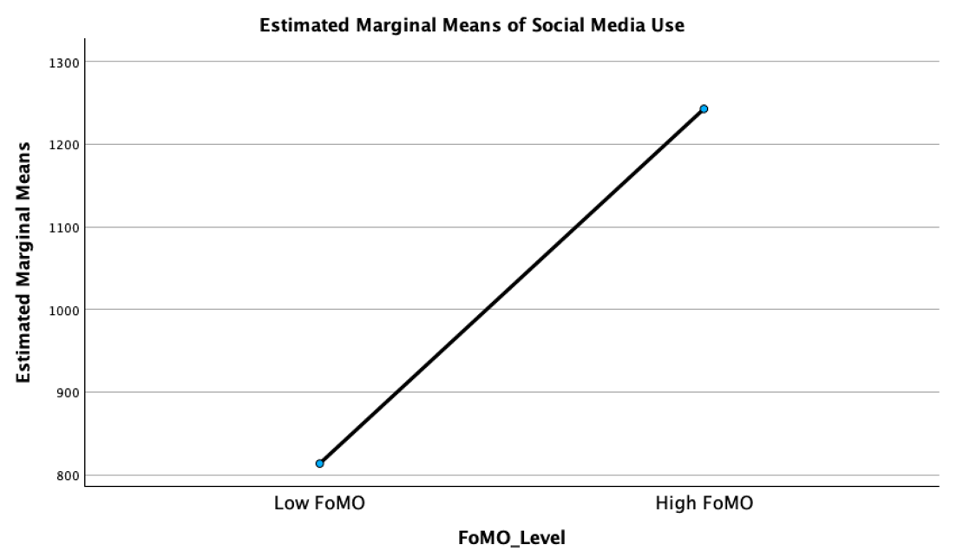

Appendix L – G*Power

