Is Tarantinos portrayal of female empowerment authentic, or is it simply another spectacle crafted for audience entertainment?
Zuzanna Zurak

Submitted to the Faculty of Film, Art and Creative Technologies in candidacy for the BA (Honours) Degree in Design for Film – Model making
Submitted 13/02/25

Declaration of Originality This dissertation is submitted by the undersigned to the Institute of Art Design & Technology, Dun Laoghaire in partial fulfilment of the examination for the BA (Honours) Design for Film. It is entirely the author’s own work except where noted and has not been submitted for an award from this or any other educational institution.

Zuzanna Zurak
Acknowledgments
This study would not be possible without the expertise of my thesis supervisor Clare Barman, to whom I would like to offer my special thanks, I am profoundly grateful for her patience, guidance and support throughout my journey in writing this thesis. Her contribution greatly benefited to my comprehension of complex feminist tropes. A debt of gratitude is also owed to my parents Mr and Mrs Zurak, especially my mother who contributed towards scholarly finances and supported my passions. Last but not least, I would like to sincerely thank the entirety of the Institute of Art Design and Technology, who I will forever be grateful to for providing me with four years of knowledge, discipline, and amazing staff who supported my every idea.

Abstract
This paper examines the portrayal of female empowerment in a selection of Quentin Tarantino's films with a focus on Kill Bill, that is often praised for its portrayal of strong women. The focus of this study questions whether the perceived empowerment is real or exists just to please viewers. To explore this, I focus on Feminist movie theorists Laura Mulvey, Simone De Beauvoir, and Judith Butler. Their work helps to analyze whether Tarantino’s films truly break away from sexist ideas or if they still follow traditional ways of presenting women. For example, Mulvey’s concept of the male gaze is key to understanding how women in these films are shown in ways that appeal to male viewers, Judith adds to this by explaining societal gender roles and Simone explains how women are “the other” in relation to men. This thesis argues that while Tarantino challenges how women are shown in movies, his style often turns their empowerment into a spectacle, balancing between breaking old stereotypes and reinforcing them.

Table of Contents

Introduction ____________________________________________ pg. 9

Chapter 1 ______________________________________________ pg. 13.

Title: Tarantino, A Postmodern Auteur

Chapter 2 ______________________________________________ pg. 28.

Title: Evolving the Female Agenda in Tarantino Films

Chapter 3 ______________________________________________ pg. 45.

Title: Final Redemption, Kill Bill

Conclusion ______________________________________________ pg. 58

Bibliography ____________________________________________ pg. 60.

List of Figures
Fig. 1: Tattoo on my leg “Kill Bill.” (Personal Image). ……………………………… p. 6
Fig. 2: Daisy from The Hateful Eight with a bruised face. (The Hateful Eight, 2015, Dir. Quentin Tarantino). ……………………………… p. 16
Fig. 3: Starry Night as an example of a pastiche. (Van Gogh, 1889). ……………………………… p. 17
Fig. 4: Mia Wallace from Pulp Fiction (1994) directed by Quentin Tarantino. ……………………………… p. 19
Fig. 5: Mia Goth in Pearl (2022) directed by Ti West, shows a hysterical portrayal of female rage. ……………………………… p. 21
Fig. 6: Margot Robbie as Sharon Tate in Once Upon a Time in Hollywood (2019), directed by Quentin Tarantino. ……………………………… p. 23
Fig. 7: Uma Thurman’s character, Mia Wallace, in Pulp Fiction (1994), as she dances at the diner with Vincent Vega. ……………………………… p. 24
Fig. 8: First image from Death Proof (2007) and second from Once Upon a Time in Hollywood (2019), directed by Quentin Tarantino. ……………………………… p. 26
Fig. 9: Vernita Green vs. The Bride (Kill Bill Vol. 1, 2003), directed by Quentin Tarantino. ……………………………… p. 30
Fig. 10: Elle Driver’s look from Kill Bill Vol. 2 (2004). ……………………………… p. 31
Fig. 11: Megan Fox fixing a car in Transformers (2007), directed by Michael Bay. ……………………………… p. 32
Fig. 12: Beatrix Kiddo kills Bill using her “Five-Point Palm Exploding Heart Technique” (Kill Bill Vol. 2, 2004). ……………………………… p. 35
Fig. 13: Girl Squad from Death Proof (2007), directed by Quentin Tarantino. ……………………………… p. 36
Fig. 14: Wonder Woman’s outfit in Wonder Woman (2017), directed by Patty Jenkins. ……………………………… p. 38
Fig. 15: Kill Bill, directed by Quentin Tarantino—full outfit compared to Wonder Woman. ……………………………… p. 39
Fig. 16: Game of Death (1972), directed by Robert Clouse and Bruce Lee, compared to The Bride’s outfit in Kill Bill (2004). ……………………………… p. 40
Fig. 17: Beatrix Kiddo’s feet in Kill Bill Vol. 1 (2003), directed by Quentin Tarantino……………………………..p.41
Fig. 18: Gender breakdown of characters in Tarantino films. (Kambhampaty & Wolfson, 2019). ……………………………… p. 44
Fig. 19: Number of spoken lines by men and women in Tarantino films. (Kambhampaty & Wolfson, 2019). ……………………………… p. 45
Fig. 20: Beatrix Kiddo stuck in a coffin (Kill Bill Vol. 2, 2004), directed by Quentin Tarantino. ……………………………… p. 47
Fig. 21: Close-up of Beatrix Kiddo in the coffin, as she struggles for a way out (Kill Bill Vol. 2, 2004). ……………………………… p. 48
Fig. 22: Close-up of Beatrix after being shot by Budd before being buried alive (Kill Bill Vol. 2, 2004). ……………………………… p. 48
Fig. 23: Beatrix Kiddo played by Uma Thurman, stuck in a coffin using a torch as her only light source, directed by Quentin Tarantino. Kill Bill Vol. 2 (2004). ……………………………… p. 49
Fig. 24: Torch-lit sewers in The Third Man (1949), directed by Carol Reed. ……………………………… p. 49
Fig. 25: Pai Mei treats Beatrix poorly in Kill Bill Vol. 2 (2004). ……………………………… p. 52
Fig. 26: Tarantino wraps a chain around Uma Thurman’s neck on the set of Kill Bill. ……………………………… p. 53
Fig. 27: Opening wedding scene in Kill Bill Vol. 1 (2003), directed by Quentin Tarantino. ……………………………… p. 55
Fig. 28: The Bride finds out she lost her baby (Kill Bill Vol. 1, 2003). ……………………………… p. 56
Fig. 29: The Bride regaining control in a fight sequence (Kill Bill Vol. 1, 2003). ……………………………… p. 57

Introduction
The portrayal of women in cinema has always been a topic of debate since its inception. Historically, movies have often shown women as side/ secondary characters there to support a man, be saved by him, or motivate his story. Even when women are the center of the story, their actions and decisions are usually influenced or caused by men. From popular tropes such as the damsels in distress in old action films to today’s strong female leads as superheroes, these portrayals reflect society’s ideas about gender. Feminist theorists such as Laura Mulvey, Simone de Beauvoir, and Judith Butler have critically examined these representations, providing a foundation to analyze how gender is portrayed and performed in film. Mulvey’s concept of the "male gaze," introduced in "Visual Pleasure and Narrative Cinema" (1975), argues that women in film are often objectified for male spectacle. Whereas De Beauvoir, in "The Second Sex" (1949), explains how women are positioned as "the Other" in relation to men, meaning that women were often defined more by how they contrast to men rather than by their own identity. Judith Butler’s book “Gender Troubles 1990” adds to this by saying that “gender is not fixed but performed through actions and roles”. In other words, we learn to be "male" or "female" through how we act, not because it's natural. These ideas help us understand how movies create and show gender roles. Postmodernism gives us another way to look at gender in film. Postmodernism is a Western twentieth-century movement that emerged as a response to the structured, idealistic, principles of modernism. The movement combines different styles while rejecting the linear and cohesive storytelling that defined modernist art and literature.
My focus is on Quentin Tarantino, as a postmodern auteur and controversial filmmaker, and the important role his representation of women plays in this discussion. Known for his unique style, mixing genres, and post-modernistic approach to storytelling, He creates worlds in which his female characters are powerful yet complex. But do his films truly challenge gender stereotypes, or do they simply exist to turn female empowerment into another form of entertainment? His postmodernist style often plays with tropes like genre blending and challenges traditional storytelling, theorists like Fredric Jameson and Jean Baudrillard bring an interesting perspective on the movement. Kill Bill does this by referencing spaghetti westerns, martial arts movies, and revenge stories into one unique story. However, postmodernism undermines some feminist tropes causing a risk of turning serious ideas into a spectacle for entertainment.
These theorists help break down these complex layers of the female characters and how these postmodernist tropes undermine them in Tarantino's film. Furthermore, these theorists help analyze whether Kill Bill, represents genuine female empowerment or simply fits into the “male gazed” storytelling world. The power and impact of the film and the strong female characters represented influenced me strongly enough to get a tattoo, a symbol to honor what her character meant to me, resilience, defiance, and the raw power of anger, that connection is why I chose Kill Bill as the focus of my analysis. As Charles Peirce explains, “We think only in signs” (Collected Papers, 1931). This means that everything we see and understand is shaped by symbols. In film, symbols aren’t just stylistic choices they hold a deeper meaning. Beatrix Kiddo is more than just a strong female character she represents vengeance, survival, and defiance. Her yellow jumpsuit, her Hattori Hanzo sword, even her codename Black Mamba all of these are symbols of her power. The way she moves, fights, and takes control of her own story makes her more than just a movie character.
This is why Kill Bill had such a strong impact on me.
I often reflect on the moment I first saw Kill Bill I admired Beatrix because she was unlike any character I’d seen before, she was not like the princesses I had grown up watching, waiting for a prince to save them. Kill Bill was the first example of a woman who reclaimed her agency, a main character who does not need a man to save her, in-fact the man needs to be saved from her
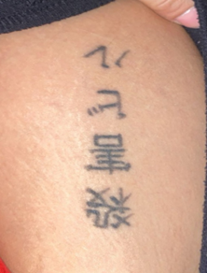
Fig 1. Tattoo on my leg “Kill Bill”
This character became an idol. However in thinking more critically about this character and her journey, I began to question whether her empowerment was as it seemed.
In Kill Bill, Beatrix’s strength and suffering are presented in a way that is both empowering and visually appealing, raising questions about whether her empowerment is truly authentic. Her moments of vulnerability, such as when she is buried alive, are both powerful and staged for dramatic impact. Simone de Beauvoir’s ideas about women being defined concerning men also apply here, as Beatrix’s journey is shaped by her male mentor, Bill, and her male trainer, Pai Mei. By exploring how Tarantino’s unique style both challenges and reinforces traditional ideas about women, this study aims to uncover the true portrayal of women and their empowerment in Tarantino's films.

Chapter one, Tarantino a Postmodern Auteur analyzed through a feminist lens.
This Chapter introduces postmodernism in cinema through Quentin Tarantino's cinematic worlds. It focuses on how Tarantino’s films follow postmodernist conventions, as observed in the use of techniques like blending genres, playing with time, and playing with traditional gender roles. It looks to Feminist theorists, Simone De Beauvoir, and Laura Mulvey to help deconstruct the complex layers of feminist tropes that parallel with some of the post-modernistic ideals. These feminist perspectives are particularly relevant in deconstructing Tarantino's complex portrayal of the women in his film, raising the question if their empowerment is ‘authentic’, or is it simply another spectacle crafted for audience entertainment
Quentin Tarantino, as post-modernistic auteur: Tarantino is known as one of the most iconic unconventional filmmakers in the history of cinema, a recognizable director of the post-modernist movement (10thingsaboutcinema, 2022). He navigates postmodernist tropes to produce films that challenge the boundaries of conventional moviemaking engaging viewers in a distinctive visual style commonly referred to as “Tarantinoesque” a term that highlights his unique blend of genre-bending, graphic and stylized violence, stylistic references, and self-aware dialogue (Oxford English Dictionary, 2023).
Looking through the lens of Laura Mulvey, Simone de Beauvoir, and Judith Butler helps us understand how gender roles in his movies challenge and support traditional ideas.
Postmodernism in movies is about mixing old ideas to make something new. Tarantino does this by taking stories like revenge or action movies and putting women in the lead roles instead of men. He also pays homage to a lot of Spaghetti Westerns and martial arts movies, he does this by showing a lot of violence and stylized fight scenes. While his female characters are strong and fight back, they often face extreme violence, and some of these scenes can feel over the top or crafted for spectacle which makes them straddle the line between empowerment and objectification which raises questions on the authenticity of his female character’s empowerment. This brings me to the focus of my inquiry, the representation of women in Tarantino’s films. My focus is on the representation of women, if they are constructed as empowered females following feminist film theory, how they are constructed visually, and if Tarantino’s representation is simply another spectacle crafted for the audience.
Tarantino’s visual aesthetic and his unique approach highlight his postmodern aesthetic, which proves that his cinema serves as a showcase of how postmodernism functions in films. A characteristic of postmodern cinema may include experimenting with narrative structure and drawing attention to the plot to let the audience see a different outcome, deconstruction of traditional genres, creating hybrid forms by mixing elements from various genres, and temporal distortion which can include time loops, and parallel storylines all elements that can disrupt the linear flow of a narrative. These principles are all evident in Tarantino’s film.

Tarantino constantly challenges non-linear storytelling where he has scenes unfold in a non-sequential manner, forcing viewers to piece together the chronology, this approach goes against the traditional narrative structure as nonlinear storytelling mixes up the order of events, showing them out of sequence instead of in chronological order, It can include flashbacks, flash-forwards, or present different timelines simultaneously.
Quentin Tarantino’s Pulp Fiction is a notable example of this style, mixing different storylines together in a non-chronological way (Film, 2024). Another characteristic of a Tarantino movie that follows a distinctive post-modernist approach is his approach to dialogue, characters often engage in long conversations, and discussions about fast food, pop culture, or films that do not always advance the plot but rather serve to create a sense of hyperreality. Baudrillard had an interesting perspective on hyper-reality, he argued that in a postmodern world, the distinction between reality and representation has broken down, leading to what is referred to as simulacra, which are copies of things that no longer have an original or real reference. Tarantinos films often create engaging worlds where the line between representation and reality blurs, paralleling Baudrillard’s concept of simulacra. An example of Baudrillard’s simulacra in Tarantino film would be the character Daisy Domergue in The Hateful Eight. She looks like an old Western outlaw she wears messy clothes, has a bruised face, and is chained up like a prisoner. But she is exaggerated, almost like a cartoon version of a villain. Tarantino takes ideas from old Westerns but makes her louder, more violent, and more extreme than any real outlaw from history.

Fig 2 Daisy from Hateful Eight with bruised face.
Fredric Jameson’s Postmodernism, or the Cultural Logic of Late Capitalism (1991) offers his perspective on postmodernism, exploring how capitalism transforms art, culture, and society by turning everything into commodities for commercial use and erasing the boundaries between reality and fiction. His analysis highlights how an element of postmodernism is pastiche, he explains pastiche to be like an imitation that is almost parody like, without the intention to mock or offend and instead takes a neutral stance. Tarantino's films demonstrate pastiche by incorporating a diverse assortment of influences, styles, and genres, blending them in a way that pays homage to, and often parodies the original sources, this raises the question of how these manipulations might also reflect or conceal female empowerment.

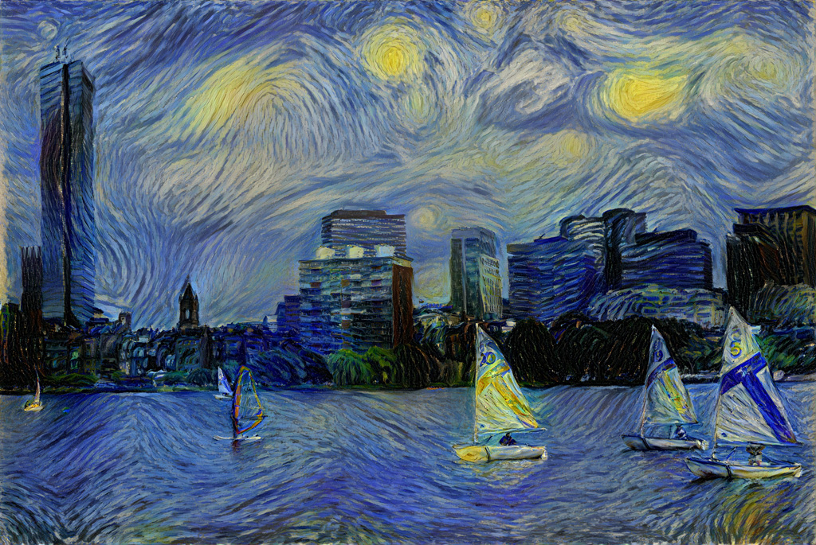
Fig 3. Starry Night as an example of a pastiche.
The image keeps the swirling sky and dreamy atmosphere of Van Gogh but adapts it to a futuristic aesthetic. Instead of creating something completely new or making fun of the original, these versions borrow Van Gogh’s style and mix it with modern elements, turning it into a layered, postmodern reimagining.
Jameson further claims that postmodernism serves as an era that is characterized by the fundamental breakdown of distinctions between high and low culture, past and present, and even reality, and simulation. Lau (2022) defines high art as artwork whose important aesthetic features are typically beyond the reach of most viewers. In contrast, low art is described as having significant aesthetic qualities that are easily understood and appreciated by most audiences: "High Art: An artwork A is an instance of high art just in case its significant aesthetic qualities (i.e., the important qualities that a perceiver must possess and respond to in order to fully appreciate it) are generally inaccessible to perceivers given their aesthetic responsive capacities. Low Art: An artwork A is an instance of low art just in case its significant aesthetic qualities are easily accessible to perceivers given their aesthetic responsive capacities.”
Tarantino's films showcase the breakdown of the boundaries between high and low culture, reflecting Jameson's idea of postmodernism. His work blends elements of both, appealing to film enthusiasts who appreciate deep cinematic references and casual viewers who enjoy entertaining stories and characters. For example Mia Wallace from Pulp Fiction (1994)

Fig 4. Mia Wallace from Pulp Fiction directed by Quentin Tarantino 1994
High culture: Mia’s look, her black short bob white shirt, cigarette is inspired by French New Wave movies, particularly Jean-Luc Godard’s Vivre Sa Vie (1962). Low culture: When She talks about burgers, TV shows, and milkshakes, uses drugs, and dances to pop music, which is part of everyday life and pop culture.
This can challenge the actor’s perception and the audience’s understanding by blurring the line between reality and fiction and manipulating the audience's ability to distinguish between what is real and what is just a performance ( FilmTheory, 2014). Like Baudrillard, Jameson thinks that today’s world has lost its real connection to history, instead of remembering the past in a meaningful way, we just take pieces of it, strip them of meaning, and turn them into styles or trends. These meaningless pieces are then sold and used, just for show. (CLA, 2019). Baudrillard's understanding of hyperreality and Jameson’s perspective on postmodernism help frame Tarantino’s films within the context of the movement where intertextuality and genre-blending are common elements in the postmodern aesthetic.
This mixing of styles in postmodernism also applies to how Tarantino portrays female rage, where he challenges traditional views of women’s anger. To understand these depictions, it is important to examine how female rage has been historically treated. For much of film history, Female rage was often a suppressed female emotion, their anger was often confined by patriarchal narratives and depicted as a sign of hysteria or irrationality. It is usually presented as a one-dimensional view of anger, centered around men. In contrast, male rage is almost seen like a characteristic, or something heroic, justifiable, and sometimes even the driving force behind a male protagonist’s quest for justice or revenge. (Seal, 2023) This double standard is the reason female rage has been reinterpreted or even silenced in cinematic history. However, in Tarantinos film, he creates a space for experimenting with different portrayals of the female rage, his female characters who present rage are not villainized or infantilized, yet he offers a more refined representation of this emotion. ) For example a more recent movie that still holds onto the ideas that a females rage must be something ‘irrational’ is Pearl (2022).
Fig 5. Mia Goth in Pearl (2022) directed by Ti West. Showing a hysterical portrayal of female rage. Mia Goth’s rage in Pearl is called hysterical because it follows the old idea that women are overly emotional and unstable. In the film, Pearl slowly loses control, showing extreme facial expressions, long emotional speeches, and sudden violent actions. This makes her anger seem crazy and dangerous instead of reasonable or strong.

This shift can be examined through Laura Mulvey's theory of the male gaze. Mulvey argues, "In a world ordered by sexual imbalance, pleasure in looking has been split between active/male and passive/female." (Mulvey, 1975, p.19).
By challenging traditional representations of female rage, Tarantino allows his female characters to move beyond passive roles. These portrayals come in complex and layered ways that blur the lines between simple categories like victim and hero, weak and strong, or masculine and feminine, this deconstruction of traditional oppositions shows that characters can embody multiple traits at once further channeling the post-modernist aesthetic and supposedly fueling the feminist agenda.
Gender roles. Females are usually cast as secondary characters, either serving as objects of desire or damsels in distress that exist primarily to enhance the male protagonist’s storyline. Simone de Beauvoir's The Second Sex provides a clear insight on women's position in these types of classic films. She explains that women are defined and valued in relation to men and society's standards, rather than on their own terms. These portrayals are also influenced by what Laura Mulvey describes as the “male gaze.” In her seminal essay "Visual Pleasure and Narrative Cinema, she argues that mainstream cinema caters to the male perspective, where women are depicted as objects for male viewers. This dynamic gives men the active roles or as the subjects who act and look whereas it forces women into passive roles or as the objects that are meant to be looked at. This gaze also reinforces patriarchal power dynamics and limits the ways in which female characters are depicted in film 
Fig 6 Margot Robbie as Sharon Tate in Once Upon in Hollywood directed by Quentin Tarantino (2019) .
According to de Beauvoir, "One is not born, but rather becomes, a woman," (De Beauvoir, 2000) suggesting that gender identity is socially constructed and a concept that can be applied to Tarantino’s female characters, On the one hand, his portrayal of female characters could be seen as celebrations of strength and independence as they take on roles traditionally reserved for men, and on the other hand, these depictions sometimes border on fetishization, raising questions about whether they genuinely subvert patriarchy or is it repurposed for aesthetic purposes? Despite Tarantino’s post-modernistic approach, which focuses on his visual style, his female character often retains elements of the male gaze. For example, even as his female characters wield power, they are frequently sexualized or placed in scenarios where their strength, power, or suffering becomes a spectacle.
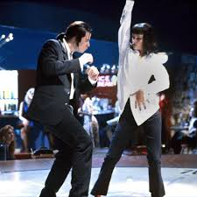
Fig 7 Uma Thurman’s character, Mia Wallace, in Pulp Fiction (1994) as she dances at the diner with Vincent Vega.
Even though Mia is confident and independent, the scene is highly stylized, and her sexuality is emphasized through the way the camera follows her movements, reinforcing the male gaze even though she’s in control of the situation. His post-modernistic approach became evident as Tarantino frequently paid homage to Westerns, grindhouse genres, and crime cinema of the 1970s, which usually objectify women through extreme violence and sexualization, and even though he reinterprets these genres, some elements seem to remain intact.
Tarantino often includes scenes with a focus on female feet feeding into his own fetishes, this can be seen as objectifying and using his status as a director to place females in scenes he gains pleasure from. When asked about these detailed scenes of women's feet he denied fetishizing them, stating “I don’t take it seriously,” he said. “There’s a lot of feet in a lot of good directors’ movies. That’s just a good direction. Like, before me, the person foot fetishism was defined by was Luis Buñuel, another film director, and Hitchcock was accused of it and Sofia Coppola has been accused of it.” (faroutmagazine.co.uk, 2023).
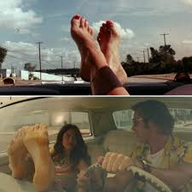
Fig 8. First image is from Death Proof (2007) and the second Once Upon A Time In Hollywood (2019)
With this in mind, could the scenes that depict women's feet just be embracing the beauty of the female form or just another version of the male gaze Mulvey talks about? This mix of challenging norms and sticking to traditional portrayals makes Tarantino's depiction of women both innovative and controversial, as it can be seen as either empowering or objectifying, depending on how it is interpreted.
Another aspect of his films that raises questions is the narrative control. Simone states, "He is the Subject, he is the Absolute she is the Other." This highlights how women in cinema, including Tarantino’s films, are often defined in relation to male characters and their experiences, especially when it comes to trauma and revenge. While Tarantino’s women are active and central to the plot, their stories often still revolve around trauma, revenge, or responses to violence influenced by men. This ties into a broader cinematic trend where strong female characters are given power primarily through their pain and depending on a man's understanding of empowerment.

CHAPTER 2
The focus of this chapter is to discuss the portrayal of women in Quentin Tarantino's films, analyzing the layers of feminist agency and contradictions within his narratives. It will explore feminist themes such as female empowerment, agency, and defiance against traditional gender roles present in Tarantino.
This chapter will focus on Kill Bill’s Beatrix Kiddo and compare her representation with other female characters across Tarantino’s films such as Death Proof (2007) Inglorious Basterds (2009) and Pulp Fiction (1994) but will also be compared against Ridley Scotts Thelma And Loiuse 1991 and Patty Jenkins Wonder Woman (2017). To substantiate these arguments, the chapter will engage with feminist theorists. Judith Butlers ideas will help us see if Tarantino’s female characters, like Beatrix Kiddo, are truly powerful or just acting strong in a way that still fits what men expect. While Simone de Beauvoirs ideas will help us look at how Tarantino’s female characters, especially Beatrix Kiddo, exist in a world mostly controlled by men and whether they have real empowerment and Laura Mulveys will help us question whether Tarantino’s female characters are truly independent or if they are made to look powerful just to entertain a male audience.. These theorists help highlight recurring themes of empowerment, isolation, and the influence of the male gaze. Still, most importantly a central question emerges Is the empowerment of Tarantino's female characters authentic, or is it a spectacle crafted for male audiences?
Evolving the female agenda in Tarantino film.
Tarantino’s postmodern style creates a space where traditional ideas about gender are both challenged and reinforced. This leads into a closer look at how his female characters are portrayed, focusing on whether their empowerment feels real or is just part of his stylized storytelling. His work occupies a compelling space where feminist agency intersects with contradictions, shaped by aesthetic and narrative choices that simultaneously elevate and limit his female characters. Theorists, Simone de Beauvoir, Judith Butler, and Laura Mulvey provide influential critiques on the representation of women in film, their critiques of gender roles, the male gaze, and the performativity of femininity through their lenses make the bride’s empowerment feel less true agency and more like a construct shaped by patriarchal and cinematic conventions. An example of this is when Mulvey states "In a world ordered by sexual imbalance, pleasure in looking has been split between active/male and passive/female" Visual Pleasure and Narrative Cinema 1975, p. 11). This means that men do all the actions and women are there for their personal desires and to be looked at. Butler argues that "gender is in no way a stable identity.. but an identity tenuously constituted in time gender trouble 1990, p. 179). This suggests that being a woman or being strong isn’t something fixed it’s something that is performed, which makes Beatrix’s empowerment feel more like a role she plays than true freedom

These theories pushed me to think more deeply about aspects of Kill Bill I had overlooked. One of these aspects was the role of other women in the bride’s story, While characters like Vernita Green O-Ren Ishii and Elle Driver are strong, they are enemies who are overshadowed and defeated by Beatrix, Vernita Green is shown as a former assassin who has settled into a domestic life, raising her young daughter. However, her character becomes more of an obstacle for Beatrix to defeat than a fully developed individual.

Fig 9. Green vs Kiddo Kill Bill Vol 1. Directed by Quentin Tarantino
In their fight scene, the brutality and rawness stand out, but the focus stays on Beatrix’s revenge, making Vernita’s life and motivations feel secondary. O-Ren Ishii is also a fascinating character who shows both strength and limitation in the story. As a leader of Tokyo's underworld, she stands out as a woman succeeding in a male-dominated world. Her traumatic childhood and rise to power give her depth, but her role is mostly another obstacle in Beatrix’s journey. The duel between them is visually stunning and meaningful, but it highlights a common theme in Tarantino’s films women being pitted against each other instead of showing solidarity or cooperation.
Elle Driver is yet another complex character, showing physical strength, cruelty, and defiance of traditional gender roles. Her ruthlessness and refusal to conform make her memorable, but her exaggerated villainy often overshadows her deeper motivations. The rivalry between Elle and Beatrix is intense, but like Vernita and O-Ren, Elle’s story mainly serves to highlight Beatrix’s journey.
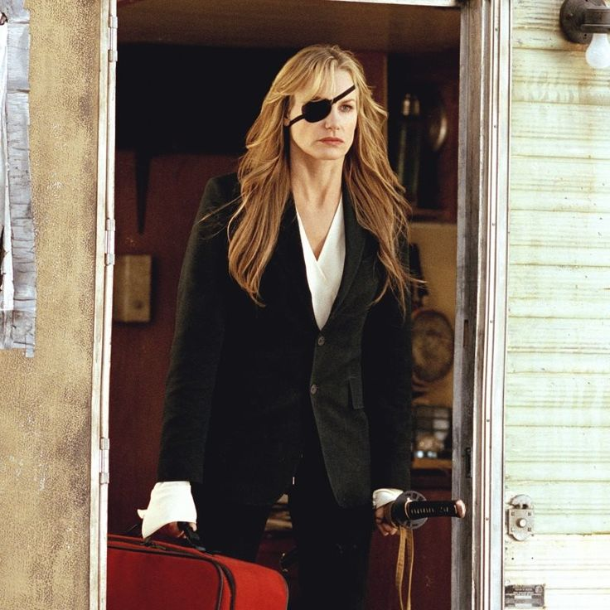
Fig 10. Elle Drivers look from Kill Bill vol 2 (2004)
Elle Driver’s look combines traditional feminine beauty with a strong, exaggerated action style. She is shown as both a dangerous woman and someone who can be seen as attractive. This mix of elegance and violence is another example of how Tarantinos worlds blends high and low culture art and he does this by blending fancy artistic style (high culture) with intense action (low culture).
Mulvey's theory on the “male gaze” is particularly relevant as she explains how women in movies are often presented as objects for male viewers, shaping their roles to fit male-driven stories. Mulvey explains, "Women are shown and looked at, with their looks made to have a strong visual and erotic impact" (Mulvey, 1975).
Fig 11. Megan Fox fixing a car in Transformers 2007 Directed by Micheal Bay
The camera focuses on her body rather than her mechanical skills, close-ups of her midriff, sweaty skin, and curves as she leans over the car. Even though she in knowledgeable about cars the way the scene is shot reduces her expertise to an aesthetic spectacle. This aligns with Laura Mulvey’s "male gaze" theory.
This can create competition between women, which goes against feminist ideas of working together and supporting each other. This idea is not just in Kill Bill, films such as Mean Girls (2004) and Gone Girl (2014) also show women in rivalry, suggesting that one woman’s success must come at the cost of another’s. But what if Beatrix and Vernita worked together? Could their shared anger have turned the story into one of collective action instead of personal revenge? This idea across our screens is still challenging today. It challenges the belief that women’s anger should be directed at each other or kept internal, instead of being used to confront the systems that oppress them. His female characters challenge stereotypes yet remain confined by the aesthetic and boundaries of his cinematic world. This chapter examines how far feminism can go in a world that values spectacle above everything.
Expanding the framework of feminist cinema:
While Kill Bill may feel revolutionary it does not stand alone. To fully understand its feminist impact, it helps to compare it with other films that explore female anger and agency, like Ridley Scott’s Thelma & Louise (1991). Unlike Beatrix’s personal, revenge-focused journey, Thelma & Louise centers on friendship Praised at the time for its daring embrace of third-wave feminism and criticized, depending on perspective, for either its "male-bashing" tone or its "betrayal" of feminist ideals (Denney, 2016). However, their anger was not aimed at a single person but at a system that repeatedly oppresses them. Their transformation is shared, making their rebellion more about solidarity than revenge. The film’s famous ending where they choose death over being captured symbolizes their rejection of that system. Beatrix, by contrast, survives and reclaims her agency, but her journey remains deeply personal and individual. This comparison shows a different view of female agency by contrasting the individual empowerment in Tarantino's films with the teamwork and shared strength in Thelma & Louise. This raises an important question, does Kill Bill’s focus on personal revenge limit its feminist message by avoiding broader issues of systemic oppression? For me, this comparison sparked a realization. Beatrix’s story is not just about empowerment, it is about survival. Her power is earned through hard training and trauma in a male-dominated world. Her anger is inspiring, but it feels extraordinary, rather than part of a shared, collective struggle that others can relate to. Her strength and anger come from the betrayal, pain, and loss she has endured, not something she is born with, her story is powerful, but it lacks the collective resistance seen in Thelma & Louise. Butler’s idea of gender as a repeated performance also applies here. In Thelma & Louise, the two women perform their transformation together, breaking away from societal norms as a team. In Tarantino’s films, however, the women’s performances are isolated, suggesting that power must come from individual action rather than shared strength. The idea of performativity is introduced in the first chapter of Gender Trouble 1990 when Butler states that gender proves to be performance that is, constituting the identity it is purported to be. In this sense, gender is always a doing, though not a doing by a subject who might be said to pre-exist the deed in other words gender is not something that one is, it is something one does, an act.. a ‘doing’ rather than a ‘being.’”. Rather than focusing on individual empowerment like in Kill Bill, Thelma & Louise challenge gender norms together, which can be seen as a stronger form of transformation because they support each other. Butler’s idea that gender is "something you do" (Butler, 1990 pg25) fits both films. In Tarantino’s work, female characters perform power in a male world, but their agency often still depends on male characters and reinforces traditional gender roles.
This means their empowerment can feel more like a spectacle rather than a deep, meaningful transformation. (Varghese, 2024) This can be seen in kill bill even though Beatrix finally takes revenge and shows her strength the entire story is still shaped by her relationship with Bill her pain, journey, and her skills are tied to him. Even the movies title being Kill Bill shows how much of her journey was shaped by Bill.
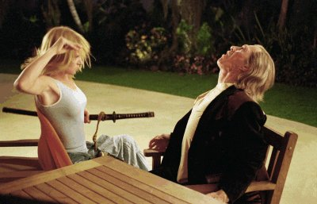
Fig 12. Beatrix Kiddo Kills Bill using her “five point palm exploding heart technique” Kill Bill vol 2 (2004) Dir Quentin Tarantino.
Tarantino initially portrays his female characters as victims but later subverts this by putting them in control and challenging traditional gender roles (Saxelby, 2017). From Beatrix Kiddo in Kill Bill to the girl squad in Death proof and Shosanna Dreyfus in Inglourious Basterds, these women are strong, intelligent, and fierce, claiming a space in narrative that is often fetishized or sidelined.
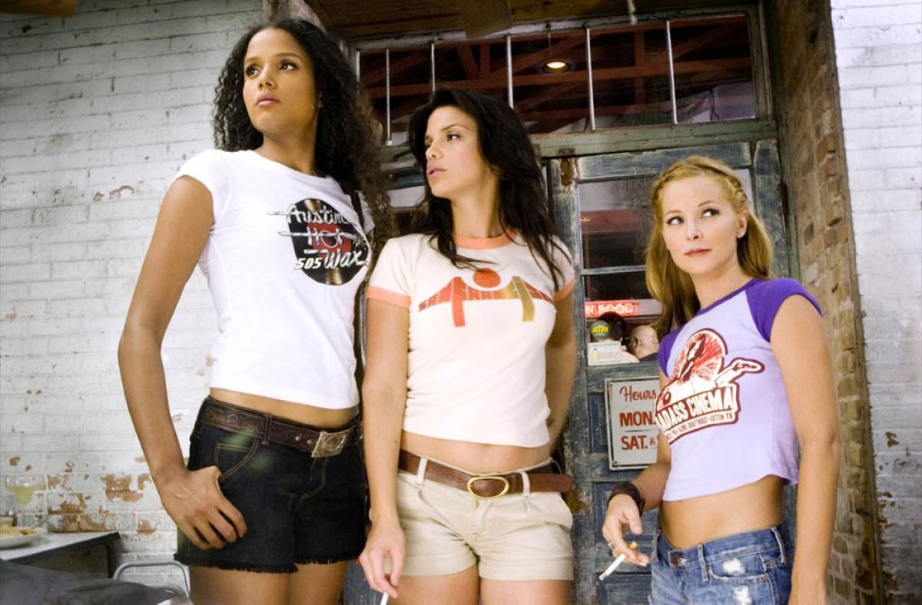
Fig 13. Girl Squad from dead proof 2007 Directed by Quentin Tarantino.
Looking at these notable female characters helps us understand similarities which helps establish what type of relationship Tarantino has with feminist representation, as one thing all these women have in common is while they all display significant strength, their narratives remain tied to the actions and influence of male characters. Shosanna's revenge is deeply emotional and complex. She starts her journey with the trauma of losing her family to Colonel Hans Landa. Unlike Beatrix, who seeks personal revenge, Shosanna's quest represents resistance against the oppressive Nazi regime. However, her story ends tragically with her death, and her final act of rebellion is carried out by the Inglourious Basterds, not by her. This diminishes her agency, suggesting her strength is secondary to the collective mission of others. In Death Proof, the women start off as victims in a male-dominated story, but they take control in the second half, led by stuntwoman Zoë Bell. They overpower Stuntman Mike, which is empowering and thrilling. However, their victory is shown through exaggerated violence, making it more of a spectacle. While their strength and sisterhood are celebrated, the film still focuses on their physicality, often reducing them to visual objects rather than fully developed characters.
much power they held, their narratives always depended on a male in some way. This is addressed in In The Fascination of Film Violence, Henry Bacon argues that Kill Bill centers on beautiful blonde women trained to kill by men and for men. He claims that, nicknamed after venomous snakes, these women exist solely to serve their "snake charmer," (Bacon, 2015,147). This continues to raise the question of whether Tarantino's female characters' empowerment is real, or is it just a show designed for spectacle designed to satisfy the “peeping Toms” and appeal to audiences who crave the violence and action that Mulvey warns of.
In Gender Trouble Feminism and the Subversion of Identity, Judith Butler explains how gender is created through repeated actions, stating that “gender is always a doing.” (Butler, 1990, 33. In Tarantino's films, female characters move through male-dominated worlds by taking on roles that challenge traditional ideas of femininity, for example, the bride who operates in a realm usually reserved for superheroes, wears a bright yellow jumpsuit that pays homage to Game Of Death (1978 Bruce lee). This jumpsuit symbolizes strength, resilience, dedication but most importantly one of the greatest fighters known to man, by referencing Bruce Lee, Tarantino situates Beatrix within a traditionally male-dominated genre while simultaneously disrupting it, it is a rejection of the hypersexualized costumes that often define female action heroes, the contrast with figures like Wonder Woman is striking. While Wonder Woman is admired for her strength, her revealing armor emphasizes spectacle and draws attention to her body, appealing to the male gaze, Mulvey disapproves such costumes stating "Women are simultaneously looked at and displayed, with their appearance coded for strong visual and erotic impact so that they can be said to connote to-be-looked-at-ness." (Mulvey, 1989, p. 19), this means that in many films, women are presented in a way that makes them objects of desire for the audience, rather than fully developed characters with their own agency that In contrast, Beatrix’s iconic yellow jumpsuit is practical, unsexualized, and designed for movement, prioritizing function over visual appeal. While it rejects over sexualization, it is still an aesthetic choice, one that plays into Tarantino’s post modernistic style. The jumpsuit draws the eye, not necessarily to sexualize Beatrix but to position her as a figure of importance


Fig 14. Wonder womans outfit in Wonder Woman Directed by Patty- Jenkins 2017.
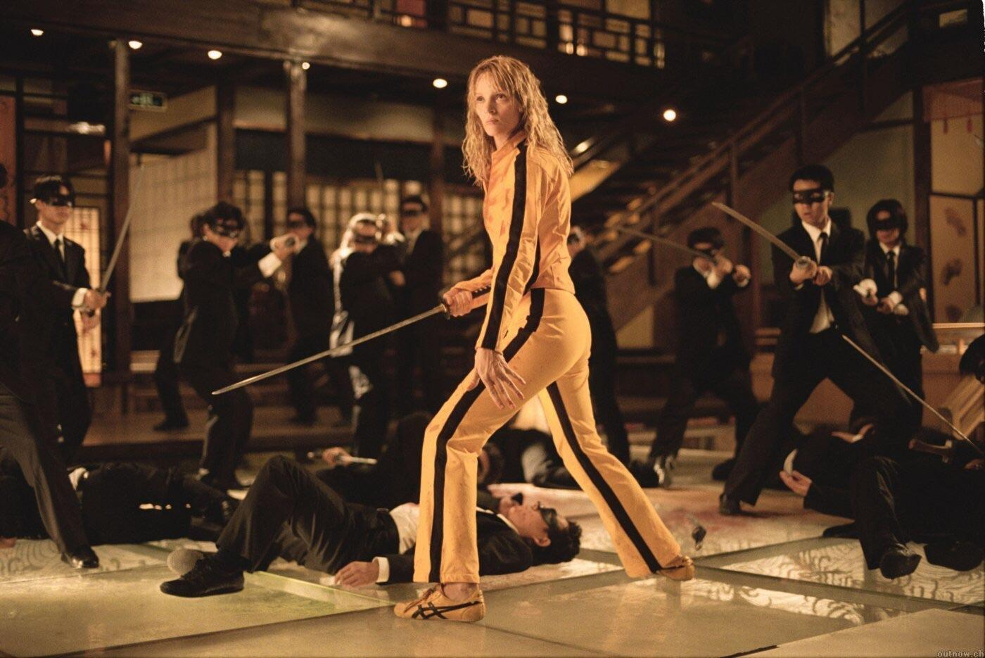
Fig 15. Kill Bill Directed by Quentin Tarantino Uma Full outfit compared to Wonder Woman.

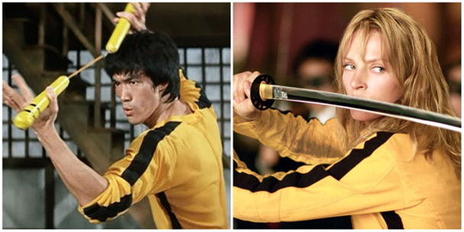
Fig 16. Game of death (1972) Directed by Robert Clouse and Bruce Lee compared to The brides outfit in Kill Bill directed by Quentin Tarantino (2004).
Because female characters are often surrounded only by men in Tarantino film, they seem so out of the norm that they do not seem to have relationships with other women. This is the case for The Bride and Mia Wallace, another female character from a Tarantino film, (Pulp Fiction) are both loners. They are wives and mothers, but also outcasts, one is an assassin, the other a drug addict. This shows how Tarantino’s female characters are isolated from other women, focusing mostly on their connections with men. (Smalls, 2024) While these women avoid the over-sexualization seen in superhero films, they are not immune to the gaze. Tarantino’s use of close-ups and stylized shots often places them in positions of aesthetic focus, balancing their empowerment with their visual impact on the audience. An example of this would be in Kill Bill Vol 1 2003 when Beatrix Kiddo wakes up from a four year long comma and struggles to move her legs. Tarantino lingers the camera around her feet as she struggles to wiggle her toes, highlighting both her vulnerability and her determination to regain control over her body. This moment is empowering she is literally nursing herself back to strength, but at the same time, it plays into Tarantino’s well-known fixation on feet. As Simone de Beauvoir says, "The body of a woman is a burden; it is her prison and her doom" (De Beauvoir, 1949) Beatrix’s body is both her strength and her struggle she is fighting to control it, but the way Tarantino films the scene also makes it part of his visual style focusing on his fetishes.

Fig 17. Kill Bill Vol 1, Close up of Beatrix kiddos feet.
The dynamic between the male characters and female shift in Death Proof (2007), the women’s agency appears more independent, with the film divided into two halves, one where women fall victim to male violence, and another where they seize control. Led by Zoë Bell, the second group of women reverses the narrative, making the male predator their prey. Throughout Tarantino films, the women depicted continuously raise an important question, is their empowerment authentic, or is it simply another spectacle crafted for audience entertainment? Unlike the bride, these women navigate their journey without the direction of a male mentor or antagonist, however, the hyper-stylized violence continues to emphasize their physicality and appearance, arguably appealing to the "male gaze." According to Mulvey, in cinema, women are “tied to her place as bearer of meaning, not maker of meaning” reinforcing passivity as a female trait. Films reflect how society sees sexual differences, with women and men shown in specific roles. Mulvey highlights how these differences shape images, gazes, and spectacle in film. (Mulvey, 1975,7)
This balance between independence and objectification highlights the contradictions in Tarantino's depiction of feminist agency. In Inglourious Basterds (2009), Shosanna Dreyfus’s revenge against the Nazis parallels Beatrix’s mission in Kill Bill. Both women channel their rage to seek revenge, though their actions unfold within exaggerated, almost cartoon-like narratives, yet their approaches and contexts differ. Shosanna’s plan to destroy the Nazis through her cinema is a bold act of rebellion against a larger oppressive system, making her a symbol of resistance. Beatrix’s journey, on the other hand, is personal, focused on avenging individual betrayals rather than challenging a bigger system. While both women are strong and independent, Shoshanna's story connects her rage to historical injustice, while Beatrix’s focuses on her own survival and determination. Her character is not over sexualized like others in the world of Quentin Tarantino film. Her character is shown as strong, smart, and determined. While she is stylish and attractive, it adds to her resourcefulness rather than objectifying her. Although her death at the hands of Frederick Zoller adds some tragedy, as she does not survive to see her plan succeed. This could take away from her agency, as the Basterds finish what she started. Still, Shosanna stands out as a bold and independent character. Even though the film features strong, smart female characters, it still fails the Bechdel test which is common for Tarantino. A New York Times reporter questioned Tarantino's decision to limit Margot Robbie's lines in Once Upon a Time in Hollywood. Tarantino responded, “Well, I just reject your hypotheses”. As long as Tarantino ignores these questions, the women in his films must speak for themselves. Ironically, analysis shows men dominate dialogue in his films, even when women are leads.
A test conducted by Times, to see how often women talked in his movies showed that across all 10 films, men consistently get more lines. Kill Bill: Volume 2 and Jackie Brown show significant male dialogue gaps, while only Kill Bill: Volume 1 and Death Proof favor women slightly. Death Proof is the only film where women speak significantly more than men. (Anna Purna Kambhampaty and Wolfson, 2019)
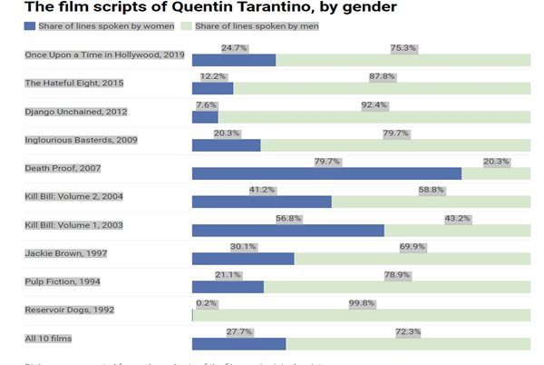

Fig 18. (Anna Purna Kambhampaty and Wolfson, 2019)
The chart above shows the number of lines spoken by men and women in Tarantino film, the data clearly show that men dominate the dialogue in Tarantino's films, partly because most feature male leads and predominantly male casts. However, even in films with female leads, like Kill Bill Volume 2, men still have more lines at a 17.5 percentage points more than women

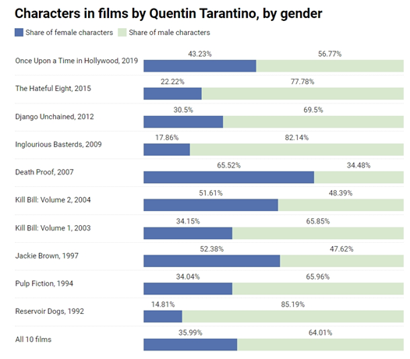
Fig 19. Chart from (Anna Purna Kambhampaty and Wolfson, 2019)
The chart above shows the number of characters by gender in Tarantino film.

Chapter three Ultimate redemption.
Kill Bill Vol 2 (2004).
This chapter provides a detailed analysis of an influential scene from Kill Bill Vol. 2 (2004). It is primarily examined through the lens of Simone de Beauvoir’s theory of women’s objectification which highlights how women were seen as the other and Laura Mulvey’s concept of the male gaze, from which I draw my own assertions. The focus is on Tarantinos cinematic style and how his depiction of women informs the larger narrative on female agency. The chapter also highlights his use of post modernist elements and how they might reinforce or contradict feminist ideals. Furthermore, this chapter will help lead an end to my analysis, dissecting and answering any remaining questions on Tarantinos authenticity when portraying female empowerment.

Context of the image:
To further understand the dynamics between Tarantino and the portrayal of women in his films, it is important to analyze a scene from one of his most notable works, which is often praised for its empowerment of women. The Kill Bill franchise consists of two films Kill Bill Vol. 1 (2003) and Kill Bill Vol. 2 (2004). The Kill Bill series tells the story of Beatrix Kiddo, a former assassin also known as the bride (played by Uma Thurman), who seeks revenge after being ambushed at her wedding by her ex-lover, Bill, and the Deadly Viper Assassination Squad she once worked with. The bride chose to leave the squad after discovering she was pregnant, but the fact she left made her a target. While the story explores themes of vengeance and redemption, these are deeply connected to a larger motherhood narrative, as her identity as a mother becomes the ultimate driving force behind her quest for revenge. This scene in particular is from Kill Bill Vol. 2, it depicts the main character Beatrix Kiddo being buried alive in a wooden coffin by a male antagonist Bud, (played by Micheal Madsen) but she ends up using her strength and willpower to escape. Before being buried she was shot at and verbally abused, capturing both physical and symbolic entrapment as the protagonist is forced into a claustrophobic, life-threatening situation. The scene is shot in a way that maximizes the audience's tension
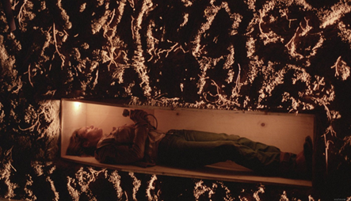
Fig 20. Beatrix Stuck in a coffin Kill Bill Directed by Quentin Tarantino.
Seeing this scene as a little girl was monumental as its rejection of typical revenge tropes, showed me that that my own anger could be powerful, fierce, and intimidating. Beatrix Kiddo is allowed to be cruel and relentless, as are her rivals. The violence is raw and, in a way, freeing. The bride fights back against those who wronged her, reclaiming her power and her motherhood. The scene utilizes close-ups of her face and body in the confined coffin to communicate both her desperation and severity of the situation.

Fig 21. Close up of Beatrix as she struggles to think of a way out.
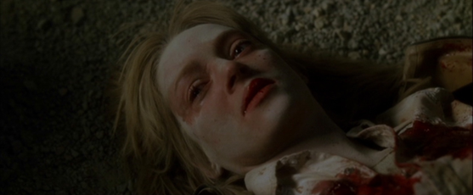
Fig 22. Close up of Beatrix after she was shot at by Bud, before being buried alive. Kill Bill Vol 1
The only light source is the torch creating an effect known as the chiaroscuro, similar to the spotlight and torch-lit sewers in The Third Man (1949) directed by Carrol Reed. (cnsmedia_williamrobinson, 2012).
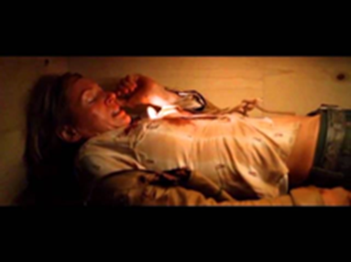
Fig 23. Beatrix Kiddo played by Uma Thurman stuck in a coffin using torch as only source of light directed by Quentin Tarantino. Kill Bill Vol.2 (2004)
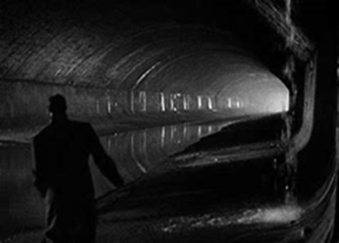
Fig 24 Torch-lit sewers in the The Third man (1949) directed by Carrol Reed.

Historical background and description of image:
Like most Tarantino movies, Kill Bill, pays homage to classic action and Japanese film genres, making it particularly impactful on Western and East Asian cinema screens, where these genres are culturally significant, however with its blend of several film conventions and genre, the scene can also be enjoyed by a mainstream audience.

Feminist theories and critiques and broader cultural significance:
Having approached this scene through the lens of Laura Mulvey and Simone De Beauvoir feminist theory that highlights various aspects of gender, identity, and representation. I gained a new perspective. As I consider Tarantino might weaken any feminist message by focusing more on paying tribute to classic action genres. These genres often highlight spectacle and physical endurance and display women through the “male gaze” rather than exploring a woman’s thoughts, emotions, or personal choices. Recognizing how Tarantino’s genre-blending style using cinematic elements such as camera work shapes how audiences interpret this moment. For example, the coffin can be seen as both a physical and symbolic trap, which suggests ideas of male control over female independence and Beatrix Kiddo’s fight for survival against massive odds. It could also function as a resurrection metaphor, her escape from the coffin symbolizes her reclaiming her identity and purpose, as it is made clear in a flashback that her decision to stop killing emerges from her discovering that she is pregnant but after she is ambushed and loses her baby she reverts back to killing and seeking revenge. This shift suggests that she has replaced her former life with a new purpose, driven by her circumstances rather than a spiritual awakening. (Crowley, 2008)
Broader Cultural significance:
Although this scene is powerful, it could be argued that this is largely due to styling rather than fully embodying feminist themes., as the focus remains on her suffering and physical display, meaning that instead of the scene being about survival and resilience, it highlights her vulnerability by presenting her physical struggle in a way that reads as sexual. The scene is stylized fetishizing her pain and struggle with camera angles that linger on her body, the emphasis being on her physical struggle.
This scene still challenges traditional gender roles where men usually hold power and women are more passive, even though she is shot at and buried alive by the male antagonist, she writes her own narrative and miraculously escapes. By showcasing a woman as the main character in a powerful action driven role, the film pushes back against patriarchy and offers a scene with a woman in control. The reversal of traditional gender roles especially in scenes of intense violence might not resonate with feminist ideals, as the film's storyline often emphasizes female beauty viewed through a conventional male gaze. This is evident in the scene as Buck makes remarks on her femininity which is common throughout this film the bride is often depicted through the lens of the male figures who label her with terms like "blood-spattered angel," "c*cksucker," and "blonde pussy." Despite this, she repeatedly defies their assaultive gaze, even in her weakest and most vulnerable moments. Her identity as a female avenger is emphasized, but only to the extent that it aligns with the conventional "masculine" perception of an action hero. (Mansi Bhalerao, 2021). Within the narrative, this scene establishes the bride's strength and determination to survive even the most extreme circumstances, but it also frames her struggle within a bigger revenge plot that is centered on a man and motherhood, rather than solely on her own motivations. This portrayal could go against feminist ideals by turning her strength into a spectacle, because it risks turning her body and suffering into an object for display. This supports the very systems of power that Beauvoir and Mulvey criticize.
Male role in shaping the character of The Bride:
Even though she holds extreme power, she lives in the shadows of Bill, whose mentorship makes his character seem more complex in contrast to the underdeveloped character of the bride. To gain the skills and strength to become powerful herself, Bill was not the only one Beatrix had to submit to. She also had to endure the harsh treatment of her trainer Pai Mei, who “hates Caucasians, despises Americans, and has nothing but contempt for women.” (The Take, 2020)
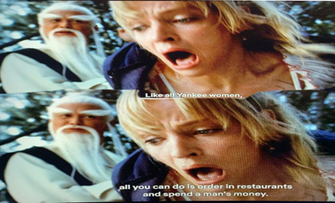
Fig 25. Pai Mei treats Beatrix poorly.

The concept that she needs to endure harsh treatment in order to gain power takes on a darker tone considering Uma’s real life experiences on set. Thurman revealed that Quentin Tarantino insisted she should drive a stunt car, which led to a severe crash that left her with permanent injuries that nearly cost them their friendship. He also admits to spitting on the actress in the scene in which Michael Madsen’s character spits on her. According to Tarantino he did not trust Madsen with “that kind of intricate work,” he later goes on to state “So the idea is, I’m doing it, I’m taking responsibility. Also, I’m the director, so I can kind of art direct this spit. I know where I want it to land. I’m right next to the camera. So, boom! I do it. Now, if I screw up and I keep missing, once we get to that third one, if she doesn’t want to do it anymore, well then, that’s on me.” Regarding the scene where Tarantino choked Thurman, the director told Deadline it was the actress's idea. The scene in question features in Kill Bill Vol 1, it shows the character of Gogo (Chiaki Kuryama) tightening a chain that she used as a weapon around Beatrix Kiddo’s neck, “It was Uma’s suggestion. To just wrap the thing around her neck, and choke her,” Tarantino stated (Sharf, 2018).

Fig 26. Tarantino wraps chain around Thurman's neck.

In a way the image states that it seems like, for some, art becomes a license to harm others. Artists often use their status to conceal abusive behavior, a pattern seen with figures like Roman Polanski and Bill Cosby, who continue to evade consequences while women who speak out are swiftly dismissed or blacklisted (Martine, 2019). These revelations add a disturbing layer to Kill Bill, despite it being Uma Thurman's idea, they blur the line between the fictional abuse endured by Beatrix kiddo and the real-life experiences of Uma on set, ultimately revealing a story of empowerment that was built on abuse. Especially that the #metoo movement brought new revelations about Tarantino’s abusive history to the surface. Artists using their status to hide abusive behavior is a common pattern.
At the time of production in 2003 this scene was praised for its thrilling action moment, and feminist message. However, with proper insight this disregards both De Beauvoir and Mulvey’s feminist theories, For example, De Beauvoir’s idea of women as "the Other" explains how female characters are often objectified, seen as symbols of male desire or suffering, instead of being portrayed as independent individuals with their own agency. Mulvey’s theory of the male gaze suggests that women in film are often shown from a male perspective, where their worth is based on their physicality or suffering rather than their inner thoughts or agency. In Kill Bill Vol. 2, while Beatrix Kiddo’s strength is highlighted, the scene focuses heavily on her suffering and physical endurance. This emphasis could reinforce the "male gaze" that Mulvey critiques, turning her pain into a spectacle instead of exploring her deeper motivations and complexities.
Many viewers saw it as a symbol of resistance and autonomy. The intensity of the scene shows her ability to survive and resist in a world dominated by men who wrong her. By subverting the usual portrayal of woman in distress and instead presenting her as a woman who could save herself the scene becomes a significant feminist moment in the 2000’s cinema. But how deserved really is this praise? With todays increased awareness of feminist film critique it can be viewed as problematic. The film still traffics on some of the more exploitative aspects of the revenge genre, a woman seeking revenge must revolve around her being assaulted or traumatized (The Take, 2020). But why should they need a reason at all? If audiences can enjoy films like Fight Club (1999) and No Country for Old Men (2007) without overthinking the reasoning, why shouldn’t there be films about unapologetically angry women, who do not attempt to soften their rage with pettiness or superficial charm? (Martine, 2019)
The characters struggle with the male gaze is noticeably clear. Hopkins cinema blog suggests that this is not the only scene where the film seems to use the camera to restrict and even objectify her particularly early on, when she is often “confined to the pressuring rectangle of the frame, truncated and reduced to parts of her body.”

Fig 27 Opening ‘wedding’ scene in Kill Bill Vol 1.

Fig 28 The bride find out she lost her baby,
However, the blog also observes that The Bride “regains control of the camera and restores her agency” during many of the film’s impressive kung-fu sequences, where she is often “empowered by the shot. (Hopkins cinema addicts, 2013)
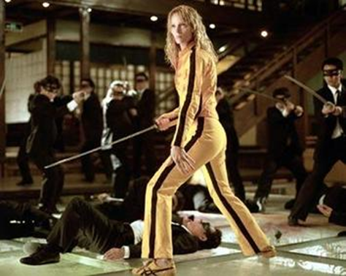
Fig 29. The ‘bride’ regaining control.

Critical response to the image:
This scene is relevant for analyzing representations of female resilience and position in Kill Bill, particularly because it offers an example of how postmodern style can sometimes clash with feminist theory. While the scene may appear to empower Beatrix, its emphasis on her suffering could actually align more with traditional cinematic tropes that exploit female pain rather than presenting her as a fully autonomous character. By examining this scene it identifies how postmodernism sometimes fuels and sometimes complicates feminist messages and most importantly gain a deeper understanding of Tarantinos depiction of women in his film. In Simone de Beauvoir’s feminist theory, she advocates for women to be recognized for their full agency beyond their physical appearance. By focusing so heavily on her suffering, the scene risks reducing her to merely a symbol of strength, Laura Mulvey's theory is relevant also as her description of the male gaze reinforces the idea that women in film are often subjected to it, as their value is reduced to what they endure or how they appear.
Appropriateness of current methodology:
While researching feminist views on this scene, I found it hard to find analyses that link both postmodern and feminist critiques, especially from Mulvey’s and De Beauvoir’s perspectives. To fill this gap, I focused on how postmodern film elements either support or challenge feminist ideas. This method allows for an analysis of how spectacle and the “male gaze” might undercut the feminist potential of such.

Conclusion
This thesis explored how Quentin Tarantino portrays female empowerment in Tarantino Movies and whether he truly challenges gender stereotypes or simply turns female strength into entertainment. Using the ideas of Laura Mulvey, Simone de Beauvoir, and Judith Butler, it became is clear that Tarantino’s portrayal is complex. While Kill Bill features a strong female lead , her story remains tied to male characters and shaped by choices that reflect the male gaze. Tarantino’s female characters are both empowered and dependent, as their strength and independence are often influenced by male figures like mentors, lovers, or sources of power. This mix of empowerment and dependence shapes how we view the representation of women in Tarantino's films and even women in general. Even with these criticisms, it’s important to recognize that Tarantino’s films do challenge traditional ways women are shown in movies. Beatrix Kiddo is a strong and complex character who breaks away from many stereotypes. Her skills, determination, and ability to overcome challenges make her inspiring. But her empowerment still happens within a system that relies on the male gaze and male-driven stories. The criticism from Judith Butler, that gender is something we learn and repeat based on society’s rules, not something we are born with along with the feminist theories of Laura Mulvey and Simone de Beauvoir, highlights the tension of Tarantino's representation of Female empowerment. Mulvey’s concept of the male gaze shows how Beatrix’s physical struggles are often framed in ways that appeal to viewers’ visual pleasure. De Beauvoir’s argument about women being defined by their relationships with men is also evident, as Beatrix’s journey is deeply influenced by Bill and other male figures. Butler’s theory of gender as performance reveals how Beatrix’s strength is not just a natural part of her identity but something shaped by the expectations of the world she lives in this all helps expose the contradictions in Tarantino’s work.
This also helped me understand that Tarantinos female characters do unfortunately fall under the male gaze. These contradictions become clearer when comparing Tarantino’s female superheroes. Female superheroes often work as part of a larger group, focusing on collective action. In contrast, Tarantino’s women are usually isolated. Their strength is tied to personal struggles, not bigger social change. Beatrix’s story, while powerful, exists in a secluded world where her victories don’t challenge the system that hurt her.
The women in his films all share one thing in common, their stories are built on male antagonists' narratives, and they often wouldn't even exist without them.
In conclusion, Tarantinos films do challenge traditional portrayals of women in cinema, but it doesn’t fully break free from the systems it critiques. Beatrix Kiddo is a powerful character, but her story remains tied to male influence and framed by visuals that appeal to the male gaze, Tarantino’s films show both empowerment and dependence in their portrayal of women. Beatrix Kiddo is a strong and iconic character, but her story is tied to male influence and framed in ways that appeal to visual pleasure. Using ideas from Mulvey, de Beauvoir, and Butler, it’s clear that Tarantino’s portrayal of women is both empowering and objecting. His characters push boundaries but don’t escape the systems they criticize. This raises important questions about how women are represented in mainstream films and whether feminist narratives can truly exist within such frameworks

Reference
Book
Bacon, H. (2015). Fascination of film violence pg 147 : Bacon, Henry, author : , Borrow, and Streaming : Internet Archive. [online] Internet Archive. Available at: https://archive.org/details/fascinationoffil0000baco/page/148/mode/2up [Accessed 28 Nov. 2024].
Butler, J. (1990). Gender Trouble: Feminism and the Subversion of Identity. [online] Available at: https://selforganizedseminar.wordpress.com/wp-content/uploads/2011/07/butler-gender_trouble.pdf [Accessed 28 Nov. 2024]. p.g33.
De Beauvoir, S. (1945). Second Sex. [online] Ebsco.com. Available at: https://research.ebsco.com/c/detf3q/search/details/ko4h6chntn?q=second+sex [Accessed 10 dec. 2024].
Fredderick, J. (1991). Postmodernism, Or​ ​The Cultural Logic of Late Capitalism​. [online] Available at: https://web.education.wisc.edu/halverson/wp-content/uploads/sites/33/2012/12/jameson.pdf [Accessed 13 dec. 2024].
Mulvey, L. (1975). Visual Pleasure and Narrative Cinema. [online] London: Palgrave Macmillan UK, p.6/18. doi:https://doi.org/10.1007/978-1-349-19798-9.
pierce, charles (1931). The Essential Peirce, Selected Philosophical Writings 1 : Charles Sanders Peirce : Free Download, Borrow, and Streaming : Internet Archive. [online] Internet Archive. Available at: https://archive.org/details/the-essential-peirce-selected-philosophical-writings-1/page/54/mode/2up [Accessed 11 Feb. 2025].

Journals
Anna Purna Kambhampaty and Wolfson, E. (2019). We Counted Every Line in Every Quentin Tarantino Film to See How Often Women Talk. [online] Time. Available at: https://time.com/5645347/quentin-tarantino-women-dialogue/.
CLA (2019). Introduction to Fredric Jameson, Module on Postmodernity. [online] Purdue.edu. Available at: https://cla.purdue.edu/academic/english/theory/postmodernism/modules/jamesonpostmodernity.html.
cnsmedia_williamrobinson (2012). Kill Bill Vol. 2 Burial Scene Analysis. [online] Blogspot.com. Available at: https://wrmedia.blogspot.com/2012/01/kill-bill-vol-2-burial-scene-analysis.html [Accessed 2 Nov. 2024].
Denney, A. (2016). Dissecting the feminist legacy of Thelma & Louise. [online] Dazed. Available at: https://www.dazeddigital.com/artsandculture/article/31284/1/dissecting-the-feminist-legacy-of-thelma-louise [Accessed 23 Nov. 2024].
Film, in (2024). Factual America Podcast. [online] Factual America Podcast. Available at: https://www.factualamerica.com/filmmaking/exploring-unconventional-narrative-structures-in-film [Accessed 20 Oct. 2024].
Lau, T. (2022). Rethinking Low, Middle, and High Art. [online] The Journal of Aesthetics and Art Criticism. Available at: https://www.academia.edu/85973485/Rethinking_Low_Middle_and_High_Art [Accessed 24 Oct. 2024].
Mansi Bhalerao and Mansi Bhalerao (2021). Female Rage Through Male Gaze: A Feminist Critique Of Quentin Tarantino’s Kill Bill. [online] Feminism in India. Available at: https://feminisminindia.com/2021/07/06/female-rage-through-male-gaze-a-feminist-critique-of-quentin-tarantinos-kill-bill/#google_vignette [Accessed 1 Nov. 2024].
Websites
10thingsaboutcinema (2022). The Unconventional Genius of Quentin Tarantino: A Look at the Director’s Iconic Filmography. [online] 10 Things About Cinema. Available at: https://10thingsaboutcinema.com/quentin-tarantino-filmography-analysis/ [Accessed 23 Oct. 2024].
Barthwal, A. (2021). Male Gaze In Visual Media: The Fetishisation Of Women And Queer Characters On Screen. [online] Feminism In India. Available at: https://feminisminindia.com/2021/06/28/male-gaze-visual-media-fetishisation-women-queer-characters-screen/.
Crowley, M. (2008). Blooming Lotus: Redemption and Spiritual Transformation in Kill Bill. [online] Slant Magazine. Available at: https://www.slantmagazine.com/film/blooming-lotus-redemption-and-spiritual-transformation-in-kill-bill/ [Accessed 2 Nov. 2024].
faroutmagazine.co.uk (2023). Quentin Tarantino explains his alleged foot fetish. [online] faroutmagazine.co.uk. Available at: https://faroutmagazine.co.uk/quentin-tarantino-foot-fetish/.
FilmTheory (2014). postmodernism in films. [online] Film Theory. Available at: https://www.filmtheory.org/postmodernism-in-films/.
Hopkins cinema addicts (2013). The Male Gaze in Kill Bill (Ingrid). [online] HopkinsCinemAddicts. Available at: https://hopkinscinemaddicts.typepad.com/hopkinscinemaddicts/2013/10/the-male-gaze-in-kill-bill.html [Accessed 15 Nov. 2024].
Martine, A. (2019). Female Rage, Male Pleasure: the True Cost of Empowerment in Kill Bill. [online] Medium. Available at: https://cosgrrrl.com/female-rage-male-pleasure-the-true-cost-of-empowerment-in-kill-bill-6f7ffc5c754a [Accessed 4 Nov. 2024].
Oxfordy English Dictionary (2023). Tarantinoesque, adj. meanings, etymology and more | Oxford English Dictionary. Oed.com. [online] doi:https://doi.org/10.1093//OED//4700244080.
Saxelby, K. (2017). Reshaping the Frame: Women and Violence in Quentin Tarantino’s Kill Bill: Volume 1 & 2 and Death Proof – Kristina Saxelby. [online] Available at: http://www.kristinasaxelby.com/2017/11/11/reshaping-the-frame-women-and-violence-in-quentin-tarantinos-kill-bill-volume-1-2-and-death-proof/.
Seal, E. (2023). Looking at the art of ‘female rage’ in film. [online] www.hercampus.com. Available at: https://www.hercampus.com/school/nottingham/looking-at-the-art-of-female-rage-in-film/.
Sharf, Z. (2018). Quentin Tarantino Breaks Silence on Uma Thurman Abuse Claims. [online] IndieWire. Available at: https://www.indiewire.com/features/general/quentin-tarantino-responds-uma-thurman-car-crash-abuse-kill-bill-1201925124/ [Accessed 3 Nov. 2024].
Smalls (2024). Inglourious Basterds: A Ladybrain Review. [online] Blogspot.com. Available at: https://ladybrainreviews.blogspot.com/2010/03/inglourious-basterds-ladybrain-review.html [Accessed 23 Nov. 2024].
Tyler, A. (2022). Pulp Fiction’s Dance Scene Real Meaning & Inspiration (It’s Not Travolta). [online] ScreenRant. Available at: https://screenrant.com/pulp-fiction-movie-dance-scene-meaning-inspiration/.
Varghese, R.R. (2024). On gender performativity: how it challenges the gender binary. [online] The Hindu. Available at: https://www.thehindu.com/specials/text-and-context/on-gender-performativity-how-it-challenges-the-gender-binary/article68701885.ece.
Videos
The Take (2020). Kill Bill’s The Bride: A Feminist Hero? YouTube. Available at: https://www.youtube.com/watch?v=UEjq_3IVX28.

