Chronotype, Gender and Life Satisfaction in Undergraduates: Exploring the Role of Circadian Preferences

BSc (Hons) in Applied Psychology
Alicia Stanley
N00210795
Research Supervisor: Dr. Irene Connolly



Dissertation submitted as a requirement for the degree of BSc (Hons) in Applied Psychology, Dun Laoghaire Institute of Art, Design & Technology, 2025.

Declaration

I, Alicia Stanley, hereby declare that the work that I have submitted for / contributed to the assessment specified above is entirely my own work. Where I have drawn from the work of others, including Generative AI systems, I have clearly indicated this within my submitted work. I recognise that Generative AI creations, no matter how small, may not be permissible within my submitted work and have checked this specific assessment brief for the admissible use of such software. I have read and complied with the IADT Academic Integrity Policy for this submission and recognise that breaches of this policy in my work may result in penalties, up to and including disqualification from IADT.

I, Alicia Stanley, hereby declare that I recognise that IADT staff may provide feedback on assessment via a range of methods, depending on the nature of the assessment and the preference of the staff member. I recognise that any grades issued by a lecturer are provisional but are not negotiable. Final grades will be issued following the relevant exam board meeting and information on appeals procedures is available on the IADT website. I agree to abide by the IADT Mutual Respect Policy in all of my communications with and regarding all IADT staff members.

Date: 11/04/2025

Word Count: 4,935

Acknowledgements
First and foremost, I would like to express my deepest thanks to my supervisor, Dr. Irene Connolly, whose exceptional supervision, steady support, and calm encouragement helped guide not only me, but our whole group, through the ups and downs of this process. Your Monday meetings meant the world.
A special thank you to Dr. Gráinne Kirwan and Dr. Christine Horne for their MRP and statistics guidance, and to Hannah Barton and Dr. Irene Connolly for allowing me to collect participants in their lectures for my survey.
To my incredible family and friends, thank you for being my foundation. To my parents that are always just a quick phone call or train away, your unwavering support and love carried me through. To my wonderful friends Paulina and Jess, thank you for filling my college years with unforgettable memories and a bond that got us through it all. I couldn’t imagine having gone through this experience without you both. To Kate, my longest friend thank you for being my constant, always there to listen, distract, and uplift me when I needed it most.
And finally, to Vincent, the love of my life, there are not enough words to thank you. Your daily support, pushing me to keep going, endless patience keeping me grounded and focused and keeping me concentrated by just being present. You were there through every high and low, every rant, every laugh, and every tear. I truly could not have done this without you by my side.
And finally, to all the participants who took the time to complete my survey, thank you for making this research possible.

Table of Contents
Abstract 1
Introduction 2
1.1 Introduction 2
1.2 Understanding Chronotype 2
1.3 Life Satisfaction 4
1.4 Chronotype and Life Satisfaction 5
1.5 Gender Differences in Chronotype and Life Satisfaction 6
1.7 Research Questions and Hypotheses 7
2. Method 8
2.1 Design 8
2.2 Participants 8
2.3 Materials 9
2.3.1 The Morningness-Eveningness Questionnaire (MEQ) 9
2.3.2 The Satisfaction with Life Scale (SWLS) 10
2.4 Procedure 10
3. Results 11
3.1 Overview of Results 11
3.2 Descriptive Statistics 12
3.3 Inferential Statistics 12
3.3.1 Hypothesis 1 13
3.3.2 Hypothesis 2 14
4. Discussion 15
4.1 Overview of findings 15
4.2 Strengths and weaknesses. 16
4.3 Theoretical and practical implications. 17
4.3.1 Theoretical Contributions 17
4.3.2 Practical Applications. 17
4.4 Future research 18
4.4.2 Alternative Research Angles 18
4.5 Conclusion 18
References 19
Appendices 23

Abstract

The present study investigated the relationship between chronotype, gender, and life satisfaction in undergraduate students. A two-way between-groups analysis of variance (ANOVA) was used to examine whether life satisfaction scores differed significantly by chronotype (morning, intermediate, evening) and gender (male, female). A total of 115 participants completed the Morningness-Eveningness Questionnaire (MEQ) and the Satisfaction with Life Scale (SWLS). Mean life satisfaction scores varied slightly across chronotype and gender groups, but no substantial patterns emerged. However, there were no significant main effects of chronotype (F(2, 109) = 0.388, p = .679, η² = .007) or gender (F(1, 109) = 0.118, p = .732, η² = .001), nor a significant interaction (F(2, 109) = 0.668, p = .515, η² = .012). Although results were non-significant, limitations such as the small and gender-skewed sample may have impacted findings. Prior research highlights potential links between circadian preferences and well-being, suggesting future studies should further explore these relationships in more representative samples.

Introduction

1.1 Introduction
From early morning lectures to late-night study sessions, university students live by the clock, but not all internal clocks are the same. Some people rise with the sun, ready to take on the day, while others feel most energetic when the day gets dark. These differences, or chronotypes, can influence everything from productivity to overall well-being. Research has shown that evening type undergraduate students are more likely to have poorer sleep quality then morning types (Arastoo et al., 2024), have higher insomnia symptoms (Li et al., 2020), more social jetlag, higher perceived stress, irregular social rhythms (Lin et al., 2023), and tend to score higher on measures of depression and anxiety than morning types (Esin & Ayyıldız, 2024). Numerous studies have also reported that morning types have higher life satisfaction, which will be explored throughout this literature review.
Understanding how chronotype influences life satisfaction in undergraduate students is crucial, as college life often disturbs natural sleep-wake patterns, potentially affecting life satisfaction. By examining this nuanced relationship within an Irish population, the present study aims to provide insight into how different chronotype groups affect perceived life satisfaction in undergraduate students and whether gender plays a role in mediating these variables.

1.2 Understanding Chronotype
The interplay of biological, social, and solar time shapes our daily functioning. Our biological clock relies on external cues known as zeitgebers (i.e. natural light) to synchronise body functions to an approximate 24-hour cycle. This synchronisation process is known as circadian entrainment, which allows the body to adapt and anticipate daily environmental changes (Roenneberg & Merrow, 2016). Chronotypes are the ways in which a person's internal biological clock and external time coincide (Roenneberg et al., 2007). Chronotypes can be classified dichotomously, contrasting 'Owls' with 'Larks,' or along a spectrum ranging from extreme eveningness to extreme morningness (Randler, 2008). The grouping of individuals based on their preferred sleep-wake cycles emerged from early research on circadian rhythms in the 20th century, but the idea began gaining traction in the 1970s, when researchers Horne and Östberg (1976) developed the Morningness-Eveningness Questionnaire (MEQ) to classify individuals as morning, evening, or intermediate types. This was one of the first standardized tools to categorize sleep-wake preferences. They investigated the relationship between morningness-eveningness preferences along with measuring body temperature. According to their findings, morning types' body temperatures rise faster after waking up and peak earlier in the day than evening types, whose temperatures rise gradually throughout the day and peak later in the day. This is further supported by a recent study by Duarte and Menna-Barreto (2021), who also found that wrist temperature peaks vary across chronotypes, with evening types exhibiting delayed temperature peaks. Horne and Östberg (1976) indicated that various biological and environmental factors, beyond solely bedtime and waking time, contribute to chronotypes.
In extensive chronobiological and psychological studies, the MEQ is a key instrument used for assessing circadian preference. Numerous studies have explored how chronotypes change with age, and conclude that young children typically display morningness, adolescents and young adults mainly fall into the intermediate and evening chronotypes, and adults gradually move toward morning types progressively as they age. (Horne & Norbury, 2018; Núñez et al., 2019; Randler, 2008; Roenneberg et al., 2007; Tonetti et al., 2015; Zimmermann, 2011). Roenneberg et al. (2003) developed another measure commonly used to categorise chronotype, the Munich ChronoType Questionnaire (MCTQ), which assesses chronotype by investigating sleep timing, light exposure, and self-reported chronotypes that distinguish between work days and free days. Their pilot study for the MCTQ recruited 500 participants, revealing that eveningness is more common than what societal demands account for. Most participants reported experiencing an imbalance between their biological and social clock, highlighting a lack of strong zeitgebers in society. Foster and Roenneberg (2008) echoed this point by arguing that modern environments disturb our natural circadian rhythm alignment, a phenomenon referred to as social jetlag (Wittmann et al., 2006). This misalignment often leads to physiological and psychological repercussions on mood, attention, and cognitive performance (Roenneberg et al, 2003).
Additionally, Roenneberg et al. (2007)’s research on the epidemiology of the human circadian clock, provided an in-depth analysis of how chronotype differs across gender, age, and societal contexts and emphasized the beneficial possibilities that could occur by applying more chronotype-sensitive approaches in workplaces and health policies. Understanding chronotype is vital, particularly when looking at undergraduates, as it has significant impacts on cognitive function, sleep quality, and academic achievement. Research shows that evening chronotypes are more prone to sleep procrastination, thus leading to poor sleep quality (Zhu et al., 2023). It has also been noted that social jetlag and the misalignment between biological and social schedules negatively affect academic performance (Smarr, 2015; Tonetti et al., 2015). Furthermore, chronotype has been linked to study habits and learning styles, demonstrating its influence on students' daily academic engagement (Palaroan et al., 2023). As chronotype shapes fundamental aspects of daily life, examining its relationship with broader psychological constructs, such as life satisfaction, provides valuable insight into its role in shaping overall well-being among undergraduates.

1.3 Life Satisfaction
Life Satisfaction is a component of subjective well-being alongside happiness and positive affect (Diener, 1984). Life satisfaction is described as a judgmental process in which individuals evaluate the quality of their lives based on personal standards. Essentially, a person's life satisfaction is determined by comparing their current situation to a self-set personal standard, rather than one imposed by others (Diener et al., 1985). The most widely used measure of life satisfaction is the Satisfaction with Life Scale (Diener et al., 1985) although many others are utilized such as the WHO-5 Well-Being Index (WHO-5)(World Health Organization, 2024), The Cantril Self-Anchoring Striving Scale (Glatzer & Gulyas, 2014), The Life Satisfaction Index (Franchignoni et al., 1999), or The Temporal Satisfaction with Life Scale (Pavot et al., 1998).
The question of what determines levels of life satisfaction is recurrent in research, with key influences noted including age, gender, income, health, personality traits, genetics, and environmental factors such as life events or life circumstances (Oladipo et al., 2013). For undergraduates, Karayagiz (2020) notes the predictors as academic satisfaction, meaning of life, emotional intelligence, anxiety, self–evaluation, and levels of stress. Research also shows that sleep quality plays a key role in life satisfaction, with both too much and too little sleep reported in a curvilinear relationship with lower life satisfaction. Weekday sleep, in particular, shows a stronger association with life satisfaction than weekend sleep, most likely due to social obligations and more consistency in sleep patterns (Piper, 2016).
Examining chronotype and life satisfaction independently underscores the necessity of investigating their interactions, as this relationship may provide crucial information about how students' daily routines and academic demands affect their overall life satisfaction. Gaining insight into these relationships may help provide a deeper understanding of what is influencing students' academic success and well-being and propose ways in which to increase overall life satisfaction in college students.

1.4 Chronotype and Life Satisfaction
Research consistently supports the idea that morning types tend to report higher life satisfaction (Díaz-Morales et al., 2013; Jankowski, 2012; Randler, 2008; Rönnlund et al., 2021) This relationship appears consistent across various cultures, geographical locations and demographics, suggesting that chronotype may play a fundamental role in life satisfaction (Jankowski, 2012). Randler’s (2008) study, one of the earliest in this area, found a small, significant positive correlation between morningness and life satisfaction in a sample of 164 university students. However, the study's reliance on a sample from one university limits its external validity. The use of self-report measures also introduces potential biases, such as social desirability or recall errors. Additionally, the cross-sectional design does not allow for causal conclusions.
Díaz-Morales et al. (2013) extended Randler’s work, analysing a larger and more diverse sample of 724 undergraduates from multiple European countries. The study confirmed a positive correlation between morningness and life satisfaction, but again, the study’s use of self-reported chronotype and snowball sampling also raises concerns about potential biases. A study by Jankowski (2012) replicated these findings with a sample of 349 Polish undergraduates, finding a small, significant correlation between morningness and life satisfaction. Similar to listed prior research, its reliance on self-report data and a cross-sectional design reduces its generalizability. Evening types have been associated with lower life satisfaction, increased social jetlag (Choi et al., 2019), poor sleep quality, and higher risks of mood disorders (Lan et al., 2024). Evening types also tend to underperform academically (Jankowski, 2012; Wittmann et al., 2006), which is reported to be another contributor to lower happiness levels (Önder, 2020).
Psychological factors, such as resilience and self-efficacy, may also help explain the link between chronotype and life satisfaction. Arastoo et al. (2024) found that morning types reported higher self-efficacy, which could enhance coping mechanisms and stress reduction, leading to greater life satisfaction. Wittmann et al. (2006) emphasized the need for more flexible schedules to accommodate different chronotypes, which could help improve life satisfaction for evening types. Interventions aimed at improving sleep quality for evening types may also be beneficial in enhancing their overall life satisfaction.
In conclusion, while the link between chronotype and life satisfaction is well-established, the current scope of research is limited by methodological concerns and highlights the need for more objective and longitudinal studies to better understand the causal relationship between chronotype and life satisfaction.

1.5 Gender Differences in Chronotype and Life Satisfaction
Gender differences within chronotypes have presented varied results. Randler (2007) and Randler (2008) found that women identified more as morning types than males, but other studies indicate no significant relationship between gender and chronotype (Díaz-Morales et al., 2013; Jankowski, 2012). In a more recent study, Lan et al. (2024) reported that males (45.5%) were more likely to be evening types than females (24.8%), but no relationship was found between gender and life satisfaction. To explain these inconsistencies, Roenneberg et al. (2007) proposed that age may play a mediating role in this relationship, stating that women reach their latest chronotype around 19.5 years of age and men at around 21 years of age. However, these differences appear to decrease around the age of 50, where both genders shift preferences toward morningness.
Findings on gender differences in life satisfaction are similarly inconsistent. Joshanloo and Jovanović (2019) reported that women report slightly higher life satisfaction than men in a large-scale study across 166 countries, though the effect size was small and varied by demographic groups. In contrast, Jankowski (2012) found no significant gender differences in either chronotype or life satisfaction. Similarly, Lan et al. (2024) found no significant association between gender and life satisfaction, despite gender differences in chronotype. These varying findings suggest that gender may not be a decisive factor in life satisfaction.
Furthermore, gender bias in research samples raises concerns about the reliability of reported differences. Studies such as Önder (2020) and Zhu et al. (2023) exhibited skewed gender distributions, with 80.4% and 71.4% female participants. Rönnlund et al. (2021) also highlighted gender imbalance in their study, with 271 female and 112 male participants. Such imbalances make it difficult to draw definitive conclusions about gender differences in chronotype and life satisfaction.
Overall, while there has been reported indication that women may be more morning-oriented than men, the evidence is inconsistent, and gender differences in life satisfaction also remain inconclusive.

1.6 The Present Study
Given the potential impact of misalignment between students' natural sleep-wake patterns and academic schedules, the present study seeks to examine how chronotype may influence overall life satisfaction. Additionally, it will assess whether gender moderates this relationship, noting findings and inconsistencies found in previous research. By utilizing established scales (MEQ and SWLS) and employing a two-way ANOVA, this study aims to contribute valuable insights into the role of chronotype in shaping student life satisfaction.

1.7 Research Questions and Hypotheses
RQ1: Is there a significant relationship between chronotype (morningness, eveningness, intermediate) and life satisfaction in university students?
RQ2: Does gender moderate the relationship between chronotype and life satisfaction?

H1: There will be a significant difference in life satisfaction scores among morning, intermediate, and evening chronotypes in undergraduate students.
H2: There will be a significant difference in life satisfaction scores between male and female undergraduate students.
H3: There will be an interaction between gender and chronotype on life satisfaction among undergraduate students, such that the effect of chronotype on life satisfaction will differ by gender.

2. Method

2.1 Design
The present study employed a quantitative, cross-sectional, between-subjects design. Questionnaire-based surveys assessed the variables. The independent variables (IV) were: Chronotype (Morning, intermediate and evening ) measured by Horne and Östberg’s Morningness-Eveningness Questionnaire (MEQ) (Horne & Östberg, 1976) and gender (male, female). The dependent variable (DV) was life satisfaction, measured by Diener's Satisfaction with Life Scale (SWLS)(Diener et al., 1985).

2.2 Participants
A total of 127 undergraduate students were initially recruited through convenience sampling from the 30th of January to the 28th of February 2025. However, non-binary (N=7) and prefer-not-to-say responses (N=0) were included in the survey but excluded from statistical analysis due to insufficient representation. Additionally, 5 participants were removed due to incomplete responses on the MEQ, resulting in a final sample of 115 participants (Male = 38, Female = 77). The participants partake in the study via a link distributed through various social media platforms. The primary data was obtained from the MEQ and SWLS questionnaires. Ethical approval was granted by the Psychology Ethics Committee (PEC) in IADT (see Appendix N), and the ethical guidelines of the Psychological Society of Ireland were followed.
Figure 1: Pie Chart showing participant gender representation

2.3 Materials
Through an online survey design using Microsoft Forms, an information sheet, a consent form, a debrief, and a demographic questionnaire were provided to the participants. The information sheet ( Appendix A) outlined the purpose of the study to the participants and what was required of them. It also contained necessary contact information for the researcher and supervisor of the study, and outlined any risks in partaking in the study. The consent form (Appendix B) was provided to obtain informed consent from the participants in adherence to the Psychological Society of Ireland (PSI). The participants were informed of their anonymity and confidentiality, with the right to withdraw their data from the study. A demographic survey was provided to ask participants age and gender (Appendix C), which was followed by two questionnaires. After the questionnaires, a debrief document (Appendix D) was included to thank the participants for taking part in the study and contained contact information and support if required.

2.3.1 The Morningness-Eveningness Questionnaire (MEQ)
The Morningness-Eveningness Questionnaire (MEQ) (Appendix E) (Horne & Östberg, 1976) was used to measure chronotype. The MEQ consists of 19 items assessing preferences for sleep and wake times. Participants choose from a multiple-choice, 4-5 point numerical scale. The sum gives a score ranging from 16 to 86; scores of 41 and below indicate "evening types", scores of 59 and above indicate "morning types", scores between 42-58 indicate "intermediate types". The questionnaire takes 5-10 minutes to complete. Questions include: “What time would you get up if you were entirely free to plan your day?” Studies using the questionnaire show that people with lower MEQ scores tend to have later biological rhythms. Cronbach's α for the MEQ has been reported between 0.83 and 0.86, indicating strong internal consistency. In the current study, the MEQ demonstrated a good internal consistency, with Cronbach’s α = .82, confirming good reliability for measuring chronotype (see Appendix M). The questionnaire has been validated in various populations using markers like body temperature and dim-light melatonin onset (DLMO).

2.3.2 The Satisfaction with Life Scale (SWLS)
The Satisfaction with Life Scale (SWLS) (Appendix F) (Diener et al., 1985) was administered to assess participants’ life satisfaction. The SWLS contains 5 items that participants respond to on a 7-point Likert scale ranging from strongly agree (7) to strongly disagree (1). Scores range from 5 to 35, with higher scores indicating higher life satisfaction. The questionnaire takes 3-5 minutes to complete. Questions include: “In most ways my life is close to my ideal.” The SWLS demonstrates a strong internal consistency, with a Cronbach's α of 0.87, and high test-retest reliability, with a two-month correlation of 0.82. In the present study, good internal consistency is demonstrated with Cronbach’s α = .82, validating good reliability for measuring satisfaction with life (see Appendix L). The SWLS aligns well with other life satisfaction measures and remains distinct from emotional well-being scales and is sensitive enough to detect changes in life satisfaction over time, making it suitable for diverse populations. Both questionnaires have been shown to have high reliability and validity in previous studies.

2.4 Procedure
Participants were recruited via IADT and other undergraduate students were recruited via social media platforms. A pilot study was conducted (N=3) to ensure the survey was clear and understandable, to identify if there were any potential issues and to confirm the approximate completion time. Feedback from the pilot study confirmed an average completion time of 8 minutes and some grammatical and formatting errors, which were adjusted for the final survey to improve clarity and participant understanding.
A link or QR code to the Microsoft Forms survey (see Appendix G) was then made available to undergraduates. Included in the link was the information sheet outlining the purpose of the study and voluntary nature of the study, a consent form to ensure participants' willingness to participate, a question for the participants to create a unique identifier (Second initial of their first name, third initial of their surname and the last three digits of their phone number). The participants were then asked their gender and age, followed by the Morningness-Eveningness Questionnaire (MEQ) and the Satisfaction with Life Questionnaire (SWLS). The participants were then debriefed at the end of the Microsoft Form and provided additional information about the study, as well as contact details for any further questions. Participants were thanked for their time and participation.

3. Results

3.1 Overview of Results
This section presents the results of the present study. A one-way analysis of variance (ANOVA) was employed for the statistical analysis to investigate the interaction and if there was a statistically significant difference in life satisfaction based on chronotype and gender in undergraduate students. The independent variables of the present study were:
- Chronotype (3 groups: Morningness: 59-86, intermediate: 42-58, and eveningness: 16-41) measured using the MEQ (Horne & Östberg, 1976)
- Gender ( 2 groups: Male, Female)
The dependent variable of the present study was life satisfaction measured using the SWLS (Diener et al., 1985). Version 29 of IBM SPSS (v29.0.2.0 ) statistics software was used to conduct the necessary statistics for the present study (IBM, 2022). (see Appendix H for SPSS Outputs)

Figure 2: Pie Chart exhibiting representation of chronotype groups

3.2 Descriptive Statistics
Table 1 below illustrates the means, standard deviations, and n-values for the participants within the groups: chronotype, gender and life satisfaction.
Table 1: Mean, standard deviation and n-values for chronotype, gender and life satisfaction
Sex | Chronotype | Mean | Standard Deviation | N
Male | Morningness | 24.00 | 0 | 1
 | Intermediate | 21.62 | 5.19 | 24
 | Eveningness | 22.15 | 4.71 | 13
 | Total | 21.87 | 4.91 | 38
Female | Morningness | 22.80 | 8.98 | 5
 | Intermediate | 22.47 | 6.11 | 49
 | Eveningness | 20.17 | 5.41 | 23
 | Total | 21.81 | 6.12 | 77
Total | Morningness | 23.00 | 8.05 | 6
 | Intermediate | 22.19 | 5.80 | 73
 | Eveningness | 20.89 | 5.19 | 36
 | Total | 21.83 | 5.73 | 115

3.3 Inferential Statistics
Before conducting the two-way analysis of variance (ANOVA), assumption tests were carried out. Levene’s Test of Equality of Error Variances indicated that the assumption of homogeneity of variance was met, F(4, 109) = 1.791, p = .136, suggesting that the variance was approximately equal across groups (see Appendix I).
A Shapiro-Wilk test of normality showed that data for gender (male: p = .163, female: p = .220) and chronotype (morning: p = .305, intermediate: p = .175, evening: p = .081) did not significantly deviate from normality (see Appendix J). However, visual inspection of histograms and Q-Q plots suggested some deviation in the Morningness group, likely due to its small sample size (n = 6 out of 127 participants)(see Appendix K). Given ANOVA’s robustness to minor deviations from normality, this assumption was considered sufficiently met, though the small Morningness group size may impact reliability.
Boxplots were examined for outliers, and no extreme values were detected (see Figure 3). The distribution of Total Life Satisfaction appeared similar across chronotype groups, though variance in the Morningness group may be more variable due to the small sample size.
Once these assumptions were assessed, a two-way between-groups ANOVA was conducted to test hypotheses H1, H2, and H3.

Figure 3. Variability in Life Satisfaction Scores Across Chronotype Groups
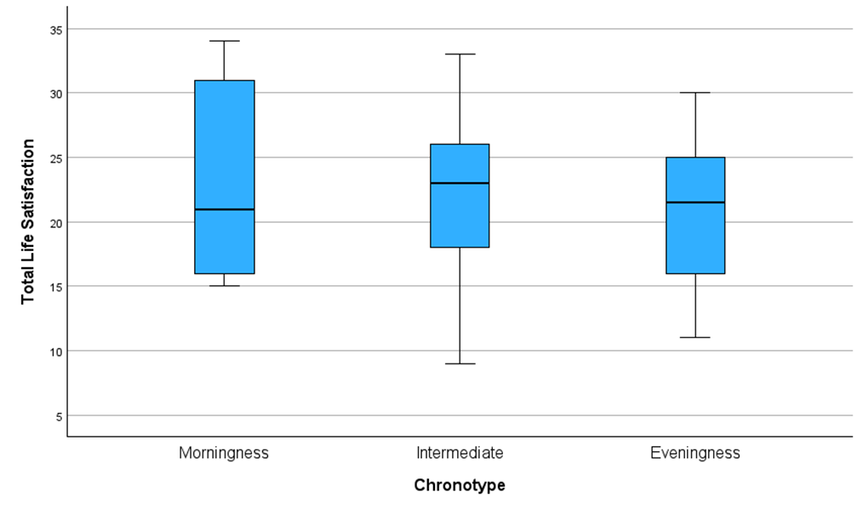

3.3.1 Hypothesis 1
Hypothesis 1 states that there would be a significant difference in life satisfaction scores based on morning, intermediate, and evening chronotypes in undergraduate students. A Levene’s test of equality of error variances was conducted, and results showed that the assumption of homogeneity of variance was met (see Appendix H). A two-way between-groups ANOVA was performed to test the effect of chronotype on life satisfaction. Results indicated that there was no significant main effect of chronotype on life satisfaction, F(2, 109) = 0.388, p = .679, partial η² = .007. Therefore, hypothesis one was not supported.

3.3.2 Hypothesis 2
Hypothesis two stated that there would be a significant difference in life satisfaction scores between male and female undergraduate students. A two-way between-groups ANOVA was conducted, and results indicated that there was no significant main effect of sex on life satisfaction, F(1, 109) = 0.118, p = .732, partial η² = .001. Therefore, hypothesis two was not supported.
Figure 4. Interaction plot of mean life satisfaction scores by chronotype and gender.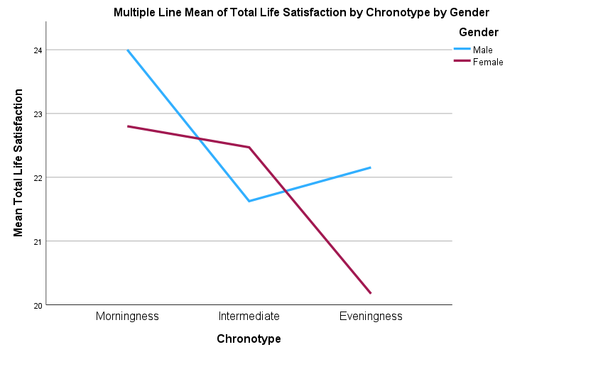3.3.3 Hypothesis 3
Hypothesis three stated that there would be a significant interaction between chronotype and sex on life satisfaction. A two-way between-groups ANOVA was performed, and results indicated that there was no significant interaction between sex and chronotype on life satisfaction, F(2, 109) = 0.668, p = .515, partial η² = .012. Therefore, hypothesis three was not supported. The implications and interpretations of these findings will be discussed in the next section.

4. Discussion

4.1 Overview of findings
The present study aimed to investigate whether chronotype influenced life satisfaction in undergraduate students, while also examining the role of gender in this relationship. Contrary to the initial hypothesis, no statistically significant relationship was found between chronotype groups and life satisfaction. Additionally, gender did not significantly influence this relationship. Consistently across prior research, a small but statistically significant positive association was found between morning types and life satisfaction (Díaz-Morales et al., 2013; Jankowski, 2012; Randler, 2008; Rönnlund et al., 2021). For instance, Randler (2008) reported a significant relationship between chronotype and life satisfaction in a German undergraduate sample, which may suggest that an Irish context with possibly different academic scheduling or social norms may buffer the impact of chronotype on life satisfaction. This is also relevant when looking at Jankowski (2012), who aimed to investigate the differences between morningness/ eveningness and satisfaction with life in a Polish sample while aiming to directly compare with the German sample from Randler (2008). They also reported a positive association but found no gender differences, a finding the present study replicated. Notably, Jankowski (2012) discusses the possibility supported by Roenneberg et al. (2007) and Randler (2008) that individuals of eastern regions within the same time zone (Poland relative to Germany) may be more morning oriented because of the earlier sunrise times, due to the sun time zeitgebers impacting circadian phase position. This again underscores the potential cultural differences that might influence the relationship between chronotypes and life satisfaction across populations of undergraduate students.
Furthermore, Díaz-Morales et al. (2013) reported a positive association between chronotype and life satisfaction in a Spanish sample, though they found it was most evident in adult males and undergraduate females, suggesting demographic factors such as age, work status, marital status, or household responsibilities may have an influence on this relationship. This may help explain why no significant association was found in the present study. Other research found a significant relationship between chronotype and life satisfaction but included other potential confounding variables, such as sleep quality (Lan et al., 2024), social jetlag and lifestyle factors (Choi et al., 2019; Khan et al., 2024), self efficacy (Arastoo et al., 2024) or academic performance (Tonetti et al., 2015). This indicates that the lack of significant findings in the present research compared to other research may stem from the exclusion of such confounding variables and their potential contribution to chronotype and life satisfaction in the undergraduate population.
In terms of gender, previous research is inconclusive, with some reporting that women are more morning-oriented (Randler, 2007), while others found no significant differences (Jankowski, 2012; Lan et al., 2024). The lack of gender differences in the present study aligns with more recent findings suggesting that gender may not significantly moderate the chronotype-life satisfaction relationship, at least within this age group. Lastly, many of the studies utilized self-reported measures and cross-sectional designs, which may limit generalizability and causal interpretations. While the present study shares similar methodological constraints, it adds to the growing body of research suggesting that the chronotype-life satisfaction relationship may be weaker, or more complex, than initially hypothesised.

4.2 Strengths and weaknesses.
Despite the non-significant findings, the present study contributes to a niche and under-researched area of psychological studies while also adding data from an extremely underrepresented Irish undergraduate student population, expanding the cultural scope of chronotype literature. Additionally, while there were no significant results found, only 6 participants were classified as morning types out of the 115 participants, which is significant in itself. The negative impacts evening types exhibit, noted from previous research, highlight the need for further investigation and implications to improve the well-being of undergraduates. Furthermore, the study used validated self-report instruments (MEQ & SWLS) and employed an online survey method that upheld ethical standards and ensured anonymity.
A key limitation of the present study was its relatively small and gender-skewed sample, with 115 participants, including more female (n = 77) than male (n = 38) participants. This demographic imbalance may have reduced statistical power. Similarly, the underrepresentation of morning types (n = 6) compared to intermediates (n = 73) and evening types (n = 36) likely weakened the ability to detect group-level differences. These imbalances reflect broader trends in psychological research. Women are generally more likely to participate in survey-based studies, as seen in previous chronotype literature (e.g., Önder, 2020 (80.4% female); Zhu et al., 2023 (71.4% female); Rönnlund et al., 2021 (70.8% female)). Similarly, the low representation of morning types among students aligns with findings from Lan et al. (2024), Hasan et al. (2023), and Choi et al. (2021), which reported lower rates of morningness in undergraduate samples. Although these patterns are not unique to the current study, they limit the generalisability of the findings and the ability to draw conclusions. Methodologically, as a cross-sectional self-report study, it restricts causal interpretation and introduces potential response biases. Participants’ self-assessments may have been influenced by temporary mood-dependent responses or inaccurate perceptions of their own behaviours.

4.3 Theoretical and practical implications.

4.3.1 Theoretical Contributions
Importantly, this research was grounded in a well-established theoretical framework of Diener’s model of subjective well-being (Diener et al., 1985), in which life satisfaction is a central component. The use of the SWLS in the present study further reinforces the alignment with this framework. Traditionally, this model emphasizes subjective evaluations of life circumstances based on internal standards. However, the current study suggests that chronotype may also play an indirect role in shaping life satisfaction. For instance, evening-type students may struggle to align their circadian rhythms with early academic schedules, potentially resulting in increased stress and reduced life satisfaction. By incorporating a chronobiological perspective, this research broadens the theoretical understanding of subjective well-being. In line with chronobiological theories (e.g., Roenneberg et al., 2007), it supports a more comprehensive view of student well-being, integrating biological rhythms with subjective evaluations of life satisfaction.

4.3.2 Practical Applications.
Although no significant results were found, the existing literature suggests important implications for student support services, educational policy, and broader public health strategies. Interestingly, the skewed distribution of chronotypes exhibits consistency with previous research, where morning types were underrepresented, which underscores a potential structural misalignment between academic systems and the chronotypes of students. Given the observed associations between chronotype and life satisfaction, universities should consider implementing more flexible academic scheduling. Options such as later class start times, online modules, or chronotype-informed timetabling could help reduce the mismatch between students' biological rhythms and academic demands. Additionally, student well-being services may benefit from integrating chronotype assessments into wellness programs, offering tailored interventions such as personalized sleep hygiene or time management advice aligned with students’ chronotypes. This could immensely benefit evening-type students to cope more efficiently with academic schedules and routines.

4.4 Future research
Future studies should aim to recruit larger, more gender-balanced samples to enhance statistical power and improve findings' generalisability. Conducting research across multiple institutions, both nationally and internationally, would provide a broader understanding of how chronotype relates to student life satisfaction in different academic and cultural contexts. This is particularly important given the variability in educational structures, start times, and support services available to students.

4.4.2 Alternative Research Angles
Future research could explore additional variables that may influence or interact with the chronotype–life satisfaction relationship. Clinical sleep disorders, such as obstructive sleep apnea or insomnia, call for attention, as they may mediate this relationship, especially in individuals with an evening chronotype who are prone to circadian misalignment. Given that conditions like sleep apnea can significantly impair sleep quality and daytime functioning, it would be valuable to investigate whether its presence predicts stronger eveningness or exacerbates the impact on satisfaction with life. Additionally, qualitative methods such as interviews or focus groups could provide deeper insight into how students experience and navigate chronotype and sleep-related challenges. These approaches would help identify both risk factors and areas for intervention to enhance life satisfaction in academic contexts.

4.5 Conclusion
Although this study did not find significant associations among chronotype, gender, and life satisfaction, it contributes to a relatively under-researched area linking biological rhythms with subjective well-being in young adults. As a niche yet increasingly relevant topic, the present study highlights areas of complexity and inconsistency, which opens the door to more targeted investigations that may ultimately inform better support strategies within academic settings and for promoting student well-being.

References
Arastoo, H. S., Ghalehbandi, M. F., Alavi, K., Kashaninasab, F., & Nojomi, M. (2024). Comparison of chronotypes and their relationship with academic performance and quality of life in university students. Sleep Science, 17(2), 157–165. https://doi.org/10.1055/s-0043-1777776
Choi, H. J., Lee, Y. J., Yoo, Y. J., Cho, Y. W., & Moon, H. J. (2019). The effects of chronotype and social jetlag on medical students. Sleep and Biological Rhythms, 17(3), 269–276. https://doi.org/10.1007/s41105-018-00198-6
Díaz-Morales, J. F., Jankowski, K. S., Vollmer, C., & Randler, C. (2013). Morningness and life satisfaction: Further evidence from Spain. Chronobiology International, 30(10), 1283–1285. https://doi.org/10.3109/07420528.2013.840786
Diener, E. (1984). Subjective well-being. Psychological Bulletin, 95(3), 542–575. https://doi.org/10.1037/0033-2909.95.3.542
Diener, E., Emmons, R. A., Larsen, R. J., & Griffin, S. (1985). The Satisfaction With Life Scale. Journal of Personality Assessment, 49(1), 71–75. https://doi.org/10.1207/s15327752jpa4901_13
Duarte, L. L., & Menna-Barreto, L. (2021). Chronotypes and circadian rhythms in university students. Biological Rhythm Research, 53(7), 1058–1072. https://doi.org/10.1080/09291016.2021.1903791
Esin, K., & Ayyıldız, F. (2024). Relationship between chronotype with emotional eating, eating disorder risk and depression: A cross-sectional study. SAGE Open, 14(1). https://doi.org/10.1177/21582440231224221
Foster, R. G., & Roenneberg, T. (2008). Human responses to the geophysical daily, annual and lunar cycles. Current Biology, 18(17), R784–R794. https://doi.org/10.1016/j.cub.2008.07.003
Franchignoni, F., Tesio, L., Ottonello, M., & Benevolo, E. (1999). Life Satisfaction Index. American Journal of Physical Medicine & Rehabilitation, 78(6), 509–515. https://doi.org/10.1097/00002060-199911000-00003
Glatzer, W., & Gulyas, J. (2014). Cantril self-anchoring striving scale. In A. C. Michalos (Ed.), Encyclopedia of quality of life and well-being research (pp. 509–511). Springer. https://doi.org/10.1007/978-94-007-0753-5_259
Horne, C. M., & Norbury, R. (2018). Late chronotype is associated with enhanced amygdala reactivity and reduced fronto-limbic functional connectivity to fearful versus happy facial expressions. NeuroImage. https://doi.org/10.1016/j.neuroimage.2018.01.025
Horne, J. A., & Östberg, O. (1976). Individual differences in human circadian rhythms. Biological Psychology, 5, 179–190.
IBM Corp. (2022). IBM SPSS Statistics for Windows (Version 29.0.2.0) [Statistical software]. IBM Corp.
Jankowski, K. S. (2012). Morningness/eveningness and satisfaction with life in a Polish sample. Chronobiology International, 29(6), 780–785. https://doi.org/10.3109/07420528.2012.685671
Joshanloo, M., & Jovanović, V. (2019). The relationship between gender and life satisfaction: Analysis across demographic groups and global regions. Archives of Women’s Mental Health, 23, 331–338. https://doi.org/10.1007/s00737-019-00998-w
Karayagiz, S. (2020). Analysis of relationships among the subjective well-being, life satisfaction and job anxiety for the undergraduate psychology students. Progress in Nutrition, 22(3), e2020026. https://doi.org/10.23751/pn.v22i3.9340
Khan, W. A., Badri, H. M., Milibari, A., Monshi, S. S., Elamin, M. O., Natto, H. A., Haries, K., Almurahhem, O., Alrubaiaan, A., Rayes, A., & Alshahrani, K. (2024). The relationship between chronotype, well-being and sleep among college students. Bahrain Medical Bulletin, 46(4). https://www.bahrainmedicalbulletin.com/Dec_2024/BMB-24-681.pdf
Lan, A., Stukalin, Y., & Einat, H. (2024). Sleep quality, but not personality traits, mediates the relationship between chronotype and life satisfaction: A study in young adults. Clocks & Sleep, 6(3), 312–321. https://doi.org/10.3390/clockssleep6030022
Li, T., Xie, Y., Tao, S., Yang, Y., Xu, H., Zou, L., Tao, F., & Wu, X. (2020). Chronotype, sleep, and depressive symptoms among Chinese college students: A cross-sectional study. Frontiers in Neurology, 11, 592825. https://doi.org/10.3389/fneur.2020.592825
Lin, E. C.-L., Chen, R.-R., Syu, J.-Y., & Chen, J. C.-T. (2023). Effects of undergraduates’ chronotypes and perceived stress on their sleep quality: A cross-sectional study. European Psychiatry, 66(S1), e1508. https://doi.org/10.1192/j.eurpsy.2023.1508
Núñez, P., Perillan, C., Argüelles, J., & Díaz, E. (2019). Comparison of sleep and chronotype between senior and undergraduate university students. Chronobiology International. https://doi.org/10.1080/07420528.2019.1660359
Oladipo, S. E., Adenaike, F. A., Adejumo, A. O., & Ojewumi, K. O. (2013). Psychological predictors of life satisfaction among undergraduates. Procedia - Social and Behavioral Sciences, 82, 292–297. https://doi.org/10.1016/j.sbspro.2013.06.263
Önder, İ. (2020). Association of happiness with morningness-eveningness preference, sleep-related variables, and academic performance in university students. Biological Rhythm Research, 53(6), 950–965. https://doi.org/10.1080/09291016.2020.1848266
Palaroan, R., Li, X., He, J., Lin, Y., & Zhao, Y. (2023). Night owl vs early bird: Students’ study habits, learning styles, and academic performance. In The IAFOR International Conference on Arts & Humanities – Hawaii 2023 Official Conference Proceedings (pp. 283–293). https://doi.org/10.22492/issn.2432-4604.2023.23
Pavot, W., Diener, E., & Suh, E. (1998). The Temporal Satisfaction With Life Scale. Journal of Personality Assessment, 70(2), 340–354.
Piper, A. (2016). Sleep duration and life satisfaction. International Review of Economics, 63(4), 305–330. https://doi.org/10.1007/s12232-016-0256-1
Randler, C. (2007). Gender differences in morningness–eveningness assessed by self-report questionnaires: A meta-analysis. Personality and Individual Differences, 43(7), 1667–1675. https://doi.org/10.1016/j.paid.2007.05.004
Randler, C. (2008). Morningness–eveningness and satisfaction with life. Social Indicators Research, 86(2), 297–302. https://doi.org/10.1007/s11205-007-9139-x
Roenneberg, T., Kuehnle, T., Juda, M., Kantermann, T., Allebrandt, K., Gordijn, M., & Merrow, M. (2007). Epidemiology of the human circadian clock. Sleep Medicine Reviews, 11(6), 429–438. https://doi.org/10.1016/j.smrv.2007.07.005
Roenneberg, T., & Merrow, M. (2016). The circadian clock and human health. Current Biology, 26(10), R432–R443. https://doi.org/10.1016/j.cub.2016.04.011
Roenneberg, T., Wirz-Justice, A., & Merrow, M. (2003). Life between clocks: Daily temporal patterns of human chronotypes. Journal of Biological Rhythms, 18(1), 80–90. https://doi.org/10.1177/0748730402239679
Rönnlund, M., Åström, E., Westlin, W., Flodén, L., Unger, A., Papastamatelou, J., & Carelli, M. G. (2021). A time to sleep well and be contented: Time perspective, sleep quality, and life satisfaction. Frontiers in Psychology, 12. https://doi.org/10.3389/fpsyg.2021.627836
Smarr, B. L. (2015). Digital sleep logs reveal potential impacts of modern temporal structure on class performance in different chronotypes. Journal of Biological Rhythms, 30(1), 61–67. https://doi.org/10.1177/0748730414565665
Tonetti, L., Natale, V., & Randler, C. (2015). Association between circadian preference and academic achievement: A systematic review and meta-analysis. Chronobiology International, 32(6), 792–801. https://doi.org/10.3109/07420528.2015.1049271
Wittmann, M., Dinich, J., Merrow, M., & Roenneberg, T. (2006). Social jetlag: Misalignment of biological and social time. Chronobiology International, 23(1–2), 497–509. https://doi.org/10.1080/07420520500545979
World Health Organization. (2024, October 2). The World Health Organization-Five Well-Being Index (WHO-5). https://www.who.int/publications/m/item/WHO-UCN-MSD-MHE-2024.01
Zhu, Y., Huang, J., & Yang, M. (2023). Association between chronotype and sleep quality among Chinese college students: The role of bedtime procrastination and sleep hygiene awareness. International Journal of Environmental Research and Public Health, 20(1), 197. https://doi.org/10.3390/ijerph20010197
Zimmermann, L. K. (2011). Chronotype and the transition to college life. Chronobiology International, 28(10), 904–910. https://doi.org/10.3109

Appendices
Appendix A - Information Sheet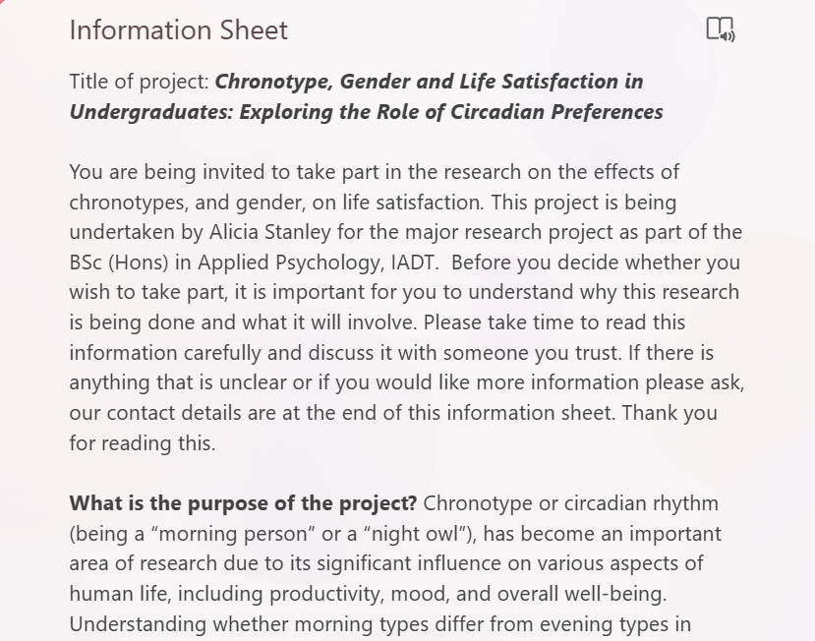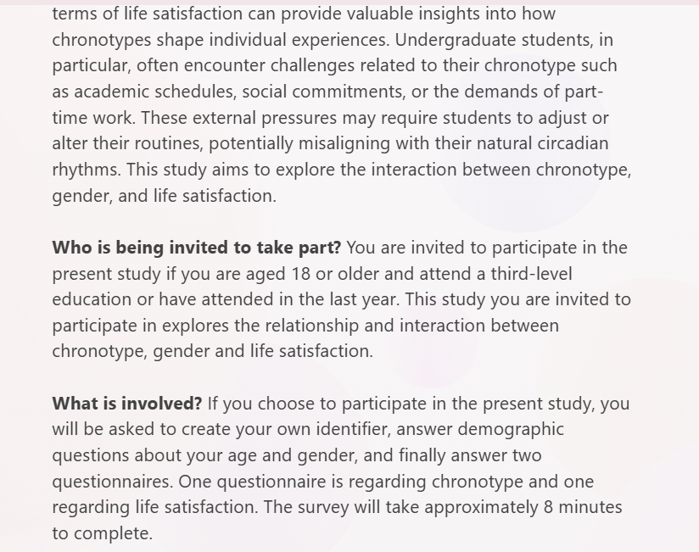

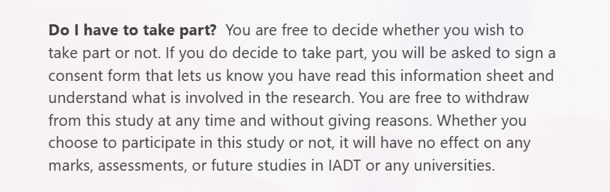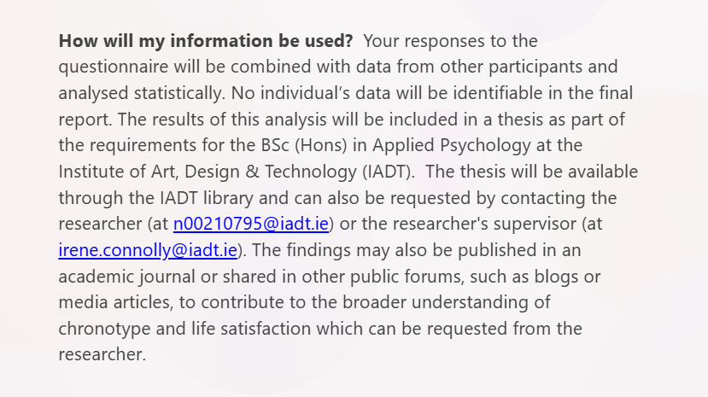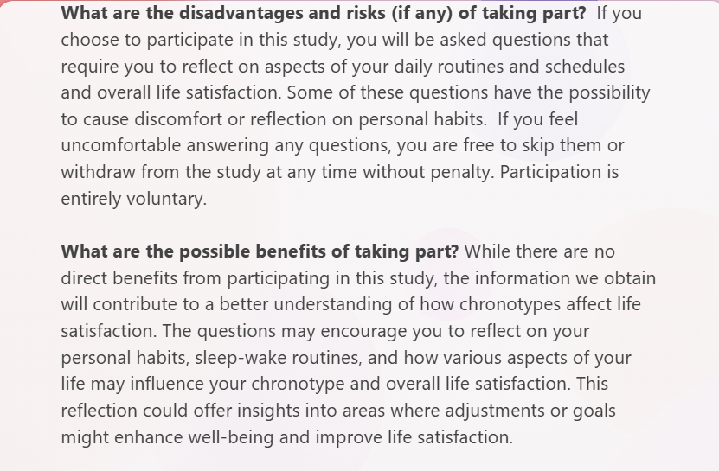

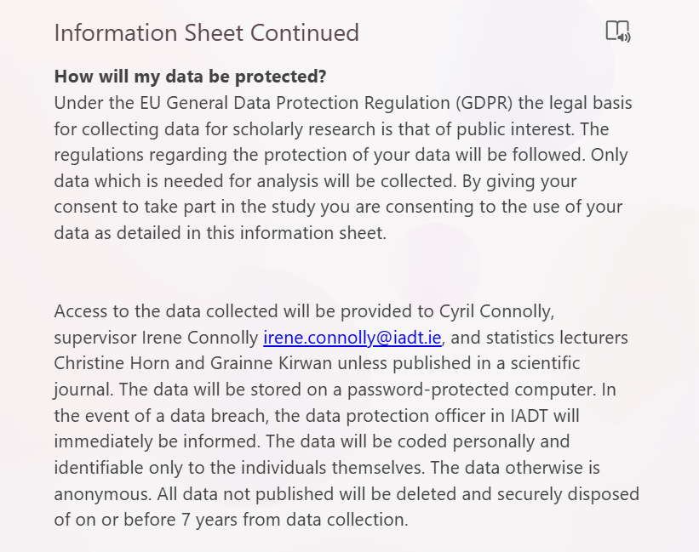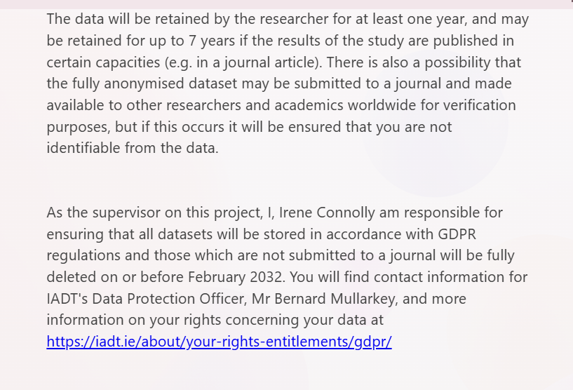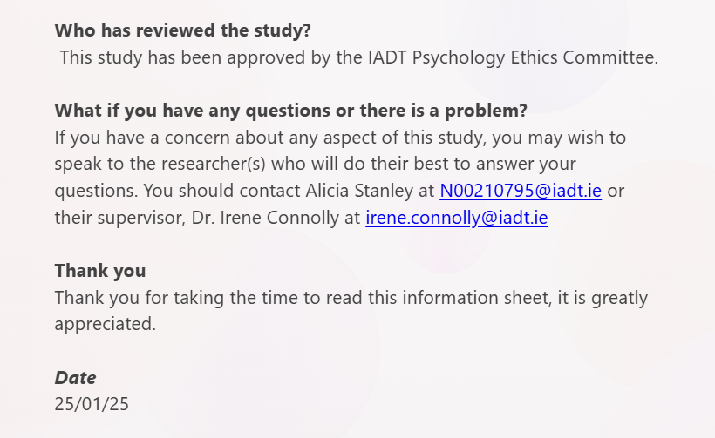

Appendix B- Consent form
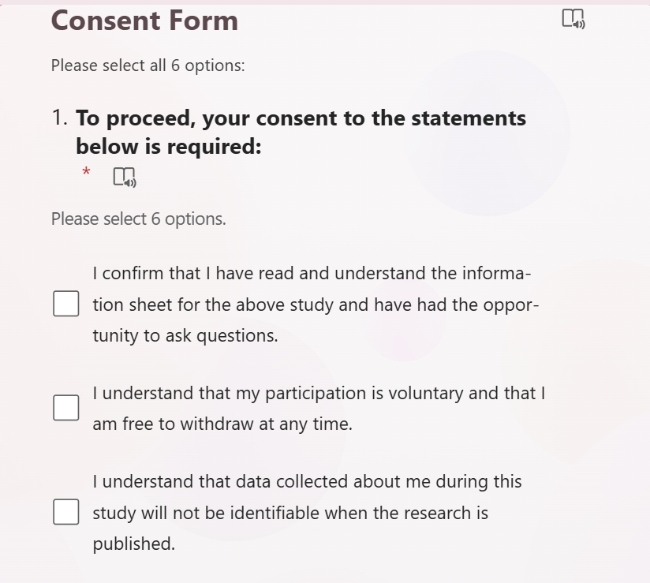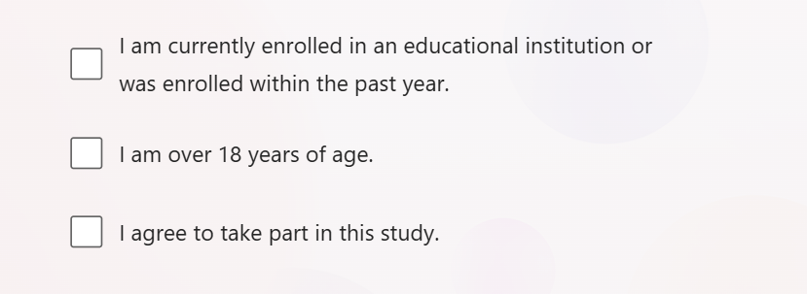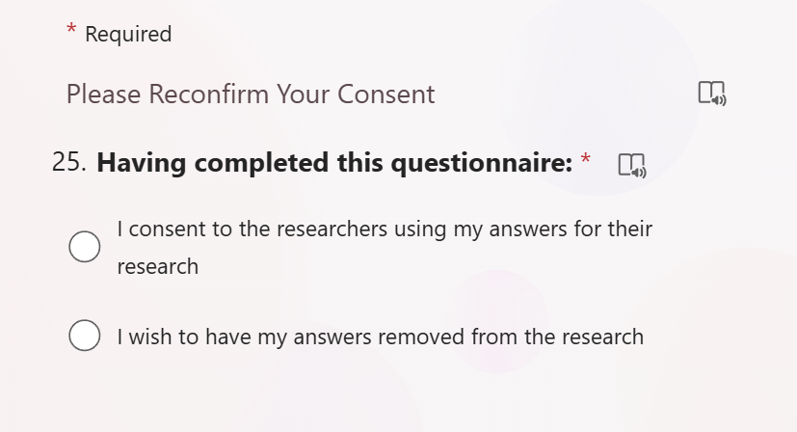
Appendix C- Demographic survey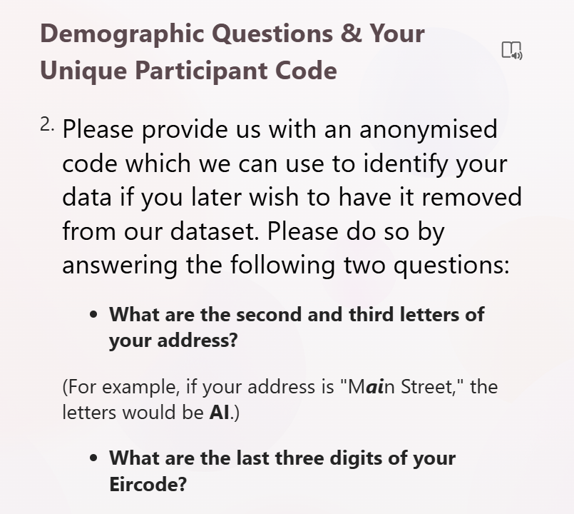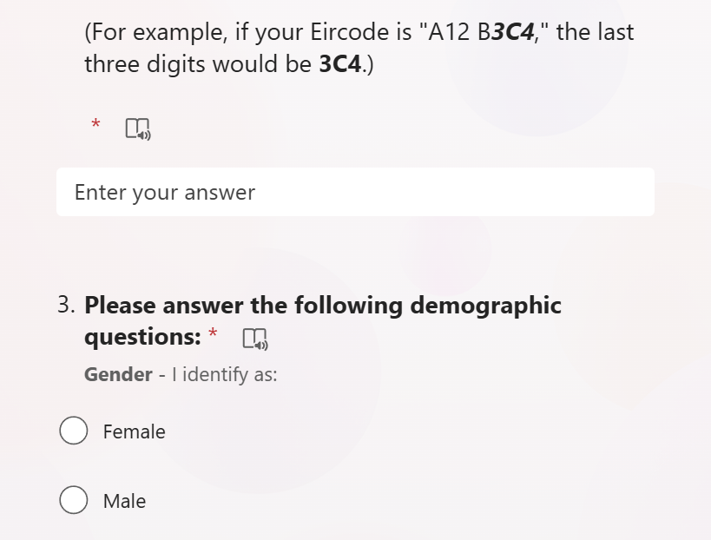
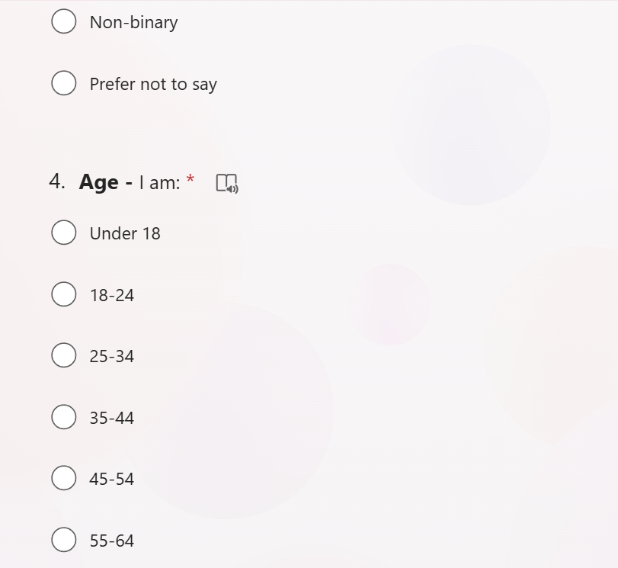

Appendix D- Debrief document 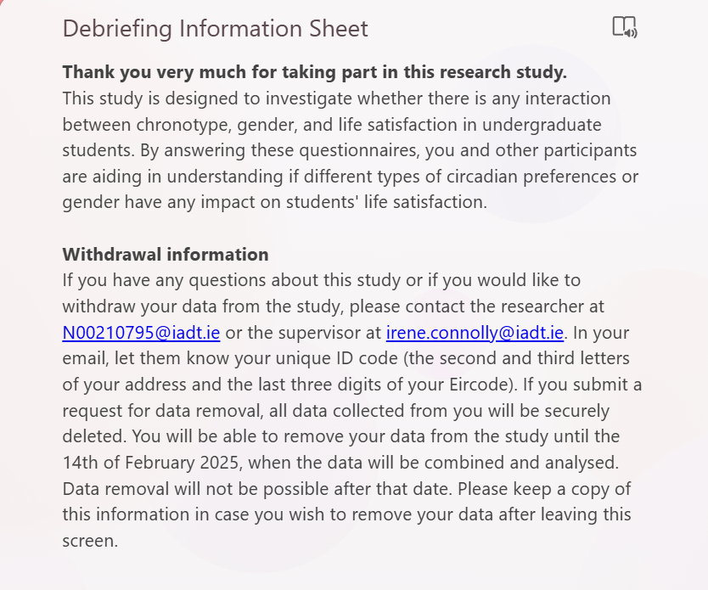
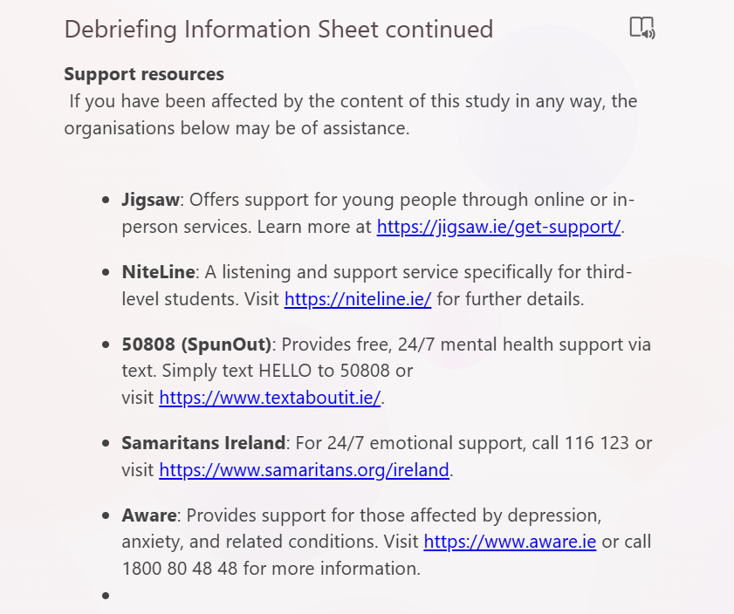
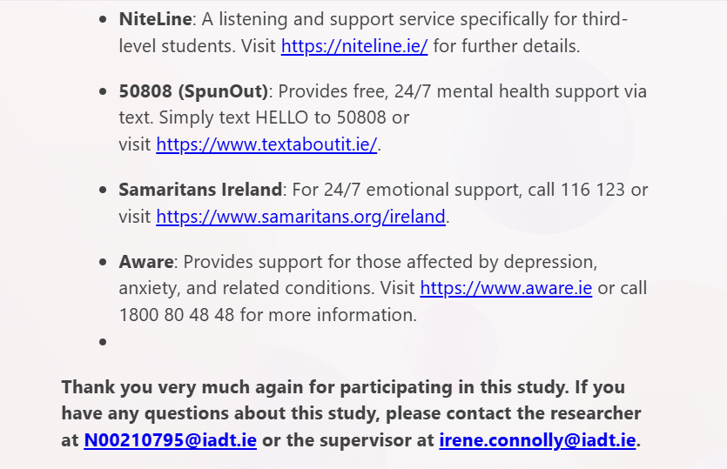

Appendix E- The Morningness-Eveningness Questionnaire (MEQ) 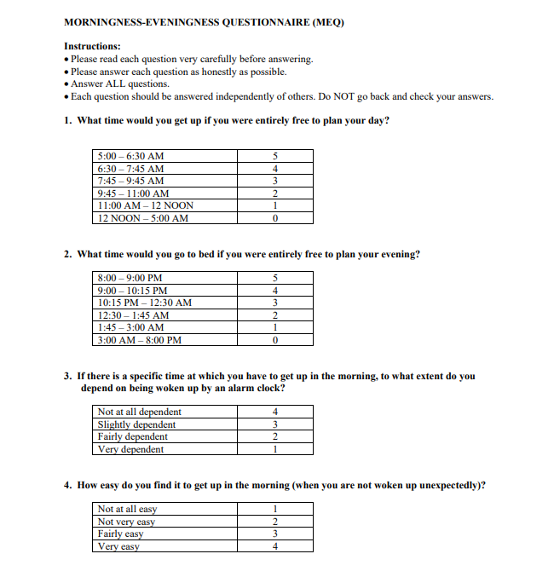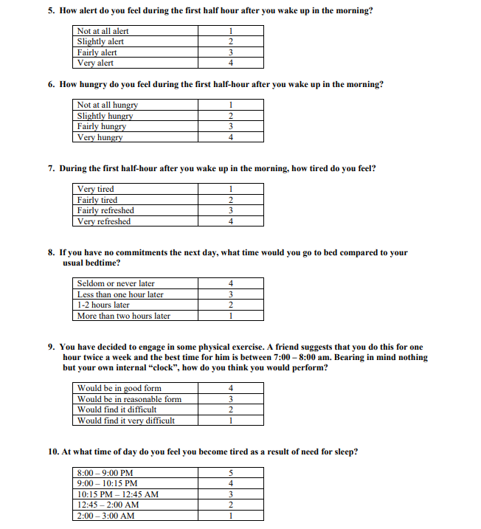

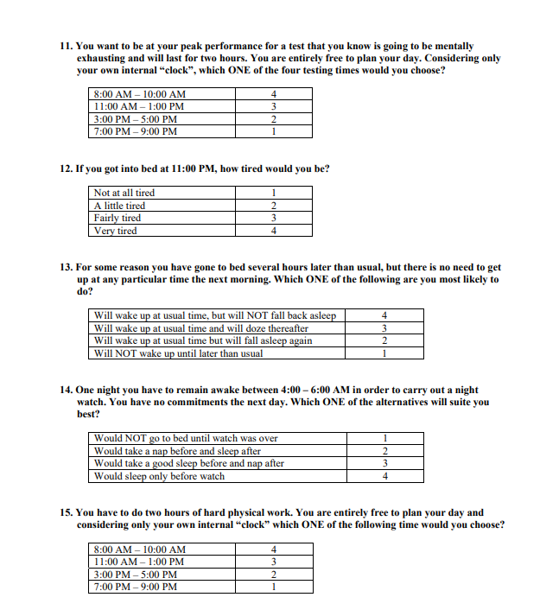
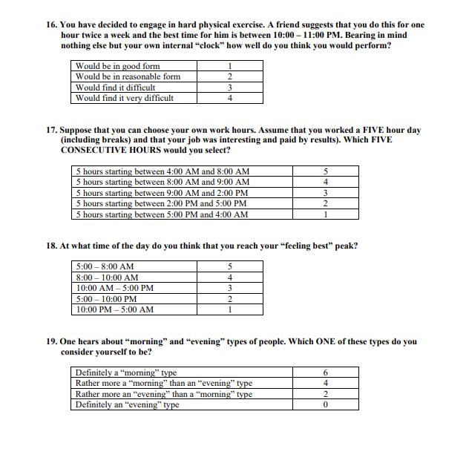
Appendix F- The Satisfaction with Life Scale (SWLS)
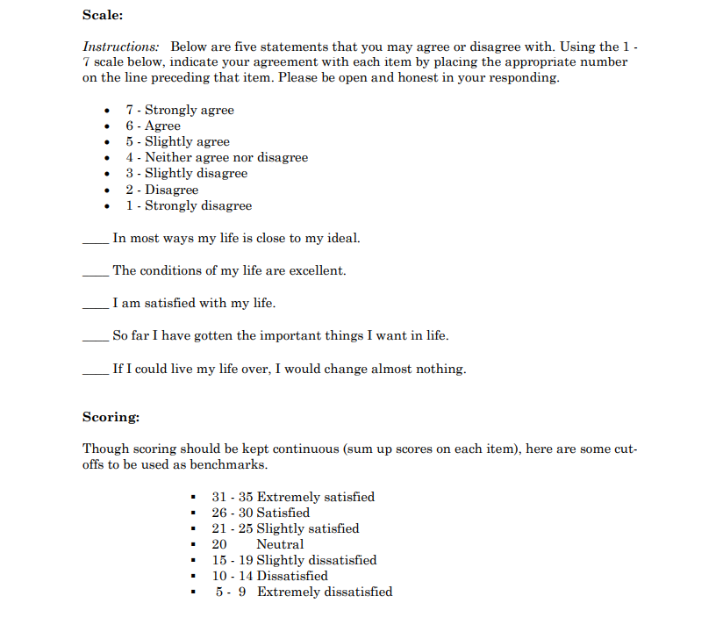
Appendix G- QR Code and link to Microsoft Forms survey
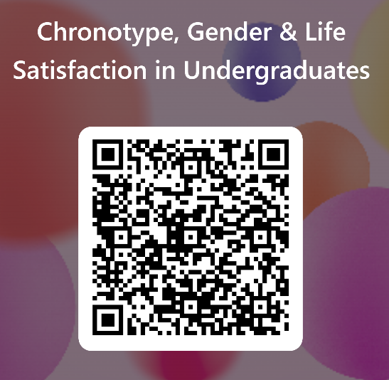https://forms.office.com/Pages/ResponsePage.aspx?id=e5V92hEVQkqy9Xj4R_jIeqYAaKjzNipCn0y5bWR3v61UMEdJU05KTkNTMFYyT0JCQktPRklRUzhSMi4u
Appendix H- Two-Way ANOVA SPSS Outputs
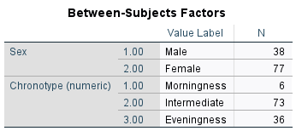
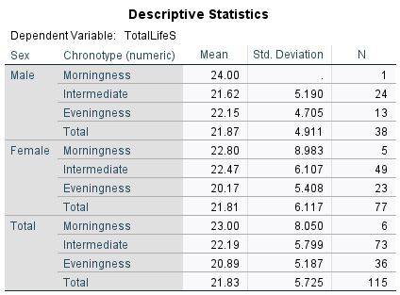
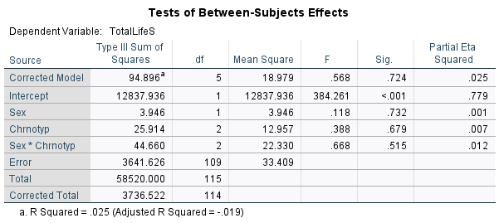

Appendix I- Levene’s Test of Equality of Error Variances
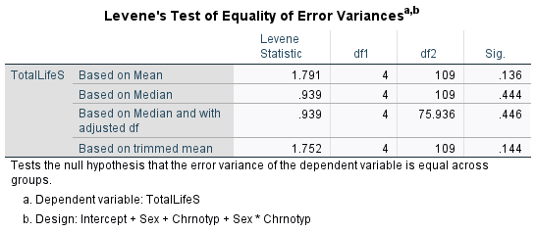
Appendix J- Normality Tests for Chronotype and Gender
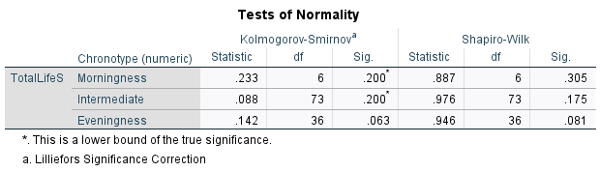
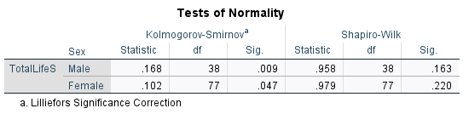

Appendix K- Histograms and Q-Q Plots for Morningness group
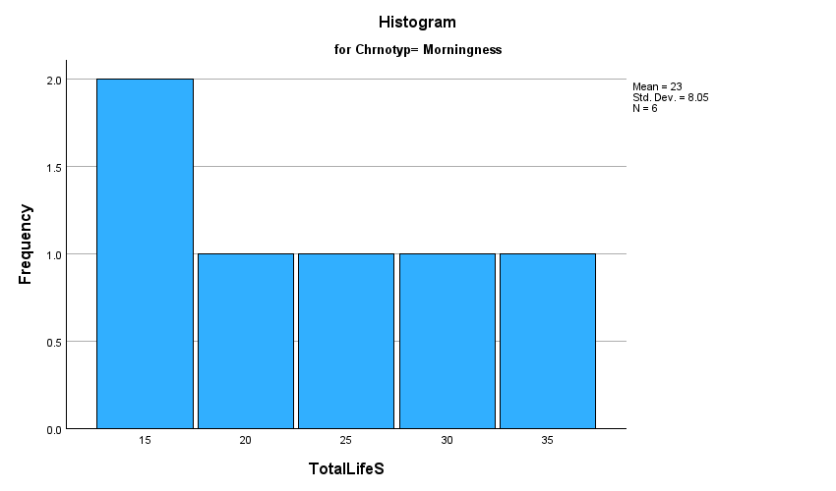

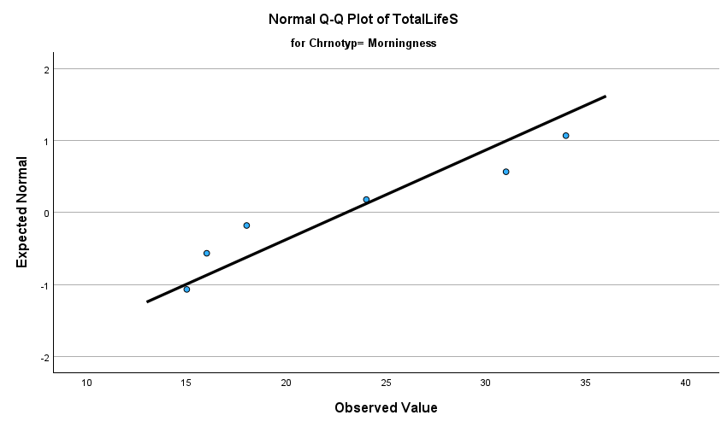

Appendix L- Reliability SPSS Output for SWLS Scale

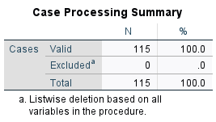
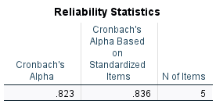
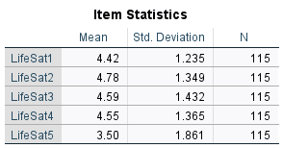
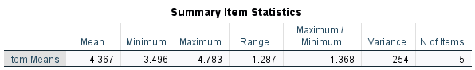
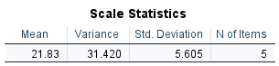

Appendix M- Reliability SPSS Output for MEQ scale
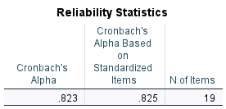
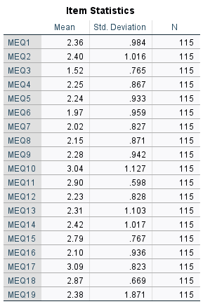
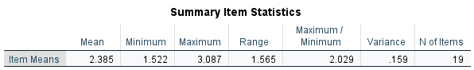
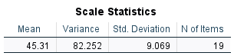
Appendix N – Ethical Approval confirmation email
