The Little Man in Godzilla (1954) and Godzilla Minus One (2023)

Zhi Fung Daniel Pong

Submitted to the Faculty of Film, Art and Creative Technologies in candidacy for the BA (hons) Degree in Animation DL832

Submitted March 2025

Declaration of Originality

This dissertation is submitted by the undersigned to the Institute of Art Design & Technology, Dun Laoghaire in partial fulfillment of the examination for the BA (Honours) (programme name). It is entirely the author’s own work except where noted and has not been submitted for an award from this or any other educational institution.

__Daniel Pong________________

Acknowledgements

I wish to say thank you to my Thesis Supervisor, Dr. Elizabeth McCarthy. She really helped me with ideation and really guided me in writing my very first thesis. She was my North Star regarding this paper. I also wish to say thanks to Dr. Michael Connerty and my family for helping me through my final year in the college. Lastly, I wish to say thank you and well done to myself for pulling through this otherwise terrifying mountain of a task.
Abstract

This thesis will go onto explore how the original Godzilla (1954) and the recent Godzilla Minus One (2023) are not just monster movies but movies that reflect Japan’s deeply rooted fears and traumas from nuclear warfare. Following the disasters of Hiroshima and Nagasaki, the original Godzilla emerged as a powerful metaphor for not only the dangers of nuclear technology but also the lasting scars of war. Nearly 70 years later, Godzilla Minus One revisit these themes. It brings a fresh take that engages modern audiences while adhering to the original’s core message. Both films use horror not just to terrify, but to help process collective trauma, exploring guilt, survival and resilience. This will be explored through the evolution of Godzilla’s design, the human stories and how these films show how the monster of Godzilla has remained culturally relevant. It adapts to different eras while keeping its allegorical identity. This thesis will be shining a light through cinematography and character arcs, showing how these films serve as both a cautionary tale and emotional catharsis. This thesis will show these films are more than just giant monster spectacles, they reflect Japan’s tragic past and a reminder of the lasting impact of nuclear use.

Table of Contents

Introduction_________________________________________________pg. no. 7

Chapter 1 - Historical Context ..………………………………………….pg no. 9

Chapter 2 - Atomic Horror Sci-Fi, Design and it’s Connection to
Trauma through Fantastic Beings and Secure Horror ….pg no. 16

2.1 – Horror, Design and How It Offers Catharsis Through
Secure Horror………………………………...………………pg no. 17

2.1 – Science Fiction and Horror…………………...………………pg no. 22

Chapter 3 - Surviving Trauma ...……….….…………..……….………...pg no. 24

3.1 - The Human Stories in Godzilla (1954) and
Godzilla Minus One (2023) ………………………………………..pg no. 24

3.2 – The Difference in Western Portrayals of Human Stories in
Godzilla (1954) …………………………………………………….pg no. 30

Conclusion _________________________________________________ pg. no. 33

Bibliography ________________________________________________ pg no. 35

List of Figures

Fig. 1: History.com Editors (n.d.) Aerial view of Hiroshima before the atomic bomb. [Online image]. Available at: https://www.history.com/news/hiroshima-nagasaki-atomic-bomb-photos-before-after (Accessed: 14 February 2025).

Fig. 2: History.com Editors (n.d.) Hiroshima after the atomic bomb explosion. [Online image]. Available at: https://www.history.com/news/hiroshima-nagasaki-atomic-bomb-photos-before-after (Accessed: 14 February 2025).

Fig. 3: LIFE Picture Collection (n.d.) Atomic Bomb Survivor. [Online image]. Available at: https://www.life.com/history/hiroshima-portraits-of-survivors/ (Accessed: 12 February 2025).
Fig. 4: Godzilla rampages in Tokyo, Godzilla (1954) Directed by Ishirō Honda. [Film still]. Japan: Toho Co., Ltd.

Fig. 5: LIFE Picture Collection (n.d.) Hiroshima survivor with keloid scars. [Online image]. Available at: https://www.life.com/history/hiroshima-portraits-of-survivors/ (Accessed: 12 February 2025).

Fig. 6: Mother holds her two children, Godzilla (1954) Directed by Ishirō Honda. [Film still]. Japan: Toho Co., Ltd.

Fig. 7: LIFE Picture Collection (n.d.) A mother and child, survivors of Hiroshima. [Online image]. Available at: https://www.life.com/history/hiroshima-portraits-of-survivors/ (Accessed: 12 February 2025).

Fig. 8: Godzilla charges his attack in the middle of the sea, Godzilla Minus One (2023) Directed by Takashi Yamazaki. [Film still]. Japan: Toho Studios.

Fig. 9: Destruction of Ginza City by Godzilla, Godzilla Minus One (2023) Directed by Takashi Yamazaki. [Film still]. Japan: Toho Studios.

Fig. 10: Shikishima returns only to be berated by Sumiko, Godzilla Minus One (2023) Directed by Takashi Yamazaki. [Film still]. Japan: Toho Studios.

Fig. 11: Shikishima is distraught by the destruction of Ginza and his partner, Noriko, Godzilla Minus One (2023) Directed by Takashi Yamazaki. [Film still]. Japan: Toho Studios.

Fig. 12: Ogata, Emiko and Serizawa contemplating the Oxygen Destroyer, Godzilla (1954) Directed by Ishirō Honda. [Film still]. Japan: Toho Co., Ltd.
Fig. 13: Raymond reports over Godzilla’s rampage, Godzilla, King of the Monsters! (1956) Directed by Terry O. Morse and Ishirō Honda. [Film still]. USA: Embassy Pictures.

Introduction

Since its debut in 1954, Godzilla has remained one of the most enduring and culturally significant figures in cinematic history. More than just a monster movie, Godzilla (1954) serves as a direct response to the horrors of nuclear warfare, reflecting Japan’s postwar trauma and the anxieties surrounding nuclear technology. Emerging less than a decade after the atomic bombings of Hiroshima and Nagasaki, the film became a metaphor for consequences of unchecked scientific ambition. Nearly seventy years later, Godzilla Minus One (2023) revisits these themes, reinforcing the franchise’s roots in historical trauma while modernizing its emotional and narrative arcs.
In Chapter 1 will talk about the historical context in which Godzilla (1954) was conceived, as it is crucial to understanding its importance. After World War II, Japan was placed under American occupation from 1945 to 1952 under strict censorship of the Press Code. I will discuss why it limited public discussions of nuclear warfare’s impact and how the devastation of the Little Man and Enola Gay bombs was often reframed within American narratives of liberation rather than acknowledged as a national tragedy. I will also go onto discuss how shortly after the end of the occupation, director Ishiro Honda channelled this collective grief into Godzilla, using the monster as a stand-in for the destruction and aftermath of the bombs. I will also discuss the solitude of Japan in processing this grief and how it compares to the upbeat atomic monster movies in America using sources from scholars such as Spencer R. Weart, Steve Ryfle & Ed Godziszewski, Hiro Saito and others.
Throughout Chapter 2, I will primarily discuss the genre of Atomic Horror Sci-Fi meanwhile navigating ideas such as Noel Carroll’s “fantastic beings” and Susan J. Napier’s “secure horror”. I will go to discuss how these two films offer audiences catharsis and healing through acknowledging the disasters of Hiroshima and Nagasaki subtlely through mostly the design of the monster but also the narrative choices within the original and the 2023’s Godzilla Minus One. I will also briefly touch on the rising nuclear anxieties of the 1950s and how horror crosses science fiction through scholars such as Fredric Jameson, Ryfle and others.
Finally, in Chapter 3 I will go on to expand on the catharsis element from Chapter 2, it will feature further discussion of the psychological undertones of the two films. My main discussions consisting of guilt, shame, post-traumatic-stress-disorder and how these emotions are seen in the characters, the Japanese culture which engages with these emotions and more importantly how these emotions affect their decisions within the films. I will also focus on the human stories in both Godzilla films, how there is always humanity alongside the monster and how the monster elevate the personal arcs, making them powerful allegories for Japan’s post war identity and its journey towards healing. I will feature sources from Chon Noriega, Sean L. Molloy, Peter H. Brothers and others.

Chapter 1 – Historical Contexts

A major reason Godzilla (1954) entered our pop cultural psyche was the historical context that it was created in. Following the destruction of the cities of Hiroshima and Nagasaki in 1945, Japan became and still is the only country to experience the horrors of nuclear warfare close-up. The twin bombings physically and emotionally scarred both the country and its survivors – (known as “Hibakusha”) for years after their initial explosion and it was this national trauma which formed the foundation where the monster of Godzilla was conceived. The giant reptile reflected a society struggling to process the unprecedented scale of devastation of nuclear warfare that was left in their doorsteps.

After World War 2, it didn’t take long for the world to develop anxieties regarding the Little Man and Enola Gay. The nuclear age forced humanity to ponder the potentials of scientific advancements, harmful or not. The Manhattan project and the creation of the atomic bomb was the pinnacle of human ingenuity, but it also symbolised its consequences. (Weart, 1988) The bombings of Hiroshima and Nagasaki not only wiped the cities but also left a legacy of radiation sickness and displacement for the Japanese to deal with. Also, the two bombs and more important what power they or its bearers’ held dominated postwar political discourse. For Japan, this was not an abstract fear but their reality, one that filmmakers like Ishiro Honda sought to explore through cinema.

Godzilla’s origins are deeply rooted with this history. It was influenced not only by the atom bombs but also events like the Lucky Dragon No.5 tuna trawler incident in 1954. While it is reduced to a footnote in most history books, the incident was widely publicized at the time, a Japanese fishing boat was unknowingly exposed to radioactive fallout from an American hydrogen bomb near Bikini Atoll. They were all immediately contaminated, both the crew and the fish they caught. This led to acute radiation sickness and even the death of a fisherman. This subsequently contaminated much of the local population as their tuna entered local markets. The widespread radioactive contamination and the death of the fisherman sparked a nationwide outrage. Being referred to as “Japan’s second Hiroshima” by scholars such as Ryfle & Godziszweski, the incident reignited fears of nuclear contamination. (2017, pg 26) Not only that, but it also started a domino effect as people begin to slowly solidify their anti-nuclear sentiment and it was against this backdrop that Godzilla was conceived. Its narrative driven by both the scars of Hiroshima & Nagasaki and the immediate anxieties of nuclear energy.
The years of American occupation from 1945 to 1952 had a profound impact on Japanese culture, as they assimilated much of American activities such as golfing, (Saito; 2006, pg 362) but more significantly Japan’s ability to address their own national trauma. The Allied occupation forces imposed strict censorship through the Press Code, which forbade criticism of the United States or discussion of sensitive topics like the atomic bombings. This led to the confinement of any records regarding the A-bomb only to the local medical arena. (Saito; 2006, pg360-1) The censorship delayed Japan’s ability to openly process and address the horrific effects of the bombings on its national psyche, even associating America as a postwar benevolent liberator. It took four years for movements such artistic expressions of the survivor’s experience to be published in the public domain such as Takashi Nagai’s bestseller memoir “The Bell of Nagasaki” but the Press Code demanded it be included alongside “The Tragedy of Manila”, a document of Japanese Military’s atrocities in Manila. We see a slow release of similar expressions such as photographs “The First exhibition of A-Bomb Damage”, a sense of accruing national pity for the Hibakusha (also known as “Atomic Maidens”), and most famously the Lucky Dragon No.5 incident, referenced in the opening scene of 1954’s Godzilla, ramped up the nation’s collective trauma through the symbolisation of Hiroshima as the warning for future atomic uses. (Saito; 2006, pg365-8)

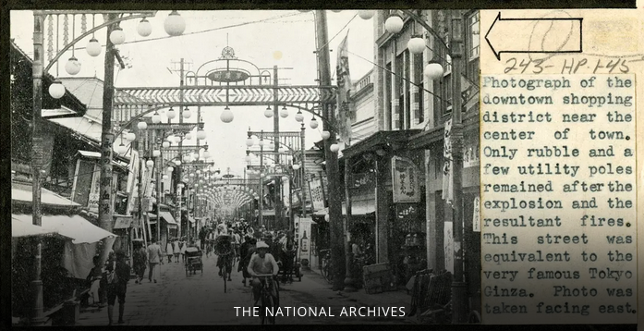
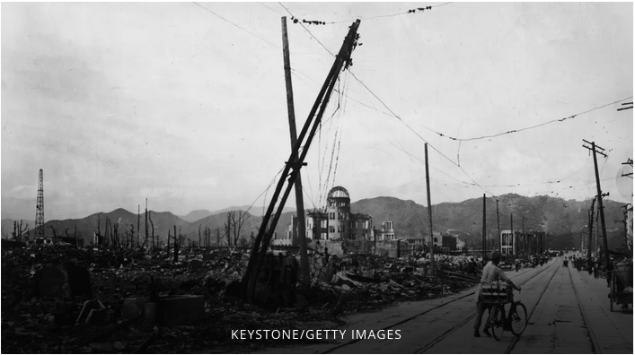
Fig.1 is a picture of Hiroshima before the bomb.
Fig. 2 is a picture of Hiroshima after the bomb, where nothing but a few utility poles remain.
Following the end of the American occupation and the Press Code, Japanese artists were freer and more inclined to exploring themes of national pain and perseverance, which resulted in the birth of Godzilla (1954). It marked the beginning of Japan’s long journey of processing their atomic trauma, setting the stage for the giant reptilian’s poignant critique of nuclear weapons. (Napier, 1993) The creature’s devastating rampage serves as a cathartic release of emotions that had been repressed by the Press Code. By casting Godzilla as the embodiment of Nuclear Terror, the film reflects the outbursts of pain, anger and sadness that the Japanese people had been unable to express openly. Godzilla Minus One (2023) -referred to as Minus One for the rest of this paper- furthers this by even showing Douglas McArthur, the Supreme Commander for the Allied Powers, refusing to send assistance to Japan due to Soviet movements. They had to face the monster alone. Succeeding through a humanistic approach, relying on Japanese ingenuity and not the US or USSR sending bigger bombs such as the case in The Beast from 20000 Fathoms (1951).

Films like The Beast from 20000 Fathoms were part of the Atomic B- movies where the knowledge is power, and people fall neatly into “good” or “evil” camps. (Waldman, 2013) Other atomic monster flicks included films Them! (1954) directed by Gordon Douglas or Tarantula (1955) directed by Jack Arnold, where Giant irradiated ants or spiders roam the streets causing chaos. These monsters symbolised the “other”, the USSR and the anxiety over who gets to control such monster – a point I will develop later in this chapter. Godzilla stands out from these atomic monster films, it shares a lot of similarity with the monster flicks of the 50s, it has a big monster caused by nuclear energy and causes destruction onto society, yet Honda imbued it with a lot of humane characteristics. It also stood out due to the fact it was a perspective from the other side of the War.

The creation of Godzilla in 1954 was influenced by the earlier Western monster films such as The Beast from 20000 Fathoms (1953) and King Kong (1933). These monsters were ultimately defeated by “the bigger bomb” or the latest military technology. (Noriega; 1987, pg67) Other American cinematic responses to nuclear dangers such as the previously mentioned films Them! (1954) or Tarantula (1955) were more obsessed with possibility of mutation and less so about how nuclear radiation directly affected human beings, showcased via extraordinary versions of everyday animals. In these Western films, the monster represents a problem that can be solved with technological process, implying a certain level of control over nature or natural threats. Even in the 1956 American adaptation, Godzilla, King of the Monsters! the ending line of “the whole world will wake up and live again” echoes an upbeat ending, that “Might makes Right” despite the sad sombre ending music. (Ryfle; 2005, pg61) Most predominantly in The Beast from 20000 Fathoms, a prehistoric creature awakened by atomic testing is finally defeated with a radioactive isotope. The solution here reinforces the notion of “nuclear weapons can solve the problems and anxieties they create”. (Noriega; 2006, pg67) – an idea that directly contrasts with the uncontrollable force of nuclear power as depicted in Godzilla.

Unlike these Western counterparts, 1954 presents a force greater than modern tools of war. The creature is eventually stopped by the Oxygen Destroyer, a new and experimental technology created by the Japanese scientist Dr. Serizawa, who chooses self-obliteration rather than to be the one who opens the pandora’s box to larger scale obliteration, considering the Global Superpower’s tendency to police not only their countries but also faraway neighbours. Fearing a potential future where there is “a reservoir of force so powerful”, (J. Sherwin; 1973, pg 953) his decision seals not only his fate but also the box. He destroys not only the monster but himself, unable to afford the ethical cost of wielding such power. We see this again in GMO, as well 1985’s rendition of Godzilla by J. Kizer & Hashimoto, as Godzilla is defeated through natural physics and Japanese resilience. In both films, Godzilla is not vanquished by superior military power but rather acts of self-sacrifice and resourcefulness outside the conventional Western monster films of the atomic age - “Where weapons fail, nature succeeds”. (Noriega; 1987, pg72) In Godzilla (1954), Dr. Serizawa’s Oxygen Destroyer serves as a metaphor for the ethical weight of scientific discovery and the responsibility that comes with it, by making the sacrifice himself, Serizawa restores a moral balance. He ensures that the weapon cannot be abused, his sacrifice serves to further emphasize the moral complexity of scientific developments as well as issues of personal accountability. Similarly in Minus One, humanity’s advanced weaponry proves ineffective against Godzilla, emphasizing the powerlessness of human beings in the face of forces they have unleashed. Rather than dominating and controlling the monster, resolution in both Godzilla (1954) and Godzilla Minus One (2023) stem from facing the deeper fears and meanings it represents. It means we must face what is beyond the monster and perhaps even ourselves – a point I will develop in chapter 3.

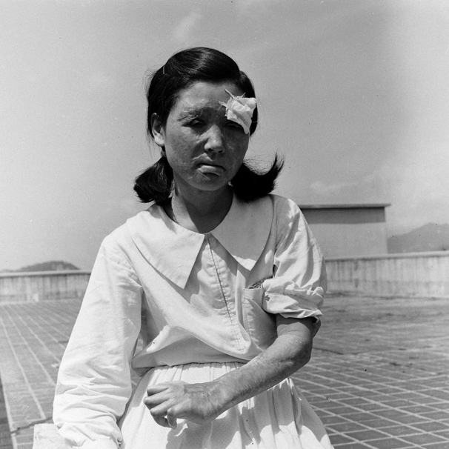
According to Saito, Hiroshima developed into a “national trauma” through which Japan has attempted to articulate its post-war identity and cope with the psychological scars left by the bomb. The trauma is not only about the destruction itself but also about the suffering caused by radiation exposure, depicted when Ogata and the team of scientists approaches Odo Island in Godzilla, or the lingering fears of radiation symbolised through the floating deep-sea fish seen in GMO. Alongside Hiroshima, “Atomic Maidens”, which can be seen in fig. 3 below, became symbols of Japan’s atomic experience. (Saito; 2006, pg 369) This represents an important cultural statement that, despite the atomic trauma imposed from the outside, Japan would find its own solutions and faces its own demons without international support, turning inward to confront the menace on its own terms. Both Godzilla and Minus One depict Japan’s nuclear trauma as a uniquely national experience, untethered from Western frameworks of intervention.
Fig. 3 shows a victim of the bomb in Hiroshima, known as “Hibakusha” or “Atomic Maidens”.

1954’s Godzilla portrays this theme by introducing the creature as a direct result of nuclear blast and radiation, the very product of modern technological advances that ultimately represent a threat to humanity. Throughout the film, it captures Japan’s ambivalence toward technological progress, especially with the potential traumatic implications of the scientific advancements of the Oxygen Destroyer in both films. Minus One furthers this theme, showing Japan isolated and vulnerable in the face of Godzilla. Both films show Japan as a nation without external assistance, echoing the real historical memory of Japan’s suppression and solitude following the bombings.

The modernisation of Japan during the early 20th century brought a complex relationship with technology. Despite creature features where giant spiders were a result of atomic testing, America’s atomic age was portrayed as an age of optimism seen in ventures such as space exploration. This triumphant and bright depiction of nuclear energy belies the darker side of this technology, presenting a narrative of modern technological advances as a world limitless progress without acknowledging its potential for catastrophic destruction. Japanese Sci-fi is far more subtle and often portrayed technological progress as a pandora’s box filled with physical dangers and possible “spiritual collapses”. (Napier; 1993, pg 329) These conflicting emotions were only made worse by the war and American occupation. This complex relationship was often reflected in Japanese cinema, especially in post-war sci-fi, which portrayed modernization as a two-edged sword that carries both scary hazards and the possibility of advancement.
Godzilla (1954) and its modern counterpart, Godzilla Minus One (2023), are deeply rooted in Japan’s historical experience of nuclear trauma, reflecting the aftermath of Hiroshima, Nagasaki, and events like the 1954 Lucky Dragon No.5 incident. These films emerged in a postwar context shaped by American occupation and censorship through the Press Code, which delayed public acknowledgement of atomic suffering. Unlike Wester atomic movies that portray technology as a cure all solution, Godzilla critiques humanity’s hubris, presenting the creature because of nuclear testing and technological recklessness. Both films highlight Japan’s isolation and resilience, emphasizing acts of self-sacrifice and resourcefulness over military triumph. By framing modernisation as a double-edged sword, Godzilla transcends the atomic monster genre of the 50s, serving as a cultural critique of nuclear power and an exploration of Japan’s journey to confront its past and rebuild its identity.

Chapter 2 – Atomic Horror Sci-Fi, Design and it’s Connection to Trauma through Fantastic Beings and Secure Horror

Godzilla (1954) introduced a groundbreaking genre to cinema that combined horror with the rising nuclear anxieties of the atomic age. While the genre of Horror and Science Fiction had crossed paths before, such as Mary Shelley’s 1818 Gothic Horror Novel, Frankenstein, and James Whale’s 1931 film adaptation. Godzilla stands apart as Japan’s first significant film of this genre. Created during the nation’s post-war recovery and rapid modernisation, the film gave voice to Japan’s unique fears about nuclear power in a way that Western cinema had yet to explore. This chapter will examine how Godzilla (1954) and Godzilla Minus One (2023) use horror, science fiction, and a massive atomic monster to illustrate the agony of atomic warfare. I will do this through design elements and the decisions made within the two films signifying the historical reality of atomic warfare and how that in turn created a deeper emotional resonance in both films.
Atomic Horror Sci-Fi was a variation of the well-known Horror Sci-Fi subgenre – a popular mix of speculative fears about the future and emotional terror. Fear has been around since the dawn of man; horror evokes not only this primal feeling through scary monsters and the supernatural but also our anxieties. Science fiction, on the other hand, helps us imagine the consequences of unchecked technological and scientific advancements, often serving as a warning about taking things too far. Together, these genres allow filmmakers to explore existential fears within a speculative lens. Together they ground the world where horror delivers emotional impact and can make the potential disasters seem uncomfortably real. With the onset of the nuclear age, atomic horror sci-fi blends speculative narratives with the dread of humanity’s destructive potential. As Susan J. Napier observes in her concept of “secure horror”, such films create a narrative framework that allows confront real-world fears in a controlled, symbolic space. They provide both a scare and a spectacle, but also a kind of catharsis – a way to process fears about nuclear doom from the safety of the local movie theatre. Noel Carroll’s exploration of horror further enhances this understanding. Emphasizing that the genre operates through the presence of “Fantastic Beings” whose abnormality represents symbolic threats to the general status quo. (1981, pg17) In the case of Godzilla (1954) and Godzilla Minus One (2023), both the titular monster and furthermore its designs embody not only immediate devastation of nuclear warfare but also its lingering, intangible consequences, making these films profound examples of atomic horror sci-fi.

2.1 – Horror, Design and How It Offers Catharsis Through Secure Horror

Carroll argues that horror works when the audiences feel disturbed by something monstrously “impure” and fundamentally “disturbing”. (1987; pg52) In Godzilla, this feeling of unease is represented by Godzilla himself. A prehistoric creature awakened by nuclear testing, who defies natural law and embodies the possible dangers of scientific ego and arrogance. Godzilla’s radioactive presence portrayed through his design renders him an abomination, a walking manifestation of radiation.
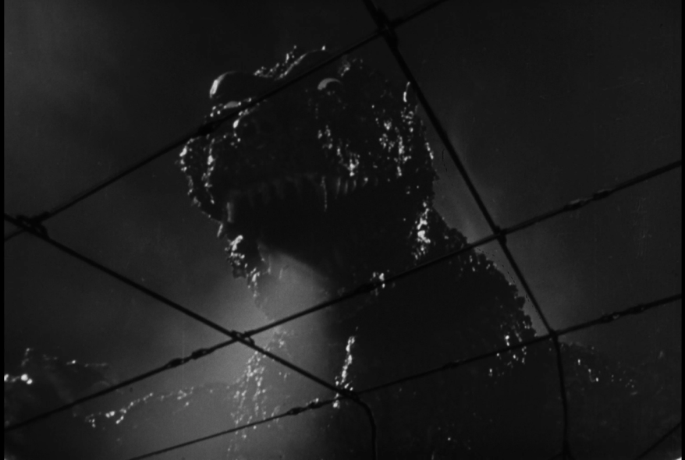
Fig. 4, left, shows the bumpy texture of Godzilla up close.
Fig. 5, right, shows the keloid scars of the survivors in Hiroshima.

With the wounds of the World War II still painfully fresh, Director Honda and effects artist Eiji Tsuburaya made Godzilla as more than just an oversized lizard. The uses of metaphors and suggestions made for a much more tasteful interpretation of the bomb and its aftermath. His whole design, seen in fig. 4, was constructed with a lot of distinct visual cues to the Little Man and its survivors. As Carroll mentioned, the horror genre is most effective when it plays between the familiar and the unfamiliar and as we can see from the picture above, Godzilla’s design of a reptilian and keloid scarred skin is at once recognizable and alien. His mushroom shaped head resembles the cloud that marked the beginning of the end for the survivors. The filmmakers purposefully chose to recreate the anguish of Hiroshima and Nagasaki by texturing keloid-like scars across his body that mirror the burns endured by atomic bomb survivors, which can be seen in fig. 5. (Ryfle, 2005, pg50) His eyes, which glow with an unusual intensity, give the impression of permanently tarnished by radiation. The radioactive pollution that endures even after Enola Gay and the Little Man’s physical explosion is conveyed by his burning spine and fiery breath. His slow hulking pace and towering, reptilian appearance reflect its symbol as an agent of nuclear destruction by conveying a sense of overpowering power and inevitable doom. These visual elements aren’t just coincidence. They were carefully constructed by designers Teizo Toshimitsu and Akira Watanabe under Tsuburaya’s supervision to make Godzilla more than a monster. They invite viewers to confront the unnatural consequences of humanity’s actions. These features align with Carroll’s observation that the most effective monster disrupt the natural order, appearing as a grotesque hybrid because it feels both alien and all too real. By giving radiation a physical form through Godzilla, the filmmakers turn an invisible threat – nuclear fallout – into something unavoidable. You confront the visual trauma of atomic warfare, yet you can’t look away and that’s the genius of Godzilla. It makes the rather abstract horror of the bomb deeply personal, unforgettable, and impossible to ignore.

A concept that reinforces Carroll’s “Fantastic Beings” is Napier’s notion of “Secure Horror”. As Napier explains, films like Godzilla (1954) and Godzilla Minus One (2023) often serve as a form of “secure horror”, (1993, pg 249) they offer audiences a safe, narrative-driven space to confront their fears while addressing real-world anxieties. This form of horror allows societal fears – like the devastating impact of atomic warfare - to be projected onto a tangible being like Godzilla. By doing so, these films create both a sense of catharsis and a feeling of control. It can give power back to survivors of the bomb by acknowledging such tragedies took place. The monster becomes a tangible stand-in for the invisible but omnipresent threat of radiation, allowing viewers to process their repressed fears in a way that feels both emotionally close and safely distant. This leads to the healing of scars, not physically but psychologically. In relation to catharsis, Godzilla has a scene that demonstrates both catharsis and horror perfectly down below in fig. 5 and fig.6.
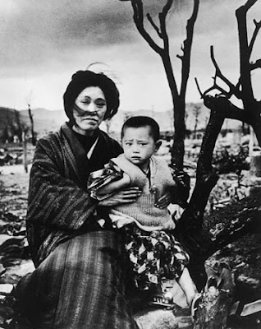
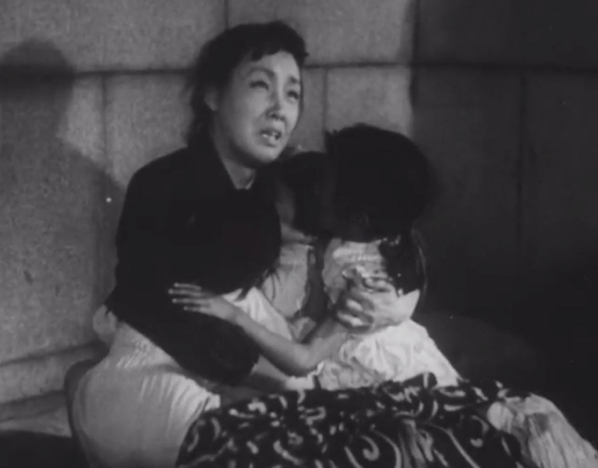
Fig. 6, left, shows a scene of a child holding her children among Godzilla’s rampages.
Fig. 7, right, is a picture of a mother and a child who survived Hiroshima.

This is a scene towards the end when Godzilla runs rampant through Tokyo, destroying everything in its way in fig. 5. Buildings and structures collapse, a mother hugs her two children closely as they embrace for their end. It reflects the real-life photo of the bomb’s aftermath seen in fig. 6. The scene has no music but only the close crackling of fire. This poignant scene asks us to engage emotionally with the powerlessness of the ordinary citizen caught in one of the world’s worst disasters. The reference to the real-world photo promotes the emotional resonance within audiences. Yet the scene epitomizes the genre of horror within the film as “both fear and disgusts are etched on the character’s features” when faced with a monster whose entire existence is constructed of “chemical waste”. (Carroll; 1987, pg53-4)
In Godzilla Minus One (2023), the framework of secure horror can be observed but it is taken deeper in a psychological manner. Napier’s research into disaster films as therapeutic experiences resonates strongly here through the protagonist of Shikishima. As the film not only revisits the immediate destruction of Godzilla but there is constant commentary on the slow psychological destruction after its presence and this is best seen through Shikishima. He struggles with the lingering trauma of wartime experiences and survivor’s guilt; it reflects the uniquely Japanese experience of collective struggle to rebuild after the atomic bombings – an idea I will explore further in the next chapter. Furthermore, Carroll’s idea of horror as a “symbolic biology” (1987, pg 53) supports this view, Godzilla not only represents the bomb but also the atomic fears and subconscious anxieties within our psyche. In Minus One (2023), Godzilla isn’t just a physical threat but a psychological one. He is a constant reminder of the devastation humanity has brought upon itself. His repeated reappearance reinforces the inescapable nature of this trauma, echoing Carroll’s observation that the monster externalizes our deepest fears and confront them in a tangible form.
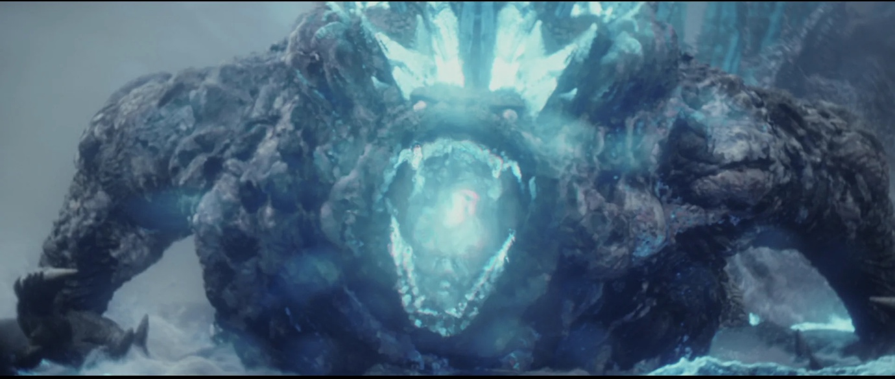
Fig. 8 shows Godzilla in Minus One charging up his atomic breath attack.

The Godzilla in Minus One (2023), seen above in fig.7, builds upon the original design while reflecting a shift in focus from immediate devastation to long-term psychological trauma. Unlike the tortured-looking monster of Godzilla (1954), Minus One’s Godzilla is powerful and graceful in his movements, suggesting an evolution of horror and radiation’s symbolic role. The updated Godzilla is more jagged, with exaggerated dorsal fins and an even more fearsome visage. The CGI allows for added layers of detail, such as glowing embers emanating from cracks in its body, which suggests he is a creature burning and charged with nuclear energy, reinforcing its identity as a walking but not-so Little Man. This enhanced design reflects how the genre of atomic horror sci-fi has adapted to the expectations of contemporary audiences while staying true to its core allegorical roots. Godzilla (1954) focuses on the raw and immediate impact of the bomb, Minus One show Godzilla as an enduring presence, embodying the catastrophe that Japan has tried but failed to fully move past.

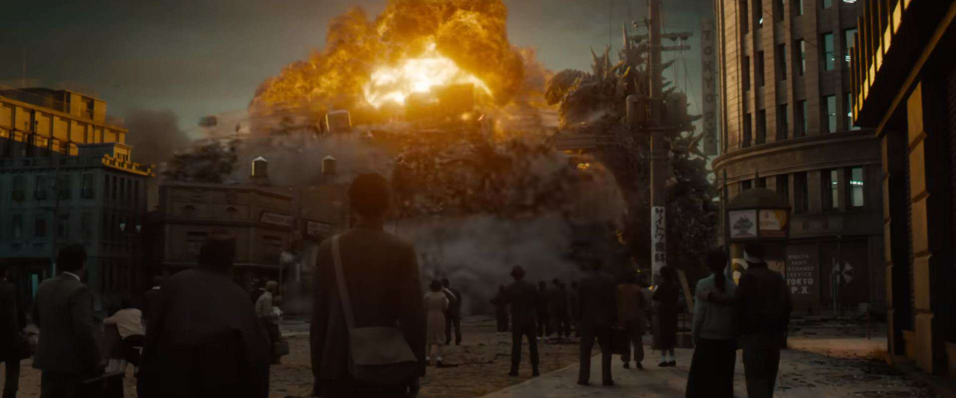
Fig. 9 shows the destruction of Ginza in Minus One.

Godzilla not only returns after being defeated once but wreaks further havoc, destroying the rebuilt city of Ginza. His attacks seem methodical and intentional, and his intelligence reflects the ways in which radiation has come to be seen not just as an external danger but deeply internalised. The destruction of Ginza in fig.8, after years of post-war progress, parallels the cultural memory of Japan’s recovery, constantly shadowed by its nuclear memory. A horrific memory that stalks the survivors, returning in flashbacks, nightmares and our history books. By portraying Godzilla as a relentless pursuer, Minus One symbolises the way that radiation and it associated psychological scars pursue those who survive – a form of survivor’s guilt.
Over the decades, his design has transformed from the practical man-in-a-suit aesthetic of the 1954 film to the stunningly realistic CGI of 2023. Both films portray Godzilla as a profoundly symbolic being, embodying the enduring consequences of nuclear energy. Despite these changes, what Godzilla represents has stayed deeply rooted in Japan’s cultural identity. He bridges the gap between historical memory and modern-day fears, reminding audiences of past disasters while tapping into present anxieties. At its core, the two Godzilla films give audiences the chance to confront their own fears and, as Carroll puts it, still find a way “to sleep (at night)”. (1981, pg24)

2.2 – Science Fiction and Horror

The two films are potent examples of the fusion between horror and science fiction. They weave imaginative storytelling with emotional depth, and as Carroll notes, the most effective horror films create monsters that disrupt the natural order which is what Godzilla (1954) achieves. The creature is portrayed as the direct consequence of humanity’s reckless pursuit of science. The film’s elements, such as discovery of Godzilla and the creation of the Oxygen Destroyer, serve to “defamiliarize and restructure our experience of our own present”. (Jameson; 1982, pg152) Within Napier’s framework, this defamiliarization provides the foundation for secure horror, as it enables audiences to confront the unimaginable, nuclear annihilation of a country, in a safe space. Minus One (2023) builds on this tradition by incorporating modern CGI and storytelling techniques to make the monster more destructive and visceral in its carnage, while still preserving the allegorical weight of its source. Takashi Yamazaki uses cutting-edge technology to depict Godzilla’s rampage to mirror humanity’s continued advancements of destructive capabilities, further aligning with Carroll’s notion of horror as a genre that exposes the consequences of humanity’s ego and hubris.
Both films also emphasize the limitations of human agency when faced with overwhelming natural forces, a recurring theme in atomic horror sci-fi. Napier’s analysis of Japanese disaster films (1993, pp. 327–329) highlights their focus on human fragility and resilience rather than outright victory, which is especially evident in both Godzilla (1954) and Godzilla Minus One (2023). In the 1954 film, Dr. Serizawa’s invention of the Oxygen Destroyer provides a bittersweet resolution—one that requires him to make the ultimate sacrifice to keep the weapon out of the wrong hands. This is strongly linked to Carroll's (1987, p. 54) insight that horror frequently centres on experiments in which human ambition unleashes uncontrollable forces. These monsters, whether they are Godzilla or Frankenstein's monster, serve as a reminder of the risks of an obsession with science that disregards its effects. They served as a reminder on whether we should rather than whether we could. Similarly in Minus One, humanity’s advanced weaponry of planes and bombs are useless against Godzilla. They only serve to slow him down and it underscores the powerless of humanity against the force it has unleashed. Both films reaffirm that facing the monster’s and subsequently our fundamental fears and anxieties, rather than destroying it, is the path to resolution.
To conclude this chapter, Godzilla (1954) and Godzilla Minus One (2023) stand out as prime examples of the Atomic Horror Sci-Fi genre, by blending Napier’s concept of secure horror with Carroll’s symbolic biology of horror. These films give audiences a way to confront the overwhelming dread of nuclear warfare, all the while exploring themes of human psyche, dangers of unchecked scientific ambition, and the lasting scars of trauma. The evolution of Godzilla’s design from the 1954 original to the 2023 update, underscores the genre’s capacity to adapt while staying true to its allegorical roots. By presenting Godzilla as both a physical and symbolic being of nuclear destruction, they elevate the monster from a mere spectacle to a deeply resonant cultural icon, ensuring the continued relevance of atomic horror sci-fi in today’s cinema.

Chapter 3 – Surviving Trauma

At the heart of Godzilla (1954) and Godzilla Minus One (2023) lies not just the spectacle of a destructive force but deeply human stories. Both films are centred on characters who personal journeys reflect the psychological and emotional toll of living under the spectre of an atomic atrocity. In this chapter I will go onto explore how these human stories develop alongside the larger themes of atomic trauma, with a focus on survivor guilt, shame, and the societal burden that comes with being a witness to unspeakable destruction.
Before going through analysis of Godzilla and Minus One, there needs to be clear distinction made between Guilt and Shame. For the purpose of this work, I will differentiate the feelings of shame and guilt. Guilt is often internal and is a personal response to a negative event. We feel guilt when something we did or the lack of, goes against our values and we feel “psychological discomfort”. Guilt is “I did something bad”. Meanwhile shame is external, it comes from the condemnation of our peers or surroundings after the negative event, it is a focus on the self. Shame makes us feel we are flawed, “unworthy of connection” and often translates to “I am bad”. (Brene Brown, 2013) Meanwhile Psychologists John P. Wilson, Boris Drozdek and Silvana Turkovic finds that shame, especially posttraumatic has a higher tendency of suicide as the person sees themselves as bad and a failure. (2006; pg124) They find that guilt is less painful, it supports “life-sustaining personal values” and seeks the value of reconciliation with others (pg 130). Now with the guilt and shame clarified, let’s move onto the stories in both films.

3.1 The Human Stories in Godzilla (1954) and Godzilla Minus One (2023)

Throughout the Godzilla franchise, there is always a narrative that connects the destructive power of Godzilla to the human characters who either experience the devastation firsthand or grapple with the ethical implications of using/ combatting such a force. This human story is essential in bridging the gap between the monster as both a symbol of atomic power and societal consequences of that power. (H. Brothers; 2011, pg 36) Godzilla focuses on a love triangle between Emiko, Ogata, and Serizawa, characters who are caught between personal loyalties and ethical quandries. Emiko’s inner conflict to reveal Serizawa’s scientific invention mirrors the moral uncertainty around using atomic power. Meanwhile Minus One follows Shikishima, a former kamikaze pilot and Odo Island survivor, whose struggle with PTSD and survivor’s guilt reflects a deeply internalised conflict between duty and personal survival. These human stories transform the kaiju genre from a mere spectacle to a powerful meditation on Japan’s “horrific sufferings of the past”. (H. Brothers; 2011, pg40)
In Godzilla, the three main characters’ complex relationship provides an emotional core that contrasts with the film’s antagonist. Serizawa, a reclusive man who is obsessed with his research very much and his death very much represents Susan Sontag’s idea that “the scientist is one who releases forces which, if not controlled for good, could destroy man himself” (1965) His relationship with Emiko and Ogata represents the theme of self-sacrifice as he decides to die with his creation to prevent it from being used as a tool of mass destruction. He was guilty over what source of power he was the sole proprietor of. Yet it can be argued that Serizawa’s choice was less concerned about the defeat of Godzilla but more so about preserving his humanity, ensuring he does not contribute to the creation of a “new kind of death”. (H. Brother; 2011, pg39) Through Serizawa’s actions, we see that his death can be in ways glorified as he did it for the greater good and even controversially, it is considered a good decision, but this cannot be said for the main character of Shikishima in Minus One.

In Minus One, Shikishima’s journey is one of self-forgiving and grappling with survivor’s guilt. The movie starts with Shikishima landing on Odo Island to have his plane fixed, lead mechanic Sosaku Tachibana deduces he is trying to escape the frontlines. Having bailed on his duty as a kamikaze and a life-changing encounter with Godzilla where he froze in fear leading to the death of the entire crew, he returns home only to find himself labelled a failure by general society. This is best seen through his neighbour, Sumiko Ota who berates him for not fighting harder and winning them the war. “If you’d only done your job my children wouldn’t have died”. He is shamed by his own people.
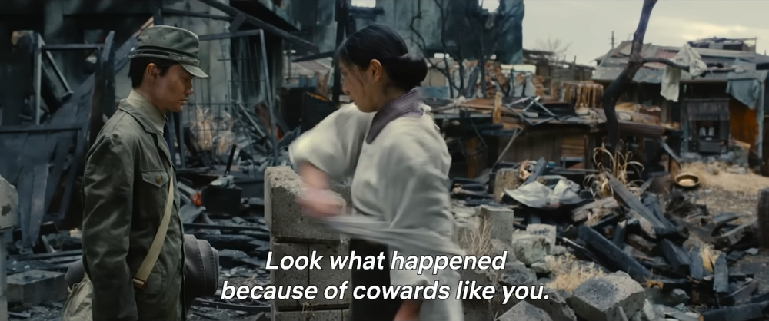
Fig. 10 shows Sumiko berating Shikishima amongst piles and rubbles.

The societal expectations would, in turn, result in a profound sense of personal shame. Expectations that somehow if he just crashed into enemy forces, killed Godzilla on Odo Island, all the buildings in the grey toned photo above would not be ruined, that Japan would win the war, that Sumiko would have her family back. He is haunted by a sense of duty unfulfilled. This psychological burden is not simply a personal issue but also echoes the sense that survival of some individuals came at the cost of others – The war he fights everyday invites the audiences to pity him just as Japan shares pity with the “Hibakusha” mentioned earlier.
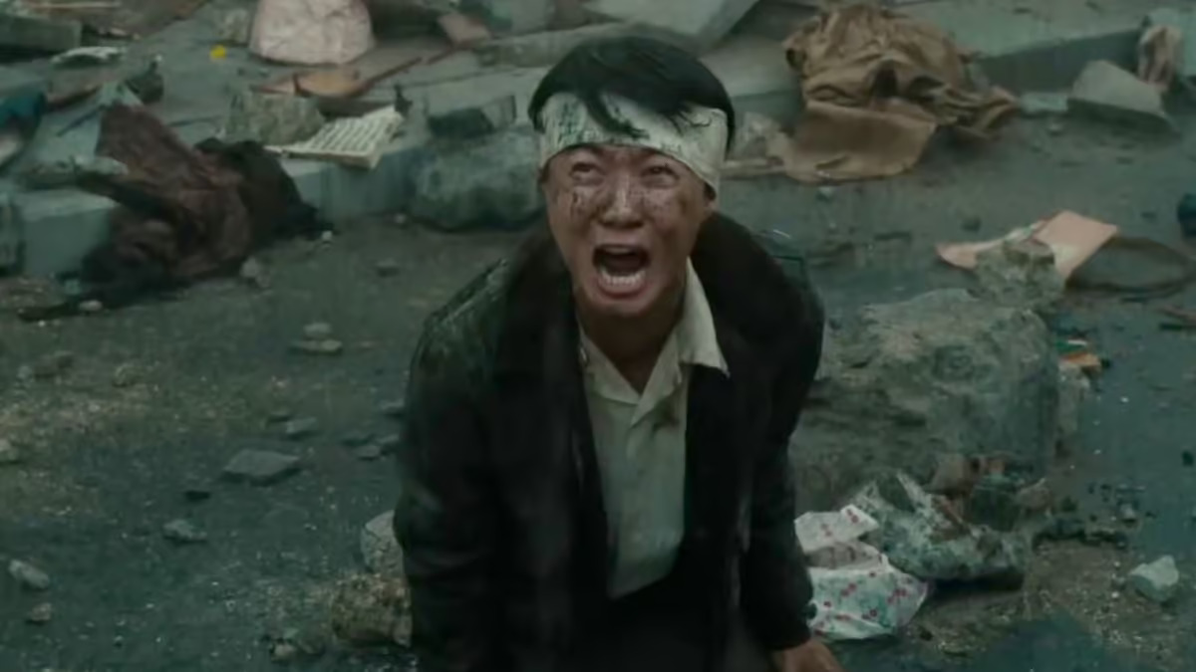
The psychological depth of Shikishima is significant in its exploration of survivor’s guilt, PTSD, and the feeling of shame associated with the judgement of others for his abject failure to do his duty. Soldiers can fight well, survive and come home to earn medals but this was not the case for Shikishima. During his time in war, Shikishima was conditioned to believe that kamikaze - a suicidal crash at the enemy - was the ultimate form of loyalty and courage to Japan and its people. This calls upon the idea of “Seppuku/ Harakiri” dating back to the 12th and 13th century Feudal Japan where ritual suicide through disembowelment was deeply embedded into Japanese culture. Such acts were committed to restore honour for themselves or their families, Shikishima failed to restore honour by surviving, he failed his fundamental duty in the war efforts. His subsequent survival of both the war and his encounter with Godzilla conflicts with what he believed, leading to intense shame and self-recriminating guilt (Wilson, Drozdek, Turkovic; 2006, pg123) It is also compounded by the cultural stigma surrounding mental health at the time. PTSD and mental distress were not well understood at the time, and Shikishima is unable to articulate or address his inner turmoil. This portrayal aligns with psychological theories of survivor’s guilt, which describes feelings of unworthiness and self-blame in individuals who survive traumatic events. (Traynham, M. Kelly, P. Long, W. Britt, L. Coolidge; 1999, pg87) In Shikishima’s case, his guilt manifests as a death wish – a drive towards self-destruction to born out of his inability to reconcile his survival with the death of his peers on Odo Island and others.
Fig. 11 shows Shikishima destroyed once more after Ginza and Noriko is presumably destroyed.

A scene that I wish to focus on in this regard is the destruction of Ginza three years after the war and Noriko Oishi, Shikishima’s partner, in the middle of the movie. Godzilla shows up again in Japan but this time to destroy the rebuilt city of Ginza where Noriko works at. She was the fundamental support in his life, offering him empathy and compassion in a time where it was frowned upon. Noriko, Shikishima and the years they spend together gave Shikishima hope again. Noriko gave Shikishima an alternative to self-destruction as repentance for the souls he could not save, she asks Shikishima to live for those who could not. Yet she sacrifices herself to save Shikishima when Godzilla uses his atomic breath, pounding further into Shikishima’s psyche. Her sacrifice leaves Shikishima bitter and destroyed but it solidifies the idea that survival of some comes at a cost of others. She survives but it is not shown until the end of the film. Her loss and the reaction of Shikishima shown in the picture above reflects the radiation of the bomb, a lingering killer that maims away at the physical and psychological health of the survivors. (L. Molloy; p2012, pg. 545) The cultural repression of these issues adds to the layer of his character. Shikishima was expected to die for Japan, yet he lives. Rather than seeking help or understanding, society views his survival as a sign of failure. The lack of support reflects the post-war repression of trauma and healing, as Japan struggled to process and move past the devastation of the war without fully addressing its lingering effects on its citizens with devices such as the Press Code mentioned above. Shikishima’s journey, ultimately one of self-forgiveness and acceptance, highlights the need for a compassionate understanding of trauma, especially in a culture where silence around personal suffering is normal.
While Shikishima embodies survivor’s guilt, Godzilla (1954) explores shame and guilt through Emiko and Ogata moral dilemmas. Emiko’s guilt for revealing Serizawa secret weapon, the Oxygen Destroyer, to Ogata creates a powerful moral conflict. Her decision is not without consequence; by sharing Serizawa’s creation, she catalyzes events that leads to his death. Emiko’s guilt stems from her betrayal of her fiancé's trust, as well as her role in revealing a weapon of mass destruction to the world. She internalises her shame, reflecting the Japanese collectivistic mentality to protect the interests of the community and less so the individual. (H. Nathan, J. Marsella, Horvath; 1999, pg712)
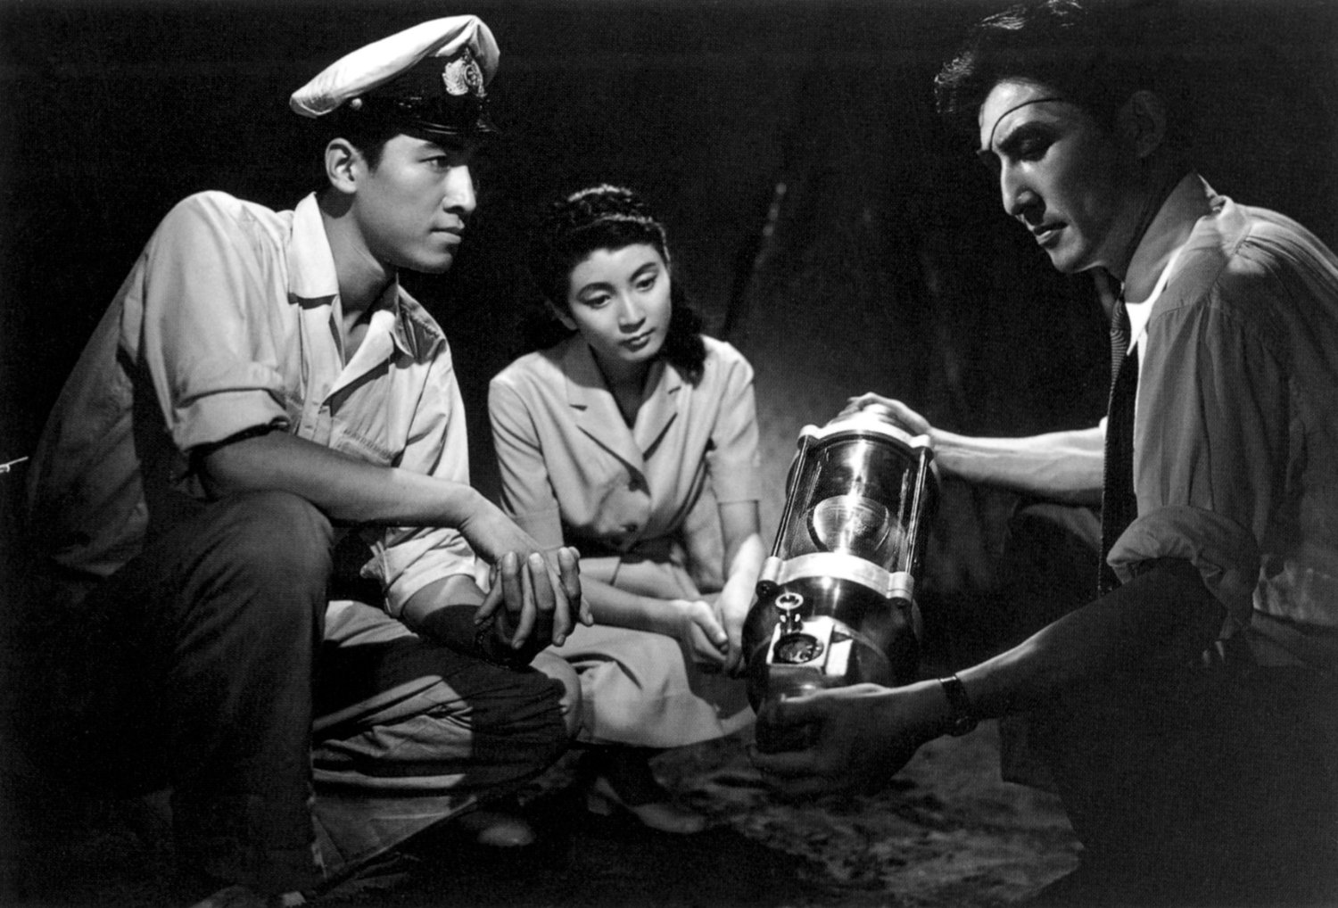
Fig. 12 shows Ogata, Emiko and Serizawa contemplating the use of the Oxygen Destroyer.
Ogata, too, bears guilt over Serizawa’s sacrifice, as he realizes the Oxygen Destroyer may attract global interest and potential misuse by politicians. His guilt is furthered by the knowledge he was part of the process that led to Serizawa’s decision to take his own life. As seen in the picture above, both Emiko and Ogata convince Serizawa to use the Oxygen Destroyer. Fearing that “as long as [he is] alive, who can say that [Serizawa] wouldn’t be coerced into using it again”, Emiko and Ogata share the guilt of convincing their friend to die alongside the knowledge of the Oxygen Destroyer.
In Minus One, Godzilla can be seen as a representation of Shikishima’s suppressed emotions, functioning as a physical manifestation of his inner conflicts. Drawing upon Freudian concepts, Godzilla might represent Shikishima’s “id” - the primal controllable forces within him that have been suppressed by societal expectations and wartime conditioning. Just as Shikishima suppresses his emotions, Japan, too, repressed its collective trauma and guilt over its wartime actions. Godzilla, in this sense, becomes a cathartic figure for both Shikishima and Japan, embodying the destructive force of suppressed trauma and anger that cannot be contained forever. This approach aligns with Japanese psychological studies, which suggests that confronting “the other” in oneself is a therapeutic means of achieving self-awareness and healing. According to Chon Noriega, “brute force cannot affect the monster[...] these films are serious attempts at dealing with trauma therapeutically[...] (the psychoanalytic process is seen as more attractive than the drive toward destruction […])”. (1987, pg 68) Shikishima’s journey reflects this process, as he comes to terms with his own guilt and ultimately takes action to stop Godzilla, symbolising his acceptance of his survival and his role in Japan’s collective recovery. The therapeutic nature of confronting Godzilla thus mirrors Shikishima’s own healing, creating a parallel between the personal and societal journeys towards acceptance and peace.

3.2 – The Difference in Western Portrayals of Human Stories in Godzilla (1954)

This journey of healing looks different when we cross the sea to see how the 1956 American adaptation compares to the 1954 original. The American version of Godzilla is far more indirect in its representation of Godzilla as an avatar of the bomb and eschews the theme of trauma that features so heavily in the original. As the origin of the bomb that were dropped on the twin cities and not the victims of the bombing, the American adaptation’s relationship with Godzilla (who is the embodiment of that attack) is one of suppressed guilt, avoidance, and denial. Japanese audiences in the 1950s reportedly cried and sympathised with Godzilla at the end of the film, viewing it not simply as a mere monster but a tragic figure displaced by nuclear testing. In America, however, Godzilla quickly became a pop-culture icon and diluted into the range of creature features. The 1956 adaptation Godzilla, King of the Monsters represents a more traditional “us vs them” mentality, where the monster is an external threat to be defeated rather than a reflection of shared guilt or trauma. This difference is further emphasized by adding Raymond Burr’s character and eliminating references to radiation, thus diluting the original’s nuanced exploration of atomic trauma. (H. Brother, 2011, pg39)
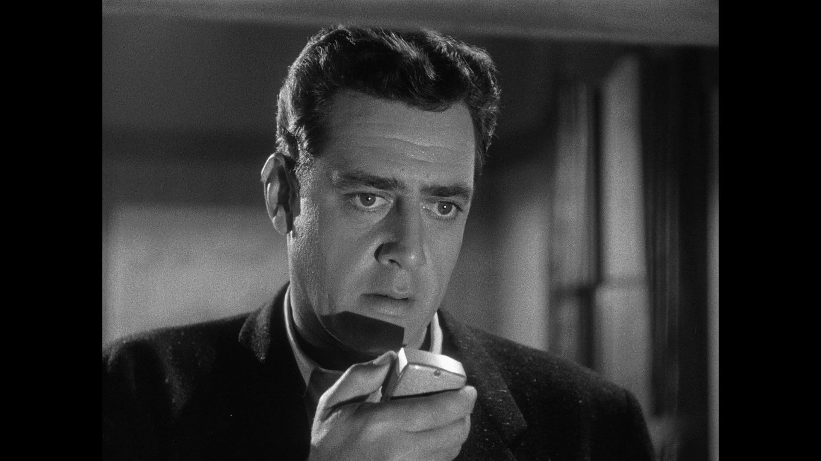
Fig. 13 shows Raymond Burr reporting Godzilla’s rampage in the 1956 American edit.

Amongst the 20 minutes of footage that was cut out from the Japanese original, there is a scene where a Japanese actor reports on Godzilla’s rampage with passion and emotion, sweat covering his face. Yet this scene is replaced with Raymond Burr’s slow monotoned dialogue. According to Noriega, “The Hollywood re-edited film plays on an American sense of guilt towards the Japanese in the early fifties [....] Godzilla’s death represses American guilt and anxieties about nuclear weapons; both history and Japan’s own filmic rendition are retextualized to erase the bomb and thereby relieve anxieties about the American occupation and H-bomb tests.” (1987, pg70) These edits alongside others such as referrals to Godzilla as “it” adds a lot of ambiguity and changes the core message of the 1954 original. The 1956 version shifted the focus to an externalised threat rather than a national trauma as it was not a national trauma for America the way it was for Japan. The adaptation trivialises the original message of collective accountability and loss. The Japanese approach, however, is more introspective, with the creature serving as a metaphor for Japan’s post war identity and psychological scars rather than a creature. It can be suggested that the 1954 Godzilla film was made to relieve the scars of Japan at the time, an idea that “horrific sufferings of the past could be addressed and soothed by the most horrific fiction of the present”. (H. Brothers, 2011, pg40)

Godzilla’s role as a therapeutic symbol in Japanese cinema can be seen in how the creature becomes a reflection of Japan’s collective pain and ultimately, resilience. Unlike many of the American creature features where the monster is purely antagonistic, Japanese portrayals of Godzilla as more so an animal defending its territory, he is a being just trying to live like the rest of us, a figure deserving of sympathy. His rampage in both the Original Godzilla and Minus One represents Japan’s struggle to process the atomic bombings as something beyond mere destruction – as a force that shapes identity, memory, and national consciousness.

Godzilla (1954) and Godzilla Minus One (2023) being deeply personal human stories to the forefront, using prominent characters like Dr. Serizawa, Emiko, Shikishima and Noriko to explore the complex emotions of guilt, shame and trauma. These human narratives are essential in the films to transcend the creature feature or mere monster genre. The two Godzilla films offer audiences a powerful reflection on Japan’s collective psyche in the aftermath of the atomic bombings. Through themes of survivor’s guilt, shame, and the need for catharsis, the films present Godzilla not only as a destructive force but as a symbol of the internal conflicts that Japanese society has faced in its journey towards healing and acceptance.

Conclusion

I have shown in this essay that Godzilla (1954) and Godzilla Minus One (2023) are not only monster films. They are deeply personal reflections of Japan’s postwar trauma after World War II. Chapter 1 investigated how both films captured the devasting impact of nuclear warfare, drawing from real historical events like the bombings of Hiroshima and Nagasaki and the 1954 Lucky Boat Incident. It also showed how the repression of the Press Code led to the birth of Godzilla, and I also argued that Godzilla differs from the atomic monster movies of the 1950s. Whereas the Western portrayals often resolute with a bigger weapon, Godzilla is unstoppable, forcing us to confront what it represents on a deeper level. Each film acts as a warning, reminding us of the dangers that come with scientific hubris and the irreversible damage it can cause.
Chapter 2 show how these films show how horror can be more than just scares, they can be a way to process real- world fears and traumas. Godzilla is not just a monster, but a symbol of nuclear devastation and survival, blending terror with deeper emotional meaning. The evolution of Godzilla’s design, from the suit in 1954 to the detailed CGI in Minus One, reflects how the story has stayed relevant while adapting to modern tastes. At its core, Godzilla represents both destruction and catharsis. Through secure horror, the fantastic being of Godzilla gives audiences a way to face their deepest anxieties about war, technology and survival in the safety of their local cinema.
What makes these films stand out even more is their focus on human stories. They aren’t just about a giant monster causing destruction – they are more about the people caught within said destruction. The characters discussed in Chapter 3, such as Dr. Serizawa, Emiko, Ogata, Shikishima and Noriko bring the emotional weight of the story to life with themes such as survivor’s guilt, grief and the need for moral redemption. From Dr. Serizawa’s decision to sacrifice himself in Godzilla speaks to the moral struggle of creating such technology, all the way to how Shikishima’s journey in Minus One shows the deep scars war leaves on the human soul. These films explore what it means to survive, how people deal with guilt and shame, and how they represent Japan in finding the strength to move forward.
In the end, Godzilla (1954) and Godzilla Minus One (2023) remain powerful because they tap into something bigger than just nuclear fear, they speak to the human experience of trauma, survival and resilience. By injecting deeply personal storytelling with history, they turn Godzilla into more than just a monster. He becomes a symbol of the past, a reminder of the cost of war, and a warning of reckless pursuit for scientific progression. Even decades later, Godzilla’s roar still echoes, ensuring that the lessons of these films remain just as relevant today as they were when he first emerged from the sea.

Bibliography

Books:
• Napier, S.J. (1993) Anime from Akira to Howl’s Moving Castle: Experiencing Contemporary Japanese Animation. Palgrave Macmillan.
• Ryfle, S. & Godzisweski, E. (2017) Ishiro Honda: A Life in Film, from Godzilla to Kurosawa. Wesleyan University Press.
• Shelley, M. (1818) Frankenstein; or, The Modern Prometheus. London: Lackington, Hughes, Harding, Mavor & Jones.
• Weart, S.R. (1988) Nuclear Fear: A History of Images. Harvard University Press.

Journal:
• Brothers, P.H. (2011) ‘Japan's Nuclear Nightmare: How the Bomb Became a Beast Called "Godzilla"’, Cinéaste, 36(3), pp. 36-40.
• Carroll, N. (1981) ‘Nightmare and the Horror Film: The Symbolic Biology of Fantastic Beings’, Film Quarterly, 34(3), pp. 16-25.
• Carroll, N. (1987) ‘The Nature of Horror’, The Journal of Aesthetics and Art Criticism, 46(1), pp. 51-59.
• Jameson, F. (1982) ‘Progress versus Utopia; Or, Can We Imagine the Future?’, Science Fiction Studies, 9(2), pp. 147-152.
• Malloy, S.L. (2012) ‘"A Very Pleasant Way to Die": Radiation Effects and the Decision to Use the Atomic Bomb against Japan’, Diplomatic History, 36(3), pp. 515-545.
• Napier, S.J. (1993) ‘Panic Sites: The Japanese Imagination of Disaster from Godzilla to Akira’, The Journal of Japanese Studies, 19(2), pp. 327-351.
• Nathan, J.H., Marsella, A.J., Horvath, A.M. and Coolidge, F.L. (1999) ‘The Concepts of Individual, Self, and Group in Japanese National, Japanese-American, and European American Samples: A Semantic Differential Analysis’, International Journal of Intercultural Relations, 23(5), pp. 711-725.
• Noriega, C. (1987) ‘Godzilla and the Japanese Nightmare: When "Them!" Is U.S.’, Cinema Journal, 27(1), pp. 63-77.
• Ryfle, S. (2005) ‘Godzilla's Footprint’, The Virginia Quarterly Review, 81(1), pp. 44-63.
• Saito, H. (2006) ‘Reiterated Commemoration: Hiroshima as National Trauma’, Sociological Theory, 24(4), pp. 353-376.
• Sherwin, M.J. (1973) ‘The Atomic Bomb and the Origins of the Cold War: U.S. Atomic-Energy Policy and Diplomacy, 1941-45’, The American Historical Review, 78(4), pp. 945-968.
• Traynham, S., Kelley, A.M., Long, C.P. and Britt, T.W. (2019) ‘Posttraumatic Stress Disorder Symptoms and Criminal Behavior in U.S. Army Populations: The Mediating Role of Psychopathy and Suicidal Ideation’, The American Journal of Psychology, 132(1), pp. 85-95.
• Wilson, J.P., Droždek, B. and Turkovic, S. (2006) ‘Posttraumatic Shame and Guilt’, Trauma, Violence & Abuse, 7(2), pp. 122-141.

Web Sources:
• Farnam Street (n.d.) Brené Brown: The difference between guilt and shame. Farnam Street. Available at: https://fs.blog/brene-brown-guilt-shame/ (Accessed: 14 February 2025).
• Katy Waldman (2013) Nuclear monster movies: Sci-fi films in the 1950s were terrifying escapism. Slate. Available at: https://slate.com/technology/2013/01/nuclear-monster-movies-sci-fi-films-in-the-1950s-were-terrifying-escapism.html (Accessed: 14 February 2025).

Filmography:
• Frankenstein (1931) Directed by James Whale [Film]. USA: Universal Pictures.
• Godzilla (1954) Directed by Ishirō Honda [Film]. Japan: Toho.
• Godzilla, King of the Monsters! (1956) Directed by Terry O. Morse and Ishirō Honda [Film]. USA: Embassy Pictures.
• Godzilla Minus One (2023) Directed by Takashi Yamazaki [Film]. Japan: Toho.
• King Kong (1933) Directed by Merian C. Cooper and Ernest B. Schoedsack [Film]. USA: RKO Radio Pictures.
• Tarantula (1955) Directed by Jack Arnold [Film]. USA: Universal Pictures.
• The Beast from 20,000 Fathoms (1953) Directed by Eugène Lourié [Film]. USA: Warner Bros.
• Them! (1954) Directed by Gordon Douglas [Film]. USA: Warner Bros.

