A Reason to be Evil:
The Villain’s perspective in Animation

Éimhin J. Smith

Submitted to the Faculty of Film, Art and Creative Technologies in candidacy for the BA (hons) Degree in Animation DL832

Submitted March 2025

Declaration of Originality

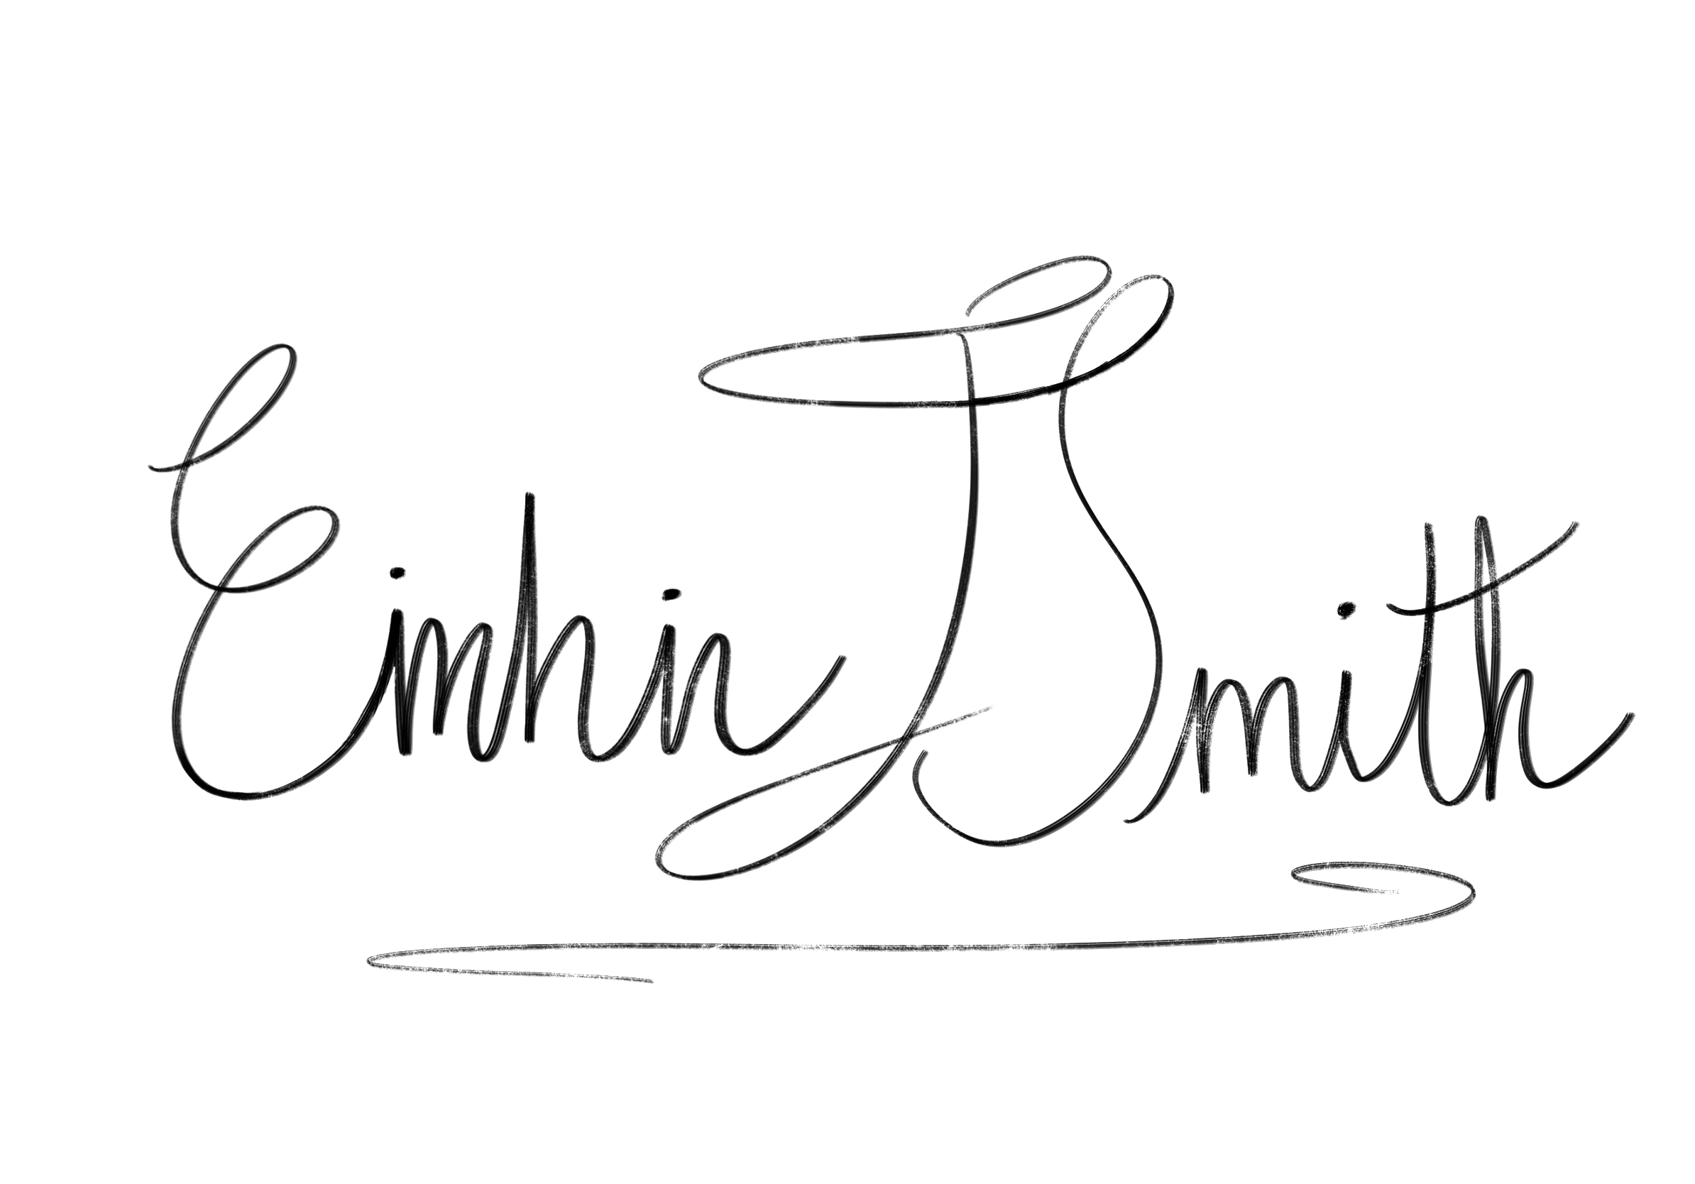
This dissertation is submitted by the undersigned to the Institute of Art Design & Technology, Dun Laoghaire in partial fulfilment of the examination for the BA (Honours) (programme name). It is entirely the author’s own work except where noted and has not been submitted for an award from this or any other educational institution.

_____________________

Éimhin J. Smith
Acknowledgements

I’d like to thank my supervisor, Dr. Austin McQuinn, for his fantastic feedback and guidance throughout this writing process. I’d like to thank my wonderful family for the constant encouragement they’ve given throughout this bachelor’s degree and helpful ideas they’ve shared whilst working on this project. I’d also like to thank my fantastic classmates for the many joyful and innovative conversations we’ve shared during this process.
Abstract

The villain in animated media is a character that holds more importance than given credit for. By pursuing their goals, a villain defines the narrative for the rest of the cast, acting as the primary reason behind the story. This thesis focuses on the villain character and the many traits the title of ‘villain' brings with it. In being the antagonist of the story, a villain is often painted in a negative light. The villain label is often simplified to pure evil, a character that commits heinous acts just because they can. This thesis defines what it means to be a villain of pure evil and what it means to be a misunderstood villain by exploring the origins of these villains. These backstories allow a true deduction of character and assist in the retrospective analysis of the villain. This thesis examines the villain’s entire story, looking at the backstory and many paths the villain’s character can go down. By studying story arcs, this thesis explores the bond a hero and villain holds and how the writer can develop their characters and manipulate the outcomes of their stories. Within this study, the methodology of character development is investigated through real world emotions and how the inclusion of these emotions can create a more relatable character. This thesis discusses, with reference to psychological theory, how villains are designed to avert expectations.

Table of Contents
Introduction 1
Chapter One: The Definition of Evil 3
Chapter Two – Character Arcs: Redemption & Corruption 10
Chapter Three – Manipulation & Betrayal: The Twist Villain trope 16
Conclusion 24
Bibliography 26

Word Count: 8436

List of Figures

Figure 1: Greg completing tasks: ‘Over The Garden Wall’ 4
Figure 2: Reveal of The Beast's true form: 'Over The Garden Wall' 5
Figure 3: The Lich: 'Adventure Time'' 6
Figure 4: The Ice King: 'Adventure Time' 8
Figure 5: Simon Petrikov: 'Adventure Time'' 8
Figure 6: Catra(right) and Adora(left): 'She-Ra and the Princesses of Power' 12
Figure 7: Eren Yeager, Final form: Attack On Titan (Manga) 14
Figure 8: Eren Yeager appearance Season 1 (left), and Season 4 (right): Attack On Titan (2013 – 2023) 15
Figure 9: Lots-o’-Huggin’ Bear (Lotso): ‘Toy Story 3’ 17
Figure 10:Wheatley at the beginning of the game: ‘Portal 2’ 20
Figure 11:Wheatley in charge of the facility: ‘Portal 2’ 21

Introduction

This thesis will explore and define the character of the villain in animation, and the many types of character the title of ‘villain’ holds under its wing. A good villain is a wild card, an unpredictable character that holds immense power over the narrative of the story. This thesis will discuss the multiple paths a villain’s story can take and how the villain shapes the narrative with their actions. In storytelling, the villain is as vital to the narrative as the hero. The villain creates a balance in the story as there could not be one without the other. Throughout this thesis, I intend to shift the spotlight away from the heroes of the animated story and focus on the villains.
The aim of this study is to delve into how a character’s story is created, to show how a character is not always as simplistic as they seem, to identify the choices a character makes and to argue how those choices influence their development throughout the narrative. These aspects of character development will be discussed in relation to emotions felt and experienced in the real world. Taking an example of each narrative archetype, I will discuss how these archetypes affect the story as a whole.
In Chapter One, I will discuss the true definition of a villain and what the title implies. I examine what traits are associated with villains, and what exactly a character must achieve in order to be labeled as a villain. In an analysis of a selection of characters who, for example, are considered ‘pure evil’ in their respective series and films, I identify where this trait defines them as a type of villain. Central to the discussion are the differences between a villain that is considered to be ‘pure evil’ and a character who is misunderstood, who acts in a certain way due to unfortunate encounters in their past. In addition, the chapter analyses the importance of a character backstory in animated storytelling and argues how the inclusion of context behind a character’s behavior has the potential to alter the initial viewpoint taken by the audience.
Chapter Two will focus on the character progression of the animated villain through a study of the narrative archetypes referred to as the ‘redemption arc’ and its counterpart the ‘corruption arc.’ These concepts will be investigated using two animated characters who undergo these developmental arcs throughout their series: Catra and Eren. This study will examine the choices made by these characters, how those choices influenced their development and how their actions affected others around them. The chapter will further discuss the inclusion of real-world emotions and experiences in animated storytelling, how they contribute to the authenticity of character development and how their inclusion creates a character more relatable to the audience.
The third chapter will discuss the deeper psychological interpretations that could be drawn from certain villain traits, the third chapter will investigate the concept of the ‘twist villain’ trope. I will explore the intricacies of this trope to gain a clearer understanding of the effects the twist has on the narrative of a story and the response it warrants from the audience. This will be achieved by mentioning memorable examples of this trope and their intentions and methodology behind the twist.

Chapter One: The Definition of Evil

This chapter investigates villains from a collection of American western animated series to gain a better understanding of the villain, their perspectives and reasoning behind their actions. The aim of this chapter is to define the character traits necessary to be considered ‘pure evil’ using specific examples and delving into the backstories of these villains; to study long-lasting mental health effects caused by previous experiences and how these mental health effects can act as an enabler for the villain’s future endeavours. This study will further examine the behavioural quirks of villains and what aspects of their past caused these quirks to manifest.
Over The Garden Wall is an American animated short series following two lost children as they wander through the mysterious territory called the Unknown trying to find their way back home. In ‘Over The Garden Wall’, there is a constant looming and ominous presence, which the viewer and the protagonists have been warned about. This presence is none other than the villain of the story, also known as The Beast. Throughout the entirety of the series, we are warned about this creature of the woods through a song sung by a side character. In this song, the character describes how The Beast lurks in the forest, searching for victims in the hope of never letting them return. This song is structured similarly to an old folk tale about a mythical creature and acts as The Beast’s stereotypical villain theme song. In a folk tale fashion, the song describes what The Beast will do to you if he catches you: “He’ll turn you to a tree of oil and use you in his lantern for to burn”. With this explanation we are informed exactly how The Beast kills and terrorises everyone, along with his motives for doing so. However, it is not until later in the series we find out whether or not his reasons for doing so are justified.
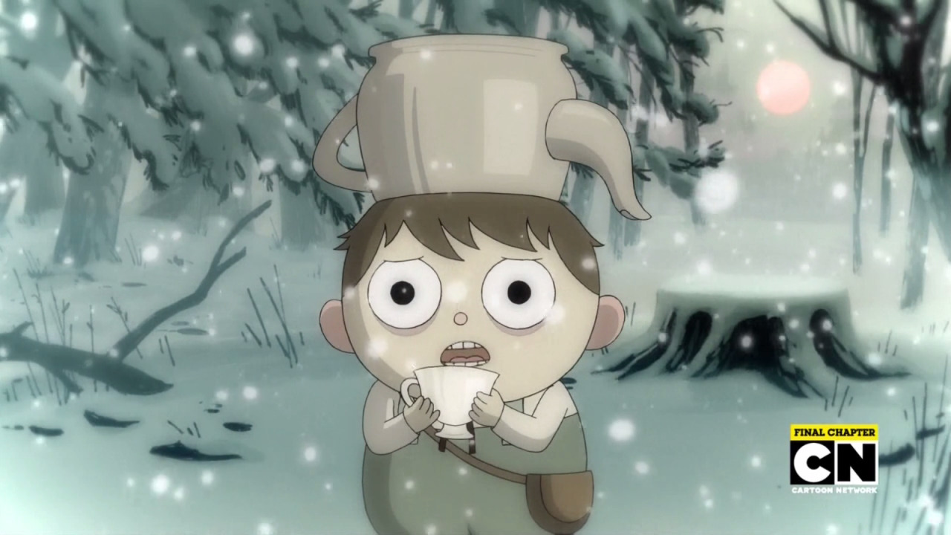
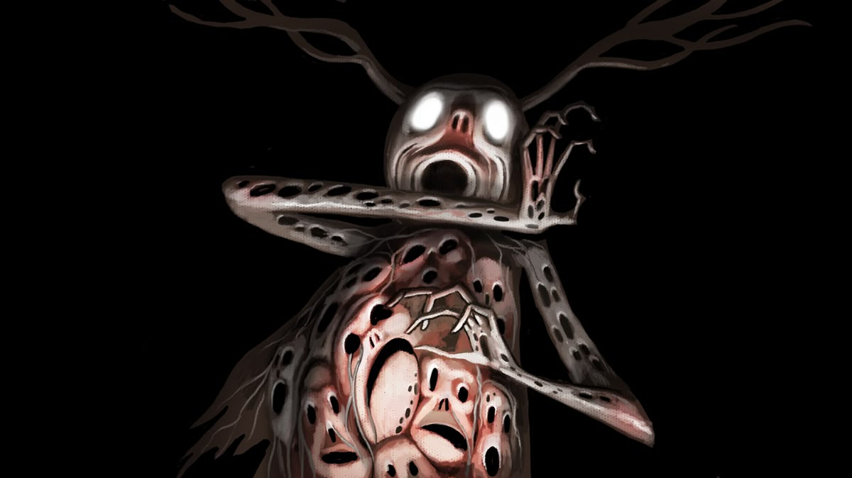
In the last episode of the series, the protagonists meet this villain face to face and all our questions are answered. We learn that The Beast’s motive for killing is purely to keep himself alive, and that the lantern into which he puts the soul he has caught, is in fact, his own soul. These other souls are therefore sacrificed and destroyed when he captures them. We discover that The Beast’s evil nature originates within his survival instinct. We witness The Beast do just about anything he can in order to stay alive; he will kill, enslave and manipulate without discrimination. We also know that The Beast not only performs these acts with pure survival instinct but that that The Beast enjoys doing this. Similar to most predatory natures, we see The Beast playing with his victims, enjoying their suffering before inevitably forcing their end. In the final episode of the series, we see The Beast give the main character Greg meaningless tasks to do, such as finding ‘a golden comb’ and ‘a spool of silk’. Along with this, The Beast gives Greg a riddle to figure out. The Beast is asking this of Greg in order to tire him out. In this scene, there is a snowstorm which, along with these mindless tasks, inevitably weaken Greg so that The Beast can have his way with him, as shown in Figure 1.
Throughout the series, we can hear The Beast singing an ominous tune in a joyful, opera-like fashion. He sings out instructions for his victims; “Chop the wood to light the fire”, referring to the lost souls harvested from trees, used to keep the lantern (which we now know is his soul) alight. This song could be compared to that of a mindless whistle, something you do whilst preoccupied. This type of tune informs the listener that not only is he doing something he considers to be mundane; he is enjoying doing it. The Beast should not be viewed from a simple black and white perspective. For example, compare The Beast with a lion in the wild. They hunt prey animals weaker than themselves, and they are both known to play with their prey before consuming them. But what makes The Beast stand out from the lion or a wild creature is how similar to a human he is. He is capable of speech and understands human cognition enough to be able to manipulate his victims, unlike the lion, who has been captured, harvested and displayed for entertainment in a zoo or circus. Emphasizing that The Beast is something that humanity cannot control, posing him as a genuine threat to the human race and as such, is automatically deemed to be the villain.
Figure 1: Greg completing tasks: ‘Over The Garden Wall’
Figure 2: Reveal of The Beast's true form: 'Over The Garden Wall'
The Beast remains fearsome throughout the series for these reasons. he remains feared or fearsome throughout - until the end where his story changes. The main character, Wirt, figures out The Beast’s weakness and uses it to revoke the power The Beast held and eventually conquers him, vanquishing him from the world indefinitely. Even though we still don’t fully understand what The Beast was or why he is there, the only possible answer provided by the show’s creator, Patrick McHale, is that The Beast, along with the many other mysteries of the series, are a part of the Unknown and are, in fact, unknown. What can certainly be concluded is that The Beast plays the role of the villain perfectly and acts as a figure to be feared throughout the entire series.
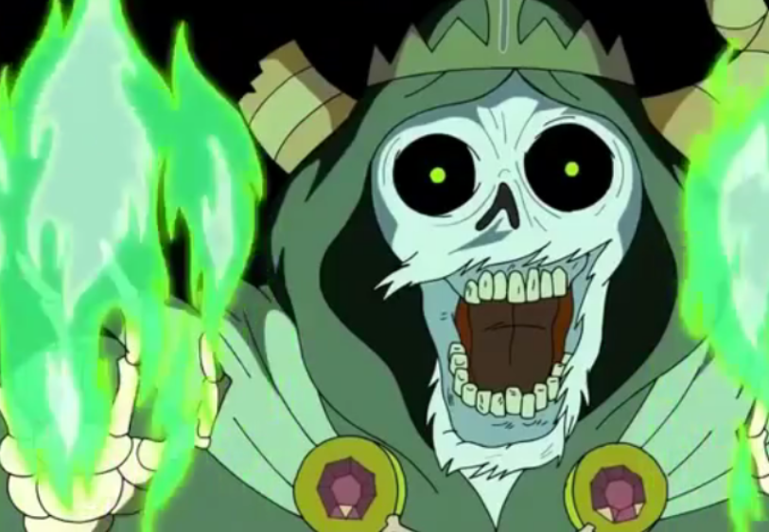
In the show Adventure Time, there are many characters who perform evil deeds. Among these characters, The Lich and The Ice King stand out the most in regards to this discussion on animated villains. The Lich is a perfect example of an evil being with no empathy whatsoever. In contrast, The Ice King is a perfect example of how a villain can be misunderstood when context of their history is unknown to in-universe characters along with the viewer. In regards to all things evil, The Lich is referred to as an ancient cosmic being who is the manifestation of the inevitable death of all things. He is an entity whose sole purpose is to incite death amongst the masses. In order to clarify further what defines The Lich, we need to mention another character in the series, Death. Adjacent to most definitions of the concept of death, he is exactly that. The character Death is a physical embodiment of the concept who rules the underworld. And you may ask yourself, there can’t be two manifestations of death can there? And you’d be correct in thinking so, as Death is the embodiment of the end of life. The Lich, however, is the embodiment of death’s inevitability, the unconscious dread that everyone has. In the Adventure Time universe, it is known that even Death fears The Lich, as fear of the inevitable does not simply end.
Figure 3: The Lich: 'Adventure Time''
In regards to morality and justification of The Lich, there is very little. It is exactly this which makes The Lich so horrific. The Lich has a goal, to kill all living beings in the universe. In many instances throughout the series, we witness exactly what lengths he will go fulfil his desire of mass destruction. In the final episodes of the Second season, we witness The Lich possess multiple beings in order to exact destruction. He is required to do this as his true form is purely spiritual. Within these episodes, The Lich escapes from the prison of amber he was being held in by possessing a simple snail. The heroes manage to destroy the old corpse of a war victim that The Lich was inhabiting whilst encased in the prison. As a response, The Lich possesses the princess; the main character (Finn)’s love interest. At the end of the episode, the heroes team up with The Ice King and manage to free the princess from The Lich’s possession. He persists however and continues to live in the snail in order to return later. Within this example, we see evidence of The Lich’s villainy; a determination for destruction, enacting emotional turmoil through hostage taking and a lack of any empathy or care for any consequences of his actions.
Up until now I have sought to understand what it means to be ‘pure evil’ through these animated villains, however within this trope there are further dimensions to be explored, like the morally grey, misunderstood madness of the villain. The Ice King is a character who was forced to become a villain out of unfortunate circumstances throughout his life. In the early seasons of Adventure Time, we observe a simple, two-dimensional villain whose only goal is to kidnap the princesses of Ooo (the world of Adventure Time) in order to get married. He is comically over the top and is often easily defeated by the protagonists. This is the audience’s initial impression of The Ice King. Throughout the early episodes of the series, we don’t pay much attention to The Ice King, nor are we encouraged to do so. The episodes and story of the early seasons are structured so that a simple villain who is yet-again foiled is all that we see.
The big reveal is that of The Ice King’s backstory, of who he truly is and why he is the villain of the piece. We learn that The Ice King lived as a man by the name of Simon Petrikov before he became The Ice King of the present. Simon Petrikov was a kind, curious and caring old man as well as a former Archaeology professor and an antiquarian. After stumbling upon a strange, jewelled crown, he became cursed by it. He formed an unspoken bond with the crown, causing him to want to wear it more often. The crown allowed him to harness its power and provided him with ice magic. Every time he used the crown however, the curse would sink its teeth in further, slowly corrupting his mind and stripping him of his personality. The curse had physical side effects alongside this, causing his skin to turn a cold blue and his facial hair to grow to obscene lengths. After the curse had fully overcome him, he became the character of The Ice King. It is clear that Petrikov’s story is one of tragedy and
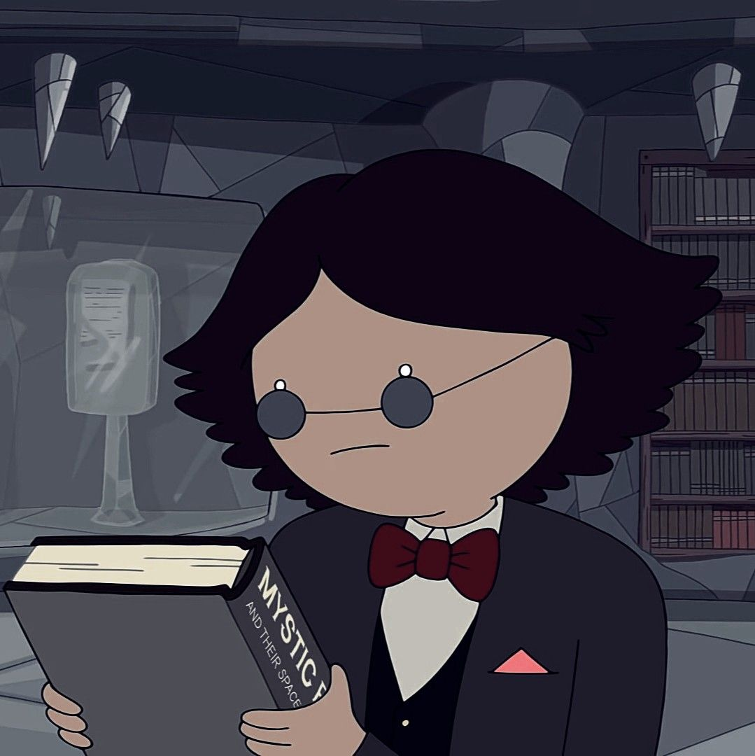
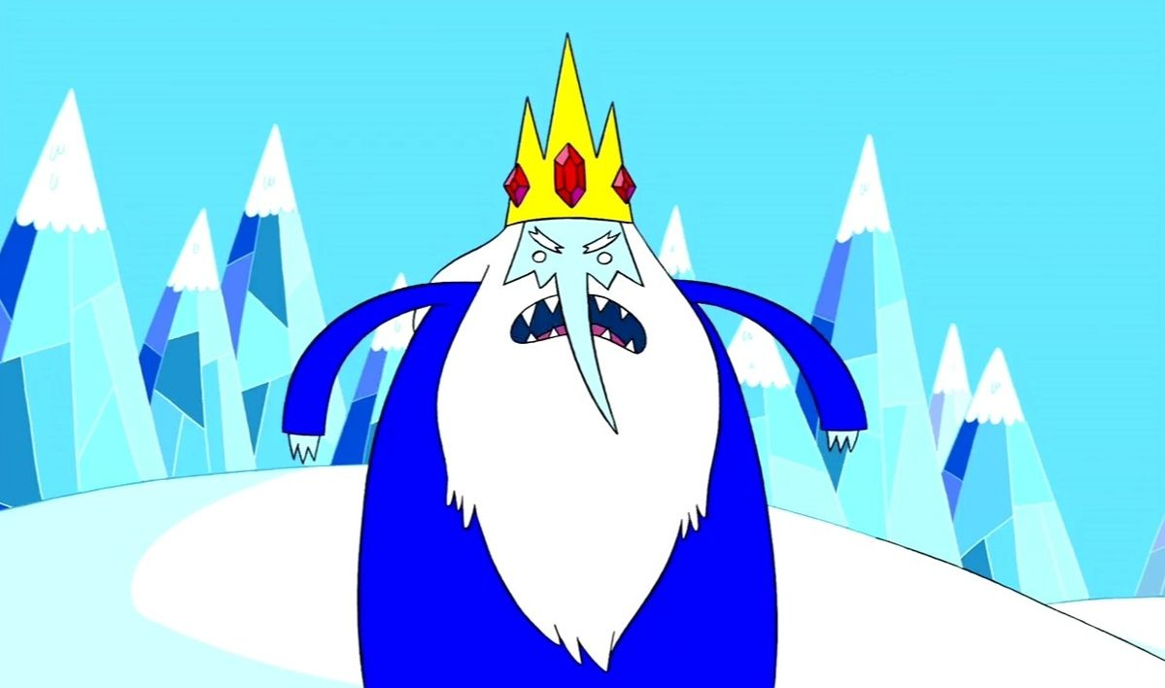
worthy of studying from a psychoanalytical perspective.
Figure 4: Simon Petrikov: 'Adventure Time''
Figure 5: The Ice King: 'Adventure Time'
Primarily, the biggest contributor to Simon’s mental state is the memory loss he suffers from as a result of the crown’s influence. It can be surmised this memory loss is a type of amnesia, inflicted by a consistent magical brain injury over a long period of time. As a result of his amnesia, we observe him forgetting key information regarding his personal life; his wife, his adopted daughter Marceline who he took care of after a war and his academic passions in life. We witness a large-scale form of personality loss throughout the series and as such this causes immense distress and turmoil for Simon as we see him try to regain his memory in the later seasons of the show. Most significantly, we witness Simon suffer from a form of addiction with the crown. In the early stages of his corruption, he is aware of how dangerous the crown is and yet he wears it regardless in the pursuit of magical power. On various occasions, Simon can be seen smiling when wearing the crown, indicating a derivative of pleasure from the power provided. To juxtapose this however, removal of the crown afterwards is met with internal regret, shame and sadness from the knowledge of having done something he is not supposed to. “Addiction is a persistent, compulsive dependence on a behaviour or substance despite awareness of the associated harms to self and others” This is a prime example of addiction derived from greed and a need to become stronger. We can see a certain behavioural quirk left behind in The Ice King from Simon after the corruption from the crown, The Ice King’s obsession with princesses. This obsession is of course a manifestation of Simon’s longing to see his wife Betty again, his lost princess.
Although Simon’s curiosity for ancient artifacts is not a crime, the acts committed in his persona as The Ice King are certainly something to be held accountable. The Ice King is a kidnapper, plain and simple. Seen continuously capturing and threatening the victims if they attempt to leave. He would not be classified as pure evil, however. He shows too much empathy and not enough vigour, being quite literally defeated by his own heart in Episode 7 of Season One. Although this negates his position as ‘pure evil’, it does not retract from his past evils. What we must understand about the nature of these crimes, is that they were of The Ice King’s doing and Simon Petrikov and no involvement with them. As such, should the audience therefore feel sorry for The Ice King, when remembering his backstory and Simon’s unfortunate surrender to the crown?
Following this exploration of the backstories and possible reasons for these characters evil nature, questions remain as to whether villains’ actions can be justified once their own psychodramas become known. In the next chapter, these questions of the psychology of animated villains are further explored with an examination of character development, character arcs and the consequences of trauma inflicted on a character.

Chapter Two – Character Arcs: Redemption & Corruption

This chapter will explore a selection of character development arcs prevalent in modern American animation and anime, examine how characters feel throughout their series and how those feelings are portrayed on-screen. This study will discuss how the inclusion of real-world emotions and experiences aid in achieving greater character relatability for the viewer and help to cause a greater emotional impact by doing so. This chapter will also delve into the ‘redemption arc’ concept; a commonly used term by fan communities to describe a certain type of character narrative used to empathise and forgive a morally frowned upon character. The discussion of this concept will aim to review both realms of possibility that this concept holds and how each possibility contributes to the finale of a character’s development. This chapter will take specific examples of characters of whom fit into the proposed topic and examine the actions and decisions those characters make; their justifications and whether the actions questioned align with the moral standpoint of the other series characters.
She-Ra and the Princesses of Power is an American animated TV series created as a reboot from the original series by the same name released in 1985. The show follows a simple plot wherein the main character She-Ra teams up with other princesses with elemental powers in order to defeat forces of evil. The first half of this character study will look at the main villain of this series and the foil to the main protagonist, Catra.
Catra is a child of misfortune. She was born into a kingdom where ruin was the norm and corruption reigned. The protagonist Adora was also born in this kingdom and together they formed a strong friendship and learned to fight for their kingdom of birth. They were both raised by Shadow Weaver, an unforgiving guardian who played favourites. Catra, however, was not the favourite and was constantly chastised and taunted in front of Adora. When Adora left to fight for the opposing party, Catra was rightfully upset. She felt left behind and betrayed by someone she thought was her best friend. As a result, we see Catra rise up the ranks and devote her life to inconveniencing Adora and ruining her efforts to succeed. From this backstory, we can derive clear examples of emotions originating from trauma inflicted by those around her. These emotions assist in the depth of her character and serve as a building block for future character development throughout the series. By seeing on-screen characters feeling and experiencing emotions that the audience can feel, a bond is formed between viewer and character which, depending on what the character is going through, allows the viewer to relate and connect with the character. This is how writers’ birth influential and thought-provoking characters for their narratives. In the words of Dara Marks, “By creating a backstory that gives a history to the fatal flaw, a writer is able to connect with the character’s humanity. When writers make this connection for themselves, they are likewise making it for the audience”.
Displays of human emotion, either subtle or raw, are a form of non-verbal, everyday human communication (e.g. facial expressions, tones and voice infliction, body language). These are a natural part of the human experience and assist in conveying emotion. This rings especially true for animation, as the mimicry of real life must do its best to appear convincing. We as humans, see these forms of communication and emotion and recognize them as human. The issue arises when such efforts are made with a series’ characters where dire consequences originating from pre-established trauma have been witnessed throughout the series and the audience has grown to understand the characters. The usual aim is for all to result in a simple forgive and forget conclusion to assure happiness for everyone. This is the core of the ‘Redemption Arc’ concept.
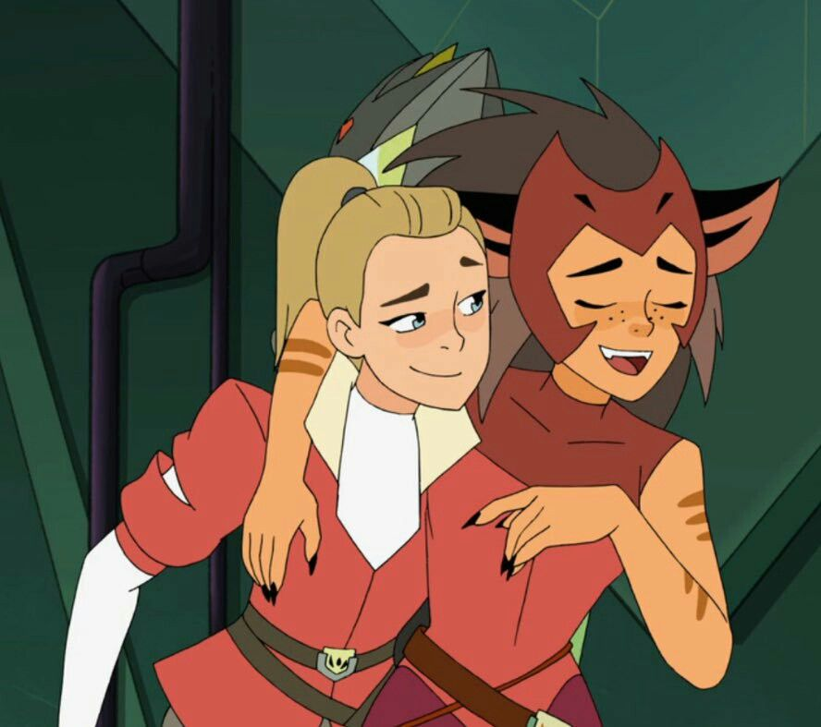
In the finale of the series, despite the trauma she has endured, Catra is redeemed. She confesses her romantic feelings for Adora, and she is forgiven of her past mistakes. This ending leaves the general audience satisfied and contempt. Although a situation like this may seem one-dimensional in theory regarding emotional depth, this is where character development sprinkled throughout the series starts to shine. A love confession from Catra to Adora is not something that appeared out of the blue, there were many occasions where we see Catra flirting with Adora, teasing her in a bratty manner. These instances of course being hints toward a romance. In regard to Catra’s villainous deeds, the main driver behind them is jealousy and anger. Catra feels robbed of the experiences Adora has throughout the series since they used to be on the same side. These feelings of anger and jealousy stem from an emotional scar left in Catra, running so deep that they alter her as a person. Emotional scars formed from tragic backstories are the true driver behind all villains. These tragedies spark empathy from the audience. The more they understand the villain as a person, the stronger the emotional connection will be. This connection is vital for the redemption arc, as this connection acts as the justification for redemption. The more hardships a character goes through, the more the audience will wish for them to succeed. This rings true for both hero and villain, but we expect this from the hero not the villain. This is what makes a redemption arc so satisfying for the audience. To be able to watch a character of whom they’ve grown close to finally receive the kindness and loved they’ve pleaded for is an irresistible fantasy that an audience cannot ignore. It is within the moment of redemption where any logical sense of justice for previous crimes is disregarded, and the only justification stems from the audience’s emotional judgement.
Figure 6: Catra(right) and Adora(left): 'She-Ra and the Princesses of Power'
In this instance, Catra’s redemption arc is satisfying for the audience as it gives them what they’re truly looking for when it comes to her character. Although there is a reason redemption arcs are more common in fiction and animation in comparison to live-action films and TV. This can be summarised by the levels of maturity that both media types have. While animation seeks to mimic reality at a fundamental level, it doesn’t intent to replicate it. The redemption arc concept in not seen within live-action media as simple forgiveness is not enough when it comes to the actions of villains. The realistic environment set in within live action holds a maturity too high to justify a character narrative such as a redemption arc. It is for this reason however that experiencing a redemption arc in fiction is sweeter. The audience is watching a fictional animation as they seek to escape from reality. The possibility of forgiveness so simple is all-the-more blissful when remorse is guaranteed to be absent. Anything is possible in fiction, when an emotion as strong as love is on the table there’s no reason to prevent satisfaction under the justification of realism.
We know that through fiction, a villain can become a hero. However, what happens when a hero becomes a villain? A character initially thought to be an honour bound hero, driven towards their goal that slowly begins to forsake those morals and turns toward the role of a villain. This type of character narrative doesn’t go by a specific name, other than the simple ‘hero to villain arc’. This narrative archetype lends itself to the characteristically complex and varies depending on which situation in which this archetype is used. This arc delves into the darker parts of the human consciousness, preying on strong intrusive thoughts capable of warping the character’s sense of morality and justice. This archetype generally follows the character through a tragic event or shocking discovery, like that of a villain’s origin story. This often takes the form of an event emotionally intense enough to drive the character to commit acts that would endanger the greater population without remorse.
An example of this can be seen in the Japanese animated series Attack On Titan. It follows a young boy, Eren Yeager and his two friends who live in a village within man-made walls in order to protect from giant, man eating humanoid creatures known as titans. After the wall protecting the village is breached and titans begin to invade, killing millions of citizens, Eren loses his mother to a titan. This sculpts Eren’s hatred of titans at the start of the series and helps define his determination as his main characteristic. He is eager to see an end to all titans out of vengeance for his mother. Since the titans are the primary enemy at this point of the series, this determination to see their end deems him a heroic protagonist as he gives his all, in order to see them perish. However, throughout the series we learn that the titans were manufactured by a provenance just outside of the walled villages and this provenance trapped the citizens in the walls due to their bloodline, which held a link to the titans. Eren learns that he holds a special power that only he can use. After discovering this, he uses this power to bring death and destruction to all outside of the walls. To enact revenge on them for torturing his bloodline. This results in the death of 80% of the world’s population due to the immense power he inherited from his ancestors.
Eren is a character who prioritises the safety of the ones he cares for over anything else. He holds pure intentions and means only to do what is right. However, he is naïve, reckless and, above all, selfish. We as the audience assume him to be the hero at the beginning of the series as we see him as merely a victim. Eren’s main drive is his need for revenge. Everything he does is built on him achieving his personal justice. At the beginning of the series, this attribute takes a backseat as we witness him showing concern for his friends and fellow soldiers. However, when he slowly learns more about his father’s research, his bloodline along with the provenance outside the walls his vengeance starts to rise. He develops a narrow-minded view on the world and believes that the only way to make outsiders pay for torturing his bloodline would be extinction of all except those he cares for.
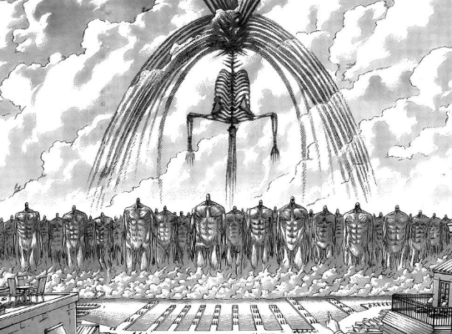
The key focus of Eren’s character arc is this slow loss of compassion and the birth of a craving for blood. Looking at Eren’s character through the morally grey perspective, he is a prime example of a corrupt moral view. In his mind, he followed his heart and did what he believed to be the right thing. For him, he was the hero. Although, the loss of compassion for anyone but himself caused the heroic view others had of him to shatter as he started to take life after life for his goal.
In the final few episodes, we see evidence that the Eren we knew at the start of the series is truly gone. We see all his friends try to stop him as he rages toward the outside provenance with an army of titans. This confirms that Eren is a pure villain and a monster (in a literal sense); any heroic traits are now gone (See Fig 7).
Figure 7: Eren Yeager, Final form: Attack On Titan (Manga)

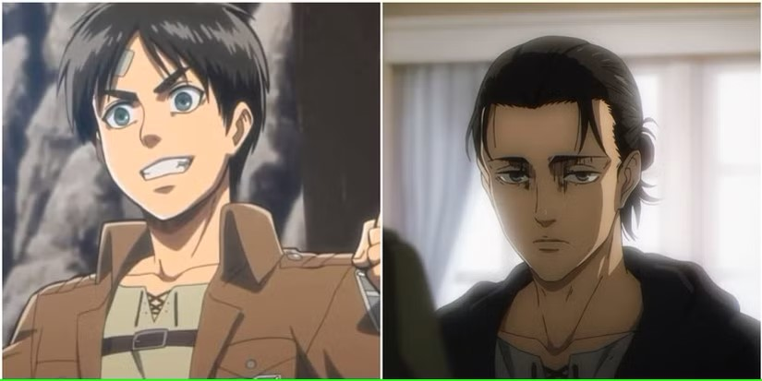
Throughout the series, we witness the slow dehumanization of Eren (See Fig 8). Every experience he’s gone through has piled up and broken down his sense of self. He learned the truth and lost faith in humanity because of it. As a result, he confided in retribution as punishment for those who wronged him, his friends and his bloodline. Eren became a villain because he became an enemy to humanity. Within Catra and Eren, the many possibilities of villainhood emerge. Simple arguments spiral into vengeful grudges, the desire to protect goes farther than anticipated and the moral alignment of the character changes along with the character themselves. With Catra, the many years she spent maturing her destructive nature and being an active hinderance on Adora outweigh the all-too neat redemption her character is simply ended with. In Eren's case, his slow decent into a more sinister true nature and a genuine threat to society is mesmerizing in its complex, dark and unrelenting commitment to vengeance. His commitment to vengeance resulted in a loss of his heroic public image. These variations of character arcs show how unpredictable and unassuming a villain's story can be. Villainy can sprout from anywhere, no matter the character.
Figure 8: Eren Yeager appearance Season 1 (left), and Season 4 (right): Attack On Titan (2013 – 2023)

Chapter Three – Manipulation & Betrayal: The Twist Villain trope

The Twist Villain trope is a relatively new concept within the history of filmmaking and surfaced within the 2000s. The trope was spearheaded by Disney Pixar and made appearances a handful of other films & series (such as Scooby Doo). Disney clung onto and expanded this trope as it allowed them to add an unanticipated shock factor and develop an unspoken depth to their characters. Along with a discussion of some prime examples of the twist villain trope and an examination of the attributes that contribute to the characters greatness and memorability, this chapter will further examine the narrative writing tools used in order to build a great twist villain, the nature of the twist itself and its position within overarching story plots. The twist villain trope is primarily based around the moment of the reveal, generally at the climax of the story, and requires more elaboration in this chapter on the reasoning behind this structure.
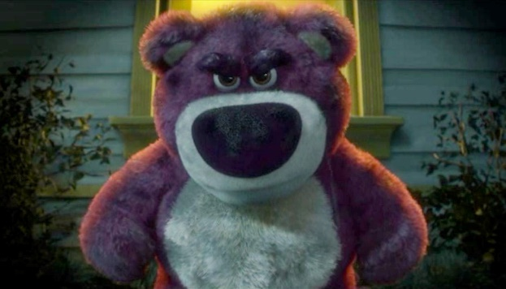
Toy Story 3, the third instalment in Disney Pixar’s popular animated film series Toy Story, was released in 2010 and was well generally received. The plot follows the usual cast of the series as they accidentally find their way to Sunnyside day-care, where the movie takes place. The main villain of the movie is Lotso (Lots-o’-Huggin’ Bear) who is initially presented to the audience as a kind, caring leader for the population of toys in the day-care. As the film unfolds, we receive hints of some malicious intent in Sunnyside. Soon we discover that Lotso rules over the day-care with an iron fist, imprisoning the residents of the day-care rather than caring for them. What makes Lotso an intriguing twist villain, therefore, is the nature of his reveal.
The twist villain trope is broadly understood as an unsuspecting character revealed to be the antagonist during the climax of the story. When discussing tropes in storytelling, Jennifer Hilt states that, ‘You can reveal the antagonists’ identity in whatever way works for your story. It’s great to surprise the reader with their identity as long as you play by the genre rules, leaving some breadcrumbs along the way’. Lotso’s villain-reveal adheres to the genre tropes discussed by Hilt slowly unveiling the truth to his character as the plot progresses. We discover more about Lotso’s misdeeds, and we learn more about the day-care itself when we encounter some escapees at a little girl named Bonnie’s house, who tell Woody all about what truly goes on inside Sunnyside. By having the audience learn about the day care in this way, it creates a natural, word-of-mouth experience that mirrors real life gossip. Where this format of reveal shines however is the sense of uncertainty in comes with. Similar to gossip, information discovered from word-of-mouth is naturally taken with a grain of salt and requires visual evidence from the source to truly solidify what has been heard. The audience is given this evidence when we follow Woody back to the day care in order to reunite with his friends. Upon returning, the essence of the day care has completely changed. We start to see the effects of Lotso’s tyrannical rule over the day care through physical and verbal abuse of the residents, justifying the rumours we heard at Bonnie’s house.
Figure 9: Lots-o’-Huggin’ Bear (Lotso): ‘Toy Story 3’
We now know that Lotso has made the day-care into a prison, trapping those who are unfortunate enough to end up there. But what were Lotso’s intentions when doing so? The answer lies within Lotso’s backstory, of which we learn about from Chuckles, the clown at Bonnie’s. Lotso was originally a kind, caring soul who loved playing with his owner Daisy. After being accidentally abandoned and replaced, Lotso felt betrayed and turned to a spiteful life, doing anything he could to keep other toys trapped at Sunnyside out of the fear that he may be abandoned again.
Lotso’s fear of abandonment is so strong that he would go so far as to imprison others so that they won’t leave. However, if the characters he is looking to contain knew this was his true intention and that he was, in fact, not the kind, cuddly and caring bear they assumed, its likely they do not go anywhere near him, let alone into the day-care. Burgoon’s Nonverbal expectancy violations theory provides a fresh perspective on the core values from which the twist villain trope is constructed; “Based on one’s own habitual behaviour and that of others within a society, one comes not only to anticipate that others will behave in a particular fashion but also to assign evaluations, or valences, to these actions”. According to this theory, we understand the basis behind the labels we place onto one another in society, and that they are based primarily on a combination of impressions made upon others along with those we hear from others. Due to his outward presentation of himself and of the day-care, Lotso is able to weave the narrative that he and the residents of the day-care live in peace and harmony, an illusion of paradise. It is this impression that he maintains which keeps the weaker, less curious toys from querying him and allows the deceptive hierarchy to stay in place. Lotso convinces these other toys that the longer they stay, and the longer they endure the vicious methods of play from the younger kids of the day-care, they will be promoted and allowed to play with the kinder, more gentle kids in the other room. This of course, never happens. If it did, then Lotso and his crew would not be able to have nicer playtime all to themselves.
Manipulative behaviour is a very common attribute within the twist villain trope. It could in fact be considered an essential baseline because of the trope’s very nature. Betrayal and manipulation usually go hand in hand with varying quantities. In the context of the twist villain trope, manipulation comes before betrayal within the traditional on-screen formula. The twist villain can conceal themselves behind presumptions made by their surrounding cast and also therefore, the audience. We have no justified reason to believe them to be a villain as they have not openly or visibly committed crimes worthy of the villain title. As such, they blend into the background until their moment in the spotlight comes in the form of their betrayal. The twist villain trope in Young Adult animation is always carried by that of a secondary/supporting role in the film’s cast rather than a primary role, such as the protagonist. The reasoning for this, I suggest, aligns with the ‘Nonverbal expectancy violations’ theory and the blind acceptance of character judgement from outward impressions.
The limited knowledge the audience is given regarding a villain character and their unfiltered personality, allows the eventual twist of betrayal to be as emotionally impactful as possible. If the audience had spent more time on-screen with the alleged twist villain, we would come to know the true contents of their character, how they respond to certain situations and how they think of and treat those around them. With access to this knowledge long before they’re supposed to, the audience would be able to piece together a clearer judgement of this character and, as such, their moral and emotional view of the character would change. By unveiling the villain before the twist, removing the narrative impact of the twist villain trope, the dynamic works best within circumstances of unpredictability. As such, characters that the audience would never expect to be villainous are the prime candidate for such a trope. A character that has a strong connection to the protagonist from the beginning of the narrative, is actively involved in the progression of the story and acts as a reliable ally for any problem the protagonist may face.
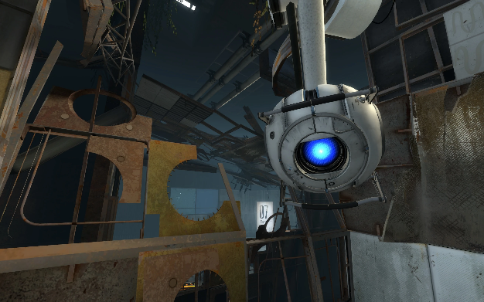
These sorts of twist villain characters are present in most forms of new and recent media. A standout medium for twist villains would be their appearances in video games. The video game villain is capable of causing an impact equivalent to that of the on-screen villains. Due to the intractability of the video game format, narrative experiences can feel a lot more personal in comparison to on-screen ones, especially video games that are played in the first-person, as seen in the game Portal 2. Portal 2 is 3D puzzle game created by Valve in 2011. The game takes place in a dystopian, futuristic laboratory by the name of Aperture Science. The video game’s narrative takes the player on an intriguing adventure as the game’s narrative holds themes of trust, betrayal, acceptance and accountability. What truly makes the game’s narrative interesting is how the characters learning and driving these themes are robots with an advanced Artificial Intelligence, with capabilities that match that of a human conscious. One of such characters is Wheatley, an Artificial Intelligence core created in order to dampen the intelligence of the series’ antagonist GLaDOS, the A.I in charge of the entire facility. The player is first introduced to Wheatley at the beginning of the game and sticks with him the entire adventure up until a specific half-way point in the story. This half-way point is critical for the story and is the primary focus of this discussion.
Wheatley and the protagonist, named Chell, team up with the intent of taking down GLaDOS, in order to free Chell from the facility she has been trapped as an experiment for many years. They aim to do this by having Wheatley replace GLaDOS as the prime administrator of the facilities systems and they succeed in doing this. However, during the process something changes within Wheatley. He is overcome with how good being in control feels, so much so that he loses sight of the original plan he made with Chell, sending her back to perform tests for the facility instead of setting her free like he promised. Ultimately betraying her and assuming the role of the antagonist for the remainder of the story. As a form of revenge and act of spite, Wheatley places GLaDOS’s conscious into a potato battery, where she accompanies Chell through the tests she formerly put her through.
Figure 10: Wheatley at the beginning of the game: ‘Portal 2’
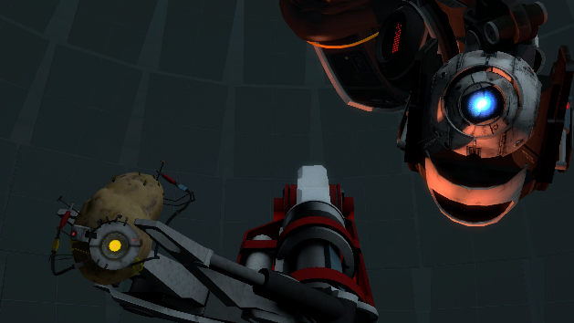
This story progression is impressive from a narrative point of view as it takes everything previous established with the player and flips it upside down. Completely altering the roles that each character plays. Such a drastic change aids in the effectiveness of the twist; by having multiple aspects of the story and characters change at the same time it provides a greater sense of surprise to the player and leaves a longer lasting emotional impact as a result. This dramatic betrayal instils questions in the player regarding Wheatley’s authenticity thus far; ‘Was he planning this betrayal from the beginning?’, ‘Did he use me to achieve his own selfish goal?’, ’Was the bond we formed genuine or a complete lie?’. The answer to these questions lies within the context of Wheatley’s background, which are provided with by GLaDOS during the change of power.
Figure 11:Wheatley in charge of the facility: ‘Portal 2’
It is at this point that the player is informed about Wheatley’s purpose for creation, to damped intelligence. Through this, we contextualise his prior behaviour, his comedic jokes and sassy remarks. They were not a cover for a greater plan in mind. They were, in fact, Wheatley at his purest and genuine state of mind. He is physically and mentally incapable of generating a long form and well-developed plan typically held by those within the twist villain trope. Knowing this, we ask what was the cause of Wheatley’s betrayal? Wheatley’s betrayal is entirely rooted in greed. Upon being instated as the facility administrator, he gained access to everything the facility had to offer, including unlimited control over the machines and access to the wealth of knowledge stored within its database. Being a simple machine, created with the intention of generating terrible ideas as a form of A.I poison, he became obsessed with his newfound power and knowledge, asking “Do you have any idea how good this feels?”.
Blindsided by this new power, Wheatley’s ego skyrockets as he starts to believe that he achieved this feat all by himself and completely disregarding the work of the player. He calls the player, selfish, saying they only bossed him around. He is completely overwhelmed with this power, and it slowly starts to get to him throughout the remainder of the story. He places the player back into the testing track, after discovering that completing a test gives the system and himself some temporary pleasure. At this point in the story, the Wheatley we were introduced to at the beginning is entirely gone. What remains is a corrupt personality who has developed an addiction for testing. It slowly becomes more difficult to achieve this pleasure through simple tests and he begins to get frustrated, until he starts to try and murder the player after discovering robots built to test within the facility storage.
What sets Wheatley apart from other villains within the twist villain trope is his mental capacity. His is driven to villainy through an external source, only turning to evil deeds after discovering a power he never realised he needed or wanted. His deep-rooted insecurity about his intelligence motivated him to push forward and act in the way he did, only after attaining endless power. Wheatley is a rare twist villain, since instead of being a manipulator he was the victim of manipulation until the very end. He was manipulated by the facility, being convinced that testing was his only function, and he was manipulated by GLaDOS, in the latter half of the story, having his insecurities exploited in order to outwit him. In contrast, Lotso is the exact opposite of Wheatley, using his power to successfully control those around him in order to attain his goal, to have people do his work for him so he can live the high life. These two characters are prime examples of the importance of strength of character and determination within the twist villain trope. If a character has the will to manipulate others and the guts to go through with maniacal plans, fuelled by the confidence to deceive with pride, they can succeed and have what they desire, like Lotso. However, if a character, such as Wheatley, is to have a weak will, harbouring insecurities that could be easily taken advantage of and the lack of foresight to plan ahead, they will be easily outsmarted and dealt with accordingly by the narrative’s protagonist.
The twist villain trope, while relatively new to the world of critique in academia, is actively being developed across contemporary media and continues to be used to this day. It is popular within video games, books and of course, extensively in animated films and series. Disney Pixar continues to develop the trope, using it in their latest film Wish (2023). There are still many aspects to this trope which remain unexplored. However, the twist villain’s many twists and turns can add an immense emotional impact to a stories narrative and add that needed element of surprise that every good story needs.

Conclusion

This thesis set out to explore and define what it truly means to be a villain, within the context of Western and Eastern animation dedicated to young adult audiences. The primary topic of this thesis was inspired by the concept of ‘the misunderstood villain’. A concept deeply grounded in characters with a poor reputation amongst the public and their peers. However, such characters are occasionally thrust into this position for a reason out of their control. It was this concept which inspired my research into the true definition of ‘evil’, what it means to be a villain and how one gets assigned a title of that calibre. This was the primary topic of discussion in the first chapter of this thesis. Examples of ‘pure evil’ characters were presented to assist in the definition of the concept. Two examples of 'pure evil’ were discussed adjacent to one example of a misunderstood villain, to compare the traits each character held, what actions that character took throughout the runtime of the series and how those actions reflected upon their character. Based on this research, the chapter concluded that a character is defined by the actions they choose to take as opposed to the words others use to paint them.
Proceeding into the second chapter of this thesis, the goal was to discover exactly how much actions spoke louder than words. The aim of this chapter was to study the impact of a character’s actions through the concept of a ‘redemption arc’ and its counterpart, the ‘corruption arc’. Using two primary examples of each trope, I examined the transformation their characters undertook as a result of their corresponding story plotlines, analysing their character’s personality at the beginning of their narratives and how they are changed at the end with the aim of identifying the stark juxtaposition created by these character arcs. This research was conducted with the aid of Dara Marks’ text discussing transformational arcs within storytelling, in order to define the narrative reasoning and impact behind the use of such arcs. Following my research of this concept, it was concluded that the characteristics one holds can change, grow and disfigure as a story’s narrative progresses. A character or person can never truly be defined by a single word or a brief description, due to the everchanging nature of humanity. The saying, ‘never judge a book by its cover’ could provide a simplified summary of this second chapter, whilst inspiring the idea for the concluding chapter of this thesis.
Chapter Three explored a further trope defined by the general fanbase of the discussed media. This trope is believed to be an iconic part of the villain identity, despite being a relatively new archetype of villain within animation media. The concept of ‘a twist villain’ was led primarily by Disney Pixar starting in the early 2000s and continuing up to the present day. This specific sub-section of the villain topic was inspired by the common themes of betrayal and manipulation often associated with villainous characters. This chapter set out to define and understand the ‘twist villain’ trope at a surface level and its core. This research was conducted using the psychological theory known as the ‘Nonverbal expectancy violations’ theory proposed and discussed by Judee K. Burgoon and Jerold L. Hale. In applying this complex theory of expectancy violations to the character of the twist villain in animated narratives, I suggested some key conclusions that could be drawn. Most notably, I argue that the story writer is able to create a more memorable experience for the audience by shattering their established expectations of a character, created when the audience was first introduced to them. This chapter ventured outside the traditional medium of animation and discussed the use of the ‘twist villain’ trope in video games. In doing so, it was concluded that the ‘Nonverbal expectancy violations’ theory is deeply rooted in every form of twist and acts as the primary source of impact held by the ‘twist villain’ trope.
Overall, the character of the villain in Young Adult animation has grown to hold many defining traits. These traits are used to create characters with vast amounts of depth, traits that may not be immediately recognisable to the average viewer. Similar to heroes, there are a plethora of different villains, those that follow the rules of a trope, becoming predictable to those familiar with its traits, those who break the rules and do the unexpected, acting as a trailblazer of a narrative in which they played a secondary role, those who are created to be the embodiment of all things evil, who concoct nefarious schemes and perform despicable acts for the sole purpose of personal entertainment. There are many villains that act as a prime example of a certain trait or trope, but every character known to be villainous is also known to be capable of manipulation, betrayal and capable of committing merciless acts for vengeance. The villain is known to be unpredictable; they are a wild card in any narrative and to be illusive to those who antagonise you is to be truly fearsome indeed.

Bibliography

Asbell, Corrine. ‘The Psychology of Villains: What Makes a Memorable Antagonist?’ Fictionphile, 24 Sept. 2023, https://fictionphile.com/psychology-of-villains/.Accessed 17 Oct. 2024.

Bergstrand, Kelly, and James M. Jasper. ‘Villains, Victims, and Heroes in Character Theory and Affect Control Theory’. Social Psychology Quarterly, vol. 81, no. 3, 2018, pp. 228–47.

Burgoon, Judee K., and Jerold L. Hale. ‘Nonverbal Expectancy Violations: Model Elaboration and Application to Immediacy Behaviors’. Communication Monographs, vol. 55, no. 1, Mar. 1988, pp. 58–79. DOI.org (Crossref), https://doi.org/10.1080/03637758809376158. Accessed 7 Mar. 2025.

Contributors to She-Ra and the Princesses of Power Wiki. “Catra.” Fandom Wiki, Fandom, Inc., https://she-raandtheprincessesofpower.fandom.com/wiki/Catra. Accessed 6 Mar. 2025.

Coplan, Amy. ‘Empathic Engagement with Narrative Fictions’. The Journal of Aesthetics and Art Criticism, vol. 62, no. 2, 2004, pp. 141–52.

ddrkreature. “I AM NOT A MORON – Portal 2 Gameplay HD” YouTube, 10 Jul. 2011, https://www.youtube.com/watch?v=LovYNScgReY&ab_channel=ddrkreature. Accessed 7 Mar. 2025.

Donahue, Anne T. ‘A Very Serious Psychological Analysis of Disney’s Greatest Villains’. CBC Arts, 21 June 2023. CBC.ca, https://www.cbc.ca/arts/disney-villains-psychological-analysis-1.6884320. Accessed 24 Sept. 2024.

Egri, Lajos. The Art of Dramatic Writing: Its Basis in the Creative Interpretation of Human Motives. Simon and Schuster, 1972.

Fahraeus, Anna, and Dikmen Yakalı-Çamoğlu. Villains and Villainy: Embodiments of Evil in Literature, Popular Culture and Media. BRILL, 2011. ProQuest Ebook Central, http://ebookcentral.proquest.com/lib/iadt-ebooks/detail.action?docID=3008279. Accessed 7 Mar. 2025.

Hilt, Jennifer. “Trope It Up.” The Trope Thesaurus, Jennifer Hilt, 2021, pp. 68–68, https://books.google.ie/books?id=I2dhEAAAQBAJ&source=gbs_navlinks_s. Accessed 2 Apr. 2025.

Haybron, Daniel M. “Moral Monsters and Saints.” The Monist, vol. 85, no. 2, 2002, pp. 260–84. JSTOR, http://www.jstor.org/stable/27903772. Accessed 18 Oct. 2024.

Hunde, Tigist S. H. I. F. E. R. A. W. Psychology of Addiction. www.academia.edu, https://www.academia.edu/104251365/Psychology_of_Addiction. Accessed 3 Mar. 2025.

Jantunen, Noora. Creating a Convincing Villain: Character Design for a Video Game. 2023, http://www.theseus.fi/handle/10024/816502. Accessed 24 Sept. 2024.

Keen, Richard, et al. “Rooting for the Bad Guy: Psychological Perspectives.” Studies in Popular Culture, vol. 34, no. 2, 2012, pp. 129–48. JSTOR, http://www.jstor.org/stable/23416402 . Accessed 24 Sept. 2024.

Kelly, Rory, and Samuel Cumming. ‘Structures of Morality and Allegiance in the Character Arc Story’. The British Journal of Aesthetics, vol. 62, no. 4, Oct. 2022, pp. 687–98. Silverchair, https://doi.org/10.1093/aesthj/ayab020. Accessed 7 Mar. 2025.

Kjeldgaard-Christiansen, Jens, and Sarah Helene Schmidt. ‘Disney’s Shifting Visions of Villainy from the 1990s to the 2010s: A Biocultural Analysis’. Evolutionary Studies in Imaginative Culture, vol. 3, no. 2, Dec. 2019, pp. 1–16. DOI.org (Crossref), https://doi.org/10.26613/esic.3.2.140. Accessed 7 Mar. 2025.

Long, Rebecca. ‘“She-Ra” and Catradora: If People Try to Murder You Maybe Don’t Date Them?’ Observer, 18 Feb. 2022, https://observer.com/2022/02/she-ra-and-catradora-if-people-try-to-murder-you-maybe-dont-date-them/. Accessed 7 Mar. 2025.

Luecke, Jane Marie. “Villains and Non-Villains in Hawthorne’s Fiction.” PMLA, vol. 78, no. 5, 1963, pp. 551–58. JSTOR, https://doi.org/10.2307/460732 . Accessed 24 Sept 2024.

Mackenzie, J. S. “The Meaning of Good and Evil.” International Journal of Ethics, vol. 21, no. 3, 1911, pp. 251–68. JSTOR, http://www.jstor.org/stable/2376991 . Accessed 24 Sept. 2024.

Marks, Dara. “The Fatal Flaw: Bringing Characters to Life.” Inside Story: The Power of the Transformational Arc, Bloomsbury Publishing Plc, New York, New York, 2007, pp. 123–123, https://books.google.ie/books?id=8yfbBQAAQBAJ.Accessed 12 Mar. 2024.

Patterson, Bailey Nicole. ‘This Guy Is Just a Dick. Viewing Twist-Villain Trends through Expectancy Violations Theory | Animationstudies 2.0’. Animationstudies 2.0, https://blog.animationstudies.org/?p=3459. Accessed 5 Feb. 2025.

Perrett, Roy W. “Evil and Human Nature.” The Monist, vol. 85, no. 2, 2002, pp. 304–19. JSTOR, http://www.jstor.org/stable/27903774 . Accessed 24 Sept. 2024.

Portal 2. Directed by Joshua Weier, Valve, 2011. Xbox 360, Sony PlayStation 3 game.

Power, Sally, and Kevin Smith. ‘“Heroes” and “Villains” in the Lives of Children and Young People’. Discourse: Studies in the Cultural Politics of Education, vol. 38, no. 4, July 2017, pp. 590–602. Taylor and Francis+NEJM, https://doi.org/10.1080/01596306.2015.1129311. Accessed 7 Mar. 2025.

Rockotar. “Why Lotso is a Terrifying Villain [Toy Story 3]” YouTube, 21 Feb. 2024, https://www.youtube.com/watch?v=nArpkxLf_dw&ab_channel=Rockotar. Accessed 7 Mar. 2025.

Rosyid, Dzulfiqar, and Rini Maulina. Character Design of Eren Yeager In Animated Attack on Titan Series from Season 1-4. ResearchGate, https://www.researchgate.net/profile/Dzulfiqar-Rosyid/publication/368881865_Character_Design_of_Eren_Yeager_In_Animated_Attack_on_Titan_Series_from_Season_1-4/links/63ff3b230cf1030a5660c29d/Character-Design-of-Eren-Yeager-In-Animated-Attack-on-Titan-Series-from-Season-1-4.pdf. Accessed 7 Mar. 2025.

Rumsey, Jean P. ‘The Development of Character in Kantian Moral Theory’. Journal of the History of Philosophy, vol. 27, no. 2, 1989, pp. 247–65.

Sarfraz, Hamza. ‘The Transformative Protagonist — A Retrospective Look at Eren Yeager’. Medium, 12 Aug. 2021, https://hamzasar.medium.com/the-transformative-protagonist-a-retrospective-look-at-eren-yeager-509ab1da4035. Accessed 7 Mar. 2025.

Singer, Marcus G. “The Concept of Evil.” Philosophy, vol. 79, no. 308, 2004, pp. 185–214. JSTOR, http://www.jstor.org/stable/3751971 . Accessed 24 Sept. 2024.

McHale, Patrick. “Songs of the Dark Lantern.” Director. Over the Garden Wall, Season 1, Episode 4. 2014

Smith, Leah Rae. “I Am the Villain of This Story!”: The Development of the Sympathetic Supervillain. May 2021. ttu-ir.tdl.org, https://hdl.handle.net/2346/87581. Accessed 7 Mar. 2025.

‘The Twist Villain: Thoughts & Problems on a Common Trope’. Rami Ungar The Writer, 23 July 2017, https://ramiungarthewriter.com/2017/07/23/the-twist-villain-thoughts-problems-on-a-common-trope/. Accessed 7 Mar. 2025.

Wiki, Contributors to Adventure Time. “The Lich (Character).” Adventure Time Wiki, Fandom, Inc., adventuretime.fandom.com/wiki/The_Lich_(character). Accessed 15 Oct. 2024.

WAITH, EUGENE M. “Concern for Villains.” Renaissance Drama, vol. 24, 1993, pp. 155–70. JSTOR, http://www.jstor.org/stable/41917299 . Accessed 20 Oct. 2024.

Yoshimura, Stephen. ‘Goals and Emotional Outcomes of Revenge Activities in Interpersonal Relationships’. Journal of Social and Personal Relationships, vol. 24, no. 1, Feb. 2007, pp. 87–98. SAGE Journals, https://doi.org/10.1177/0265407507072592. Accessed 7 Mar. 2025.

Figures:

Figure 1:
pogromnewall (2021). The Best 23 Over The Garden Wall Greg Tree. [online] kondenewall. Available at: https://kondenewall.blogspot.com/2021/12/the-best-23-over-garden-wall-greg-tree.html. Accessed 5 Mar. 2025.

Figure 2:
“Bestiusz: Over the Garden Wall, Garden Wall Art, Garden Wall.” Pinterest, 23 Feb. 2015, ie.pinterest.com/pin/527624912570069121/. Accessed 7 Mar. 2025.

Figure 3:
Wiki, Contributors to Adventure Time. “The Lich (Character).” Adventure Time Wiki, Fandom, Inc., adventuretime.fandom.com/wiki/The_Lich_(character). Accessed 15 Oct. 2024.

Figure 4:
“Ꜥ ᱖ Ꮪ𝐢᧗oᥒ ✿𓂃 ˒: Adventure Time Characters, Adventure Time Vampire, Adventure Time.” Pinterest, 15 Sept. 2023, ie.pinterest.com/pin/29484572555438976/. Accessed 7 Mar. 2025.

Figure 5:
“Пин От Пользователя Tayo Johnson На Доске Cartoon Network в 2025 г: Приключение, Время Приключений.” Pinterest, 7 Nov. 2024, ie.pinterest.com/pin/111041947056498383/. Accessed 7 Mar. 2025.

Figure 6:
“Pin by Lea on Catradora Rights &lt;3: She Ra, She Ra Princess of Power, Princess of Power.” Pinterest, 13 Aug. 2019, ie.pinterest.com/pin/210613720062373814/. Accessed 7 Mar. 2025.

Figure 7:
R/Berserk on Reddit: [Ganishka vs Eren]1. Who Is More Badass as the World Ender, Ganishka or Eren Yeager? 2. If Both Ganishka and Eren Fought in Their Final Forms, Who Would Win?, www.reddit.com/r/Berserk/comments/zkyfqc/ganishka_vs_eren1_who_is_more_badass_as_the_world/. Accessed 7 Mar. 2025.

Figure 8:
Tahir, Ali. “Attack on Titan: The Tragic Tale of Eren Yeager: From Hero to Anti-Hero.” Game Rant, 2 Sept. 2024, gamerant.com/attack-on-titan-eren-yeager-character-progression/. Accessed 7 Mar. 2025.

Figure 9:
James, A. (2021). Disney Villainous Needs a Pixar Expansion. [online] Game Rant. Available at: https://gamerant.com/disney-villainous-pixar-expansion/ Accessed 6 Feb. 2025.

Figure 10:
Unknown (2020). Portal 2. [online] Nerds-feather.com. Available at: http://www.nerds-feather.com/2013/07/portal-2.html Accessed 12 Feb. 2025.

Figure 11:
to, C. (2016). Wheatley. [online] Antagonists Wiki. Available at: https://antagonists.fandom.com/wiki/Wheatley Accessed 12 Feb. 2025.

McHale, “Songs of the Dark Lantern.”, Over the Garden Wall, Season 1, Episode 4. 2014
McHale, “Songs of the Dark Lantern.”, Over the Garden Wall, Season 1, Episode 4. 2014
Wiki, Contributors to Adventure Time. “The Lich (Character).” Adventure Time Wiki.
Hunde, Tigist S. H. I. F. E. R. A. W. Psychology of Addiction. Pg. 1
Paraphrased from Contributors to She-Ra and the Princesses of Power Wiki. “Catra.” Fandom Wiki, Fandom, Inc.
Marks, “The Fatal Flaw: Bringing Characters to Life.” Inside Story: The Power of the Transformational Arc, 2007, pp. 123–123.
Hilt, “Trope It Up.” The Trope Thesaurus, 2021, pp. 68–68.
Burgoon and Hale, ‘Nonverbal Expectancy Violations: Model Elaboration and Application to Immediacy Behaviors’. Communication Monographs, vol. 55, no. 1, Mar. 1988, pp. 58–79.
Portal 2. Directed by Joshua Weier, Valve, 2011.

